Table of Contents

UNITED STATES
SECURITIES AND EXCHANGE COMMISSION
Washington, D.C. 20549
__________________________________________
FORM 10-Q
__________________________________________
(Mark One)
☒ |  |  | QUARTERLY REPORT PURSUANT TO SECTION 13 OR 15(d) OF THE SECURITIES EXCHANGE ACT OF 1934
For the quarterly period ended June 30, 2026
OR
o |  |  | TRANSITION REPORT PURSUANT TO SECTION 13 OR 15(d) OF THE SECURITIES EXCHANGE ACT OF 1934
For the transition period from to .
Commission File Number: 001-38672
__________________________________________
ARVINAS, INC.
(Exact name of registrant as specified in its Charter)
__________________________________________
Delaware |  |  | 47-2566120
(State or other jurisdiction of  incorporation or organization) |  |  | (I.R.S. Employer  Identification No.)
5 Science Park  395 Winchester Ave.  New Haven, Connecticut |  |  | 06511
(Address of principal executive offices) |  |  | (Zip Code)
Registrant’s telephone number, including area code: (203) 535-1456
__________________________________________
Securities registered pursuant to Section 12(b) of the Act:
Title of each class |  |  |  |  |  | Trading  Symbol(s) |  |  |  |  |  | Name of each exchange on which registered
Common stock, par value $0.001 per share |  |  |  |  |  | ARVN |  |  |  |  |  | The Nasdaq Stock Market LLC
Indicate by check mark whether the registrant: (1) has filed all reports required to be filed by Section 13 or 15(d) of the Securities Exchange Act of 1934 during the preceding 12 months (or for such shorter period that the registrant was required to file such reports), and (2) has been subject to such filing requirements for the past 90 days. Yes ☒ No o
Indicate by check mark whether the registrant has submitted electronically every Interactive Data File required to be submitted pursuant to Rule 405 of Regulation S-T (§232.405 of this chapter) during the preceding 12 months (or for such shorter period that the registrant was required to submit such files). Yes ☒ No o
Indicate by check mark whether the registrant is a large accelerated filer, an accelerated filer, a non-accelerated filer, a smaller reporting company, or an emerging growth company. See the definitions of “large accelerated filer,” “accelerated filer,” “smaller reporting company,” and “emerging growth company” in Rule 12b-2 of the Exchange Act.
Large accelerated filer |  |  | o |  |  | Accelerated filer |  |  | ☒
Non-accelerated filer |  |  | o |  |  | Smaller reporting company |  |  | o
 |  |  |  |  |  | Emerging growth company |  |  | o
If an emerging growth company, indicate by check mark if the registrant has elected not to use the extended transition period for complying with any new or revised financial accounting standards provided pursuant to Section 13(a) of the Exchange Act. o
Indicate by check mark whether the registrant is a shell company (as defined in Rule 12b-2 of the Exchange Act). Yes ☐ No ☒
As of July 31, 2026, the registrant had 65,386,191 shares of common stock, $0.001 par value per share, outstanding.

Table of Contents
Table of Contents
 |  |  |  |  |  | Page
PART I. |  |  | FINANCIAL INFORMATION |  |  | 2
Item 1. |  |  | Financial Statements (Unaudited) |  |  | 2
 |  |  | Condensed Consolidated Balance Sheets |  |  | 2
 |  |  | Condensed Consolidated Statements of Operations and Comprehensive Income (Loss) |  |  | 3
 |  |  | Condensed Consolidated Statements of Changes in Stockholders’ Equity |  |  | 4
 |  |  | Condensed Consolidated Statements of Cash Flows |  |  | 6
 |  |  | Notes to Condensed Consolidated Financial Statements |  |  | 7
Item 2. |  |  | Management’s Discussion and Analysis of Financial Condition and Results of Operations |  |  | 23
Item 3. |  |  | Quantitative and Qualitative Disclosures About Market Risk |  |  | 46
Item 4. |  |  | Controls and Procedures |  |  | 46
PART II. |  |  | OTHER INFORMATION |  |  | 47
Item 1. |  |  | Legal Proceedings |  |  | 47
Item 1A. |  |  | Risk Factors |  |  | 47
Item 2. |  |  | Unregistered Sales of Equity Securities and Use of Proceeds |  |  | 52
Item 5. |  |  | Other Information |  |  | 52
Item 6. |  |  | Exhibits |  |  | 54
Signatures |  |  |  |  |  | 55

i
Table of Contents
CAUTIONARY NOTE REGARDING FORWARD-LOOKING STATEMENTS
Forward-Looking Statements
This Quarterly Report on Form 10-Q contains forward-looking statements that involve substantial risks and uncertainties. All statements, other than statements of historical facts, contained in this Quarterly Report on Form 10-Q, including statements regarding our strategy, future operations, future financial position, future revenues, projected costs, prospects, plans and objectives of management, are forward-looking statements. The words “anticipate,” “believe,” “estimate,” “expect,” “intend,” “may,” “might,” “plan,” “predict,” “project,” “target,” “potential,” “goals,” “will,” “would,” “could,” “should,” “continue” and similar expressions are intended to identify forward-looking statements, although not all forward-looking statements contain these identifying words.
The forward-looking statements in this Quarterly Report on Form 10-Q include, among other things, statements about:
•the initiation, timing, progress and results of our current and/or future clinical trials of ARV-393, ARV-102, ARV-027 and ARV-806, including statements regarding the period during which the results of the clinical trials will become available or the forum in which we will present such results;
•the initiation, timing, progress and results of our current preclinical studies and any future preclinical studies or clinical trials of our other programs, including ARV-6723 and our pan-KRAS degrader, including statements regarding the period during which the results of preclinical studies or clinical trials will become available or the forum in which we will present such results;
•our belief, based on data from our preclinical studies and clinical trials, that PROTAC protein degraders may have distinct advantages over traditional small molecule inhibitors, antibodies and gene-based medicines;
•our belief that PROTAC degraders offer distinct advantages that enable perturbation of protein targets traditionally considered undruggable by conventional therapeutics;
•the timing of, and our ability to obtain, marketing approval of our product candidates and the ability of our product candidates to meet existing or future regulatory standards;
•our plans to pursue research and development of other product candidates;
•the potential advantages of our platform technology and potential advantages and therapeutic benefits of our product candidates;
•our belief that and the extent to which our targeted protein degradation approach may provide distinct advantages over existing therapies and address a broad range of targets, including historically undruggable proteins, in areas of significant unmet need;
•the potential achievement of milestones and receipt of payments under our collaborations and license agreements, including our license agreement with Pfizer Inc. and Rigel Pharmaceuticals, Inc.;
•the potential receipt of payments based on the achievement of milestones related to luxdegalutamide (ARV-766) and future royalties under our license agreement with Novartis Pharma AG;
•the potential payments to be made to Yale University ("Yale") under our amended and restated license agreement with Yale;
•favorable clinical trial results in our ongoing oncology and neurology programs providing further validation of our platform as a new therapeutic modality for the potential treatment of diseases caused by dysregulated intracellular proteins;
•our belief that our leucine-rich repeat kinase 2 ("LRRK2") degraders are particularly well positioned to be evaluated in neurodegenerative diseases where there are currently no disease modifying therapies available, including progressive supranuclear palsy ("PSP") and Parkinson's disease ("PD");
•our belief that the data from our preclinical studies of ARV-102 further support the potential of PROTAC-induced LRRK2 degradation as a treatment for patients with neurodegenerative disease;
•our belief that ARV-806 has the potential to address high unmet need in solid tumors, such as pancreatic, colorectal and non-small cell lung cancer ("NSCLC"), with Kirsten rat sarcoma G12D mutation;
ii
Table of Contents
•our belief that ARV-806 has the potential to be developed as a monotherapy and in combination with chemotherapy in pancreatic ductal adenocarcinoma and in combination with standard of care ("SOC") treatments in colorectal and non-small cell lung cancer;
•our belief that preclinical data for ARV-806 supports intermittent clinical dosing;
•our plans to seek an out-licensing agreement for any additional clinical trials, including dose expansion or combination clinical trials, for ARV-806;
•our belief that ARV-027 has the potential to become the first treatment option for patients with spinal bulbar muscular atrophy, where no therapies have been approved the U.S. or European Union;
•our belief that PROTAC-mediated degradation has the potential to address the historically undruggable nature of the B-cell lymphoma 6 protein ("BCL6") and that ARV-393 PROTAC-mediated degradation of BCL6 may provide an important novel therapeutic option for patients with non-Hodgkin lymphoma ("NHL");
•our belief that ARV-393 can be an attractive combination partner for development of novel therapies for lymphoma, including chemo-free combination regimens and/or “all oral” treatment options;
•our belief that the totality of our preclinical data for ARV-393 provides a compelling rationale to evaluate ARV-393 in combination with bi-specifics, oral pathway inhibitors, and potentially other standards of care, in the larger diffuse large B-cell lymphoma indication;
•our belief that the higher-than-predicted proportion of patients with T-cell lymphomas, when compared to the overall lymphoma population, in the early monotherapy cohorts of the Phase 1 clinical trial of ARV-393 in patients with relapsed/refractory NHL may reflect the limited treatment options for these patients;
•the potential receipt of revenue from future sales of our product candidates;
•the rate and degree of market acceptance and clinical utility of our product candidates;
•our estimates regarding the potential market opportunity for our product candidates;
•our ability to manage the search for a new chief medical officer;
•our commercialization plans, and sales, marketing and distribution capabilities and strategy;
•our ability to establish and maintain arrangements for manufacture and testing of our product candidates;
•our ability to enter into additional collaborations with third parties;
•our intellectual property position;
•our plans with respect to our strategy;
•our estimates regarding expenses, future revenues, capital requirements and needs for additional financing, and statements regarding our cash, cash equivalents and marketable securities, including their sufficiency to fund planned operating expenses and capital expenditure requirements into the second half of 2028;
•our belief that non-GAAP financial information, when taken collectively, may be helpful to investors because it provides consistency and comparability with past financial performance;
•the impact of any government laws and regulations; and
•our competitive position.
We may not actually achieve the plans, intentions or expectations disclosed in our forward-looking statements, and you should not place undue reliance on our forward-looking statements. Actual results or events could differ materially from the plans, intentions and expectations disclosed in the forward-looking statements we make. We have included important factors in the cautionary statements included in our Annual Report on Form 10-K for the year ended December 31, 2025, filed on February 24, 2026, and this Quarterly Report on Form 10-Q, particularly in the “Risk Factors” sections, that we believe could cause actual results or events to differ materially from the forward-looking statements that we make. Our forward-looking statements do not reflect the potential impact of any future acquisitions, mergers, dispositions, joint ventures or investments we may make.
iii
Table of Contents
You should read this Quarterly Report on Form 10-Q and the documents that we have filed as exhibits to this Quarterly Report on Form 10-Q completely and with the understanding that our actual future results may differ materially from what we expect. We do not assume any obligation to update any forward-looking statements except as required by applicable law.
Throughout this Quarterly Report on Form 10-Q, references to the “Company,” “Arvinas,” “we,” “us,” and “our,” refer to Arvinas, Inc. and its consolidated subsidiaries, except where the context requires otherwise, or any one or more of them as the context may require, and “board of directors” refers to the board of directors of Arvinas, Inc.
The Arvinas name and logo are our trademarks. This Quarterly Report on Form 10-Q contains references to our trademarks and service marks and to those belonging to other entities. Solely for convenience, trademarks and trade names referred to in this Quarterly Report on Form 10-Q, including logos, artwork and other visual displays, may appear without the ® or ™ symbols, but such references are not intended to indicate in any way that we will not assert, to the fullest extent under applicable law, our rights or the rights of the applicable licensor to these trademarks and trade names. We do not intend our use or display of other entities’ trade names, trademarks or service marks to imply a relationship with, or endorsement or sponsorship of us by, any other entity.

iv
Table of Contents
PART I—FINANCIAL INFORMATION

Item 1. Financial Statements.

ARVINAS, INC. AND SUBSIDIARIES
Condensed Consolidated Balance Sheets (unaudited)
(dollars and shares in millions, except per share amounts) |  |  | June 30,  2026 |  |  |  |  |  | December 31,  2025
Assets
Current assets:
Cash and cash equivalents |  |  | $ | 94.3 |  |  |  |  | $ | 142.9
Marketable securities |  |  | 473.6 |  |  |  |  |  | 542.5
Accounts receivable |  |  | 50.3 |  |  |  |  |  | 1.0
Other receivables |  |  | 4.0 |  |  |  |  |  | 5.4
Prepaid expenses and other current assets |  |  | 30.0 |  |  |  |  |  | 8.9
Total current assets |  |  | 652.2 |  |  |  |  |  | 700.7
Property, equipment and leasehold improvements, net |  |  | 5.0 |  |  |  |  |  | 5.2
Operating lease right-of-use assets |  |  | 7.3 |  |  |  |  |  | 8.2
Contract and other assets |  |  | 10.6 |  |  |  |  |  | 3.8
Total assets |  |  | $ | 675.1 |  |  |  |  | $ | 717.9
Liabilities and stockholders' equity
Current liabilities:
Accounts payable and accrued liabilities |  |  | $ | 52.2 |  |  |  |  | $ | 69.5
Deferred revenue |  |  | — |  |  |  |  |  | 71.3
Current portion of collaboration liability |  |  | 28.4 |  |  |  |  |  | —
Current portion of operating lease liabilities |  |  | 1.9 |  |  |  |  |  | 1.7
Total current liabilities |  |  | 82.5 |  |  |  |  |  | 142.5
Deferred revenue |  |  | — |  |  |  |  |  | 134.3
Collaboration liability |  |  | 24.3 |  |  |  |  |  | —
Long-term debt |  |  | 0.3 |  |  |  |  |  | 0.4
Operating lease liabilities |  |  | 5.8 |  |  |  |  |  | 6.8
Total liabilities |  |  | 112.9 |  |  |  |  |  | 284.0
Commitments and Contingencies (Note 12)
Stockholders’ equity:
Preferred stock, $0.001 par value, zero shares issued and outstanding as of June 30, 2026 and December 31, 2025, respectively |  |  | — |  |  |  |  |  | —
Common stock, $0.001 par value; 75.3 shares issued and 65.3 shares outstanding as of June 30, 2026, and 73.5 shares issued and 63.5 outstanding as of December 31, 2025 |  |  | 0.1 |  |  |  |  |  | 0.1
Accumulated deficit |  |  | (1,500.6) |  |  |  |  |  | (1,612.4)
Additional paid-in capital |  |  | 2,155.4 |  |  |  |  |  | 2,136.9
Accumulated other comprehensive (loss) income |  |  | (0.8) |  |  |  |  |  | 1.2
Treasury Stock, at cost (10.0 shares as of June 30, 2026 and December 31, 2025) |  |  | (91.9) |  |  |  |  |  | (91.9)
Total stockholders’ equity |  |  | 562.2 |  |  |  |  |  | 433.9
Total liabilities and stockholders’ equity |  |  | $ | 675.1 |  |  |  |  | $ | 717.9
See accompanying notes to the condensed consolidated financial statements

2
Table of Contents
ARVINAS, INC. AND SUBSIDIARIES
Condensed Consolidated Statements of Operations and Comprehensive Income (Loss) (unaudited)
(dollars and shares in millions, except per share amounts) |  |  | For the Three Months Ended  June 30, |  |  |  |  |  |  |  |  |  |  |  | For the Six Months Ended  June 30,
Consolidated Statements of Operations |  |  | 2026 |  |  |  |  |  | 2025 |  |  |  |  |  | 2026 |  |  |  |  |  | 2025
Revenue |  |  | $ | 249.7 |  |  |  |  | $ | 22.4 |  |  |  |  | $ | 265.3 |  |  |  |  | $ | 211.2
Operating expenses:
Cost of license revenue |  |  | 9.0 |  |  |  |  |  | — |  |  |  |  |  | 9.0 |  |  |  |  |  | —
Research and development |  |  | 52.6 |  |  |  |  |  | 68.6 |  |  |  |  |  | 113.0 |  |  |  |  |  | 159.4
General and administrative |  |  | 24.0 |  |  |  |  |  | 25.3 |  |  |  |  |  | 43.0 |  |  |  |  |  | 51.9
Total operating expenses |  |  | 85.6 |  |  |  |  |  | 93.9 |  |  |  |  |  | 165.0 |  |  |  |  |  | 211.3
Income (loss) from operations |  |  | 164.1 |  |  |  |  |  | (71.5) |  |  |  |  |  | 100.3 |  |  |  |  |  | (0.1)
Other income
Other expense, net |  |  | — |  |  |  |  |  | (0.3) |  |  |  |  |  | (0.1) |  |  |  |  |  | (0.4)
Interest income, net |  |  | 5.5 |  |  |  |  |  | 10.3 |  |  |  |  |  | 11.9 |  |  |  |  |  | 22.0
Total other income |  |  | 5.5 |  |  |  |  |  | 10.0 |  |  |  |  |  | 11.8 |  |  |  |  |  | 21.6
Net income (loss) before income taxes |  |  | 169.6 |  |  |  |  |  | (61.5) |  |  |  |  |  | 112.1 |  |  |  |  |  | 21.5
Income tax (expense) benefit |  |  | (0.2) |  |  |  |  |  | 0.3 |  |  |  |  |  | (0.3) |  |  |  |  |  | 0.2
Net income (loss) |  |  | $ | 169.4 |  |  |  |  | $ | (61.2) |  |  |  |  | $ | 111.8 |  |  |  |  | $ | 21.7
Earnings (loss) per common share
Basic |  |  | $ | 2.61 |  |  |  |  | $ | (0.84) |  |  |  |  | $ | 1.74 |  |  |  |  | $ | 0.30
Diluted |  |  | $ | 2.58 |  |  |  |  | $ | (0.84) |  |  |  |  | $ | 1.70 |  |  |  |  | $ | 0.30
Weighted average common shares outstanding
Basic |  |  | 64.8 |  |  |  |  |  | 73.0 |  |  |  |  |  | 64.4 |  |  |  |  |  | 72.8
Diluted |  |  | 65.7 |  |  |  |  |  | 73.0 |  |  |  |  |  | 65.7 |  |  |  |  |  | 73.0

(dollars in millions) |  |  | For the Three Months Ended  June 30, |  |  |  |  |  |  |  |  |  |  |  | For the Six Months Ended  June 30,
Consolidated Statements of Comprehensive Income (Loss) |  |  | 2026 |  |  |  |  |  | 2025 |  |  |  |  |  | 2026 |  |  |  |  |  | 2025
Net income (loss) |  |  | $ | 169.4 |  |  |  |  | $ | (61.2) |  |  |  |  | $ | 111.8 |  |  |  |  | $ | 21.7
Other comprehensive loss:
Unrealized loss on available-for-sale securities |  |  | (0.4) |  |  |  |  |  | (0.5) |  |  |  |  |  | (2.0) |  |  |  |  |  | —
Comprehensive income (loss) |  |  | $ | 169.0 |  |  |  |  | $ | (61.7) |  |  |  |  | $ | 109.8 |  |  |  |  | $ | 21.7
See accompanying notes to the condensed consolidated financial statements

3
Table of Contents
ARVINAS, INC. AND SUBSIDIARIES
Condensed Consolidated Statements of Changes in Stockholders’ Equity (unaudited)
(dollars and shares in millions) |  |  | Common |  |  |  |  |  |  |  |  |  |  |  | Accumulated  Deficit |  |  |  |  |  | Additional  Paid-in  Capital |  |  |  |  |  | Accumulated  Other  Comprehensive  Income (Loss) |  |  |  |  |  | Treasury |  |  |  |  |  |  |  |  |  |  |  | Total  Stockholders'  Equity
For the Three Months Ended June 30, 2026 and 2025 |  |  | Shares |  |  |  |  |  | Amount |  |  |  |  |  |  |  |  |  |  |  |  |  |  |  |  |  |  |  |  |  |  |  | Shares |  |  |  |  |  | Amount
Balance as of March 31, 2026 |  |  | 74.5 |  |  |  |  |  | $ | 0.1 |  |  |  |  | $ | (1,670.0) |  |  |  |  | $ | 2,149.0 |  |  |  |  | $ | (0.4) |  |  |  |  | 10.0 |  |  |  |  |  | $ | (91.9) |  |  |  |  | $ | 386.8
Stock-based compensation |  |  | — |  |  |  |  |  | — |  |  |  |  |  | — |  |  |  |  |  | 5.9 |  |  |  |  |  | — |  |  |  |  |  | — |  |  |  |  |  | — |  |  |  |  |  | 5.9
Net income |  |  | — |  |  |  |  |  | — |  |  |  |  |  | 169.4 |  |  |  |  |  | — |  |  |  |  |  | — |  |  |  |  |  | — |  |  |  |  |  | — |  |  |  |  |  | 169.4
Issuance of common stock under equity incentive plans |  |  | 0.8 |  |  |  |  |  | — |  |  |  |  |  | — |  |  |  |  |  | 0.5 |  |  |  |  |  | — |  |  |  |  |  | — |  |  |  |  |  | — |  |  |  |  |  | 0.5
Unrealized loss on available-for-sale securities |  |  | — |  |  |  |  |  | — |  |  |  |  |  | — |  |  |  |  |  | — |  |  |  |  |  | (0.4) |  |  |  |  |  | — |  |  |  |  |  | — |  |  |  |  |  | (0.4)
Balance as of June 30, 2026 |  |  | 75.3 |  |  |  |  |  | $ | 0.1 |  |  |  |  | $ | (1,500.6) |  |  |  |  | $ | 2,155.4 |  |  |  |  | $ | (0.8) |  |  |  |  | 10.0 |  |  |  |  |  | $ | (91.9) |  |  |  |  | $ | 562.2
Balance as of March 31, 2025 |  |  | 73.0 |  |  |  |  |  | $ | 0.1 |  |  |  |  | $ | (1,448.7) |  |  |  |  | $ | 2,107.2 |  |  |  |  | $ | 1.5 |  |  |  |  | — |  |  |  |  |  | $ | — |  |  |  |  | $ | 660.1
Stock-based compensation |  |  | — |  |  |  |  |  | — |  |  |  |  |  | — |  |  |  |  |  | 10.4 |  |  |  |  |  | — |  |  |  |  |  | — |  |  |  |  |  | — |  |  |  |  |  | 10.4
Net loss |  |  | — |  |  |  |  |  | — |  |  |  |  |  | (61.2) |  |  |  |  |  | — |  |  |  |  |  | — |  |  |  |  |  | — |  |  |  |  |  | — |  |  |  |  |  | (61.2)
Issuance of common stock under equity incentive plans |  |  | 0.2 |  |  |  |  |  | — |  |  |  |  |  | — |  |  |  |  |  | 0.5 |  |  |  |  |  | — |  |  |  |  |  | — |  |  |  |  |  | — |  |  |  |  |  | 0.5
Unrealized loss on available-for-sale securities |  |  | — |  |  |  |  |  | — |  |  |  |  |  | — |  |  |  |  |  | — |  |  |  |  |  | (0.5) |  |  |  |  |  | — |  |  |  |  |  | — |  |  |  |  |  | (0.5)
Balance as of June 30, 2025 |  |  | 73.2 |  |  |  |  |  | $ | 0.1 |  |  |  |  | $ | (1,509.9) |  |  |  |  | $ | 2,118.1 |  |  |  |  | $ | 1.0 |  |  |  |  | — |  |  |  |  |  | $ | — |  |  |  |  | $ | 609.3
See accompanying notes to the condensed consolidated financial statements

4
Table of Contents
ARVINAS, INC. AND SUBSIDIARIES
Condensed Consolidated Statements of Changes in Stockholders’ Equity (unaudited), continued
(dollars and shares in millions) |  |  | Common |  |  |  |  |  |  |  |  |  |  |  | Accumulated  Deficit |  |  |  |  |  | Additional  Paid-in  Capital |  |  |  |  |  | Accumulated  Other  Comprehensive  Income (Loss) |  |  |  |  |  | Treasury |  |  |  |  |  |  |  |  |  |  |  | Total  Stockholders'  Equity
For the Six Months Ended June 30, 2026 and 2025 |  |  | Shares |  |  |  |  |  | Amount |  |  |  |  |  |  |  |  |  |  |  |  |  |  |  |  |  |  |  |  |  |  |  | Shares |  |  |  |  |  | Amount
Balance as of December 31, 2025 |  |  | 73.5 |  |  |  |  |  | $ | 0.1 |  |  |  |  | $ | (1,612.4) |  |  |  |  | $ | 2,136.9 |  |  |  |  | $ | 1.2 |  |  |  |  | 10.0 |  |  |  |  |  | $ | (91.9) |  |  |  |  | $ | 433.9
Stock-based compensation |  |  | — |  |  |  |  |  | — |  |  |  |  |  | — |  |  |  |  |  | 18.0 |  |  |  |  |  | — |  |  |  |  |  | — |  |  |  |  |  | — |  |  |  |  |  | 18.0
Net income |  |  | — |  |  |  |  |  | — |  |  |  |  |  | 111.8 |  |  |  |  |  | — |  |  |  |  |  | — |  |  |  |  |  | — |  |  |  |  |  | — |  |  |  |  |  | 111.8
Issuance of common stock under equity incentive plans |  |  | 1.8 |  |  |  |  |  | — |  |  |  |  |  | — |  |  |  |  |  | 0.5 |  |  |  |  |  | — |  |  |  |  |  | — |  |  |  |  |  | — |  |  |  |  |  | 0.5
Unrealized loss on available-for-sale securities |  |  | — |  |  |  |  |  | — |  |  |  |  |  | — |  |  |  |  |  | — |  |  |  |  |  | (2.0) |  |  |  |  |  | — |  |  |  |  |  | — |  |  |  |  |  | (2.0)
Balance as of June 30, 2026 |  |  | 75.3 |  |  |  |  |  | $ | 0.1 |  |  |  |  | $ | (1,500.6) |  |  |  |  | $ | 2,155.4 |  |  |  |  | $ | (0.8) |  |  |  |  | 10.0 |  |  |  |  |  | $ | (91.9) |  |  |  |  | $ | 562.2
Balance as of December 31, 2024 |  |  | 68.8 |  |  |  |  |  | $ | 0.1 |  |  |  |  | $ | (1,531.6) |  |  |  |  | $ | 2,092.2 |  |  |  |  | $ | 1.0 |  |  |  |  | — |  |  |  |  |  | $ | — |  |  |  |  | $ | 561.7
Stock-based compensation |  |  | — |  |  |  |  |  | — |  |  |  |  |  | — |  |  |  |  |  | 25.4 |  |  |  |  |  | — |  |  |  |  |  | — |  |  |  |  |  | — |  |  |  |  |  | 25.4
Net income |  |  | — |  |  |  |  |  | — |  |  |  |  |  | 21.7 |  |  |  |  |  | — |  |  |  |  |  | — |  |  |  |  |  | — |  |  |  |  |  | — |  |  |  |  |  | 21.7
Issuance of common stock under equity incentive plans |  |  | 1.0 |  |  |  |  |  | — |  |  |  |  |  | — |  |  |  |  |  | 0.5 |  |  |  |  |  | — |  |  |  |  |  | — |  |  |  |  |  | — |  |  |  |  |  | 0.5
Issuance of common stock for pre-funded warrants |  |  | 3.4 |  |  |  |  |  | — |  |  |  |  |  | — |  |  |  |  |  | — |  |  |  |  |  | — |  |  |  |  |  | — |  |  |  |  |  | — |  |  |  |  |  | —
Balance as of June 30, 2025 |  |  | 73.2 |  |  |  |  |  | $ | 0.1 |  |  |  |  | $ | (1,509.9) |  |  |  |  | $ | 2,118.1 |  |  |  |  | $ | 1.0 |  |  |  |  | — |  |  |  |  |  | $ | — |  |  |  |  | $ | 609.3
See accompanying notes to the condensed consolidated financial statements

5
Table of Contents
ARVINAS, INC. AND SUBSIDIARIES
Condensed Consolidated Statements of Cash Flows (unaudited)
For the Six Months Ended
June 30,
(dollars in millions) |  |  | 2026 |  |  |  |  |  | 2025
Cash flows from operating activities:
Net income |  |  | $ | 111.8 |  |  |  |  | $ | 21.7
Adjustments to reconcile net income to net cash used in operating activities:
Depreciation and amortization |  |  | 1.4 |  |  |  |  |  | 1.5
Net accretion of bond discounts/premiums |  |  | (3.2) |  |  |  |  |  | (7.3)
Amortization of right-of-use assets |  |  | 0.9 |  |  |  |  |  | 1.2
Amortization of collaboration contract asset |  |  | 3.5 |  |  |  |  |  | 3.7
Stock-based compensation |  |  | 18.0 |  |  |  |  |  | 25.3
Changes in operating assets and liabilities:
Accounts receivable |  |  | (49.3) |  |  |  |  |  | 5.2
Other receivables |  |  | 1.4 |  |  |  |  |  | (2.6)
Prepaid expenses and other assets |  |  | (4.6) |  |  |  |  |  | (3.1)
Contract assets |  |  | (26.8) |  |  |  |  |  | —
Accounts payable and accrued liabilities |  |  | (16.9) |  |  |  |  |  | (17.6)
Operating lease liability |  |  | (0.9) |  |  |  |  |  | (1.0)
Deferred revenue |  |  | (205.5) |  |  |  |  |  | (211.3)
Collaboration liability |  |  | 52.7 |  |  |  |  |  | —
Net cash used in operating activities |  |  | (117.5) |  |  |  |  |  | (184.3)
Cash flows from investing activities:
Purchases of marketable securities |  |  | (239.3) |  |  |  |  |  | (237.6)
Maturities of marketable securities |  |  | 280.5 |  |  |  |  |  | 437.5
Sales of marketable securities |  |  | 28.9 |  |  |  |  |  | —
Purchases of property, equipment and leasehold improvements |  |  | (1.5) |  |  |  |  |  | (1.6)
Net cash provided by investing activities |  |  | 68.6 |  |  |  |  |  | 198.3
Cash flows from financing activities:
Repayments of long-term debt |  |  | (0.2) |  |  |  |  |  | (0.1)
Proceeds from exercise of stock options and issuance of ESPP shares |  |  | 0.5 |  |  |  |  |  | 0.5
Net cash provided by financing activities |  |  | 0.3 |  |  |  |  |  | 0.4
Net (decrease) increase in cash and cash equivalents |  |  | (48.6) |  |  |  |  |  | 14.4
Cash and cash equivalents, beginning of the period |  |  | 142.9 |  |  |  |  |  | 100.5
Cash and cash equivalents, end of the period |  |  | $ | 94.3 |  |  |  |  | $ | 114.9
See accompanying notes to the condensed consolidated financial statements

6
Table of Contents
ARVINAS, INC. AND SUBSIDIARIES
Notes to Condensed Consolidated Financial Statements (unaudited)

1. Nature of Business and Basis of Presentation

Arvinas, Inc. and its subsidiaries (“Arvinas” or the "Company”) is a biotechnology company dedicated to improving the lives of patients suffering from debilitating and life-threatening diseases.
The accompanying unaudited condensed consolidated financial statements include the accounts of Arvinas, Inc. and its subsidiaries. The financial statements have been prepared in accordance with accounting principles generally accepted in the United States of America (“U.S. GAAP”) for interim financial information and the instructions to Form 10-Q and Article 10 of Regulation S-X under the Securities Exchange Act of 1934, as amended (“Exchange Act”). Certain information and footnote disclosures normally included in annual financial statements prepared in accordance with U.S. GAAP have been condensed or omitted pursuant to U.S. Securities and Exchange Commission (“SEC”) rules. In the opinion of management, all adjustments (consisting of normal recurring adjustments) necessary for a fair presentation have been included. The condensed consolidated balance sheet as of December 31, 2025 has been derived from the Company's audited consolidated financial statements as of that date. The financial statements should be read in conjunction with the audited consolidated financial statements and notes thereto for the year ended December 31, 2025, forming part of Arvinas’ 2025 Annual Report on Form 10-K filed with the SEC on February 24, 2026.
The preparation of the Company’s unaudited condensed consolidated financial statements in conformity with U.S. GAAP requires management to make certain estimates and assumptions that affect the reported amount of assets, liabilities, revenue and expenses. These estimates include assumptions and judgments based on historical experience, current conditions, future expectations and other factors the Company considers reasonable. These estimates are reviewed on an ongoing basis and revised as necessary. Actual results could differ from these estimates.
Risks and Uncertainties
The Company is subject to a number of risks similar to other biotechnology companies in a similar stage, including, but not limited to, the need to obtain adequate additional funding, possible failure of preclinical testing or clinical trials, the need to obtain marketing approval for its product candidates, competitors developing new technological innovations, and the need to successfully commercialize and gain market acceptance of the Company’s products and to protect its proprietary technology. If the Company does not successfully obtain regulatory approval of its product candidates, it will be unable to generate revenue from product sales or achieve profitability.
To date, the Company has not generated any revenue from product sales and expects to incur additional operating losses and negative operating cash flows for the foreseeable future. The Company has financed its operations primarily through sales of assets and equity interests, proceeds from collaborations and licensing arrangements, grant funding and debt financing. The Company had cash, cash equivalents and marketable securities of approximately $567.9 million as of June 30, 2026.

2. Summary of Accounting Pronouncements and Significant Accounting Policies
Accounting Pronouncements
Recently Adopted Accounting Pronouncements
There have been no recently adopted accounting pronouncements that have had a material impact on the Company's unaudited condensed consolidated financial statements.
Recently Issued Accounting Pronouncements Not Yet Adopted
Income Statement - Reporting Comprehensive Income - Expense Disaggregation Disclosures (Subtopic 220-40) - In November 2024, the Financial Accounting Standards Board (“FASB”) issued Accounting
7
Table of Contents
Standards Update (“ASU”) No. 2024-03, "Disaggregation of Income Statement Expenses," which requires disclosures of certain disaggregated income statement expense captions into specified categories within the footnotes to the financial statements. The requirements of the ASU are effective for annual periods beginning after December 15, 2026 and interim reporting periods beginning after December 15, 2027, with early adoption permitted. The requirements will be applied prospectively with the option for retrospective application. The Company is currently evaluating the impact ASU No. 2024-03 will have on its condensed consolidated financial statements.
Significant Accounting Policies
There were no changes to the Company’s significant accounting policies during the six months ended June 30, 2026.

3. Research Collaboration and License Agreements

Rigel License Agreement
On May 11, 2026, the Company and the Company's direct subsidiaries, Arvinas Operations, Inc. and Arvinas Estrogen Receptor, Inc., together with Pfizer Inc. (“Pfizer”), entered into a license agreement (the “Rigel License Agreement”) with Rigel Pharmaceuticals, Inc. (“Rigel”). Pursuant to the Rigel License Agreement, the Company and Pfizer granted to Rigel a license for the exclusive global development, manufacturing and commercialization rights for VEPPANU™ (vepdegestrant), an orally bioavailable PROteolysis TArgeting Chimera (PROTAC), estrogen receptor degrader approved in the U.S. for use as a monotherapy in the treatment of adults with estrogen receptor–positive ("ER+"), human epidermal growth factor receptor 2–negative ("HER2-"), estrogen receptor 1 (“ESR1”)-mutated advanced or metastatic breast cancer, as detected by a U.S. Food and Drug Administration ("FDA")-authorized test, with disease progression following at least one line of endocrine therapy.
In connection with the execution of the Rigel License Agreement, the Company and Pfizer entered into a separate letter agreement supplementing and amending certain terms of the Original Vepdegestrant (ARV-471) Collaboration Agreement (as defined below) to facilitate the licensing of VEPPANU to Rigel, which was accounted for as a contract modification. See "Original Vepdegestrant (ARV-471) Collaboration Agreement" below for additional information.
Under the terms of the Rigel License Agreement, Rigel is responsible for the launch and commercialization of VEPPANU in the U.S. and owns global rights with the ability to sublicense to potential partners to further develop and commercialize VEPPANU outside of the U.S. The Company and Pfizer will be entitled to a percentage of sublicensing revenue generated outside the U.S.
The Company's future performance obligations under the Original Vepdegestrant (ARV-471) Collaboration Agreement have been satisfied under Accounting Standards Codification ("ASC") Topic 606, Revenue from Contracts with Customers, ("ASC 606"), as a result of the terms of the Rigel Agreement. Rigel has agreed to reimburse the Company and Pfizer up to $40.0 million of the costs of ongoing development activities that were in progress as of the effective date of the Rigel License Agreement. While Pfizer is responsible for these ongoing development activities, the Company and Pfizer will share equally in this reimbursement and therefore the Company will reimburse Pfizer for 50% of the costs of such activities. The Company recognized its share of the contribution totaling $20.0 million in revenue in the accompanying unaudited condensed consolidated statement of operations and prepaid expenses and other current assets and contract and other assets in the accompanying unaudited condensed consolidated balance sheet.
Under the terms of and as consideration for entering into the Rigel License Agreement, Rigel paid to the Company and Pfizer a one-time, upfront payment in the aggregate amount of $70.0 million. In addition, the Company and Pfizer will receive an additional payment in the amount of $15.0 million from Rigel upon successful completion of select development and manufacturing transition activities. The Company and Pfizer will also be eligible to receive up to an additional $320.0 million in the aggregate as contingent payments based on future development, regulatory and commercial milestones being met, as well as tiered royalties in the mid-teens to mid-20s based upon worldwide net sales of VEPPANU, subject to reduction under certain circumstances as provided in the Rigel License Agreement. All payments under the Rigel License Agreement will be distributed evenly between the Company and Pfizer. The milestones and royalty payments under the
8
Table of Contents
Rigel License Agreement replace any unearned future amounts that may be owed by Pfizer to the Company under the collaboration agreement, dated as of July 21, 2021, by and between the Company, certain of the Company’s subsidiaries and Pfizer.
The Company determined that the exclusive license granted to Rigel represents a functional intellectual property license under ASC 606 and constitutes a single performance obligation that was satisfied at a point in time when control of the license transferred to Rigel. The Company recognized license revenue consisting of the upfront license payment of $70.0 million and additional payment due upon completion of transition activities of $15.0 million, offset by $42.5 million of consideration payable to Pfizer under the Original Vepdegestrant (ARV-471) Collaboration Agreement, as amended as discussed below, resulting in the recognition of $42.5 million of net revenue, in addition to $20.0 million of cost reimbursement fees noted above.
The Rigel License Agreement became effective on June 11, 2026 and will expire on a country-by-country and licensed product-by-licensed product basis until the expiration of the applicable royalty term. The Rigel License Agreement contains customary termination provisions, including that Rigel may terminate the Rigel License Agreement upon the material breach of the Company and/or Pfizer and the Company and Pfizer may terminate the Rigel License Agreement upon the material breach of Rigel. Additionally, Rigel may terminate the Rigel License Agreement for convenience subject to a written notice period, following a pre-defined period of time.

Original Vepdegestrant (ARV-471) Collaboration Agreement
In July 2021, the Company entered into a Collaboration Agreement with Pfizer (the “Original Vepdegestrant (ARV-471) Collaboration Agreement”) pursuant to which the Company granted Pfizer worldwide co-exclusive rights to develop and commercialize products containing the Company’s proprietary compound vepdegestrant (the “Licensed Products”). Under the Original Vepdegestrant (ARV-471) Collaboration Agreement, the Company received an upfront, non-refundable payment of $650.0 million. In addition, the Company was eligible to receive up to an additional $1.4 billion in contingent payments based on specific regulatory and sales-based milestones for the Licensed Products. Of the total contingent payments, $400.0 million in regulatory milestones were related to marketing approvals and $1.0 billion were related to sales-based milestones. There were no sales-based milestone payments received through June 30, 2026.
Under the Original Vepdegestrant (ARV-471) Collaboration Agreement, the Company and Pfizer shared equally all development costs for the Licensed Products, including costs of conducting clinical trials, subject to certain exceptions, and the parties were also to share equally all profits and losses in commercialization and medical affairs activities for the Licensed Products in all other countries, subject to certain exceptions.
As a direct result of the Company’s entry into the Original Vepdegestrant (ARV-471) Collaboration Agreement, the Company incurred direct and incremental costs to obtain the contract, paid to a financial advisor, totaling $12.9 million. In accordance with Accounting Standards Codification ("ASC") 340, Other Assets and Deferred Costs, the Company recognized an asset of $12.9 million in collaboration contract asset and other assets in the condensed consolidated balance sheet at inception of the Original Vepdegestrant (ARV-471) Collaboration Agreement, which was being amortized as general and administrative expense over the total estimated period of performance under the Original Vepdegestrant (ARV-471) Collaboration Agreement prior to the Rigel License Agreement. During the three months ended June 30, 2026, the remaining collaboration contract asset of $3.1 million was recorded to general and administration expense.
In the second quarter of 2026, the Company announced that the FDA has granted approval for VEPPANU for the treatment of adults with ER+/HER2-, ESR1-mutated advanced or metastatic breast cancer, as detected by an FDA-authorized test, with disease progression following at least one line of endocrine-based therapy. The Company received $50.0 million as a development milestone payment in connection with the FDA’s approval of VEPPANU which was recognized as revenue during the three months ended June 30, 2026.
In May 2026, the Company, Pfizer and Rigel entered into the Rigel License Agreement. In connection with and to facilitate entry into the Rigel License Agreement, the Company and Pfizer also entered into a letter agreement supplementing and amending the terms of the Original Vepdegestrant (ARV-471) Collaboration Agreement (the "Pfizer Letter Agreement") which was accounted for as a contract modification. Pursuant to the terms of the Pfizer Letter Agreement, until any termination of the Rigel License Agreement, the milestones and
9
Table of Contents
royalty payments under the Rigel License Agreement replace any unearned future amounts that may be owed by Pfizer to the Company under the Original Vepdegestrant (ARV-471) Collaboration Agreement.
As a result of the Pfizer Letter Agreement supplementing and amending the Original Vepdegestrant (ARV-471) Collaboration Agreement, the Company concluded that its future performance obligations under the Original Vepdegestrant (ARV-471) Collaboration Agreement have been satisfied under ASC 606, as a result of the terms of the Rigel Agreement, and recognized the remaining deferred revenue of $179.1 million. In the same period, the Company recognized a consideration payable collaboration liability of $52.7 million to fund certain ongoing development activities in progress as of the effective date of the Rigel License Agreement being performed by Pfizer, which was recorded as a reduction of revenue. Accordingly, the Company recognized net revenue of $126.4 million during the three months ended June 30, 2026. Prior to the Rigel License Agreement, the Company recognized $7.3 million and $21.7 million of revenue related to the Original Vepdegestrant (ARV-471) Collaboration Agreement during the three and six months ended June 30, 2026, respectively.

Pfizer Research Collaboration Agreement
In December 2017, the Company entered into a Research Collaboration and License Agreement with Pfizer (the “Pfizer Research Collaboration Agreement”). Under the terms of the Pfizer Research Collaboration Agreement, the Company received an upfront, non-refundable payment and certain additional payments totaling $28.0 million in 2018 in exchange for use of the Company’s technology license and to fund Pfizer-related research as defined within the Pfizer Research Collaboration Agreement. These payments were being recognized over the total estimated period of performance. As of June 30, 2026, the research program term under the Pfizer Research Collaboration Agreement has concluded and no targets currently remain. The Company recognized the remaining deferred revenue of $3.5 million during the three months ended June 30, 2026. In accordance with the terms of the Pfizer Research Collaboration Agreement, the Company was eligible to receive up to an additional $3.8 million in non-refundable option payments if Pfizer exercised its option for the then-remaining target protein under the Pfizer Research Collaboration Agreement. Under the terms of the Pfizer Research Collaboration Agreement, the Company was also entitled to receive up to $225.0 million in development milestone payments and up to $550.0 million in sales-based milestone payments for all designated target proteins under the Pfizer Research Collaboration Agreement, as well as tiered royalties based on sales, which were subject to reductions. There were no sales-based milestone payments or royalties received through June 30, 2026.

Novartis License and Asset Agreements
In April 2024, the Company entered into a transaction (the "Novartis Transaction"), including both a license agreement (the "Novartis License Agreement") and an asset purchase agreement (the "Novartis Asset Agreement") with Novartis Pharma AG ("Novartis") for the worldwide development, manufacture and commercialization of luxdegalutamide (ARV-766), the Company's second generation PROTAC androgen receptor (AR) degrader for patients with prostate cancer and for the sale of the Company's preclinical AR-V7 program. Under the terms of the agreements, Novartis is responsible for worldwide clinical development and commercialization of luxdegalutamide (ARV-766) and has all research, development, manufacturing, and commercialization rights with respect to the Company’s PROTAC protein degrader targeting AR-V7, a splice variant of the AR.
In May 2024, Novartis paid to the Company a one-time, upfront payment in the aggregate amount of $150.0 million in accordance with the terms of the Novartis License Agreement and the Novartis Asset Agreement. The upfront payment was recognized as revenue over the performance period, which concluded as of December 31, 2024 as the technology transfer period ended as the Company completed the transition of its ongoing and planned clinical trials of luxdegalutamide (ARV-766) to Novartis.
Under the terms of the Novartis License Agreement, the Company is eligible to receive up to an additional $1.01 billion as contingent payments based on specified development, regulatory and commercial milestones for luxdegalutamide (ARV-766) being met, as well as tiered royalties based on worldwide net sales of luxdegalutamide (ARV-766), subject to reduction under certain circumstances as provided in the Novartis
10
Table of Contents
License Agreement. There were no development, regulatory or commercial milestone payments, or sales-based royalties received during the three and six months ended June 30, 2026 and 2025.
The Novartis License Agreement will continue on a country-by-country basis (or, in certain cases, a region-by-region basis) until the expiration of the applicable royalty term for such country (or region, as applicable). The Novartis License Agreement contains customary termination provisions, including that either party may terminate the Novartis License Agreement (a) upon the material breach of the other party or (b) in the event the other party experiences an insolvency event. Additionally, Novartis may terminate the Novartis License Agreement for convenience or upon a safety or regulatory issue.

Restated Genentech Agreement
In November 2017, the Company entered into an Amended and Restated Option, License, and Collaboration Agreement (the “Restated Genentech Agreement”) with Genentech, Inc. and F. Hoffman-La Roche Ltd. (together "Genentech"), amending a previous Genentech agreement entered into in September 2015. Under the Restated Genentech Agreement, the Company received additional upfront, non-refundable payments of $34.5 million (in addition to $11.0 million received under the previous agreement in 2015) to fund Genentech-related research. Upfront non-refundable payments were recognized as revenue over the performance period, which concluded during the first quarter of 2023. The research phase of the collaboration with Genentech ended, and Genentech was no longer able to nominate new targets into the collaboration. As of March 31, 2026, the only target that remained part of the collaboration was the PROTAC targeted protein degrader for which Genentech exercised its exclusive option upon amendment and restatement of the agreement. Pursuant to notice received from Genentech on June 9, 2026 in accordance with the terms of the Restated Genentech Agreement, the Restated Genentech Agreement will terminate effective August 8, 2026.
Under the Restated Genentech Agreement, the Company was eligible to receive up to $44.0 million per target protein in development milestone payments, $52.5 million in regulatory milestone payments and $60.0 million in commercial milestone payments based on sales as well as tiered royalties based on sales. There were no development, regulatory or commercial milestone payments or royalties received through June 30, 2026.

During the three and six months ended June 30, 2026 and 2025, the Company's sources of revenue were as follows:
 |  |  | Three Months Ended  June 30, |  |  |  |  |  |  |  |  |  |  |  | Six Months Ended  June 30,
(dollars in millions) |  |  | 2026 |  |  |  |  |  | 2025 |  |  |  |  |  | 2026 |  |  |  |  |  | 2025
Revenue
Original Vepdegestrant (ARV-471) Collaboration Agreement |  |  | $ | 133.7 |  |  |  |  | $ | 21.1 |  |  |  |  | $ | 148.1 |  |  |  |  | $ | 211.0
Original Vepdegestrant (ARV-471) Collaboration Agreement - milestone payment |  |  | 50.0 |  |  |  |  |  | — |  |  |  |  |  | 50.0 |  |  |  |  |  | —
Pfizer Research Collaboration Agreement |  |  | 3.5 |  |  |  |  |  | 1.3 |  |  |  |  |  | 4.7 |  |  |  |  |  | 0.2
Rigel License Agreement |  |  | 62.5 |  |  |  |  |  | — |  |  |  |  |  | 62.5 |  |  |  |  |  | —
Total Revenue |  |  | $ | 249.7 |  |  |  |  | $ | 22.4 |  |  |  |  | $ | 265.3 |  |  |  |  | $ | 211.2
During the six months ended June 30, 2025, the Company updated its estimate to satisfy the performance obligations under the Original Vepdegestrant (ARV-471) Collaboration Agreement due to the removal of the first-line Phase 3 combination trial with Pfizer’s novel investigational CDK4 inhibitor, atirmociclib, and the removal of the second-line Phase 3 combination trial with a CDK4/6 inhibitor from the development plan. The change in accounting estimate resulted in an increase in revenue of $150.2 million, an increase in operating expenses of $2.6 million, an increase in net income of $147.6 million, and an increase in basic and diluted earnings per share of $2.04 and $2.03, respectively, for the six months ended June 30, 2025.
During the six months ended June 30, 2025, the Company also changed its estimate of the duration of
11
Table of Contents
the performance period under the Pfizer Research Collaboration Agreement as a result of updated research timelines. The change in accounting estimate resulted in a decrease in revenue and net income of $2.5 million, and a decrease in basic and diluted earnings per share of $0.03 for the six months ended June 30, 2025.
During the three months ended June 30, 2026 and 2025, and the six months ended June 30, 2026, no changes in accounting estimates related to the Company's collaborations were recorded.
Changes in the Company's contract balances for the six months ended June 30, 2026 and 2025 were as follows:
(dollars in millions) |  |  | June 30,  2026 |  |  |  |  |  | June 30,  2025
Accounts receivable related to collaborations
Beginning balance |  |  | $ | 1.0 |  |  |  |  | $ | 5.7
Additions |  |  | 51.1 |  |  |  |  |  | 0.1
Payments received |  |  | (1.8) |  |  |  |  |  | (5.3)
Ending balance |  |  | $ | 50.3 |  |  |  |  | $ | 0.5
Accounts payable related to collaborations
Beginning balance |  |  | $ | 16.8 |  |  |  |  | $ | 5.4
Additions |  |  | 12.6 |  |  |  |  |  | 29.5
Payments made |  |  | (26.0) |  |  |  |  |  | (24.8)
Ending balance |  |  | $ | 3.4 |  |  |  |  | $ | 10.1
Contract assets: Collaboration contract asset
Beginning balance |  |  | $ | 3.5 |  |  |  |  | $ | 7.8
Amortization |  |  | (3.5) |  |  |  |  |  | (3.7)
Ending balance |  |  | $ | — |  |  |  |  | $ | 4.1
Contract assets: Contract assets
Beginning balance |  |  | $ | — |  |  |  |  | $ | —
Additions |  |  | 27.5 |  |  |  |  |  | —
Deductions |  |  | (0.7) |  |  |  |  |  | —
Ending balance |  |  | $ | 26.8 |  |  |  |  | $ | —
Contract liabilities: Deferred revenue
Beginning balance |  |  | $ | 205.6 |  |  |  |  | $ | 448.2
Revenue recognized from balances held at the beginning of the period |  |  | (152.9) |  |  |  |  |  | (211.2)
Deductions from collaboration agreements |  |  | (52.7) |  |  |  |  |  | —
Ending balance |  |  | $ | — |  |  |  |  | $ | 237.0
Contract liabilities: Collaboration liability
Beginning balance |  |  | $ | — |  |  |  |  | $ | —
Additions |  |  | 52.7 |  |  |  |  |  | —
Ending balance |  |  | $ | 52.7 |  |  |  |  | $ | —

12
Table of Contents
4. Marketable Securities and Fair Value Measurements
The following is a summary of the Company’s available-for-sale marketable securities measured at fair value on a recurring basis.
 |  |  |  |  |  | June 30, 2026
(dollars in millions) |  |  |  |  |  | Valuation  Hierarchy |  |  |  |  |  | Amortized  Cost |  |  |  |  |  | Gross  Unrealized  Gains |  |  |  |  |  | Gross  Unrealized  Losses |  |  |  |  |  | Fair Value
Corporate bonds |  |  |  |  |  | Level 2 |  |  |  |  |  | $ | 450.1 |  |  |  |  | $ | 0.1 |  |  |  |  | $ | (0.8) |  |  |  |  | $ | 449.4
Government securities |  |  |  |  |  | Level 2 |  |  |  |  |  | 24.3 |  |  |  |  |  | — |  |  |  |  |  | (0.1) |  |  |  |  |  | 24.2
Total |  |  |  |  |  |  |  |  |  |  |  | $ | 474.4 |  |  |  |  | $ | 0.1 |  |  |  |  | $ | (0.9) |  |  |  |  | $ | 473.6
 |  |  |  |  |  | December 31, 2025
(dollars in millions) |  |  |  |  |  | Valuation  Hierarchy |  |  |  |  |  | Amortized  Cost |  |  |  |  |  | Gross  Unrealized  Gains |  |  |  |  |  | Gross  Unrealized  Losses |  |  |  |  |  | Fair Value
Corporate bonds |  |  |  |  |  | Level 2 |  |  |  |  |  | $ | 528.0 |  |  |  |  | $ | 1.1 |  |  |  |  | $ | — |  |  |  |  | $ | 529.1
Government securities |  |  |  |  |  | Level 2 |  |  |  |  |  | 13.3 |  |  |  |  |  | 0.1 |  |  |  |  |  | — |  |  |  |  |  | 13.4
Total |  |  |  |  |  |  |  |  |  |  |  | $ | 541.3 |  |  |  |  | $ | 1.2 |  |  |  |  | $ | — |  |  |  |  | $ | 542.5
The Company generally does not intend to sell any investments prior to recovery of their amortized cost basis for any investment in an unrealized loss position. As such, the Company has classified these losses as temporary in nature.
The carrying value of cash and cash equivalents, accounts receivable and accounts payable and accrued liabilities approximate their fair values due to the short-term nature of these assets and liabilities.

5. Property, Equipment and Leasehold Improvements
Property, equipment and leasehold improvements consist of the following:
(dollars in millions) |  |  | June 30,  2026 |  |  |  |  |  | December 31,  2025
Laboratory equipment |  |  | $ | 21.9 |  |  |  |  | $ | 21.3
Leasehold improvements |  |  | 9.1 |  |  |  |  |  | 9.1
Office equipment |  |  | 3.2 |  |  |  |  |  | 3.0
Total property, equipment and leasehold improvements |  |  | 34.2 |  |  |  |  |  | 33.4
Less: accumulated depreciation and amortization |  |  | (29.2) |  |  |  |  |  | (28.2)
Property, equipment and leasehold improvements, net |  |  | $ | 5.0 |  |  |  |  | $ | 5.2
During the three months ended June 30, 2026 and 2025, the Company recognized depreciation and amortization expense of $0.7 million and $0.8 million, respectively.
During the six months ended June 30, 2026 and 2025, the Company recognized depreciation and amortization expense of $1.4 million and $1.5 million, respectively.

6. Right-of-Use Assets and Liabilities
Operating lease liabilities and their corresponding right-of-use ("ROU") assets are recorded based on the present value of lease payments over the expected remaining lease term. The interest rate implicit in lease contracts is typically not readily determinable. As a result, the Company utilizes its incremental borrowing rate, which reflects the fixed rate at which it could borrow on a collateralized basis the amount of the lease payments in the same currency, for a similar term, in a similar economic environment. The Company's weighted average
13
Table of Contents
incremental borrowing rate at June 30, 2026 totaled 7.0%. Lease expense is recognized on a straight-line basis over the lease term.
The Company has an operating lease, as amended, for its corporate office and laboratories, which expires no later than December 2029. The lease has a weighted average remaining term of approximately 3.5 years.
The components of lease expense were as follows:
 |  |  | Three Months Ended  June 30, |  |  |  |  |  |  |  |  |  |  |  | Six Months Ended  June 30,
(dollars in millions) |  |  | 2026 |  |  |  |  |  | 2025 |  |  |  |  |  | 2026 |  |  |  |  |  | 2025
Operating lease cost |  |  | $ | 0.6 |  |  |  |  | $ | 0.7 |  |  |  |  | $ | 1.2 |  |  |  |  | $ | 1.5
Supplemental cash flow information related to the Company's lease was as follows:
Six Months Ended
June 30,
(dollars in millions) |  |  | 2026 |  |  |  |  |  | 2025
Cash paid for amounts included in the measurement of lease liabilities:
Operating cash flows from operating lease |  |  | $ | 0.9 |  |  |  |  | $ | 1.0
Supplemental non-cash information:
Right-of-use assets obtained in exchange for new lease obligations |  |  | $ | — |  |  |  |  | $ | 1.5
Maturities of operating lease liabilities as of June 30, 2026, were as follows:
(dollars in millions)
Remainder of 2026 |  |  | $ | 1.2
2027 |  |  | 2.4
2028 |  |  | 2.5
2029 |  |  | 2.6
2030 |  |  | —
Total lease payments |  |  | 8.7
Less: imputed interest |  |  | (1.0)
Total |  |  | $ | 7.7

7. Accounts Payable and Accrued Liabilities
Accounts payable and accrued liabilities consisted of the following:
(dollars in millions) |  |  | June 30,  2026 |  |  |  |  |  | December 31,  2025
Accounts payable |  |  | $ | 7.5 |  |  |  |  | $ | 24.4
Accrued liabilities
Research and development expenses |  |  | 29.7 |  |  |  |  |  | 18.2
Employee expenses |  |  | 7.8 |  |  |  |  |  | 17.5
Income taxes |  |  | 4.3 |  |  |  |  |  | 4.8
General and administrative and commercial expenses |  |  | 1.6 |  |  |  |  |  | 3.7
Professional fees |  |  | 1.3 |  |  |  |  |  | 0.9
Total accounts payable and accrued liabilities |  |  | $ | 52.2 |  |  |  |  | $ | 69.5

14
Table of Contents
8. Long-Term Debt
Debt obligations consisted of the following:
(dollars in millions) |  |  | Maturity Date |  |  |  |  |  | Interest Rate |  |  |  |  |  | June 30,  2026 |  |  |  |  |  | December 31,  2025
2018 Assistance Agreement Debt |  |  | 09/28 |  |  |  |  |  | 3.25% |  |  |  |  |  | $ | 0.5 |  |  |  |  | $ | 0.6
Less: current installments included within Accounts payable and accrued liabilities |  |  |  |  |  |  |  |  |  |  |  |  |  |  | (0.2) |  |  |  |  |  | (0.2)
Total long-term debt |  |  |  |  |  |  |  |  |  |  |  |  |  |  | $ | 0.3 |  |  |  |  | $ | 0.4
In June 2018, the Company entered into an assistance agreement with the State of Connecticut (the "2018 Assistance Agreement") to provide funding for the expansion and renovation of laboratory and office space. The Company borrowed $2.0 million under the 2018 Assistance Agreement in September 2018, of which $1.0 million was forgiven upon meeting certain employment conditions. Borrowings under the 2018 Assistance Agreement bear an interest rate of 3.25% per annum, with interest-only payments required for the first 60 months, and mature in September 2028. The 2018 Assistance Agreement requires that the Company be located in the State of Connecticut through September 2028, with a default penalty of repayment of the full original funding amount of $2.0 million plus liquidated damages of 7.5% of the total amount of funding received.
Minimum future principal payments on long-term debt as of June 30, 2026 are as follows:
(dollars in millions)
Remainder of 2026 |  |  | $ | 0.1
2027 |  |  | 0.2
2028 |  |  | 0.2
Total |  |  | $ | 0.5
During the three and six months ended June 30, 2026 and 2025, interest expense was immaterial.

9. Equity
Equity Distribution Agreements
In November 2023, the Company amended and restated the Equity Distribution Agreement with Piper Sandler & Company (“Piper Sandler”) and Cantor Fitzgerald & Co. (“Cantor”), as agents, pursuant to which the Company may offer and sell from time to time, through the agents, up to approximately $262.8 million of the common stock registered under a universal shelf registration statement pursuant to one or more “at-the-market” offerings. During the six months ended June 30, 2026, no shares were issued under this agreement.
Stock-based Compensation
2018 Employee Stock Purchase Plan
In September 2018, the Company adopted the 2018 Employee Stock Purchase Plan (the “2018 ESPP”), with the first offering period under the 2018 ESPP commencing on January 1, 2020, by initially providing participating employees with the opportunity to purchase an aggregate of 311,850 shares of the Company’s common stock. The number of shares of the Company’s common stock reserved for issuance under the 2018 ESPP increased, pursuant to the terms of the 2018 ESPP, by additional shares equal to 1% of the Company’s then-outstanding common stock, effective as of January 1 of each year. As of June 30, 2026, 4,156,796 shares remained available for purchase. During the six months ended June 30, 2026 and 2025, the Company issued 55,551 and 86,008 shares of common stock, respectively, under the 2018 ESPP.
2018 Stock Incentive Plan
In September 2018, the Company’s board of directors adopted, and the Company’s stockholders approved, the 2018 Stock Incentive Plan (the “2018 Plan”), which became effective upon the effectiveness of the registration statement on Form S-1 for the Company’s initial public offering. The number of shares of
15
Table of Contents
common stock initially available for issuance under the 2018 Plan equaled the sum of (1) 4,067,007 shares of common stock; plus (2) the number of shares of common stock (up to 1,277,181 shares) issued in respect of incentive units granted under the Fourth Amendment to the Company’s Incentive Share Plan, which was terminated in September 2018, that were subject to vesting immediately prior to the effectiveness of the registration statement that expire, terminate or are otherwise surrendered, canceled, forfeited or repurchased by the Company at their original issuance price pursuant to a contractual repurchase right; plus (3) an annual increase on the first day of each fiscal year beginning with the fiscal year ended December 31, 2019 and continuing to, and including, the fiscal year ending December 31, 2028, equal to the lesser of 4,989,593 shares of the Company’s common stock, 4% of the number of shares of the Company’s common stock outstanding on the first day of the year or an amount determined by the Company’s board of directors. As of June 30, 2026, 3,183,946 shares remained available for issuance under the 2018 Plan. Shares of common stock subject to outstanding equity awards that expire or are terminated, surrendered or canceled without having been fully exercised or are forfeited in whole or in part are available for future grants of awards.
Compensation Expense
During the three months ended June 30, 2026 and 2025, the Company recognized compensation expense of $5.9 million and $10.4 million, respectively, related to the issuance of incentive awards, including $0.1 million and $0.2 million, respectively, related to the 2018 ESPP.
During the six months ended June 30, 2026 and 2025, the Company recognized compensation expense of $18.0 million and $25.4 million, respectively, related to the issuance of incentive awards, including $0.2 million and $0.4 million, respectively, related to the 2018 ESPP.
Stock-based compensation expense for the three and six months ended June 30, 2026 reflects a $1.1 million reduction related to modifications to the vesting terms of certain restricted stock units and stock options previously granted to employees. Stock-based compensation expense for the three and six months ended June 30, 2025 reflects a $1.7 million reduction related to modifications to the vesting terms of certain restricted stock units previously granted to employees in connection with the Company's strategic restructuring plan initiated during the second quarter of 2025.
As of June 30, 2026, there was $35.0 million of total unrecognized compensation expense that is expected to be amortized over a weighted average period of approximately 1.8 years.
Stock Options
The fair value of the stock options granted during the six months ended June 30, 2026 and 2025 was determined using the Black-Scholes option pricing model with the following assumptions:
 |  |  | June 30,  2026 |  |  |  |  |  | June 30,  2025
Expected volatility (1) |  |  | 77.4% - 77.6% |  |  |  |  |  | 72.1% - 80.1%
Expected term (years) (2) |  |  | 5.6 - 5.7 |  |  |  |  |  | 5.5 - 5.7
Risk free interest rate (3) |  |  | 3.6% - 4.2% |  |  |  |  |  | 3.9% - 4.4%
Expected dividend yield |  |  | 0 |  | % |  |  |  | 0 |  | %
Exercise price |  |  | $8.00 - $13.38 |  |  |  |  |  | $6.61 - $17.70
(1) Expected volatility is calculated by utilizing the Company's historical volatility of its stock price over a period equal to the expected term.
(2) Expected term is calculated based on the Company's historical experience.
(3) Risk free interest rate is based on an interpolation of U.S. Treasury rates to reflect the expected term at the date of grant.
16
Table of Contents
A summary of the stock option activity under the 2018 Plan during the six months ended June 30, 2026 is presented below. Included in the table are stock options granted to employees, directors and consultants under the 2018 Plan, as well as options to purchase 255,611 shares of common stock granted to certain employees pursuant to the Nasdaq inducement grant exception in accordance with Nasdaq Listing Rule 5635(c)(4).
(dollars in millions,  except weighted average exercise price) |  |  |  |  |  | Options |  |  |  |  |  | Weighted Average  Exercise Price |  |  |  |  |  | Weighted Average  Remaining Contractual  Term (Years) |  |  |  |  |  | Aggregate Intrinsic Value
Outstanding as of December 31, 2025 |  |  |  |  |  | 8,631,075 |  |  |  |  |  | $ | 35.89 |  |  |  |  | 6.5 |  |  |  |  |  | $ | 5.3
Granted |  |  |  |  |  | 1,084,677 |  |  |  |  |  | $ | 12.60
Exercised |  |  |  |  |  | (9,050) |  |  |  |  |  | $ | 6.61
Cancelled / Forfeited |  |  |  |  |  | (448,924) |  |  |  |  |  | $ | 34.22
Outstanding as of June 30, 2026 |  |  |  |  |  | 9,257,778 |  |  |  |  |  | $ | 33.27 |  |  |  |  | 6.4 |  |  |  |  |  | $ | 1.4
Vested and exercisable  as of June 30, 2026 |  |  |  |  |  | 6,851,781 |  |  |  |  |  | $ | 39.58 |  |  |  |  | 5.5 |  |  |  |  |  | $ | 0.7
Vested and expected to vest  as of June 30, 2026 |  |  |  |  |  | 8,983,547 |  |  |  |  |  | $ | 33.86 |  |  |  |  | 6.3 |  |  |  |  |  | $ | 1.4
The weighted-average grant date fair value per share of options granted during the six months ended June 30, 2026 and 2025 was $8.54 and $12.54, respectively. The total intrinsic value of options exercised during the six months ended June 30, 2026 was immaterial. There were no options exercised during the six months ended June 30, 2025.
Restricted Stock Units ("RSUs")
A summary of RSU activity under the 2018 Plan during the six months ended June 30, 2026 is presented below. Included in the table are RSUs granted to employees, directors and consultants under the 2018 Plan, as well as RSUs representing 127,774 shares of common stock granted to certain employees pursuant to the Nasdaq inducement grant exception in accordance with Nasdaq Listing Rule 5635(c)(4).
 |  |  |  |  |  | Shares |  |  |  |  |  | Weighted Average  Grant Date  Fair Value Per  Share
Unvested RSUs as of December 31, 2025 |  |  |  |  |  | 3,624,051 |  |  |  |  |  | $ | 18.59
Granted |  |  |  |  |  | 1,975,671 |  |  |  |  |  | $ | 13.09
Vested |  |  |  |  |  | (1,716,203) |  |  |  |  |  | $ | 21.85
Cancelled / Forfeited |  |  |  |  |  | (287,675) |  |  |  |  |  | $ | 9.02
Unvested RSUs as of June 30, 2026 |  |  |  |  |  | 3,595,844 |  |  |  |  |  | $ | 14.78
The weighted-average grant date fair value per share of RSUs granted during the six months ended June 30, 2026 and 2025 was $13.09 and $13.98, respectively. The total intrinsic value of RSUs released during the six months ended June 30, 2026 and 2025 was $18.7 million and $14.9 million, respectively. The total fair value of RSUs vested during the six months ended June 30, 2026 and 2025 was $37.4 million and $42.4 million, respectively.

10. Income Taxes
For the three months ended June 30, 2026, the Company recognized income tax expense of $0.2 million, resulting in an effective tax rate of 0.1%, as compared to income tax benefit of $0.3 million, resulting in an effective tax rate of 0.6%, in the same period for 2025. The primary reconciling items between the federal statutory rate of 21.0% and the Company’s overall effective tax rates for the three months ended June 30, 2026
17
Table of Contents
and 2025 was the effect of equity compensation and the valuation allowance recorded against the full amount of its net deferred tax assets.
For the six months ended June 30, 2026, the Company recognized income tax expense of $0.3 million resulting in an effective tax rate of 0.3%, as compared to income tax benefit of $0.2 million resulting in an effective tax rate of (0.9)% in the same period for 2025. The primary reconciling items between the federal statutory rate of 21.0% and the Company’s overall effective tax rates for the six months ended June 30, 2026 and 2025 was the effect of equity compensation and the valuation allowance recorded against the full amount of its net deferred tax assets.
A valuation allowance is established when it is more likely than not that some portion or all of a deferred tax asset will not be realized. The realization of deferred tax assets depends on the generation of future taxable income during the period in which related temporary differences become deductible. The Company continues to establish a valuation allowance against the full amount of its net deferred tax assets since it is more likely than not that benefits will not be realized, including those benefits created in the current year. This assessment is based on the Company's historical cumulative losses, which provide strong objective evidence that cannot be overcome with projections of income, as well as the fact the Company expects continuing losses in the future.

11. Earnings (Loss) Per Common Share
Basic and diluted earnings (loss) per common share was calculated as follows:
 |  |  | For the Three Months Ended  June 30, |  |  |  |  |  |  |  |  |  |  |  | For the Six Months Ended  June 30,
(dollars and shares in millions, except per share amounts) |  |  | 2026 |  |  |  |  |  | 2025 |  |  |  |  |  | 2026 |  |  |  |  |  | 2025
Net income (loss) |  |  | $ | 169.4 |  |  |  |  | $ | (61.2) |  |  |  |  | $ | 111.8 |  |  |  |  | $ | 21.7
Weighted average common shares outstanding - basic |  |  | 64.8 |  |  |  |  |  | 73.0 |  |  |  |  |  | 64.4 |  |  |  |  |  | 72.8
Denominator adjustments for diluted EPS:
Number of stock options and RSUs |  |  | 0.9 |  |  |  |  |  | — |  |  |  |  |  | 1.3 |  |  |  |  |  | 0.2
Denominator adjustments for diluted EPS: |  |  | 0.9 |  |  |  |  |  | — |  |  |  |  |  | 1.3 |  |  |  |  |  | 0.2
Diluted weighted average common shares outstanding |  |  | 65.7 |  |  |  |  |  | 73.0 |  |  |  |  |  | 65.7 |  |  |  |  |  | 73.0
Earnings (loss) per common share
Basic |  |  | $ | 2.61 |  |  |  |  | $ | (0.84) |  |  |  |  | $ | 1.74 |  |  |  |  | $ | 0.30
Diluted |  |  | $ | 2.58 |  |  |  |  | $ | (0.84) |  |  |  |  | $ | 1.70 |  |  |  |  | $ | 0.30
Treasury shares are not considered outstanding and are excluded from the calculation of basic and diluted earnings (loss) per common share.
18
Table of Contents
The Company reported a net loss for the three months ended June 30, 2025 and therefore excluded all stock options and RSUs from the calculation of diluted net loss per common share as their inclusion would have had an anti-dilutive effect, as summarized below:
For the Three Months Ended
June 30,
 |  |  |  |  |  |  |  | 2025
Stock options |  |  |  |  |  |  |  | 9.6
RSUs |  |  |  |  |  |  |  | 4.2
 |  |  |  |  |  |  |  | 13.8

12. Commitments and Contingencies
Clinical and Preclinical Development and Licensing Arrangements
From time to time, the Company enters into contracts in the normal course of business with various third parties who support its clinical trials, preclinical research studies and other services related to its development activities. The scope of the services under these agreements can generally be modified at any time, and the agreement can be terminated by either party after a period of notice and receipt of written notice.
In addition, under licensing and related arrangements to which the Company is a party, the Company may be obligated to make milestone payments to third parties. The payment obligations under these arrangements are contingent upon future events, such as achievement of specified milestones or generation of product sales, and the amount, timing and likelihood of such payments are not known.
Yale University License Agreement
In June 2024, the Company entered into an Amended and Restated License Agreement (the “Amended Yale License Agreement”) with Yale pursuant to which the parties amended and restated the license agreement dated July 5, 2013, as amended to date (the "Original Yale Agreement"). In connection with the signing of the Amended Yale License Agreement, the Company made a payment of $14.95 million to Yale in June 2024, comprising both an upfront payment connected to the Amended Yale License Agreement and an amount related to the collaboration income under the Novartis License Agreement and Novartis Asset Agreement (see Note 3, Research Collaboration and License Agreements, for a description of the agreements) and the Company made another $5.0 million payment to Yale in June 2025 on the first anniversary of signing. Thereafter, the Company will also pay to Yale (1) up to $15.0 million if it secures approval of the first and second royalty products (as defined in the Amended Yale License Agreement), (2) a low single digit percentage royalty on certain, more narrowly defined “collaboration products,” and (3) a lower single digit royalty on its aggregate worldwide net sales of certain newly defined “meaningfully involved products.”
The Company’s obligations under the Original Yale Agreement to pay Yale minimum annual royalties and certain other annual fees have been eliminated and Yale has agreed to release all claims arising previously under the Original Yale Agreement. Other provisions of the Original Yale Agreement remain materially unchanged under the Amended Yale License Agreement, including the requirement to pay to Yale a minimum license maintenance royalty totaling $0.1 million per year until the first sale to a third party of any licensed product, followed by success-based milestones for the first two licensed products for the development of the protein degradation technologies totaling approximately $3.0 million for the first licensed product and approximately $1.5 million for the second licensed product, certain of which milestones have already been satisfied, and low single-digit royalties on aggregate worldwide net sales of certain licensed products, which may be subject to reductions, and subject to minimum royalty payments that range from $0.2 million to $0.5 million.
During the three and six months ended June 30, 2026, the Company recognized $9.0 million of expense under the Amended Yale License Agreement, which was reflected in cost of license revenue in the accompanying unaudited condensed consolidated financial statements, related to the FDA’s approval of VEPPANU and the entry into the Rigel License Agreement. See Note 3, Research Collaboration and License
19
Table of Contents
Agreements, for further details. Payments made in connection with signing the Amended Yale License Agreement are summarized above.

13. Related Party Transactions
Consulting Agreement
On February 12, 2026, the Company entered into a consulting agreement with John Houston, Ph.D., the Company’s former President and Chief Executive Officer and a current member of its Board of Directors. Under the terms of the agreement, Dr. Houston will provide consulting and advisory services to the Company until March 1, 2027.
Pursuant to the agreement, the Company agreed to (i) pay Dr. Houston a lump sum of $457,000 in March 2026, which amount was equivalent to the amount that Dr. Houston would have received as an employee for a 2025 bonus based on achievement of our 2025 corporate goals as approved by the Company's board of directors, had he continued to be employed by the Company as President and Chief Executive Officer on the date of payment, (ii) reimburse Dr. Houston for up to $27,914 in COBRA health continuation coverage, subject to his election of such coverage, (iii) pay an hourly rate of $500 for services provided in excess of eight hours per month. The vesting of Dr. Houston's previously-granted equity continued pursuant to terms of the relevant grant agreements. During the six months ended June 30, 2026, the Company recognized $0.5 million of expense related to this agreement, which was reflected in general and administrative expenses in the accompanying unaudited condensed consolidated financial statements. Expense recognized under the agreement during the three months ended June 30, 2026 was immaterial.

14. Restructuring Activity
In September 2025, the Company announced an update on its collaboration with Pfizer and further actions to support value creation by optimizing organizational and cost structures and streamlining operations in advance of multiple anticipated upcoming value inflection points, including: further limiting additional expenditures on the vepdegestrant program to support activities required for commercialization readiness and identification, with Pfizer, of a third party for the commercialization and potential further development of vepdegestrant; reducing the Company's workforce by 15% to streamline operations, with the most significant reductions being roles related to vepdegestrant commercialization; and proactively managing pipeline cost by seeking strategic business development opportunities and by identifying further efficiencies across the business. The September 2025 workforce reduction was completed in the second quarter of 2026.
Components of Restructuring Charges
During the three months ended June 30, 2026, the Company recognized net restructuring related charges of $1.6 million, comprised of severance and bonus expenses and non-cash stock compensation expense, of which $0.3 million was reflected in research and development expenses and $1.3 million was reflected in general and administrative expenses in the accompanying unaudited condensed consolidated financial statements.
During the six months ended June 30, 2026, the Company recognized net restructuring related charges of $2.7 million, comprised of severance and bonus expenses and non-cash stock compensation expense, of which 0.6 million was reflected in research and development expenses and $2.1 million was reflected in general and administrative expenses in the accompanying unaudited condensed consolidated financial statements.
During the three and six months ended June 30, 2025, the Company recognized net restructuring related charges of $1.0 million, including $7.4 million of cash severance and other one-time employee related termination benefit related to the workforce reduction, offset by a reversal of $6.4 million of non-cash stock compensation and bonus expenses, of which $0.6 million was reflected in research and development expenses and $0.4 million was reflected in general and administrative expenses in the accompanying unaudited condensed consolidated financial statements.
20
Table of Contents
The Company's restructuring accrual totaled zero and $4.4 million as of June 30, 2026 and December 31, 2025, respectively.

15. Segment Information

The Company's operations are organized into one operating and reportable segment focused on the discovery, development and commercialization of therapies that degrade disease-causing proteins. The segment develops protein degradation therapies designed to harness the body's natural protein disposal system to selectively and efficiently degrade and remove disease-causing protein through the Company's PROteolysis TArgeting Chimera (PROTAC) protein degrader platform.
In the second quarter of 2026, the Company announced that the FDA granted approval for VEPPANU for the treatment of adults with ER+/HER2-, ESR1-mutated advanced or metastatic breast cancer, as detected by an FDA-authorized test, with disease progression following at least one line of endocrine-based therapy. VEPPANU is the first and only FDA-approved PROTAC protein degrader, a type of heterobifunctional protein degrader therapy. Commercialization of VEPPANU has been outlicensed to Rigel pursuant to the Rigel License Agreement.
The Company is also progressing multiple product candidates through clinical development programs, including ARV-393, targeting the B-cell lymphoma 6 protein for the treatment of relapsed/refractory non-Hodgkin Lymphoma; ARV-102, targeting the leucine-rich repeat kinase 2 protein for the treatment of neurodegenerative diseases; ARV-027, targeting the polyQ-AR in skeletal muscle for the treatment of Spinal-Bulbar Muscular Atrophy, or SBMA, also known as Kennedy's disease, and ARV-806, targeting Kirsten rat sarcoma G12D protein for cancers with the G12D mutation, including pancreatic, colorectal and non-small cell lung cancers.
The Company's tangible assets are held in the United States and all of the Company's revenue has been generated in the United States. The Company manages all business activities on a consolidated basis. The Company's chief operating decision maker is the Chief Executive Officer.
The operating segment's revenue is primarily generated through research collaborations and licensing arrangements with pharmaceutical partners. The terms of these agreements contain multiple goods and services which may include (i) licenses, (ii) research and development activities, and (iii) participation in joint research and development steering committees. The terms of these agreements may include non-refundable, upfront license or option fees, payments for research and development activities, payments upon the achievement of certain milestones and royalty payments based on product sales derived from the collaboration. Revenue is recognized ratably over the Company’s expected performance period under each respective arrangement. The Company also generated revenue through the sale of assets based on fair value. The Company does not have intra-entity sales or transfers.
The accounting policies of the operating segment are the same as those described in the Company's Annual Report on Form 10-K for the year ended December 31, 2025 and in Note 2, Summary of Accounting Pronouncements and Significant Accounting Policies. The chief operating decision maker evaluates the performance of the operating segment and allocates resources based on net income/loss that also is reported on the consolidated income statement as net income (loss). The measure of the operating segment assets is reported on the consolidated balance sheet as total assets.
The chief operating decision maker uses net loss to monitor budget versus actual results and to analyze cash flows in assessing performance of the segment and allocating resources.
21
Table of Contents
The following table summarizes the reportable segment's financial information:
 |  |  | Three Months Ended  June 30, |  |  |  |  |  |  |  |  |  |  |  | Six Months Ended  June 30,
(dollars in millions) |  |  | 2026 |  |  |  |  |  | 2025 |  |  |  |  |  | 2026 |  |  |  |  |  | 2025
Revenue |  |  | $ | 249.7 |  |  |  |  | $ | 22.4 |  |  |  |  | $ | 265.3 |  |  |  |  | $ | 211.2
Less:
Cost of license revenue |  |  | 9.0 |  |  |  |  |  | — |  |  |  |  |  | 9.0 |  |  |  |  |  | —
Research and development expense
Vepdegestrant (ARV-471) (*) |  |  | 4.5 |  |  |  |  |  | 15.1 |  |  |  |  |  | 13.3 |  |  |  |  |  | 39.2
ARV-806 |  |  | 5.6 |  |  |  |  |  | 1.7 |  |  |  |  |  | 12.1 |  |  |  |  |  | 2.6
ARV-102 |  |  | 5.1 |  |  |  |  |  | 3.8 |  |  |  |  |  | 10.7 |  |  |  |  |  | 10.3
ARV-393 |  |  | 4.8 |  |  |  |  |  | 2.5 |  |  |  |  |  | 8.5 |  |  |  |  |  | 5.1
ARV-027 |  |  | 3.3 |  |  |  |  |  | 0.1 |  |  |  |  |  | 5.0 |  |  |  |  |  | 0.2
Bavdegalutamide (ARV-110) |  |  | (0.4) |  |  |  |  |  | 0.9 |  |  |  |  |  | (0.2) |  |  |  |  |  | 2.0
Other programs |  |  | 1.3 |  |  |  |  |  | 0.7 |  |  |  |  |  | 2.3 |  |  |  |  |  | 2.3
Non-program-specific external expense |  |  | 8.5 |  |  |  |  |  | 11.1 |  |  |  |  |  | 17.7 |  |  |  |  |  | 25.0
Compensation and related personnel expense (including stock-based compensation) |  |  | 17.4 |  |  |  |  |  | 28.4 |  |  |  |  |  | 38.7 |  |  |  |  |  | 65.3
Other research and development expense |  |  | 2.5 |  |  |  |  |  | 4.3 |  |  |  |  |  | 4.9 |  |  |  |  |  | 7.4
Total research and development expense |  |  | 52.6 |  |  |  |  |  | 68.6 |  |  |  |  |  | 113.0 |  |  |  |  |  | 159.4
General and administrative expense |  |  | 24.0 |  |  |  |  |  | 25.3 |  |  |  |  |  | 43.0 |  |  |  |  |  | 51.9
Other segment expense, net (**) |  |  | — |  |  |  |  |  | 0.3 |  |  |  |  |  | 0.1 |  |  |  |  |  | 0.4
Income tax expense (benefit) |  |  | 0.2 |  |  |  |  |  | (0.3) |  |  |  |  |  | 0.3 |  |  |  |  |  | (0.2)
Plus:
Interest income, net |  |  | 5.5 |  |  |  |  |  | 10.3 |  |  |  |  |  | 11.9 |  |  |  |  |  | 22.0
Segment net income (loss) |  |  | $ | 169.4 |  |  |  |  | $ | (61.2) |  |  |  |  | $ | 111.8 |  |  |  |  | $ | 21.7
(*) As of June 11, 2026, the effective date of the Rigel License Agreement, the Company's future performance obligations under the Original Vepdegestrant (ARV-471) Collaboration Agreement have been satisfied under ASC 606, as a result of the terms of the Rigel Agreement. The Company recognized a collaboration liability to fund certain ongoing development activities in progress as of the effective date of the Rigel License Agreement being performed by Pfizer, which was recorded as a reduction of revenue. See Note 3, Research Collaboration and License Agreements, for further details. Prior to June 11, 2026, vepdegestrant expense included net reimbursements to and from Pfizer pursuant to the Original Vepdegestrant (ARV-471) Collaboration Agreement which were accounted for pursuant to ASC 808, Collaborative Arrangements, and were recorded as an offset or an increase to research and development expenses.
(**) Includes realized gains/ losses on foreign currency transactions and gains/ losses on sale of marketable securities.
During the three months ended June 30, 2026 and 2025, the Company recognized depreciation and amortization expense of $0.7 million and $0.8 million, respectively.
During the six months ended June 30, 2026 and 2025, the Company recognized depreciation and amortization expense of $1.4 million and $1.5 million, respectively.

22
Table of Contents
Item 2. Management’s Discussion and Analysis of Financial Condition and Results of Operations.
The following discussion and analysis is meant to provide material information relevant to an assessment of the financial condition and results of operations of our company, including an evaluation of the amount and certainty of cash flows from operations and from outside sources, so as to allow investors to better view our company from management’s perspective. You should read the following discussion and analysis of financial condition and results of operations together with our unaudited condensed consolidated financial statements and the related notes appearing elsewhere in this Quarterly Report on Form 10-Q and the consolidated financial statements and the related notes and discussion and analysis of financial condition and results of operations in our Annual Report on Form 10-K for the year ended December 31, 2025 filed on February 24, 2026. This discussion contains forward-looking statements that involve risks and uncertainties. As a result of many factors, such as those set forth in the section titled “Risk Factors” in our Annual Report on Form 10-K for the year ended December 31, 2025, filed on February 24, 2026 and elsewhere in this Quarterly Report on Form 10-Q, our actual results may differ materially from those anticipated in or implied by these forward-looking statements.

Business Overview

Our Business
We are a biotechnology company dedicated to improving the lives of patients suffering from debilitating and life-threatening diseases. Through our PROteolysis TArgeting Chimera, or PROTAC, protein degradation platform, we are pioneering the development of a new class of therapeutics designed to harness the body’s own natural protein disposal system to selectively and efficiently degrade and remove disease-causing proteins. We believe that our targeted protein degradation approach is a novel therapeutic modality that may provide distinct advantages over existing therapies and address a broad range of targets, including historically undruggable proteins, in areas of significant unmet need.
In the past five years, seven of the programs developed using our PROTAC protein degradation platform have progressed to clinical trials in oncology and neurology indications after demonstrating potent and selective protein degradation in our preclinical studies. We believe favorable clinical trial results in our ongoing oncology and neurology programs would further validate our platform as a new therapeutic modality for the potential treatment of diseases caused by dysregulated intracellular proteins.
In the second quarter of 2026, the U.S. Food and Drug Administration, or FDA, approved VEPPANU™ (vepdegestrant) for the treatment of adults with estrogen receptor-positive, or ER+,/human epidermal growth factor receptor 2-negative, or HER2-, estrogen receptor 1, or ESR1, -mutated advanced or metastatic breast cancer, as detected by an FDA-authorized test, with disease progression following at least one line of endocrine-based therapy. VEPPANU is the first and only FDA-approved PROTAC protein degrader, a type of heterobifunctional protein degrader therapy.
Also in the second quarter of 2026, we and Pfizer Inc., or Pfizer, entered into a license agreement with Rigel Pharmaceuticals, Inc., or Rigel, for the exclusive global development, manufacturing, and commercialization rights for VEPPANU, or the Rigel License Agreement. Under the terms of the Rigel License Agreement, Rigel is responsible for the launch and commercialization of VEPPANU in the U.S. and owns global rights with the ability to sublicense to potential partners to further develop and commercialize VEPPANU outside of the U.S. We and Pfizer are entitled to a percentage of sublicensing revenue generated outside the U.S. Rigel has agreed to reimburse us and Pfizer up to $40.0 million of the costs of ongoing development activities that were in progress as of the effective date of the Rigel License Agreement. While Pfizer is responsible for these ongoing development activities, we and Pfizer will share equally in this reimbursement and therefore we will reimburse Pfizer for 50% of the costs of such activities.
Pursuant to the terms of the Rigel License Agreement, Rigel paid to us and Pfizer a one-time, upfront payment in the aggregate amount of $70.0 million. In addition, we and Pfizer will receive an additional upfront payment in the amount of $15.0 million upon successful completion of select development and manufacturing transition activities. We and Pfizer are also eligible to receive up to an additional $320.0 million as contingent payments based on future development, regulatory and commercial milestones being met, as well as tiered royalties in the mid-teens to mid-20s based upon worldwide net sales of VEPPANU, subject to reduction under
23
Table of Contents
certain circumstances as provided in the Rigel License Agreement. All payments under the Rigel License Agreement will be shared equally between us and Pfizer. In connection with and to facilitate entry into the Rigel License Agreement, in the second quarter of 2026, we and Pfizer also entered into a letter agreement supplementing and amending the terms of the Original Vepdegestrant (ARV-471) Collaboration Agreement, or the Pfizer Letter Agreement, which was accounted for as a contract modification. Pursuant to the terms of the Pfizer Letter Agreement, until any termination of the Rigel License Agreement, the milestones and royalty payments under the Rigel License Agreement replace any unearned future amounts that may be owed by Pfizer to us under the Original Vepdegestrant (ARV-471) Collaboration Agreement.
Our pipeline, which includes an overview of our clinical and preclinical programs, as well as out-licensed programs, is summarized below.
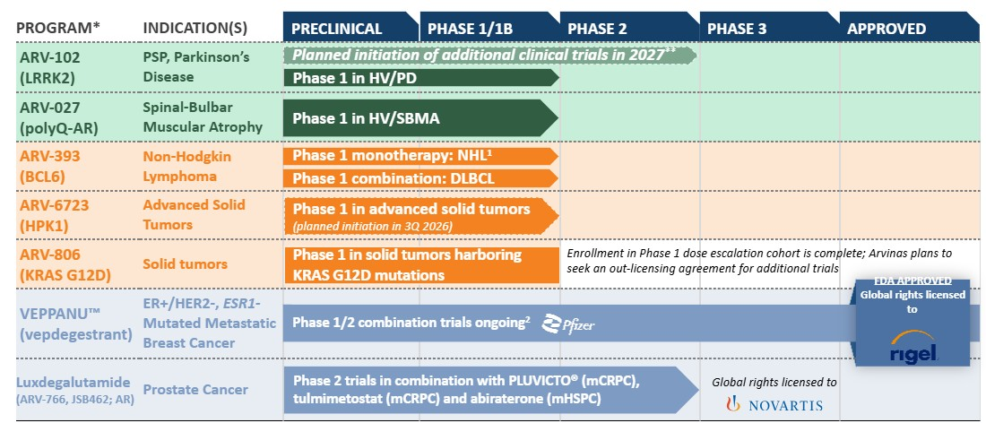
*The agents, other than VEPPANU which has been approved by the FDA, in the pipeline graphic above are currently under investigation; their safety and effectiveness for these investigational uses have not been established.
**Upon health authority clearance to proceed with clinical trials.
•Defined terms used in pipeline graphic: AR, androgen receptor; BCL6, B-cell lymphoma 6; ER+, estrogen receptor positive; ESR1, estrogen receptor 1; DLBCL, diffuse large b-cell lymphoma; HER2-, human epidermal growth factor receptor 2-negative; HPK1, hematopoietic progenitor kinase 1; HV: healthy volunteers; I-O, immuno-oncology; KRAS, Kirsten rat sarcoma viral oncogene homolog; LRRK2, leucine-rich repeat kinase 2; mCRPC, metastatic castration resistant prostate cancer; mHSPC, metastatic hormone sensitive prostate cancer; NSCLC, non-small cell lung cancer; NDA, new drug application; NHL, non-Hodgkin lymphoma; polyQ, expanded polyglutamine; PSP, progressive supranuclear palsy; SBMA, spinal-bulbar muscular atrophy.
•Footnotes included in pipeline graphic: 1. Includes relapsed/refractory angioimmunoblastic T-cell lymphoma (AITL) and relapsed/refractory mature B cell NHL; 2. Phase 1/2 combination trials with palbociclib, atirmociclib, abemaciclib, ribociclib, samuraciclib, everolimus.
In addition to the programs above and any early-stage collaborations, including with Pfizer, we are conducting exploratory research and development work on multiple other undisclosed targets.

Clinical Stage Programs: ARV-393, ARV-102, ARV-027 and ARV-806

ARV-393: Oral PROTAC BCL6 Degrader Program
ARV-393 is an investigational, orally bioavailable PROTAC designed to specifically target and degrade BCL6, a transcriptional repressor and a key regulator of normal B-cell maturation and differentiation processes. Deregulation of BCL6 function (e.g., via chromosomal translocation, mutations) may lead to malignant transformation and development of NHL. Also as a lineage defining transcription factor of T-follicular helper
24
Table of Contents
cells, BCL6 has been implicated in nodal T-follicular helper cell lymphoma, or nTFHL, including the angioimmunoblastic type, formerly angioimmunoblastic T-cell lymphoma, or AITL.
We believe that PROTAC-mediated degradation has the potential to address the historically undruggable nature of BCL6 and that ARV-393 PROTAC-mediated degradation of BCL6 may provide an important novel therapeutic option for patients with NHL. Furthermore, we believe current preclinical data suggest that ARV-393 has the potential to be an attractive combination partner for development of novel therapies for lymphoma, including chemo-free combination regimens and/or “all oral” treatment options.
Preclinical Development
We have conducted preclinical studies of ARV-393 alone, in combination with SOC chemotherapy and biologic agents, as well as oral, investigational small molecule inhibitors in high grade and aggressive diffuse large B-cell lymphoma, or DLBCL, and in combination with glofitamab, a CD20xCD3 bispecific antibody and an emerging SOC option for DLBCL, in models of aggressive high grade DLBCL. We believe the totality of our ARV-393 preclinical data provides a compelling rationale to evaluate ARV-393 in combination with bi-specifics, oral pathway inhibitors, and potentially other SOCs in the larger DLBCL indication.
Clinical Development
We initiated the monotherapy cohort of our first-in-human Phase 1 clinical trial of ARV-393 in patients with relapsed or refractory NHL in the second quarter of 2024 and are currently recruiting patients for this clinical trial. This is an open-label, multicenter, Phase 1 dose escalation trial to evaluate the safety, tolerability PK, pharmacodynamics, and preliminary anti-tumor activity of ARV-393 as a single agent in adult patients with relapsed/refractory NHL. We announced in the first quarter of 2026, and have since reiterated that there have been multiple responses observed in early cohorts at doses below the predicted effective exposure level in patients with both B- and T-cell lymphomas in the first-in-human Phase 1 clinical trial. We believe these early data support an emerging, and differentiated, therapeutic benefit of ARV-393. Dose escalation in the trial is ongoing and the safety profile of ARV-393 supports continuing dose escalation. We plan to share clinical data from the early monotherapy cohorts in the ongoing Phase 1 dose escalation clinical trial of ARV-393 in patients with relapsed/refractory NHL at a medical congress in the second half of 2026. We expect that the majority of this data in 2026 will be from the early cohorts dosed below the expected efficacious range. These early monotherapy cohorts, when compared with the overall lymphoma population, include a higher-than-predicted proportion of patients with T-cell lymphomas, which we believe reflects the limited treatment options for these patients. However, as we’ve approached the predicted efficacious range, enrollment of patients, including those with B-cell lymphomas, has increased. We anticipate sharing additional monotherapy data in the ongoing Phase 1 dose escalation clinical trial in patients with B- and T-cell lymphomas in mid-2027.
In addition, in the second quarter of 2026, we announced the initiation of a combination cohort in the ongoing Phase 1 clinical trial to evaluate ARV-393 in combination with glofitamab as a chemotherapy-free combination approach in patients with DLBCL. Enrollment in this clinical trial is currently ongoing, and we plan to share data from this combination cohort of ARV-393 with glofitamab in patients with DLBCL in mid-2027.

ARV-102: Oral PROTAC LRRK2 Degrader Program
ARV-102 is an investigational, orally bioavailable PROTAC designed to cross the blood-brain barrier and specifically target and degrade LRRK2, which is a large, multi-domain scaffolding kinase with GTPase activity. ARV-102 is our first oral PROTAC protein degrader in clinical development to treat neurodegenerative diseases.
Traditional small molecule inhibitors, or SMIs, only block LRRK2’s kinase activity, and thus only modify disease processes regulated by the LRRK2 kinase. By degrading the entire protein, LRRK2 degraders are designed to eliminate all of the ways LRRK2 interacts with disease pathology: the scaffolding function, GTPase activity, as well as kinase activity. We believe our LRRK2 degraders are particularly well positioned to be evaluated in neurodegenerative diseases where there are currently no disease modifying therapies available, including:
•PSP, where genetic variations in LRRK2 are associated with PSP progression and accelerated time to death. PSP is a primary tau-driven disease, and tau uptake by human neurons requires LRRK2
25
Table of Contents
activity. Additionally, we have published data associating the tau pathology of PSP with LRRK2-mediated endolysosomal dysfunction; and
•PD, where increased LRRK2 expression and activity, as well as specific LRRK2 mutations, contributes to neurodegeneration and pathogenesis of PD.
Preclinical Development
In preclinical studies, ARV-102 was shown to cross the blood-brain barrier and degrade LRRK2 in cerebrospinal fluid, or CSF, in non-human primates, or NHPs. Our preclinical studies also showed that ARV-102 and other similar LRRK2 PROTAC degrader molecules pharmacologically enhanced lysosomal degradative capacity and number, and reduced pathologic forms of tau in vitro and in vivo. We believe the data from our preclinical studies of ARV-102 further support the potential of PROTAC-induced LRRK2 degradation as a treatment for patients with neurodegenerative diseases.
Clinical Development
We have evaluated ARV-102 in Phase 1 clinical trials in healthy volunteers and patients with PD.
•Healthy Volunteers: We initiated the first-in-human Phase 1 clinical trial for ARV-102 in the first quarter of 2024. We completed the single ascending dose, or SAD, and multiple ascending dose, or MAD, cohorts of the ARV-102 Phase 1 clinical trial in healthy volunteers.
•Patients with PD: We completed enrollment in the SAD cohort of the ARV-102 Phase 1 clinical trial in patients with PD in the second quarter of 2025. We received Clinical Trial Application approval in the Netherlands to initiate a multiple dose cohort of the Phase 1 clinical trial in patients with PD in the second quarter of 2025, and we initiated this multiple dose, or MD, cohort in the third quarter of 2025. In the fourth quarter of 2025, we completed enrollment in the multiple dose cohort.
The ARV-102 Phase 1 clinical trial was designed to assess the safety, pharmacokinetics, and pharmacodynamics of orally administered ARV-102 in patients with Parkinson's disease.
In the first quarter of 2026, we presented data from the single-center, randomized, double-blind, placebo-controlled, multiple dose, or MD, cohort of the Phase 1 clinical trial in patients with Parkinson's disease in an oral presentation at the 2026 International Conference on Alzheimer’s and Parkinson’s Diseases and Related Neurological Disorders 2026 in Copenhagen, Denmark. In the MD cohort, patients were randomized to either placebo or multiple oral doses of ARV-102 (20 mg, 40 mg, or 80 mg) for 28 days with follow-up at day 42.
Data presented from the clinical trial included the following:
Safety Profile
•Multiple oral doses of ARV-102 (20 mg, 40 mg, or 80 mg once daily for 28 days) were well tolerated in participants with Parkinson's disease.
•All treatment-emergent adverse events and treatment-related adverse events were mild in severity, with no serious adverse events, discontinuations, or deaths reported.
•No significant changes in lung functions or respiratory symptoms were observed during the 28 days of treatment or during follow-up.
Pharmacokinetic and Pharmacodynamic Evaluation
•ARV-102 levels in CSF increased in a dose-dependent manner after multiple doses, indicating brain penetration.
•The area under the concentration-time curve (AUC0-24) and the maximum plasma concentration (Cmax) after daily dosing increased with dose with a mean terminal plasma half-life (t1/2) of 68 hours.
•ARV-102 achieved peripheral LRRK2 degradation and dose-dependent degradation of LRRK2 in CSF, with approximately 50% or greater degradation observed at all doses by day 14 and maintained through day 28.
26
Table of Contents
•Endolysosomal and neuroinflammatory pathway proteins that are elevated in LRRK2-related Parkinson's disease (e.g., CD68, GPNMB) were reduced with ARV-102.
•Pharmacology and changes in peripheral biomarkers in patients with Parkinson's disease were consistent with observations in healthy volunteers dosed with ARV-102.
Based on the data, we plan to continue investigation of ARV-102 in neurodegenerative diseases associated with LRRK2 and endolysosomal dysfunction. We plan to share additional biomarker data from the Phase 1 clinical trial in patients with PD at the International Congress on Parkinson’s Disease and Movement Disorders in the fourth quarter of 2026.
We submitted an investigational new drug application, or IND, earlier this year for ARV-102 with the intention of initiating a Phase 1b clinical trial in patients with PSP in the U.S. during first half of 2026. Following the 30-day review period, prior to authorizing the initiation of the Phase 1b clinical trial in the U.S. in patients with PSP, the FDA requested additional information as well as final data from our chronic toxicology studies in non-human primates, which we recently completed. As a result of the FDA’s request, the planned Phase 1b clinical trial, in which we have not yet dosed any patients, is on clinical hold and will not begin until the FDA completes its review and authorizes initiation of the clinical trial. In addition, during the second quarter of 2026, we engaged with European and Japanese health authorities on our ARV-102 program in patients with PSP. Our discussions with global health authorities are ongoing. We plan to continue these discussions and, subject to regulatory clearance, we plan to initiate clinical trials in patients with PSP in 2027. We continue to evaluate development options for ARV-102 in PD.
In addition, in the second quarter of 2026, we announced that we joined the LRRK2 Investigative Therapeutics Exchange (LITE) program and the Parkinson’s Precision Medicine Initiative (PPMI), both supported by The Michael J. Fox Foundation for Parkinson’s Research (MJFF).

ARV-027: Oral PROTAC polyQ-AR Degrader Program
ARV-027 is an investigational, oral, peripherally restricted PROTAC designed to selectively target and eliminate the polyQ-AR in skeletal muscle. ARV-027 is a product candidate specifically selected for potent in vitro reduction of cytosolic and nuclear polyQ-AR and for favorable skeletal muscle exposure following oral administration.

The polyQ-AR protein is the pathogenic driver of spinal bulbar muscular atrophy, or SBMA, a rare, X-linked, genetically defined neuromuscular disease caused by a CAG trinucleotide repeat expansion in the androgen receptor, or AR, gene, causing protein misfolding and leading to progressive degeneration of the neuromuscular system in men. SBMA is also known as Kennedy's disease. SBMA leads to progressive muscle weakness, dysphagia, and functional decline, and currently has no disease-modifying therapies approved by the FDA or EMA, representing a significant unmet medical need.
In the first quarter of 2026, at the Kennedy's Disease Association conference, we shared preclinical data in an aggressive SBMA mouse model showing that oral ARV-027 degraded polyQ-AR in muscle, led to meaningful functional improvements, and extended survival. We believe ARV-027 has the potential to become the first treatment option for many patients with SBMA, where no disease-modifying therapies have been approved in the U.S. or European Union.
We initiated the first-in-human Phase 1 clinical trial in ARV-027 in healthy volunteers in the first quarter of 2026. In the second quarter of 2026, we completed the single-ascending dose cohorts in the first-in-human Phase 1 clinical trial in healthy volunteers and, in the third quarter of 2026, we initiated enrollment in the multiple dose cohorts in the Phase 1 clinical trial in healthy volunteers. We plan to continue enrollment in the multiple dose cohort of the Phase 1 clinical trial of ARV-027 in healthy volunteers and share initial data evaluating AR-degradation in muscle in the first half of 2027. In addition, the Phase 1 clinical trial design also includes patients with SBMA in the later multiple dose cohorts.

27
Table of Contents
ARV-806: Novel PROTAC KRAS G12D Degrader Program
ARV-806 is an investigational novel PROTAC designed to selectively target and degrade mutant KRAS G12D in solid tumors. KRAS is one of the most frequently mutated human oncogenes and G12D is the most common mutation of the KRAS protein. In normal cells, the KRAS protein regulates cell growth and functions as a molecular switch, cycling between a baseline “OFF” state and only turning “ON” when conditions are appropriate for growth. Mutations, including G12D, lock KRAS in the “ON” form, leading to uncontrolled cell growth and cancer. ARV-806 is designed to degrade both the ON and OFF forms of KRAS G12D and by removing this oncogenic protein, has the potential to shut down the constitutive growth signal and lead to death of the cancer cells. We believe ARV-806 has the potential to address high unmet need in solid tumors, such as pancreatic, colorectal and non-small cell lung cancer, or NSCLC, with KRAS G12D mutation.
Preclinical Development
In the preclinical setting, ARV-806 demonstrated high potency and selectivity, with robust antitumor activity through dose-responsive degradation of KRAS G12D in KRAS G12D mutated cancer models, including pancreatic and colorectal models. ARV-806 formed a ternary complex with both the active "ON" and inactive "OFF" forms of KRAS G12D, achieving potent and durable elimination rather than inhibition of the target. As a result, in preclinical studies, ARV-806 achieved in vitro potency more than 25 times greater than clinical stage KRAS G12D "ON" and "OFF" inhibitors and more than 40 times greater than the leading KRAS G12D clinical-stage degrader.
Clinical Development
We filed an IND with the FDA for ARV-806 in the first quarter of 2025 and received a safe-to-proceed letter from the FDA in the second quarter of 2025. We initiated enrollment in a Phase 1 clinical trial of ARV-806 in patients with advanced solid tumors harboring KRAS G12D mutations in the second quarter of 2025 and this trial is currently ongoing.
In the second quarter of 2026, we announced that we had completed dose escalation enrollment of the Phase 1 clinical trial evaluating ARV-806 in patients with solid tumors harboring KRAS G12D mutations. We are planning to complete this Phase 1 monotherapy dose escalation clinical trial and share clinical data in the second half of 2026. In the second quarter of 2026 we also announced that we plan to seek an out-licensing agreement for any additional clinical trials of ARV-806, including dose expansion or combination clinical trials.

Approved Product: VEPPANU
VEPPANU is an orally bioavailable PROTAC, estrogen receptor degrader approved in the U.S. for use as a monotherapy in the treatment of adults with ER+/HER2-, ESR1-mutated advanced or metastatic breast cancer, as detected by an FDA-authorized test, with disease progression following at least one line of endocrine therapy. VEPPANU is the first and only FDA-approved PROTAC protein degrader, a type of heterobifunctional protein degrader therapy.
We have been co-developing vepdegestrant with Pfizer, pursuant to a collaboration agreement that we and Pfizer entered into in July 2021. Pursuant to this agreement, we granted Pfizer worldwide co-exclusive rights to develop and commercialize vepdegestrant, which at that time, was an investigational, oral PROTAC estrogen receptor degrader.
In the second quarter of 2026, we and Pfizer entered into the Rigel License Agreement with Rigel for the exclusive global development, manufacturing, and commercialization rights for VEPPANU. Under the terms of the Rigel License Agreement, Rigel will be responsible for the launch and commercialization of VEPPANU in the U.S. and will own global rights with the ability to sublicense to potential partners to further develop and commercialize VEPPANU outside of the U.S.
Preclinical Development
In preclinical studies, vepdegestrant demonstrated near-complete ER degradation in tumor cells, induced robust tumor shrinkage when dosed as a single agent in multiple ER-driven xenograft models and showed superior anti-tumor activity when compared to a standard of care agent, fulvestrant, both as a single agent and in combination with a cyclin-dependent kinase, or CDK, 4/6 inhibitor.
28
Table of Contents
Clinical Development
We, along with Pfizer, have ongoing clinical trials of vepdegestrant, for which enrollment of patients is complete, which are summarized below.
•TACTIVE-K, a Phase 1b/2 clinical trial of vepdegestrant in combination with Pfizer's cyclin-dependent kinase 4, or CDK4, inhibitor, atirmociclib; and
•TACTIVE-U, a Phase 1b/2 clinical trial of vepdegestrant in combination with multiple targeted therapies including abemaciclib, ribociclib or Carrick Therapeutics, Inc.'s, or Carrick, cyclin-dependent kinase 7, or CDK7, inhibitor, samuraciclib.

We, along with Pfizer, also have several completed clinical trials of vepdegestrant:
•VERITAC-2, a Phase 3 clinical trial of vepdegestrant as a monotherapy, targeting metastatic breast cancer previously treated with endocrine based therapy;
•VERITAC, a Phase 2 dose expansion clinical trial of vepdegestrant as a monotherapy, targeting previously treated metastatic breast cancer;
•TACTIVE-N, a Phase 2 clinical trial of vepdegestrant as a monotherapy in the neoadjuvant setting; and
•TACTIVE-E, a Phase 1 clinical trial of vepdegestrant in combination with everolimus.
Additionally, VERITAC-3, a clinical trial with a study lead-in of vepdegestrant in combination with palbociclib for the treatment of patients with first-line metastatic breast cancer, is ongoing and enrollment of patients is complete. As previously disclosed, VERITAC-3 will not proceed beyond the study lead-in.
VERITAC-2 Clinical Trial, VEPPANU FDA Approval and Rigel License Agreement
In the first quarter of 2025, we, along with Pfizer, announced positive topline results from the Phase 3 VERITAC-2 clinical trial in the estrogen receptor 1-mutant, or ESR1m, population, and in the second quarter of 2025, we, along with Pfizer, announced detailed results from this clinical trial.
In the clinical trial, vepdegestrant, now approved as VEPPANU, demonstrated a statistically significant and clinically meaningful improvement in progression-free survival, or PFS, among ER+/HER2- advanced and metastatic breast cancer patients with an ESR1 mutation, reducing the risk of disease progression or death by 43% compared to fulvestrant, which is administered via an intramuscular injection. The median PFS, as assessed by blinded independent central review, was 5.0 months with VEPPANU versus 2.1 months with fulvestrant. In the clinical trial, VEPPANU was generally well tolerated, with a safety profile consistent with what has been observed in previous studies, and mostly low-grade treatment-emergent adverse events, or TEAEs. The three most common TEAEs observed with VEPPANU were fatigue, increased alanine transaminase, and increased aspartate aminotransferase. Detailed results were presented in a late-breaking oral presentation at the American Society of Clinical Oncology, or ASCO, 2025 Annual Meeting and were highlighted in the ASCO press briefing and selected for Best of ASCO, and were also simultaneously published in the New England Journal of Medicine.
Based on the results from VERITAC-2, in the second quarter of 2025, we and Pfizer submitted an NDA to the FDA for vepdegestrant for the treatment of patients with ER+/HER2- ESR1-mutated advanced or metastatic breast cancer previously treated with endocrine-based therapy. This represented the first NDA submitted for a PROTAC. In the third quarter of 2025, we announced that the FDA accepted the NDA for vepdegestrant and assigned a PDUFA action date of June 5, 2026. In the second quarter of 2026, we announced that the FDA has approved the Company’s new drug application for VEPPANU for the treatment of adults with ER+/ HER2-, ESR1-mutated advanced or metastatic breast cancer, as detected by an FDA-authorized test, with disease progression following at least one line of endocrine-based therapy. In the second quarter of 2026, we and Pfizer entered into the Rigel License Agreement with Rigel for the exclusive global development, manufacturing, and commercialization rights for VEPPANU, which is discussed in greater detail below and in Note 3, Research Collaboration and License Agreements.
In addition, on May 8, 2026, the National Comprehensive Cancer Network® (NCCN®) added vepdegestrant (VEPPANU) to the latest NCCN Clinical Practice Guidelines in Oncology (NCCN Guidelines®)
29
Table of Contents
for Breast Cancer. Vepdegestrant (VEPPANU) was added as a Category 2A treatment option for patients with hormone receptor (HR)-positive/HER2-negative, ESR1-mutated advanced or metastatic breast cancer after at least one line of endocrine therapy + cyclin-dependent kinase (CDK) 4/6 inhibitor.*
*NCCN makes no warranties of any kind whatsoever regarding their content, use, or application and disclaims any responsibility for their application or use in any way.

Preclinical and Other Programs
We have active preclinical programs in neurology and oncology. In 2025 we announced two new product candidate nominees, ARV-027 and ARV-6723. As described above, we initiated a Phase 1 clinical trial for ARV-027 in the first quarter of 2026.

ARV-6723: Oral PROTAC HPK1 Degrader
ARV-6723 is an oral investigational PROTAC designed to degrade HPK1 in solid malignancies. Preclinically, ARV-6723 has shown potent, selective HPK1 degradation and strong anti-tumor immune responses with superior tumor control in low- and high- immunogenic murine syngeneic tumor models. In solid tumor malignancies, such as NSCLC, melanoma, and renal cell carcinoma, or RCC, HPK1 acts as a negative regulator in T-cell receptor signaling, contributing to T-cell exhaustion and suppressing antitumor immunity. In addition, HPK1 has a regulatory role in other immune cell types that can be co-opted by tumors, thus enabling these cancers to resist immuno-oncology therapy. Degrading HPK1 and thus eliminating both its kinase and scaffolding functions has the potential to unleash an immune response with potent anti-tumor effects and minimum off-target toxicity.
We presented preclinical data at the Society for Immunotherapy of Cancer annual meeting in the fourth quarter of 2025 that we believe supports the potential of ARV-6723 to provide sustained anti-tumor immune response as a single agent or in combination with standards of care with improved clinical benefits, including that: ARV-6723, as a single agent, demonstrates anti-tumor efficacy superior to anti-PD1 or a clinical HPK1 inhibitor and combines with anti-PD1 to further enhance response; and ARV-6723 single agent activity outperforms the HPK1 inhibitor and anti-PD-1 efficacy and reinstitutes the tumor microenvironment.
In addition, we presented preclinical data for ARV-6723 at the AACR Immuno-Oncology Conference in the first quarter of 2026 that support clinical investigation of ARV-6723 in patients with solid tumors harboring high- or low-immunogenic tumor microenvironments, or TME, including immune checkpoint inhibitor, or ICI,-resistant tumor settings. This preclinical data showed robust single-agent antitumor and proinflammatory activity in multiple syngeneic tumor models, including those with immunosuppressive TMEs, and showed greater preclinical activity than an investigational HPK1 inhibitor or an anti-PD-1 antibody.
At the AACR Annual Meeting in the second quarter of 2026, we presented preclinical data that demonstrated greater antitumor activity than SOC ICIs or an investigational HPK1 inhibitor. These preclinical data presented showed that ARV-6723, unlike an inhibitor and the ICIs, reverses T-cell exhaustion, reverses the immunosuppressive microenvironment and boosts innate cell immunity in ICI-(aPD1 and aCTLA4) resistant models. We believe these preclinical results support future investigation of ARV-6723 alone or in combination with other agents in patients with high- or low-immunogenic tumors.
We plan to initiate a Phase 1 clinical trial of ARV-6723 in patients with advanced solid tumors in the third quarter of 2026. Upon initiation of the clinical trial, ARV-6723 will be our first clinical candidate in immuno-oncology. The trial design includes a plan for dose escalation and an expansion combination cohort with
pembrolizumab once sufficient monotherapy data are available.

Pan-KRAS Program
Our preclinical oral pan-KRAS program targets multiple variants of KRAS that drive solid tumors such as PDAC, colorectal cancer, NSCLC, and esophageal cancer, while sparing other RAS isoforms. We believe selectively targeting KRAS for removal may have benefits to tolerability compared with a pan-RAS approach. The poster presented at the 2025 Triple Meeting in the fourth quarter of 2025 showed that orally bioavailable pan-KRAS degraders have been identified that potently degrade multiple variants of KRAS and spare other RAS isoforms. A tool pan-KRAS PROTAC demonstrated robust single-agent activity and superior combination
30
Table of Contents
efficacy with immune checkpoint blockade compared with a pan-RAS (ON) inhibitor (seven complete responses compared with two complete responses).
In the first quarter of 2026, at the AACR Special Conference in Cancer Research: RAS Oncogenesis and Therapeutics, we presented preclinical data that demonstrated: robust efficacy in CDX models of pancreatic, colorectal, and lung cancer, greater tumor growth inhibition than a pan-RAS (ON) inhibitor in a KRAS G13D model, and enhanced combination efficacy with immune checkpoint blockade compared with a pan-RAS (ON) inhibitor in a KRAS G12D syngeneic model.

Other Out-licensed or Completed Programs: Luxdegalutamide (ARV-766) and Bavdegalutamide (ARV-110)
We had been developing luxdegalutamide and bavdegalutamide, each an investigational, orally bioavailable, AR degrading PROTAC targeted protein degrader, for the treatment of men with metastatic castration-resistant prostate cancer, or mCRPC. Both luxdegalutamide and bavdegalutamide demonstrated activity in preclinical models of AR overexpression and AR mutations, both common mechanisms of resistance to current standard-of-care agents in men with prostate cancer. We believed that the differentiated PROTAC pharmacology of luxdegalutamide and bavdegalutamide, including their iterative activity, had the potential to translate into significantly improved clinical outcomes over current SOC agents. However, a comparison of clinical data from separate studies of luxdegalutamide and bavdegalutamide showed that luxdegalutamide’s tolerability and efficacy was more promising than that of bavdegalutamide. As a result, early in the fourth quarter of 2023, we determined to prioritize the initiation of a Phase 3 clinical trial with luxdegalutamide in mCRPC instead of the previously planned Phase 3 clinical trial for bavdegalutamide. Clinical trials for bavdegalutamide (ARV-110-101 and ARV-110-103) were completed in the second quarter of 2025.
In the second quarter of 2024, we completed a transaction with Novartis Pharma AG, or Novartis, which comprised a license agreement, or the Novartis License Agreement, and an asset agreement, or the Novartis Asset Agreement. Pursuant to the Novartis License Agreement, we granted Novartis an exclusive worldwide license for the development, manufacture and commercialization of luxdegalutamide, and we completed the transition of our ongoing and planned clinical trials of luxdegalutamide to Novartis in the fourth quarter of 2024. Pursuant to the Novartis Asset Agreement, we sold Novartis all of our rights, title and interest in our PROTAC protein degrader targeting AR-V7, a splice variant of the AR.

Our Operations
We commenced operations in 2013. Our operations to date have been limited to organizing and staffing our company, business planning, raising capital, conducting discovery and research activities, filing patent applications, identifying potential product candidates, undertaking preclinical studies and clinical trials, establishing arrangements with third parties for collaborations or licensing arrangements and for the manufacture of initial quantities of our product candidates and preparing for potential commercialization. To date, we have not generated any revenue from product sales and have financed our operations primarily through sales of assets and equity interests, proceeds from our collaborations and licensing arrangements, an asset sale, grant funding and debt financing. Since inception through June 30, 2026, we raised approximately $1.7 billion in gross proceeds from the sale of assets and equity interests and the exercise of stock options and had received an aggregate of $1.0 billion in payments primarily from collaboration partners and a licensing arrangement.
We are a biotechnology company, with product candidates in clinical development and other drug discovery activities in the research and preclinical development stages. Our ability to generate revenue from product sales sufficient to achieve profitability will depend heavily on the successful development and eventual commercialization of one or more of our product candidates.
In the second quarter of 2026, we announced that the FDA has approved VEPPANU for the treatment of adults with ER+/HER2-, ESR1-mutated advanced or metastatic breast cancer, as detected by an FDA-authorized test, with disease progression following at least one line of endocrine-based therapy. Also in the second quarter of 2026, we and Pfizer entered into the Rigel License Agreement with Rigel for the exclusive global development, manufacturing, and commercialization rights for VEPPANU. All decisions related to pricing, access, reimbursement, sublicense and ex-U.S. regulatory plans for VEPPANU will be determined by Rigel. Our ability to generate revenue from the sale of VEPPANU will be entirely dependent on Rigel, and we may never
31
Table of Contents
generate product revenue from the Rigel License Agreement to realize any profits from the out-license of VEPPANU.
Any delay or failure to obtain regulatory approvals would materially adversely affect our product candidate development efforts and our business overall. Because of the numerous risks and uncertainties associated with product development, we are unable to predict the timing or amount of increased expenses or when or if we will be able to achieve or maintain profitability. Even if we are able to generate product sales, we may not become profitable. If we fail to become profitable or are unable to sustain profitability on a continuing basis, then we may be unable to continue our operations at planned levels and be forced to reduce or terminate our operations.
We regularly review our operations and make decisions we believe best support our business strategy. In April 2025, as part of our decision to streamline operations across our organization and enable the efficient progression of our portfolio, we committed to and approved a reduction of our workforce by approximately 33% across all areas of our company. The workforce reduction was aimed at reducing internal costs while minimally impacting our targeted clinical stage programs to drive value over the next several years by aligning our operations with long-term program development objectives. The April 2025 workforce reduction was completed by the end of the second quarter of 2025.
In September 2025, we announced an update on our collaboration with Pfizer and further actions to support value creation by optimizing organizational and cost structures and streamlining operations in advance of multiple anticipated upcoming value inflection points, including: further limiting additional expenditures on the vepdegestrant program to support activities required for commercialization readiness and identification, with Pfizer, of a third party for the commercialization and potential further development of vepdegestrant; reducing our workforce by an additional 15% to streamline operations, with the most significant reductions being roles related to vepdegestrant commercialization; and proactively managing pipeline cost by seeking strategic business development opportunities and by identifying further efficiencies across the business. The September 2025 workforce reduction was completed by the second quarter of 2026. Refer to Note 14, Restructuring Activity, in this Quarterly Report on Form 10-Q for further details.
In the first quarter of 2026, we announced the appointment of Randy Teel, Ph.D., as our President, Chief Executive Officer and as a member of our board of directors. Dr. Teel, who previously served as our Chief Business Officer, succeeds John Houston, Ph.D., who is retired from his role as President, Chief Executive Officer, and Chair of our board of directors. Dr. Houston will continue to serve as a member of the Board and has entered into a consulting agreement with us whereby he will provide consulting and advisory services. Briggs Morrison, M.D., our lead independent director, has been elected to serve as Chair of our board of directors. In the second quarter of 2026, we announced that Noah Berkowitz, M.D., Ph.D. would depart from his employment with us as chief medical officer effective July 3, 2026. We have begun a search to find a new chief medical officer to replace Dr. Berkowitz.
Since inception, we have incurred significant operating losses and, even in light of our workforce reductions and cost optimization decisions, expect to continue to incur operating losses for at least the next several years. In addition to any additional costs not currently contemplated due to the events associated with or resulting from our workforce reductions, our ability to achieve profitability and our financial position will depend, in part, on the rate of our future expenditures, potential collaboration revenue, our ability to successfully implement cost avoidance measures and reduce overhead costs and our ability to obtain additional funding.
We expect to continue to incur significant expenses associated with: our ongoing and anticipated preclinical and clinical activities, development activities, research activities in oncology, neuroscience and other disease areas, managing our employees and retaining key talent in research, clinical trials, quality and other functional areas, expenses incurred with contract manufacturing organizations, or CMOs, and contract development and manufacturing organizations, or CDMOs, to supply us with product for our preclinical and clinical studies and expenses incurred with contract research organizations, or CROs, for the synthesis of compounds in our preclinical development activities, as well as other associated costs including those related to partnering with us on our clinical trial portfolio and the management of our intellectual property portfolio.
We do not expect to generate any revenue from product sales in the near future, if ever.
32
Table of Contents
As noted above, our ability to generate revenue from the sale of VEPPANU will be entirely dependent on Rigel's performance of its obligations under the Rigel License Agreement, and we may never generate product revenue from the Rigel License Agreement to realize any profits from the out-license of VEPPANU.
Accordingly, we will need to obtain substantial additional funding in connection with our continuing operations. If we are unable to raise capital when needed or on attractive terms, we could be forced to delay, reduce or eliminate our research or product development programs or any future commercialization efforts, or to relinquish valuable rights to our technologies, future revenue streams, research programs or product candidates or to grant licenses on terms that may not be favorable to us.
As of June 30, 2026, we had cash, cash equivalents and marketable securities of $567.9 million. We believe the existing cash, cash equivalents and marketable securities on hand will be sufficient to fund our operations into the second half of 2028, which will enable us to execute on multiple data readouts across our programs. We have based this estimate on assumptions that may prove to be wrong, and we could exhaust our available capital resources sooner than we expect. See “Liquidity and Capital Resources” below.

Financial Operations Overview

Revenue
To date, we have not generated any revenue from product sales and do not expect to generate any revenue from the sale of products in the near future, other than potentially pursuant to the Rigel License Agreement. Our revenues to date have been generated through research collaborations, licensing arrangements and an asset sale. Revenue is recognized ratably over our expected performance period under each agreement.
While we do have one approved product, VEPPANU, and we have entered into the Rigel License Agreement, our ability to generate revenue from the sale of VEPPANU will be entirely dependent on Rigel's performance of its obligations under the Rigel License Agreement, and we may never generate product revenue from the Rigel License Agreement to realize any profits from the out-license of VEPPANU. All decisions related to pricing, access, reimbursement, sublicense and ex-U.S. regulatory plans for VEPPANU will be determined by Rigel.
We expect that any revenue recognized in the near term will be derived primarily from our current collaboration agreements and licensing arrangements and any additional arrangements that we may enter into in the future. We received a $20.0 million development milestone during the year ended December 31, 2025 pursuant to the terms of the Novartis License Agreement and a $50.0 million development milestone during the three months ended June 30, 2026 pursuant to the Original Vepdegestrant (ARV-471) Collaboration Agreement in connection with the FDA’s approval of VEPPANU. To date, no other development, regulatory and commercial milestone payments or royalties have been received under any of our other collaboration agreements or licensing arrangements.

Rigel License Agreement
On May 11, 2026, we, including our direct subsidiaries, Arvinas Operations, Inc. and Arvinas Estrogen Receptor, Inc., together with Pfizer, entered into the Rigel License Agreement with Rigel. Pursuant to the Rigel License Agreement, we and Pfizer granted to Rigel a license for the exclusive global development, manufacturing and commercialization rights for VEPPANU, an orally bioavailable PROteolysis TArgeting Chimera (PROTAC), ER+/HER2-, ESR1-mutated advanced or metastatic breast cancer, as detected by a FDA-authorized test, with disease progression following at least one line of endocrine therapy.
Under the terms of the Rigel License Agreement, Rigel will be responsible for the launch and commercialization of VEPPANU in the U.S. and will own global rights with the ability to sublicense to potential partners to further develop and commercialize VEPPANU outside of the U.S. We and Pfizer will be entitled to a percentage of sublicensing revenue generated outside the U.S. Rigel has agreed to reimburse us and Pfizer up to $40.0 million of the costs of ongoing development activities that were in progress as of the effective date of the Rigel License Agreement. While Pfizer is responsible for these ongoing development activities, we and
33
Table of Contents
Pfizer will share equally in this reimbursement and therefore we will reimburse Pfizer for 50% of the costs of such activities.
Under the terms of and as consideration for entering into the Rigel License Agreement, Rigel paid to us and Pfizer a one-time, upfront payment in the aggregate amount of $70.0 million. In addition, we and Pfizer will receive an additional payment in the amount of $15.0 million from Rigel upon successful completion of select development and manufacturing transition activities. We and Pfizer will also be eligible to receive up to an additional $320.0 million in the aggregate as contingent payments based on future development, regulatory and commercial milestones being met, as well as tiered royalties in the mid-teens to mid-20s based upon worldwide net sales of VEPPANU, subject to reduction under certain circumstances as provided in the Rigel License Agreement. All payments under the Rigel License Agreement will be distributed evenly between us and Pfizer. The milestones and royalty payments under the Rigel License Agreement replace any unearned future amounts that may be owed by Pfizer to us under the Original Vepdegestrant (ARV-471) Collaboration Agreement.
The Rigel License Agreement became effective on June 11, 2026 and will expire on a country-by-country and licensed product-by-licensed product basis until the expiration of the applicable royalty term. The Rigel License Agreement contains customary termination provisions, including that Rigel may terminate the Rigel License Agreement upon the material breach of us and/or Pfizer and we and Pfizer may terminate the Rigel License Agreement upon the material breach of Rigel. Additionally, Rigel may terminate the Rigel License Agreement for convenience subject to a written notice period, following a pre-defined period of time.

Pfizer Vepdegestrant (ARV-471) Collaboration Agreement
In July 2021, we entered into the Original Vepdegestrant (ARV-471) Collaboration Agreement, pursuant to which we granted Pfizer worldwide co-exclusive rights to develop and commercialize products containing our proprietary compound vepdegestrant (ARV-471), or the Licensed Products.
Under the Original Vepdegestrant (ARV-471) Collaboration Agreement, we received an upfront, non-refundable payment of $650.0 million. In addition, we were eligible to receive up to an additional $1.4 billion in contingent payments based on specified regulatory and sales-based milestones for the Licensed Products. Of the total contingent payments, $400.0 million in regulatory milestones were related to marketing approvals and $1.0 billion were related to sales-based milestones.
Further, under the Original Vepdegestrant (ARV-471) Collaboration Agreement, we and Pfizer shared equally (50/50) all development costs for the Licensed Products (including costs for conducting any clinical trials), subject to certain exceptions.
Unless earlier terminated in accordance with its terms, the Original Vepdegestrant (ARV-471) Collaboration Agreement will expire on a Licensed Product-by-Licensed Product and country-by-country basis when such Licensed Product is no longer commercialized or developed for commercialization in such country. Pfizer may terminate the Original Vepdegestrant (ARV-471) Collaboration Agreement for convenience in its entirety or on a region-by-region basis subject to certain notice periods. Either party may terminate the Original Vepdegestrant (ARV-471) Collaboration Agreement for the other party’s uncured material breach or insolvency. Subject to applicable terms of the Original Vepdegestrant (ARV-471) Collaboration Agreement, including certain payments to Pfizer upon termination for our uncured material breach, effective upon termination of the Original Vepdegestrant (ARV-471) Collaboration Agreement, we are entitled to retain specified licenses to be able to continue to exploit the Licensed Products.
Subject to specified exceptions, under the Original Vepdegestrant (ARV-471) Collaboration Agreement, we and Pfizer each agreed not to directly or indirectly research, develop, or commercialize any competing products outside of the Original Vepdegestrant (ARV-471) Collaboration Agreement anywhere in the world during the term of the Original Vepdegestrant (ARV-471) Collaboration Agreement.
In the second quarter of 2026, we announced that the FDA has granted approval for VEPPANU for the treatment of adults with ER+/HER2-, ESR1-mutated advanced or metastatic breast cancer, as detected by an FDA-authorized test, with disease progression following at least one line of endocrine-based therapy. Pursuant to the Original Vepdegestrant (ARV-471) Collaboration Agreement, we received $50.0 million as a development milestone payment in connection with the FDA’s approval of VEPPANU.
34
Table of Contents
In May 2026, we, Pfizer and Rigel entered into the Rigel License Agreement. In connection with and to facilitate entry into the Rigel License Agreement, we and Pfizer also entered into a letter agreement supplementing and amending the terms of the Original Vepdegestrant (ARV-471) Collaboration Agreement, or the Pfizer Letter Agreement. Pursuant to the terms of the Pfizer Letter Agreement, until any termination of the Rigel License Agreement, the milestones and royalty payments under the Rigel License Agreement replace any unearned future amounts that may be owed by Pfizer to us under the Original Vepdegestrant (ARV-471) Collaboration Agreement.

Pfizer Research Collaboration Agreement
In December 2017, we entered into a Research Collaboration and License Agreement with Pfizer, setting forth our collaboration to identify or optimize PROTAC targeted protein degraders that mediate for degradation of targets, using our proprietary platform technology that are identified in the agreement or subsequently selected by Pfizer, subject to certain exclusions. We refer to this agreement as the Pfizer Research Collaboration Agreement.
Under the Pfizer Research Collaboration Agreement, Pfizer designated a number of initial targets. Pursuant to the terms of the Pfizer Research Collaboration Agreement, for each identified target protein, we and Pfizer would conduct a separate research program pursuant to a research plan. Pfizer was also entitled to make substitutions for any of the initial target protein candidates, subject to the stage of research for such target.
In the year ended December 31, 2018, we received an upfront non-refundable payment and certain additional payments totaling $28.0 million in exchange for use of the technology license and to fund Pfizer-related research, as defined within the Pfizer Research Collaboration Agreement. As of June 30, 2026, the research program term under the Pfizer Research Collaboration Agreement has concluded and no targets currently remain. In accordance with the terms of the Pfizer Research Collaboration Agreement, we were eligible to receive up to an additional $3.8 million in non-refundable option payments if Pfizer exercised its option for the then-remaining target protein under the Pfizer Research Collaboration Agreement. Under the terms of the Pfizer Research Collaboration Agreement, we were also entitled to receive up to $225.0 million in development milestone payments and up to $550.0 million in sales-based milestone payments for all designated target proteins under the Pfizer Research Collaboration Agreement, as well as tiered royalties based on sales, which were subject to reductions. There were no sales-based milestone payments or royalties received through June 30, 2026.

Novartis Transaction
In April 2024, we entered into a transaction, or the Novartis Transaction, including both a license agreement, or the Novartis License Agreement, and an asset agreement, or the Novartis Asset Agreement, with Novartis Pharma AG, or Novartis. The Novartis Transaction closed in May 2024 upon the expiration of the waiting period under the Hart-Scott-Rodino Antitrust Improvements Act of 1976, as amended, at which time both the Novartis License Agreement and the Novartis Asset Agreement became effective.
Pursuant to the Novartis License Agreement, we granted Novartis an exclusive worldwide license for the development, manufacture and commercialization of luxdegalutamide (ARV-766), our second generation PROTAC AR degrader for patients with prostate cancer. Pursuant to the Novartis Asset Agreement, we sold to Novartis all of our rights, title and interest in our PROTAC protein degrader targeting AR-V7, a splice variant of the AR.
Under the terms of and as consideration for entering into the Novartis Transaction, we received a one-time, upfront payment in the aggregate amount of $150.0 million from Novartis. Under the Novartis License Agreement, we are also eligible to receive up to an additional $1.01 billion as contingent payments based on specified development, regulatory, and commercial milestones for luxdegalutamide (ARV-766) being met, as well as tiered royalties based upon worldwide net sales of luxdegalutamide (ARV-766), subject to reduction under certain circumstances as provided in the Novartis License Agreement. During the year ended December 31, 2025, we received $20.0 million upon the achievement of a development milestone pursuant to the terms of the Novartis License Agreement. There were no development, regulatory or commercial milestone payments, or sales-based royalties received during the six months ended June 30, 2026.
35
Table of Contents
The Novartis License Agreement will continue on a country-by-country basis (or, in certain cases, a region-by-region basis) until the expiration of the applicable royalty term for such country (or region, as applicable). The Novartis License Agreement contains customary termination provisions, including that either party may terminate the Novartis License Agreement (a) upon the material breach of the other party or (b) in the event the other party experiences an insolvency event. Additionally, Novartis may terminate the Novartis License Agreement for convenience or upon a safety or regulatory issue.

Genentech License Agreement
In September 2015, we entered into an Option and License Agreement with Genentech focused on PROTAC targeted protein degrader discovery and research for target proteins based on our proprietary platform technology, other than excluded target proteins as described below. This collaboration was expanded in November 2017 through an Amended and Restated Option, License and Collaboration Agreement, which we refer to as the Restated Genentech Agreement. Concurrently with entering into the Restated Genentech Agreement, Genentech exercised its exclusive option with respect to a PROTAC targeted protein degrader. We receive annual updates on research and development activities related to this option.
Under the Restated Genentech Agreement, Genentech had the right to designate up to ten targets for further discovery and research utilizing our PROTAC platform technology and also had the right to remove a target from the collaboration and substitute a different target that is not an excluded target at any time prior to us commencing research on such target or in certain circumstances following commencement of research by us. The research phase of the collaboration with Genentech ended, and Genentech was no longer able to nominate new targets into the collaboration. As of March 31, 2026, the only target that remained part of the collaboration was the PROTAC targeted protein degrader for which Genentech exercised its exclusive option upon amendment and restatement of the agreement. Pursuant to notice received from Genentech on June 9, 2026 in accordance with the terms of the Restated Genentech Agreement, the Restated Genentech Agreement will terminate effective August 8, 2026.
At the time we entered into the original agreement with Genentech, we received an upfront payment of $11.0 million, and at the time we entered into the Restated Genentech Agreement, we received an additional $34.5 million in upfront and expansion target payments. Under the Restated Genentech Agreement, prior to termination, we were eligible to receive payments aggregating up to $44.0 million per target protein upon the achievement of specified development milestones; payments aggregating up to $52.5 million per target protein (assuming approval of two indications) subject to the achievement of specified regulatory milestones; and payments aggregating up to $60.0 million per PROTAC targeted protein degrader directed against the applicable target protein, subject to the achievement of specified sales milestones. These milestone payments were subject to reduction if we did not have a valid patent claim covering the licensed PROTAC targeted protein degrader at the time the milestone is achieved. We were also eligible to receive, on net sales of licensed PROTAC targeted protein degraders, mid-single digit royalties, which may be subject to reductions.

Operating Expenses
Our operating expenses since inception have consisted solely of research and development costs and general and administrative costs.

Cost of License Revenue
Costs of license revenue consist primarily of royalties and other amounts payable to third parties that are directly attributable to license revenue recognized under our licensing arrangements. These costs are recognized in the same period as the related license revenue.

Research and Development Expenses
Research and development expenses consist primarily of costs incurred for our research activities, including our discovery efforts, and the development of our product candidates, and include:
•employee related expenses, including salaries, benefits, stock-based compensation expense and travel, for personnel engaged in research and development functions;
36
Table of Contents
•expenses incurred under agreements with third parties, including CROs and other third parties that conduct research, preclinical and clinical activities on our behalf as well as third parties that manufacture our product candidates for use in our preclinical studies and clinical trials;
•costs of outside consultants, including their fees, stock-based compensation and related travel expenses;
•the costs of laboratory supplies and developing preclinical studies and clinical trial materials;
•facility-related expenses, which include direct depreciation costs of equipment and allocated expenses for rent and maintenance of facilities and other operating costs;
•costs incurred in the development of intellectual property; and
•third-party licensing fees.
We expense research and development costs as incurred.
We typically use our employee and infrastructure resources across our development programs, and as such, do not track all of our internal research and development expenses on a program-by-program basis. The following table summarizes our research and development expenses for the three and six months ended June 30, 2026 and 2025:
 |  |  | For the Three Months Ended  June 30, |  |  |  |  |  |  |  |  |  |  |  | For the Six Months Ended  June 30,
(dollars in millions) |  |  | 2026 |  |  |  |  |  | 2025 |  |  |  |  |  | 2026 |  |  |  |  |  | 2025
Program-specific external expense:
Vepdegestrant (ARV-471) (*) |  |  | $ | 4.5 |  |  |  |  | $ | 15.1 |  |  |  |  | $ | 13.3 |  |  |  |  | $ | 39.2
ARV-806 |  |  | 5.6 |  |  |  |  |  | 1.7 |  |  |  |  |  | 12.1 |  |  |  |  |  | 2.6
ARV-102 |  |  | 5.1 |  |  |  |  |  | 3.8 |  |  |  |  |  | 10.7 |  |  |  |  |  | 10.3
ARV-393 |  |  | 4.8 |  |  |  |  |  | 2.5 |  |  |  |  |  | 8.5 |  |  |  |  |  | 5.1
ARV-027 |  |  | 3.3 |  |  |  |  |  | 0.1 |  |  |  |  |  | 5.0 |  |  |  |  |  | 0.2
Bavdegalutamide (ARV-110) |  |  | (0.4) |  |  |  |  |  | 0.9 |  |  |  |  |  | (0.2) |  |  |  |  |  | 2.0
Other programs |  |  | 1.3 |  |  |  |  |  | 0.7 |  |  |  |  |  | 2.3 |  |  |  |  |  | 2.3
Total program-specific external expense |  |  | 24.2 |  |  |  |  |  | 24.8 |  |  |  |  |  | 51.7 |  |  |  |  |  | 61.7
Non-program-specific external expense |  |  | 8.5 |  |  |  |  |  | 11.1 |  |  |  |  |  | 17.7 |  |  |  |  |  | 25.0
Unallocated internal expense
Compensation and related personnel expense  (including stock-based compensation) |  |  | 17.4 |  |  |  |  |  | 28.4 |  |  |  |  |  | 38.7 |  |  |  |  |  | 65.3
Other research and development expense |  |  | 2.5 |  |  |  |  |  | 4.3 |  |  |  |  |  | 4.9 |  |  |  |  |  | 7.4
Total unallocated internal expense |  |  | 19.9 |  |  |  |  |  | 32.7 |  |  |  |  |  | 43.6 |  |  |  |  |  | 72.7
Total research and development expense |  |  | $ | 52.6 |  |  |  |  | $ | 68.6 |  |  |  |  | $ | 113.0 |  |  |  |  | $ | 159.4
(*) As of June 11, 2026, the effective date of the Rigel License Agreement, the Company's future performance obligations under the Original Vepdegestrant (ARV-471) Collaboration Agreement have been satisfied under Accounting Standards Codification Topic 606, Revenue from Contracts with Customers, or ASC 606, as a result of the terms of the Rigel Agreement. The Company recognized a collaboration liability to fund certain ongoing development activities in progress as of the effective date of the Rigel License Agreement being performed by Pfizer, which was recorded as a reduction of revenue. See Note 3, Research Collaboration and License Agreements, for further details. Prior to June 11, 2026, vepdegestrant expense included net reimbursements to and from Pfizer pursuant to the Original Vepdegestrant (ARV-471) Collaboration Agreement which were accounted for pursuant to ASC 808, Collaborative Arrangements, or ASC 808, and were recorded as an offset or an increase to research and development expenses.
37
Table of Contents
Research and development activities are central to our business model. We expect that our research and development expenses will continue to increase substantially for the foreseeable future as we continue to conduct our ongoing and/or planned clinical trials, including for ARV-393, ARV-102, ARV-027 and ARV-6723, and continue to discover and develop additional product candidates. Research and development expenses related to vepdegestrant, now approved as VEPPANU, have been shared equally with Pfizer since July 22, 2021, the effective date of the Original Vepdegestrant (ARV-471) Collaboration Agreement. Under the Original Vepdegestrant (ARV-471) Collaboration Agreement, we may have received reimbursement from, or make payments to, Pfizer to satisfy the cost sharing requirements. These payments are accounted for pursuant to ASC 808, which are recorded as an offset or an increase to research and development expenses.
We cannot determine with certainty the duration and costs of ongoing and any potential future clinical trials, including for ARV-393, ARV-102, ARV-027 or ARV-6723, or unexpected costs of ongoing clinical trials for any other product candidate we have or may develop or if, when, or to what extent we will generate revenue from the commercialization and sale of any product candidate for which we obtain marketing approval.
In the second quarter of 2026, we announced that the FDA has granted approval for VEPPANU for the treatment of adults with ER+/HER2-, ESR1-mutated advanced or metastatic breast cancer, as detected by an FDA-authorized test, with disease progression following at least one line of endocrine-based therapy. Also in the second quarter of 2026, we, Pfizer and Rigel entered into the Rigel License Agreement. Our ability to generate revenue from the sale of VEPPANU will be entirely dependent on Rigel, and we may never generate product revenue from the Rigel License Agreement to realize any profits from the out-license of VEPPANU. All decisions related to pricing, access, reimbursement, sublicense and ex-U.S. regulatory plans for VEPPANU will be determined by Rigel. We may never succeed in obtaining marketing approval for any other product candidate.
Further, the successful development and commercialization of our product candidates is highly uncertain. This is due to the numerous risks and uncertainties associated with developing drugs, including the uncertainty of:
•successfully completing preclinical studies and clinical trials;
•receipt and related terms of marketing approvals from applicable regulatory authorities;
•obtaining and maintaining patent and trade secret protection and regulatory exclusivity for our product candidates;
•making or maintaining arrangements with third-party manufacturers, or establishing manufacturing capabilities, for both clinical and commercial supplies of our product candidates;
•establishing sales, marketing, market access and distribution capabilities and launching commercial sales of our products, if and when approved, whether alone or in collaboration with others;
•acceptance of our products, if and when approved, by patients, the medical community and third-party payors;
•obtaining and maintaining third-party coverage and adequate reimbursement;
•maintaining a continued acceptable safety profile of the products following approval; and
•effectively competing with other therapies.
A change in the outcome of any of these variables with respect to the development of a product candidate could mean a significant change in the costs and timing associated with the development of that product candidate. For example, if the FDA or another regulatory authority were to require us to conduct clinical trials beyond those that we anticipate will be required for the completion of clinical development of a product candidate, or if we experience significant delays in our clinical trials due to patient enrollment or other reasons, we would be required to expend significant additional financial resources and time on the completion of clinical development.

General and Administrative Expenses
General and administrative expenses consist primarily of salaries and other related costs, including stock-based compensation for personnel in our executive, finance, business development and administrative
38
Table of Contents
functions. General and administrative expenses also include legal fees relating to intellectual property and corporate matters; professional fees for accounting, auditing, tax and consulting services; insurance costs; travel expenses; and facility-related expenses, which include direct depreciation costs and allocated expenses for rent and maintenance of facilities and other operating costs.
We expect that our general and administrative expenses will increase in the future as we manage our personnel, including retaining or hiring of key employees, and, as a result of any future need to increase our headcount to support research and development activities relating to our product candidates, develop our infrastructure and build out commercial operations for any potential launch of commercial sales of our products. We also have incurred and expect to continue to incur expenses associated with being a public company, including costs of accounting, audit, legal, regulatory and tax-related services associated with maintaining compliance with the Nasdaq Stock Market and U.S. Securities and Exchange Commission requirements; director and officer insurance costs; and investor and public relations costs.

Other Income
Other income consists primarily of interest income from marketable securities and money market accounts.

Income Taxes
Since our inception in 2013, we have not recorded any U.S. federal or state income tax benefits for the net losses we have incurred in any year or for our federal or state earned research and development tax credits, due to our uncertainty of realizing a benefit from those items.
As of December 31, 2025, we had $533.6 million of federal net operating loss carryforwards, all of which may be carried forward indefinitely, but the deductibility of such carryforwards is limited to 80% of our taxable income in the year in which carryforwards are used, $563.2 million of state and local net operating loss carryforwards which expire at various dates beginning in 2035, and $44.7 million of federal tax credit carryforwards and $22.3 million of state tax credit carryforwards which expire at various dates beginning in 2035.
We expect to generate federal and state net operating losses and credit carryforwards in 2026 and future periods. The revenue recognition and capitalization of research expenses are timing differences for tax purposes and deferred tax assets were established. We have provided a valuation allowance against the full amount of the deferred tax assets since, in the opinion of management, based upon our earnings history, it is more likely than not that the benefits will not be realized.
As of June 30, 2026, Arvinas, Inc. had four wholly owned subsidiaries organized as C-corporations: Arvinas Operations, Inc., Arvinas Androgen Receptor, Inc., Arvinas Estrogen Receptor, Inc., and Arvinas Winchester, Inc.

Critical Accounting Policies and Use of Estimates
Our management’s discussion and analysis of financial condition and results of operations is based on our unaudited condensed consolidated financial statements, which have been prepared in accordance with generally accepted accounting principles in the United States. The preparation of our unaudited condensed consolidated financial statements and related disclosures requires us to make estimates and assumptions that affect the reported amounts of assets and liabilities, costs and expenses and the disclosure of contingent assets and liabilities in our unaudited condensed consolidated financial statements. We base our estimates on historical experience, known trends and events and various other factors that we believe are reasonable under the circumstances, the results of which form the basis for making judgments about the carrying values of assets and liabilities that are not readily apparent from other sources. We evaluate our estimates and assumptions on an ongoing basis. Our actual results may differ from these estimates under different assumptions or conditions.
There have been no material changes to our critical accounting policies from those described in “Management’s Discussion and Analysis of Financial Condition and Results of Operations” in our Annual Report on Form 10-K for the year ended December 31, 2025, filed with the Securities and Exchange Commission on February 24, 2026.

39
Table of Contents
Results of Operations

Comparison of the Three and Six Months Ended June 30, 2026 and 2025
 |  |  | For the Three Months Ended  June 30, |  |  |  |  |  |  |  |  |  |  |  |  |  |  |  |  |  | For the Six Months Ended  June 30,
(dollars in millions) |  |  | 2026 |  |  |  |  |  | 2025 |  |  |  |  |  | $ change |  |  |  |  |  | 2026 |  |  |  |  |  | 2025 |  |  |  |  |  | $ change
Revenue |  |  | $ | 249.7 |  |  |  |  | $ | 22.4 |  |  |  |  | $ | 227.3 |  |  |  |  | $ | 265.3 |  |  |  |  | $ | 211.2 |  |  |  |  | $ | 54.1
Cost of license revenue |  |  | (9.0) |  |  |  |  |  | — |  |  |  |  |  | (9.0) |  |  |  |  |  | (9.0) |  |  |  |  |  | — |  |  |  |  |  | (9.0)
Research and development expenses |  |  | (52.6) |  |  |  |  |  | (68.6) |  |  |  |  |  | 16.0 |  |  |  |  |  | (113.0) |  |  |  |  |  | (159.4) |  |  |  |  |  | 46.4
General and administrative expenses |  |  | (24.0) |  |  |  |  |  | (25.3) |  |  |  |  |  | 1.3 |  |  |  |  |  | (43.0) |  |  |  |  |  | (51.9) |  |  |  |  |  | 8.9
Other income |  |  | 5.5 |  |  |  |  |  | 10.0 |  |  |  |  |  | (4.5) |  |  |  |  |  | 11.8 |  |  |  |  |  | 21.6 |  |  |  |  |  | (9.8)
Income tax (expense) benefit |  |  | (0.2) |  |  |  |  |  | 0.3 |  |  |  |  |  | (0.5) |  |  |  |  |  | (0.3) |  |  |  |  |  | 0.2 |  |  |  |  |  | (0.5)
Net income (loss) |  |  | $ | 169.4 |  |  |  |  | $ | (61.2) |  |  |  |  | $ | 230.6 |  |  |  |  | $ | 111.8 |  |  |  |  | $ | 21.7 |  |  |  |  | $ | 90.1
Reconciliation of GAAP and Non-GAAP Information
 |  |  | For the Three Months Ended  June 30, |  |  |  |  |  |  |  |  |  |  |  | For the Six Months Ended  June 30,
(dollars in millions) |  |  | 2026 |  |  |  |  |  | 2025 |  |  |  |  |  | 2026 |  |  |  |  |  | 2025
Research and development reconciliation
GAAP research and development expenses |  |  | $ | 52.6 |  |  |  |  | $ | 68.6 |  |  |  |  | $ | 113.0 |  |  |  |  | $ | 159.4
Less: restructuring expense |  |  | 0.3 |  |  |  |  |  | 0.6 |  |  |  |  |  | 0.6 |  |  |  |  |  | 0.6
Less: stock-based compensation expense (*) |  |  | 0.9 |  |  |  |  |  | 8.5 |  |  |  |  |  | 6.7 |  |  |  |  |  | 20.0
Non-GAAP research and development expenses |  |  | $ | 51.4 |  |  |  |  | $ | 59.5 |  |  |  |  | $ | 105.7 |  |  |  |  | $ | 138.8
General and administrative reconciliation
GAAP general and administrative expenses |  |  | $ | 24.0 |  |  |  |  | $ | 25.3 |  |  |  |  | $ | 43.0 |  |  |  |  | $ | 51.9
Less: restructuring expense |  |  | 1.3 |  |  |  |  |  | 0.4 |  |  |  |  |  | 2.1 |  |  |  |  |  | 0.4
Less: stock-based compensation expense (*) |  |  | 4.3 |  |  |  |  |  | 6.8 |  |  |  |  |  | 9.6 |  |  |  |  |  | 10.2
Non-GAAP general and administrative expenses |  |  | $ | 18.4 |  |  |  |  | $ | 18.1 |  |  |  |  | $ | 31.3 |  |  |  |  | $ | 41.3
(*) Excludes restructuring related stock-based compensation. See Note 14, Restructuring Activity, to the unaudited condensed consolidated financial statements for further details.

Non-GAAP Financial Information
We define non-GAAP expenses as GAAP expenses excluding restructuring and stock-based compensation expense. We use the non-GAAP financial measures, non-GAAP research and development expense and non-GAAP general and administrative expense, to evaluate our ongoing operations and for internal planning and forecasting purposes. We believe that non-GAAP financial information, when taken collectively, may be helpful to investors because it provides consistency and comparability with past financial performance. However, non-GAAP financial information is presented for supplemental informational purposes only, has limitations as an analytical tool, and should not be considered in isolation or as a substitute for financial information presented in accordance with GAAP. Other companies, including companies in our industry, may calculate similarly titled non-GAAP measures differently or may use other measures to evaluate their performance, all of which could reduce the usefulness of our non-GAAP financial measures as tools for comparison. Investors are encouraged to review the related GAAP financial measures and the reconciliation of these non-GAAP financial measures to their most directly comparable GAAP financial measures and not rely on any single financial measure to evaluate our business.

40
Table of Contents
Revenue
Revenue for the three months ended June 30, 2026 totaled $249.7 million, compared to $22.4 million for the three months ended June 30, 2025. The increase of $227.3 million was primarily due to $112.6 million of revenue from the Original Vepdegestrant (ARV-471) Collaboration Agreement with Pfizer, driven by the recognition of the remaining deferred revenue of $126.4 million upon entry into the Rigel License Agreement as we concluded our remaining future performance obligations have been satisfied as a result of the terms of the Rigel License Agreement, partially offset by a decrease in revenue of $13.8 million for the period prior to the Rigel License Agreement. In addition, we recognized $62.5 million of revenue from the Rigel License Agreement, $50.0 million of revenue from a development milestone payment in connection with the FDA’s approval of VEPPANU, and $2.2 million of revenue from the Pfizer Research Collaboration Agreement driven by the conclusion of the research program term and recognition of the remaining deferred revenue under the agreement.
Revenue for the six months ended June 30, 2026 totaled $265.3 million, compared to $211.2 million for the six months ended June 30, 2025. The increase of $54.1 million was primarily due to $62.5 million of revenue from the Rigel License Agreement, $50.0 million of revenue from a development milestone payment in connection with the FDA’s approval of VEPPANU, and $4.5 million of revenue from the Pfizer Research Collaboration Agreement driven by the conclusion of the research program term and recognition of the remaining deferred revenue under the agreement, offset by a net decrease of $62.9 million in revenue from the Original Vepdegestrant (ARV-471) Collaboration Agreement due to i) a decrease of $189.3 million for the period prior to the Rigel License Agreement driven primarily by prior year changes in total program cost estimates and (ii) an increase of $126.4 million driven by the recognition of the remaining deferred revenue upon entry into the Rigel License Agreement.

Cost of License Revenue
Cost of license revenue for the three and six months ended June 30, 2026 totaled $9.0 million, compared to zero for the three and six months ended June 30, 2025. The increase of $9.0 million was due to expenses under the Amended Yale License Agreement related to the FDA’s approval of VEPPANU and the entry into the Rigel License Agreement.

Research and Development Expenses
Research and development expenses for the three months ended June 30, 2026 totaled $52.6 million, compared to $68.6 million for the three months ended June 30, 2025. The decrease of $16.0 million was primarily due to a decrease in compensation and related personnel expenses of $11.0 million, which are not allocated by program, and a decrease in external expenses of $3.2 million. External expenses include (i) program-specific expenses, which decreased by $0.6 million, primarily driven by a decrease in our vepdegestrant (ARV-471) program of $10.6 million, partially offset by increases in our ARV-806, ARV-027 and ARV-393 programs of $3.9 million, $3.2 million and $2.3 million, respectively, and (ii) non-program specific expenses, which decreased by $2.6 million.
Non-GAAP research and development expenses for the three months ended June 30, 2026 totaled $51.4 million, compared to $59.5 million for the three months ended June 30, 2025, excluding $0.3 million and $0.6 million of restructuring expense for the three months ended June 30, 2026 and 2025, respectively, and $0.9 million and $8.5 million of non-cash stock-based compensation expense for the three months ended June 30, 2026 and 2025, respectively.
Research and development expenses for the six months ended June 30, 2026 totaled $113.0 million, compared to $159.4 million for the six months ended June 30, 2025. The decrease of $46.4 million was primarily due to a decrease in compensation and related personnel expenses of $26.6 million, which are not allocated by program, and a decrease in external expenses of $17.3 million. External expenses include (i) program-specific expenses, which decreased by $10.0 million, primarily driven by decreases in our vepdegestrant (ARV-471) and bavdegalutamide (ARV-110) programs of $25.9 million and $2.2 million, respectively, partially offset by increases in our ARV-806, ARV-027 and ARV-393 programs of $9.5 million, $4.8 million and $3.4 million, respectively, and (ii) our non-program specific expenses, which decreased by $7.3 million.
41
Table of Contents
Non-GAAP research and development expenses for the six months ended June 30, 2026 totaled $105.7 million, compared to $138.8 million for the six months ended June 30, 2025, excluding $0.6 million of restructuring expense for each of the six months ended June 30, 2026 and 2025, and $6.7 million and $20.0 million of non-cash stock-based compensation expense for the six months ended June 30, 2026 and 2025, respectively.

General and Administrative Expenses
General and administrative expenses totaled $24.0 million for the three months ended June 30, 2026, compared to $25.3 million for the three months ended June 30, 2025. The decrease of $1.3 million was primarily due to decreases in personnel and infrastructure related costs of $3.9 million and costs related to developing our commercial operations of $1.4 million, partially offset by an increase in professional fees of $4.2 million, inclusive of an increase in the amortization of costs to obtain a contract related to the Pfizer Letter Agreement supplementing and amending the terms of the Original Vepdegestrant (ARV-471) Collaboration Agreement and professional fees related to the Rigel License Agreement.
Non-GAAP general and administrative expenses for the three months ended June 30, 2026 totaled $18.4 million, compared to $18.1 million for the three months ended June 30, 2025, excluding $1.3 million and $0.4 million of restructuring expense for the three months ended June 30, 2026 and 2025, respectively, and $4.3 million and $6.8 million of non-cash stock-based compensation expense for the three months ended June 30, 2026 and 2025, respectively.
General and administrative expenses totaled $43.0 million for the six months ended June 30, 2026, compared to $51.9 million for the six months ended June 30, 2025. The decrease of $8.9 million was primarily due to decreases in personnel and infrastructure related costs of $4.1 million, costs related to developing our commercial operations of $3.2 million, and professional fees of $1.1 million, inclusive of an increase in the amortization of costs to obtain a contract related to the Pfizer Letter Agreement supplementing and amending the terms of the Original Vepdegestrant (ARV-471) Collaboration Agreement and professional fees related to the Rigel License Agreement.
Non-GAAP general and administrative expenses for the six months ended June 30, 2026 totaled $31.3 million, compared to $41.3 million for the six months ended June 30, 2025, excluding $2.1 million and $0.4 million of restructuring expense for the six months ended June 30, 2026 and 2025, respectively, and $9.6 million and $10.2 million of non-cash stock-based compensation expense for the six months ended June 30, 2026 and 2025, respectively.

Other Income
Other income totaled $5.5 million for the three months ended June 30, 2026, compared to $10.0 million for the three months ended June 30, 2025. The decrease of $4.5 million was primarily due to a decrease in interest income on our marketable securities of $4.8 million, partially offset by a decrease in realized foreign exchange losses of $0.3 million.
Other income totaled $11.8 million for the six months ended June 30, 2026, compared to $21.6 million for the six months ended June 30, 2025. The decrease of $9.8 million was primarily due to a decrease in interest income on our marketable securities of $10.1 million, partially offset by a decrease in realized foreign exchange losses of $0.3 million.

Income Tax Expense
Income tax expense totaled $0.2 million for the three months ended June 30, 2026, compared to an income tax benefit of $0.3 million for the three months ended June 30, 2025. The current and prior income tax totals were driven by the effect of equity compensation and the valuation allowance recorded against the full amount of our net deferred tax assets.
Income tax expense totaled $0.3 million for the six months ended June 30, 2026, compared to an income tax benefit of $0.2 million for the six months ended June 30, 2025. The current and prior income tax totals were driven by the effect of equity compensation and the valuation allowance recorded against the full amount of our net deferred tax assets.

42
Table of Contents
Liquidity and Capital Resources

Overview
We have one product, VEPPANU, approved for commercial sale in the United States. In the second quarter of 2026, we and Pfizer entered into the Rigel License Agreement with Rigel for the exclusive global development, manufacturing, and commercialization rights for VEPPANU. Our ability to generate revenue from the sale of VEPPANU will be entirely dependent on Rigel's performance of its obligations under the Rigel License Agreement, and we may never generate product revenue from the Rigel License Agreement to realize any profits from the out-license of VEPPANU. All decisions related to pricing, access, reimbursement, and plans for VEPPANU will be determined by Rigel.
To date, we have financed our operations primarily through the sales of assets and equity interests, proceeds from our collaborations and license arrangements, grant funding and debt financing. Since inception through June 30, 2026, we had received an aggregate of $1.0 billion in payments from collaboration partners and licensing arrangements, grant funding and forgivable and partially forgivable loans from the State of Connecticut, and raised approximately $1.7 billion in gross proceeds from the sale of assets and equity interests, and the exercise of stock options, including:
•October 2018: completion of our initial public offering in which we issued and sold an aggregate of 7,700,482 shares of common stock, for aggregate gross proceeds of $123.2 million before fees and expenses;
•July 2019: sale of 1,346,313 shares of common stock to Bayer AG for aggregate gross proceeds of $32.5 million;
•November 2019: completion of a follow-on offering in which we issued and sold 5,227,273 shares of common stock for aggregate gross proceeds of $115.0 million before fees and expenses;
•September – December 2020: sale of 2,593,637 shares of common stock in an “at-the-market offering” for aggregate gross proceeds of $65.6 million before fees and expenses;
•December 2020: completion of a follow-on offering in which we issued and sold 6,571,428 shares of common stock for aggregate gross proceeds of $460.0 million before fees and expenses;
•September 2021: issuance of 3,457,815 shares of common stock to Pfizer for aggregate gross proceeds of $350.0 million;
•July - September 2023: sale of 1,449,275 shares of common stock in an “at-the-market offering” for aggregate gross proceeds of $37.2 million before fees and expenses;
•November 2023: sale of 12,963,542 shares of common stock and pre-funded warrants to purchase 3,422,380 shares of common stock in a private placement for aggregate gross proceeds of $350.0 million before fees and expenses; and
•April 2024: sale of AR-V7 to Novartis under the Novartis Asset Agreement for $20.0 million.
In November 2023, we amended and restated the Equity Distribution Agreement with Piper Sandler & Company and Cantor Fitzgerald & Co., pursuant to which we may offer and sell from time to time, through the agents, up to approximately $262.8 million of the common stock registered under our universal shelf registration statement pursuant to one or more “at-the-market" offerings. During the six months ended June 30, 2026, no shares were issued under the amended and restated agreement.

Cash Flows
Our cash, cash equivalents, and marketable securities totaled $567.9 million and $685.4 million as of June 30, 2026 and December 31, 2025, respectively. We had an outstanding loan balance of $0.5 million and $0.6 million as of June 30, 2026 and December 31, 2025, respectively.
43
Table of Contents
The following table summarizes our sources and uses of cash for the period presented:
For the Six Months Ended
June 30,
(dollars in millions) |  |  | 2026 |  |  |  |  |  | 2025 |  |  |  |  |  | $ change
Net cash used in operating activities |  |  | $ | (117.5) |  |  |  |  | $ | (184.3) |  |  |  |  | $ | 66.8
Net cash provided by investing activities |  |  | 68.6 |  |  |  |  |  | 198.3 |  |  |  |  |  | (129.7)
Net cash provided by financing activities |  |  | 0.3 |  |  |  |  |  | 0.4 |  |  |  |  |  | (0.1)
Net (decrease) increase in cash and cash equivalents |  |  | $ | (48.6) |  |  |  |  | $ | 14.4 |  |  |  |  | $ | (63.0)
Operating Activities
Net cash used in operating activities for the six months ended June 30, 2026 decreased by $66.8 million, compared with the six months ended June 30, 2025, primarily due to an increase in net income of $90.1 million and the establishment of a collaboration liability of $52.7 million related to the Pfizer Letter Agreement supplementing and amending the terms of the Original Vepdegestrant (ARV-471) Collaboration Agreement, and a decrease in deferred revenue of $5.8 million, partially offset by an increase in accounts receivable of $54.5 million related primarily to a milestone receivable under the Original Vepdegestrant (ARV-471) Collaboration Agreement, the establishment of contract assets of $26.8 million related to entry into the Rigel License Agreement, as well as a decrease in non-cash charges of $3.8 million. The change in non-cash charges was primarily due to a decrease in stock-based compensation of $7.3 million, partially offset by net accretion of bond discounts/premiums of $4.1 million.
Investing Activities
Net cash provided by investing activities for the six months ended June 30, 2026 decreased by $129.7 million, compared with the six months ended June 30, 2025, primarily due to a decrease in maturities of $157.0 million, partially offset by an increase in sales of marketable securities of $28.9 million.
Financing Activities
Net cash provided by financing activities for the six months ended June 30, 2026 decreased by $0.1 million, compared with the six months ended June 30, 2025.

Funding Requirements
Since our inception, we have incurred significant operating losses. We expect to continue to incur significant expenses and increasing operating losses for the foreseeable future as we advance the preclinical and clinical development of our product candidates.
Specifically, we anticipate that our expenses will increase substantially if and as we:
•continue our ongoing and/or planned clinical trials of our product candidates, including ARV-393, our PROTAC protein degrader designed to target the BCL6 protein, ARV-102, our PROTAC protein degrader designed to target the LRRK2 protein, ARV-027, our PROTAC protein degrader designed to target the polyQ-AR protein, and ARV-806, our PROTAC protein degrader designed to target KRAS G12D for mutated cancers;
•progress our preclinical programs, including ARV-6723 and our pan-KRAS degrader program;
•progress additional PROTAC protein degrader programs into IND- or CTA-enabling studies;
•seek a third party for the further development of ARV-806;
•apply our PROTAC Discovery Engine to advance additional product candidates into preclinical and clinical development;
•expand the capabilities of our PROTAC Discovery Engine;
•seek marketing approvals for any product candidates that successfully complete clinical trials;
44
Table of Contents
•make decisions with respect to our personnel, including retention or future hiring of key employees, and establishment of a sales, marketing, market access, and distribution infrastructure to launch commercial sales of our products, if and when approved, whether alone or in collaboration with others;
•make decisions with respect to our infrastructure and capabilities, including to support our operations as a public company and our research, product development and future commercialization efforts;
•make or maintain arrangements with third-party manufacturers, or establish manufacturing capabilities, for both clinical and commercial supplies of our product candidates; and
•expand, maintain and protect our intellectual property portfolio.
We had cash, cash equivalents and marketable securities totaling approximately $567.9 million as of June 30, 2026. We believe that our cash, cash equivalents and marketable securities as of June 30, 2026 will enable us to fund our planned operating expenses and capital expenditure requirements into the second half of 2028. We have based this estimate on assumptions that may prove to be wrong, and we could use our capital resources sooner than we currently expect. Our future capital requirements will depend on many factors, including:
•the progress, scope, costs and results of our ongoing and/or planned clinical trials of ARV-393, ARV-102, ARV-027 and ARV-806;
•the progress, scope, costs and results of preclinical and clinical development for our other product candidates and development programs, including ARV-6723 and our pan-KRAS degrader program;
•the number of, and development requirements for, other product candidates that we pursue, including our other oncology and neurology research programs;
•the success of any collaborations, including with Pfizer, and Novartis' and Rigel's performances under the Novartis License Agreement and Rigel License Agreement, respectively;
•the costs, timing and outcome of regulatory review of our product candidates;
•the costs and timing of future commercialization activities, including product manufacturing, marketing, sales and distribution, for any of our product candidates for which we receive marketing approval and which we choose to commercialize ourselves;
•the revenue, if any, received from commercial sales of our product candidates for which we receive marketing approval;
•the costs and timing of preparing, filing and prosecuting patent applications, maintaining and enforcing our intellectual property rights and defending any intellectual property-related claims; and
•our ability to establish additional collaboration arrangements with other biotechnology or pharmaceutical companies on favorable terms, if at all, or enter into license, marketing and royalty arrangements, and similar transactions for the development or commercialization of our product candidates.
As a result of these anticipated expenditures, we will need to obtain substantial additional financing in connection with our continuing operations. Until such time, if ever, as we can generate substantial revenue from product sales, we expect to finance our cash needs through a combination of equity offerings, debt financings, collaborations, strategic alliances and marketing, distribution or licensing arrangements. Although we may receive potential future payments under our collaborations and our out-licenses to Novartis and Rigel, we do not currently have any committed external source of funds. Adequate additional funds may not be available to us on acceptable terms, or at all. If we are unable to raise capital when needed or on attractive terms, we may be required to delay, limit, reduce or terminate our research, product development programs or any future commercialization efforts or grant rights to develop and market product candidates that we would otherwise prefer to develop and market ourselves.
To the extent that we raise additional capital through the sale of equity or convertible debt securities, the terms of these securities may include liquidation or other preferences that adversely affect the rights of our
45
Table of Contents
common stockholders. Debt financing and preferred equity financing, if available, may involve agreements that include covenants limiting or restricting our ability to take specific actions, such as incurring additional debt, making acquisitions or capital expenditures or declaring dividends.
If we raise additional funds through collaborations, strategic alliances or marketing, distribution or licensing arrangements with third parties, we may have to relinquish valuable rights to our technologies, future revenue streams, research programs or product candidates or grant licenses on terms that may not be favorable to us.

Borrowings
In June 2018, we entered into an additional assistance agreement with the State of Connecticut, or the 2018 Assistance Agreement, to provide funding for the expansion and renovation of laboratory and office space. We borrowed $2.0 million under the 2018 Assistance Agreement in September 2018, of which $1.0 million was forgiven upon meeting certain employment conditions. Borrowings under the agreement bear an interest rate of 3.25% per annum, with interest only payments required for the first 60 months, and mature in September 2028. The 2018 Assistance Agreement requires that we be located in the State of Connecticut through September 2028 with a default penalty of repayment of the full original funding amount of $2.0 million plus liquidated damages of 7.5% of the total amount of funding received. As of June 30, 2026, $0.5 million remains outstanding under the 2018 Assistance Agreement.

Item 3. Quantitative and Qualitative Disclosures About Market Risk.
We are exposed to market risks in the ordinary course of our business. These risks primarily include interest rate sensitivities. Our interest-earning assets consist of cash, cash equivalents and marketable securities. Interest income earned on these assets totaled $11.9 million and $22.0 million for the six months ended June 30, 2026 and 2025, respectively. Our interest income is sensitive to changes in the general level of interest rates, primarily U.S. interest rates. As of June 30, 2026, our cash equivalents consisted of bank deposits and money market funds, and our marketable securities included interest-earning securities. Such interest earning instruments carry a degree of interest rate risk. Our outstanding debt totaled $0.5 million and $0.6 million as of June 30, 2026 and December 31, 2025, respectively, and carries a fixed interest rate of 3.25% per annum.

Item 4. Controls and Procedures.
Evaluation of Disclosure Controls and Procedures
Our management, with the participation of our Chief Executive Officer and Chief Financial Officer (our principal executive officer and principal financial officer, respectively), evaluated the effectiveness of our disclosure controls and procedures as of June 30, 2026. The term “disclosure controls and procedures,” as defined in Rules 13a-15(e) and 15d-15(e) under the Securities Exchange Act of 1934, as amended, or the Exchange Act, means controls and other procedures of a company that are designed to ensure that information required to be disclosed by the company in the reports that it files or submits under the Exchange Act is recorded, processed, summarized and reported, within the time periods specified in the Securities and Exchange Commission’s rules and forms. Disclosure controls and procedures include, without limitation, controls and procedures designed to ensure that information required to be disclosed by a company in the reports that it files or submits under the Exchange Act is accumulated and communicated to the company’s management, including its principal executive and principal financial officers, or persons performing similar functions, as appropriate to allow timely decisions regarding required disclosure. Our management recognizes that any controls and procedures, no matter how well designed and operated, can provide only reasonable assurance of achieving their objectives and our management necessarily applies its judgment in evaluating the cost-benefit relationship of possible controls and procedures. Based on the evaluation of our disclosure controls and procedures as of June 30, 2026, our Chief Executive Officer and Chief Financial Officer concluded that, as of such date, our disclosure controls and procedures were effective at the reasonable assurance level.
Changes in Internal Control over Financial Reporting
No change in our internal control over financial reporting (as defined in Rules 13a-15(f) and 15d-15(f) under the Exchange Act) occurred during the fiscal quarter ended June 30, 2026 that has materially affected, or is reasonably likely to materially affect, our internal control over financial reporting.

46
Table of Contents
PART II—OTHER INFORMATION

Item 1. Legal Proceedings.
From time to time, we may become involved in litigation or other legal proceedings arising in the ordinary course of business and regardless of outcome, litigation can have an adverse impact on our business, financial condition, results of operations and prospects because of defense and settlement costs, diversion of management resources and other factors. We are not currently a party to any material litigation or legal proceedings.

Item 1A. Risk Factors.
Investing in our common stock involves a high degree of risk. You should carefully consider the risks and uncertainties discussed in “Part I, Item 1A, Risk Factors,” in our Annual Report on Form 10-K for the year ended December 31, 2025 filed with the U.S. Securities and Exchange Commission, or SEC, on February 24, 2026, together with all of the other information contained in this Quarterly Report on Form 10-Q, including our unaudited condensed consolidated financial statements and the related notes appearing elsewhere in this Quarterly Report on Form 10-Q. New or revised risk factors can emerge from time to time, and it is not possible to predict the impact that any factor or combination of factors may have on our business, prospects, financial condition and results of operations. The risk factor disclosures in our Annual Report on Form 10-K for the year ended December 31, 2025 are qualified by the information that is described in this Quarterly Report on Form 10-Q. If any of the risks in our Annual Report on Form 10-K for the year ended December 31, 2025 actually occur, our business, prospects, operating results and financial condition could suffer materially. In such an event, the trading price of our common stock could decline and you might lose all or part of your investment. The new and revised risks described below and the risks described in our Annual Report on Form 10-K for the year ended December 31, 2025 are not our only risks. Additional risks and uncertainties not currently known to us or that we currently deem to be immaterial also may materially adversely affect our business, financial condition or future results.
Amended Risk Factors
The risks listed below, versions of which were included in our Annual Report on Form 10-K for the year ended December 31, 2025 and Quarterly Report on Form 10-Q for the quarter ended March 31, 2026, are replaced in their entirety by the following.
We and Pfizer entered into the Rigel License Agreement for the commercialization and future development of VEPPANU™ (vepdegestrant), which is currently our only approved product. The success of VEPPANU will be entirely dependent on Rigel's performance of its obligations under the Rigel License Agreement.
In July 2021, we entered into a collaboration agreement with Pfizer, or the Original Vepdegestrant (ARV-471) Collaboration Agreement, pursuant to which we granted Pfizer worldwide co-exclusive rights to develop and commercialize products containing our proprietary compound vepdegestrant, or the Licensed Products. Pursuant to the terms of the Original Vepdegestrant (ARV-471) Collaboration Agreement, we and Pfizer shared equally (50/50) all development costs, including costs for conducting clinical trials, for the Licensed Products. Subject to certain exceptions, our control over the amount and timing of resources that Pfizer dedicated to the development or commercialization of the Licensed Products was limited, including with respect to oversight and management of CMOs, CDMOs and CROs. In the second quarter of 2026, we announced that the FDA granted approval for VEPPANU for the treatment of adults with ER+/HER2-, ESR1-mutated advanced or metastatic breast cancer, as detected by an FDA-authorized test, with disease progression following at least one line of endocrine-based therapy. VEPPANU is the first and only FDA-approved PROTAC protein degrader, a type of heterobifunctional protein degrader therapy.
Also in the second quarter of 2026, we, Pfizer and Rigel entered into the Rigel License Agreement for the exclusive global development, manufacturing, and commercialization rights for VEPPANU. Under the terms of the Rigel License Agreement, Rigel is responsible for the launch and commercialization of VEPPANU in the U.S. and will own global rights with the ability to sublicense to potential partners to further develop and commercialize VEPPANU outside of the U.S. We and Pfizer will be entitled to a percentage of sublicensing
47
Table of Contents
revenue generated outside the U.S. All decisions related to pricing, access, reimbursement, sublicense and ex-U.S. regulatory plans for VEPPANU will be determined by Rigel. We will have no control over these decisions.
We are entirely dependent on the resources and expertise of Rigel for the commercialization and further development of VEPPANU. Rigel may not adequately fund or perform its obligations to commercialize VEPPANU or may not achieve desired results in a timely manner. Rigel not performing its obligations under the Rigel License Agreement may mean that VEPPANU does not enter the market on a timely basis, or at all, and could mean that we and Pfizer do not receive any milestone or royalty payments under the Rigel License Agreement, which may adversely impact our business operations.
We currently depend, and expect to continue to depend, on collaborations, license arrangements, and other strategic alliances with third parties for the research, development, and the potential future commercialization of certain of the product candidates we may develop. If any such collaborations are not successful, we may not be able to capitalize on the market potential of those product candidates.
We have in the past entered into, and anticipate in the future seeking additional, third-party collaborators for the research, development, and potential future commercialization of some of our PROTAC programs. For example, in September 2015 we entered into a research collaboration with Genentech, which we amended and restated in November 2017, and which will terminate in August 2026; in December 2017 we entered into a research collaboration with Pfizer, for which the research program term has concluded; in July 2021 we entered into a development and commercialization collaboration with Pfizer, and in May 2026 we, Pfizer and Rigel entered into the Rigel License Agreement pursuant to which Rigel will be responsible for the commercialization and development of VEPPANU; and in April 2024 we entered into an out-license agreement with Novartis for luxdegalutamide (ARV-766). Rigel may not adequately fund or perform its obligations to commercialize VEPPANU or may not achieve desired results in a timely manner. We are entirely dependent on the resources and expertise of Rigel for the commercialization of VEPPANU. Failure of Rigel to perform its obligations under the Rigel License Agreement may mean that VEPPANU does not enter the market on a timely basis, or at all. In addition, Novartis may not adequately fund or perform its obligations under the Novartis License Agreement and we are entirely dependent on the resources and expertise of Novartis for the development and potential commercialization of luxdegalutamide (ARV-766). Failure of Novartis to perform its obligations under the Novartis License Agreement may mean that luxdegalutamide (ARV-766) does not continue in its development or reach commercialization on a timely basis, or at all.
Our likely collaborators for any other collaboration arrangements include large and mid-size pharmaceutical companies and biotechnology companies. Any such arrangements with third parties will likely limit our control over the amount and timing of resources that our collaborators dedicate to the development or commercialization of any product candidates we may seek to develop with them. Our ability to generate revenues from these arrangements will depend on our collaborators’ abilities to successfully perform the functions assigned to them in these arrangements. We are unable to predict when, if ever, we will enter into any additional strategic collaborations because of the numerous risks and uncertainties associated with establishing them, and we cannot predict the success of any collaboration that we enter into. We may enter into strategic collaborations that we subsequently no longer wish to pursue, and we may not be able to negotiate strategic collaborations on acceptable terms, or at all. At the current time, we cannot predict what form any future strategic collaboration might take, and we are likely to face significant competition in seeking appropriate strategic collaborators, and strategic collaborations can be complicated and time consuming to negotiate and document.
Any collaborations or license agreements involving our research programs or any product candidates we may develop, including our out-licenses to Novartis and Rigel, pose the following risks to us:
•Collaborators and licensees have significant discretion in determining the efforts and resources that they will apply to these collaborations or licenses. For example, our research collaboration with Pfizer is managed by a joint research committee composed of an equal number of representatives from us and our respective collaborative partners, with the collaborative partner having final decision-making authority. In addition, following our out-license of luxdegalutamide (ARV-766) to Novartis, Novartis is responsible for worldwide clinical development and commercialization of ARV-766 and therefore has full decision-making authority with respect to the luxdegalutamide (ARV-766) program. Following our out-license of VEPPANU to Rigel pursuant to the Rigel License
48
Table of Contents
Agreement, Rigel is solely responsible for commercialization and development of VEPPANU and has full decision-making authority with respect to the program.
•Collaborators or licensees may not pursue development and commercialization of any product candidates we may develop or may elect not to continue or renew development or commercialization programs based on clinical trial results, changes in the collaborator’s or licensee's strategic focus or available funding or external factors such as an acquisition or business combination that diverts resources or creates competing priorities.
•Collaborators have broad rights to select any target for protein degradation development on an exclusive basis, even as to us, so long as not excluded by us under the terms of each collaboration and may select targets we are considering but have not taken sufficient action to exclude under the collaboration.
•Collaborators and licensees may delay clinical trials, provide insufficient funding for a clinical trial program, stop a clinical trial or abandon a product candidate, repeat or conduct new clinical trials, or require a new formulation of a product candidate for clinical testing.
•Collaborators and licensees could independently develop, or develop with third parties, products that compete directly or indirectly with our products or product candidates if the collaborators believe that competitive products are more likely to be successfully developed or can be commercialized under terms that are more economically attractive than ours.
•Collaborators with marketing and distribution rights to one or more products may not commit sufficient resources to the marketing and distribution of such product or products.
•Collaborators and licensees may not properly obtain, maintain, enforce, or defend our intellectual property or proprietary rights or may use our proprietary information in such a way that could jeopardize or invalidate our proprietary information or expose us to potential litigation. For example, Pfizer, Genentech, Novartis and Rigel have had, or have, the first right to enforce or defend certain intellectual property rights under the applicable collaboration arrangement or license agreement with respect to particular licensed programs, and although we may have the right to assume the enforcement and defense of such intellectual property rights if the collaborator does not, our ability to do so may be compromised by their actions.
•Disputes may arise between the collaborators or licensees and us that result in the delay or termination of the research, development, or commercialization of our products or product candidates or that result in costly litigation or arbitration that diverts management attention and resources.
•We may lose certain valuable rights under circumstances identified in our collaborations and licenses, including if we undergo a change of control.
•Collaborations and licenses may be terminated and, if terminated, may result in a need for additional capital to pursue further development or commercialization of the applicable product candidates. For example, Genentech provided notice of termination in June 2026 and the Restated Genentech Agreement will therefore terminate in August 2026. Additionally, the research term under the Pfizer Collaboration Agreement has ended. Novartis may terminate its agreement with us upon our material breach or for convenience or upon a safety or regulatory issue, subject to specified notice periods. Rigel may terminate its agreement with us and Pfizer upon material breach of us and/or Pfizer or upon a certain prior written notice period, following a pre-defined period of time.
•Collaboration or license agreements may not lead to development or commercialization of product candidates in the most efficient manner or at all. If a present or future collaborator or licensee of ours were to be involved in a business combination, the continued pursuit and emphasis on our product development or commercialization program under such collaboration or license could be delayed, diminished, or terminated.
If our collaborations and licenses do not result in the successful development and commercialization of products, or if one of our collaborators or licensees terminates its agreement with us, we may not receive any future research funding or milestone or royalty payments under the collaboration or license, as appropriate. If we do not receive the funding we expect under these agreements, our development of product candidates could be delayed, and we may need additional resources to develop product candidates. In addition, if one of our
49
Table of Contents
collaborators or licensees terminates its agreement with us, we may find it more difficult to find a suitable replacement collaborator or licensee or attract new collaborators or licensees, and our development programs may be delayed or the perception of us in the business and financial communities could be adversely affected. All of the risks relating to product development, marketing approval, and commercialization described in our Annual Report on Form 10-K for the year ended December 31, 2025, apply to the activities of our collaborators.
We may seek to establish additional collaborations or out-license the development of our product candidates. If we are not able to establish collaborations or enter into these out-licenses on commercially reasonable terms, we may have to alter our business development plans or product development and commercialization plans.
To realize the full potential of our PROTAC Discovery Engine and accelerate the development of our PROTAC programs, we plan to continue to selectively pursue collaborations with companies with particular experience, including development and commercial expertise and capabilities. For example, in the third quarter of 2025, we announced that we and Pfizer were seeking a third party collaborator for the commercialization and potential future development of vepdegestrant, and we entered into the Rigel License Agreement in May 2026. In addition, in the second quarter of 2026, we announced that we are planning to seek an out-licensing agreement for any additional clinical trials, including dose expansion or combination clinical trials, for ARV-806.
We face significant competition in attracting appropriate collaborators to advance the development of any product candidates for which we may seek a collaboration. We also may choose to out-license product candidates at any time. Whether we reach a definitive agreement for a collaboration or out-license will depend, among other things, upon our assessment of the potential collaborator’s or licensee's resources and expertise, the terms and conditions of the proposed collaboration or license, and the proposed collaborator’s or licensee's evaluation of a number of factors. Those factors may include the design or results of clinical trials, the likelihood of approval by the FDA or other regulatory authorities, the potential market for the subject product candidate, the costs and complexities of manufacturing and delivering such product candidate to patients, the potential of competing products, the existence of uncertainty with respect to our ownership of technology, which can exist if there is a challenge to such ownership without regard to the merits of the challenge, the terms of any existing collaboration or license agreements, and industry and market conditions generally. The collaborator or licensee may also have the opportunity to collaborate on other product candidates or technologies for similar indications and will have to evaluate whether such a collaboration could be more attractive than one with us.
Collaborations and licenses are complex and time-consuming to negotiate, document and execute. In addition, consolidation among large pharmaceutical companies has reduced the number of potential future collaborators. Our existing collaboration and license agreements limit our ability to enter into future agreements on certain terms with potential collaborators. For example, we previously granted exclusive rights to Genentech and Pfizer for the discovery, development and commercialization of PROTAC targeted protein degraders directed to certain protein targets, and during the terms of those agreements, we are restricted from granting rights to other parties to use our PROTAC technology for those targets. The agreement with Genentech will terminate in August 2026, and the research program term under the research collaboration agreement with Pfizer has concluded. In addition, we granted an exclusive worldwide license for the development, manufacture and commercialization of luxdegalutamide (ARV-766) to Novartis and during the term of the Novartis License Agreement, are restricted from granting rights to other parties related to luxdegalutamide (ARV-766). We also granted an exclusive license for the global development, manufacturing, and commercialization rights for VEPPANU to Rigel, and during the term of the Rigel Agreement, we are restricted from granting rights to other parties related to VEPPANU. Any collaboration or license we enter into may limit our ability to enter into future agreements on particular terms or covering similar target indications with other potential collaborators or licensees
We may not be able to negotiate collaborations or licenses on a timely basis, on acceptable terms or at all. If we are unable to do so, we may have to curtail the development of the product candidate for which we are seeking to collaborate or license, reduce or delay its development program or one or more of our other development programs, delay its potential commercialization or reduce the scope of any sales or marketing activities, or increase our expenditures and undertake development or commercialization activities at our own expense. If we elect to fund development or commercialization activities on our own, we may need to obtain additional capital, which may not be available to us on acceptable terms or at all. If we do not have sufficient funds, we may not be able to further develop our product candidates or bring them to market and generate
50
Table of Contents
revenue from product sales, which could have an adverse effect on our business, prospects, financial condition and results of operations.
Raising additional capital may cause dilution to our stockholders, restrict our operations or require us to relinquish rights to our technologies or product candidates.
Until such time, if ever, as we can generate substantial revenue from product sales, we expect to finance our cash needs through a combination of equity offerings, debt financings, collaborations, strategic alliances and marketing, distribution or licensing arrangements. Although we may receive potential future payments under any collaboration and our out-licenses of luxdegalutamide to Novartis and VEPPANU to Rigel, we do not currently have any committed external source of funds.
To the extent that we raise additional capital through the sale of equity or convertible debt securities, our stockholders’ ownership interests will be diluted, and the terms of these securities may include liquidation or other preferences that adversely affect our stockholders’ rights as common stockholders. Debt financing and equity financing, if available, may involve agreements that include covenants limiting or restricting our ability to take specific actions, such as incurring additional debt, making acquisitions or capital expenditures or declaring dividends.
If we raise additional funds through collaborations, strategic alliances or marketing, distribution or licensing arrangements with third parties, we may have to relinquish valuable rights to our technologies, future revenue streams, research programs or product candidates or grant licenses on terms that may not be acceptable or favorable to us.
New Risk Factor
In addition to the risks included in our Annual Report on Form 10-K for the year ended December 31, 2025 and Quarterly Report on Form 10-Q for the quarter ended March 31, 2026, the following risk may also affect our business:
Issues relating to the use of artificial intelligence and machine learning could adversely affect our business and operating results.
As part of our continuous effort to be innovative and increase efficiency throughout our business, we have incorporated artificial intelligence (“AI”) and machine learning solutions in applications that are important to our operations and our drug discovery processes, including our PROTAC Discovery Engine, which is an interlocking suite of tools and expertise that assists with our goal of creating and advancing our programs. Specifically, we have deployed AI and machine learning tools in the prediction of preclinical pharmacokinetic properties to find drug-like PROTACs early in the discovery process, structural biology modeling, and ligand identification. While AI and machine learning present opportunities for enhanced productivity and innovation, they also introduce cybersecurity, data privacy, information technology (“IT”), intellectual property, regulatory, legal, operational, competitive, reputational and other risks that could adversely impact our business. Specifically, risks related to AI hallucinations, rogue AI agent behaviors, targeted attacks (including model poisoning or data poisoning), misinformation, data leakage, bias, discrimination, harmful content, fraud, scams, surveillance, inequality, environmental harms, and other harms may flow from our development, use, or deployment of AI or machine learning technologies. If the data used to train AI or the content, analyses, or recommendations that AI applications assist in producing are or are alleged to be deficient, inaccurate, incomplete, overbroad or biased, our business, financial condition, and results of operations may be adversely affected.
The rapid evolution of AI will require the application of significant resources to help ensure that AI is implemented in accordance with applicable laws and regulations and in a socially responsible manner and to minimize any real or perceived unintended harmful impacts. The use of certain AI technology can give rise to intellectual property risks, including compromises to proprietary intellectual property and intellectual property infringement. There can be no assurance that any governance and control mechanisms that we implement will adequately prevent or mitigate the adverse effects that the integration and use of AI may have on our business, financial condition, and results of operations.
The evolving regulatory landscape surrounding AI also poses a risk, as new laws and regulations could impose additional compliance burdens, resulting in increased operational costs to comply with U.S. and non-
51
Table of Contents
U.S. laws concerning the use of AI. We expect to see increasing regulation related to AI use and ethics, which may also significantly increase the burden and cost of research, development and compliance in this area. For example, the EU’s Artificial Intelligence Act (“AI Act”) entered into force on August 1, 2024, and, with some exceptions, will become fully effective in August 2026. As enacted, the AI Act imposes significant obligations on providers and deployers of high-risk AI systems and general purpose AI models and encourages providers and deployers to account for EU ethical principles when developing and using AI technology. In the United States, the regulatory environment is complex and uncertain. Over the past year, states have advanced, and in some cases passed, dozens of laws focusing on AI governance and regulation, including on deployment of AI in healthcare settings. At the federal level, although there is no comprehensive federal AI status, the current administration has endorsed a federal moratorium on the enforcement of state AI laws, including through a December 11, 2025, executive order on “Ensuring a National Policy Framework for Artificial Intelligence” and related National Policy Framework for Artificial Intelligence released on March 20, 2026. So far, these efforts have not been successful at curtailing state action on AI regulation, contributing to a complicated legislative patchwork, which may be litigated in state and federal courts. Various federal and state regulators have also issued guidance and focused enforcement efforts on the use of AI in regulated sectors, such as healthcare. The FDA, for example, issued guidance on the use of AI in regulatory decision-making for drug and biological products that centers on the context of use while establishing a credibility assessment framework for establishing and evaluating AI model outputs intended to support regulatory decision-making. If we develop or use AI systems that are governed by these laws or regulations, including as informed by regulatory guidance, we will need to meet higher standards of data quality, transparency, and human oversight, as well as adhering to specific and potentially burdensome and costly ethical, accountability, and administrative requirements. We may also be subject to significant enforcement or litigation in the event of any perceived non-compliance.
In addition, our vendors may in turn incorporate AI tools into their offerings, and the providers of these AI tools may not meet existing or rapidly evolving regulatory or industry standards, including with respect to privacy and data security. Further, bad actors around the world use increasingly sophisticated methods, including the use of AI, to engage in illegal activities involving the theft and misuse of personal information, confidential information and intellectual property. In addition, the use of generative AI models in our internal or third-party systems may create new attack surfaces or methods for adversaries, which could impact us and our vendors. The integration of AI systems, by us or by our vendors, may increase cybersecurity risk. Any of these effects could damage our reputation, result in the loss of valuable property and information, cause us to breach applicable laws and regulations, and adversely impact our business.

Item 2. Unregistered Sales of Equity Securities and Use of Proceeds.
Sales of Unregistered Securities
We did not issue any securities that were not registered under the Securities Act during the three months ended June 30, 2026.

Item 5. Other Information
Director and Officer Trading Arrangements
From time to time, our directors and officers (as defined in Rule 16a-1(f) under the Exchange Act), engage in open-market transactions with respect to our securities, including to satisfy tax withholding obligations when equity awards vest or are exercised, and for diversification or other personal reasons.
Transactions in our securities by directors and officers are required to be made in accordance with our insider trading policy, which requires that the transactions be in accordance with applicable U.S. federal securities laws that prohibit trading while in possession of material nonpublic information. Rule 10b5-1 under the Exchange Act provides an affirmative defense that enables directors and officers to prearrange transactions in our securities in a manner that avoids concerns about initiating transactions while in possession of material nonpublic information.
The following table describes, for the second quarter of 2026, each trading arrangement for the sale or purchase of Company securities adopted or terminated by our directors and officers that is either (1) a contract, instruction or written plan intended to satisfy the affirmative defense conditions of Rule 10b5-1(c) (a “Rule
52
Table of Contents
10b5-1 trading arrangement”) or (2) a “non-Rule 10b5-1 trading arrangement” (as defined in Item 408(c) of Regulation S-K):
Name (Title) |  |  |  |  |  | Action Taken (Date of Action) |  |  |  |  |  | Type of Trading Arrangement |  |  |  |  |  | Nature of Trading Arrangement |  |  |  |  |  | Duration of Trading Arrangement |  |  |  |  |  | Aggregate Number of Securities (2)
Noah Berkowitz, M.D., Ph.D. (former Chief Medical Officer) (1) |  |  |  |  |  | Adoption (6/4/2026); Termination (6/30/2026) |  |  |  |  |  | 10b5-1 Preset Diversification Program ("10b5-1 Plan") for sale of common stock acquired upon the vesting and settlement of restricted stock units ("RSUs") (2) |  |  |  |  |  | Sale |  |  |  |  |  | Until 8/31/2028 or earlier terminated in accordance with the terms of the 10b5-1 Plan (1) |  |  |  |  |  | N/A
(1) Noah Berkowitz, M.D., Ph.D. separated from employment with the Company effective July 3, 2026. Prior to his separation, on June 30, 2026, Dr. Berkowitz terminated the 10b5-1 Plan.
(2) No sales were made under the 10b5-1 Plan as a result of the 10b5-1 Plan terminating prior to the date of first scheduled sale. The 10b5-1 Plan provided for the sale of up to 42,500 shares of common stock, plus a number of shares of RSUs to be determined based on the extent to which vesting conditions were satisfied and the market price of the Company's common stock at the time of settlement.

53
Table of Contents
Item 6. Exhibits.
Exhibit  Number |  |  |  |  |  | Description
3.1 |  |  |  |  |  | Restated Certificate of Incorporation of the Registrant (incorporated by reference to Exhibit 3.1 to the Registrant’s Current Report on Form 8-K (File No. 001-38672) filed with the SEC on October 1, 2018).
3.2 |  |  |  |  |  | Second Amended and Restated Bylaws of the Registrant (incorporated by reference to Exhibit 3.1 to the Registrant’s Current Report on Form 8-K (File No. 001-38672) filed with the SEC on June 21, 2023).
10.1*† |  |  |  |  |  | License Agreement, dated May 11, 2026, by and between Arvinas, Inc., Arvinas Operations, Inc., Arvinas Estrogen Receptor, Inc., Pfizer Inc., and Rigel Pharmaceuticals, Inc.
10.2*† |  |  |  |  |  | Letter Agreement, dated May 11, 2026, by and between Arvinas, Inc., Arvinas Operations, Inc., Arvinas Estrogen Receptor, Inc. and Pfizer Inc.
10.3*+ |  |  |  |  |  | Separation Agreement, dated June 22, 2026, by and between Arvinas, Inc. and Noah Berkowitz, M.D., Ph.D.
10.4*+ |  |  |  |  |  | Consulting Agreement, dated June 6, 2025, by and between Arvinas Operations, Inc. and Ian Taylor, Ph.D., as amended June 13, 2025 and May 14, 2026.
31.1* |  |  |  |  |  | Certification of Principal Executive Officer Pursuant to Rules 13a-14(a) and 15d-14(a) under the Securities Exchange Act of 1934, as Adopted Pursuant to Section 302 of the Sarbanes-Oxley Act of 2002.
31.2* |  |  |  |  |  | Certification of Principal Financial Officer Pursuant to Rules 13a-14(a) and 15d-14(a) under the Securities Exchange Act of 1934, as Adopted Pursuant to Section 302 of the Sarbanes-Oxley Act of 2002.
32.1** |  |  |  |  |  | Certification of Principal Executive Officer Pursuant to 18 U.S.C. Section 1350, as Adopted Pursuant to Section 906 of the Sarbanes-Oxley Act of 2002.
32.2** |  |  |  |  |  | Certification of Principal Financial Officer Pursuant to 18 U.S.C. Section 1350, as Adopted Pursuant to Section 906 of the Sarbanes-Oxley Act of 2002.
101.INS* |  |  |  |  |  | Inline XBRL Instance Document - the instance document does not appear in the Interactive Data File because its XBRL tags are embedded within the Inline XBRL document.
101.SCH* |  |  |  |  |  | Inline XBRL Taxonomy Extension Schema Document.
101.CAL* |  |  |  |  |  | Inline XBRL Taxonomy Extension Calculation Linkbase Document.
101.DEF* |  |  |  |  |  | Inline XBRL Taxonomy Extension Definition Linkbase Document.
101.LAB* |  |  |  |  |  | Inline XBRL Taxonomy Extension Label Linkbase Document.
101.PRE* |  |  |  |  |  | Inline XBRL Taxonomy Extension Presentation Linkbase Document.
104.00 |  |  |  |  |  | Cover Page Interactive Date File (formatted as Inline XBRL and contained in Exhibit 101).
__________________________________________________
* Filed herewith.
** Furnished herewith.
† Portions of this exhibit have been omitted pursuant to Item 601(b)(10)(iv) of Regulation S-K.
+ Management contract or compensatory plan or arrangement

54
Table of Contents
SIGNATURES
Pursuant to the requirements of the Securities Exchange Act of 1934, the registrant has duly caused this report to be signed on its behalf by the undersigned thereunto duly authorized.
 |  |  | Arvinas, Inc.
Date: August 4, 2026 |  |  | By: |  |  | /s/ Randy Teel, Ph.D.
 |  |  |  |  |  | Randy Teel, Ph.D.
President and Chief Executive Officer
(Principal Executive Officer)
Date: August 4, 2026 |  |  | By: |  |  | /s/ Andrew Saik
 |  |  |  |  |  | Andrew Saik
Chief Financial Officer and Treasurer
(Principal Financial Officer)
Date: August 4, 2026 |  |  | By: |  |  | /s/ David K. Loomis
 |  |  |  |  |  | David K. Loomis
Vice President and Chief Accounting Officer
(Principal Accounting Officer)
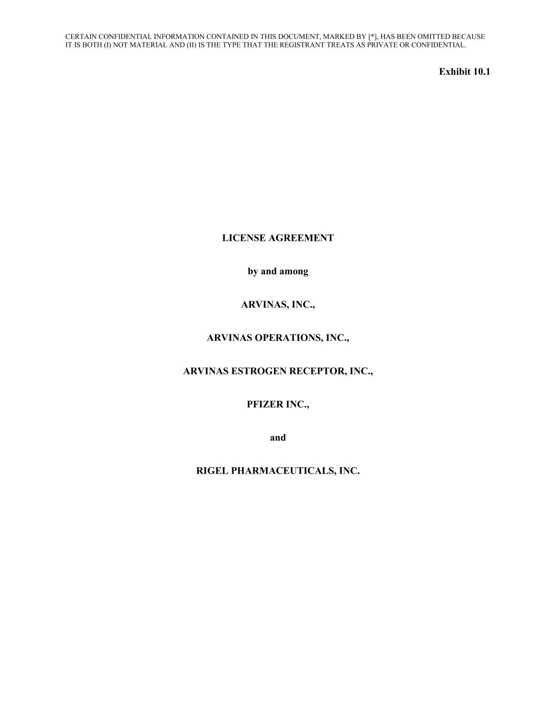
55
CERTAIN CONFIDENTIAL INFORMATION CONTAINED IN THIS DOCUMENT, MARKED BY [*], HAS BEEN OMITTED BECAUSE IT IS BOTH (I) NOT MATERIAL AND (II) IS THE TYPE THAT THE REGISTRANT TREATS AS PRIVATE OR CONFIDENTIAL. Exhibit 10.1 LICENSE AGREEMENT by and among ARVINAS, INC., ARVINAS OPERATIONS, INC., ARVINAS ESTROGEN RECEPTOR, INC., PFIZER INC., and RIGEL PHARMACEUTICALS, INC.

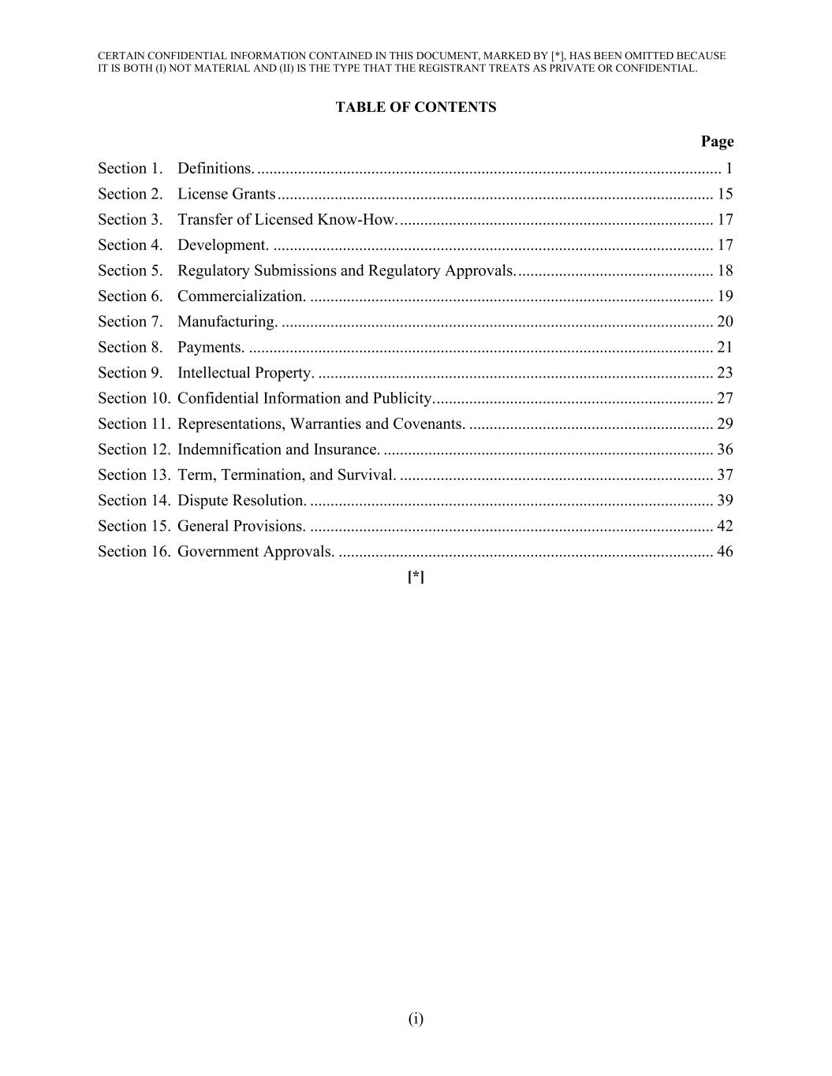
CERTAIN CONFIDENTIAL INFORMATION CONTAINED IN THIS DOCUMENT, MARKED BY [*], HAS BEEN OMITTED BECAUSE IT IS BOTH (I) NOT MATERIAL AND (II) IS THE TYPE THAT THE REGISTRANT TREATS AS PRIVATE OR CONFIDENTIAL. (i) TABLE OF CONTENTS Page Section 1. Definitions. .................................................................................................................. 1 Section 2. License Grants ........................................................................................................... 15 Section 3. Transfer of Licensed Know-How. ............................................................................. 17 Section 4. Development. ............................................................................................................ 17 Section 5. Regulatory Submissions and Regulatory Approvals. ................................................ 18 Section 6. Commercialization. ................................................................................................... 19 Section 7. Manufacturing. .......................................................................................................... 20 Section 8. Payments. .................................................................................................................. 21 Section 9. Intellectual Property. ................................................................................................. 23 Section 10. Confidential Information and Publicity. .................................................................... 27 Section 11. Representations, Warranties and Covenants. ............................................................ 29 Section 12. Indemnification and Insurance. ................................................................................. 36 Section 13. Term, Termination, and Survival. ............................................................................. 37 Section 14. Dispute Resolution. ................................................................................................... 39 Section 15. General Provisions. ................................................................................................... 42 Section 16. Government Approvals. ............................................................................................ 46 [*]

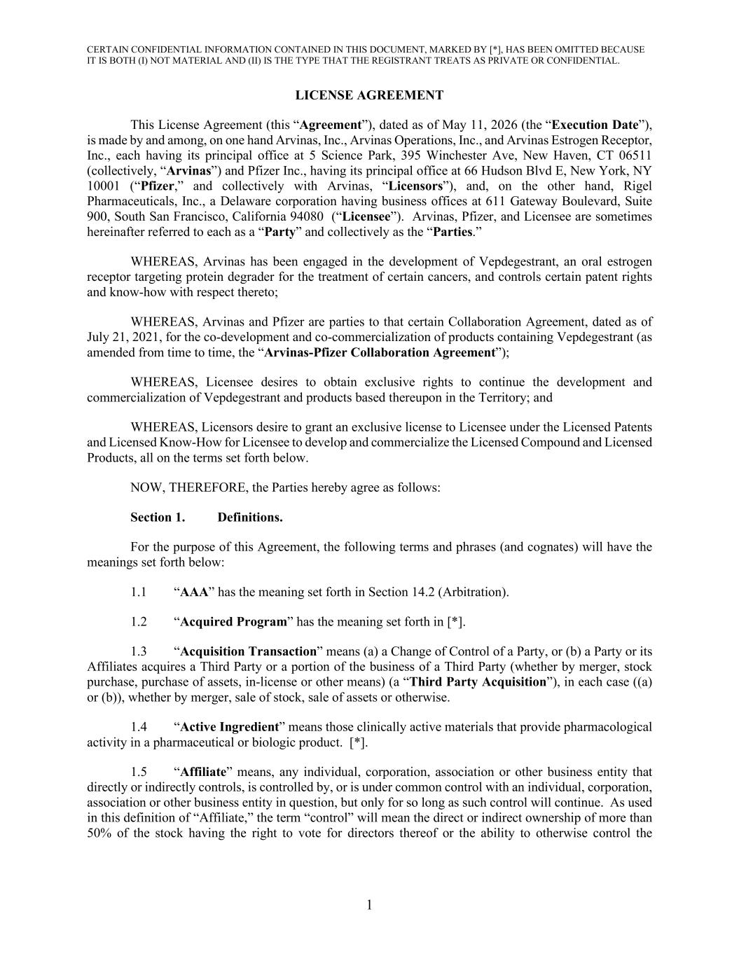
CERTAIN CONFIDENTIAL INFORMATION CONTAINED IN THIS DOCUMENT, MARKED BY [*], HAS BEEN OMITTED BECAUSE IT IS BOTH (I) NOT MATERIAL AND (II) IS THE TYPE THAT THE REGISTRANT TREATS AS PRIVATE OR CONFIDENTIAL. 1 LICENSE AGREEMENT This License Agreement (this “Agreement”), dated as of May 11, 2026 (the “Execution Date”), is made by and among, on one hand Arvinas, Inc., Arvinas Operations, Inc., and Arvinas Estrogen Receptor, Inc., each having its principal office at 5 Science Park, 395 Winchester Ave, New Haven, CT 06511 (collectively, “Arvinas”) and Pfizer Inc., having its principal office at 66 Hudson Blvd E, New York, NY 10001 (“Pfizer,” and collectively with Arvinas, “Licensors”), and, on the other hand, Rigel Pharmaceuticals, Inc., a Delaware corporation having business offices at 611 Gateway Boulevard, Suite 900, South San Francisco, California 94080 (“Licensee”). Arvinas, Pfizer, and Licensee are sometimes hereinafter referred to each as a “Party” and collectively as the “Parties.” WHEREAS, Arvinas has been engaged in the development of Vepdegestrant, an oral estrogen receptor targeting protein degrader for the treatment of certain cancers, and controls certain patent rights and know-how with respect thereto; WHEREAS, Arvinas and Pfizer are parties to that certain Collaboration Agreement, dated as of July 21, 2021, for the co-development and co-commercialization of products containing Vepdegestrant (as amended from time to time, the “Arvinas-Pfizer Collaboration Agreement”); WHEREAS, Licensee desires to obtain exclusive rights to continue the development and commercialization of Vepdegestrant and products based thereupon in the Territory; and WHEREAS, Licensors desire to grant an exclusive license to Licensee under the Licensed Patents and Licensed Know-How for Licensee to develop and commercialize the Licensed Compound and Licensed Products, all on the terms set forth below. NOW, THEREFORE, the Parties hereby agree as follows: Section 1. Definitions. For the purpose of this Agreement, the following terms and phrases (and cognates) will have the meanings set forth below: 1.1 “AAA” has the meaning set forth in Section 14.2 (Arbitration). 1.2 “Acquired Program” has the meaning set forth in [*]. 1.3 “Acquisition Transaction” means (a) a Change of Control of a Party, or (b) a Party or its Affiliates acquires a Third Party or a portion of the business of a Third Party (whether by merger, stock purchase, purchase of assets, in-license or other means) (a “Third Party Acquisition”), in each case ((a) or (b)), whether by merger, sale of stock, sale of assets or otherwise. 1.4 “Active Ingredient” means those clinically active materials that provide pharmacological activity in a pharmaceutical or biologic product. [*]. 1.5 “Affiliate” means, any individual, corporation, association or other business entity that directly or indirectly controls, is controlled by, or is under common control with an individual, corporation, association or other business entity in question, but only for so long as such control will continue. As used in this definition of “Affiliate,” the term “control” will mean the direct or indirect ownership of more than 50% of the stock having the right to vote for directors thereof or the ability to otherwise control the

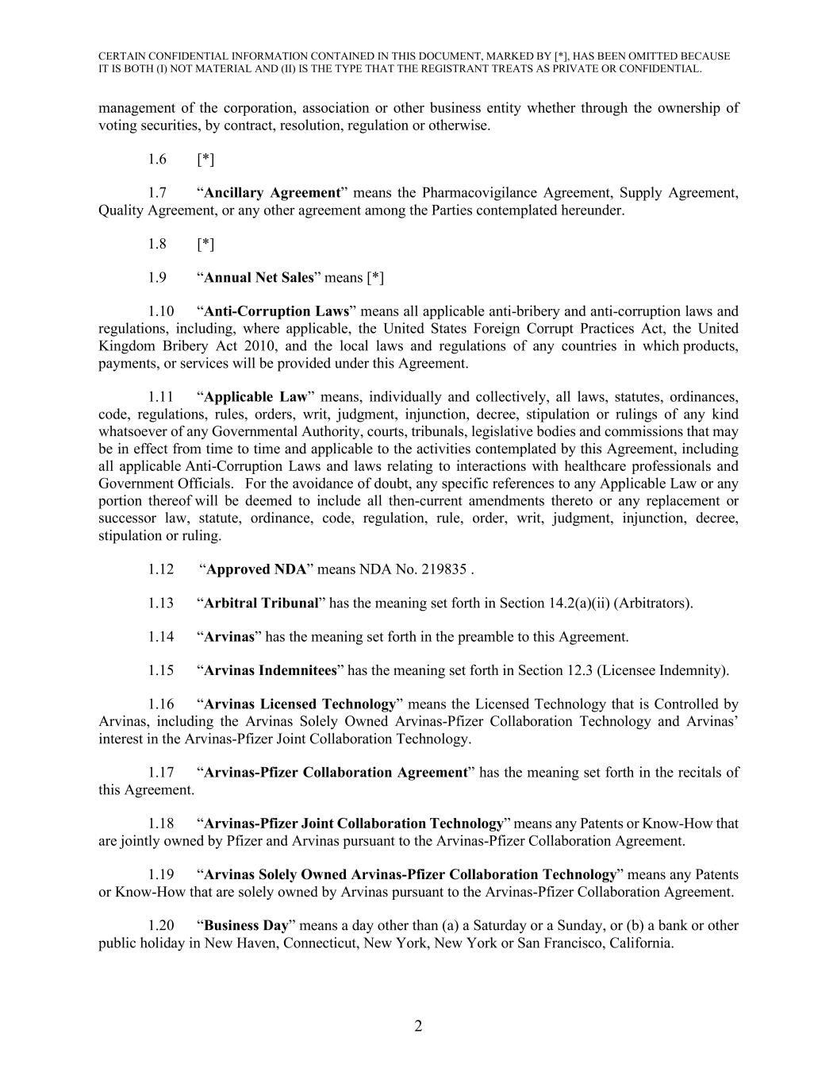
CERTAIN CONFIDENTIAL INFORMATION CONTAINED IN THIS DOCUMENT, MARKED BY [*], HAS BEEN OMITTED BECAUSE IT IS BOTH (I) NOT MATERIAL AND (II) IS THE TYPE THAT THE REGISTRANT TREATS AS PRIVATE OR CONFIDENTIAL. 2 management of the corporation, association or other business entity whether through the ownership of voting securities, by contract, resolution, regulation or otherwise. 1.6 [*] 1.7 “Ancillary Agreement” means the Pharmacovigilance Agreement, Supply Agreement, Quality Agreement, or any other agreement among the Parties contemplated hereunder. 1.8 [*] 1.9 “Annual Net Sales” means [*] 1.10 “Anti-Corruption Laws” means all applicable anti-bribery and anti-corruption laws and regulations, including, where applicable, the United States Foreign Corrupt Practices Act, the United Kingdom Bribery Act 2010, and the local laws and regulations of any countries in which products, payments, or services will be provided under this Agreement. 1.11 “Applicable Law” means, individually and collectively, all laws, statutes, ordinances, code, regulations, rules, orders, writ, judgment, injunction, decree, stipulation or rulings of any kind whatsoever of any Governmental Authority, courts, tribunals, legislative bodies and commissions that may be in effect from time to time and applicable to the activities contemplated by this Agreement, including all applicable Anti-Corruption Laws and laws relating to interactions with healthcare professionals and Government Officials. For the avoidance of doubt, any specific references to any Applicable Law or any portion thereof will be deemed to include all then-current amendments thereto or any replacement or successor law, statute, ordinance, code, regulation, rule, order, writ, judgment, injunction, decree, stipulation or ruling. 1.12 “Approved NDA” means NDA No. 219835 . 1.13 “Arbitral Tribunal” has the meaning set forth in Section 14.2(a)(ii) (Arbitrators). 1.14 “Arvinas” has the meaning set forth in the preamble to this Agreement. 1.15 “Arvinas Indemnitees” has the meaning set forth in Section 12.3 (Licensee Indemnity). 1.16 “Arvinas Licensed Technology” means the Licensed Technology that is Controlled by Arvinas, including the Arvinas Solely Owned Arvinas-Pfizer Collaboration Technology and Arvinas’ interest in the Arvinas-Pfizer Joint Collaboration Technology. 1.17 “Arvinas-Pfizer Collaboration Agreement” has the meaning set forth in the recitals of this Agreement. 1.18 “Arvinas-Pfizer Joint Collaboration Technology” means any Patents or Know-How that are jointly owned by Pfizer and Arvinas pursuant to the Arvinas-Pfizer Collaboration Agreement. 1.19 “Arvinas Solely Owned Arvinas-Pfizer Collaboration Technology” means any Patents or Know-How that are solely owned by Arvinas pursuant to the Arvinas-Pfizer Collaboration Agreement. 1.20 “Business Day” means a day other than (a) a Saturday or a Sunday, or (b) a bank or other public holiday in New Haven, Connecticut, New York, New York or San Francisco, California.

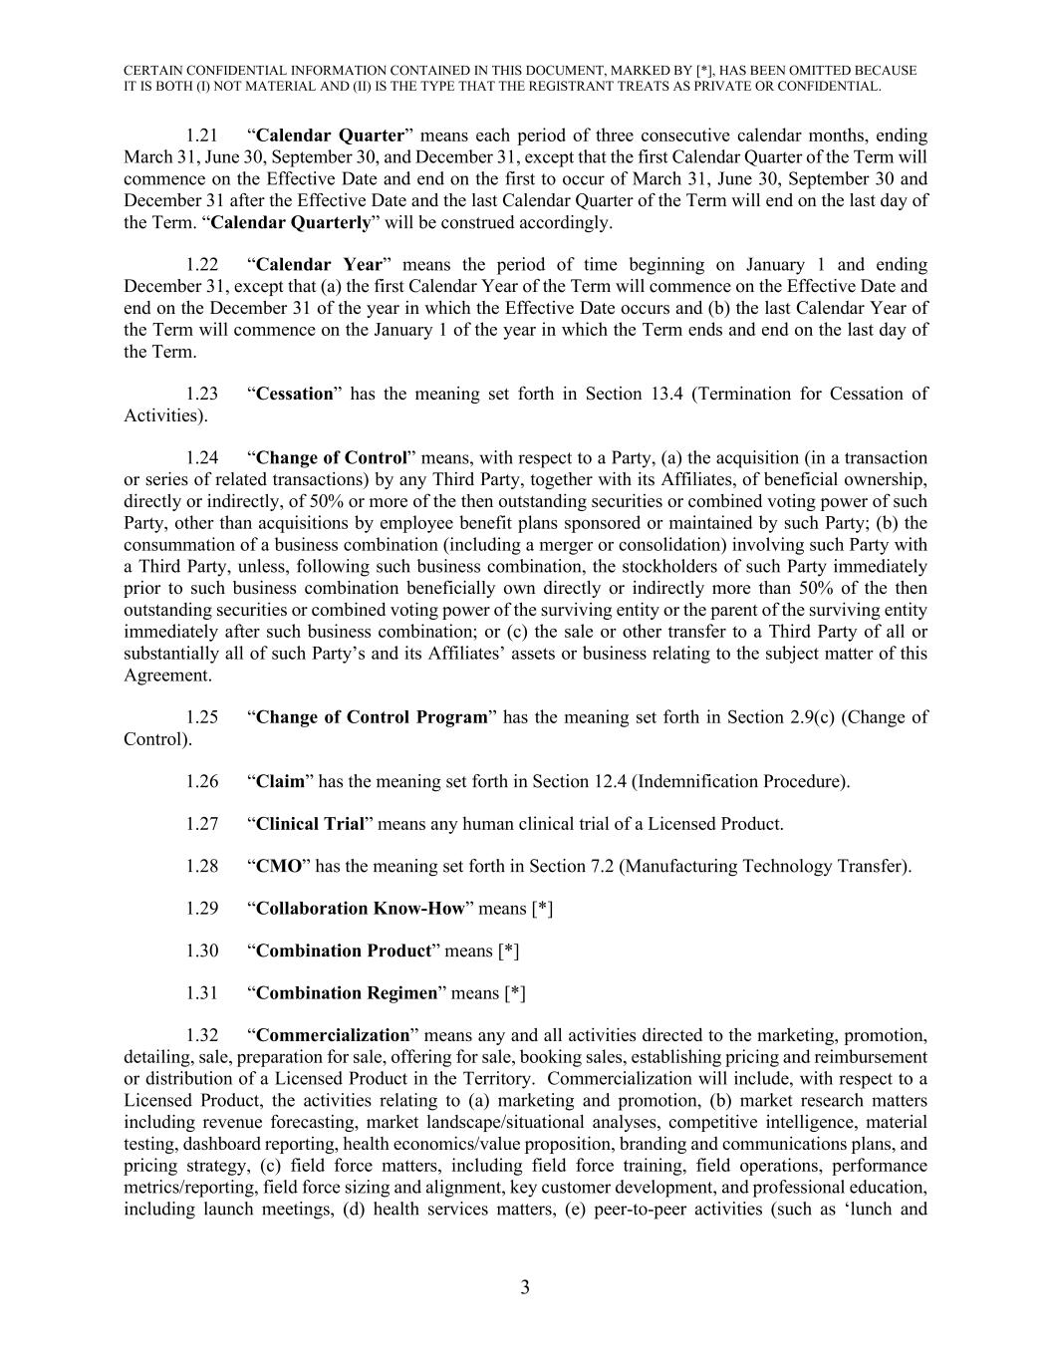
CERTAIN CONFIDENTIAL INFORMATION CONTAINED IN THIS DOCUMENT, MARKED BY [*], HAS BEEN OMITTED BECAUSE IT IS BOTH (I) NOT MATERIAL AND (II) IS THE TYPE THAT THE REGISTRANT TREATS AS PRIVATE OR CONFIDENTIAL. 3 1.21 “Calendar Quarter” means each period of three consecutive calendar months, ending March 31, June 30, September 30, and December 31, except that the first Calendar Quarter of the Term will commence on the Effective Date and end on the first to occur of March 31, June 30, September 30 and December 31 after the Effective Date and the last Calendar Quarter of the Term will end on the last day of the Term. “Calendar Quarterly” will be construed accordingly. 1.22 “Calendar Year” means the period of time beginning on January 1 and ending December 31, except that (a) the first Calendar Year of the Term will commence on the Effective Date and end on the December 31 of the year in which the Effective Date occurs and (b) the last Calendar Year of the Term will commence on the January 1 of the year in which the Term ends and end on the last day of the Term. 1.23 “Cessation” has the meaning set forth in Section 13.4 (Termination for Cessation of Activities). 1.24 “Change of Control” means, with respect to a Party, (a) the acquisition (in a transaction or series of related transactions) by any Third Party, together with its Affiliates, of beneficial ownership, directly or indirectly, of 50% or more of the then outstanding securities or combined voting power of such Party, other than acquisitions by employee benefit plans sponsored or maintained by such Party; (b) the consummation of a business combination (including a merger or consolidation) involving such Party with a Third Party, unless, following such business combination, the stockholders of such Party immediately prior to such business combination beneficially own directly or indirectly more than 50% of the then outstanding securities or combined voting power of the surviving entity or the parent of the surviving entity immediately after such business combination; or (c) the sale or other transfer to a Third Party of all or substantially all of such Party’s and its Affiliates’ assets or business relating to the subject matter of this Agreement. 1.25 “Change of Control Program” has the meaning set forth in Section 2.9(c) (Change of Control). 1.26 “Claim” has the meaning set forth in Section 12.4 (Indemnification Procedure). 1.27 “Clinical Trial” means any human clinical trial of a Licensed Product. 1.28 “CMO” has the meaning set forth in Section 7.2 (Manufacturing Technology Transfer). 1.29 “Collaboration Know-How” means [*] 1.30 “Combination Product” means [*] 1.31 “Combination Regimen” means [*] 1.32 “Commercialization” means any and all activities directed to the marketing, promotion, detailing, sale, preparation for sale, offering for sale, booking sales, establishing pricing and reimbursement or distribution of a Licensed Product in the Territory. Commercialization will include, with respect to a Licensed Product, the activities relating to (a) marketing and promotion, (b) market research matters including revenue forecasting, market landscape/situational analyses, competitive intelligence, material testing, dashboard reporting, health economics/value proposition, branding and communications plans, and pricing strategy, (c) field force matters, including field force training, field operations, performance metrics/reporting, field force sizing and alignment, key customer development, and professional education, including launch meetings, (d) health services matters, (e) peer-to-peer activities (such as ‘lunch and

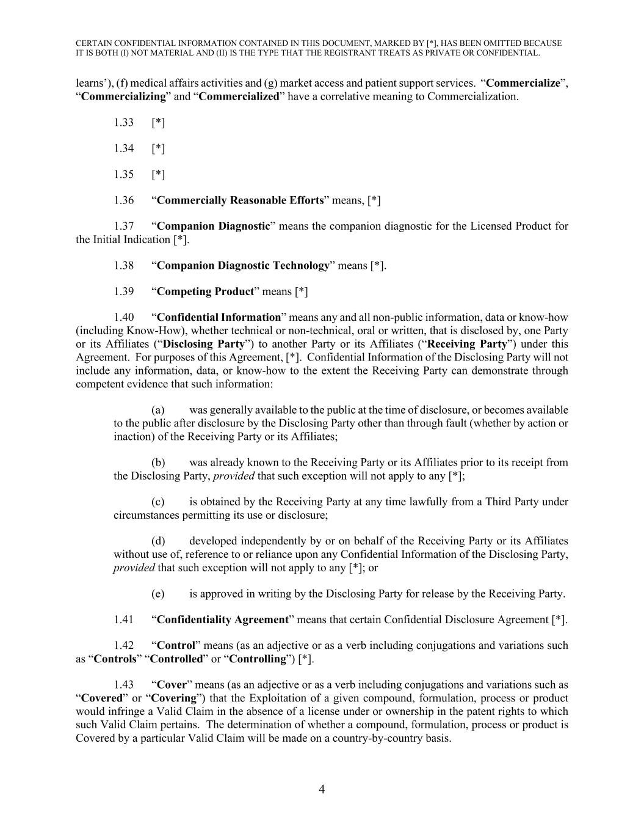
CERTAIN CONFIDENTIAL INFORMATION CONTAINED IN THIS DOCUMENT, MARKED BY [*], HAS BEEN OMITTED BECAUSE IT IS BOTH (I) NOT MATERIAL AND (II) IS THE TYPE THAT THE REGISTRANT TREATS AS PRIVATE OR CONFIDENTIAL. 4 learns’), (f) medical affairs activities and (g) market access and patient support services. “Commercialize”, “Commercializing” and “Commercialized” have a correlative meaning to Commercialization. 1.33 [*] 1.34 [*] 1.35 [*] 1.36 “Commercially Reasonable Efforts” means, [*] 1.37 “Companion Diagnostic” means the companion diagnostic for the Licensed Product for the Initial Indication [*]. 1.38 “Companion Diagnostic Technology” means [*]. 1.39 “Competing Product” means [*] 1.40 “Confidential Information” means any and all non-public information, data or know-how (including Know-How), whether technical or non-technical, oral or written, that is disclosed by, one Party or its Affiliates (“Disclosing Party”) to another Party or its Affiliates (“Receiving Party”) under this Agreement. For purposes of this Agreement, [*]. Confidential Information of the Disclosing Party will not include any information, data, or know-how to the extent the Receiving Party can demonstrate through competent evidence that such information: (a) was generally available to the public at the time of disclosure, or becomes available to the public after disclosure by the Disclosing Party other than through fault (whether by action or inaction) of the Receiving Party or its Affiliates; (b) was already known to the Receiving Party or its Affiliates prior to its receipt from the Disclosing Party, provided that such exception will not apply to any [*]; (c) is obtained by the Receiving Party at any time lawfully from a Third Party under circumstances permitting its use or disclosure; (d) developed independently by or on behalf of the Receiving Party or its Affiliates without use of, reference to or reliance upon any Confidential Information of the Disclosing Party, provided that such exception will not apply to any [*]; or (e) is approved in writing by the Disclosing Party for release by the Receiving Party. 1.41 “Confidentiality Agreement” means that certain Confidential Disclosure Agreement [*]. 1.42 “Control” means (as an adjective or as a verb including conjugations and variations such as “Controls” “Controlled” or “Controlling”) [*]. 1.43 “Cover” means (as an adjective or as a verb including conjugations and variations such as “Covered” or “Covering”) that the Exploitation of a given compound, formulation, process or product would infringe a Valid Claim in the absence of a license under or ownership in the patent rights to which such Valid Claim pertains. The determination of whether a compound, formulation, process or product is Covered by a particular Valid Claim will be made on a country-by-country basis.

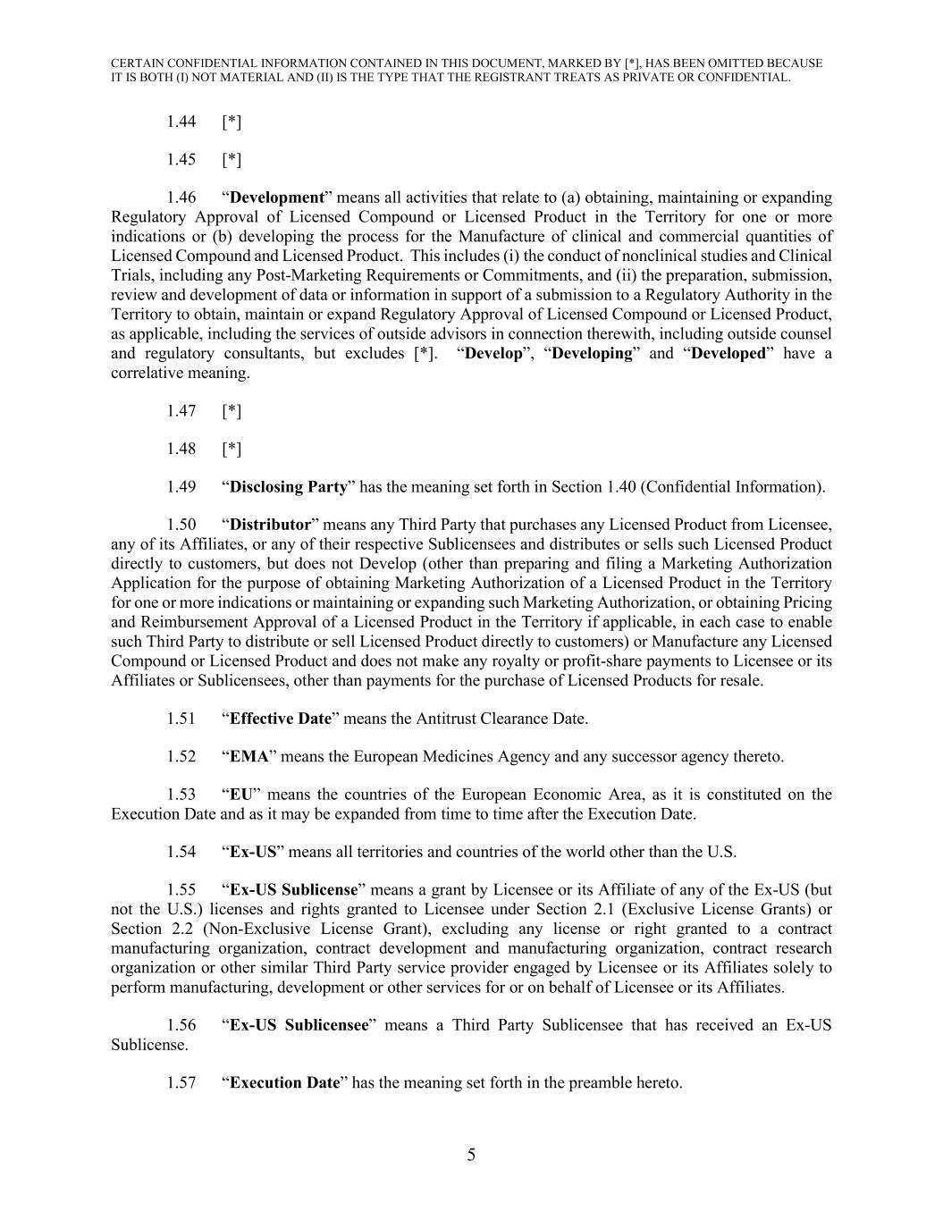
CERTAIN CONFIDENTIAL INFORMATION CONTAINED IN THIS DOCUMENT, MARKED BY [*], HAS BEEN OMITTED BECAUSE IT IS BOTH (I) NOT MATERIAL AND (II) IS THE TYPE THAT THE REGISTRANT TREATS AS PRIVATE OR CONFIDENTIAL. 5 1.44 [*] 1.45 [*] 1.46 “Development” means all activities that relate to (a) obtaining, maintaining or expanding Regulatory Approval of Licensed Compound or Licensed Product in the Territory for one or more indications or (b) developing the process for the Manufacture of clinical and commercial quantities of Licensed Compound and Licensed Product. This includes (i) the conduct of nonclinical studies and Clinical Trials, including any Post-Marketing Requirements or Commitments, and (ii) the preparation, submission, review and development of data or information in support of a submission to a Regulatory Authority in the Territory to obtain, maintain or expand Regulatory Approval of Licensed Compound or Licensed Product, as applicable, including the services of outside advisors in connection therewith, including outside counsel and regulatory consultants, but excludes [*]. “Develop”, “Developing” and “Developed” have a correlative meaning. 1.47 [*] 1.48 [*] 1.49 “Disclosing Party” has the meaning set forth in Section 1.40 (Confidential Information). 1.50 “Distributor” means any Third Party that purchases any Licensed Product from Licensee, any of its Affiliates, or any of their respective Sublicensees and distributes or sells such Licensed Product directly to customers, but does not Develop (other than preparing and filing a Marketing Authorization Application for the purpose of obtaining Marketing Authorization of a Licensed Product in the Territory for one or more indications or maintaining or expanding such Marketing Authorization, or obtaining Pricing and Reimbursement Approval of a Licensed Product in the Territory if applicable, in each case to enable such Third Party to distribute or sell Licensed Product directly to customers) or Manufacture any Licensed Compound or Licensed Product and does not make any royalty or profit-share payments to Licensee or its Affiliates or Sublicensees, other than payments for the purchase of Licensed Products for resale. 1.51 “Effective Date” means the Antitrust Clearance Date. 1.52 “EMA” means the European Medicines Agency and any successor agency thereto. 1.53 “EU” means the countries of the European Economic Area, as it is constituted on the Execution Date and as it may be expanded from time to time after the Execution Date. 1.54 “Ex-US” means all territories and countries of the world other than the U.S. 1.55 “Ex-US Sublicense” means a grant by Licensee or its Affiliate of any of the Ex-US (but not the U.S.) licenses and rights granted to Licensee under Section 2.1 (Exclusive License Grants) or Section 2.2 (Non-Exclusive License Grant), excluding any license or right granted to a contract manufacturing organization, contract development and manufacturing organization, contract research organization or other similar Third Party service provider engaged by Licensee or its Affiliates solely to perform manufacturing, development or other services for or on behalf of Licensee or its Affiliates. 1.56 “Ex-US Sublicensee” means a Third Party Sublicensee that has received an Ex-US Sublicense. 1.57 “Execution Date” has the meaning set forth in the preamble hereto.

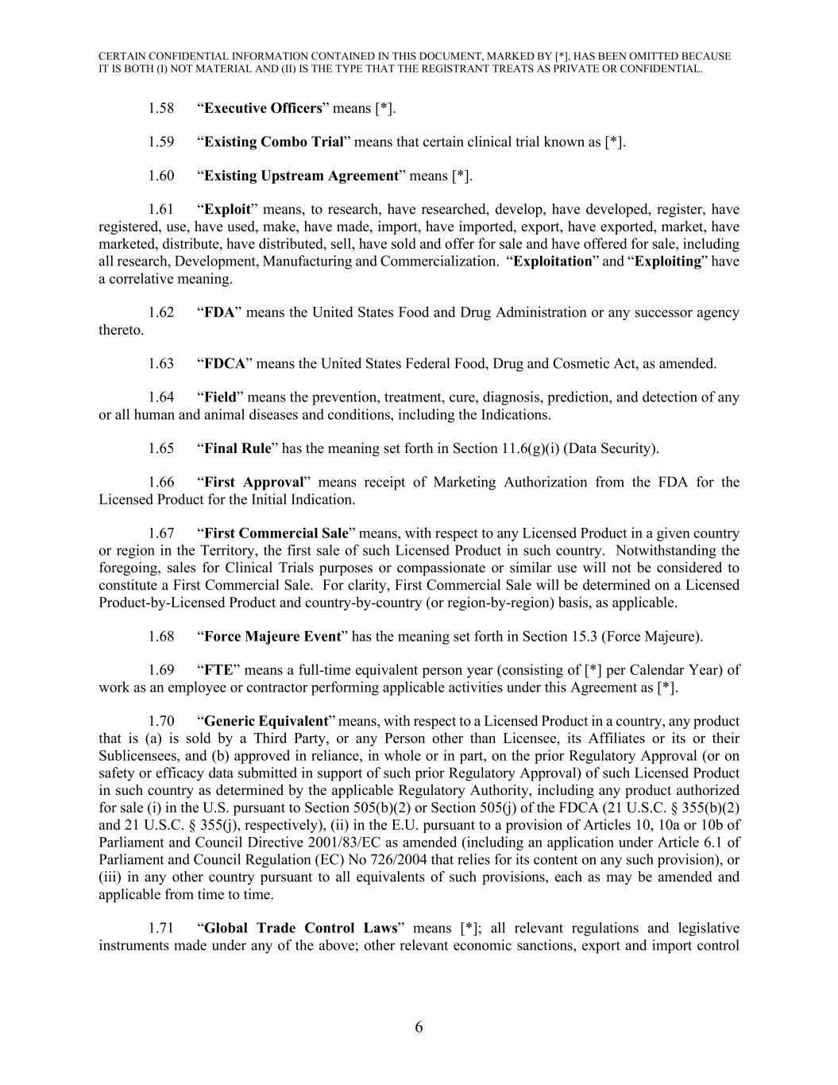
CERTAIN CONFIDENTIAL INFORMATION CONTAINED IN THIS DOCUMENT, MARKED BY [*], HAS BEEN OMITTED BECAUSE IT IS BOTH (I) NOT MATERIAL AND (II) IS THE TYPE THAT THE REGISTRANT TREATS AS PRIVATE OR CONFIDENTIAL. 6 1.58 “Executive Officers” means [*]. 1.59 “Existing Combo Trial” means that certain clinical trial known as [*]. 1.60 “Existing Upstream Agreement” means [*]. 1.61 “Exploit” means, to research, have researched, develop, have developed, register, have registered, use, have used, make, have made, import, have imported, export, have exported, market, have marketed, distribute, have distributed, sell, have sold and offer for sale and have offered for sale, including all research, Development, Manufacturing and Commercialization. “Exploitation” and “Exploiting” have a correlative meaning. 1.62 “FDA” means the United States Food and Drug Administration or any successor agency thereto. 1.63 “FDCA” means the United States Federal Food, Drug and Cosmetic Act, as amended. 1.64 “Field” means the prevention, treatment, cure, diagnosis, prediction, and detection of any or all human and animal diseases and conditions, including the Indications. 1.65 “Final Rule” has the meaning set forth in Section 11.6(g)(i) (Data Security). 1.66 “First Approval” means receipt of Marketing Authorization from the FDA for the Licensed Product for the Initial Indication. 1.67 “First Commercial Sale” means, with respect to any Licensed Product in a given country or region in the Territory, the first sale of such Licensed Product in such country. Notwithstanding the foregoing, sales for Clinical Trials purposes or compassionate or similar use will not be considered to constitute a First Commercial Sale. For clarity, First Commercial Sale will be determined on a Licensed Product-by-Licensed Product and country-by-country (or region-by-region) basis, as applicable. 1.68 “Force Majeure Event” has the meaning set forth in Section 15.3 (Force Majeure). 1.69 “FTE” means a full-time equivalent person year (consisting of [*] per Calendar Year) of work as an employee or contractor performing applicable activities under this Agreement as [*]. 1.70 “Generic Equivalent” means, with respect to a Licensed Product in a country, any product that is (a) is sold by a Third Party, or any Person other than Licensee, its Affiliates or its or their Sublicensees, and (b) approved in reliance, in whole or in part, on the prior Regulatory Approval (or on safety or efficacy data submitted in support of such prior Regulatory Approval) of such Licensed Product in such country as determined by the applicable Regulatory Authority, including any product authorized for sale (i) in the U.S. pursuant to Section 505(b)(2) or Section 505(j) of the FDCA (21 U.S.C. § 355(b)(2) and 21 U.S.C. § 355(j), respectively), (ii) in the E.U. pursuant to a provision of Articles 10, 10a or 10b of Parliament and Council Directive 2001/83/EC as amended (including an application under Article 6.1 of Parliament and Council Regulation (EC) No 726/2004 that relies for its content on any such provision), or (iii) in any other country pursuant to all equivalents of such provisions, each as may be amended and applicable from time to time. 1.71 “Global Trade Control Laws” means [*]; all relevant regulations and legislative instruments made under any of the above; other relevant economic sanctions, export and import control

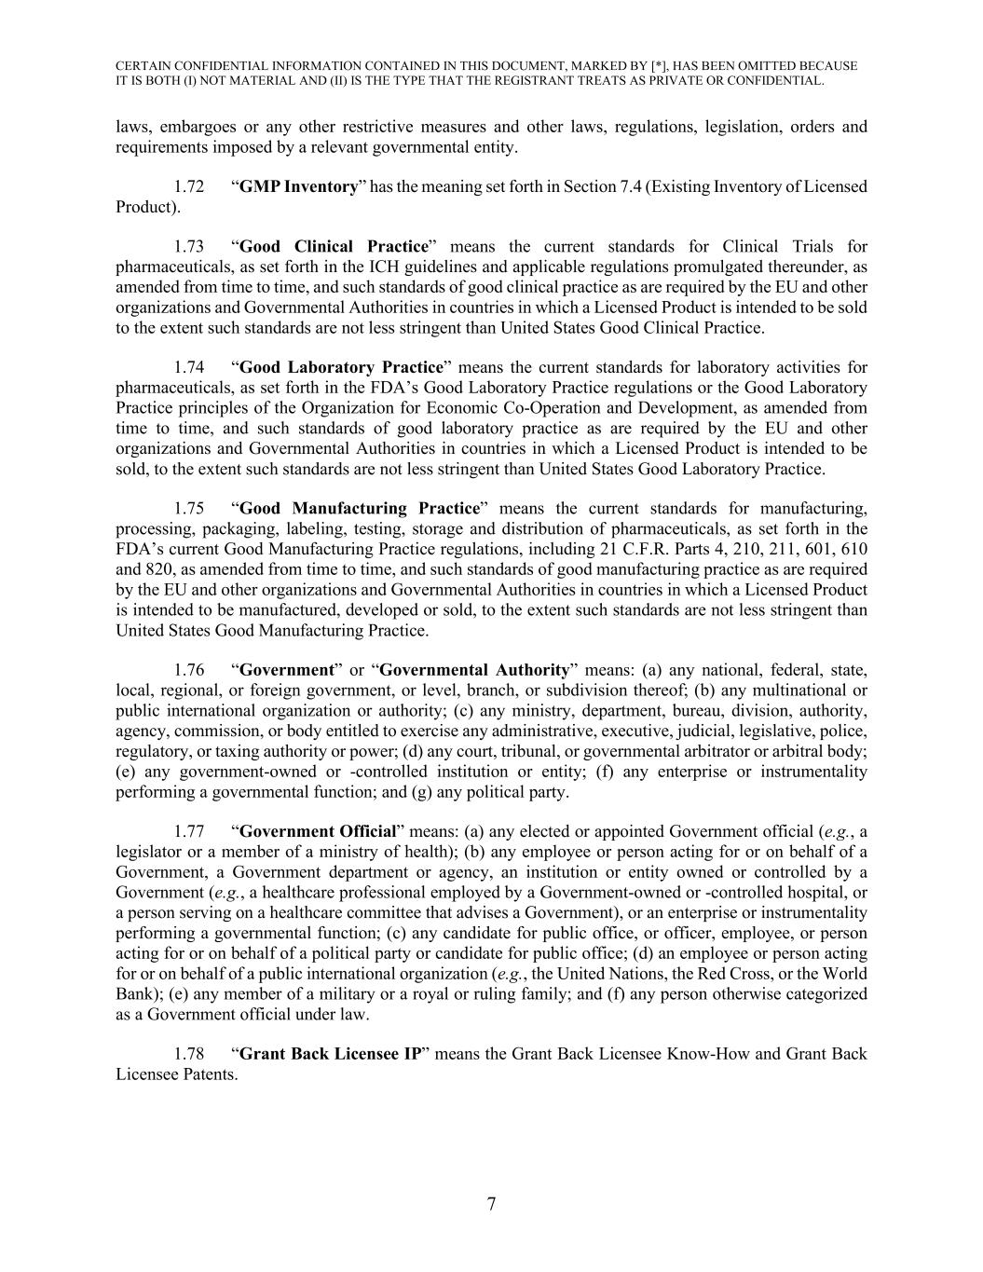
CERTAIN CONFIDENTIAL INFORMATION CONTAINED IN THIS DOCUMENT, MARKED BY [*], HAS BEEN OMITTED BECAUSE IT IS BOTH (I) NOT MATERIAL AND (II) IS THE TYPE THAT THE REGISTRANT TREATS AS PRIVATE OR CONFIDENTIAL. 7 laws, embargoes or any other restrictive measures and other laws, regulations, legislation, orders and requirements imposed by a relevant governmental entity. 1.72 “GMP Inventory” has the meaning set forth in Section 7.4 (Existing Inventory of Licensed Product). 1.73 “Good Clinical Practice” means the current standards for Clinical Trials for pharmaceuticals, as set forth in the ICH guidelines and applicable regulations promulgated thereunder, as amended from time to time, and such standards of good clinical practice as are required by the EU and other organizations and Governmental Authorities in countries in which a Licensed Product is intended to be sold to the extent such standards are not less stringent than United States Good Clinical Practice. 1.74 “Good Laboratory Practice” means the current standards for laboratory activities for pharmaceuticals, as set forth in the FDA’s Good Laboratory Practice regulations or the Good Laboratory Practice principles of the Organization for Economic Co-Operation and Development, as amended from time to time, and such standards of good laboratory practice as are required by the EU and other organizations and Governmental Authorities in countries in which a Licensed Product is intended to be sold, to the extent such standards are not less stringent than United States Good Laboratory Practice. 1.75 “Good Manufacturing Practice” means the current standards for manufacturing, processing, packaging, labeling, testing, storage and distribution of pharmaceuticals, as set forth in the FDA’s current Good Manufacturing Practice regulations, including 21 C.F.R. Parts 4, 210, 211, 601, 610 and 820, as amended from time to time, and such standards of good manufacturing practice as are required by the EU and other organizations and Governmental Authorities in countries in which a Licensed Product is intended to be manufactured, developed or sold, to the extent such standards are not less stringent than United States Good Manufacturing Practice. 1.76 “Government” or “Governmental Authority” means: (a) any national, federal, state, local, regional, or foreign government, or level, branch, or subdivision thereof; (b) any multinational or public international organization or authority; (c) any ministry, department, bureau, division, authority, agency, commission, or body entitled to exercise any administrative, executive, judicial, legislative, police, regulatory, or taxing authority or power; (d) any court, tribunal, or governmental arbitrator or arbitral body; (e) any government-owned or -controlled institution or entity; (f) any enterprise or instrumentality performing a governmental function; and (g) any political party. 1.77 “Government Official” means: (a) any elected or appointed Government official (e.g., a legislator or a member of a ministry of health); (b) any employee or person acting for or on behalf of a Government, a Government department or agency, an institution or entity owned or controlled by a Government (e.g., a healthcare professional employed by a Government-owned or -controlled hospital, or a person serving on a healthcare committee that advises a Government), or an enterprise or instrumentality performing a governmental function; (c) any candidate for public office, or officer, employee, or person acting for or on behalf of a political party or candidate for public office; (d) an employee or person acting for or on behalf of a public international organization (e.g., the United Nations, the Red Cross, or the World Bank); (e) any member of a military or a royal or ruling family; and (f) any person otherwise categorized as a Government official under law. 1.78 “Grant Back Licensee IP” means the Grant Back Licensee Know-How and Grant Back Licensee Patents.

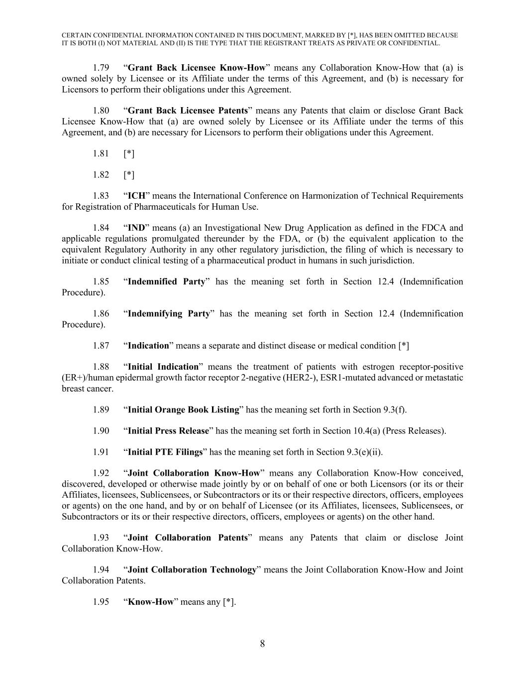
CERTAIN CONFIDENTIAL INFORMATION CONTAINED IN THIS DOCUMENT, MARKED BY [*], HAS BEEN OMITTED BECAUSE IT IS BOTH (I) NOT MATERIAL AND (II) IS THE TYPE THAT THE REGISTRANT TREATS AS PRIVATE OR CONFIDENTIAL. 8 1.79 “Grant Back Licensee Know-How” means any Collaboration Know-How that (a) is owned solely by Licensee or its Affiliate under the terms of this Agreement, and (b) is necessary for Licensors to perform their obligations under this Agreement. 1.80 “Grant Back Licensee Patents” means any Patents that claim or disclose Grant Back Licensee Know-How that (a) are owned solely by Licensee or its Affiliate under the terms of this Agreement, and (b) are necessary for Licensors to perform their obligations under this Agreement. 1.81 [*] 1.82 [*] 1.83 “ICH” means the International Conference on Harmonization of Technical Requirements for Registration of Pharmaceuticals for Human Use. 1.84 “IND” means (a) an Investigational New Drug Application as defined in the FDCA and applicable regulations promulgated thereunder by the FDA, or (b) the equivalent application to the equivalent Regulatory Authority in any other regulatory jurisdiction, the filing of which is necessary to initiate or conduct clinical testing of a pharmaceutical product in humans in such jurisdiction. 1.85 “Indemnified Party” has the meaning set forth in Section 12.4 (Indemnification Procedure). 1.86 “Indemnifying Party” has the meaning set forth in Section 12.4 (Indemnification Procedure). 1.87 “Indication” means a separate and distinct disease or medical condition [*] 1.88 “Initial Indication” means the treatment of patients with estrogen receptor-positive (ER+)/human epidermal growth factor receptor 2-negative (HER2-), ESR1-mutated advanced or metastatic breast cancer. 1.89 “Initial Orange Book Listing” has the meaning set forth in Section 9.3(f). 1.90 “Initial Press Release” has the meaning set forth in Section 10.4(a) (Press Releases). 1.91 “Initial PTE Filings” has the meaning set forth in Section 9.3(e)(ii). 1.92 “Joint Collaboration Know-How” means any Collaboration Know-How conceived, discovered, developed or otherwise made jointly by or on behalf of one or both Licensors (or its or their Affiliates, licensees, Sublicensees, or Subcontractors or its or their respective directors, officers, employees or agents) on the one hand, and by or on behalf of Licensee (or its Affiliates, licensees, Sublicensees, or Subcontractors or its or their respective directors, officers, employees or agents) on the other hand. 1.93 “Joint Collaboration Patents” means any Patents that claim or disclose Joint Collaboration Know-How. 1.94 “Joint Collaboration Technology” means the Joint Collaboration Know-How and Joint Collaboration Patents. 1.95 “Know-How” means any [*].

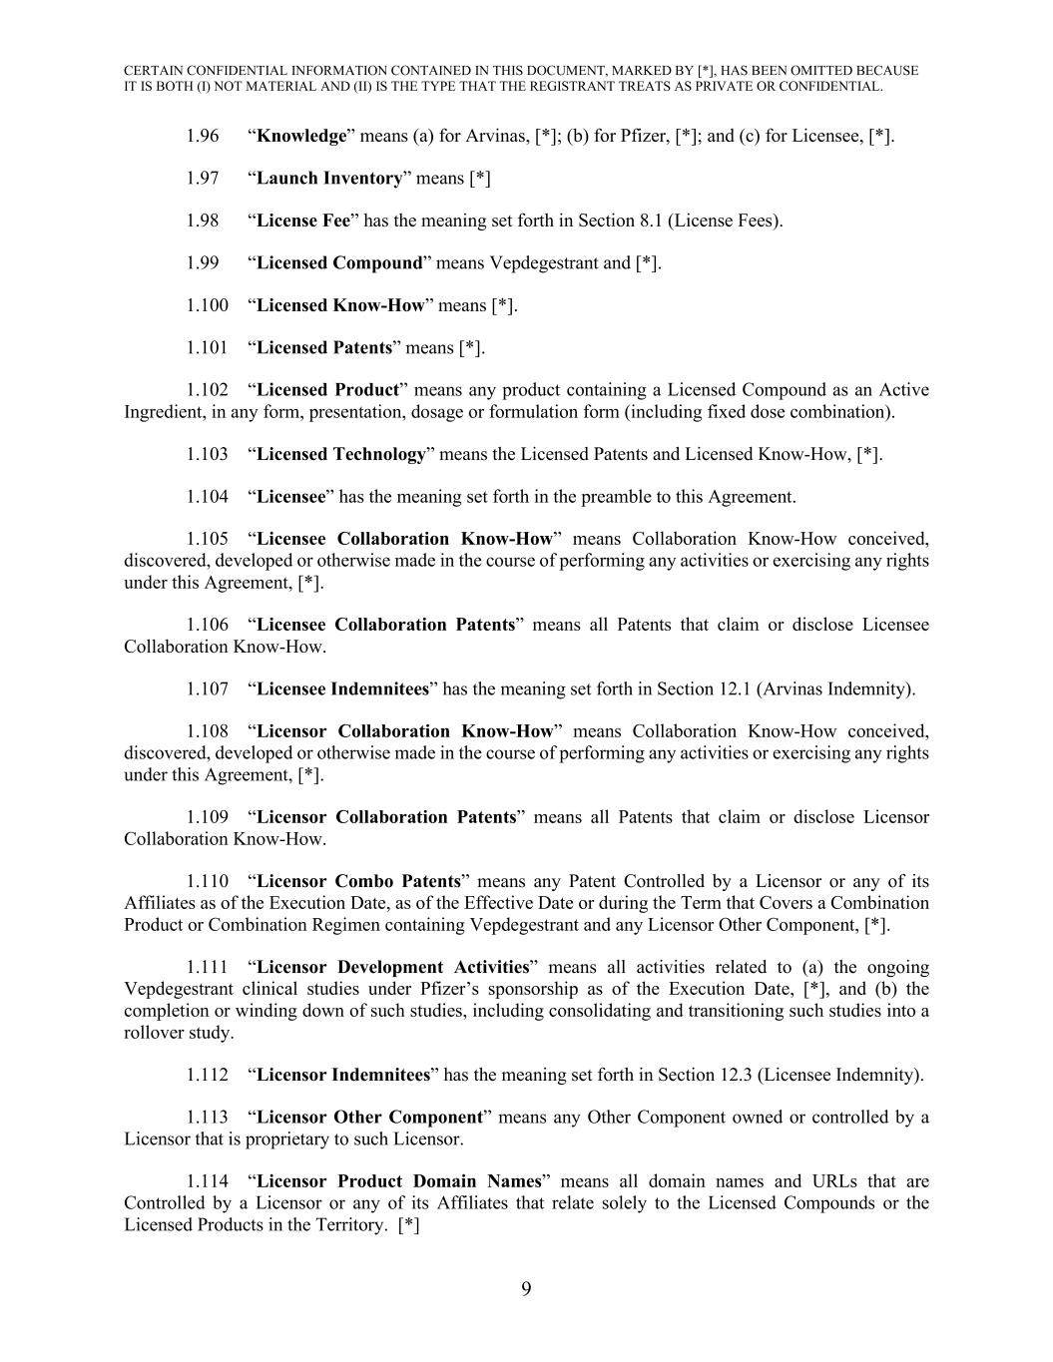
CERTAIN CONFIDENTIAL INFORMATION CONTAINED IN THIS DOCUMENT, MARKED BY [*], HAS BEEN OMITTED BECAUSE IT IS BOTH (I) NOT MATERIAL AND (II) IS THE TYPE THAT THE REGISTRANT TREATS AS PRIVATE OR CONFIDENTIAL. 9 1.96 “Knowledge” means (a) for Arvinas, [*]; (b) for Pfizer, [*]; and (c) for Licensee, [*]. 1.97 “Launch Inventory” means [*] 1.98 “License Fee” has the meaning set forth in Section 8.1 (License Fees). 1.99 “Licensed Compound” means Vepdegestrant and [*]. 1.100 “Licensed Know-How” means [*]. 1.101 “Licensed Patents” means [*]. 1.102 “Licensed Product” means any product containing a Licensed Compound as an Active Ingredient, in any form, presentation, dosage or formulation form (including fixed dose combination). 1.103 “Licensed Technology” means the Licensed Patents and Licensed Know-How, [*]. 1.104 “Licensee” has the meaning set forth in the preamble to this Agreement. 1.105 “Licensee Collaboration Know-How” means Collaboration Know-How conceived, discovered, developed or otherwise made in the course of performing any activities or exercising any rights under this Agreement, [*]. 1.106 “Licensee Collaboration Patents” means all Patents that claim or disclose Licensee Collaboration Know-How. 1.107 “Licensee Indemnitees” has the meaning set forth in Section 12.1 (Arvinas Indemnity). 1.108 “Licensor Collaboration Know-How” means Collaboration Know-How conceived, discovered, developed or otherwise made in the course of performing any activities or exercising any rights under this Agreement, [*]. 1.109 “Licensor Collaboration Patents” means all Patents that claim or disclose Licensor Collaboration Know-How. 1.110 “Licensor Combo Patents” means any Patent Controlled by a Licensor or any of its Affiliates as of the Execution Date, as of the Effective Date or during the Term that Covers a Combination Product or Combination Regimen containing Vepdegestrant and any Licensor Other Component, [*]. 1.111 “Licensor Development Activities” means all activities related to (a) the ongoing Vepdegestrant clinical studies under Pfizer’s sponsorship as of the Execution Date, [*], and (b) the completion or winding down of such studies, including consolidating and transitioning such studies into a rollover study. 1.112 “Licensor Indemnitees” has the meaning set forth in Section 12.3 (Licensee Indemnity). 1.113 “Licensor Other Component” means any Other Component owned or controlled by a Licensor that is proprietary to such Licensor. 1.114 “Licensor Product Domain Names” means all domain names and URLs that are Controlled by a Licensor or any of its Affiliates that relate solely to the Licensed Compounds or the Licensed Products in the Territory. [*]

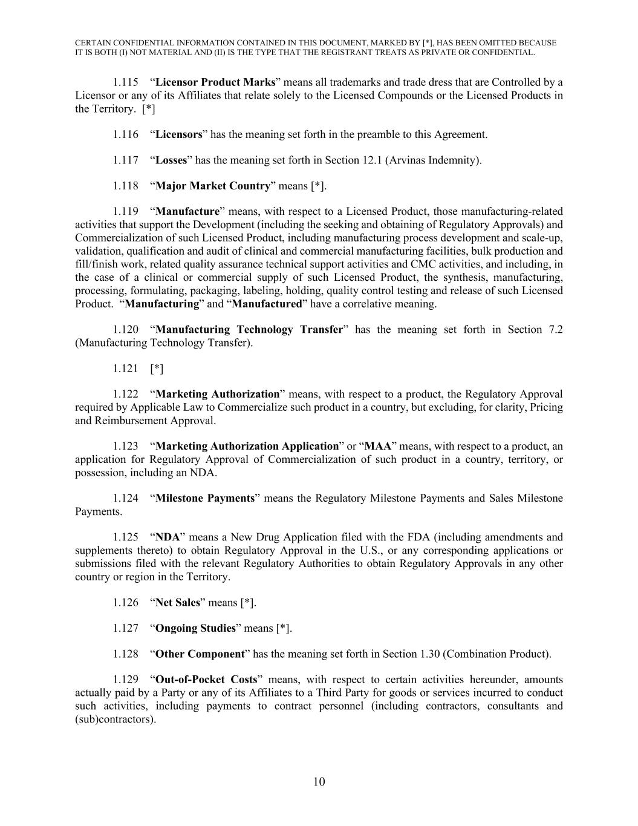
CERTAIN CONFIDENTIAL INFORMATION CONTAINED IN THIS DOCUMENT, MARKED BY [*], HAS BEEN OMITTED BECAUSE IT IS BOTH (I) NOT MATERIAL AND (II) IS THE TYPE THAT THE REGISTRANT TREATS AS PRIVATE OR CONFIDENTIAL. 10 1.115 “Licensor Product Marks” means all trademarks and trade dress that are Controlled by a Licensor or any of its Affiliates that relate solely to the Licensed Compounds or the Licensed Products in the Territory. [*] 1.116 “Licensors” has the meaning set forth in the preamble to this Agreement. 1.117 “Losses” has the meaning set forth in Section 12.1 (Arvinas Indemnity). 1.118 “Major Market Country” means [*]. 1.119 “Manufacture” means, with respect to a Licensed Product, those manufacturing-related activities that support the Development (including the seeking and obtaining of Regulatory Approvals) and Commercialization of such Licensed Product, including manufacturing process development and scale-up, validation, qualification and audit of clinical and commercial manufacturing facilities, bulk production and fill/finish work, related quality assurance technical support activities and CMC activities, and including, in the case of a clinical or commercial supply of such Licensed Product, the synthesis, manufacturing, processing, formulating, packaging, labeling, holding, quality control testing and release of such Licensed Product. “Manufacturing” and “Manufactured” have a correlative meaning. 1.120 “Manufacturing Technology Transfer” has the meaning set forth in Section 7.2 (Manufacturing Technology Transfer). 1.121 [*] 1.122 “Marketing Authorization” means, with respect to a product, the Regulatory Approval required by Applicable Law to Commercialize such product in a country, but excluding, for clarity, Pricing and Reimbursement Approval. 1.123 “Marketing Authorization Application” or “MAA” means, with respect to a product, an application for Regulatory Approval of Commercialization of such product in a country, territory, or possession, including an NDA. 1.124 “Milestone Payments” means the Regulatory Milestone Payments and Sales Milestone Payments. 1.125 “NDA” means a New Drug Application filed with the FDA (including amendments and supplements thereto) to obtain Regulatory Approval in the U.S., or any corresponding applications or submissions filed with the relevant Regulatory Authorities to obtain Regulatory Approvals in any other country or region in the Territory. 1.126 “Net Sales” means [*]. 1.127 “Ongoing Studies” means [*]. 1.128 “Other Component” has the meaning set forth in Section 1.30 (Combination Product). 1.129 “Out-of-Pocket Costs” means, with respect to certain activities hereunder, amounts actually paid by a Party or any of its Affiliates to a Third Party for goods or services incurred to conduct such activities, including payments to contract personnel (including contractors, consultants and (sub)contractors).

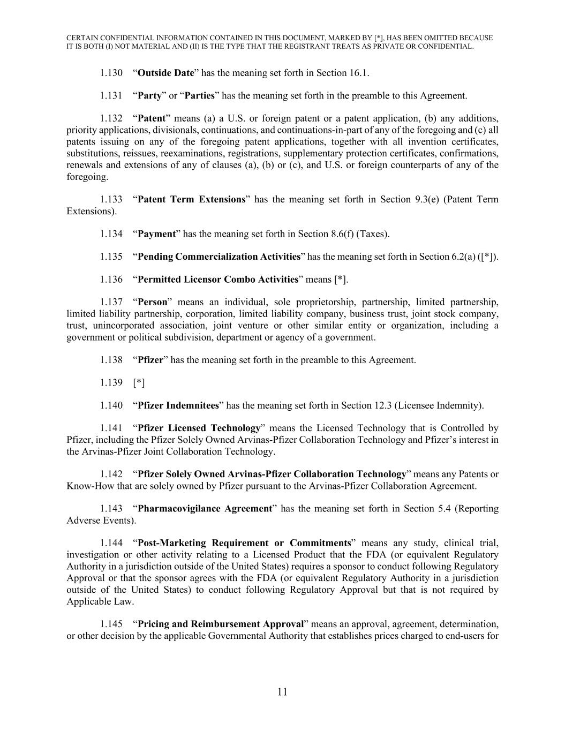
CERTAIN CONFIDENTIAL INFORMATION CONTAINED IN THIS DOCUMENT, MARKED BY [*], HAS BEEN OMITTED BECAUSE IT IS BOTH (I) NOT MATERIAL AND (II) IS THE TYPE THAT THE REGISTRANT TREATS AS PRIVATE OR CONFIDENTIAL. 11 1.130 “Outside Date” has the meaning set forth in Section 16.1. 1.131 “Party” or “Parties” has the meaning set forth in the preamble to this Agreement. 1.132 “Patent” means (a) a U.S. or foreign patent or a patent application, (b) any additions, priority applications, divisionals, continuations, and continuations-in-part of any of the foregoing and (c) all patents issuing on any of the foregoing patent applications, together with all invention certificates, substitutions, reissues, reexaminations, registrations, supplementary protection certificates, confirmations, renewals and extensions of any of clauses (a), (b) or (c), and U.S. or foreign counterparts of any of the foregoing. 1.133 “Patent Term Extensions” has the meaning set forth in Section 9.3(e) (Patent Term Extensions). 1.134 “Payment” has the meaning set forth in Section 8.6(f) (Taxes). 1.135 “Pending Commercialization Activities” has the meaning set forth in Section 6.2(a) ([*]). 1.136 “Permitted Licensor Combo Activities” means [*]. 1.137 “Person” means an individual, sole proprietorship, partnership, limited partnership, limited liability partnership, corporation, limited liability company, business trust, joint stock company, trust, unincorporated association, joint venture or other similar entity or organization, including a government or political subdivision, department or agency of a government. 1.138 “Pfizer” has the meaning set forth in the preamble to this Agreement. 1.139 [*] 1.140 “Pfizer Indemnitees” has the meaning set forth in Section 12.3 (Licensee Indemnity). 1.141 “Pfizer Licensed Technology” means the Licensed Technology that is Controlled by Pfizer, including the Pfizer Solely Owned Arvinas-Pfizer Collaboration Technology and Pfizer’s interest in the Arvinas-Pfizer Joint Collaboration Technology. 1.142 “Pfizer Solely Owned Arvinas-Pfizer Collaboration Technology” means any Patents or Know-How that are solely owned by Pfizer pursuant to the Arvinas-Pfizer Collaboration Agreement. 1.143 “Pharmacovigilance Agreement” has the meaning set forth in Section 5.4 (Reporting Adverse Events). 1.144 “Post-Marketing Requirement or Commitments” means any study, clinical trial, investigation or other activity relating to a Licensed Product that the FDA (or equivalent Regulatory Authority in a jurisdiction outside of the United States) requires a sponsor to conduct following Regulatory Approval or that the sponsor agrees with the FDA (or equivalent Regulatory Authority in a jurisdiction outside of the United States) to conduct following Regulatory Approval but that is not required by Applicable Law. 1.145 “Pricing and Reimbursement Approval” means an approval, agreement, determination, or other decision by the applicable Governmental Authority that establishes prices charged to end-users for

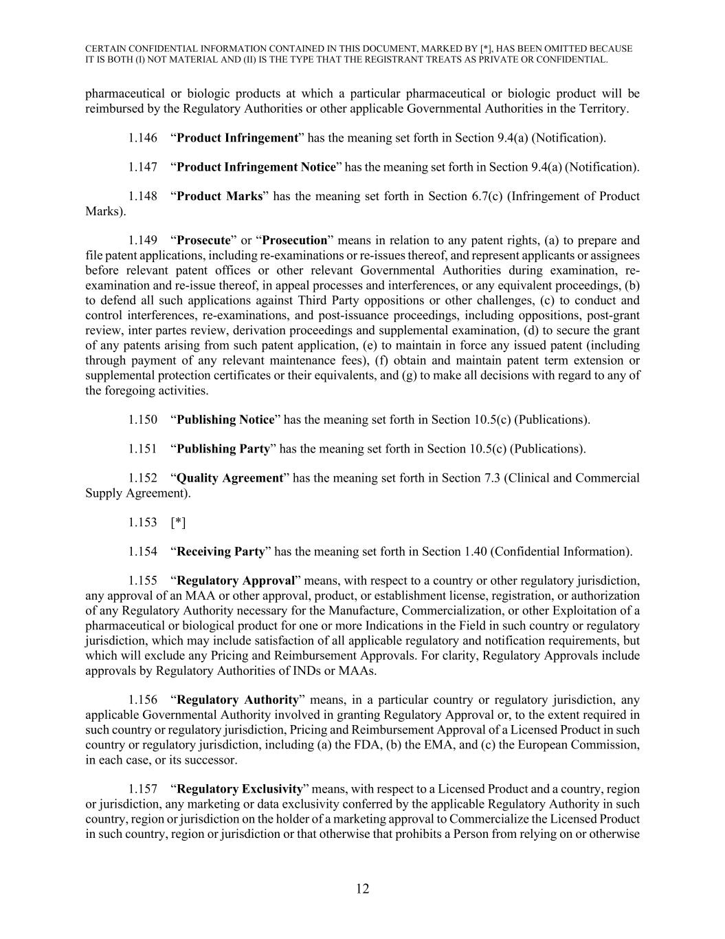
CERTAIN CONFIDENTIAL INFORMATION CONTAINED IN THIS DOCUMENT, MARKED BY [*], HAS BEEN OMITTED BECAUSE IT IS BOTH (I) NOT MATERIAL AND (II) IS THE TYPE THAT THE REGISTRANT TREATS AS PRIVATE OR CONFIDENTIAL. 12 pharmaceutical or biologic products at which a particular pharmaceutical or biologic product will be reimbursed by the Regulatory Authorities or other applicable Governmental Authorities in the Territory. 1.146 “Product Infringement” has the meaning set forth in Section 9.4(a) (Notification). 1.147 “Product Infringement Notice” has the meaning set forth in Section 9.4(a) (Notification). 1.148 “Product Marks” has the meaning set forth in Section 6.7(c) (Infringement of Product Marks). 1.149 “Prosecute” or “Prosecution” means in relation to any patent rights, (a) to prepare and file patent applications, including re-examinations or re-issues thereof, and represent applicants or assignees before relevant patent offices or other relevant Governmental Authorities during examination, re- examination and re-issue thereof, in appeal processes and interferences, or any equivalent proceedings, (b) to defend all such applications against Third Party oppositions or other challenges, (c) to conduct and control interferences, re-examinations, and post-issuance proceedings, including oppositions, post-grant review, inter partes review, derivation proceedings and supplemental examination, (d) to secure the grant of any patents arising from such patent application, (e) to maintain in force any issued patent (including through payment of any relevant maintenance fees), (f) obtain and maintain patent term extension or supplemental protection certificates or their equivalents, and (g) to make all decisions with regard to any of the foregoing activities. 1.150 “Publishing Notice” has the meaning set forth in Section 10.5(c) (Publications). 1.151 “Publishing Party” has the meaning set forth in Section 10.5(c) (Publications). 1.152 “Quality Agreement” has the meaning set forth in Section 7.3 (Clinical and Commercial Supply Agreement). 1.153 [*] 1.154 “Receiving Party” has the meaning set forth in Section 1.40 (Confidential Information). 1.155 “Regulatory Approval” means, with respect to a country or other regulatory jurisdiction, any approval of an MAA or other approval, product, or establishment license, registration, or authorization of any Regulatory Authority necessary for the Manufacture, Commercialization, or other Exploitation of a pharmaceutical or biological product for one or more Indications in the Field in such country or regulatory jurisdiction, which may include satisfaction of all applicable regulatory and notification requirements, but which will exclude any Pricing and Reimbursement Approvals. For clarity, Regulatory Approvals include approvals by Regulatory Authorities of INDs or MAAs. 1.156 “Regulatory Authority” means, in a particular country or regulatory jurisdiction, any applicable Governmental Authority involved in granting Regulatory Approval or, to the extent required in such country or regulatory jurisdiction, Pricing and Reimbursement Approval of a Licensed Product in such country or regulatory jurisdiction, including (a) the FDA, (b) the EMA, and (c) the European Commission, in each case, or its successor. 1.157 “Regulatory Exclusivity” means, with respect to a Licensed Product and a country, region or jurisdiction, any marketing or data exclusivity conferred by the applicable Regulatory Authority in such country, region or jurisdiction on the holder of a marketing approval to Commercialize the Licensed Product in such country, region or jurisdiction or that otherwise that prohibits a Person from relying on or otherwise

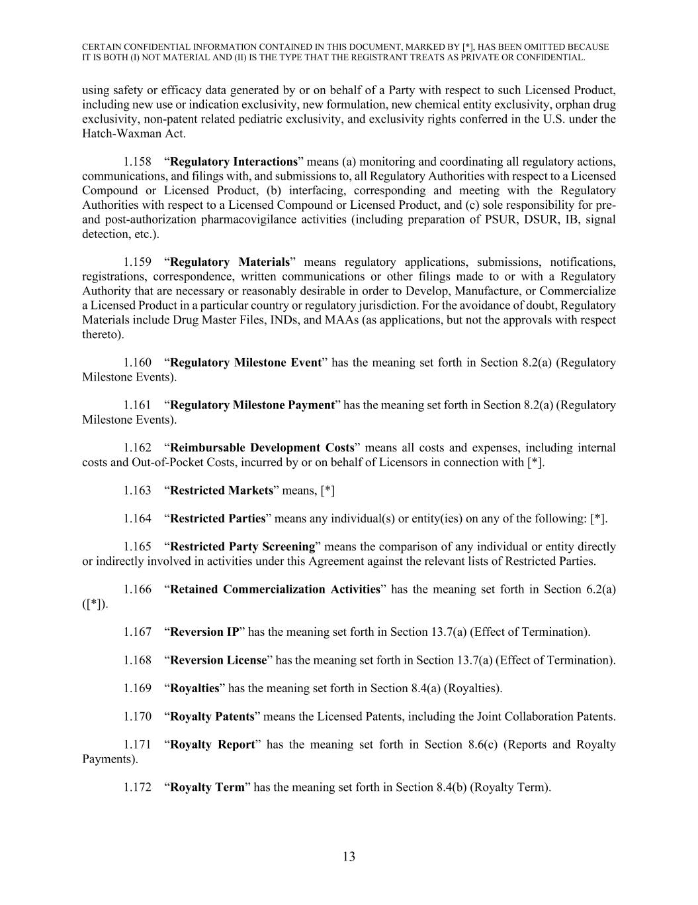
CERTAIN CONFIDENTIAL INFORMATION CONTAINED IN THIS DOCUMENT, MARKED BY [*], HAS BEEN OMITTED BECAUSE IT IS BOTH (I) NOT MATERIAL AND (II) IS THE TYPE THAT THE REGISTRANT TREATS AS PRIVATE OR CONFIDENTIAL. 13 using safety or efficacy data generated by or on behalf of a Party with respect to such Licensed Product, including new use or indication exclusivity, new formulation, new chemical entity exclusivity, orphan drug exclusivity, non-patent related pediatric exclusivity, and exclusivity rights conferred in the U.S. under the Hatch-Waxman Act. 1.158 “Regulatory Interactions” means (a) monitoring and coordinating all regulatory actions, communications, and filings with, and submissions to, all Regulatory Authorities with respect to a Licensed Compound or Licensed Product, (b) interfacing, corresponding and meeting with the Regulatory Authorities with respect to a Licensed Compound or Licensed Product, and (c) sole responsibility for pre- and post-authorization pharmacovigilance activities (including preparation of PSUR, DSUR, IB, signal detection, etc.). 1.159 “Regulatory Materials” means regulatory applications, submissions, notifications, registrations, correspondence, written communications or other filings made to or with a Regulatory Authority that are necessary or reasonably desirable in order to Develop, Manufacture, or Commercialize a Licensed Product in a particular country or regulatory jurisdiction. For the avoidance of doubt, Regulatory Materials include Drug Master Files, INDs, and MAAs (as applications, but not the approvals with respect thereto). 1.160 “Regulatory Milestone Event” has the meaning set forth in Section 8.2(a) (Regulatory Milestone Events). 1.161 “Regulatory Milestone Payment” has the meaning set forth in Section 8.2(a) (Regulatory Milestone Events). 1.162 “Reimbursable Development Costs” means all costs and expenses, including internal costs and Out-of-Pocket Costs, incurred by or on behalf of Licensors in connection with [*]. 1.163 “Restricted Markets” means, [*] 1.164 “Restricted Parties” means any individual(s) or entity(ies) on any of the following: [*]. 1.165 “Restricted Party Screening” means the comparison of any individual or entity directly or indirectly involved in activities under this Agreement against the relevant lists of Restricted Parties. 1.166 “Retained Commercialization Activities” has the meaning set forth in Section 6.2(a) ([*]). 1.167 “Reversion IP” has the meaning set forth in Section 13.7(a) (Effect of Termination). 1.168 “Reversion License” has the meaning set forth in Section 13.7(a) (Effect of Termination). 1.169 “Royalties” has the meaning set forth in Section 8.4(a) (Royalties). 1.170 “Royalty Patents” means the Licensed Patents, including the Joint Collaboration Patents. 1.171 “Royalty Report” has the meaning set forth in Section 8.6(c) (Reports and Royalty Payments). 1.172 “Royalty Term” has the meaning set forth in Section 8.4(b) (Royalty Term).

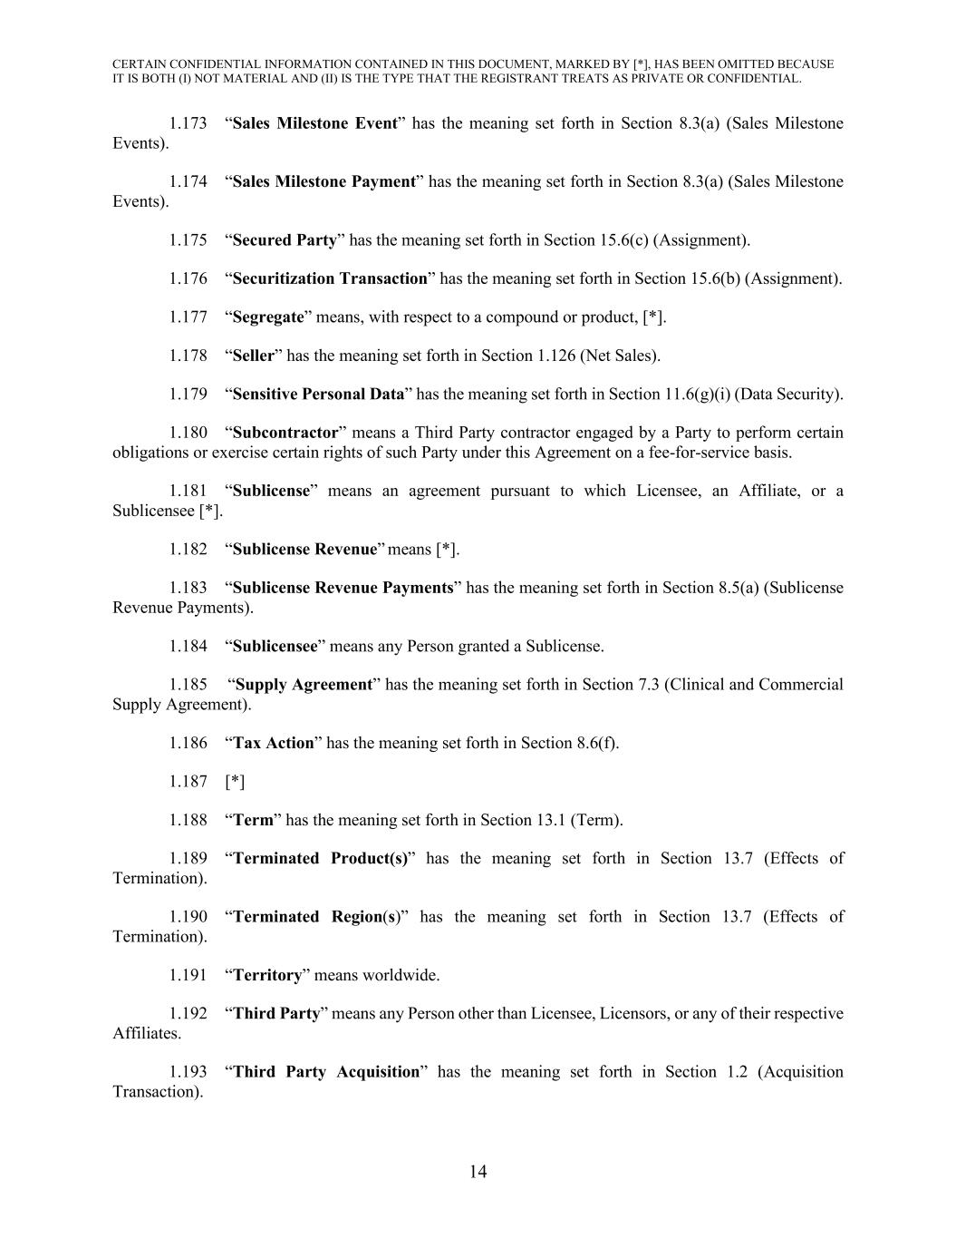
CERTAIN CONFIDENTIAL INFORMATION CONTAINED IN THIS DOCUMENT, MARKED BY [*], HAS BEEN OMITTED BECAUSE IT IS BOTH (I) NOT MATERIAL AND (II) IS THE TYPE THAT THE REGISTRANT TREATS AS PRIVATE OR CONFIDENTIAL. 14 1.173 “Sales Milestone Event” has the meaning set forth in Section 8.3(a) (Sales Milestone Events). 1.174 “Sales Milestone Payment” has the meaning set forth in Section 8.3(a) (Sales Milestone Events). 1.175 “Secured Party” has the meaning set forth in Section 15.6(c) (Assignment). 1.176 “Securitization Transaction” has the meaning set forth in Section 15.6(b) (Assignment). 1.177 “Segregate” means, with respect to a compound or product, [*]. 1.178 “Seller” has the meaning set forth in Section 1.126 (Net Sales). 1.179 “Sensitive Personal Data” has the meaning set forth in Section 11.6(g)(i) (Data Security). 1.180 “Subcontractor” means a Third Party contractor engaged by a Party to perform certain obligations or exercise certain rights of such Party under this Agreement on a fee-for-service basis. 1.181 “Sublicense” means an agreement pursuant to which Licensee, an Affiliate, or a Sublicensee [*]. 1.182 “Sublicense Revenue” means [*]. 1.183 “Sublicense Revenue Payments” has the meaning set forth in Section 8.5(a) (Sublicense Revenue Payments). 1.184 “Sublicensee” means any Person granted a Sublicense. 1.185 “Supply Agreement” has the meaning set forth in Section 7.3 (Clinical and Commercial Supply Agreement). 1.186 “Tax Action” has the meaning set forth in Section 8.6(f). 1.187 [*] 1.188 “Term” has the meaning set forth in Section 13.1 (Term). 1.189 “Terminated Product(s)” has the meaning set forth in Section 13.7 (Effects of Termination). 1.190 “Terminated Region(s)” has the meaning set forth in Section 13.7 (Effects of Termination). 1.191 “Territory” means worldwide. 1.192 “Third Party” means any Person other than Licensee, Licensors, or any of their respective Affiliates. 1.193 “Third Party Acquisition” has the meaning set forth in Section 1.2 (Acquisition Transaction).

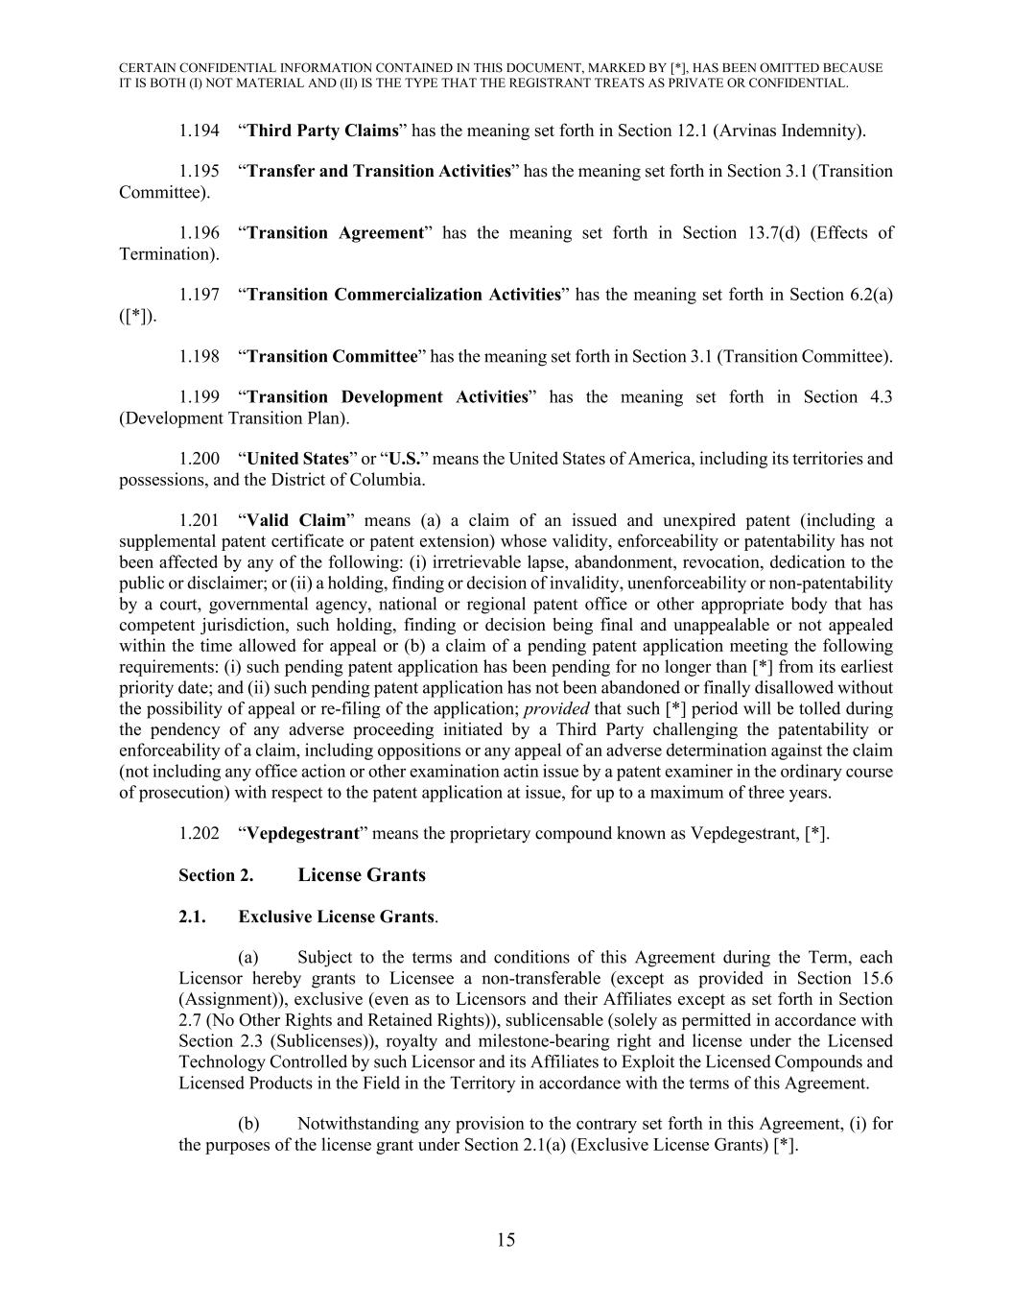
CERTAIN CONFIDENTIAL INFORMATION CONTAINED IN THIS DOCUMENT, MARKED BY [*], HAS BEEN OMITTED BECAUSE IT IS BOTH (I) NOT MATERIAL AND (II) IS THE TYPE THAT THE REGISTRANT TREATS AS PRIVATE OR CONFIDENTIAL. 15 1.194 “Third Party Claims” has the meaning set forth in Section 12.1 (Arvinas Indemnity). 1.195 “Transfer and Transition Activities” has the meaning set forth in Section 3.1 (Transition Committee). 1.196 “Transition Agreement” has the meaning set forth in Section 13.7(d) (Effects of Termination). 1.197 “Transition Commercialization Activities” has the meaning set forth in Section 6.2(a) ([*]). 1.198 “Transition Committee” has the meaning set forth in Section 3.1 (Transition Committee). 1.199 “Transition Development Activities” has the meaning set forth in Section 4.3 (Development Transition Plan). 1.200 “United States” or “U.S.” means the United States of America, including its territories and possessions, and the District of Columbia. 1.201 “Valid Claim” means (a) a claim of an issued and unexpired patent (including a supplemental patent certificate or patent extension) whose validity, enforceability or patentability has not been affected by any of the following: (i) irretrievable lapse, abandonment, revocation, dedication to the public or disclaimer; or (ii) a holding, finding or decision of invalidity, unenforceability or non-patentability by a court, governmental agency, national or regional patent office or other appropriate body that has competent jurisdiction, such holding, finding or decision being final and unappealable or not appealed within the time allowed for appeal or (b) a claim of a pending patent application meeting the following requirements: (i) such pending patent application has been pending for no longer than [*] from its earliest priority date; and (ii) such pending patent application has not been abandoned or finally disallowed without the possibility of appeal or re-filing of the application; provided that such [*] period will be tolled during the pendency of any adverse proceeding initiated by a Third Party challenging the patentability or enforceability of a claim, including oppositions or any appeal of an adverse determination against the claim (not including any office action or other examination actin issue by a patent examiner in the ordinary course of prosecution) with respect to the patent application at issue, for up to a maximum of three years. 1.202 “Vepdegestrant” means the proprietary compound known as Vepdegestrant, [*]. Section 2. License Grants 2.1. Exclusive License Grants. (a) Subject to the terms and conditions of this Agreement during the Term, each Licensor hereby grants to Licensee a non-transferable (except as provided in Section 15.6 (Assignment)), exclusive (even as to Licensors and their Affiliates except as set forth in Section 2.7 (No Other Rights and Retained Rights)), sublicensable (solely as permitted in accordance with Section 2.3 (Sublicenses)), royalty and milestone-bearing right and license under the Licensed Technology Controlled by such Licensor and its Affiliates to Exploit the Licensed Compounds and Licensed Products in the Field in the Territory in accordance with the terms of this Agreement. (b) Notwithstanding any provision to the contrary set forth in this Agreement, (i) for the purposes of the license grant under Section 2.1(a) (Exclusive License Grants) [*].

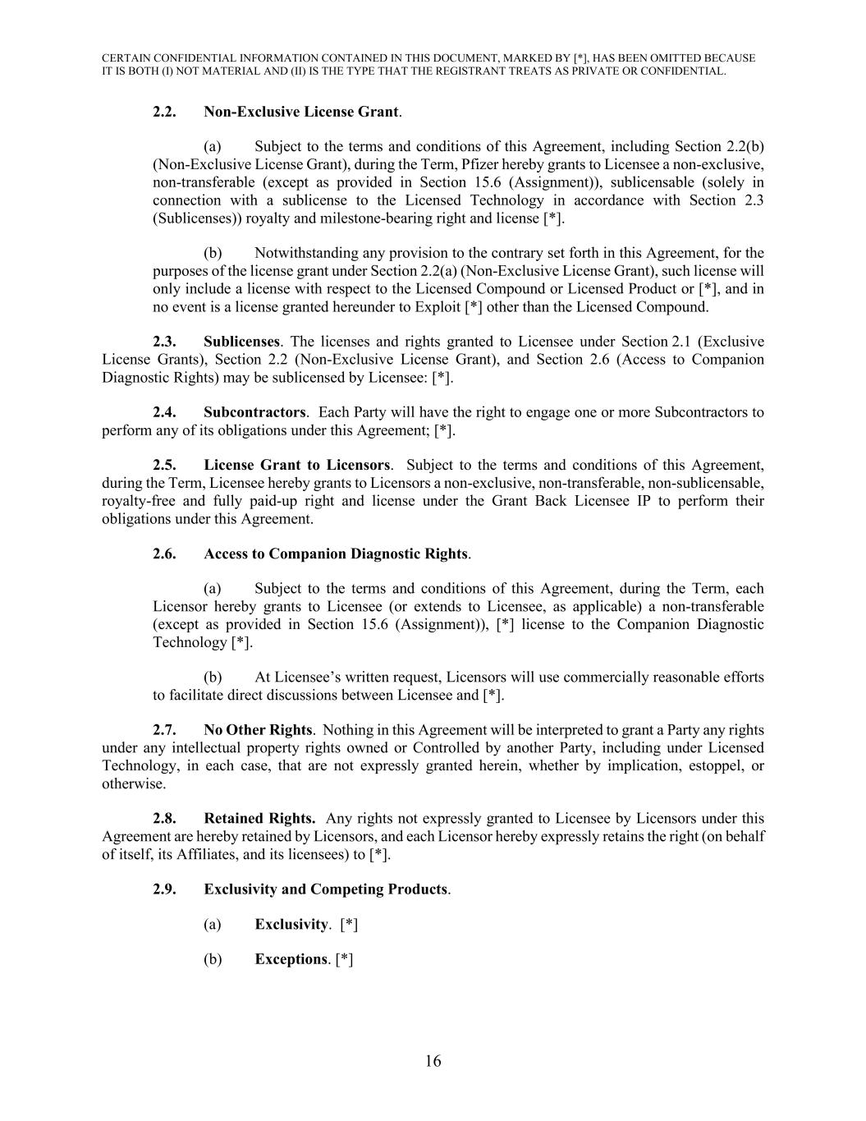
CERTAIN CONFIDENTIAL INFORMATION CONTAINED IN THIS DOCUMENT, MARKED BY [*], HAS BEEN OMITTED BECAUSE IT IS BOTH (I) NOT MATERIAL AND (II) IS THE TYPE THAT THE REGISTRANT TREATS AS PRIVATE OR CONFIDENTIAL. 16 2.2. Non-Exclusive License Grant. (a) Subject to the terms and conditions of this Agreement, including Section 2.2(b) (Non-Exclusive License Grant), during the Term, Pfizer hereby grants to Licensee a non-exclusive, non-transferable (except as provided in Section 15.6 (Assignment)), sublicensable (solely in connection with a sublicense to the Licensed Technology in accordance with Section 2.3 (Sublicenses)) royalty and milestone-bearing right and license [*]. (b) Notwithstanding any provision to the contrary set forth in this Agreement, for the purposes of the license grant under Section 2.2(a) (Non-Exclusive License Grant), such license will only include a license with respect to the Licensed Compound or Licensed Product or [*], and in no event is a license granted hereunder to Exploit [*] other than the Licensed Compound. 2.3. Sublicenses. The licenses and rights granted to Licensee under Section 2.1 (Exclusive License Grants), Section 2.2 (Non-Exclusive License Grant), and Section 2.6 (Access to Companion Diagnostic Rights) may be sublicensed by Licensee: [*]. 2.4. Subcontractors. Each Party will have the right to engage one or more Subcontractors to perform any of its obligations under this Agreement; [*]. 2.5. License Grant to Licensors. Subject to the terms and conditions of this Agreement, during the Term, Licensee hereby grants to Licensors a non-exclusive, non-transferable, non-sublicensable, royalty-free and fully paid-up right and license under the Grant Back Licensee IP to perform their obligations under this Agreement. 2.6. Access to Companion Diagnostic Rights. (a) Subject to the terms and conditions of this Agreement, during the Term, each Licensor hereby grants to Licensee (or extends to Licensee, as applicable) a non-transferable (except as provided in Section 15.6 (Assignment)), [*] license to the Companion Diagnostic Technology [*]. (b) At Licensee’s written request, Licensors will use commercially reasonable efforts to facilitate direct discussions between Licensee and [*]. 2.7. No Other Rights. Nothing in this Agreement will be interpreted to grant a Party any rights under any intellectual property rights owned or Controlled by another Party, including under Licensed Technology, in each case, that are not expressly granted herein, whether by implication, estoppel, or otherwise. 2.8. Retained Rights. Any rights not expressly granted to Licensee by Licensors under this Agreement are hereby retained by Licensors, and each Licensor hereby expressly retains the right (on behalf of itself, its Affiliates, and its licensees) to [*]. 2.9. Exclusivity and Competing Products. (a) Exclusivity. [*] (b) Exceptions. [*]

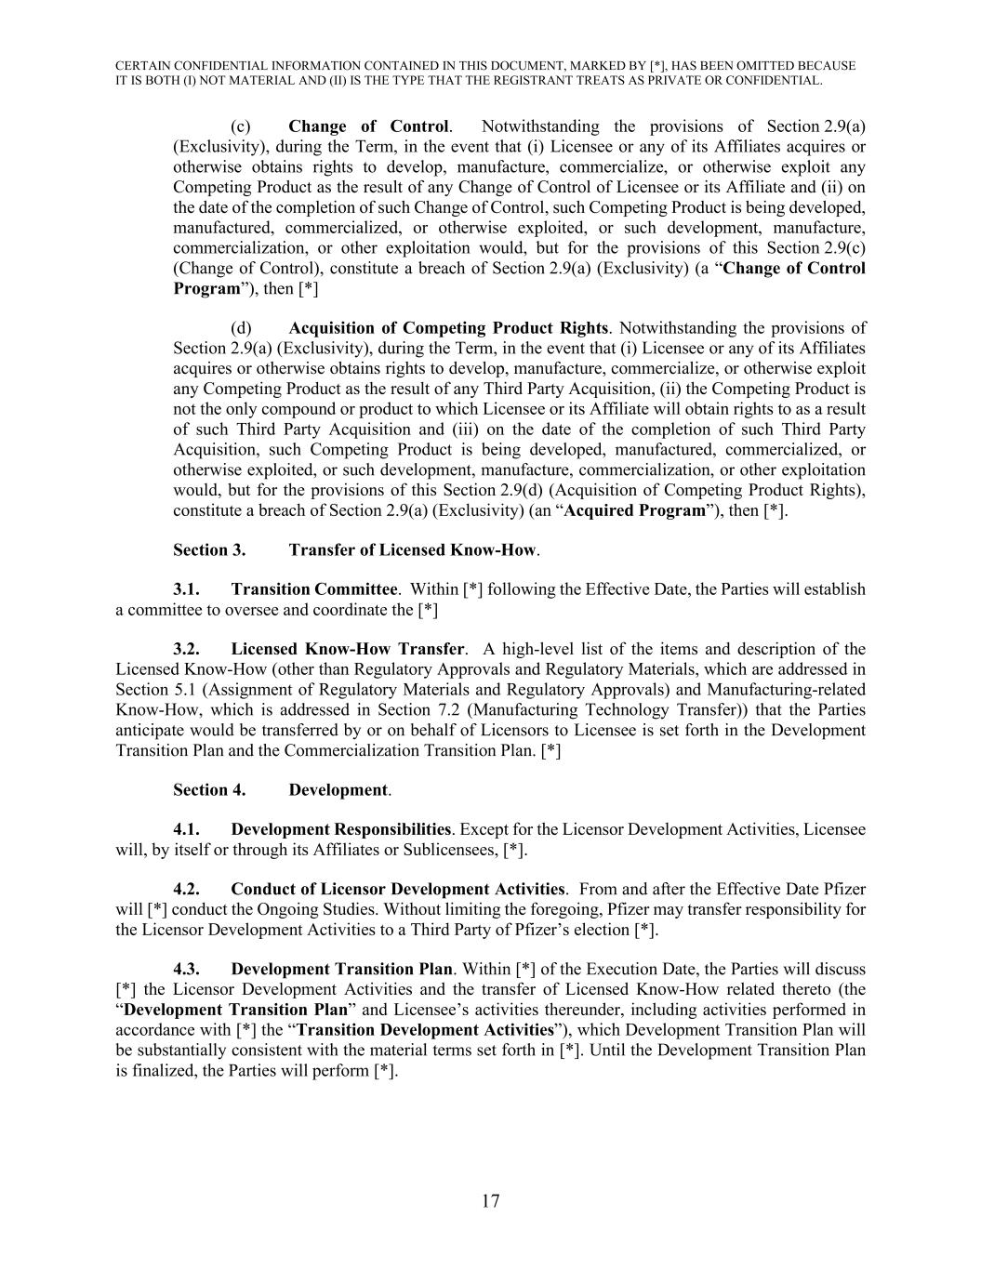
CERTAIN CONFIDENTIAL INFORMATION CONTAINED IN THIS DOCUMENT, MARKED BY [*], HAS BEEN OMITTED BECAUSE IT IS BOTH (I) NOT MATERIAL AND (II) IS THE TYPE THAT THE REGISTRANT TREATS AS PRIVATE OR CONFIDENTIAL. 17 (c) Change of Control. Notwithstanding the provisions of Section 2.9(a) (Exclusivity), during the Term, in the event that (i) Licensee or any of its Affiliates acquires or otherwise obtains rights to develop, manufacture, commercialize, or otherwise exploit any Competing Product as the result of any Change of Control of Licensee or its Affiliate and (ii) on the date of the completion of such Change of Control, such Competing Product is being developed, manufactured, commercialized, or otherwise exploited, or such development, manufacture, commercialization, or other exploitation would, but for the provisions of this Section 2.9(c) (Change of Control), constitute a breach of Section 2.9(a) (Exclusivity) (a “Change of Control Program”), then [*] (d) Acquisition of Competing Product Rights. Notwithstanding the provisions of Section 2.9(a) (Exclusivity), during the Term, in the event that (i) Licensee or any of its Affiliates acquires or otherwise obtains rights to develop, manufacture, commercialize, or otherwise exploit any Competing Product as the result of any Third Party Acquisition, (ii) the Competing Product is not the only compound or product to which Licensee or its Affiliate will obtain rights to as a result of such Third Party Acquisition and (iii) on the date of the completion of such Third Party Acquisition, such Competing Product is being developed, manufactured, commercialized, or otherwise exploited, or such development, manufacture, commercialization, or other exploitation would, but for the provisions of this Section 2.9(d) (Acquisition of Competing Product Rights), constitute a breach of Section 2.9(a) (Exclusivity) (an “Acquired Program”), then [*]. Section 3. Transfer of Licensed Know-How. 3.1. Transition Committee. Within [*] following the Effective Date, the Parties will establish a committee to oversee and coordinate the [*] 3.2. Licensed Know-How Transfer. A high-level list of the items and description of the Licensed Know-How (other than Regulatory Approvals and Regulatory Materials, which are addressed in Section 5.1 (Assignment of Regulatory Materials and Regulatory Approvals) and Manufacturing-related Know-How, which is addressed in Section 7.2 (Manufacturing Technology Transfer)) that the Parties anticipate would be transferred by or on behalf of Licensors to Licensee is set forth in the Development Transition Plan and the Commercialization Transition Plan. [*] Section 4. Development. 4.1. Development Responsibilities. Except for the Licensor Development Activities, Licensee will, by itself or through its Affiliates or Sublicensees, [*]. 4.2. Conduct of Licensor Development Activities. From and after the Effective Date Pfizer will [*] conduct the Ongoing Studies. Without limiting the foregoing, Pfizer may transfer responsibility for the Licensor Development Activities to a Third Party of Pfizer’s election [*]. 4.3. Development Transition Plan. Within [*] of the Execution Date, the Parties will discuss [*] the Licensor Development Activities and the transfer of Licensed Know-How related thereto (the “Development Transition Plan” and Licensee’s activities thereunder, including activities performed in accordance with [*] the “Transition Development Activities”), which Development Transition Plan will be substantially consistent with the material terms set forth in [*]. Until the Development Transition Plan is finalized, the Parties will perform [*].

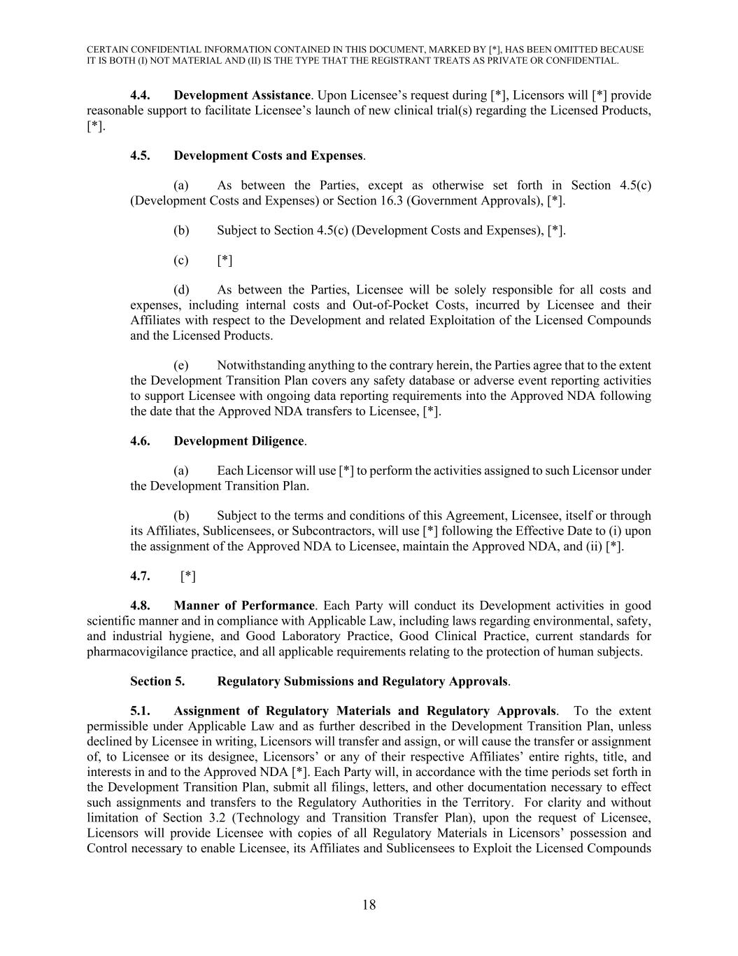
CERTAIN CONFIDENTIAL INFORMATION CONTAINED IN THIS DOCUMENT, MARKED BY [*], HAS BEEN OMITTED BECAUSE IT IS BOTH (I) NOT MATERIAL AND (II) IS THE TYPE THAT THE REGISTRANT TREATS AS PRIVATE OR CONFIDENTIAL. 18 4.4. Development Assistance. Upon Licensee’s request during [*], Licensors will [*] provide reasonable support to facilitate Licensee’s launch of new clinical trial(s) regarding the Licensed Products, [*]. 4.5. Development Costs and Expenses. (a) As between the Parties, except as otherwise set forth in Section 4.5(c) (Development Costs and Expenses) or Section 16.3 (Government Approvals), [*]. (b) Subject to Section 4.5(c) (Development Costs and Expenses), [*]. (c) [*] (d) As between the Parties, Licensee will be solely responsible for all costs and expenses, including internal costs and Out-of-Pocket Costs, incurred by Licensee and their Affiliates with respect to the Development and related Exploitation of the Licensed Compounds and the Licensed Products. (e) Notwithstanding anything to the contrary herein, the Parties agree that to the extent the Development Transition Plan covers any safety database or adverse event reporting activities to support Licensee with ongoing data reporting requirements into the Approved NDA following the date that the Approved NDA transfers to Licensee, [*]. 4.6. Development Diligence. (a) Each Licensor will use [*] to perform the activities assigned to such Licensor under the Development Transition Plan. (b) Subject to the terms and conditions of this Agreement, Licensee, itself or through its Affiliates, Sublicensees, or Subcontractors, will use [*] following the Effective Date to (i) upon the assignment of the Approved NDA to Licensee, maintain the Approved NDA, and (ii) [*]. 4.7. [*] 4.8. Manner of Performance. Each Party will conduct its Development activities in good scientific manner and in compliance with Applicable Law, including laws regarding environmental, safety, and industrial hygiene, and Good Laboratory Practice, Good Clinical Practice, current standards for pharmacovigilance practice, and all applicable requirements relating to the protection of human subjects. Section 5. Regulatory Submissions and Regulatory Approvals. 5.1. Assignment of Regulatory Materials and Regulatory Approvals. To the extent permissible under Applicable Law and as further described in the Development Transition Plan, unless declined by Licensee in writing, Licensors will transfer and assign, or will cause the transfer or assignment of, to Licensee or its designee, Licensors’ or any of their respective Affiliates’ entire rights, title, and interests in and to the Approved NDA [*]. Each Party will, in accordance with the time periods set forth in the Development Transition Plan, submit all filings, letters, and other documentation necessary to effect such assignments and transfers to the Regulatory Authorities in the Territory. For clarity and without limitation of Section 3.2 (Technology and Transition Transfer Plan), upon the request of Licensee, Licensors will provide Licensee with copies of all Regulatory Materials in Licensors’ possession and Control necessary to enable Licensee, its Affiliates and Sublicensees to Exploit the Licensed Compounds

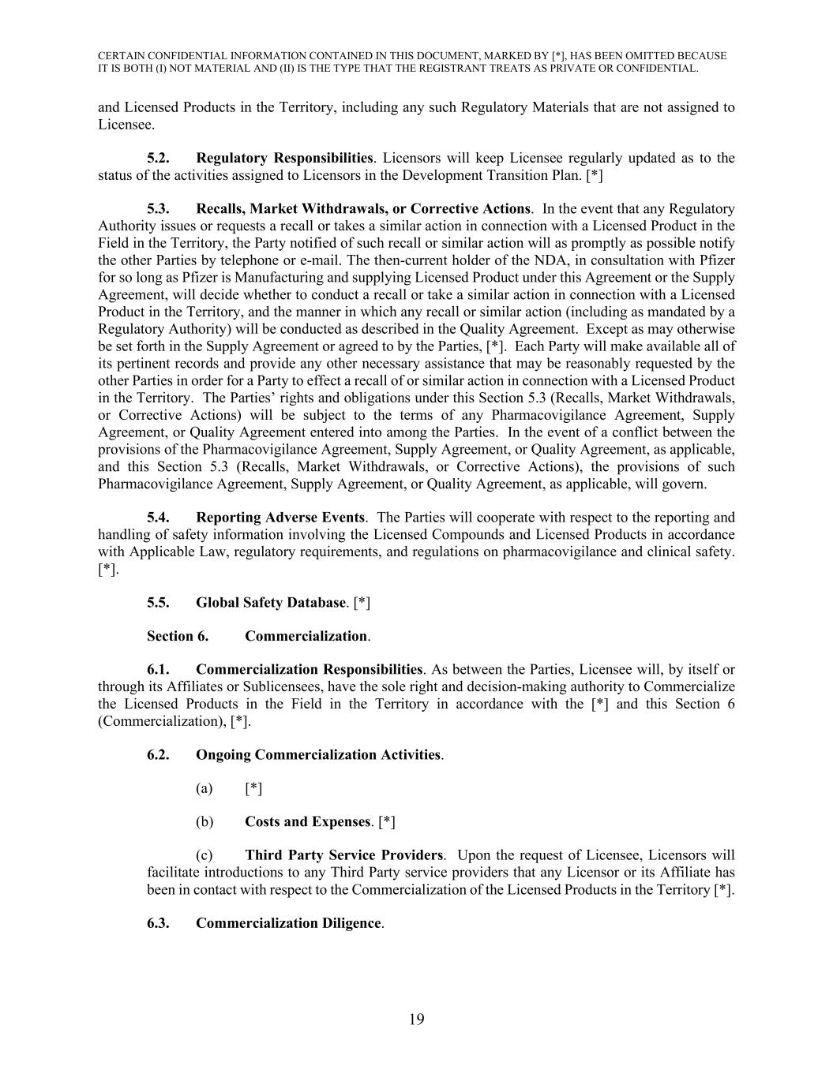
CERTAIN CONFIDENTIAL INFORMATION CONTAINED IN THIS DOCUMENT, MARKED BY [*], HAS BEEN OMITTED BECAUSE IT IS BOTH (I) NOT MATERIAL AND (II) IS THE TYPE THAT THE REGISTRANT TREATS AS PRIVATE OR CONFIDENTIAL. 19 and Licensed Products in the Territory, including any such Regulatory Materials that are not assigned to Licensee. 5.2. Regulatory Responsibilities. Licensors will keep Licensee regularly updated as to the status of the activities assigned to Licensors in the Development Transition Plan. [*] 5.3. Recalls, Market Withdrawals, or Corrective Actions. In the event that any Regulatory Authority issues or requests a recall or takes a similar action in connection with a Licensed Product in the Field in the Territory, the Party notified of such recall or similar action will as promptly as possible notify the other Parties by telephone or e-mail. The then-current holder of the NDA, in consultation with Pfizer for so long as Pfizer is Manufacturing and supplying Licensed Product under this Agreement or the Supply Agreement, will decide whether to conduct a recall or take a similar action in connection with a Licensed Product in the Territory, and the manner in which any recall or similar action (including as mandated by a Regulatory Authority) will be conducted as described in the Quality Agreement. Except as may otherwise be set forth in the Supply Agreement or agreed to by the Parties, [*]. Each Party will make available all of its pertinent records and provide any other necessary assistance that may be reasonably requested by the other Parties in order for a Party to effect a recall of or similar action in connection with a Licensed Product in the Territory. The Parties’ rights and obligations under this Section 5.3 (Recalls, Market Withdrawals, or Corrective Actions) will be subject to the terms of any Pharmacovigilance Agreement, Supply Agreement, or Quality Agreement entered into among the Parties. In the event of a conflict between the provisions of the Pharmacovigilance Agreement, Supply Agreement, or Quality Agreement, as applicable, and this Section 5.3 (Recalls, Market Withdrawals, or Corrective Actions), the provisions of such Pharmacovigilance Agreement, Supply Agreement, or Quality Agreement, as applicable, will govern. 5.4. Reporting Adverse Events. The Parties will cooperate with respect to the reporting and handling of safety information involving the Licensed Compounds and Licensed Products in accordance with Applicable Law, regulatory requirements, and regulations on pharmacovigilance and clinical safety. [*]. 5.5. Global Safety Database. [*] Section 6. Commercialization. 6.1. Commercialization Responsibilities. As between the Parties, Licensee will, by itself or through its Affiliates or Sublicensees, have the sole right and decision-making authority to Commercialize the Licensed Products in the Field in the Territory in accordance with the [*] and this Section 6 (Commercialization), [*]. 6.2. Ongoing Commercialization Activities. (a) [*] (b) Costs and Expenses. [*] (c) Third Party Service Providers. Upon the request of Licensee, Licensors will facilitate introductions to any Third Party service providers that any Licensor or its Affiliate has been in contact with respect to the Commercialization of the Licensed Products in the Territory [*]. 6.3. Commercialization Diligence.

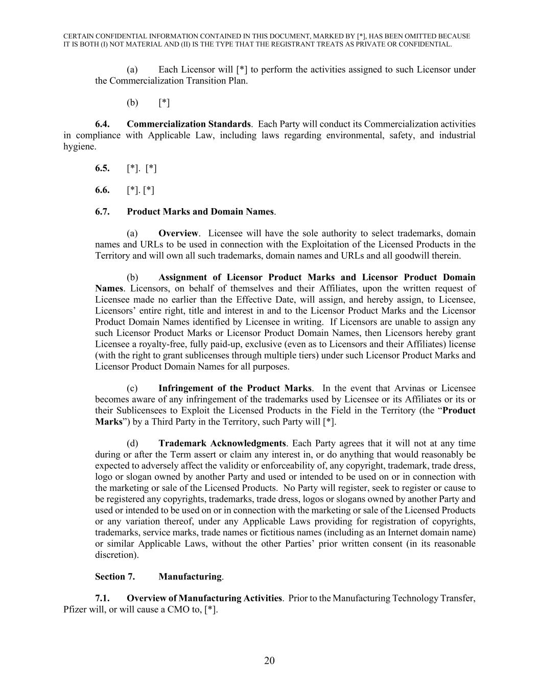
CERTAIN CONFIDENTIAL INFORMATION CONTAINED IN THIS DOCUMENT, MARKED BY [*], HAS BEEN OMITTED BECAUSE IT IS BOTH (I) NOT MATERIAL AND (II) IS THE TYPE THAT THE REGISTRANT TREATS AS PRIVATE OR CONFIDENTIAL. 20 (a) Each Licensor will [*] to perform the activities assigned to such Licensor under the Commercialization Transition Plan. (b) [*] 6.4. Commercialization Standards. Each Party will conduct its Commercialization activities in compliance with Applicable Law, including laws regarding environmental, safety, and industrial hygiene. 6.5. [*]. [*] 6.6. [*]. [*] 6.7. Product Marks and Domain Names. (a) Overview. Licensee will have the sole authority to select trademarks, domain names and URLs to be used in connection with the Exploitation of the Licensed Products in the Territory and will own all such trademarks, domain names and URLs and all goodwill therein. (b) Assignment of Licensor Product Marks and Licensor Product Domain Names. Licensors, on behalf of themselves and their Affiliates, upon the written request of Licensee made no earlier than the Effective Date, will assign, and hereby assign, to Licensee, Licensors’ entire right, title and interest in and to the Licensor Product Marks and the Licensor Product Domain Names identified by Licensee in writing. If Licensors are unable to assign any such Licensor Product Marks or Licensor Product Domain Names, then Licensors hereby grant Licensee a royalty-free, fully paid-up, exclusive (even as to Licensors and their Affiliates) license (with the right to grant sublicenses through multiple tiers) under such Licensor Product Marks and Licensor Product Domain Names for all purposes. (c) Infringement of the Product Marks. In the event that Arvinas or Licensee becomes aware of any infringement of the trademarks used by Licensee or its Affiliates or its or their Sublicensees to Exploit the Licensed Products in the Field in the Territory (the “Product Marks”) by a Third Party in the Territory, such Party will [*]. (d) Trademark Acknowledgments. Each Party agrees that it will not at any time during or after the Term assert or claim any interest in, or do anything that would reasonably be expected to adversely affect the validity or enforceability of, any copyright, trademark, trade dress, logo or slogan owned by another Party and used or intended to be used on or in connection with the marketing or sale of the Licensed Products. No Party will register, seek to register or cause to be registered any copyrights, trademarks, trade dress, logos or slogans owned by another Party and used or intended to be used on or in connection with the marketing or sale of the Licensed Products or any variation thereof, under any Applicable Laws providing for registration of copyrights, trademarks, service marks, trade names or fictitious names (including as an Internet domain name) or similar Applicable Laws, without the other Parties’ prior written consent (in its reasonable discretion). Section 7. Manufacturing. 7.1. Overview of Manufacturing Activities. Prior to the Manufacturing Technology Transfer, Pfizer will, or will cause a CMO to, [*].

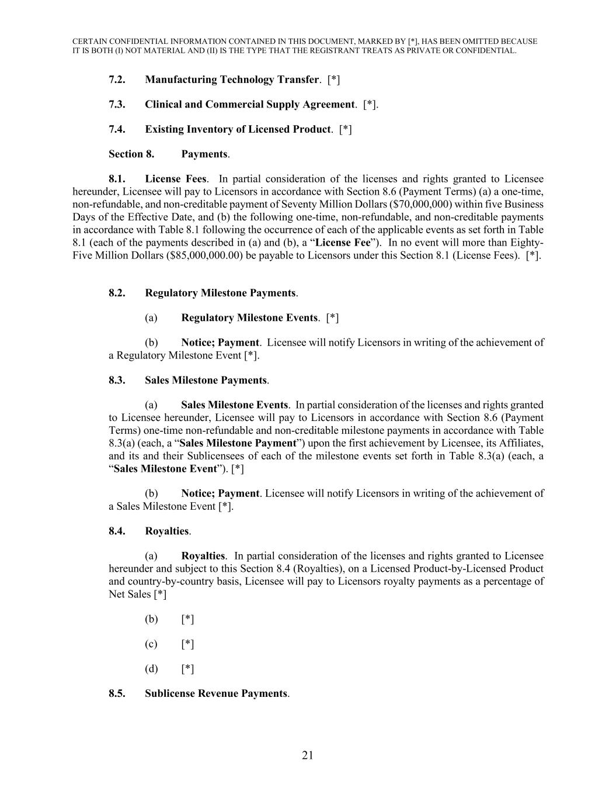
CERTAIN CONFIDENTIAL INFORMATION CONTAINED IN THIS DOCUMENT, MARKED BY [*], HAS BEEN OMITTED BECAUSE IT IS BOTH (I) NOT MATERIAL AND (II) IS THE TYPE THAT THE REGISTRANT TREATS AS PRIVATE OR CONFIDENTIAL. 21 7.2. Manufacturing Technology Transfer. [*] 7.3. Clinical and Commercial Supply Agreement. [*]. 7.4. Existing Inventory of Licensed Product. [*] Section 8. Payments. 8.1. License Fees. In partial consideration of the licenses and rights granted to Licensee hereunder, Licensee will pay to Licensors in accordance with Section 8.6 (Payment Terms) (a) a one-time, non-refundable, and non-creditable payment of Seventy Million Dollars ($70,000,000) within five Business Days of the Effective Date, and (b) the following one-time, non-refundable, and non-creditable payments in accordance with Table 8.1 following the occurrence of each of the applicable events as set forth in Table 8.1 (each of the payments described in (a) and (b), a “License Fee”). In no event will more than Eighty- Five Million Dollars ($85,000,000.00) be payable to Licensors under this Section 8.1 (License Fees). [*]. 8.2. Regulatory Milestone Payments. (a) Regulatory Milestone Events. [*] (b) Notice; Payment. Licensee will notify Licensors in writing of the achievement of a Regulatory Milestone Event [*]. 8.3. Sales Milestone Payments. (a) Sales Milestone Events. In partial consideration of the licenses and rights granted to Licensee hereunder, Licensee will pay to Licensors in accordance with Section 8.6 (Payment Terms) one-time non-refundable and non-creditable milestone payments in accordance with Table 8.3(a) (each, a “Sales Milestone Payment”) upon the first achievement by Licensee, its Affiliates, and its and their Sublicensees of each of the milestone events set forth in Table 8.3(a) (each, a “Sales Milestone Event”). [*] (b) Notice; Payment. Licensee will notify Licensors in writing of the achievement of a Sales Milestone Event [*]. 8.4. Royalties. (a) Royalties. In partial consideration of the licenses and rights granted to Licensee hereunder and subject to this Section 8.4 (Royalties), on a Licensed Product-by-Licensed Product and country-by-country basis, Licensee will pay to Licensors royalty payments as a percentage of Net Sales [*] (b) [*] (c) [*] (d) [*] 8.5. Sublicense Revenue Payments.

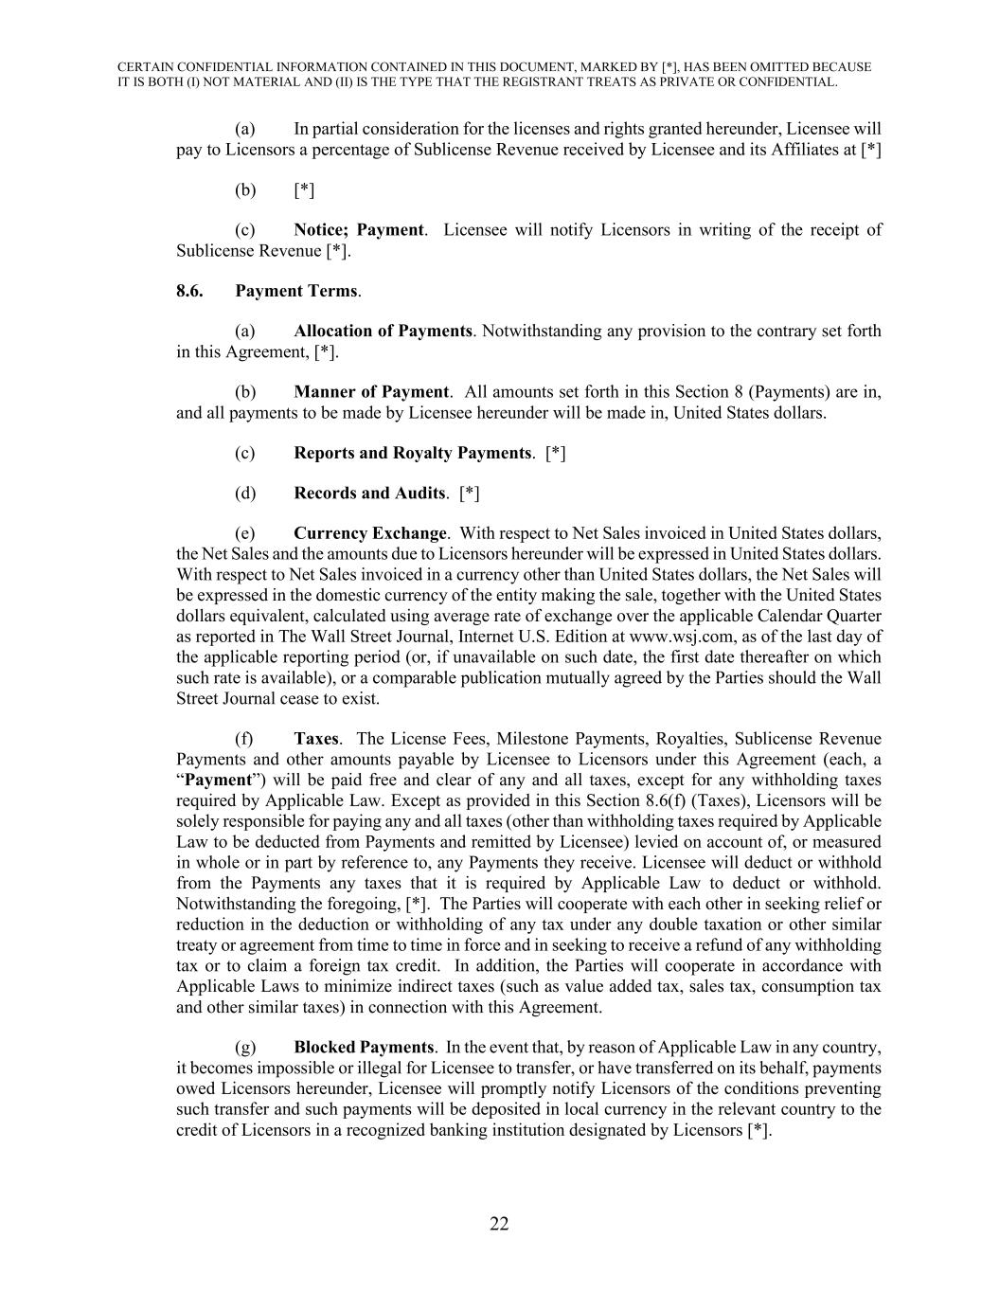
CERTAIN CONFIDENTIAL INFORMATION CONTAINED IN THIS DOCUMENT, MARKED BY [*], HAS BEEN OMITTED BECAUSE IT IS BOTH (I) NOT MATERIAL AND (II) IS THE TYPE THAT THE REGISTRANT TREATS AS PRIVATE OR CONFIDENTIAL. 22 (a) In partial consideration for the licenses and rights granted hereunder, Licensee will pay to Licensors a percentage of Sublicense Revenue received by Licensee and its Affiliates at [*] (b) [*] (c) Notice; Payment. Licensee will notify Licensors in writing of the receipt of Sublicense Revenue [*]. 8.6. Payment Terms. (a) Allocation of Payments. Notwithstanding any provision to the contrary set forth in this Agreement, [*]. (b) Manner of Payment. All amounts set forth in this Section 8 (Payments) are in, and all payments to be made by Licensee hereunder will be made in, United States dollars. (c) Reports and Royalty Payments. [*] (d) Records and Audits. [*] (e) Currency Exchange. With respect to Net Sales invoiced in United States dollars, the Net Sales and the amounts due to Licensors hereunder will be expressed in United States dollars. With respect to Net Sales invoiced in a currency other than United States dollars, the Net Sales will be expressed in the domestic currency of the entity making the sale, together with the United States dollars equivalent, calculated using average rate of exchange over the applicable Calendar Quarter as reported in The Wall Street Journal, Internet U.S. Edition at www.wsj.com, as of the last day of the applicable reporting period (or, if unavailable on such date, the first date thereafter on which such rate is available), or a comparable publication mutually agreed by the Parties should the Wall Street Journal cease to exist. (f) Taxes. The License Fees, Milestone Payments, Royalties, Sublicense Revenue Payments and other amounts payable by Licensee to Licensors under this Agreement (each, a “Payment”) will be paid free and clear of any and all taxes, except for any withholding taxes required by Applicable Law. Except as provided in this Section 8.6(f) (Taxes), Licensors will be solely responsible for paying any and all taxes (other than withholding taxes required by Applicable Law to be deducted from Payments and remitted by Licensee) levied on account of, or measured in whole or in part by reference to, any Payments they receive. Licensee will deduct or withhold from the Payments any taxes that it is required by Applicable Law to deduct or withhold. Notwithstanding the foregoing, [*]. The Parties will cooperate with each other in seeking relief or reduction in the deduction or withholding of any tax under any double taxation or other similar treaty or agreement from time to time in force and in seeking to receive a refund of any withholding tax or to claim a foreign tax credit. In addition, the Parties will cooperate in accordance with Applicable Laws to minimize indirect taxes (such as value added tax, sales tax, consumption tax and other similar taxes) in connection with this Agreement. (g) Blocked Payments. In the event that, by reason of Applicable Law in any country, it becomes impossible or illegal for Licensee to transfer, or have transferred on its behalf, payments owed Licensors hereunder, Licensee will promptly notify Licensors of the conditions preventing such transfer and such payments will be deposited in local currency in the relevant country to the credit of Licensors in a recognized banking institution designated by Licensors [*].

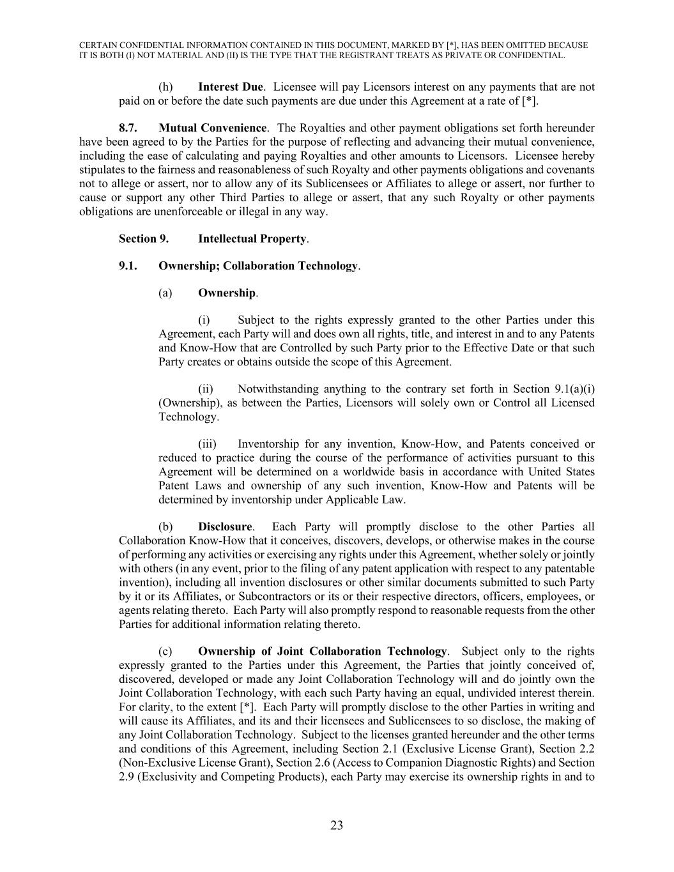
CERTAIN CONFIDENTIAL INFORMATION CONTAINED IN THIS DOCUMENT, MARKED BY [*], HAS BEEN OMITTED BECAUSE IT IS BOTH (I) NOT MATERIAL AND (II) IS THE TYPE THAT THE REGISTRANT TREATS AS PRIVATE OR CONFIDENTIAL. 23 (h) Interest Due. Licensee will pay Licensors interest on any payments that are not paid on or before the date such payments are due under this Agreement at a rate of [*]. 8.7. Mutual Convenience. The Royalties and other payment obligations set forth hereunder have been agreed to by the Parties for the purpose of reflecting and advancing their mutual convenience, including the ease of calculating and paying Royalties and other amounts to Licensors. Licensee hereby stipulates to the fairness and reasonableness of such Royalty and other payments obligations and covenants not to allege or assert, nor to allow any of its Sublicensees or Affiliates to allege or assert, nor further to cause or support any other Third Parties to allege or assert, that any such Royalty or other payments obligations are unenforceable or illegal in any way. Section 9. Intellectual Property. 9.1. Ownership; Collaboration Technology. (a) Ownership. (i) Subject to the rights expressly granted to the other Parties under this Agreement, each Party will and does own all rights, title, and interest in and to any Patents and Know-How that are Controlled by such Party prior to the Effective Date or that such Party creates or obtains outside the scope of this Agreement. (ii) Notwithstanding anything to the contrary set forth in Section 9.1(a)(i) (Ownership), as between the Parties, Licensors will solely own or Control all Licensed Technology. (iii) Inventorship for any invention, Know-How, and Patents conceived or reduced to practice during the course of the performance of activities pursuant to this Agreement will be determined on a worldwide basis in accordance with United States Patent Laws and ownership of any such invention, Know-How and Patents will be determined by inventorship under Applicable Law. (b) Disclosure. Each Party will promptly disclose to the other Parties all Collaboration Know-How that it conceives, discovers, develops, or otherwise makes in the course of performing any activities or exercising any rights under this Agreement, whether solely or jointly with others (in any event, prior to the filing of any patent application with respect to any patentable invention), including all invention disclosures or other similar documents submitted to such Party by it or its Affiliates, or Subcontractors or its or their respective directors, officers, employees, or agents relating thereto. Each Party will also promptly respond to reasonable requests from the other Parties for additional information relating thereto. (c) Ownership of Joint Collaboration Technology. Subject only to the rights expressly granted to the Parties under this Agreement, the Parties that jointly conceived of, discovered, developed or made any Joint Collaboration Technology will and do jointly own the Joint Collaboration Technology, with each such Party having an equal, undivided interest therein. For clarity, to the extent [*]. Each Party will promptly disclose to the other Parties in writing and will cause its Affiliates, and its and their licensees and Sublicensees to so disclose, the making of any Joint Collaboration Technology. Subject to the licenses granted hereunder and the other terms and conditions of this Agreement, including Section 2.1 (Exclusive License Grant), Section 2.2 (Non-Exclusive License Grant), Section 2.6 (Access to Companion Diagnostic Rights) and Section 2.9 (Exclusivity and Competing Products), each Party may exercise its ownership rights in and to

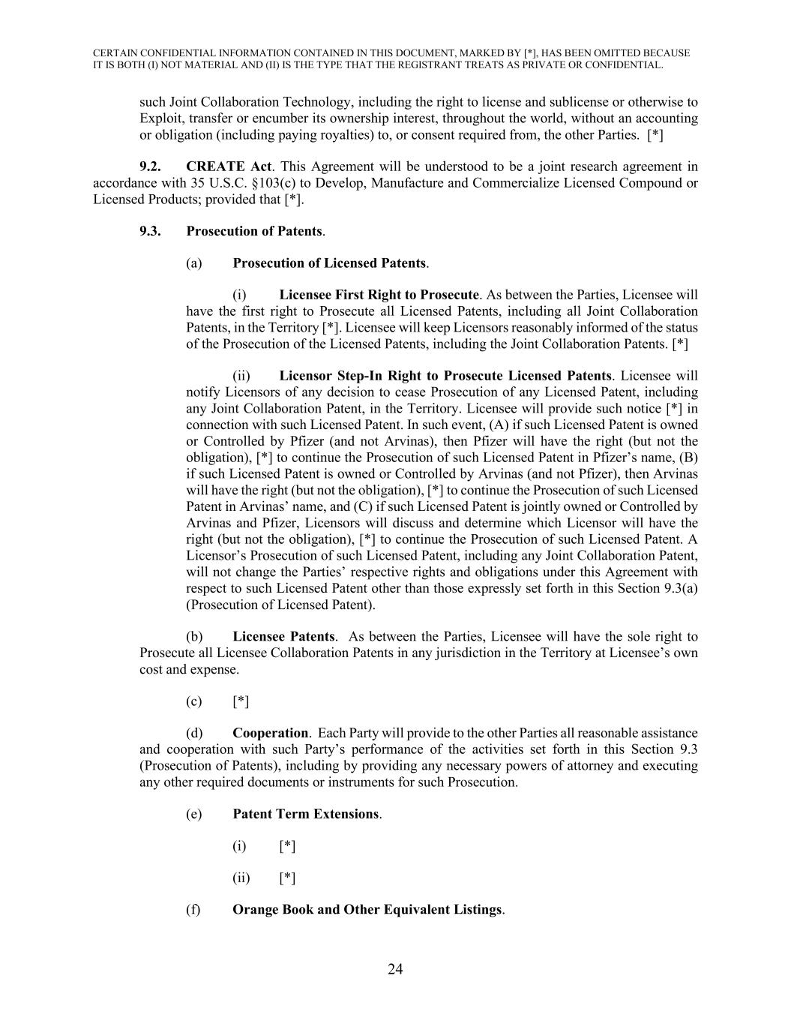
CERTAIN CONFIDENTIAL INFORMATION CONTAINED IN THIS DOCUMENT, MARKED BY [*], HAS BEEN OMITTED BECAUSE IT IS BOTH (I) NOT MATERIAL AND (II) IS THE TYPE THAT THE REGISTRANT TREATS AS PRIVATE OR CONFIDENTIAL. 24 such Joint Collaboration Technology, including the right to license and sublicense or otherwise to Exploit, transfer or encumber its ownership interest, throughout the world, without an accounting or obligation (including paying royalties) to, or consent required from, the other Parties. [*] 9.2. CREATE Act. This Agreement will be understood to be a joint research agreement in accordance with 35 U.S.C. §103(c) to Develop, Manufacture and Commercialize Licensed Compound or Licensed Products; provided that [*]. 9.3. Prosecution of Patents. (a) Prosecution of Licensed Patents. (i) Licensee First Right to Prosecute. As between the Parties, Licensee will have the first right to Prosecute all Licensed Patents, including all Joint Collaboration Patents, in the Territory [*]. Licensee will keep Licensors reasonably informed of the status of the Prosecution of the Licensed Patents, including the Joint Collaboration Patents. [*] (ii) Licensor Step-In Right to Prosecute Licensed Patents. Licensee will notify Licensors of any decision to cease Prosecution of any Licensed Patent, including any Joint Collaboration Patent, in the Territory. Licensee will provide such notice [*] in connection with such Licensed Patent. In such event, (A) if such Licensed Patent is owned or Controlled by Pfizer (and not Arvinas), then Pfizer will have the right (but not the obligation), [*] to continue the Prosecution of such Licensed Patent in Pfizer’s name, (B) if such Licensed Patent is owned or Controlled by Arvinas (and not Pfizer), then Arvinas will have the right (but not the obligation), [*] to continue the Prosecution of such Licensed Patent in Arvinas’ name, and (C) if such Licensed Patent is jointly owned or Controlled by Arvinas and Pfizer, Licensors will discuss and determine which Licensor will have the right (but not the obligation), [*] to continue the Prosecution of such Licensed Patent. A Licensor’s Prosecution of such Licensed Patent, including any Joint Collaboration Patent, will not change the Parties’ respective rights and obligations under this Agreement with respect to such Licensed Patent other than those expressly set forth in this Section 9.3(a) (Prosecution of Licensed Patent). (b) Licensee Patents. As between the Parties, Licensee will have the sole right to Prosecute all Licensee Collaboration Patents in any jurisdiction in the Territory at Licensee’s own cost and expense. (c) [*] (d) Cooperation. Each Party will provide to the other Parties all reasonable assistance and cooperation with such Party’s performance of the activities set forth in this Section 9.3 (Prosecution of Patents), including by providing any necessary powers of attorney and executing any other required documents or instruments for such Prosecution. (e) Patent Term Extensions. (i) [*] (ii) [*] (f) Orange Book and Other Equivalent Listings.

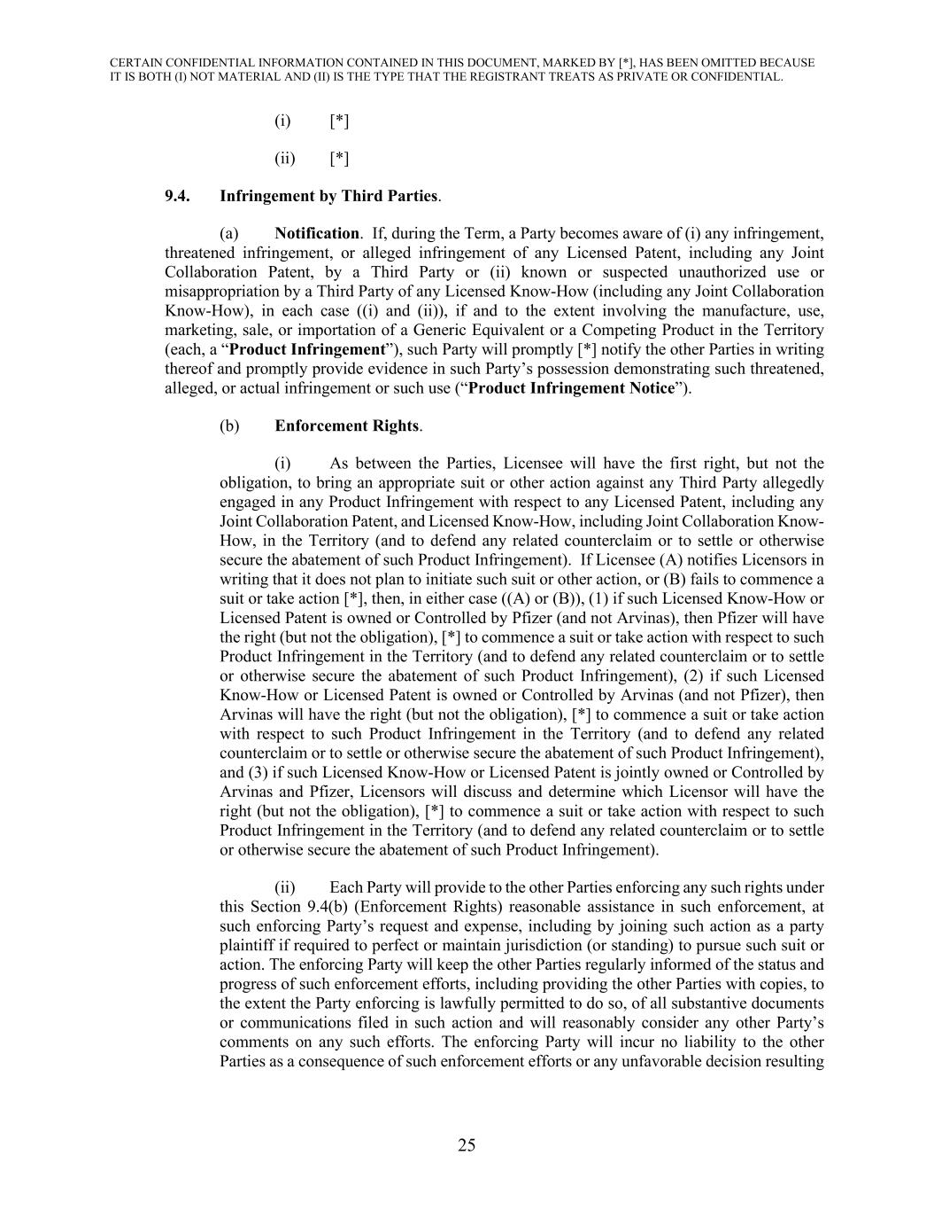
CERTAIN CONFIDENTIAL INFORMATION CONTAINED IN THIS DOCUMENT, MARKED BY [*], HAS BEEN OMITTED BECAUSE IT IS BOTH (I) NOT MATERIAL AND (II) IS THE TYPE THAT THE REGISTRANT TREATS AS PRIVATE OR CONFIDENTIAL. 25 (i) [*] (ii) [*] 9.4. Infringement by Third Parties. (a) Notification. If, during the Term, a Party becomes aware of (i) any infringement, threatened infringement, or alleged infringement of any Licensed Patent, including any Joint Collaboration Patent, by a Third Party or (ii) known or suspected unauthorized use or misappropriation by a Third Party of any Licensed Know-How (including any Joint Collaboration Know-How), in each case ((i) and (ii)), if and to the extent involving the manufacture, use, marketing, sale, or importation of a Generic Equivalent or a Competing Product in the Territory (each, a “Product Infringement”), such Party will promptly [*] notify the other Parties in writing thereof and promptly provide evidence in such Party’s possession demonstrating such threatened, alleged, or actual infringement or such use (“Product Infringement Notice”). (b) Enforcement Rights. (i) As between the Parties, Licensee will have the first right, but not the obligation, to bring an appropriate suit or other action against any Third Party allegedly engaged in any Product Infringement with respect to any Licensed Patent, including any Joint Collaboration Patent, and Licensed Know-How, including Joint Collaboration Know- How, in the Territory (and to defend any related counterclaim or to settle or otherwise secure the abatement of such Product Infringement). If Licensee (A) notifies Licensors in writing that it does not plan to initiate such suit or other action, or (B) fails to commence a suit or take action [*], then, in either case ((A) or (B)), (1) if such Licensed Know-How or Licensed Patent is owned or Controlled by Pfizer (and not Arvinas), then Pfizer will have the right (but not the obligation), [*] to commence a suit or take action with respect to such Product Infringement in the Territory (and to defend any related counterclaim or to settle or otherwise secure the abatement of such Product Infringement), (2) if such Licensed Know-How or Licensed Patent is owned or Controlled by Arvinas (and not Pfizer), then Arvinas will have the right (but not the obligation), [*] to commence a suit or take action with respect to such Product Infringement in the Territory (and to defend any related counterclaim or to settle or otherwise secure the abatement of such Product Infringement), and (3) if such Licensed Know-How or Licensed Patent is jointly owned or Controlled by Arvinas and Pfizer, Licensors will discuss and determine which Licensor will have the right (but not the obligation), [*] to commence a suit or take action with respect to such Product Infringement in the Territory (and to defend any related counterclaim or to settle or otherwise secure the abatement of such Product Infringement). (ii) Each Party will provide to the other Parties enforcing any such rights under this Section 9.4(b) (Enforcement Rights) reasonable assistance in such enforcement, at such enforcing Party’s request and expense, including by joining such action as a party plaintiff if required to perfect or maintain jurisdiction (or standing) to pursue such suit or action. The enforcing Party will keep the other Parties regularly informed of the status and progress of such enforcement efforts, including providing the other Parties with copies, to the extent the Party enforcing is lawfully permitted to do so, of all substantive documents or communications filed in such action and will reasonably consider any other Party’s comments on any such efforts. The enforcing Party will incur no liability to the other Parties as a consequence of such enforcement efforts or any unfavorable decision resulting

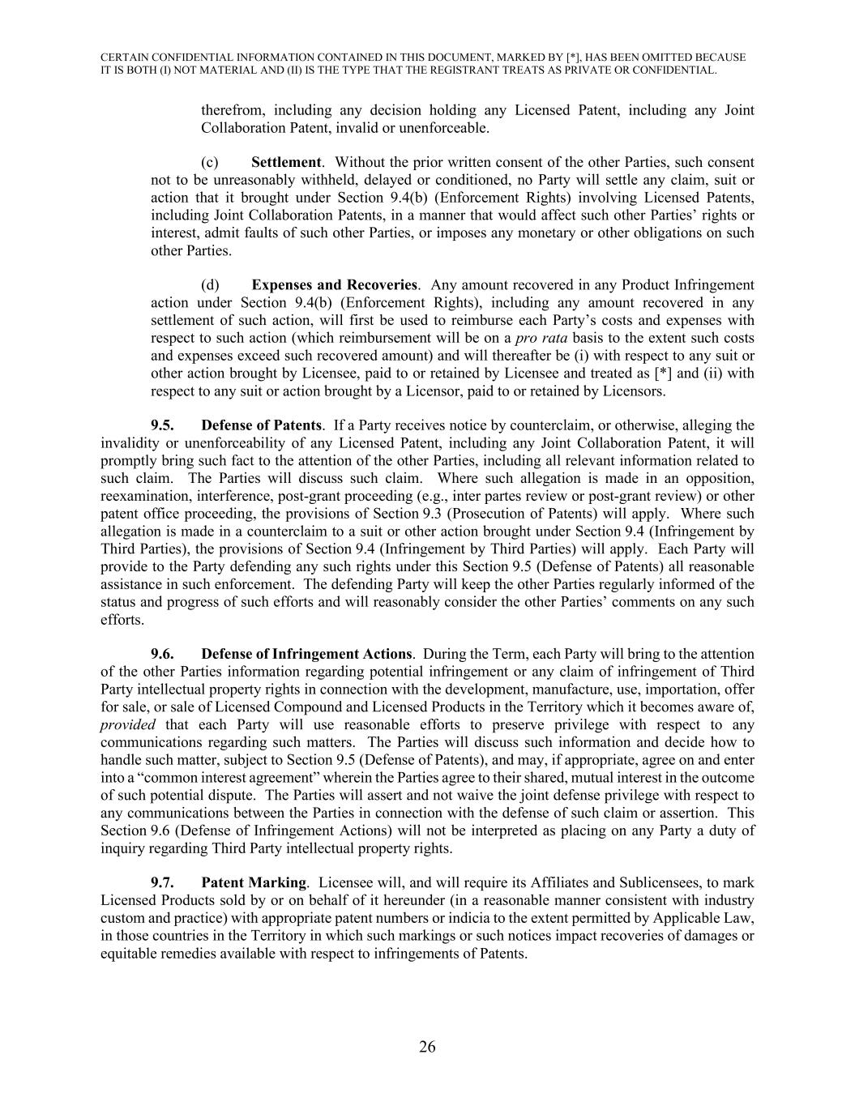
CERTAIN CONFIDENTIAL INFORMATION CONTAINED IN THIS DOCUMENT, MARKED BY [*], HAS BEEN OMITTED BECAUSE IT IS BOTH (I) NOT MATERIAL AND (II) IS THE TYPE THAT THE REGISTRANT TREATS AS PRIVATE OR CONFIDENTIAL. 26 therefrom, including any decision holding any Licensed Patent, including any Joint Collaboration Patent, invalid or unenforceable. (c) Settlement. Without the prior written consent of the other Parties, such consent not to be unreasonably withheld, delayed or conditioned, no Party will settle any claim, suit or action that it brought under Section 9.4(b) (Enforcement Rights) involving Licensed Patents, including Joint Collaboration Patents, in a manner that would affect such other Parties’ rights or interest, admit faults of such other Parties, or imposes any monetary or other obligations on such other Parties. (d) Expenses and Recoveries. Any amount recovered in any Product Infringement action under Section 9.4(b) (Enforcement Rights), including any amount recovered in any settlement of such action, will first be used to reimburse each Party’s costs and expenses with respect to such action (which reimbursement will be on a pro rata basis to the extent such costs and expenses exceed such recovered amount) and will thereafter be (i) with respect to any suit or other action brought by Licensee, paid to or retained by Licensee and treated as [*] and (ii) with respect to any suit or action brought by a Licensor, paid to or retained by Licensors. 9.5. Defense of Patents. If a Party receives notice by counterclaim, or otherwise, alleging the invalidity or unenforceability of any Licensed Patent, including any Joint Collaboration Patent, it will promptly bring such fact to the attention of the other Parties, including all relevant information related to such claim. The Parties will discuss such claim. Where such allegation is made in an opposition, reexamination, interference, post-grant proceeding (e.g., inter partes review or post-grant review) or other patent office proceeding, the provisions of Section 9.3 (Prosecution of Patents) will apply. Where such allegation is made in a counterclaim to a suit or other action brought under Section 9.4 (Infringement by Third Parties), the provisions of Section 9.4 (Infringement by Third Parties) will apply. Each Party will provide to the Party defending any such rights under this Section 9.5 (Defense of Patents) all reasonable assistance in such enforcement. The defending Party will keep the other Parties regularly informed of the status and progress of such efforts and will reasonably consider the other Parties’ comments on any such efforts. 9.6. Defense of Infringement Actions. During the Term, each Party will bring to the attention of the other Parties information regarding potential infringement or any claim of infringement of Third Party intellectual property rights in connection with the development, manufacture, use, importation, offer for sale, or sale of Licensed Compound and Licensed Products in the Territory which it becomes aware of, provided that each Party will use reasonable efforts to preserve privilege with respect to any communications regarding such matters. The Parties will discuss such information and decide how to handle such matter, subject to Section 9.5 (Defense of Patents), and may, if appropriate, agree on and enter into a “common interest agreement” wherein the Parties agree to their shared, mutual interest in the outcome of such potential dispute. The Parties will assert and not waive the joint defense privilege with respect to any communications between the Parties in connection with the defense of such claim or assertion. This Section 9.6 (Defense of Infringement Actions) will not be interpreted as placing on any Party a duty of inquiry regarding Third Party intellectual property rights. 9.7. Patent Marking. Licensee will, and will require its Affiliates and Sublicensees, to mark Licensed Products sold by or on behalf of it hereunder (in a reasonable manner consistent with industry custom and practice) with appropriate patent numbers or indicia to the extent permitted by Applicable Law, in those countries in the Territory in which such markings or such notices impact recoveries of damages or equitable remedies available with respect to infringements of Patents.

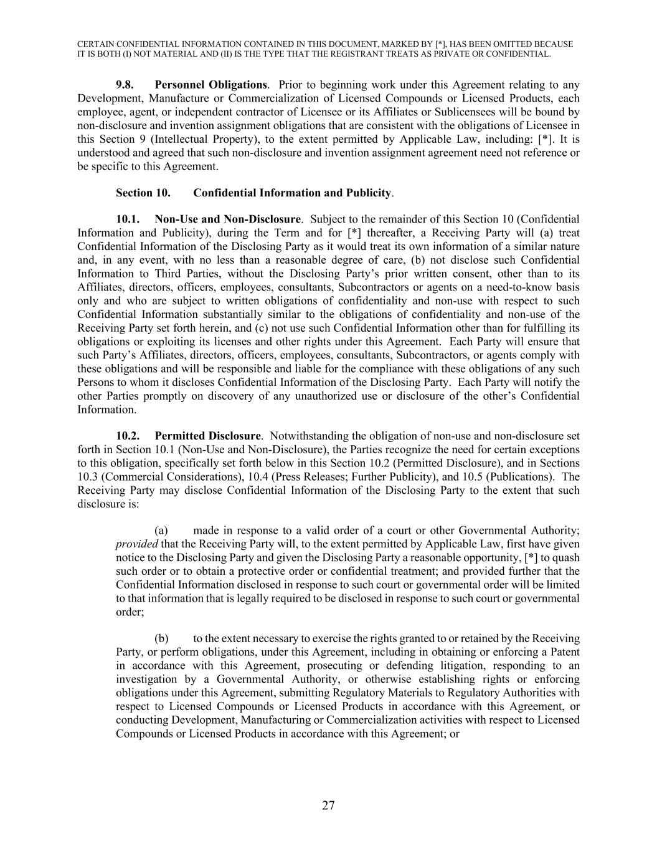
CERTAIN CONFIDENTIAL INFORMATION CONTAINED IN THIS DOCUMENT, MARKED BY [*], HAS BEEN OMITTED BECAUSE IT IS BOTH (I) NOT MATERIAL AND (II) IS THE TYPE THAT THE REGISTRANT TREATS AS PRIVATE OR CONFIDENTIAL. 27 9.8. Personnel Obligations. Prior to beginning work under this Agreement relating to any Development, Manufacture or Commercialization of Licensed Compounds or Licensed Products, each employee, agent, or independent contractor of Licensee or its Affiliates or Sublicensees will be bound by non-disclosure and invention assignment obligations that are consistent with the obligations of Licensee in this Section 9 (Intellectual Property), to the extent permitted by Applicable Law, including: [*]. It is understood and agreed that such non-disclosure and invention assignment agreement need not reference or be specific to this Agreement. Section 10. Confidential Information and Publicity. 10.1. Non-Use and Non-Disclosure. Subject to the remainder of this Section 10 (Confidential Information and Publicity), during the Term and for [*] thereafter, a Receiving Party will (a) treat Confidential Information of the Disclosing Party as it would treat its own information of a similar nature and, in any event, with no less than a reasonable degree of care, (b) not disclose such Confidential Information to Third Parties, without the Disclosing Party’s prior written consent, other than to its Affiliates, directors, officers, employees, consultants, Subcontractors or agents on a need-to-know basis only and who are subject to written obligations of confidentiality and non-use with respect to such Confidential Information substantially similar to the obligations of confidentiality and non-use of the Receiving Party set forth herein, and (c) not use such Confidential Information other than for fulfilling its obligations or exploiting its licenses and other rights under this Agreement. Each Party will ensure that such Party’s Affiliates, directors, officers, employees, consultants, Subcontractors, or agents comply with these obligations and will be responsible and liable for the compliance with these obligations of any such Persons to whom it discloses Confidential Information of the Disclosing Party. Each Party will notify the other Parties promptly on discovery of any unauthorized use or disclosure of the other’s Confidential Information. 10.2. Permitted Disclosure. Notwithstanding the obligation of non-use and non-disclosure set forth in Section 10.1 (Non-Use and Non-Disclosure), the Parties recognize the need for certain exceptions to this obligation, specifically set forth below in this Section 10.2 (Permitted Disclosure), and in Sections 10.3 (Commercial Considerations), 10.4 (Press Releases; Further Publicity), and 10.5 (Publications). The Receiving Party may disclose Confidential Information of the Disclosing Party to the extent that such disclosure is: (a) made in response to a valid order of a court or other Governmental Authority; provided that the Receiving Party will, to the extent permitted by Applicable Law, first have given notice to the Disclosing Party and given the Disclosing Party a reasonable opportunity, [*] to quash such order or to obtain a protective order or confidential treatment; and provided further that the Confidential Information disclosed in response to such court or governmental order will be limited to that information that is legally required to be disclosed in response to such court or governmental order; (b) to the extent necessary to exercise the rights granted to or retained by the Receiving Party, or perform obligations, under this Agreement, including in obtaining or enforcing a Patent in accordance with this Agreement, prosecuting or defending litigation, responding to an investigation by a Governmental Authority, or otherwise establishing rights or enforcing obligations under this Agreement, submitting Regulatory Materials to Regulatory Authorities with respect to Licensed Compounds or Licensed Products in accordance with this Agreement, or conducting Development, Manufacturing or Commercialization activities with respect to Licensed Compounds or Licensed Products in accordance with this Agreement; or

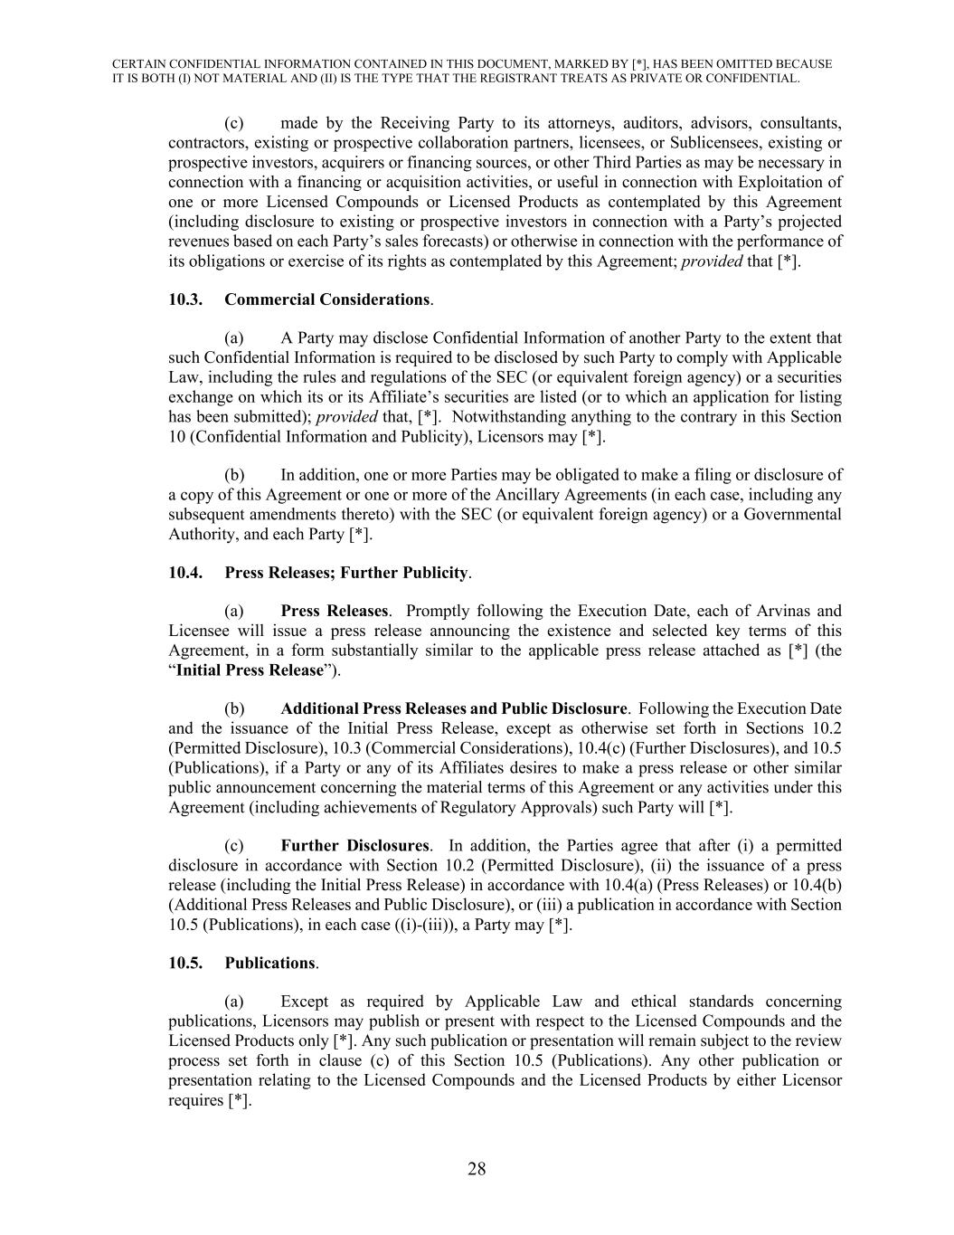
CERTAIN CONFIDENTIAL INFORMATION CONTAINED IN THIS DOCUMENT, MARKED BY [*], HAS BEEN OMITTED BECAUSE IT IS BOTH (I) NOT MATERIAL AND (II) IS THE TYPE THAT THE REGISTRANT TREATS AS PRIVATE OR CONFIDENTIAL. 28 (c) made by the Receiving Party to its attorneys, auditors, advisors, consultants, contractors, existing or prospective collaboration partners, licensees, or Sublicensees, existing or prospective investors, acquirers or financing sources, or other Third Parties as may be necessary in connection with a financing or acquisition activities, or useful in connection with Exploitation of one or more Licensed Compounds or Licensed Products as contemplated by this Agreement (including disclosure to existing or prospective investors in connection with a Party’s projected revenues based on each Party’s sales forecasts) or otherwise in connection with the performance of its obligations or exercise of its rights as contemplated by this Agreement; provided that [*]. 10.3. Commercial Considerations. (a) A Party may disclose Confidential Information of another Party to the extent that such Confidential Information is required to be disclosed by such Party to comply with Applicable Law, including the rules and regulations of the SEC (or equivalent foreign agency) or a securities exchange on which its or its Affiliate’s securities are listed (or to which an application for listing has been submitted); provided that, [*]. Notwithstanding anything to the contrary in this Section 10 (Confidential Information and Publicity), Licensors may [*]. (b) In addition, one or more Parties may be obligated to make a filing or disclosure of a copy of this Agreement or one or more of the Ancillary Agreements (in each case, including any subsequent amendments thereto) with the SEC (or equivalent foreign agency) or a Governmental Authority, and each Party [*]. 10.4. Press Releases; Further Publicity. (a) Press Releases. Promptly following the Execution Date, each of Arvinas and Licensee will issue a press release announcing the existence and selected key terms of this Agreement, in a form substantially similar to the applicable press release attached as [*] (the “Initial Press Release”). (b) Additional Press Releases and Public Disclosure. Following the Execution Date and the issuance of the Initial Press Release, except as otherwise set forth in Sections 10.2 (Permitted Disclosure), 10.3 (Commercial Considerations), 10.4(c) (Further Disclosures), and 10.5 (Publications), if a Party or any of its Affiliates desires to make a press release or other similar public announcement concerning the material terms of this Agreement or any activities under this Agreement (including achievements of Regulatory Approvals) such Party will [*]. (c) Further Disclosures. In addition, the Parties agree that after (i) a permitted disclosure in accordance with Section 10.2 (Permitted Disclosure), (ii) the issuance of a press release (including the Initial Press Release) in accordance with 10.4(a) (Press Releases) or 10.4(b) (Additional Press Releases and Public Disclosure), or (iii) a publication in accordance with Section 10.5 (Publications), in each case ((i)-(iii)), a Party may [*]. 10.5. Publications. (a) Except as required by Applicable Law and ethical standards concerning publications, Licensors may publish or present with respect to the Licensed Compounds and the Licensed Products only [*]. Any such publication or presentation will remain subject to the review process set forth in clause (c) of this Section 10.5 (Publications). Any other publication or presentation relating to the Licensed Compounds and the Licensed Products by either Licensor requires [*].

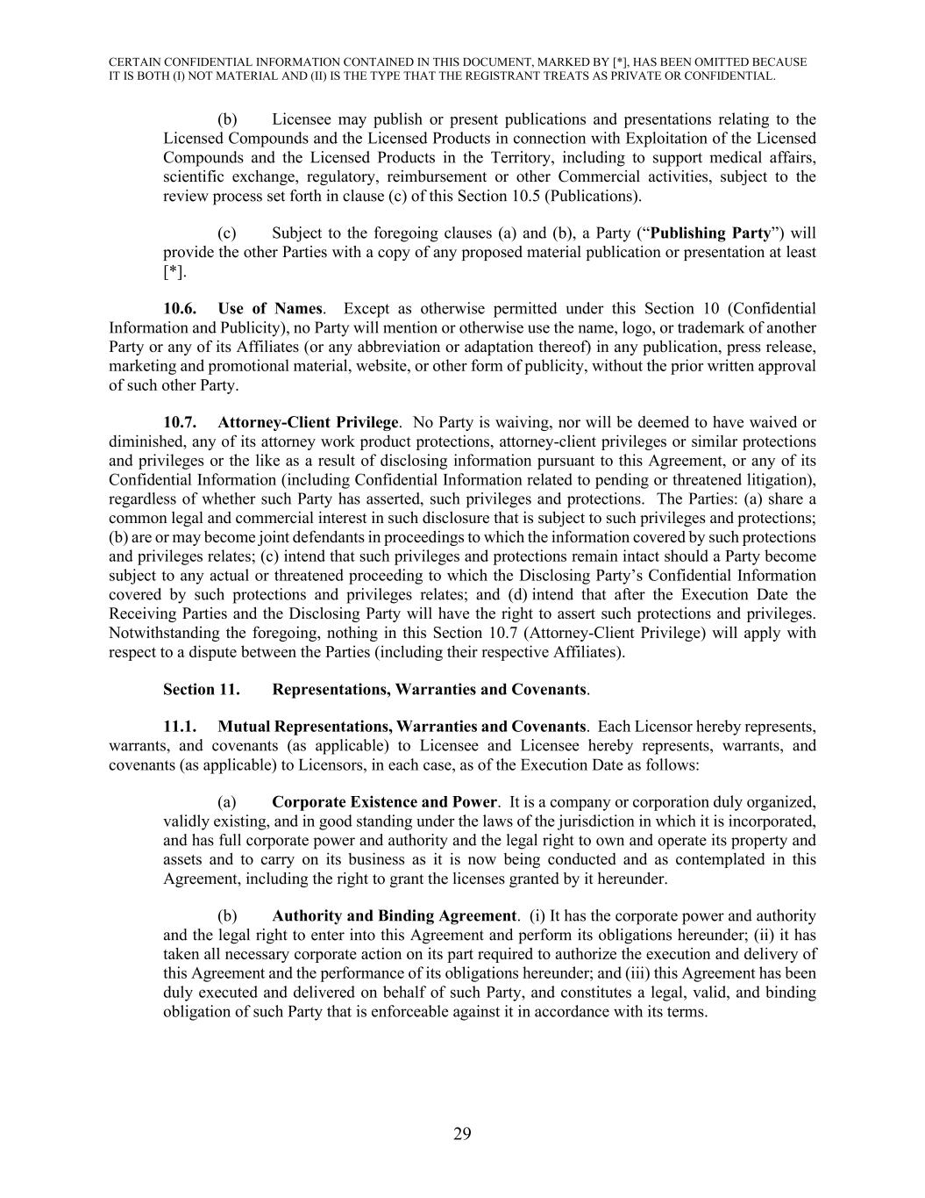
CERTAIN CONFIDENTIAL INFORMATION CONTAINED IN THIS DOCUMENT, MARKED BY [*], HAS BEEN OMITTED BECAUSE IT IS BOTH (I) NOT MATERIAL AND (II) IS THE TYPE THAT THE REGISTRANT TREATS AS PRIVATE OR CONFIDENTIAL. 29 (b) Licensee may publish or present publications and presentations relating to the Licensed Compounds and the Licensed Products in connection with Exploitation of the Licensed Compounds and the Licensed Products in the Territory, including to support medical affairs, scientific exchange, regulatory, reimbursement or other Commercial activities, subject to the review process set forth in clause (c) of this Section 10.5 (Publications). (c) Subject to the foregoing clauses (a) and (b), a Party (“Publishing Party”) will provide the other Parties with a copy of any proposed material publication or presentation at least [*]. 10.6. Use of Names. Except as otherwise permitted under this Section 10 (Confidential Information and Publicity), no Party will mention or otherwise use the name, logo, or trademark of another Party or any of its Affiliates (or any abbreviation or adaptation thereof) in any publication, press release, marketing and promotional material, website, or other form of publicity, without the prior written approval of such other Party. 10.7. Attorney-Client Privilege. No Party is waiving, nor will be deemed to have waived or diminished, any of its attorney work product protections, attorney-client privileges or similar protections and privileges or the like as a result of disclosing information pursuant to this Agreement, or any of its Confidential Information (including Confidential Information related to pending or threatened litigation), regardless of whether such Party has asserted, such privileges and protections. The Parties: (a) share a common legal and commercial interest in such disclosure that is subject to such privileges and protections; (b) are or may become joint defendants in proceedings to which the information covered by such protections and privileges relates; (c) intend that such privileges and protections remain intact should a Party become subject to any actual or threatened proceeding to which the Disclosing Party’s Confidential Information covered by such protections and privileges relates; and (d) intend that after the Execution Date the Receiving Parties and the Disclosing Party will have the right to assert such protections and privileges. Notwithstanding the foregoing, nothing in this Section 10.7 (Attorney-Client Privilege) will apply with respect to a dispute between the Parties (including their respective Affiliates). Section 11. Representations, Warranties and Covenants. 11.1. Mutual Representations, Warranties and Covenants. Each Licensor hereby represents, warrants, and covenants (as applicable) to Licensee and Licensee hereby represents, warrants, and covenants (as applicable) to Licensors, in each case, as of the Execution Date as follows: (a) Corporate Existence and Power. It is a company or corporation duly organized, validly existing, and in good standing under the laws of the jurisdiction in which it is incorporated, and has full corporate power and authority and the legal right to own and operate its property and assets and to carry on its business as it is now being conducted and as contemplated in this Agreement, including the right to grant the licenses granted by it hereunder. (b) Authority and Binding Agreement. (i) It has the corporate power and authority and the legal right to enter into this Agreement and perform its obligations hereunder; (ii) it has taken all necessary corporate action on its part required to authorize the execution and delivery of this Agreement and the performance of its obligations hereunder; and (iii) this Agreement has been duly executed and delivered on behalf of such Party, and constitutes a legal, valid, and binding obligation of such Party that is enforceable against it in accordance with its terms.

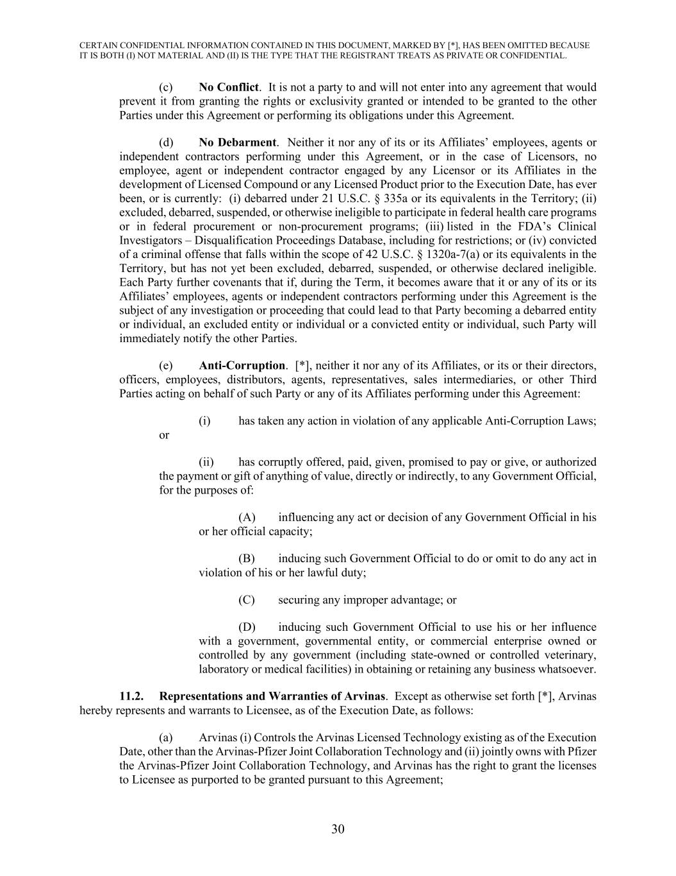
CERTAIN CONFIDENTIAL INFORMATION CONTAINED IN THIS DOCUMENT, MARKED BY [*], HAS BEEN OMITTED BECAUSE IT IS BOTH (I) NOT MATERIAL AND (II) IS THE TYPE THAT THE REGISTRANT TREATS AS PRIVATE OR CONFIDENTIAL. 30 (c) No Conflict. It is not a party to and will not enter into any agreement that would prevent it from granting the rights or exclusivity granted or intended to be granted to the other Parties under this Agreement or performing its obligations under this Agreement. (d) No Debarment. Neither it nor any of its or its Affiliates’ employees, agents or independent contractors performing under this Agreement, or in the case of Licensors, no employee, agent or independent contractor engaged by any Licensor or its Affiliates in the development of Licensed Compound or any Licensed Product prior to the Execution Date, has ever been, or is currently: (i) debarred under 21 U.S.C. § 335a or its equivalents in the Territory; (ii) excluded, debarred, suspended, or otherwise ineligible to participate in federal health care programs or in federal procurement or non-procurement programs; (iii) listed in the FDA’s Clinical Investigators – Disqualification Proceedings Database, including for restrictions; or (iv) convicted of a criminal offense that falls within the scope of 42 U.S.C. § 1320a-7(a) or its equivalents in the Territory, but has not yet been excluded, debarred, suspended, or otherwise declared ineligible. Each Party further covenants that if, during the Term, it becomes aware that it or any of its or its Affiliates’ employees, agents or independent contractors performing under this Agreement is the subject of any investigation or proceeding that could lead to that Party becoming a debarred entity or individual, an excluded entity or individual or a convicted entity or individual, such Party will immediately notify the other Parties. (e) Anti-Corruption. [*], neither it nor any of its Affiliates, or its or their directors, officers, employees, distributors, agents, representatives, sales intermediaries, or other Third Parties acting on behalf of such Party or any of its Affiliates performing under this Agreement: (i) has taken any action in violation of any applicable Anti-Corruption Laws; or (ii) has corruptly offered, paid, given, promised to pay or give, or authorized the payment or gift of anything of value, directly or indirectly, to any Government Official, for the purposes of: (A) influencing any act or decision of any Government Official in his or her official capacity; (B) inducing such Government Official to do or omit to do any act in violation of his or her lawful duty; (C) securing any improper advantage; or (D) inducing such Government Official to use his or her influence with a government, governmental entity, or commercial enterprise owned or controlled by any government (including state-owned or controlled veterinary, laboratory or medical facilities) in obtaining or retaining any business whatsoever. 11.2. Representations and Warranties of Arvinas. Except as otherwise set forth [*], Arvinas hereby represents and warrants to Licensee, as of the Execution Date, as follows: (a) Arvinas (i) Controls the Arvinas Licensed Technology existing as of the Execution Date, other than the Arvinas-Pfizer Joint Collaboration Technology and (ii) jointly owns with Pfizer the Arvinas-Pfizer Joint Collaboration Technology, and Arvinas has the right to grant the licenses to Licensee as purported to be granted pursuant to this Agreement;

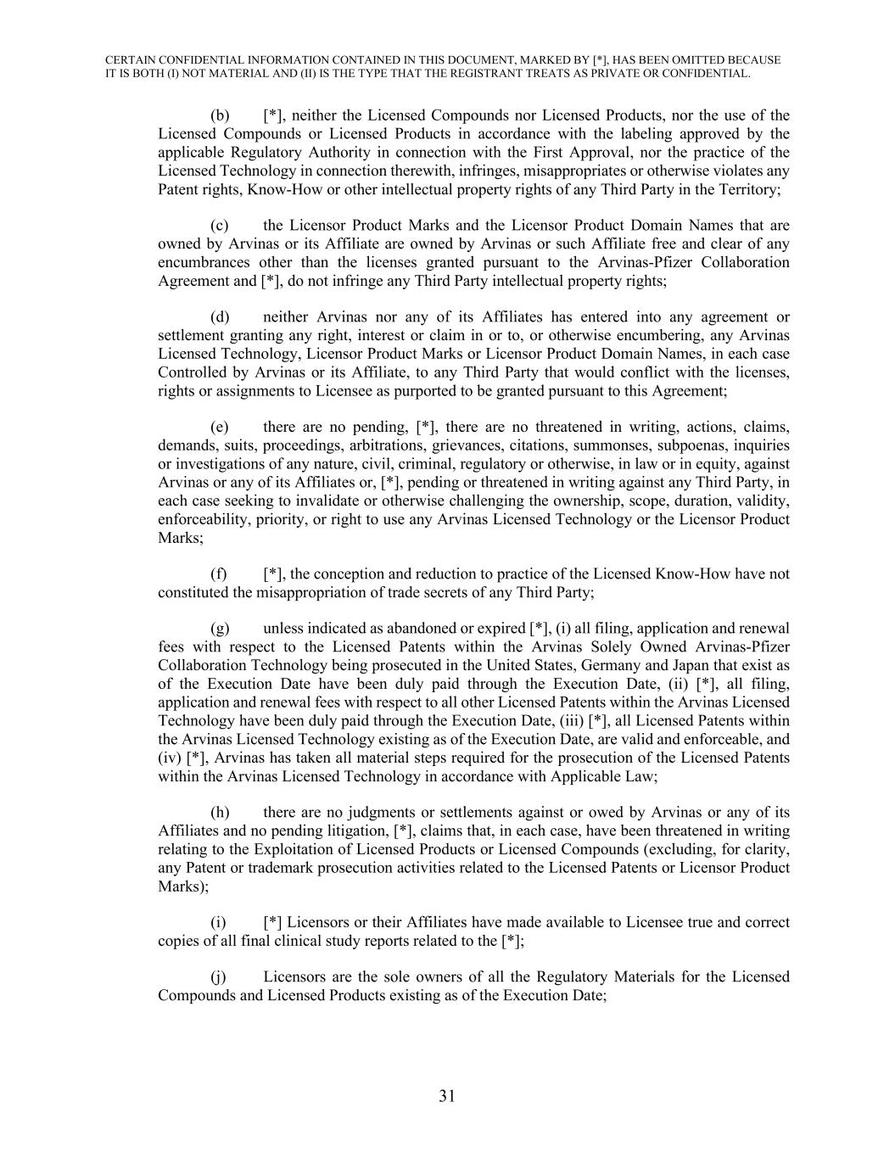
CERTAIN CONFIDENTIAL INFORMATION CONTAINED IN THIS DOCUMENT, MARKED BY [*], HAS BEEN OMITTED BECAUSE IT IS BOTH (I) NOT MATERIAL AND (II) IS THE TYPE THAT THE REGISTRANT TREATS AS PRIVATE OR CONFIDENTIAL. 31 (b) [*], neither the Licensed Compounds nor Licensed Products, nor the use of the Licensed Compounds or Licensed Products in accordance with the labeling approved by the applicable Regulatory Authority in connection with the First Approval, nor the practice of the Licensed Technology in connection therewith, infringes, misappropriates or otherwise violates any Patent rights, Know-How or other intellectual property rights of any Third Party in the Territory; (c) the Licensor Product Marks and the Licensor Product Domain Names that are owned by Arvinas or its Affiliate are owned by Arvinas or such Affiliate free and clear of any encumbrances other than the licenses granted pursuant to the Arvinas-Pfizer Collaboration Agreement and [*], do not infringe any Third Party intellectual property rights; (d) neither Arvinas nor any of its Affiliates has entered into any agreement or settlement granting any right, interest or claim in or to, or otherwise encumbering, any Arvinas Licensed Technology, Licensor Product Marks or Licensor Product Domain Names, in each case Controlled by Arvinas or its Affiliate, to any Third Party that would conflict with the licenses, rights or assignments to Licensee as purported to be granted pursuant to this Agreement; (e) there are no pending, [*], there are no threatened in writing, actions, claims, demands, suits, proceedings, arbitrations, grievances, citations, summonses, subpoenas, inquiries or investigations of any nature, civil, criminal, regulatory or otherwise, in law or in equity, against Arvinas or any of its Affiliates or, [*], pending or threatened in writing against any Third Party, in each case seeking to invalidate or otherwise challenging the ownership, scope, duration, validity, enforceability, priority, or right to use any Arvinas Licensed Technology or the Licensor Product Marks; (f) [*], the conception and reduction to practice of the Licensed Know-How have not constituted the misappropriation of trade secrets of any Third Party; (g) unless indicated as abandoned or expired [*], (i) all filing, application and renewal fees with respect to the Licensed Patents within the Arvinas Solely Owned Arvinas-Pfizer Collaboration Technology being prosecuted in the United States, Germany and Japan that exist as of the Execution Date have been duly paid through the Execution Date, (ii) [*], all filing, application and renewal fees with respect to all other Licensed Patents within the Arvinas Licensed Technology have been duly paid through the Execution Date, (iii) [*], all Licensed Patents within the Arvinas Licensed Technology existing as of the Execution Date, are valid and enforceable, and (iv) [*], Arvinas has taken all material steps required for the prosecution of the Licensed Patents within the Arvinas Licensed Technology in accordance with Applicable Law; (h) there are no judgments or settlements against or owed by Arvinas or any of its Affiliates and no pending litigation, [*], claims that, in each case, have been threatened in writing relating to the Exploitation of Licensed Products or Licensed Compounds (excluding, for clarity, any Patent or trademark prosecution activities related to the Licensed Patents or Licensor Product Marks); (i) [*] Licensors or their Affiliates have made available to Licensee true and correct copies of all final clinical study reports related to the [*]; (j) Licensors are the sole owners of all the Regulatory Materials for the Licensed Compounds and Licensed Products existing as of the Execution Date;

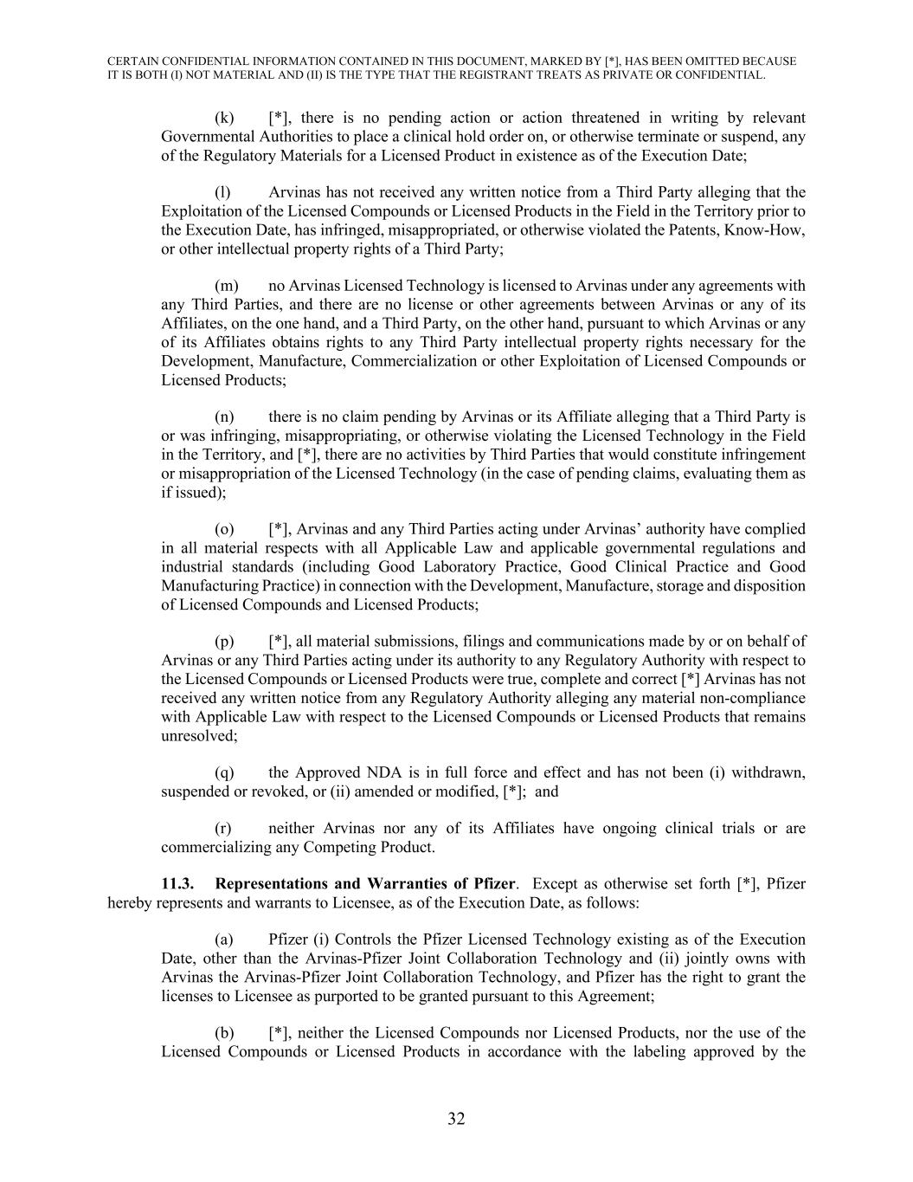
CERTAIN CONFIDENTIAL INFORMATION CONTAINED IN THIS DOCUMENT, MARKED BY [*], HAS BEEN OMITTED BECAUSE IT IS BOTH (I) NOT MATERIAL AND (II) IS THE TYPE THAT THE REGISTRANT TREATS AS PRIVATE OR CONFIDENTIAL. 32 (k) [*], there is no pending action or action threatened in writing by relevant Governmental Authorities to place a clinical hold order on, or otherwise terminate or suspend, any of the Regulatory Materials for a Licensed Product in existence as of the Execution Date; (l) Arvinas has not received any written notice from a Third Party alleging that the Exploitation of the Licensed Compounds or Licensed Products in the Field in the Territory prior to the Execution Date, has infringed, misappropriated, or otherwise violated the Patents, Know-How, or other intellectual property rights of a Third Party; (m) no Arvinas Licensed Technology is licensed to Arvinas under any agreements with any Third Parties, and there are no license or other agreements between Arvinas or any of its Affiliates, on the one hand, and a Third Party, on the other hand, pursuant to which Arvinas or any of its Affiliates obtains rights to any Third Party intellectual property rights necessary for the Development, Manufacture, Commercialization or other Exploitation of Licensed Compounds or Licensed Products; (n) there is no claim pending by Arvinas or its Affiliate alleging that a Third Party is or was infringing, misappropriating, or otherwise violating the Licensed Technology in the Field in the Territory, and [*], there are no activities by Third Parties that would constitute infringement or misappropriation of the Licensed Technology (in the case of pending claims, evaluating them as if issued); (o) [*], Arvinas and any Third Parties acting under Arvinas’ authority have complied in all material respects with all Applicable Law and applicable governmental regulations and industrial standards (including Good Laboratory Practice, Good Clinical Practice and Good Manufacturing Practice) in connection with the Development, Manufacture, storage and disposition of Licensed Compounds and Licensed Products; (p) [*], all material submissions, filings and communications made by or on behalf of Arvinas or any Third Parties acting under its authority to any Regulatory Authority with respect to the Licensed Compounds or Licensed Products were true, complete and correct [*] Arvinas has not received any written notice from any Regulatory Authority alleging any material non-compliance with Applicable Law with respect to the Licensed Compounds or Licensed Products that remains unresolved; (q) the Approved NDA is in full force and effect and has not been (i) withdrawn, suspended or revoked, or (ii) amended or modified, [*]; and (r) neither Arvinas nor any of its Affiliates have ongoing clinical trials or are commercializing any Competing Product. 11.3. Representations and Warranties of Pfizer. Except as otherwise set forth [*], Pfizer hereby represents and warrants to Licensee, as of the Execution Date, as follows: (a) Pfizer (i) Controls the Pfizer Licensed Technology existing as of the Execution Date, other than the Arvinas-Pfizer Joint Collaboration Technology and (ii) jointly owns with Arvinas the Arvinas-Pfizer Joint Collaboration Technology, and Pfizer has the right to grant the licenses to Licensee as purported to be granted pursuant to this Agreement; (b) [*], neither the Licensed Compounds nor Licensed Products, nor the use of the Licensed Compounds or Licensed Products in accordance with the labeling approved by the

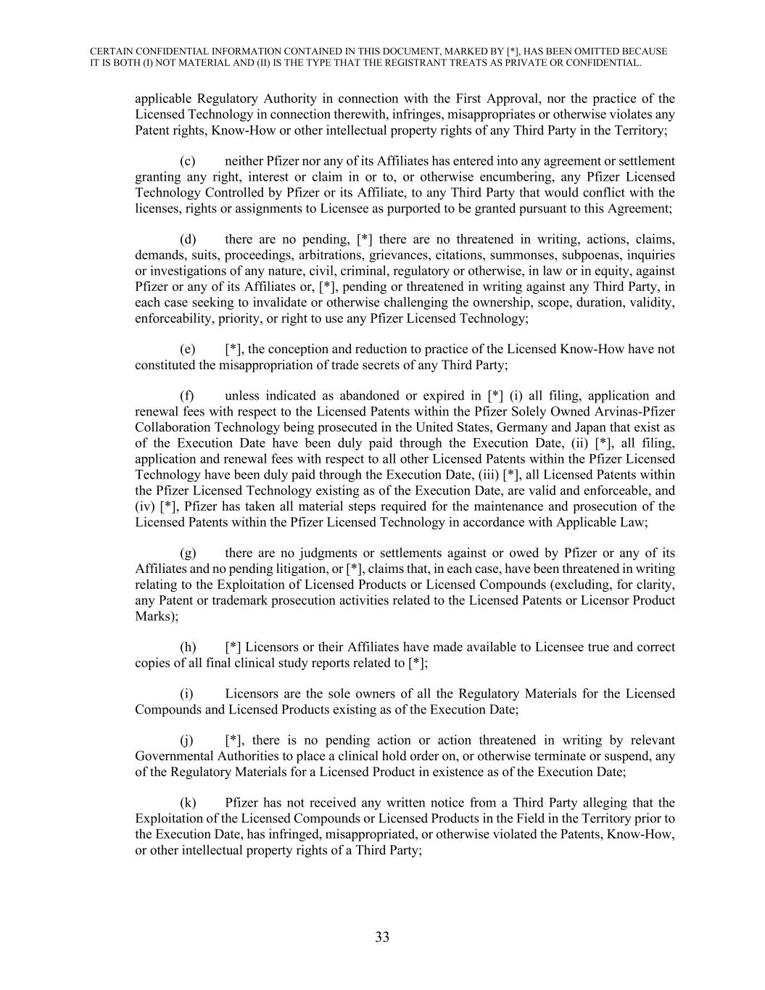
CERTAIN CONFIDENTIAL INFORMATION CONTAINED IN THIS DOCUMENT, MARKED BY [*], HAS BEEN OMITTED BECAUSE IT IS BOTH (I) NOT MATERIAL AND (II) IS THE TYPE THAT THE REGISTRANT TREATS AS PRIVATE OR CONFIDENTIAL. 33 applicable Regulatory Authority in connection with the First Approval, nor the practice of the Licensed Technology in connection therewith, infringes, misappropriates or otherwise violates any Patent rights, Know-How or other intellectual property rights of any Third Party in the Territory; (c) neither Pfizer nor any of its Affiliates has entered into any agreement or settlement granting any right, interest or claim in or to, or otherwise encumbering, any Pfizer Licensed Technology Controlled by Pfizer or its Affiliate, to any Third Party that would conflict with the licenses, rights or assignments to Licensee as purported to be granted pursuant to this Agreement; (d) there are no pending, [*] there are no threatened in writing, actions, claims, demands, suits, proceedings, arbitrations, grievances, citations, summonses, subpoenas, inquiries or investigations of any nature, civil, criminal, regulatory or otherwise, in law or in equity, against Pfizer or any of its Affiliates or, [*], pending or threatened in writing against any Third Party, in each case seeking to invalidate or otherwise challenging the ownership, scope, duration, validity, enforceability, priority, or right to use any Pfizer Licensed Technology; (e) [*], the conception and reduction to practice of the Licensed Know-How have not constituted the misappropriation of trade secrets of any Third Party; (f) unless indicated as abandoned or expired in [*] (i) all filing, application and renewal fees with respect to the Licensed Patents within the Pfizer Solely Owned Arvinas-Pfizer Collaboration Technology being prosecuted in the United States, Germany and Japan that exist as of the Execution Date have been duly paid through the Execution Date, (ii) [*], all filing, application and renewal fees with respect to all other Licensed Patents within the Pfizer Licensed Technology have been duly paid through the Execution Date, (iii) [*], all Licensed Patents within the Pfizer Licensed Technology existing as of the Execution Date, are valid and enforceable, and (iv) [*], Pfizer has taken all material steps required for the maintenance and prosecution of the Licensed Patents within the Pfizer Licensed Technology in accordance with Applicable Law; (g) there are no judgments or settlements against or owed by Pfizer or any of its Affiliates and no pending litigation, or [*], claims that, in each case, have been threatened in writing relating to the Exploitation of Licensed Products or Licensed Compounds (excluding, for clarity, any Patent or trademark prosecution activities related to the Licensed Patents or Licensor Product Marks); (h) [*] Licensors or their Affiliates have made available to Licensee true and correct copies of all final clinical study reports related to [*]; (i) Licensors are the sole owners of all the Regulatory Materials for the Licensed Compounds and Licensed Products existing as of the Execution Date; (j) [*], there is no pending action or action threatened in writing by relevant Governmental Authorities to place a clinical hold order on, or otherwise terminate or suspend, any of the Regulatory Materials for a Licensed Product in existence as of the Execution Date; (k) Pfizer has not received any written notice from a Third Party alleging that the Exploitation of the Licensed Compounds or Licensed Products in the Field in the Territory prior to the Execution Date, has infringed, misappropriated, or otherwise violated the Patents, Know-How, or other intellectual property rights of a Third Party;

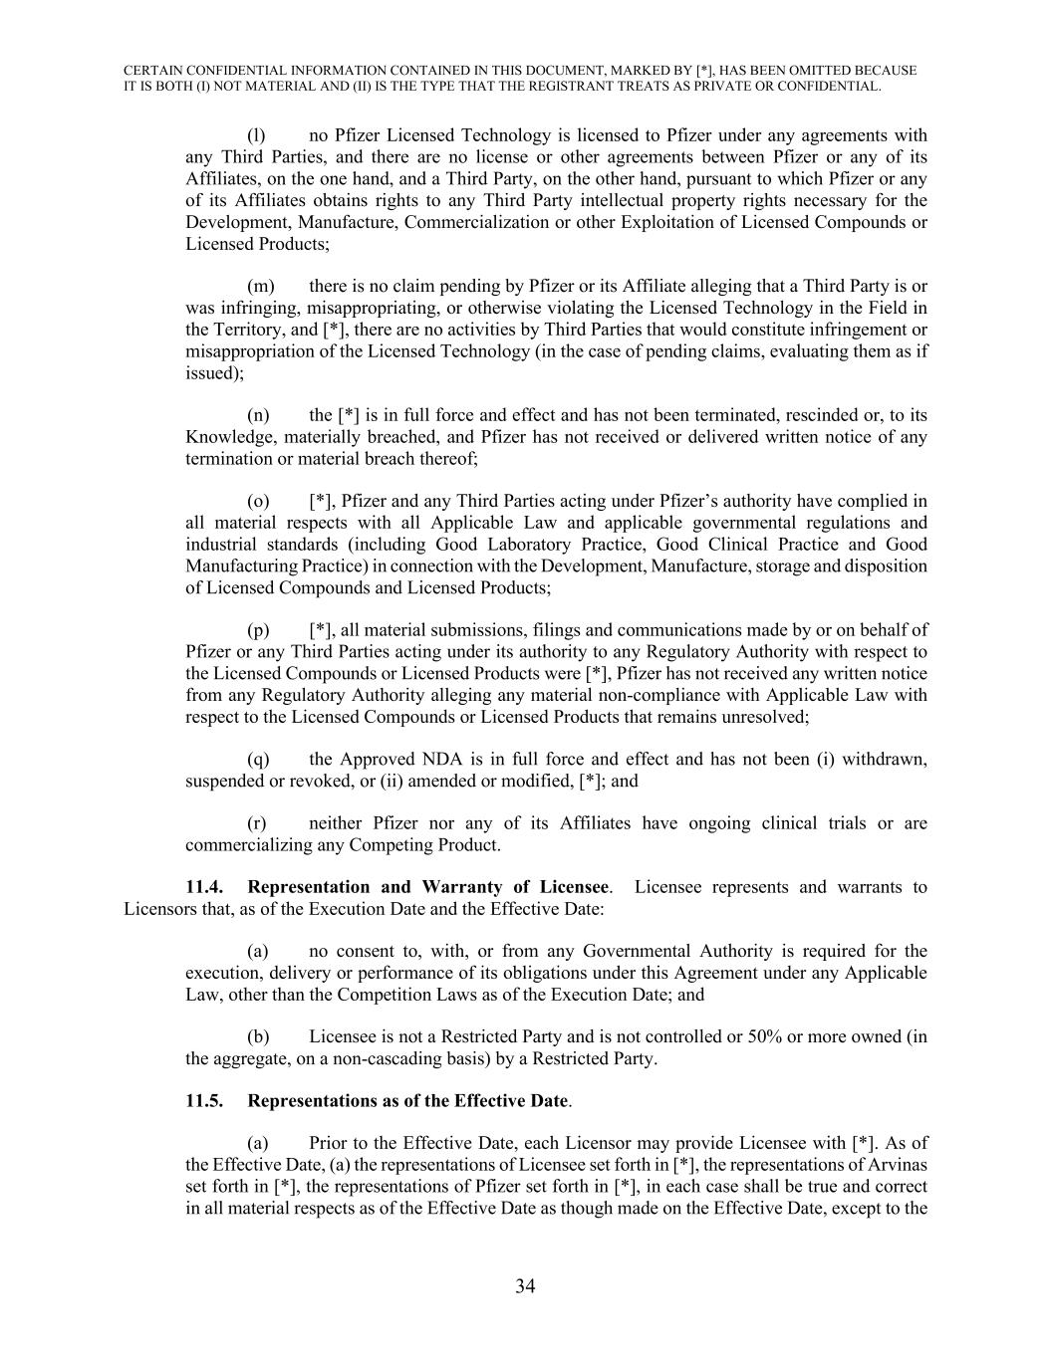
CERTAIN CONFIDENTIAL INFORMATION CONTAINED IN THIS DOCUMENT, MARKED BY [*], HAS BEEN OMITTED BECAUSE IT IS BOTH (I) NOT MATERIAL AND (II) IS THE TYPE THAT THE REGISTRANT TREATS AS PRIVATE OR CONFIDENTIAL. 34 (l) no Pfizer Licensed Technology is licensed to Pfizer under any agreements with any Third Parties, and there are no license or other agreements between Pfizer or any of its Affiliates, on the one hand, and a Third Party, on the other hand, pursuant to which Pfizer or any of its Affiliates obtains rights to any Third Party intellectual property rights necessary for the Development, Manufacture, Commercialization or other Exploitation of Licensed Compounds or Licensed Products; (m) there is no claim pending by Pfizer or its Affiliate alleging that a Third Party is or was infringing, misappropriating, or otherwise violating the Licensed Technology in the Field in the Territory, and [*], there are no activities by Third Parties that would constitute infringement or misappropriation of the Licensed Technology (in the case of pending claims, evaluating them as if issued); (n) the [*] is in full force and effect and has not been terminated, rescinded or, to its Knowledge, materially breached, and Pfizer has not received or delivered written notice of any termination or material breach thereof; (o) [*], Pfizer and any Third Parties acting under Pfizer’s authority have complied in all material respects with all Applicable Law and applicable governmental regulations and industrial standards (including Good Laboratory Practice, Good Clinical Practice and Good Manufacturing Practice) in connection with the Development, Manufacture, storage and disposition of Licensed Compounds and Licensed Products; (p) [*], all material submissions, filings and communications made by or on behalf of Pfizer or any Third Parties acting under its authority to any Regulatory Authority with respect to the Licensed Compounds or Licensed Products were [*], Pfizer has not received any written notice from any Regulatory Authority alleging any material non-compliance with Applicable Law with respect to the Licensed Compounds or Licensed Products that remains unresolved; (q) the Approved NDA is in full force and effect and has not been (i) withdrawn, suspended or revoked, or (ii) amended or modified, [*]; and (r) neither Pfizer nor any of its Affiliates have ongoing clinical trials or are commercializing any Competing Product. 11.4. Representation and Warranty of Licensee. Licensee represents and warrants to Licensors that, as of the Execution Date and the Effective Date: (a) no consent to, with, or from any Governmental Authority is required for the execution, delivery or performance of its obligations under this Agreement under any Applicable Law, other than the Competition Laws as of the Execution Date; and (b) Licensee is not a Restricted Party and is not controlled or 50% or more owned (in the aggregate, on a non-cascading basis) by a Restricted Party. 11.5. Representations as of the Effective Date. (a) Prior to the Effective Date, each Licensor may provide Licensee with [*]. As of the Effective Date, (a) the representations of Licensee set forth in [*], the representations of Arvinas set forth in [*], the representations of Pfizer set forth in [*], in each case shall be true and correct in all material respects as of the Effective Date as though made on the Effective Date, except to the

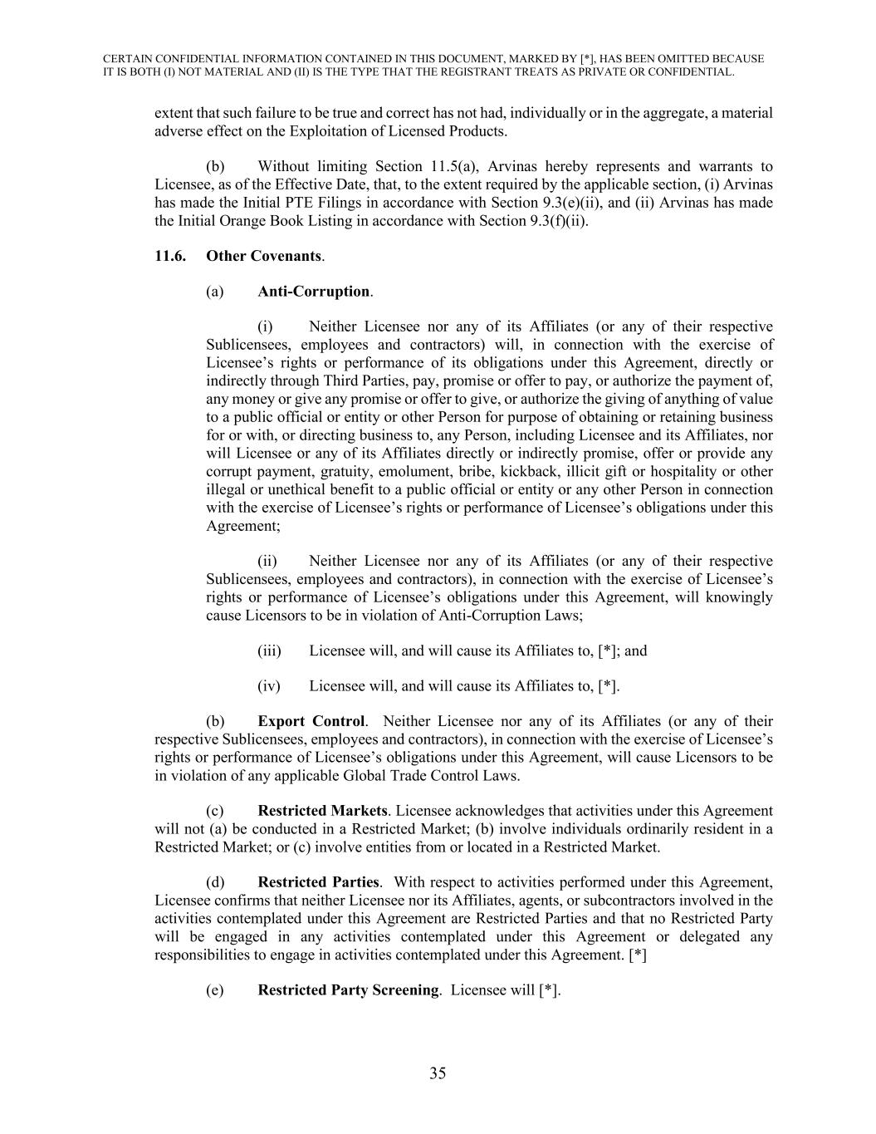
CERTAIN CONFIDENTIAL INFORMATION CONTAINED IN THIS DOCUMENT, MARKED BY [*], HAS BEEN OMITTED BECAUSE IT IS BOTH (I) NOT MATERIAL AND (II) IS THE TYPE THAT THE REGISTRANT TREATS AS PRIVATE OR CONFIDENTIAL. 35 extent that such failure to be true and correct has not had, individually or in the aggregate, a material adverse effect on the Exploitation of Licensed Products. (b) Without limiting Section 11.5(a), Arvinas hereby represents and warrants to Licensee, as of the Effective Date, that, to the extent required by the applicable section, (i) Arvinas has made the Initial PTE Filings in accordance with Section 9.3(e)(ii), and (ii) Arvinas has made the Initial Orange Book Listing in accordance with Section 9.3(f)(ii). 11.6. Other Covenants. (a) Anti-Corruption. (i) Neither Licensee nor any of its Affiliates (or any of their respective Sublicensees, employees and contractors) will, in connection with the exercise of Licensee’s rights or performance of its obligations under this Agreement, directly or indirectly through Third Parties, pay, promise or offer to pay, or authorize the payment of, any money or give any promise or offer to give, or authorize the giving of anything of value to a public official or entity or other Person for purpose of obtaining or retaining business for or with, or directing business to, any Person, including Licensee and its Affiliates, nor will Licensee or any of its Affiliates directly or indirectly promise, offer or provide any corrupt payment, gratuity, emolument, bribe, kickback, illicit gift or hospitality or other illegal or unethical benefit to a public official or entity or any other Person in connection with the exercise of Licensee’s rights or performance of Licensee’s obligations under this Agreement; (ii) Neither Licensee nor any of its Affiliates (or any of their respective Sublicensees, employees and contractors), in connection with the exercise of Licensee’s rights or performance of Licensee’s obligations under this Agreement, will knowingly cause Licensors to be in violation of Anti-Corruption Laws; (iii) Licensee will, and will cause its Affiliates to, [*]; and (iv) Licensee will, and will cause its Affiliates to, [*]. (b) Export Control. Neither Licensee nor any of its Affiliates (or any of their respective Sublicensees, employees and contractors), in connection with the exercise of Licensee’s rights or performance of Licensee’s obligations under this Agreement, will cause Licensors to be in violation of any applicable Global Trade Control Laws. (c) Restricted Markets. Licensee acknowledges that activities under this Agreement will not (a) be conducted in a Restricted Market; (b) involve individuals ordinarily resident in a Restricted Market; or (c) involve entities from or located in a Restricted Market. (d) Restricted Parties. With respect to activities performed under this Agreement, Licensee confirms that neither Licensee nor its Affiliates, agents, or subcontractors involved in the activities contemplated under this Agreement are Restricted Parties and that no Restricted Party will be engaged in any activities contemplated under this Agreement or delegated any responsibilities to engage in activities contemplated under this Agreement. [*] (e) Restricted Party Screening. Licensee will [*].

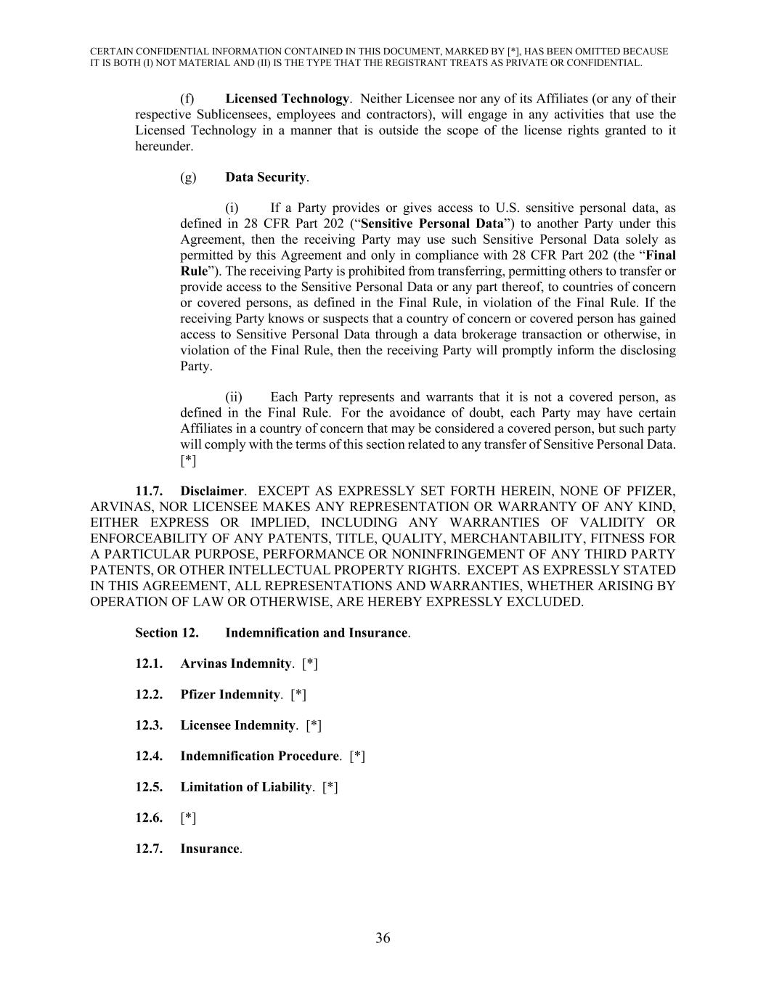
CERTAIN CONFIDENTIAL INFORMATION CONTAINED IN THIS DOCUMENT, MARKED BY [*], HAS BEEN OMITTED BECAUSE IT IS BOTH (I) NOT MATERIAL AND (II) IS THE TYPE THAT THE REGISTRANT TREATS AS PRIVATE OR CONFIDENTIAL. 36 (f) Licensed Technology. Neither Licensee nor any of its Affiliates (or any of their respective Sublicensees, employees and contractors), will engage in any activities that use the Licensed Technology in a manner that is outside the scope of the license rights granted to it hereunder. (g) Data Security. (i) If a Party provides or gives access to U.S. sensitive personal data, as defined in 28 CFR Part 202 (“Sensitive Personal Data”) to another Party under this Agreement, then the receiving Party may use such Sensitive Personal Data solely as permitted by this Agreement and only in compliance with 28 CFR Part 202 (the “Final Rule”). The receiving Party is prohibited from transferring, permitting others to transfer or provide access to the Sensitive Personal Data or any part thereof, to countries of concern or covered persons, as defined in the Final Rule, in violation of the Final Rule. If the receiving Party knows or suspects that a country of concern or covered person has gained access to Sensitive Personal Data through a data brokerage transaction or otherwise, in violation of the Final Rule, then the receiving Party will promptly inform the disclosing Party. (ii) Each Party represents and warrants that it is not a covered person, as defined in the Final Rule. For the avoidance of doubt, each Party may have certain Affiliates in a country of concern that may be considered a covered person, but such party will comply with the terms of this section related to any transfer of Sensitive Personal Data. [*] 11.7. Disclaimer. EXCEPT AS EXPRESSLY SET FORTH HEREIN, NONE OF PFIZER, ARVINAS, NOR LICENSEE MAKES ANY REPRESENTATION OR WARRANTY OF ANY KIND, EITHER EXPRESS OR IMPLIED, INCLUDING ANY WARRANTIES OF VALIDITY OR ENFORCEABILITY OF ANY PATENTS, TITLE, QUALITY, MERCHANTABILITY, FITNESS FOR A PARTICULAR PURPOSE, PERFORMANCE OR NONINFRINGEMENT OF ANY THIRD PARTY PATENTS, OR OTHER INTELLECTUAL PROPERTY RIGHTS. EXCEPT AS EXPRESSLY STATED IN THIS AGREEMENT, ALL REPRESENTATIONS AND WARRANTIES, WHETHER ARISING BY OPERATION OF LAW OR OTHERWISE, ARE HEREBY EXPRESSLY EXCLUDED. Section 12. Indemnification and Insurance. 12.1. Arvinas Indemnity. [*] 12.2. Pfizer Indemnity. [*] 12.3. Licensee Indemnity. [*] 12.4. Indemnification Procedure. [*] 12.5. Limitation of Liability. [*] 12.6. [*] 12.7. Insurance.

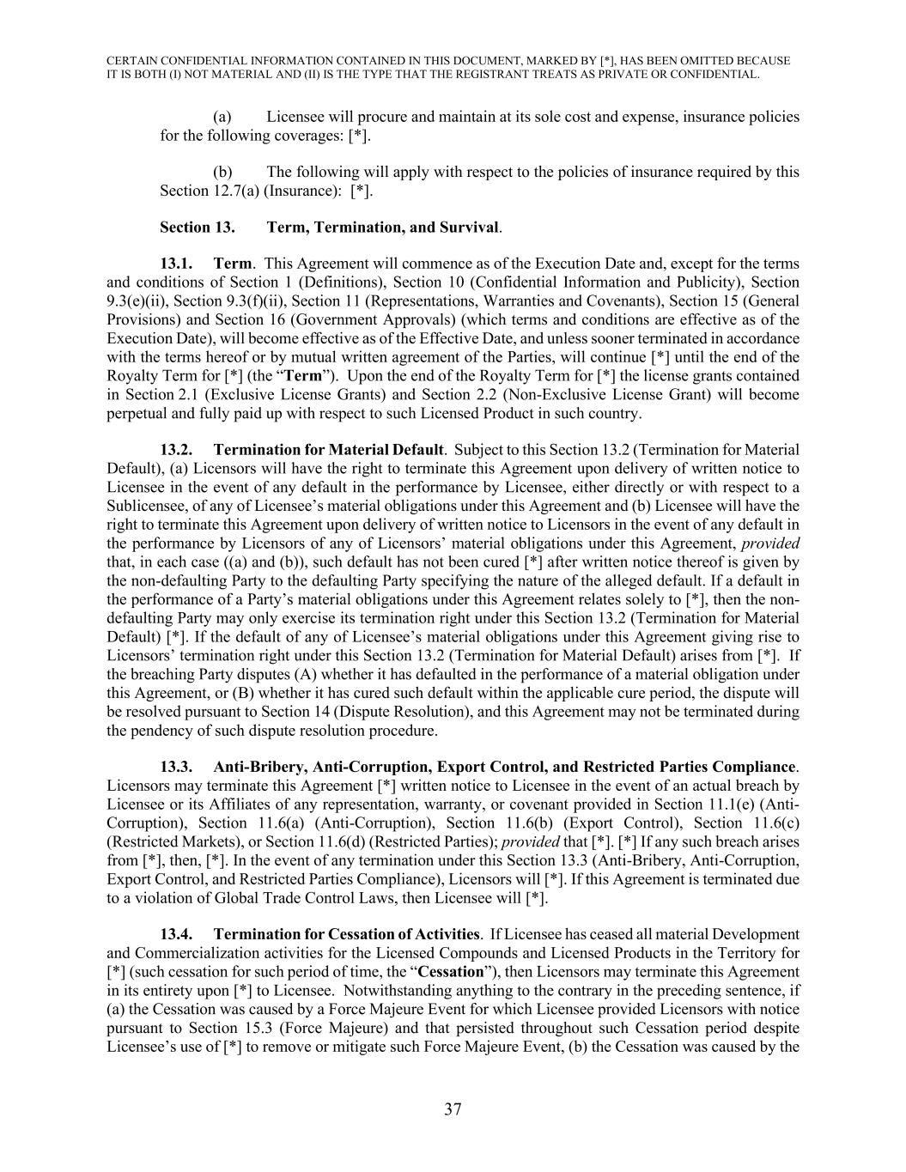
CERTAIN CONFIDENTIAL INFORMATION CONTAINED IN THIS DOCUMENT, MARKED BY [*], HAS BEEN OMITTED BECAUSE IT IS BOTH (I) NOT MATERIAL AND (II) IS THE TYPE THAT THE REGISTRANT TREATS AS PRIVATE OR CONFIDENTIAL. 37 (a) Licensee will procure and maintain at its sole cost and expense, insurance policies for the following coverages: [*]. (b) The following will apply with respect to the policies of insurance required by this Section 12.7(a) (Insurance): [*]. Section 13. Term, Termination, and Survival. 13.1. Term. This Agreement will commence as of the Execution Date and, except for the terms and conditions of Section 1 (Definitions), Section 10 (Confidential Information and Publicity), Section 9.3(e)(ii), Section 9.3(f)(ii), Section 11 (Representations, Warranties and Covenants), Section 15 (General Provisions) and Section 16 (Government Approvals) (which terms and conditions are effective as of the Execution Date), will become effective as of the Effective Date, and unless sooner terminated in accordance with the terms hereof or by mutual written agreement of the Parties, will continue [*] until the end of the Royalty Term for [*] (the “Term”). Upon the end of the Royalty Term for [*] the license grants contained in Section 2.1 (Exclusive License Grants) and Section 2.2 (Non-Exclusive License Grant) will become perpetual and fully paid up with respect to such Licensed Product in such country. 13.2. Termination for Material Default. Subject to this Section 13.2 (Termination for Material Default), (a) Licensors will have the right to terminate this Agreement upon delivery of written notice to Licensee in the event of any default in the performance by Licensee, either directly or with respect to a Sublicensee, of any of Licensee’s material obligations under this Agreement and (b) Licensee will have the right to terminate this Agreement upon delivery of written notice to Licensors in the event of any default in the performance by Licensors of any of Licensors’ material obligations under this Agreement, provided that, in each case ((a) and (b)), such default has not been cured [*] after written notice thereof is given by the non-defaulting Party to the defaulting Party specifying the nature of the alleged default. If a default in the performance of a Party’s material obligations under this Agreement relates solely to [*], then the non- defaulting Party may only exercise its termination right under this Section 13.2 (Termination for Material Default) [*]. If the default of any of Licensee’s material obligations under this Agreement giving rise to Licensors’ termination right under this Section 13.2 (Termination for Material Default) arises from [*]. If the breaching Party disputes (A) whether it has defaulted in the performance of a material obligation under this Agreement, or (B) whether it has cured such default within the applicable cure period, the dispute will be resolved pursuant to Section 14 (Dispute Resolution), and this Agreement may not be terminated during the pendency of such dispute resolution procedure. 13.3. Anti-Bribery, Anti-Corruption, Export Control, and Restricted Parties Compliance. Licensors may terminate this Agreement [*] written notice to Licensee in the event of an actual breach by Licensee or its Affiliates of any representation, warranty, or covenant provided in Section 11.1(e) (Anti- Corruption), Section 11.6(a) (Anti-Corruption), Section 11.6(b) (Export Control), Section 11.6(c) (Restricted Markets), or Section 11.6(d) (Restricted Parties); provided that [*]. [*] If any such breach arises from [*], then, [*]. In the event of any termination under this Section 13.3 (Anti-Bribery, Anti-Corruption, Export Control, and Restricted Parties Compliance), Licensors will [*]. If this Agreement is terminated due to a violation of Global Trade Control Laws, then Licensee will [*]. 13.4. Termination for Cessation of Activities. If Licensee has ceased all material Development and Commercialization activities for the Licensed Compounds and Licensed Products in the Territory for [*] (such cessation for such period of time, the “Cessation”), then Licensors may terminate this Agreement in its entirety upon [*] to Licensee. Notwithstanding anything to the contrary in the preceding sentence, if (a) the Cessation was caused by a Force Majeure Event for which Licensee provided Licensors with notice pursuant to Section 15.3 (Force Majeure) and that persisted throughout such Cessation period despite Licensee’s use of [*] to remove or mitigate such Force Majeure Event, (b) the Cessation was caused by the

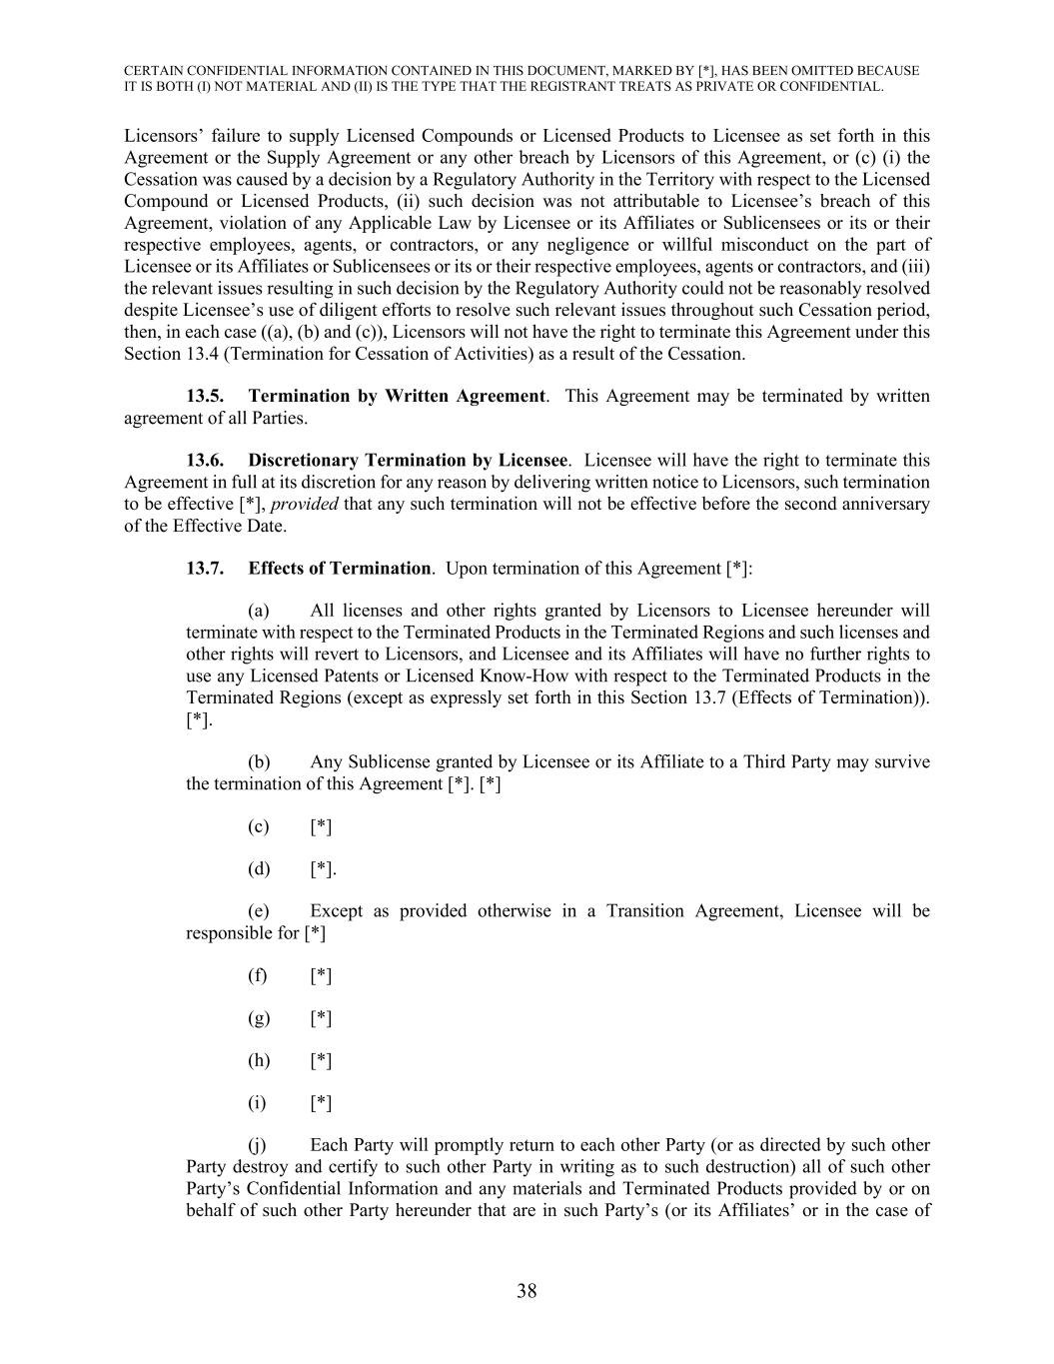
CERTAIN CONFIDENTIAL INFORMATION CONTAINED IN THIS DOCUMENT, MARKED BY [*], HAS BEEN OMITTED BECAUSE IT IS BOTH (I) NOT MATERIAL AND (II) IS THE TYPE THAT THE REGISTRANT TREATS AS PRIVATE OR CONFIDENTIAL. 38 Licensors’ failure to supply Licensed Compounds or Licensed Products to Licensee as set forth in this Agreement or the Supply Agreement or any other breach by Licensors of this Agreement, or (c) (i) the Cessation was caused by a decision by a Regulatory Authority in the Territory with respect to the Licensed Compound or Licensed Products, (ii) such decision was not attributable to Licensee’s breach of this Agreement, violation of any Applicable Law by Licensee or its Affiliates or Sublicensees or its or their respective employees, agents, or contractors, or any negligence or willful misconduct on the part of Licensee or its Affiliates or Sublicensees or its or their respective employees, agents or contractors, and (iii) the relevant issues resulting in such decision by the Regulatory Authority could not be reasonably resolved despite Licensee’s use of diligent efforts to resolve such relevant issues throughout such Cessation period, then, in each case ((a), (b) and (c)), Licensors will not have the right to terminate this Agreement under this Section 13.4 (Termination for Cessation of Activities) as a result of the Cessation. 13.5. Termination by Written Agreement. This Agreement may be terminated by written agreement of all Parties. 13.6. Discretionary Termination by Licensee. Licensee will have the right to terminate this Agreement in full at its discretion for any reason by delivering written notice to Licensors, such termination to be effective [*], provided that any such termination will not be effective before the second anniversary of the Effective Date. 13.7. Effects of Termination. Upon termination of this Agreement [*]: (a) All licenses and other rights granted by Licensors to Licensee hereunder will terminate with respect to the Terminated Products in the Terminated Regions and such licenses and other rights will revert to Licensors, and Licensee and its Affiliates will have no further rights to use any Licensed Patents or Licensed Know-How with respect to the Terminated Products in the Terminated Regions (except as expressly set forth in this Section 13.7 (Effects of Termination)). [*]. (b) Any Sublicense granted by Licensee or its Affiliate to a Third Party may survive the termination of this Agreement [*]. [*] (c) [*] (d) [*]. (e) Except as provided otherwise in a Transition Agreement, Licensee will be responsible for [*] (f) [*] (g) [*] (h) [*] (i) [*] (j) Each Party will promptly return to each other Party (or as directed by such other Party destroy and certify to such other Party in writing as to such destruction) all of such other Party’s Confidential Information and any materials and Terminated Products provided by or on behalf of such other Party hereunder that are in such Party’s (or its Affiliates’ or in the case of

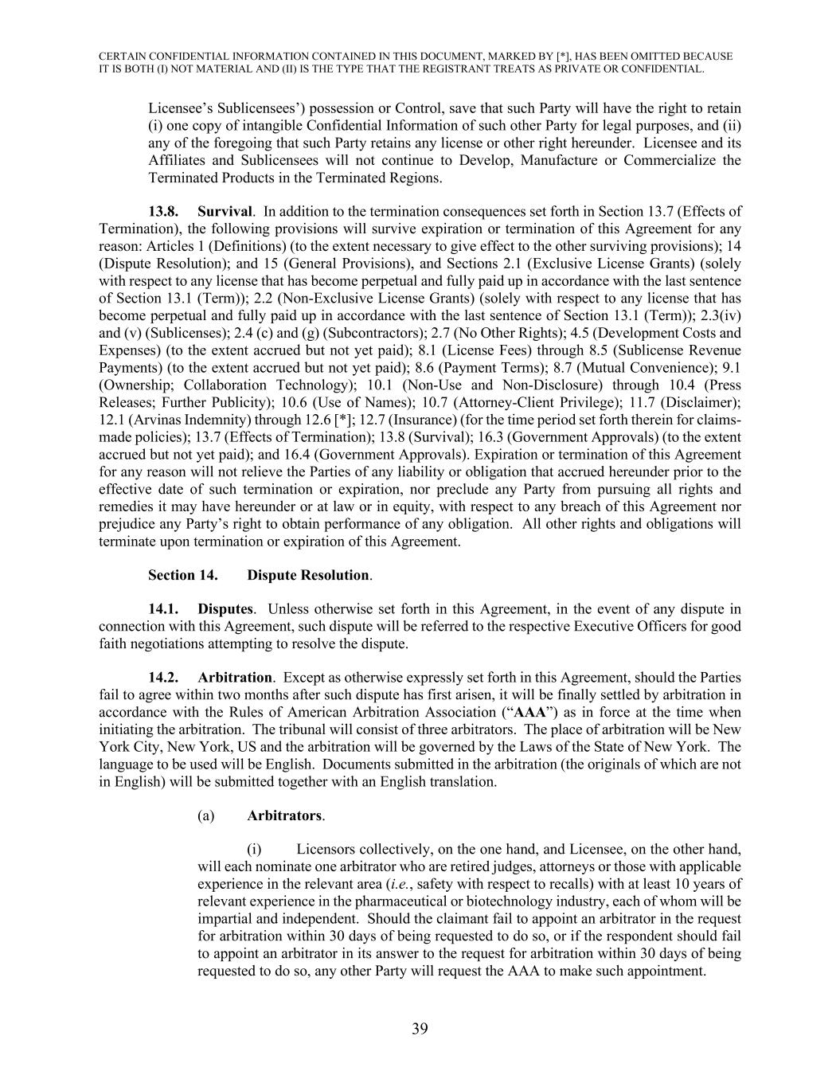
CERTAIN CONFIDENTIAL INFORMATION CONTAINED IN THIS DOCUMENT, MARKED BY [*], HAS BEEN OMITTED BECAUSE IT IS BOTH (I) NOT MATERIAL AND (II) IS THE TYPE THAT THE REGISTRANT TREATS AS PRIVATE OR CONFIDENTIAL. 39 Licensee’s Sublicensees’) possession or Control, save that such Party will have the right to retain (i) one copy of intangible Confidential Information of such other Party for legal purposes, and (ii) any of the foregoing that such Party retains any license or other right hereunder. Licensee and its Affiliates and Sublicensees will not continue to Develop, Manufacture or Commercialize the Terminated Products in the Terminated Regions. 13.8. Survival. In addition to the termination consequences set forth in Section 13.7 (Effects of Termination), the following provisions will survive expiration or termination of this Agreement for any reason: Articles 1 (Definitions) (to the extent necessary to give effect to the other surviving provisions); 14 (Dispute Resolution); and 15 (General Provisions), and Sections 2.1 (Exclusive License Grants) (solely with respect to any license that has become perpetual and fully paid up in accordance with the last sentence of Section 13.1 (Term)); 2.2 (Non-Exclusive License Grants) (solely with respect to any license that has become perpetual and fully paid up in accordance with the last sentence of Section 13.1 (Term)); 2.3(iv) and (v) (Sublicenses); 2.4 (c) and (g) (Subcontractors); 2.7 (No Other Rights); 4.5 (Development Costs and Expenses) (to the extent accrued but not yet paid); 8.1 (License Fees) through 8.5 (Sublicense Revenue Payments) (to the extent accrued but not yet paid); 8.6 (Payment Terms); 8.7 (Mutual Convenience); 9.1 (Ownership; Collaboration Technology); 10.1 (Non-Use and Non-Disclosure) through 10.4 (Press Releases; Further Publicity); 10.6 (Use of Names); 10.7 (Attorney-Client Privilege); 11.7 (Disclaimer); 12.1 (Arvinas Indemnity) through 12.6 [*]; 12.7 (Insurance) (for the time period set forth therein for claims- made policies); 13.7 (Effects of Termination); 13.8 (Survival); 16.3 (Government Approvals) (to the extent accrued but not yet paid); and 16.4 (Government Approvals). Expiration or termination of this Agreement for any reason will not relieve the Parties of any liability or obligation that accrued hereunder prior to the effective date of such termination or expiration, nor preclude any Party from pursuing all rights and remedies it may have hereunder or at law or in equity, with respect to any breach of this Agreement nor prejudice any Party’s right to obtain performance of any obligation. All other rights and obligations will terminate upon termination or expiration of this Agreement. Section 14. Dispute Resolution. 14.1. Disputes. Unless otherwise set forth in this Agreement, in the event of any dispute in connection with this Agreement, such dispute will be referred to the respective Executive Officers for good faith negotiations attempting to resolve the dispute. 14.2. Arbitration. Except as otherwise expressly set forth in this Agreement, should the Parties fail to agree within two months after such dispute has first arisen, it will be finally settled by arbitration in accordance with the Rules of American Arbitration Association (“AAA”) as in force at the time when initiating the arbitration. The tribunal will consist of three arbitrators. The place of arbitration will be New York City, New York, US and the arbitration will be governed by the Laws of the State of New York. The language to be used will be English. Documents submitted in the arbitration (the originals of which are not in English) will be submitted together with an English translation. (a) Arbitrators. (i) Licensors collectively, on the one hand, and Licensee, on the other hand, will each nominate one arbitrator who are retired judges, attorneys or those with applicable experience in the relevant area (i.e., safety with respect to recalls) with at least 10 years of relevant experience in the pharmaceutical or biotechnology industry, each of whom will be impartial and independent. Should the claimant fail to appoint an arbitrator in the request for arbitration within 30 days of being requested to do so, or if the respondent should fail to appoint an arbitrator in its answer to the request for arbitration within 30 days of being requested to do so, any other Party will request the AAA to make such appointment.

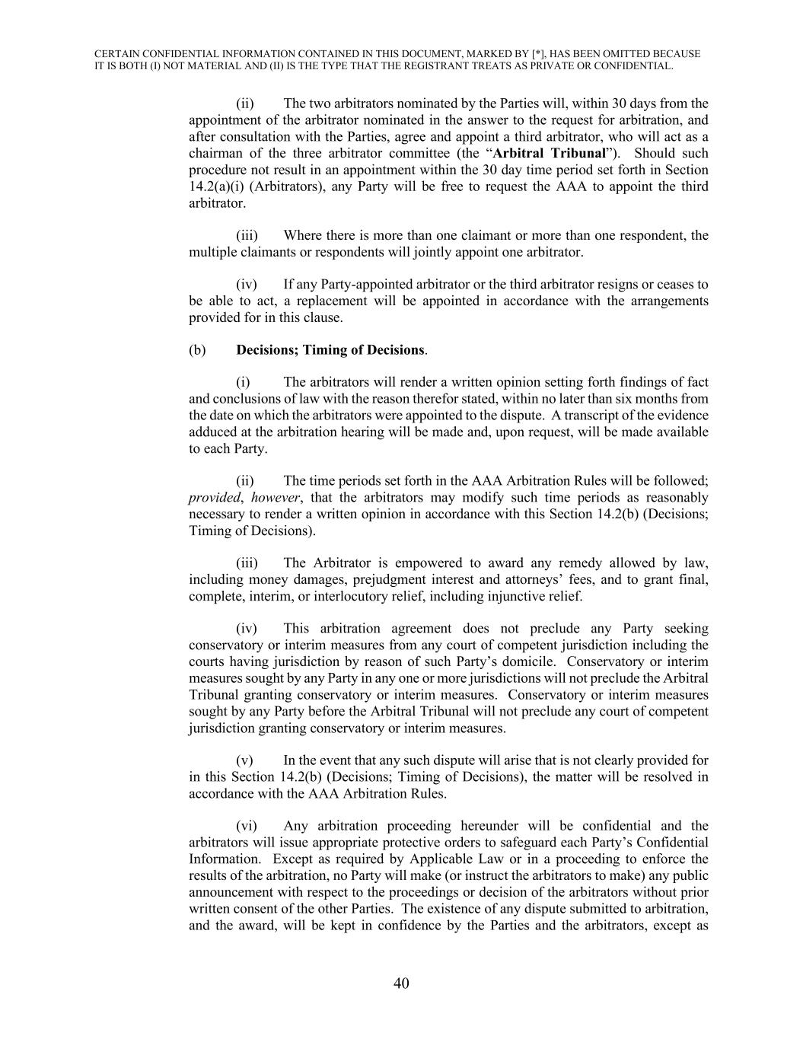
CERTAIN CONFIDENTIAL INFORMATION CONTAINED IN THIS DOCUMENT, MARKED BY [*], HAS BEEN OMITTED BECAUSE IT IS BOTH (I) NOT MATERIAL AND (II) IS THE TYPE THAT THE REGISTRANT TREATS AS PRIVATE OR CONFIDENTIAL. 40 (ii) The two arbitrators nominated by the Parties will, within 30 days from the appointment of the arbitrator nominated in the answer to the request for arbitration, and after consultation with the Parties, agree and appoint a third arbitrator, who will act as a chairman of the three arbitrator committee (the “Arbitral Tribunal”). Should such procedure not result in an appointment within the 30 day time period set forth in Section 14.2(a)(i) (Arbitrators), any Party will be free to request the AAA to appoint the third arbitrator. (iii) Where there is more than one claimant or more than one respondent, the multiple claimants or respondents will jointly appoint one arbitrator. (iv) If any Party-appointed arbitrator or the third arbitrator resigns or ceases to be able to act, a replacement will be appointed in accordance with the arrangements provided for in this clause. (b) Decisions; Timing of Decisions. (i) The arbitrators will render a written opinion setting forth findings of fact and conclusions of law with the reason therefor stated, within no later than six months from the date on which the arbitrators were appointed to the dispute. A transcript of the evidence adduced at the arbitration hearing will be made and, upon request, will be made available to each Party. (ii) The time periods set forth in the AAA Arbitration Rules will be followed; provided, however, that the arbitrators may modify such time periods as reasonably necessary to render a written opinion in accordance with this Section 14.2(b) (Decisions; Timing of Decisions). (iii) The Arbitrator is empowered to award any remedy allowed by law, including money damages, prejudgment interest and attorneys’ fees, and to grant final, complete, interim, or interlocutory relief, including injunctive relief. (iv) This arbitration agreement does not preclude any Party seeking conservatory or interim measures from any court of competent jurisdiction including the courts having jurisdiction by reason of such Party’s domicile. Conservatory or interim measures sought by any Party in any one or more jurisdictions will not preclude the Arbitral Tribunal granting conservatory or interim measures. Conservatory or interim measures sought by any Party before the Arbitral Tribunal will not preclude any court of competent jurisdiction granting conservatory or interim measures. (v) In the event that any such dispute will arise that is not clearly provided for in this Section 14.2(b) (Decisions; Timing of Decisions), the matter will be resolved in accordance with the AAA Arbitration Rules. (vi) Any arbitration proceeding hereunder will be confidential and the arbitrators will issue appropriate protective orders to safeguard each Party’s Confidential Information. Except as required by Applicable Law or in a proceeding to enforce the results of the arbitration, no Party will make (or instruct the arbitrators to make) any public announcement with respect to the proceedings or decision of the arbitrators without prior written consent of the other Parties. The existence of any dispute submitted to arbitration, and the award, will be kept in confidence by the Parties and the arbitrators, except as

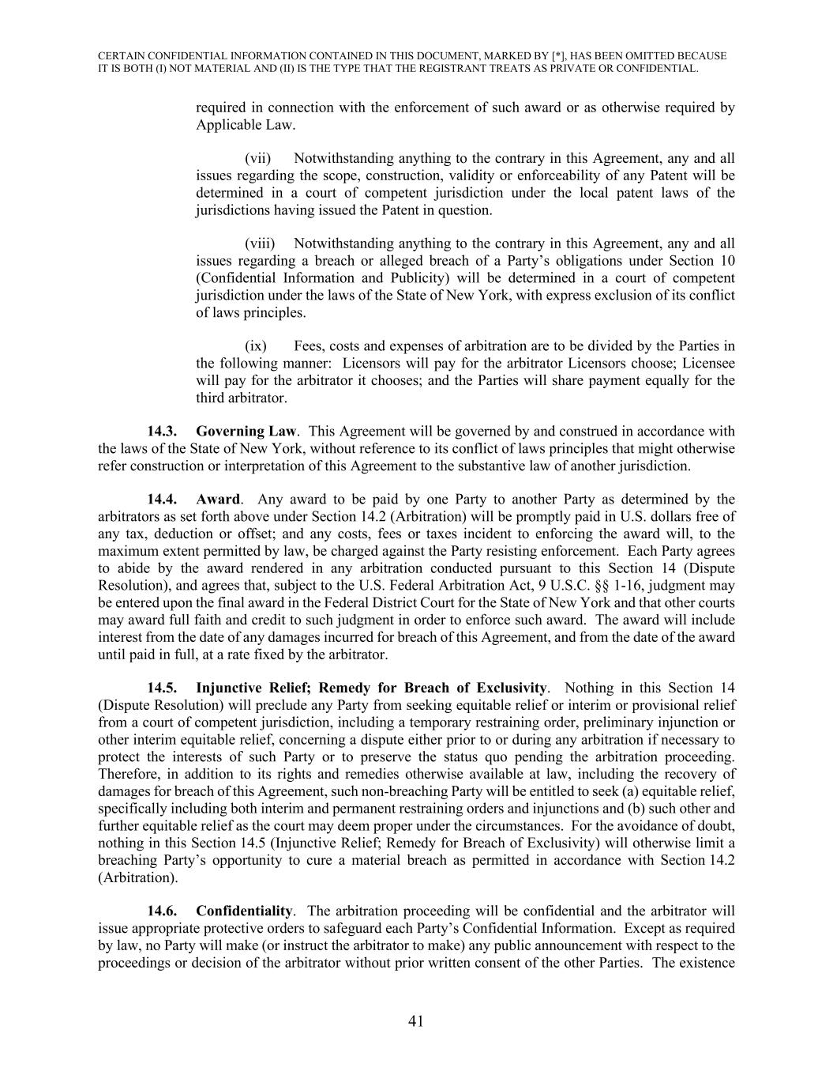
CERTAIN CONFIDENTIAL INFORMATION CONTAINED IN THIS DOCUMENT, MARKED BY [*], HAS BEEN OMITTED BECAUSE IT IS BOTH (I) NOT MATERIAL AND (II) IS THE TYPE THAT THE REGISTRANT TREATS AS PRIVATE OR CONFIDENTIAL. 41 required in connection with the enforcement of such award or as otherwise required by Applicable Law. (vii) Notwithstanding anything to the contrary in this Agreement, any and all issues regarding the scope, construction, validity or enforceability of any Patent will be determined in a court of competent jurisdiction under the local patent laws of the jurisdictions having issued the Patent in question. (viii) Notwithstanding anything to the contrary in this Agreement, any and all issues regarding a breach or alleged breach of a Party’s obligations under Section 10 (Confidential Information and Publicity) will be determined in a court of competent jurisdiction under the laws of the State of New York, with express exclusion of its conflict of laws principles. (ix) Fees, costs and expenses of arbitration are to be divided by the Parties in the following manner: Licensors will pay for the arbitrator Licensors choose; Licensee will pay for the arbitrator it chooses; and the Parties will share payment equally for the third arbitrator. 14.3. Governing Law. This Agreement will be governed by and construed in accordance with the laws of the State of New York, without reference to its conflict of laws principles that might otherwise refer construction or interpretation of this Agreement to the substantive law of another jurisdiction. 14.4. Award. Any award to be paid by one Party to another Party as determined by the arbitrators as set forth above under Section 14.2 (Arbitration) will be promptly paid in U.S. dollars free of any tax, deduction or offset; and any costs, fees or taxes incident to enforcing the award will, to the maximum extent permitted by law, be charged against the Party resisting enforcement. Each Party agrees to abide by the award rendered in any arbitration conducted pursuant to this Section 14 (Dispute Resolution), and agrees that, subject to the U.S. Federal Arbitration Act, 9 U.S.C. §§ 1-16, judgment may be entered upon the final award in the Federal District Court for the State of New York and that other courts may award full faith and credit to such judgment in order to enforce such award. The award will include interest from the date of any damages incurred for breach of this Agreement, and from the date of the award until paid in full, at a rate fixed by the arbitrator. 14.5. Injunctive Relief; Remedy for Breach of Exclusivity. Nothing in this Section 14 (Dispute Resolution) will preclude any Party from seeking equitable relief or interim or provisional relief from a court of competent jurisdiction, including a temporary restraining order, preliminary injunction or other interim equitable relief, concerning a dispute either prior to or during any arbitration if necessary to protect the interests of such Party or to preserve the status quo pending the arbitration proceeding. Therefore, in addition to its rights and remedies otherwise available at law, including the recovery of damages for breach of this Agreement, such non-breaching Party will be entitled to seek (a) equitable relief, specifically including both interim and permanent restraining orders and injunctions and (b) such other and further equitable relief as the court may deem proper under the circumstances. For the avoidance of doubt, nothing in this Section 14.5 (Injunctive Relief; Remedy for Breach of Exclusivity) will otherwise limit a breaching Party’s opportunity to cure a material breach as permitted in accordance with Section 14.2 (Arbitration). 14.6. Confidentiality. The arbitration proceeding will be confidential and the arbitrator will issue appropriate protective orders to safeguard each Party’s Confidential Information. Except as required by law, no Party will make (or instruct the arbitrator to make) any public announcement with respect to the proceedings or decision of the arbitrator without prior written consent of the other Parties. The existence

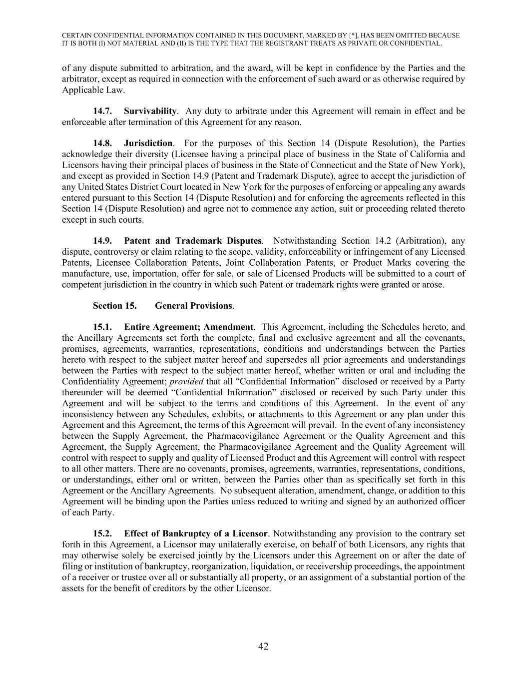
CERTAIN CONFIDENTIAL INFORMATION CONTAINED IN THIS DOCUMENT, MARKED BY [*], HAS BEEN OMITTED BECAUSE IT IS BOTH (I) NOT MATERIAL AND (II) IS THE TYPE THAT THE REGISTRANT TREATS AS PRIVATE OR CONFIDENTIAL. 42 of any dispute submitted to arbitration, and the award, will be kept in confidence by the Parties and the arbitrator, except as required in connection with the enforcement of such award or as otherwise required by Applicable Law. 14.7. Survivability. Any duty to arbitrate under this Agreement will remain in effect and be enforceable after termination of this Agreement for any reason. 14.8. Jurisdiction. For the purposes of this Section 14 (Dispute Resolution), the Parties acknowledge their diversity (Licensee having a principal place of business in the State of California and Licensors having their principal places of business in the State of Connecticut and the State of New York), and except as provided in Section 14.9 (Patent and Trademark Dispute), agree to accept the jurisdiction of any United States District Court located in New York for the purposes of enforcing or appealing any awards entered pursuant to this Section 14 (Dispute Resolution) and for enforcing the agreements reflected in this Section 14 (Dispute Resolution) and agree not to commence any action, suit or proceeding related thereto except in such courts. 14.9. Patent and Trademark Disputes. Notwithstanding Section 14.2 (Arbitration), any dispute, controversy or claim relating to the scope, validity, enforceability or infringement of any Licensed Patents, Licensee Collaboration Patents, Joint Collaboration Patents, or Product Marks covering the manufacture, use, importation, offer for sale, or sale of Licensed Products will be submitted to a court of competent jurisdiction in the country in which such Patent or trademark rights were granted or arose. Section 15. General Provisions. 15.1. Entire Agreement; Amendment. This Agreement, including the Schedules hereto, and the Ancillary Agreements set forth the complete, final and exclusive agreement and all the covenants, promises, agreements, warranties, representations, conditions and understandings between the Parties hereto with respect to the subject matter hereof and supersedes all prior agreements and understandings between the Parties with respect to the subject matter hereof, whether written or oral and including the Confidentiality Agreement; provided that all “Confidential Information” disclosed or received by a Party thereunder will be deemed “Confidential Information” disclosed or received by such Party under this Agreement and will be subject to the terms and conditions of this Agreement. In the event of any inconsistency between any Schedules, exhibits, or attachments to this Agreement or any plan under this Agreement and this Agreement, the terms of this Agreement will prevail. In the event of any inconsistency between the Supply Agreement, the Pharmacovigilance Agreement or the Quality Agreement and this Agreement, the Supply Agreement, the Pharmacovigilance Agreement and the Quality Agreement will control with respect to supply and quality of Licensed Product and this Agreement will control with respect to all other matters. There are no covenants, promises, agreements, warranties, representations, conditions, or understandings, either oral or written, between the Parties other than as specifically set forth in this Agreement or the Ancillary Agreements. No subsequent alteration, amendment, change, or addition to this Agreement will be binding upon the Parties unless reduced to writing and signed by an authorized officer of each Party. 15.2. Effect of Bankruptcy of a Licensor. Notwithstanding any provision to the contrary set forth in this Agreement, a Licensor may unilaterally exercise, on behalf of both Licensors, any rights that may otherwise solely be exercised jointly by the Licensors under this Agreement on or after the date of filing or institution of bankruptcy, reorganization, liquidation, or receivership proceedings, the appointment of a receiver or trustee over all or substantially all property, or an assignment of a substantial portion of the assets for the benefit of creditors by the other Licensor.

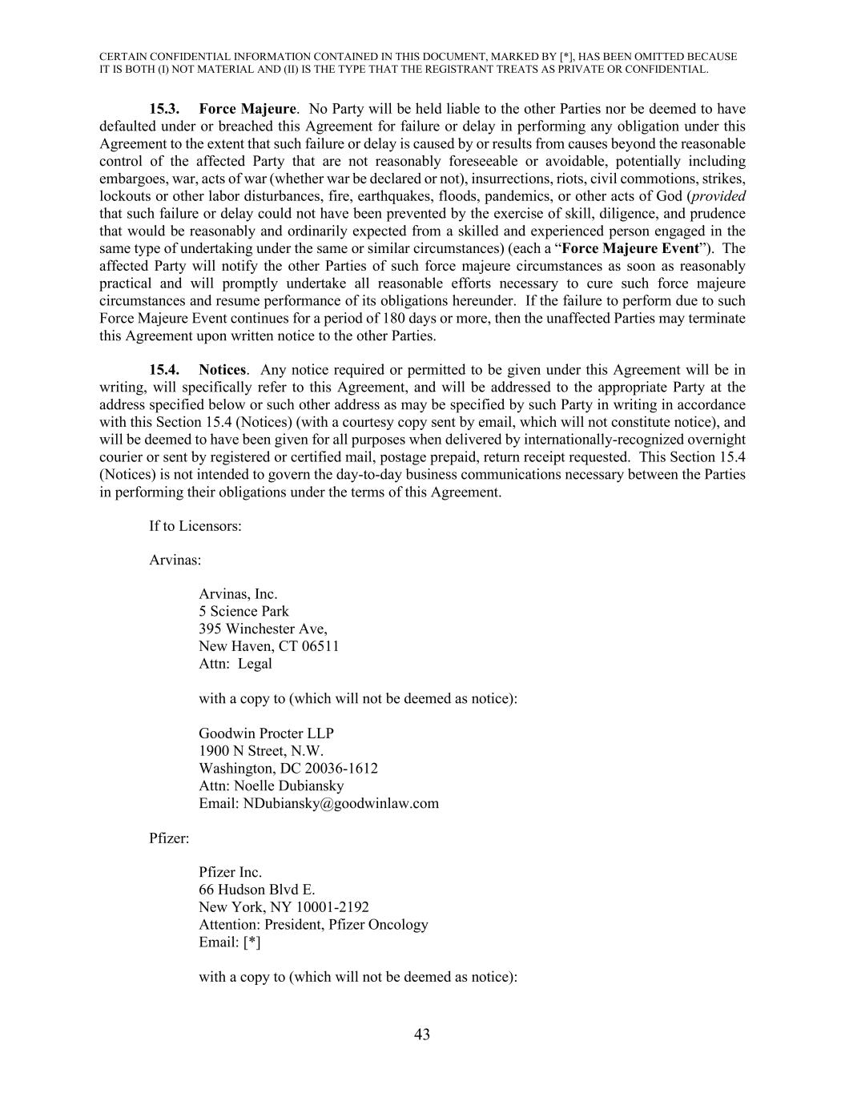
CERTAIN CONFIDENTIAL INFORMATION CONTAINED IN THIS DOCUMENT, MARKED BY [*], HAS BEEN OMITTED BECAUSE IT IS BOTH (I) NOT MATERIAL AND (II) IS THE TYPE THAT THE REGISTRANT TREATS AS PRIVATE OR CONFIDENTIAL. 43 15.3. Force Majeure. No Party will be held liable to the other Parties nor be deemed to have defaulted under or breached this Agreement for failure or delay in performing any obligation under this Agreement to the extent that such failure or delay is caused by or results from causes beyond the reasonable control of the affected Party that are not reasonably foreseeable or avoidable, potentially including embargoes, war, acts of war (whether war be declared or not), insurrections, riots, civil commotions, strikes, lockouts or other labor disturbances, fire, earthquakes, floods, pandemics, or other acts of God (provided that such failure or delay could not have been prevented by the exercise of skill, diligence, and prudence that would be reasonably and ordinarily expected from a skilled and experienced person engaged in the same type of undertaking under the same or similar circumstances) (each a “Force Majeure Event”). The affected Party will notify the other Parties of such force majeure circumstances as soon as reasonably practical and will promptly undertake all reasonable efforts necessary to cure such force majeure circumstances and resume performance of its obligations hereunder. If the failure to perform due to such Force Majeure Event continues for a period of 180 days or more, then the unaffected Parties may terminate this Agreement upon written notice to the other Parties. 15.4. Notices. Any notice required or permitted to be given under this Agreement will be in writing, will specifically refer to this Agreement, and will be addressed to the appropriate Party at the address specified below or such other address as may be specified by such Party in writing in accordance with this Section 15.4 (Notices) (with a courtesy copy sent by email, which will not constitute notice), and will be deemed to have been given for all purposes when delivered by internationally-recognized overnight courier or sent by registered or certified mail, postage prepaid, return receipt requested. This Section 15.4 (Notices) is not intended to govern the day-to-day business communications necessary between the Parties in performing their obligations under the terms of this Agreement. If to Licensors: Arvinas: Arvinas, Inc. 5 Science Park 395 Winchester Ave, New Haven, CT 06511 Attn: Legal with a copy to (which will not be deemed as notice): Goodwin Procter LLP 1900 N Street, N.W. Washington, DC 20036-1612 Attn: Noelle Dubiansky Email: NDubiansky@goodwinlaw.com Pfizer: Pfizer Inc. 66 Hudson Blvd E. New York, NY 10001-2192 Attention: President, Pfizer Oncology Email: [*] with a copy to (which will not be deemed as notice):

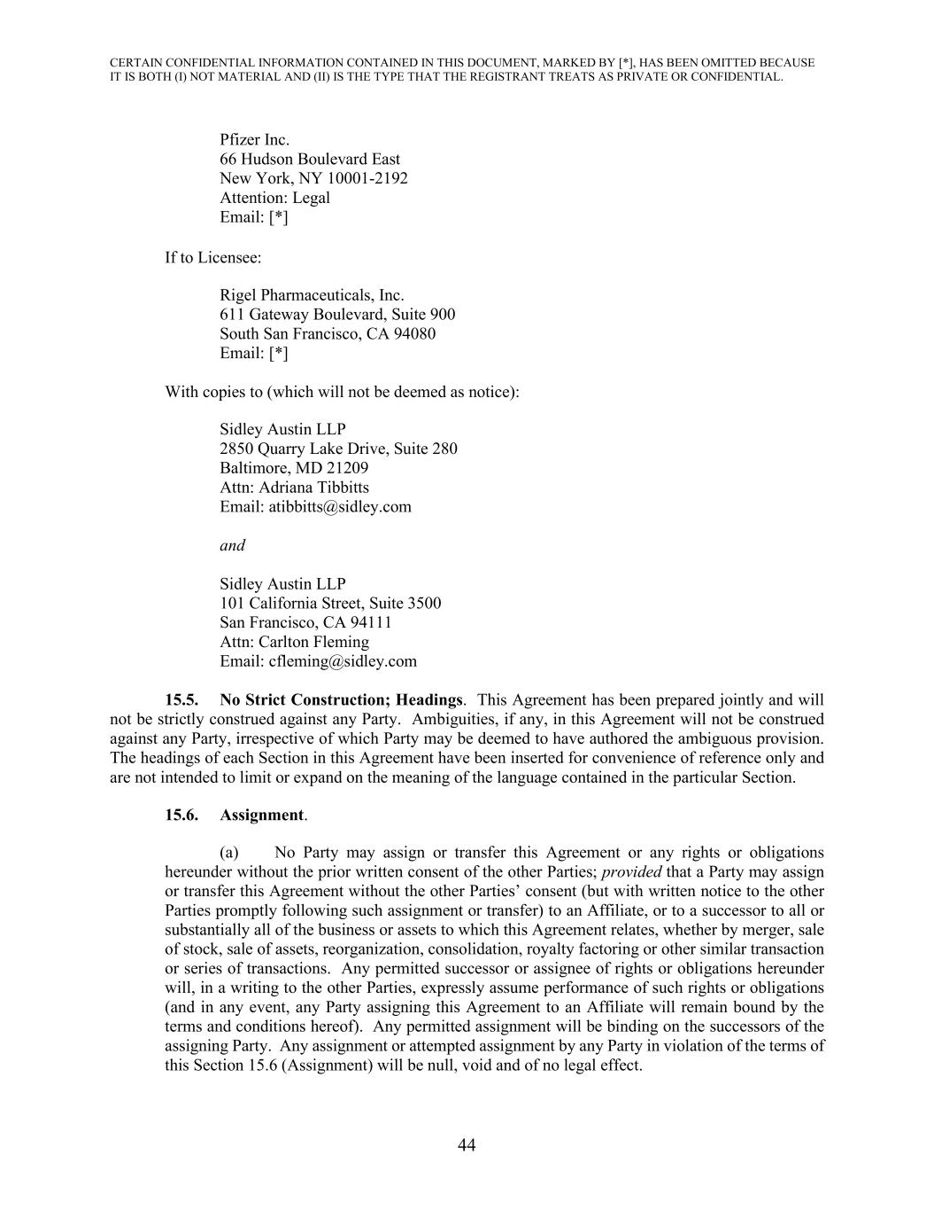
CERTAIN CONFIDENTIAL INFORMATION CONTAINED IN THIS DOCUMENT, MARKED BY [*], HAS BEEN OMITTED BECAUSE IT IS BOTH (I) NOT MATERIAL AND (II) IS THE TYPE THAT THE REGISTRANT TREATS AS PRIVATE OR CONFIDENTIAL. 44 Pfizer Inc. 66 Hudson Boulevard East New York, NY 10001-2192 Attention: Legal Email: [*] If to Licensee: Rigel Pharmaceuticals, Inc. 611 Gateway Boulevard, Suite 900 South San Francisco, CA 94080 Email: [*] With copies to (which will not be deemed as notice): Sidley Austin LLP 2850 Quarry Lake Drive, Suite 280 Baltimore, MD 21209 Attn: Adriana Tibbitts Email: atibbitts@sidley.com and Sidley Austin LLP 101 California Street, Suite 3500 San Francisco, CA 94111 Attn: Carlton Fleming Email: cfleming@sidley.com 15.5. No Strict Construction; Headings. This Agreement has been prepared jointly and will not be strictly construed against any Party. Ambiguities, if any, in this Agreement will not be construed against any Party, irrespective of which Party may be deemed to have authored the ambiguous provision. The headings of each Section in this Agreement have been inserted for convenience of reference only and are not intended to limit or expand on the meaning of the language contained in the particular Section. 15.6. Assignment. (a) No Party may assign or transfer this Agreement or any rights or obligations hereunder without the prior written consent of the other Parties; provided that a Party may assign or transfer this Agreement without the other Parties’ consent (but with written notice to the other Parties promptly following such assignment or transfer) to an Affiliate, or to a successor to all or substantially all of the business or assets to which this Agreement relates, whether by merger, sale of stock, sale of assets, reorganization, consolidation, royalty factoring or other similar transaction or series of transactions. Any permitted successor or assignee of rights or obligations hereunder will, in a writing to the other Parties, expressly assume performance of such rights or obligations (and in any event, any Party assigning this Agreement to an Affiliate will remain bound by the terms and conditions hereof). Any permitted assignment will be binding on the successors of the assigning Party. Any assignment or attempted assignment by any Party in violation of the terms of this Section 15.6 (Assignment) will be null, void and of no legal effect.

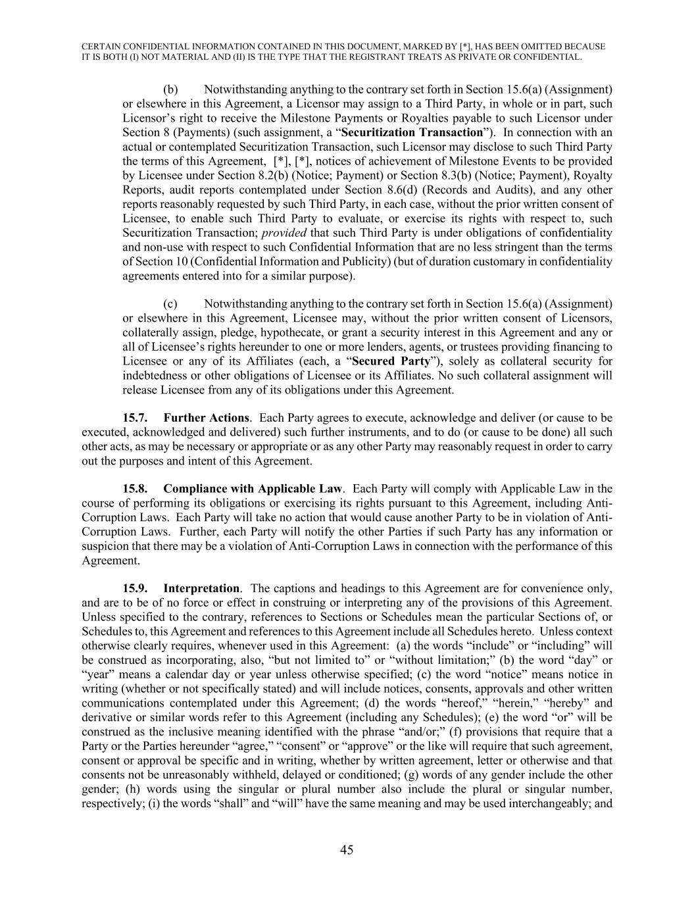
CERTAIN CONFIDENTIAL INFORMATION CONTAINED IN THIS DOCUMENT, MARKED BY [*], HAS BEEN OMITTED BECAUSE IT IS BOTH (I) NOT MATERIAL AND (II) IS THE TYPE THAT THE REGISTRANT TREATS AS PRIVATE OR CONFIDENTIAL. 45 (b) Notwithstanding anything to the contrary set forth in Section 15.6(a) (Assignment) or elsewhere in this Agreement, a Licensor may assign to a Third Party, in whole or in part, such Licensor’s right to receive the Milestone Payments or Royalties payable to such Licensor under Section 8 (Payments) (such assignment, a “Securitization Transaction”). In connection with an actual or contemplated Securitization Transaction, such Licensor may disclose to such Third Party the terms of this Agreement, [*], [*], notices of achievement of Milestone Events to be provided by Licensee under Section 8.2(b) (Notice; Payment) or Section 8.3(b) (Notice; Payment), Royalty Reports, audit reports contemplated under Section 8.6(d) (Records and Audits), and any other reports reasonably requested by such Third Party, in each case, without the prior written consent of Licensee, to enable such Third Party to evaluate, or exercise its rights with respect to, such Securitization Transaction; provided that such Third Party is under obligations of confidentiality and non-use with respect to such Confidential Information that are no less stringent than the terms of Section 10 (Confidential Information and Publicity) (but of duration customary in confidentiality agreements entered into for a similar purpose). (c) Notwithstanding anything to the contrary set forth in Section 15.6(a) (Assignment) or elsewhere in this Agreement, Licensee may, without the prior written consent of Licensors, collaterally assign, pledge, hypothecate, or grant a security interest in this Agreement and any or all of Licensee’s rights hereunder to one or more lenders, agents, or trustees providing financing to Licensee or any of its Affiliates (each, a “Secured Party”), solely as collateral security for indebtedness or other obligations of Licensee or its Affiliates. No such collateral assignment will release Licensee from any of its obligations under this Agreement. 15.7. Further Actions. Each Party agrees to execute, acknowledge and deliver (or cause to be executed, acknowledged and delivered) such further instruments, and to do (or cause to be done) all such other acts, as may be necessary or appropriate or as any other Party may reasonably request in order to carry out the purposes and intent of this Agreement. 15.8. Compliance with Applicable Law. Each Party will comply with Applicable Law in the course of performing its obligations or exercising its rights pursuant to this Agreement, including Anti- Corruption Laws. Each Party will take no action that would cause another Party to be in violation of Anti- Corruption Laws. Further, each Party will notify the other Parties if such Party has any information or suspicion that there may be a violation of Anti-Corruption Laws in connection with the performance of this Agreement. 15.9. Interpretation. The captions and headings to this Agreement are for convenience only, and are to be of no force or effect in construing or interpreting any of the provisions of this Agreement. Unless specified to the contrary, references to Sections or Schedules mean the particular Sections of, or Schedules to, this Agreement and references to this Agreement include all Schedules hereto. Unless context otherwise clearly requires, whenever used in this Agreement: (a) the words “include” or “including” will be construed as incorporating, also, “but not limited to” or “without limitation;” (b) the word “day” or “year” means a calendar day or year unless otherwise specified; (c) the word “notice” means notice in writing (whether or not specifically stated) and will include notices, consents, approvals and other written communications contemplated under this Agreement; (d) the words “hereof,” “herein,” “hereby” and derivative or similar words refer to this Agreement (including any Schedules); (e) the word “or” will be construed as the inclusive meaning identified with the phrase “and/or;” (f) provisions that require that a Party or the Parties hereunder “agree,” “consent” or “approve” or the like will require that such agreement, consent or approval be specific and in writing, whether by written agreement, letter or otherwise and that consents not be unreasonably withheld, delayed or conditioned; (g) words of any gender include the other gender; (h) words using the singular or plural number also include the plural or singular number, respectively; (i) the words “shall” and “will” have the same meaning and may be used interchangeably; and

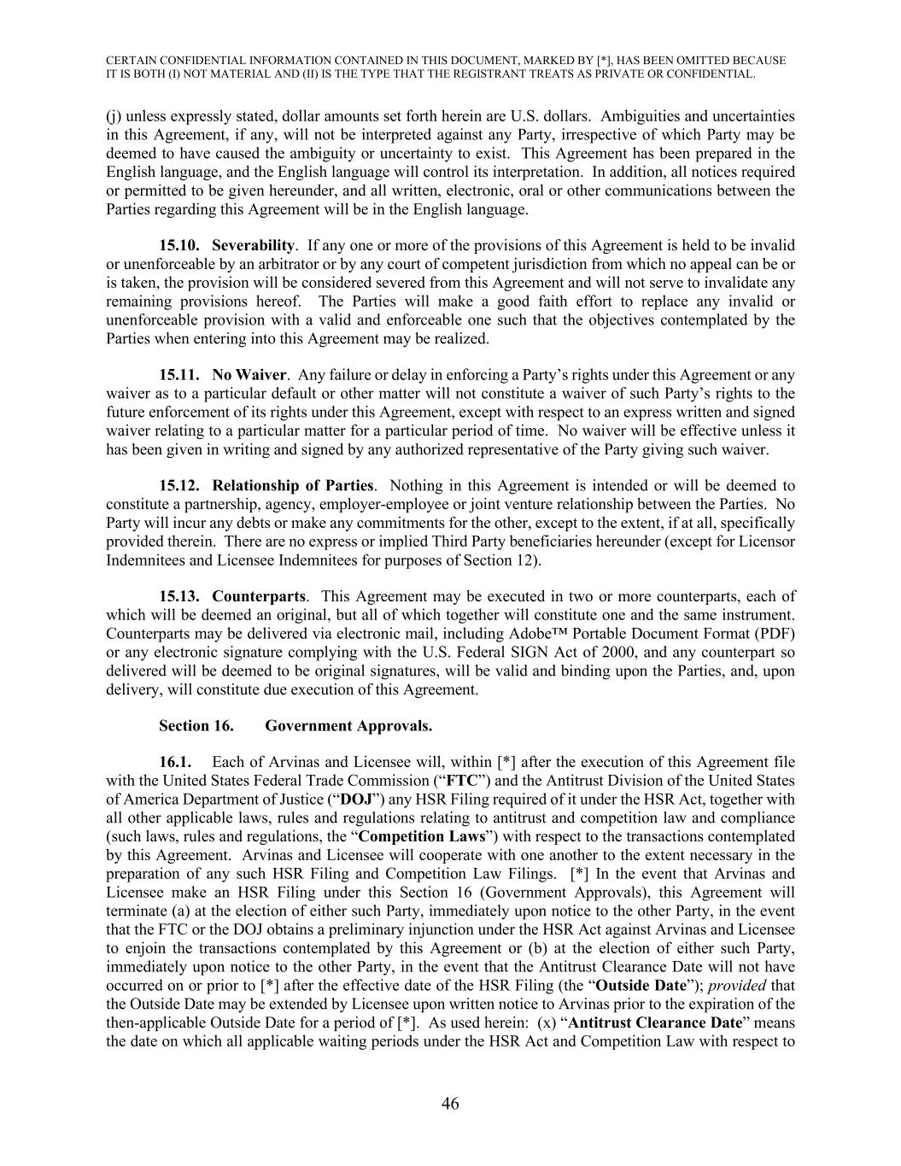
CERTAIN CONFIDENTIAL INFORMATION CONTAINED IN THIS DOCUMENT, MARKED BY [*], HAS BEEN OMITTED BECAUSE IT IS BOTH (I) NOT MATERIAL AND (II) IS THE TYPE THAT THE REGISTRANT TREATS AS PRIVATE OR CONFIDENTIAL. 46 (j) unless expressly stated, dollar amounts set forth herein are U.S. dollars. Ambiguities and uncertainties in this Agreement, if any, will not be interpreted against any Party, irrespective of which Party may be deemed to have caused the ambiguity or uncertainty to exist. This Agreement has been prepared in the English language, and the English language will control its interpretation. In addition, all notices required or permitted to be given hereunder, and all written, electronic, oral or other communications between the Parties regarding this Agreement will be in the English language. 15.10. Severability. If any one or more of the provisions of this Agreement is held to be invalid or unenforceable by an arbitrator or by any court of competent jurisdiction from which no appeal can be or is taken, the provision will be considered severed from this Agreement and will not serve to invalidate any remaining provisions hereof. The Parties will make a good faith effort to replace any invalid or unenforceable provision with a valid and enforceable one such that the objectives contemplated by the Parties when entering into this Agreement may be realized. 15.11. No Waiver. Any failure or delay in enforcing a Party’s rights under this Agreement or any waiver as to a particular default or other matter will not constitute a waiver of such Party’s rights to the future enforcement of its rights under this Agreement, except with respect to an express written and signed waiver relating to a particular matter for a particular period of time. No waiver will be effective unless it has been given in writing and signed by any authorized representative of the Party giving such waiver. 15.12. Relationship of Parties. Nothing in this Agreement is intended or will be deemed to constitute a partnership, agency, employer-employee or joint venture relationship between the Parties. No Party will incur any debts or make any commitments for the other, except to the extent, if at all, specifically provided therein. There are no express or implied Third Party beneficiaries hereunder (except for Licensor Indemnitees and Licensee Indemnitees for purposes of Section 12). 15.13. Counterparts. This Agreement may be executed in two or more counterparts, each of which will be deemed an original, but all of which together will constitute one and the same instrument. Counterparts may be delivered via electronic mail, including Adobe™ Portable Document Format (PDF) or any electronic signature complying with the U.S. Federal SIGN Act of 2000, and any counterpart so delivered will be deemed to be original signatures, will be valid and binding upon the Parties, and, upon delivery, will constitute due execution of this Agreement. Section 16. Government Approvals. 16.1. Each of Arvinas and Licensee will, within [*] after the execution of this Agreement file with the United States Federal Trade Commission (“FTC”) and the Antitrust Division of the United States of America Department of Justice (“DOJ”) any HSR Filing required of it under the HSR Act, together with all other applicable laws, rules and regulations relating to antitrust and competition law and compliance (such laws, rules and regulations, the “Competition Laws”) with respect to the transactions contemplated by this Agreement. Arvinas and Licensee will cooperate with one another to the extent necessary in the preparation of any such HSR Filing and Competition Law Filings. [*] In the event that Arvinas and Licensee make an HSR Filing under this Section 16 (Government Approvals), this Agreement will terminate (a) at the election of either such Party, immediately upon notice to the other Party, in the event that the FTC or the DOJ obtains a preliminary injunction under the HSR Act against Arvinas and Licensee to enjoin the transactions contemplated by this Agreement or (b) at the election of either such Party, immediately upon notice to the other Party, in the event that the Antitrust Clearance Date will not have occurred on or prior to [*] after the effective date of the HSR Filing (the “Outside Date”); provided that the Outside Date may be extended by Licensee upon written notice to Arvinas prior to the expiration of the then-applicable Outside Date for a period of [*]. As used herein: (x) “Antitrust Clearance Date” means the date on which all applicable waiting periods under the HSR Act and Competition Law with respect to

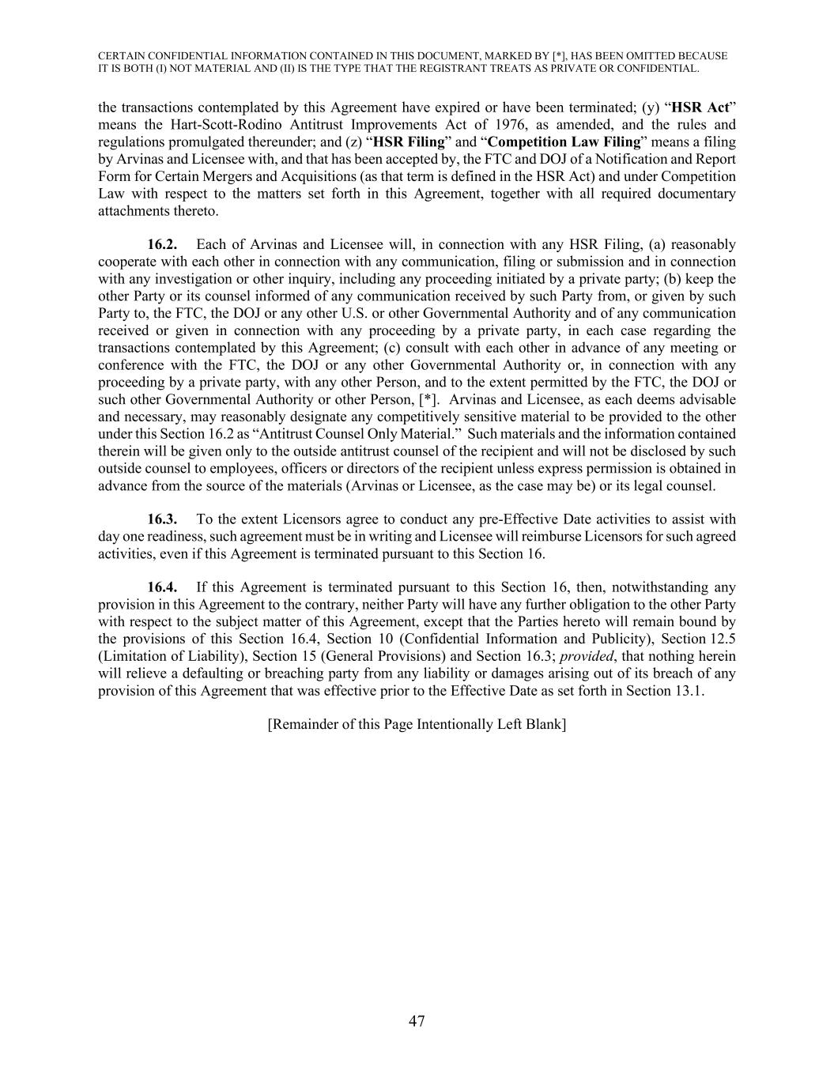
CERTAIN CONFIDENTIAL INFORMATION CONTAINED IN THIS DOCUMENT, MARKED BY [*], HAS BEEN OMITTED BECAUSE IT IS BOTH (I) NOT MATERIAL AND (II) IS THE TYPE THAT THE REGISTRANT TREATS AS PRIVATE OR CONFIDENTIAL. 47 the transactions contemplated by this Agreement have expired or have been terminated; (y) “HSR Act” means the Hart-Scott-Rodino Antitrust Improvements Act of 1976, as amended, and the rules and regulations promulgated thereunder; and (z) “HSR Filing” and “Competition Law Filing” means a filing by Arvinas and Licensee with, and that has been accepted by, the FTC and DOJ of a Notification and Report Form for Certain Mergers and Acquisitions (as that term is defined in the HSR Act) and under Competition Law with respect to the matters set forth in this Agreement, together with all required documentary attachments thereto. 16.2. Each of Arvinas and Licensee will, in connection with any HSR Filing, (a) reasonably cooperate with each other in connection with any communication, filing or submission and in connection with any investigation or other inquiry, including any proceeding initiated by a private party; (b) keep the other Party or its counsel informed of any communication received by such Party from, or given by such Party to, the FTC, the DOJ or any other U.S. or other Governmental Authority and of any communication received or given in connection with any proceeding by a private party, in each case regarding the transactions contemplated by this Agreement; (c) consult with each other in advance of any meeting or conference with the FTC, the DOJ or any other Governmental Authority or, in connection with any proceeding by a private party, with any other Person, and to the extent permitted by the FTC, the DOJ or such other Governmental Authority or other Person, [*]. Arvinas and Licensee, as each deems advisable and necessary, may reasonably designate any competitively sensitive material to be provided to the other under this Section 16.2 as “Antitrust Counsel Only Material.” Such materials and the information contained therein will be given only to the outside antitrust counsel of the recipient and will not be disclosed by such outside counsel to employees, officers or directors of the recipient unless express permission is obtained in advance from the source of the materials (Arvinas or Licensee, as the case may be) or its legal counsel. 16.3. To the extent Licensors agree to conduct any pre-Effective Date activities to assist with day one readiness, such agreement must be in writing and Licensee will reimburse Licensors for such agreed activities, even if this Agreement is terminated pursuant to this Section 16. 16.4. If this Agreement is terminated pursuant to this Section 16, then, notwithstanding any provision in this Agreement to the contrary, neither Party will have any further obligation to the other Party with respect to the subject matter of this Agreement, except that the Parties hereto will remain bound by the provisions of this Section 16.4, Section 10 (Confidential Information and Publicity), Section 12.5 (Limitation of Liability), Section 15 (General Provisions) and Section 16.3; provided, that nothing herein will relieve a defaulting or breaching party from any liability or damages arising out of its breach of any provision of this Agreement that was effective prior to the Effective Date as set forth in Section 13.1. [Remainder of this Page Intentionally Left Blank]

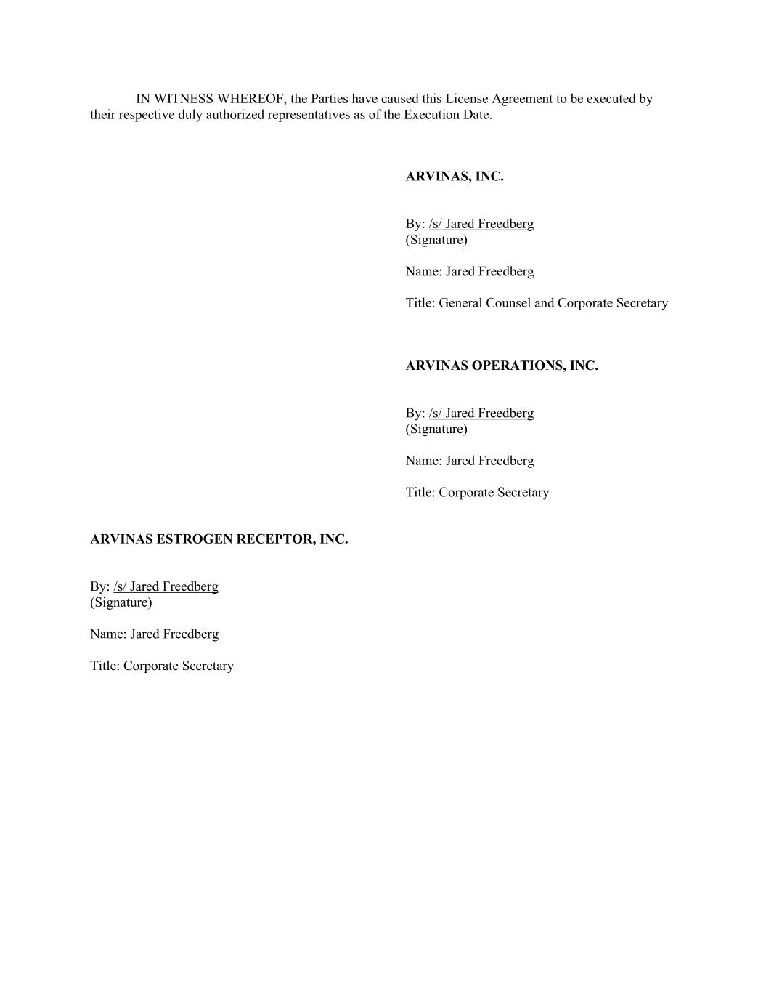
IN WITNESS WHEREOF, the Parties have caused this License Agreement to be executed by their respective duly authorized representatives as of the Execution Date. ARVINAS, INC. By: /s/ Jared Freedberg (Signature) Name: Jared Freedberg Title: General Counsel and Corporate Secretary ARVINAS OPERATIONS, INC. By: /s/ Jared Freedberg (Signature) Name: Jared Freedberg Title: Corporate Secretary ARVINAS ESTROGEN RECEPTOR, INC. By: /s/ Jared Freedberg (Signature) Name: Jared Freedberg Title: Corporate Secretary

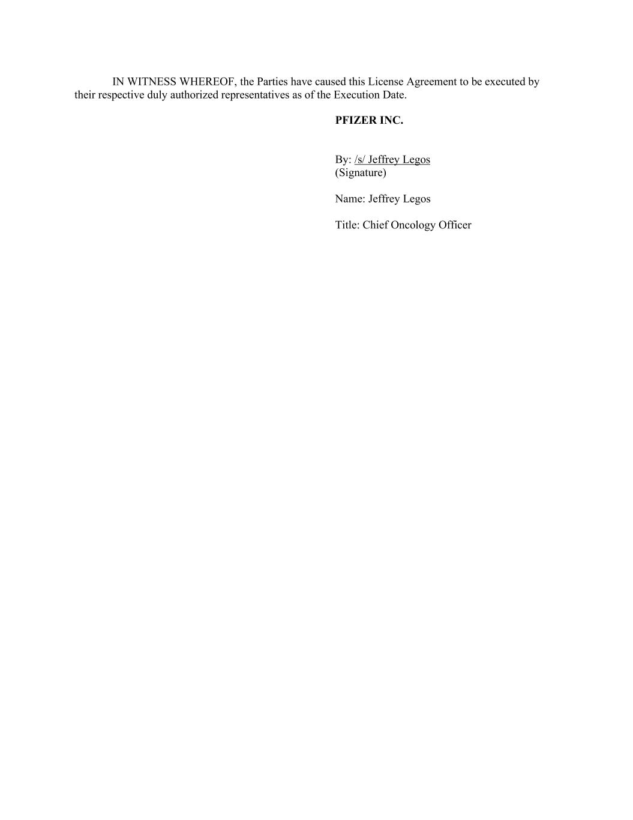
IN WITNESS WHEREOF, the Parties have caused this License Agreement to be executed by their respective duly authorized representatives as of the Execution Date. PFIZER INC. By: /s/ Jeffrey Legos (Signature) Name: Jeffrey Legos Title: Chief Oncology Officer

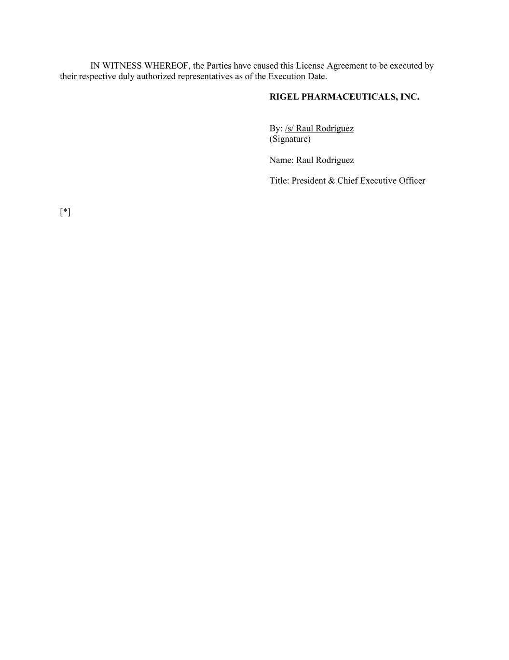
IN WITNESS WHEREOF, the Parties have caused this License Agreement to be executed by their respective duly authorized representatives as of the Execution Date. RIGEL PHARMACEUTICALS, INC. By: /s/ Raul Rodriguez (Signature) Name: Raul Rodriguez Title: President & Chief Executive Officer [*]

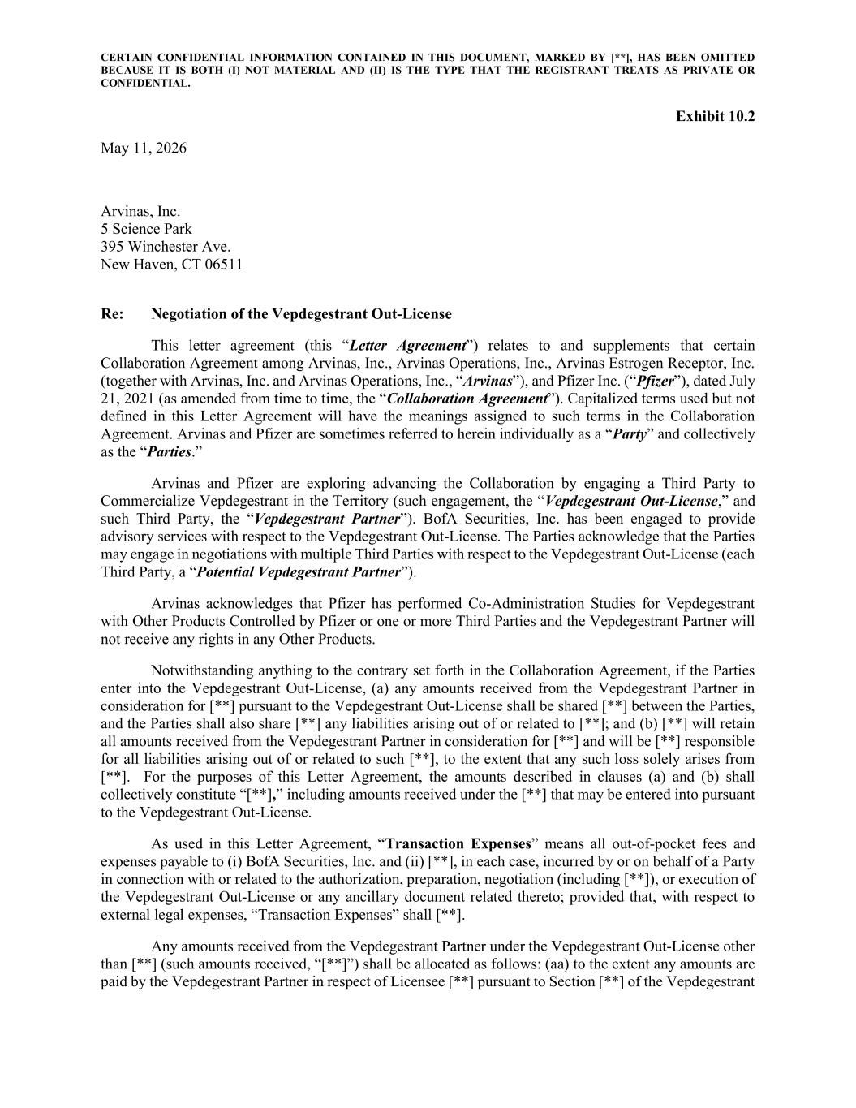
CERTAIN CONFIDENTIAL INFORMATION CONTAINED IN THIS DOCUMENT, MARKED BY [**], HAS BEEN OMITTED BECAUSE IT IS BOTH (I) NOT MATERIAL AND (II) IS THE TYPE THAT THE REGISTRANT TREATS AS PRIVATE OR CONFIDENTIAL. Exhibit 10.2 May 11, 2026 Arvinas, Inc. 5 Science Park 395 Winchester Ave. New Haven, CT 06511 Re: Negotiation of the Vepdegestrant Out-License This letter agreement (this “Letter Agreement”) relates to and supplements that certain Collaboration Agreement among Arvinas, Inc., Arvinas Operations, Inc., Arvinas Estrogen Receptor, Inc. (together with Arvinas, Inc. and Arvinas Operations, Inc., “Arvinas”), and Pfizer Inc. (“Pfizer”), dated July 21, 2021 (as amended from time to time, the “Collaboration Agreement”). Capitalized terms used but not defined in this Letter Agreement will have the meanings assigned to such terms in the Collaboration Agreement. Arvinas and Pfizer are sometimes referred to herein individually as a “Party” and collectively as the “Parties.” Arvinas and Pfizer are exploring advancing the Collaboration by engaging a Third Party to Commercialize Vepdegestrant in the Territory (such engagement, the “Vepdegestrant Out-License,” and such Third Party, the “Vepdegestrant Partner”). BofA Securities, Inc. has been engaged to provide advisory services with respect to the Vepdegestrant Out-License. The Parties acknowledge that the Parties may engage in negotiations with multiple Third Parties with respect to the Vepdegestrant Out-License (each Third Party, a “Potential Vepdegestrant Partner”). Arvinas acknowledges that Pfizer has performed Co-Administration Studies for Vepdegestrant with Other Products Controlled by Pfizer or one or more Third Parties and the Vepdegestrant Partner will not receive any rights in any Other Products. Notwithstanding anything to the contrary set forth in the Collaboration Agreement, if the Parties enter into the Vepdegestrant Out-License, (a) any amounts received from the Vepdegestrant Partner in consideration for [**] pursuant to the Vepdegestrant Out-License shall be shared [**] between the Parties, and the Parties shall also share [**] any liabilities arising out of or related to [**]; and (b) [**] will retain all amounts received from the Vepdegestrant Partner in consideration for [**] and will be [**] responsible for all liabilities arising out of or related to such [**], to the extent that any such loss solely arises from [**]. For the purposes of this Letter Agreement, the amounts described in clauses (a) and (b) shall collectively constitute “[**],” including amounts received under the [**] that may be entered into pursuant to the Vepdegestrant Out-License. As used in this Letter Agreement, “Transaction Expenses” means all out-of-pocket fees and expenses payable to (i) BofA Securities, Inc. and (ii) [**], in each case, incurred by or on behalf of a Party in connection with or related to the authorization, preparation, negotiation (including [**]), or execution of the Vepdegestrant Out-License or any ancillary document related thereto; provided that, with respect to external legal expenses, “Transaction Expenses” shall [**]. Any amounts received from the Vepdegestrant Partner under the Vepdegestrant Out-License other than [**] (such amounts received, “[**]”) shall be allocated as follows: (aa) to the extent any amounts are paid by the Vepdegestrant Partner in respect of Licensee [**] pursuant to Section [**] of the Vepdegestrant

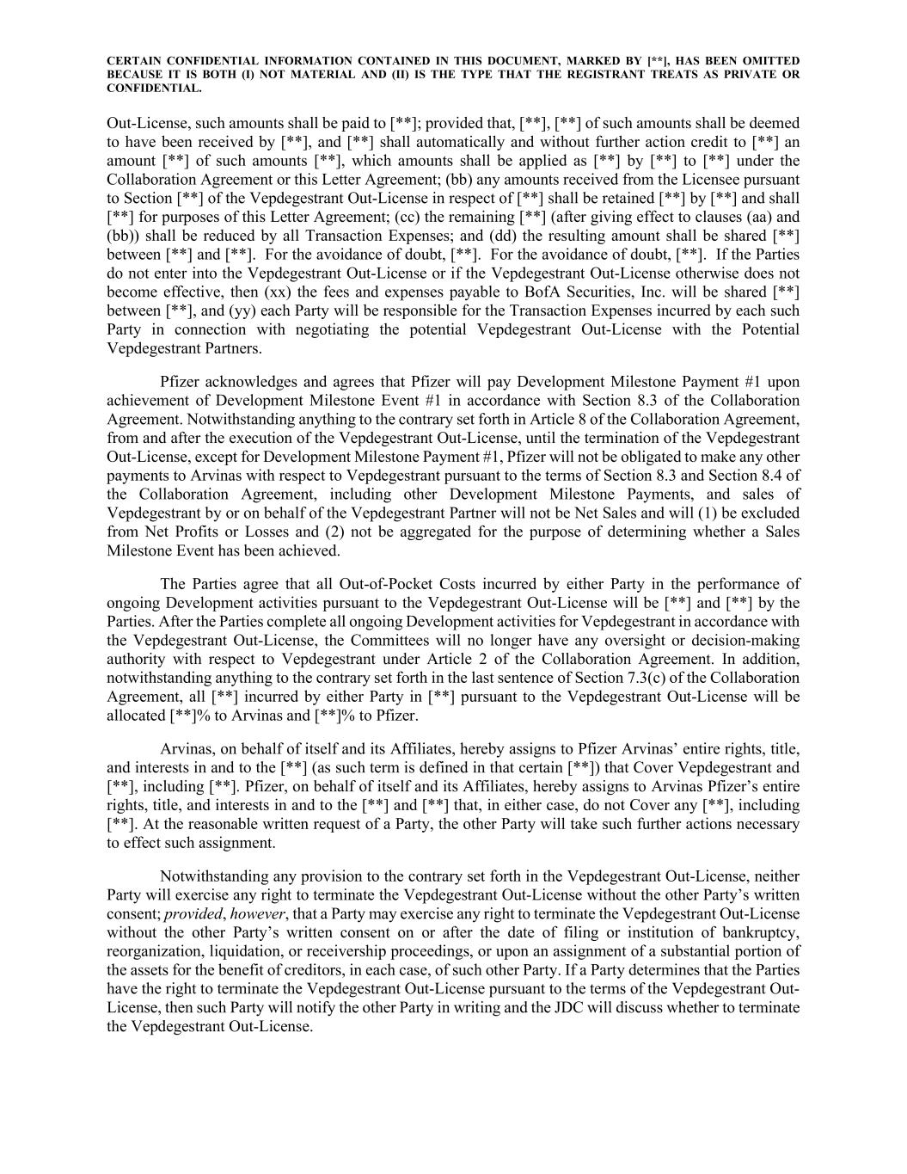
CERTAIN CONFIDENTIAL INFORMATION CONTAINED IN THIS DOCUMENT, MARKED BY [**], HAS BEEN OMITTED BECAUSE IT IS BOTH (I) NOT MATERIAL AND (II) IS THE TYPE THAT THE REGISTRANT TREATS AS PRIVATE OR CONFIDENTIAL. Out-License, such amounts shall be paid to [**]; provided that, [**], [**] of such amounts shall be deemed to have been received by [**], and [**] shall automatically and without further action credit to [**] an amount [**] of such amounts [**], which amounts shall be applied as [**] by [**] to [**] under the Collaboration Agreement or this Letter Agreement; (bb) any amounts received from the Licensee pursuant to Section [**] of the Vepdegestrant Out-License in respect of [**] shall be retained [**] by [**] and shall [**] for purposes of this Letter Agreement; (cc) the remaining [**] (after giving effect to clauses (aa) and (bb)) shall be reduced by all Transaction Expenses; and (dd) the resulting amount shall be shared [**] between [**] and [**]. For the avoidance of doubt, [**]. For the avoidance of doubt, [**]. If the Parties do not enter into the Vepdegestrant Out-License or if the Vepdegestrant Out-License otherwise does not become effective, then (xx) the fees and expenses payable to BofA Securities, Inc. will be shared [**] between [**], and (yy) each Party will be responsible for the Transaction Expenses incurred by each such Party in connection with negotiating the potential Vepdegestrant Out-License with the Potential Vepdegestrant Partners. Pfizer acknowledges and agrees that Pfizer will pay Development Milestone Payment #1 upon achievement of Development Milestone Event #1 in accordance with Section 8.3 of the Collaboration Agreement. Notwithstanding anything to the contrary set forth in Article 8 of the Collaboration Agreement, from and after the execution of the Vepdegestrant Out-License, until the termination of the Vepdegestrant Out-License, except for Development Milestone Payment #1, Pfizer will not be obligated to make any other payments to Arvinas with respect to Vepdegestrant pursuant to the terms of Section 8.3 and Section 8.4 of the Collaboration Agreement, including other Development Milestone Payments, and sales of Vepdegestrant by or on behalf of the Vepdegestrant Partner will not be Net Sales and will (1) be excluded from Net Profits or Losses and (2) not be aggregated for the purpose of determining whether a Sales Milestone Event has been achieved. The Parties agree that all Out-of-Pocket Costs incurred by either Party in the performance of ongoing Development activities pursuant to the Vepdegestrant Out-License will be [**] and [**] by the Parties. After the Parties complete all ongoing Development activities for Vepdegestrant in accordance with the Vepdegestrant Out-License, the Committees will no longer have any oversight or decision-making authority with respect to Vepdegestrant under Article 2 of the Collaboration Agreement. In addition, notwithstanding anything to the contrary set forth in the last sentence of Section 7.3(c) of the Collaboration Agreement, all [**] incurred by either Party in [**] pursuant to the Vepdegestrant Out-License will be allocated [**]% to Arvinas and [**]% to Pfizer. Arvinas, on behalf of itself and its Affiliates, hereby assigns to Pfizer Arvinas’ entire rights, title, and interests in and to the [**] (as such term is defined in that certain [**]) that Cover Vepdegestrant and [**], including [**]. Pfizer, on behalf of itself and its Affiliates, hereby assigns to Arvinas Pfizer’s entire rights, title, and interests in and to the [**] and [**] that, in either case, do not Cover any [**], including [**]. At the reasonable written request of a Party, the other Party will take such further actions necessary to effect such assignment. Notwithstanding any provision to the contrary set forth in the Vepdegestrant Out-License, neither Party will exercise any right to terminate the Vepdegestrant Out-License without the other Party’s written consent; provided, however, that a Party may exercise any right to terminate the Vepdegestrant Out-License without the other Party’s written consent on or after the date of filing or institution of bankruptcy, reorganization, liquidation, or receivership proceedings, or upon an assignment of a substantial portion of the assets for the benefit of creditors, in each case, of such other Party. If a Party determines that the Parties have the right to terminate the Vepdegestrant Out-License pursuant to the terms of the Vepdegestrant Out- License, then such Party will notify the other Party in writing and the JDC will discuss whether to terminate the Vepdegestrant Out-License.

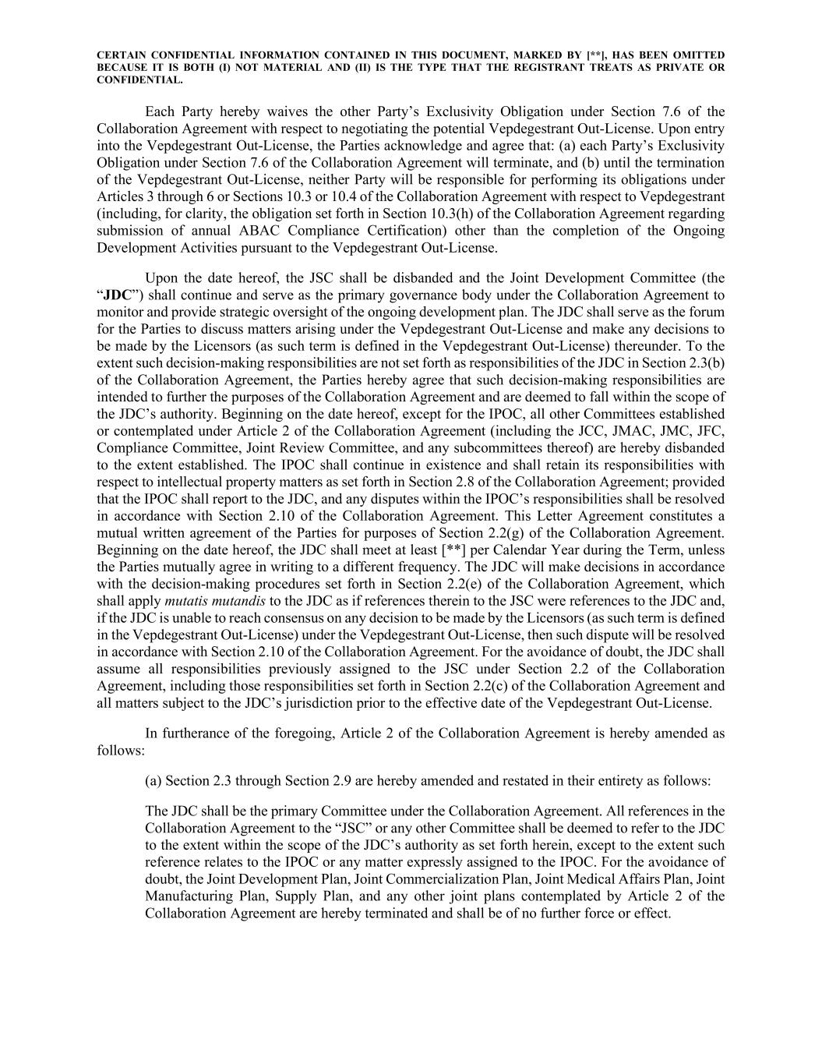
CERTAIN CONFIDENTIAL INFORMATION CONTAINED IN THIS DOCUMENT, MARKED BY [**], HAS BEEN OMITTED BECAUSE IT IS BOTH (I) NOT MATERIAL AND (II) IS THE TYPE THAT THE REGISTRANT TREATS AS PRIVATE OR CONFIDENTIAL. Each Party hereby waives the other Party’s Exclusivity Obligation under Section 7.6 of the Collaboration Agreement with respect to negotiating the potential Vepdegestrant Out-License. Upon entry into the Vepdegestrant Out-License, the Parties acknowledge and agree that: (a) each Party’s Exclusivity Obligation under Section 7.6 of the Collaboration Agreement will terminate, and (b) until the termination of the Vepdegestrant Out-License, neither Party will be responsible for performing its obligations under Articles 3 through 6 or Sections 10.3 or 10.4 of the Collaboration Agreement with respect to Vepdegestrant (including, for clarity, the obligation set forth in Section 10.3(h) of the Collaboration Agreement regarding submission of annual ABAC Compliance Certification) other than the completion of the Ongoing Development Activities pursuant to the Vepdegestrant Out-License. Upon the date hereof, the JSC shall be disbanded and the Joint Development Committee (the “JDC”) shall continue and serve as the primary governance body under the Collaboration Agreement to monitor and provide strategic oversight of the ongoing development plan. The JDC shall serve as the forum for the Parties to discuss matters arising under the Vepdegestrant Out-License and make any decisions to be made by the Licensors (as such term is defined in the Vepdegestrant Out-License) thereunder. To the extent such decision-making responsibilities are not set forth as responsibilities of the JDC in Section 2.3(b) of the Collaboration Agreement, the Parties hereby agree that such decision-making responsibilities are intended to further the purposes of the Collaboration Agreement and are deemed to fall within the scope of the JDC’s authority. Beginning on the date hereof, except for the IPOC, all other Committees established or contemplated under Article 2 of the Collaboration Agreement (including the JCC, JMAC, JMC, JFC, Compliance Committee, Joint Review Committee, and any subcommittees thereof) are hereby disbanded to the extent established. The IPOC shall continue in existence and shall retain its responsibilities with respect to intellectual property matters as set forth in Section 2.8 of the Collaboration Agreement; provided that the IPOC shall report to the JDC, and any disputes within the IPOC’s responsibilities shall be resolved in accordance with Section 2.10 of the Collaboration Agreement. This Letter Agreement constitutes a mutual written agreement of the Parties for purposes of Section 2.2(g) of the Collaboration Agreement. Beginning on the date hereof, the JDC shall meet at least [**] per Calendar Year during the Term, unless the Parties mutually agree in writing to a different frequency. The JDC will make decisions in accordance with the decision-making procedures set forth in Section 2.2(e) of the Collaboration Agreement, which shall apply mutatis mutandis to the JDC as if references therein to the JSC were references to the JDC and, if the JDC is unable to reach consensus on any decision to be made by the Licensors (as such term is defined in the Vepdegestrant Out-License) under the Vepdegestrant Out-License, then such dispute will be resolved in accordance with Section 2.10 of the Collaboration Agreement. For the avoidance of doubt, the JDC shall assume all responsibilities previously assigned to the JSC under Section 2.2 of the Collaboration Agreement, including those responsibilities set forth in Section 2.2(c) of the Collaboration Agreement and all matters subject to the JDC’s jurisdiction prior to the effective date of the Vepdegestrant Out-License. In furtherance of the foregoing, Article 2 of the Collaboration Agreement is hereby amended as follows: (a) Section 2.3 through Section 2.9 are hereby amended and restated in their entirety as follows: The JDC shall be the primary Committee under the Collaboration Agreement. All references in the Collaboration Agreement to the “JSC” or any other Committee shall be deemed to refer to the JDC to the extent within the scope of the JDC’s authority as set forth herein, except to the extent such reference relates to the IPOC or any matter expressly assigned to the IPOC. For the avoidance of doubt, the Joint Development Plan, Joint Commercialization Plan, Joint Medical Affairs Plan, Joint Manufacturing Plan, Supply Plan, and any other joint plans contemplated by Article 2 of the Collaboration Agreement are hereby terminated and shall be of no further force or effect.

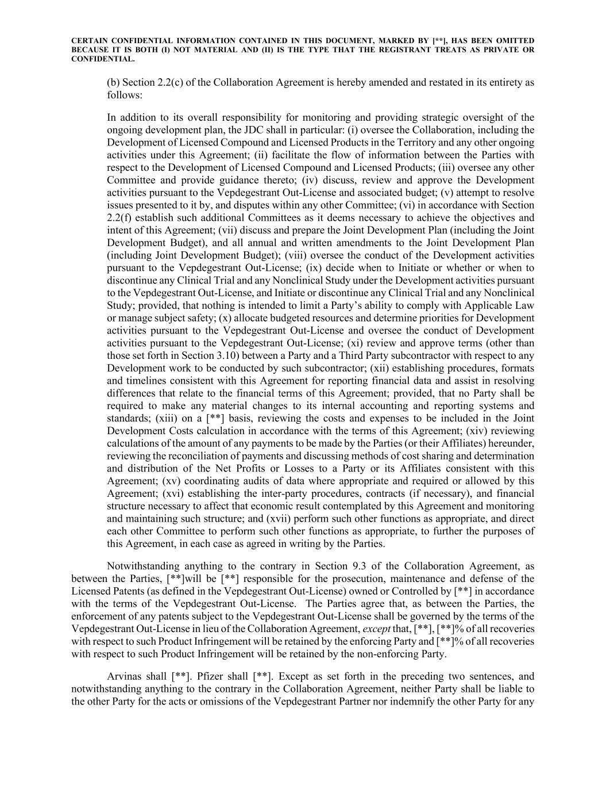
CERTAIN CONFIDENTIAL INFORMATION CONTAINED IN THIS DOCUMENT, MARKED BY [**], HAS BEEN OMITTED BECAUSE IT IS BOTH (I) NOT MATERIAL AND (II) IS THE TYPE THAT THE REGISTRANT TREATS AS PRIVATE OR CONFIDENTIAL. (b) Section 2.2(c) of the Collaboration Agreement is hereby amended and restated in its entirety as follows: In addition to its overall responsibility for monitoring and providing strategic oversight of the ongoing development plan, the JDC shall in particular: (i) oversee the Collaboration, including the Development of Licensed Compound and Licensed Products in the Territory and any other ongoing activities under this Agreement; (ii) facilitate the flow of information between the Parties with respect to the Development of Licensed Compound and Licensed Products; (iii) oversee any other Committee and provide guidance thereto; (iv) discuss, review and approve the Development activities pursuant to the Vepdegestrant Out-License and associated budget; (v) attempt to resolve issues presented to it by, and disputes within any other Committee; (vi) in accordance with Section 2.2(f) establish such additional Committees as it deems necessary to achieve the objectives and intent of this Agreement; (vii) discuss and prepare the Joint Development Plan (including the Joint Development Budget), and all annual and written amendments to the Joint Development Plan (including Joint Development Budget); (viii) oversee the conduct of the Development activities pursuant to the Vepdegestrant Out-License; (ix) decide when to Initiate or whether or when to discontinue any Clinical Trial and any Nonclinical Study under the Development activities pursuant to the Vepdegestrant Out-License, and Initiate or discontinue any Clinical Trial and any Nonclinical Study; provided, that nothing is intended to limit a Party’s ability to comply with Applicable Law or manage subject safety; (x) allocate budgeted resources and determine priorities for Development activities pursuant to the Vepdegestrant Out-License and oversee the conduct of Development activities pursuant to the Vepdegestrant Out-License; (xi) review and approve terms (other than those set forth in Section 3.10) between a Party and a Third Party subcontractor with respect to any Development work to be conducted by such subcontractor; (xii) establishing procedures, formats and timelines consistent with this Agreement for reporting financial data and assist in resolving differences that relate to the financial terms of this Agreement; provided, that no Party shall be required to make any material changes to its internal accounting and reporting systems and standards; (xiii) on a [**] basis, reviewing the costs and expenses to be included in the Joint Development Costs calculation in accordance with the terms of this Agreement; (xiv) reviewing calculations of the amount of any payments to be made by the Parties (or their Affiliates) hereunder, reviewing the reconciliation of payments and discussing methods of cost sharing and determination and distribution of the Net Profits or Losses to a Party or its Affiliates consistent with this Agreement; (xv) coordinating audits of data where appropriate and required or allowed by this Agreement; (xvi) establishing the inter-party procedures, contracts (if necessary), and financial structure necessary to affect that economic result contemplated by this Agreement and monitoring and maintaining such structure; and (xvii) perform such other functions as appropriate, and direct each other Committee to perform such other functions as appropriate, to further the purposes of this Agreement, in each case as agreed in writing by the Parties. Notwithstanding anything to the contrary in Section 9.3 of the Collaboration Agreement, as between the Parties, [**]will be [**] responsible for the prosecution, maintenance and defense of the Licensed Patents (as defined in the Vepdegestrant Out-License) owned or Controlled by [**] in accordance with the terms of the Vepdegestrant Out-License. The Parties agree that, as between the Parties, the enforcement of any patents subject to the Vepdegestrant Out-License shall be governed by the terms of the Vepdegestrant Out-License in lieu of the Collaboration Agreement, except that, [**], [**]% of all recoveries with respect to such Product Infringement will be retained by the enforcing Party and [**]% of all recoveries with respect to such Product Infringement will be retained by the non-enforcing Party. Arvinas shall [**]. Pfizer shall [**]. Except as set forth in the preceding two sentences, and notwithstanding anything to the contrary in the Collaboration Agreement, neither Party shall be liable to the other Party for the acts or omissions of the Vepdegestrant Partner nor indemnify the other Party for any

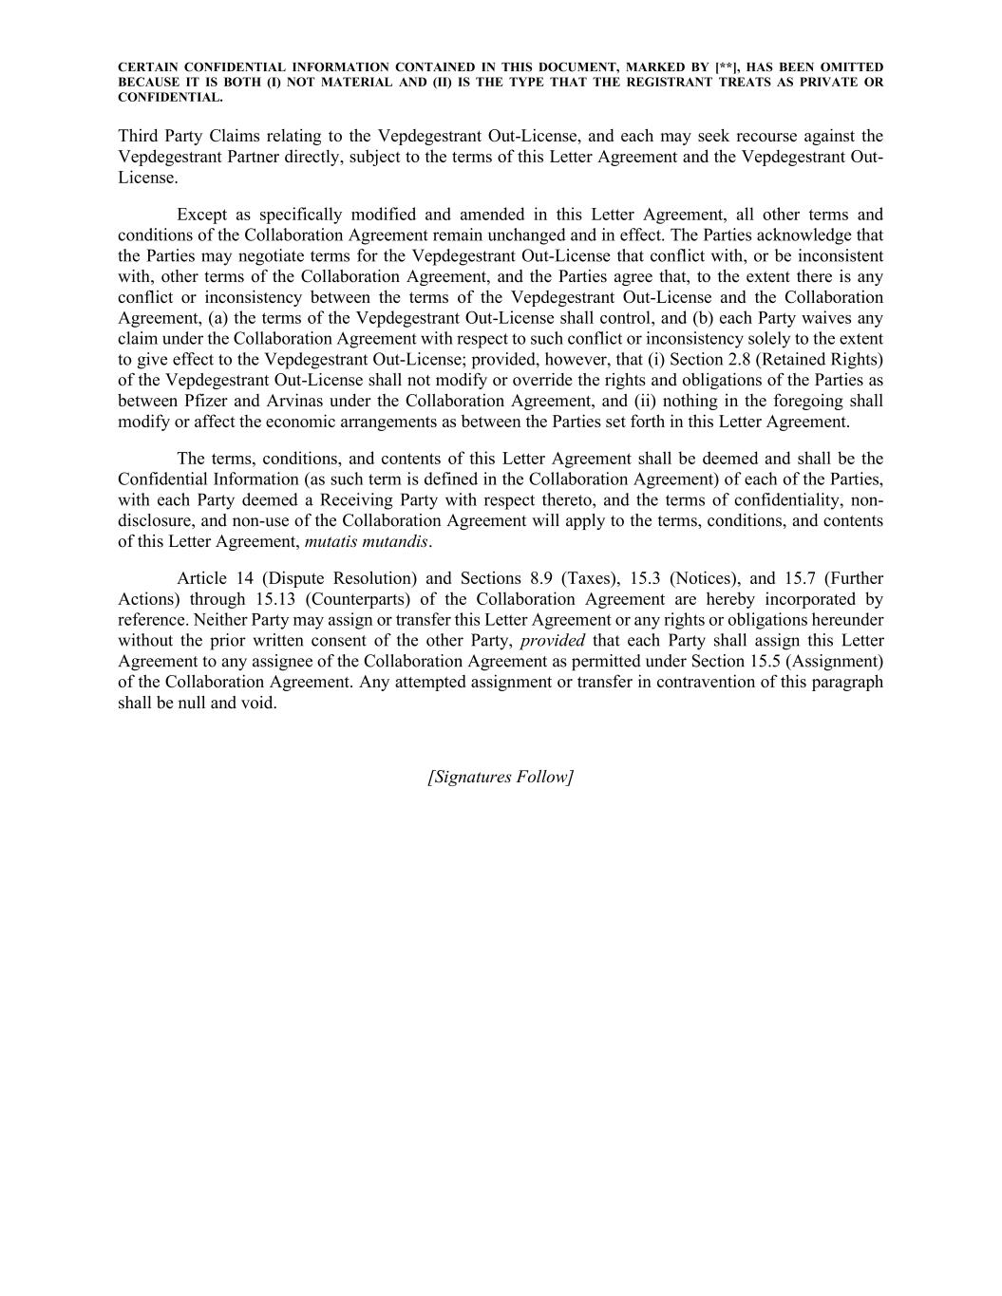
CERTAIN CONFIDENTIAL INFORMATION CONTAINED IN THIS DOCUMENT, MARKED BY [**], HAS BEEN OMITTED BECAUSE IT IS BOTH (I) NOT MATERIAL AND (II) IS THE TYPE THAT THE REGISTRANT TREATS AS PRIVATE OR CONFIDENTIAL. Third Party Claims relating to the Vepdegestrant Out-License, and each may seek recourse against the Vepdegestrant Partner directly, subject to the terms of this Letter Agreement and the Vepdegestrant Out- License. Except as specifically modified and amended in this Letter Agreement, all other terms and conditions of the Collaboration Agreement remain unchanged and in effect. The Parties acknowledge that the Parties may negotiate terms for the Vepdegestrant Out-License that conflict with, or be inconsistent with, other terms of the Collaboration Agreement, and the Parties agree that, to the extent there is any conflict or inconsistency between the terms of the Vepdegestrant Out-License and the Collaboration Agreement, (a) the terms of the Vepdegestrant Out-License shall control, and (b) each Party waives any claim under the Collaboration Agreement with respect to such conflict or inconsistency solely to the extent to give effect to the Vepdegestrant Out-License; provided, however, that (i) Section 2.8 (Retained Rights) of the Vepdegestrant Out-License shall not modify or override the rights and obligations of the Parties as between Pfizer and Arvinas under the Collaboration Agreement, and (ii) nothing in the foregoing shall modify or affect the economic arrangements as between the Parties set forth in this Letter Agreement. The terms, conditions, and contents of this Letter Agreement shall be deemed and shall be the Confidential Information (as such term is defined in the Collaboration Agreement) of each of the Parties, with each Party deemed a Receiving Party with respect thereto, and the terms of confidentiality, non- disclosure, and non-use of the Collaboration Agreement will apply to the terms, conditions, and contents of this Letter Agreement, mutatis mutandis. Article 14 (Dispute Resolution) and Sections 8.9 (Taxes), 15.3 (Notices), and 15.7 (Further Actions) through 15.13 (Counterparts) of the Collaboration Agreement are hereby incorporated by reference. Neither Party may assign or transfer this Letter Agreement or any rights or obligations hereunder without the prior written consent of the other Party, provided that each Party shall assign this Letter Agreement to any assignee of the Collaboration Agreement as permitted under Section 15.5 (Assignment) of the Collaboration Agreement. Any attempted assignment or transfer in contravention of this paragraph shall be null and void. [Signatures Follow]

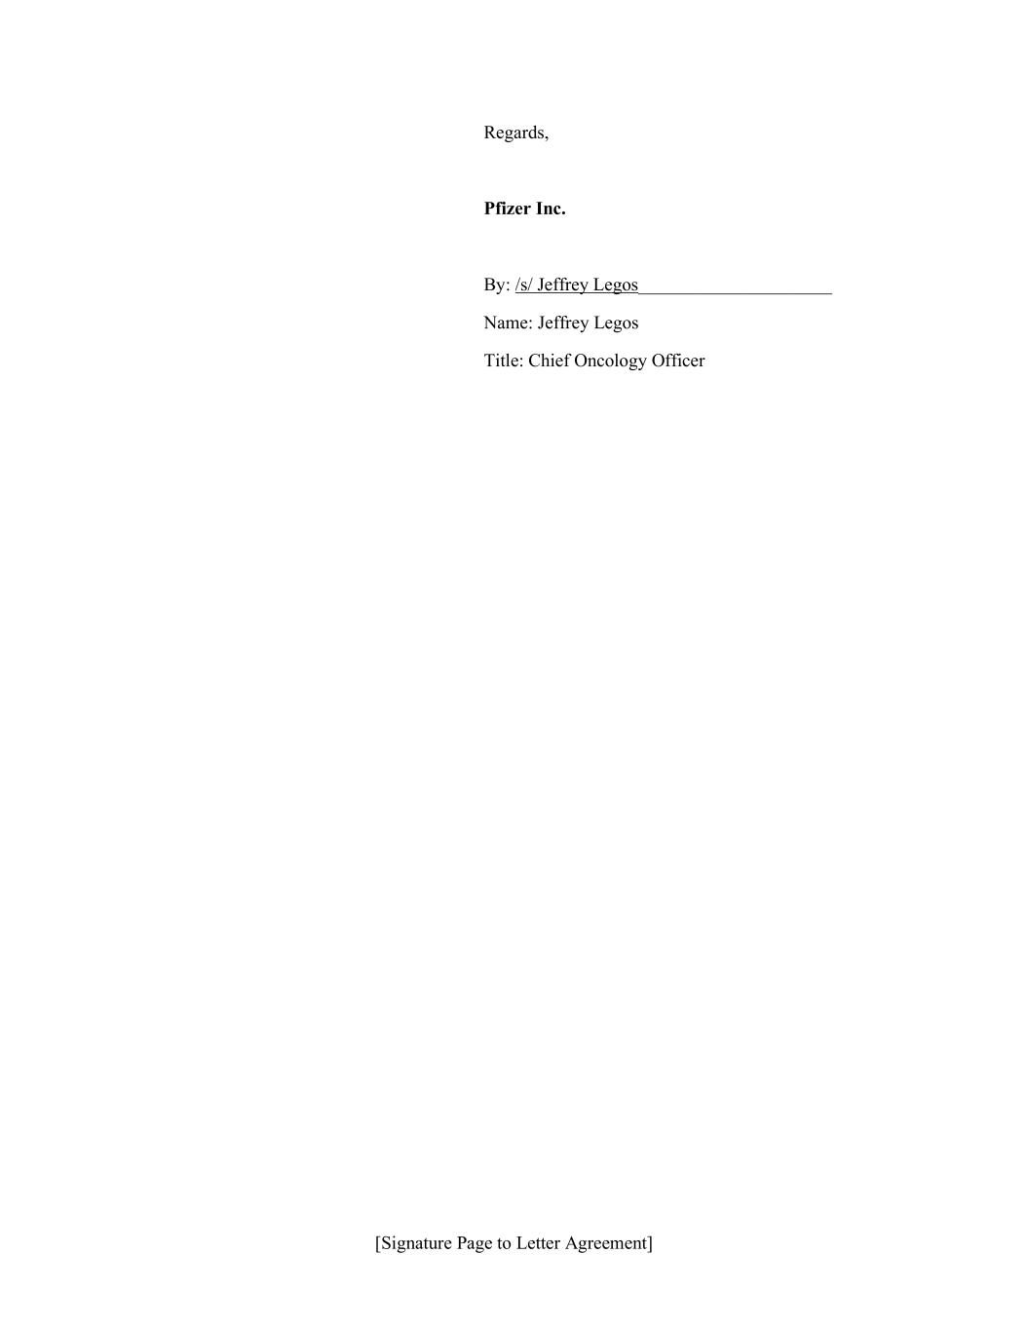
[Signature Page to Letter Agreement] Regards, Pfizer Inc. By: /s/ Jeffrey Legos_____________________ Name: Jeffrey Legos Title: Chief Oncology Officer

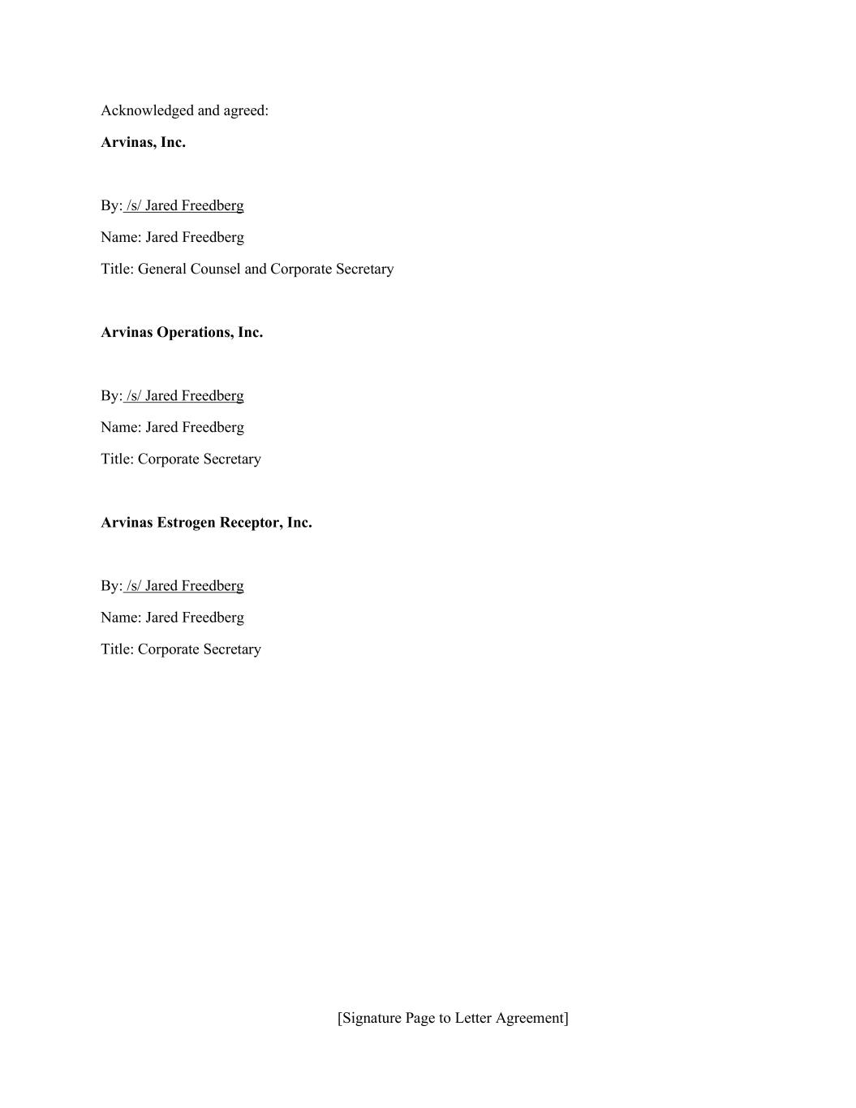
[Signature Page to Letter Agreement] Acknowledged and agreed: Arvinas, Inc. By: /s/ Jared Freedberg Name: Jared Freedberg Title: General Counsel and Corporate Secretary Arvinas Operations, Inc. By: /s/ Jared Freedberg Name: Jared Freedberg Title: Corporate Secretary Arvinas Estrogen Receptor, Inc. By: /s/ Jared Freedberg Name: Jared Freedberg Title: Corporate Secretary


[**]

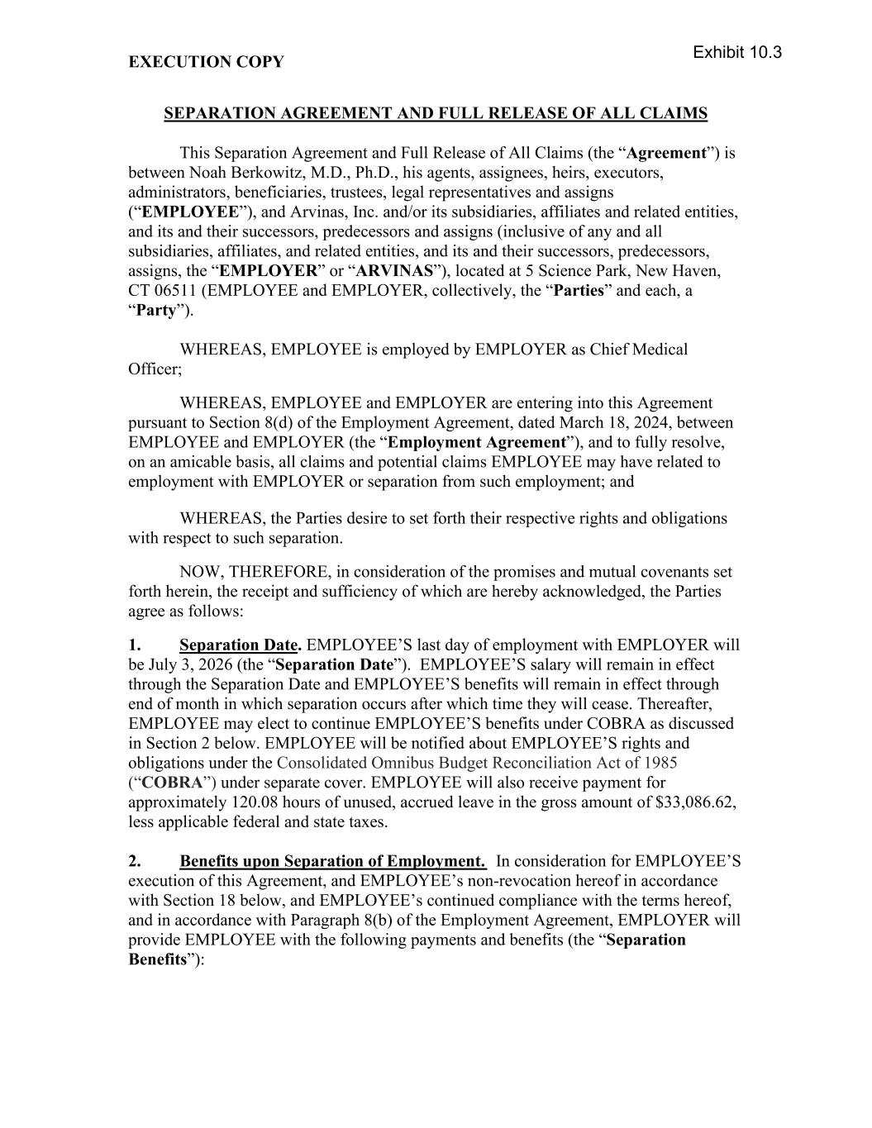
EXECUTION COPY SEPARATION AGREEMENT AND FULL RELEASE OF ALL CLAIMS This Separation Agreement and Full Release of All Claims (the “Agreement”) is between Noah Berkowitz, M.D., Ph.D., his agents, assignees, heirs, executors, administrators, beneficiaries, trustees, legal representatives and assigns (“EMPLOYEE”), and Arvinas, Inc. and/or its subsidiaries, affiliates and related entities, and its and their successors, predecessors and assigns (inclusive of any and all subsidiaries, affiliates, and related entities, and its and their successors, predecessors, assigns, the “EMPLOYER” or “ARVINAS”), located at 5 Science Park, New Haven, CT 06511 (EMPLOYEE and EMPLOYER, collectively, the “Parties” and each, a “Party”). WHEREAS, EMPLOYEE is employed by EMPLOYER as Chief Medical Officer; WHEREAS, EMPLOYEE and EMPLOYER are entering into this Agreement pursuant to Section 8(d) of the Employment Agreement, dated March 18, 2024, between EMPLOYEE and EMPLOYER (the “Employment Agreement”), and to fully resolve, on an amicable basis, all claims and potential claims EMPLOYEE may have related to employment with EMPLOYER or separation from such employment; and WHEREAS, the Parties desire to set forth their respective rights and obligations with respect to such separation. NOW, THEREFORE, in consideration of the promises and mutual covenants set forth herein, the receipt and sufficiency of which are hereby acknowledged, the Parties agree as follows: 1. Separation Date. EMPLOYEE’S last day of employment with EMPLOYER will be July 3, 2026 (the “Separation Date”). EMPLOYEE’S salary will remain in effect through the Separation Date and EMPLOYEE’S benefits will remain in effect through end of month in which separation occurs after which time they will cease. Thereafter, EMPLOYEE may elect to continue EMPLOYEE’S benefits under COBRA as discussed in Section 2 below. EMPLOYEE will be notified about EMPLOYEE’S rights and obligations under the Consolidated Omnibus Budget Reconciliation Act of 1985 (“COBRA”) under separate cover. EMPLOYEE will also receive payment for approximately 120.08 hours of unused, accrued leave in the gross amount of $33,086.62, less applicable federal and state taxes. 2. Benefits upon Separation of Employment. In consideration for EMPLOYEE’S execution of this Agreement, and EMPLOYEE’s non-revocation hereof in accordance with Section 18 below, and EMPLOYEE’s continued compliance with the terms hereof, and in accordance with Paragraph 8(b) of the Employment Agreement, EMPLOYER will provide EMPLOYEE with the following payments and benefits (the “Separation Benefits”): Exhibit 10.3

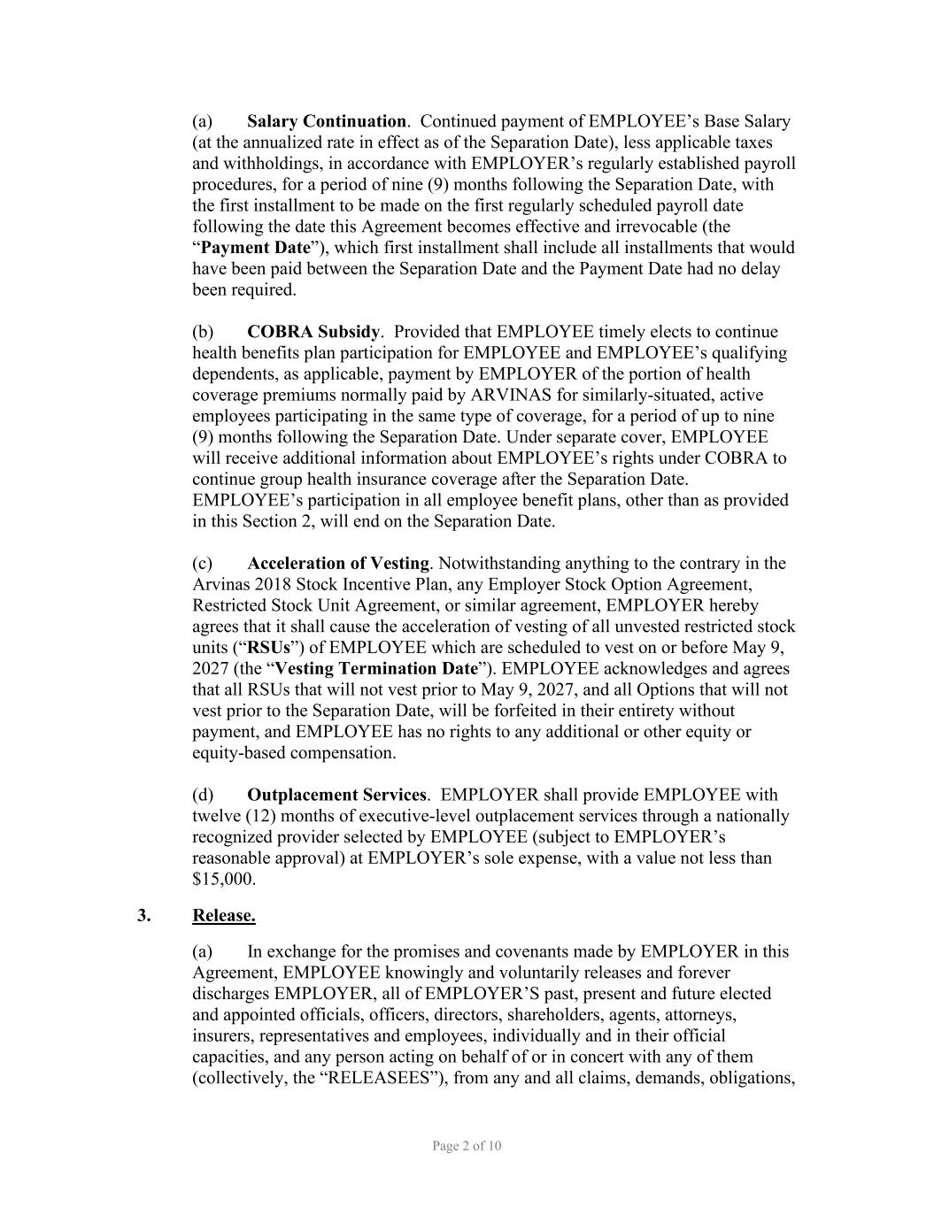
Page 2 of 10 (a) Salary Continuation. Continued payment of EMPLOYEE’s Base Salary (at the annualized rate in effect as of the Separation Date), less applicable taxes and withholdings, in accordance with EMPLOYER’s regularly established payroll procedures, for a period of nine (9) months following the Separation Date, with the first installment to be made on the first regularly scheduled payroll date following the date this Agreement becomes effective and irrevocable (the “Payment Date”), which first installment shall include all installments that would have been paid between the Separation Date and the Payment Date had no delay been required. (b) COBRA Subsidy. Provided that EMPLOYEE timely elects to continue health benefits plan participation for EMPLOYEE and EMPLOYEE’s qualifying dependents, as applicable, payment by EMPLOYER of the portion of health coverage premiums normally paid by ARVINAS for similarly-situated, active employees participating in the same type of coverage, for a period of up to nine (9) months following the Separation Date. Under separate cover, EMPLOYEE will receive additional information about EMPLOYEE’s rights under COBRA to continue group health insurance coverage after the Separation Date. EMPLOYEE’s participation in all employee benefit plans, other than as provided in this Section 2, will end on the Separation Date. (c) Acceleration of Vesting. Notwithstanding anything to the contrary in the Arvinas 2018 Stock Incentive Plan, any Employer Stock Option Agreement, Restricted Stock Unit Agreement, or similar agreement, EMPLOYER hereby agrees that it shall cause the acceleration of vesting of all unvested restricted stock units (“RSUs”) of EMPLOYEE which are scheduled to vest on or before May 9, 2027 (the “Vesting Termination Date”). EMPLOYEE acknowledges and agrees that all RSUs that will not vest prior to May 9, 2027, and all Options that will not vest prior to the Separation Date, will be forfeited in their entirety without payment, and EMPLOYEE has no rights to any additional or other equity or equity-based compensation. (d) Outplacement Services. EMPLOYER shall provide EMPLOYEE with twelve (12) months of executive-level outplacement services through a nationally recognized provider selected by EMPLOYEE (subject to EMPLOYER’s reasonable approval) at EMPLOYER’s sole expense, with a value not less than $15,000. 3. Release. (a) In exchange for the promises and covenants made by EMPLOYER in this Agreement, EMPLOYEE knowingly and voluntarily releases and forever discharges EMPLOYER, all of EMPLOYER’S past, present and future elected and appointed officials, officers, directors, shareholders, agents, attorneys, insurers, representatives and employees, individually and in their official capacities, and any person acting on behalf of or in concert with any of them (collectively, the “RELEASEES”), from any and all claims, demands, obligations,

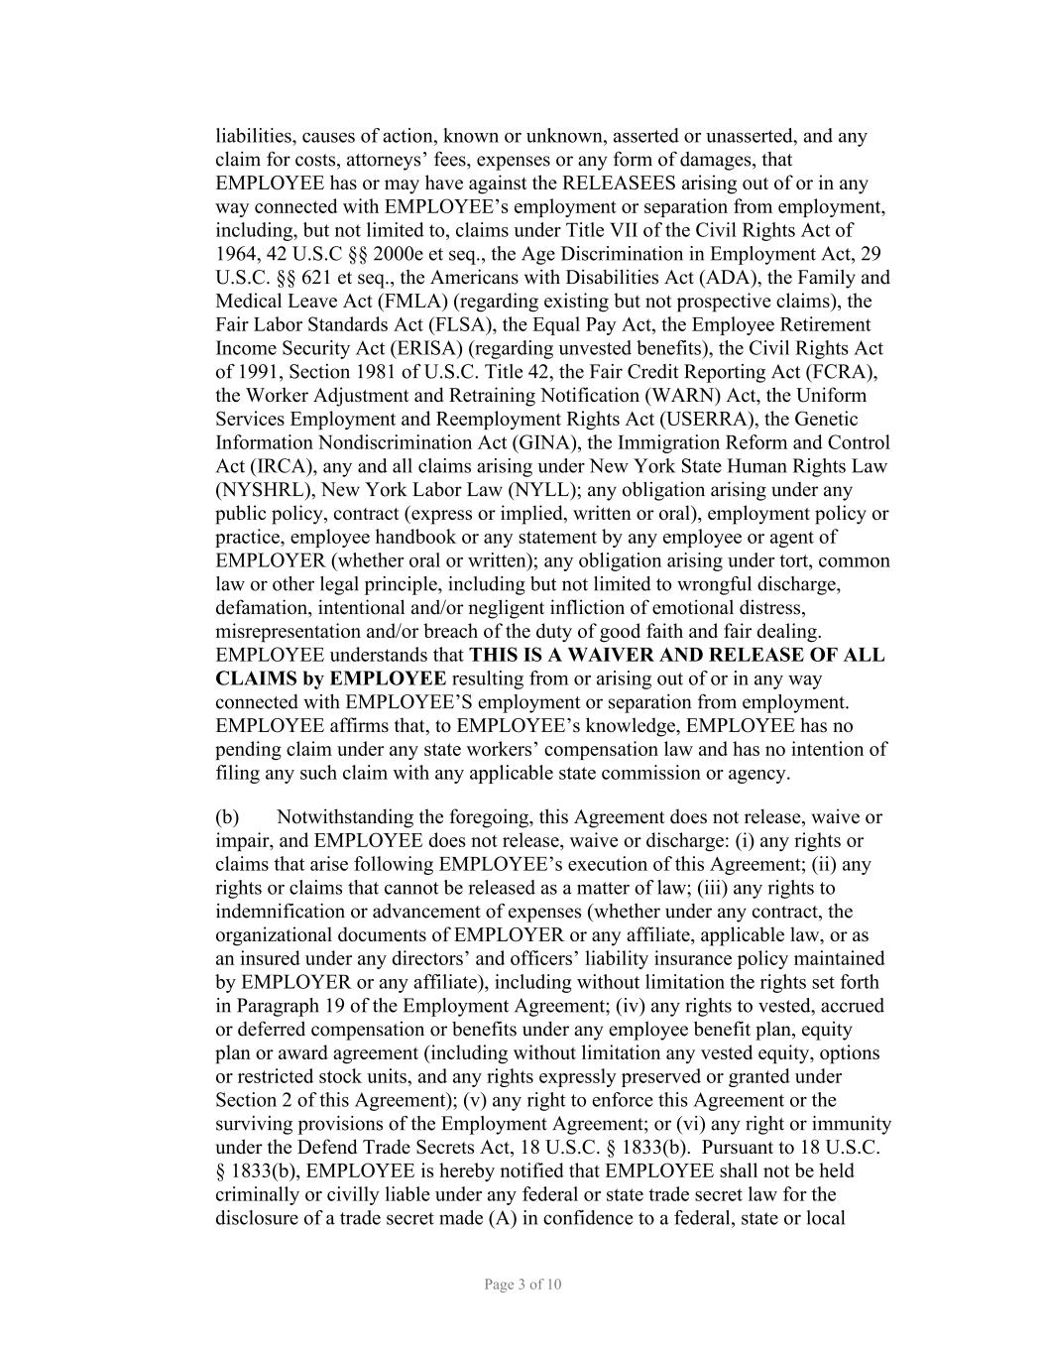
Page 3 of 10 liabilities, causes of action, known or unknown, asserted or unasserted, and any claim for costs, attorneys’ fees, expenses or any form of damages, that EMPLOYEE has or may have against the RELEASEES arising out of or in any way connected with EMPLOYEE’s employment or separation from employment, including, but not limited to, claims under Title VII of the Civil Rights Act of 1964, 42 U.S.C §§ 2000e et seq., the Age Discrimination in Employment Act, 29 U.S.C. §§ 621 et seq., the Americans with Disabilities Act (ADA), the Family and Medical Leave Act (FMLA) (regarding existing but not prospective claims), the Fair Labor Standards Act (FLSA), the Equal Pay Act, the Employee Retirement Income Security Act (ERISA) (regarding unvested benefits), the Civil Rights Act of 1991, Section 1981 of U.S.C. Title 42, the Fair Credit Reporting Act (FCRA), the Worker Adjustment and Retraining Notification (WARN) Act, the Uniform Services Employment and Reemployment Rights Act (USERRA), the Genetic Information Nondiscrimination Act (GINA), the Immigration Reform and Control Act (IRCA), any and all claims arising under New York State Human Rights Law (NYSHRL), New York Labor Law (NYLL); any obligation arising under any public policy, contract (express or implied, written or oral), employment policy or practice, employee handbook or any statement by any employee or agent of EMPLOYER (whether oral or written); any obligation arising under tort, common law or other legal principle, including but not limited to wrongful discharge, defamation, intentional and/or negligent infliction of emotional distress, misrepresentation and/or breach of the duty of good faith and fair dealing. EMPLOYEE understands that THIS IS A WAIVER AND RELEASE OF ALL CLAIMS by EMPLOYEE resulting from or arising out of or in any way connected with EMPLOYEE’S employment or separation from employment. EMPLOYEE affirms that, to EMPLOYEE’s knowledge, EMPLOYEE has no pending claim under any state workers’ compensation law and has no intention of filing any such claim with any applicable state commission or agency. (b) Notwithstanding the foregoing, this Agreement does not release, waive or impair, and EMPLOYEE does not release, waive or discharge: (i) any rights or claims that arise following EMPLOYEE’s execution of this Agreement; (ii) any rights or claims that cannot be released as a matter of law; (iii) any rights to indemnification or advancement of expenses (whether under any contract, the organizational documents of EMPLOYER or any affiliate, applicable law, or as an insured under any directors’ and officers’ liability insurance policy maintained by EMPLOYER or any affiliate), including without limitation the rights set forth in Paragraph 19 of the Employment Agreement; (iv) any rights to vested, accrued or deferred compensation or benefits under any employee benefit plan, equity plan or award agreement (including without limitation any vested equity, options or restricted stock units, and any rights expressly preserved or granted under Section 2 of this Agreement); (v) any right to enforce this Agreement or the surviving provisions of the Employment Agreement; or (vi) any right or immunity under the Defend Trade Secrets Act, 18 U.S.C. § 1833(b). Pursuant to 18 U.S.C. § 1833(b), EMPLOYEE is hereby notified that EMPLOYEE shall not be held criminally or civilly liable under any federal or state trade secret law for the disclosure of a trade secret made (A) in confidence to a federal, state or local

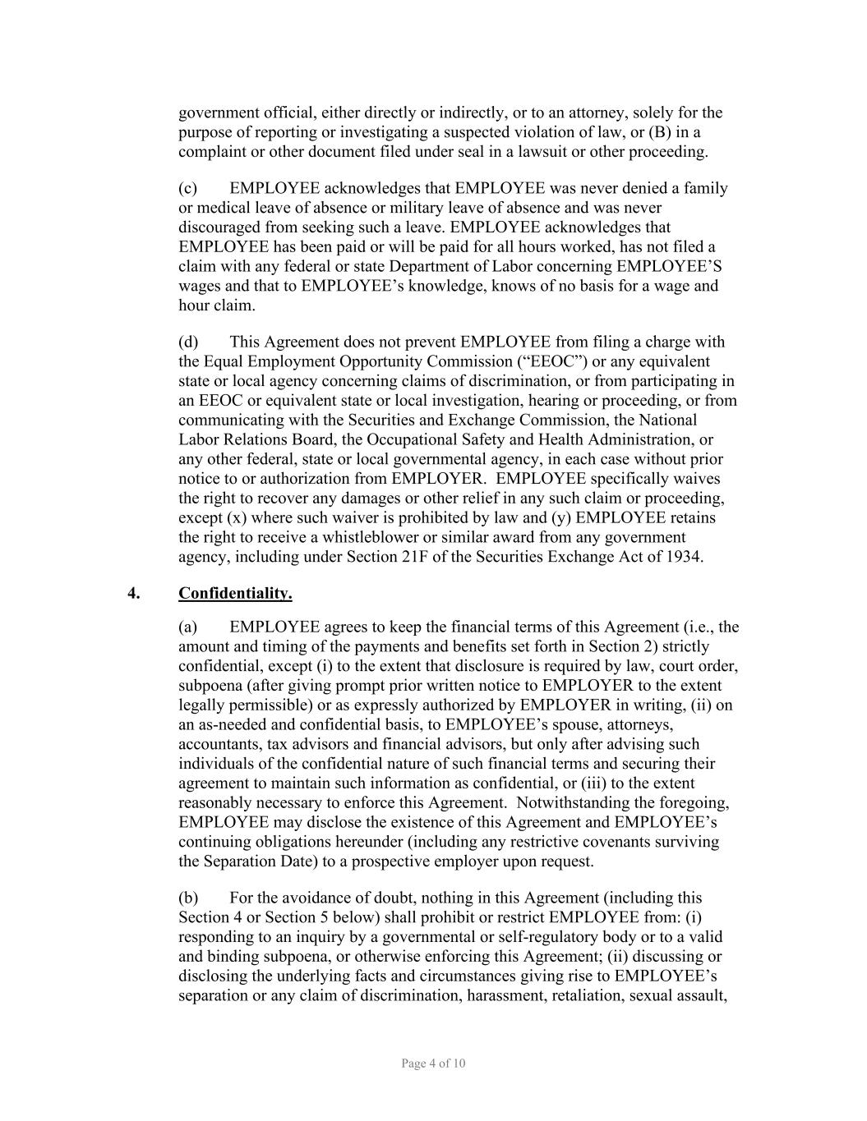
Page 4 of 10 government official, either directly or indirectly, or to an attorney, solely for the purpose of reporting or investigating a suspected violation of law, or (B) in a complaint or other document filed under seal in a lawsuit or other proceeding. (c) EMPLOYEE acknowledges that EMPLOYEE was never denied a family or medical leave of absence or military leave of absence and was never discouraged from seeking such a leave. EMPLOYEE acknowledges that EMPLOYEE has been paid or will be paid for all hours worked, has not filed a claim with any federal or state Department of Labor concerning EMPLOYEE’S wages and that to EMPLOYEE’s knowledge, knows of no basis for a wage and hour claim. (d) This Agreement does not prevent EMPLOYEE from filing a charge with the Equal Employment Opportunity Commission (“EEOC”) or any equivalent state or local agency concerning claims of discrimination, or from participating in an EEOC or equivalent state or local investigation, hearing or proceeding, or from communicating with the Securities and Exchange Commission, the National Labor Relations Board, the Occupational Safety and Health Administration, or any other federal, state or local governmental agency, in each case without prior notice to or authorization from EMPLOYER. EMPLOYEE specifically waives the right to recover any damages or other relief in any such claim or proceeding, except (x) where such waiver is prohibited by law and (y) EMPLOYEE retains the right to receive a whistleblower or similar award from any government agency, including under Section 21F of the Securities Exchange Act of 1934. 4. Confidentiality. (a) EMPLOYEE agrees to keep the financial terms of this Agreement (i.e., the amount and timing of the payments and benefits set forth in Section 2) strictly confidential, except (i) to the extent that disclosure is required by law, court order, subpoena (after giving prompt prior written notice to EMPLOYER to the extent legally permissible) or as expressly authorized by EMPLOYER in writing, (ii) on an as-needed and confidential basis, to EMPLOYEE’s spouse, attorneys, accountants, tax advisors and financial advisors, but only after advising such individuals of the confidential nature of such financial terms and securing their agreement to maintain such information as confidential, or (iii) to the extent reasonably necessary to enforce this Agreement. Notwithstanding the foregoing, EMPLOYEE may disclose the existence of this Agreement and EMPLOYEE’s continuing obligations hereunder (including any restrictive covenants surviving the Separation Date) to a prospective employer upon request. (b) For the avoidance of doubt, nothing in this Agreement (including this Section 4 or Section 5 below) shall prohibit or restrict EMPLOYEE from: (i) responding to an inquiry by a governmental or self-regulatory body or to a valid and binding subpoena, or otherwise enforcing this Agreement; (ii) discussing or disclosing the underlying facts and circumstances giving rise to EMPLOYEE’s separation or any claim of discrimination, harassment, retaliation, sexual assault,

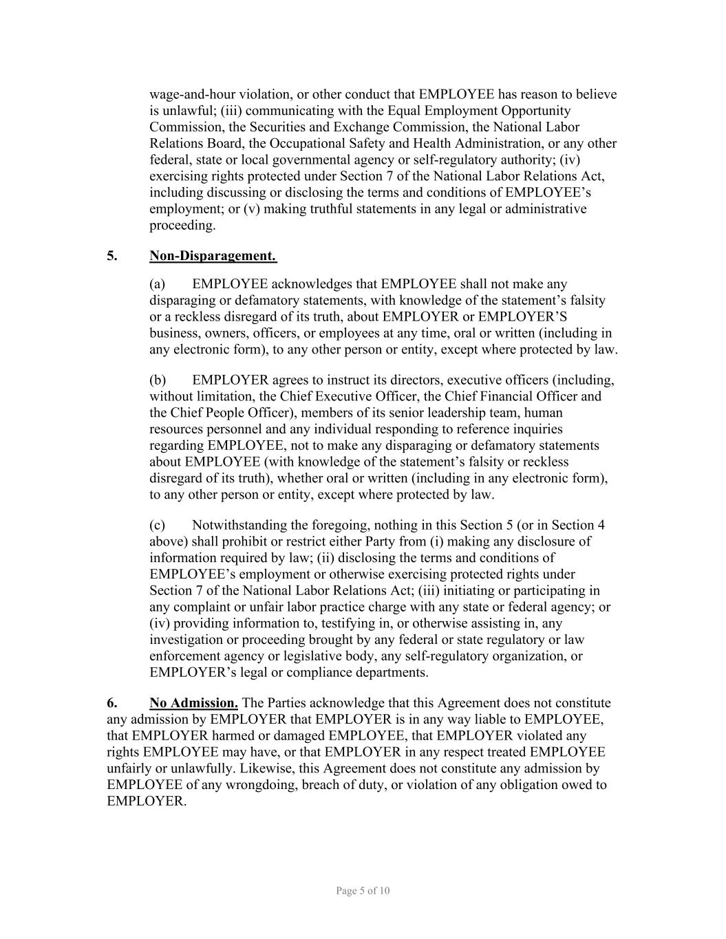
Page 5 of 10 wage-and-hour violation, or other conduct that EMPLOYEE has reason to believe is unlawful; (iii) communicating with the Equal Employment Opportunity Commission, the Securities and Exchange Commission, the National Labor Relations Board, the Occupational Safety and Health Administration, or any other federal, state or local governmental agency or self-regulatory authority; (iv) exercising rights protected under Section 7 of the National Labor Relations Act, including discussing or disclosing the terms and conditions of EMPLOYEE’s employment; or (v) making truthful statements in any legal or administrative proceeding. 5. Non-Disparagement. (a) EMPLOYEE acknowledges that EMPLOYEE shall not make any disparaging or defamatory statements, with knowledge of the statement’s falsity or a reckless disregard of its truth, about EMPLOYER or EMPLOYER’S business, owners, officers, or employees at any time, oral or written (including in any electronic form), to any other person or entity, except where protected by law. (b) EMPLOYER agrees to instruct its directors, executive officers (including, without limitation, the Chief Executive Officer, the Chief Financial Officer and the Chief People Officer), members of its senior leadership team, human resources personnel and any individual responding to reference inquiries regarding EMPLOYEE, not to make any disparaging or defamatory statements about EMPLOYEE (with knowledge of the statement’s falsity or reckless disregard of its truth), whether oral or written (including in any electronic form), to any other person or entity, except where protected by law. (c) Notwithstanding the foregoing, nothing in this Section 5 (or in Section 4 above) shall prohibit or restrict either Party from (i) making any disclosure of information required by law; (ii) disclosing the terms and conditions of EMPLOYEE’s employment or otherwise exercising protected rights under Section 7 of the National Labor Relations Act; (iii) initiating or participating in any complaint or unfair labor practice charge with any state or federal agency; or (iv) providing information to, testifying in, or otherwise assisting in, any investigation or proceeding brought by any federal or state regulatory or law enforcement agency or legislative body, any self-regulatory organization, or EMPLOYER’s legal or compliance departments. 6. No Admission. The Parties acknowledge that this Agreement does not constitute any admission by EMPLOYER that EMPLOYER is in any way liable to EMPLOYEE, that EMPLOYER harmed or damaged EMPLOYEE, that EMPLOYER violated any rights EMPLOYEE may have, or that EMPLOYER in any respect treated EMPLOYEE unfairly or unlawfully. Likewise, this Agreement does not constitute any admission by EMPLOYEE of any wrongdoing, breach of duty, or violation of any obligation owed to EMPLOYER.

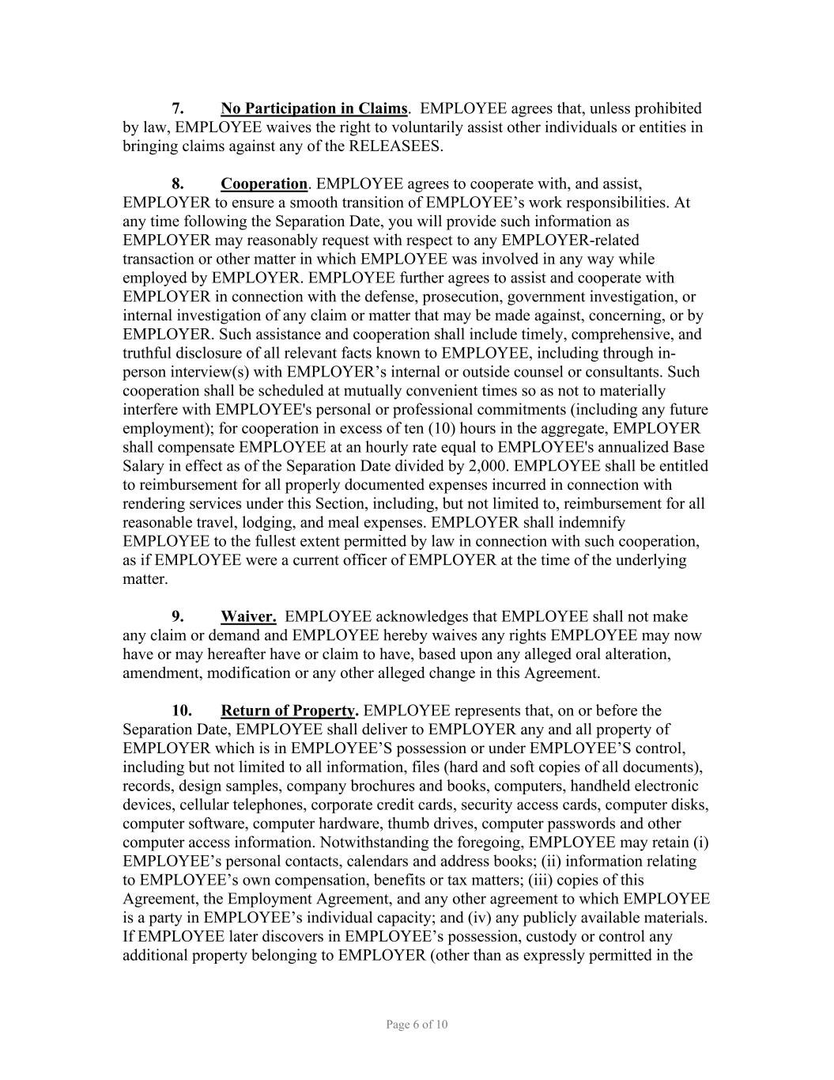
Page 6 of 10 7. No Participation in Claims. EMPLOYEE agrees that, unless prohibited by law, EMPLOYEE waives the right to voluntarily assist other individuals or entities in bringing claims against any of the RELEASEES. 8. Cooperation. EMPLOYEE agrees to cooperate with, and assist, EMPLOYER to ensure a smooth transition of EMPLOYEE’s work responsibilities. At any time following the Separation Date, you will provide such information as EMPLOYER may reasonably request with respect to any EMPLOYER-related transaction or other matter in which EMPLOYEE was involved in any way while employed by EMPLOYER. EMPLOYEE further agrees to assist and cooperate with EMPLOYER in connection with the defense, prosecution, government investigation, or internal investigation of any claim or matter that may be made against, concerning, or by EMPLOYER. Such assistance and cooperation shall include timely, comprehensive, and truthful disclosure of all relevant facts known to EMPLOYEE, including through in- person interview(s) with EMPLOYER’s internal or outside counsel or consultants. Such cooperation shall be scheduled at mutually convenient times so as not to materially interfere with EMPLOYEE's personal or professional commitments (including any future employment); for cooperation in excess of ten (10) hours in the aggregate, EMPLOYER shall compensate EMPLOYEE at an hourly rate equal to EMPLOYEE's annualized Base Salary in effect as of the Separation Date divided by 2,000. EMPLOYEE shall be entitled to reimbursement for all properly documented expenses incurred in connection with rendering services under this Section, including, but not limited to, reimbursement for all reasonable travel, lodging, and meal expenses. EMPLOYER shall indemnify EMPLOYEE to the fullest extent permitted by law in connection with such cooperation, as if EMPLOYEE were a current officer of EMPLOYER at the time of the underlying matter. 9. Waiver. EMPLOYEE acknowledges that EMPLOYEE shall not make any claim or demand and EMPLOYEE hereby waives any rights EMPLOYEE may now have or may hereafter have or claim to have, based upon any alleged oral alteration, amendment, modification or any other alleged change in this Agreement. 10. Return of Property. EMPLOYEE represents that, on or before the Separation Date, EMPLOYEE shall deliver to EMPLOYER any and all property of EMPLOYER which is in EMPLOYEE’S possession or under EMPLOYEE’S control, including but not limited to all information, files (hard and soft copies of all documents), records, design samples, company brochures and books, computers, handheld electronic devices, cellular telephones, corporate credit cards, security access cards, computer disks, computer software, computer hardware, thumb drives, computer passwords and other computer access information. Notwithstanding the foregoing, EMPLOYEE may retain (i) EMPLOYEE’s personal contacts, calendars and address books; (ii) information relating to EMPLOYEE’s own compensation, benefits or tax matters; (iii) copies of this Agreement, the Employment Agreement, and any other agreement to which EMPLOYEE is a party in EMPLOYEE’s individual capacity; and (iv) any publicly available materials. If EMPLOYEE later discovers in EMPLOYEE’s possession, custody or control any additional property belonging to EMPLOYER (other than as expressly permitted in the

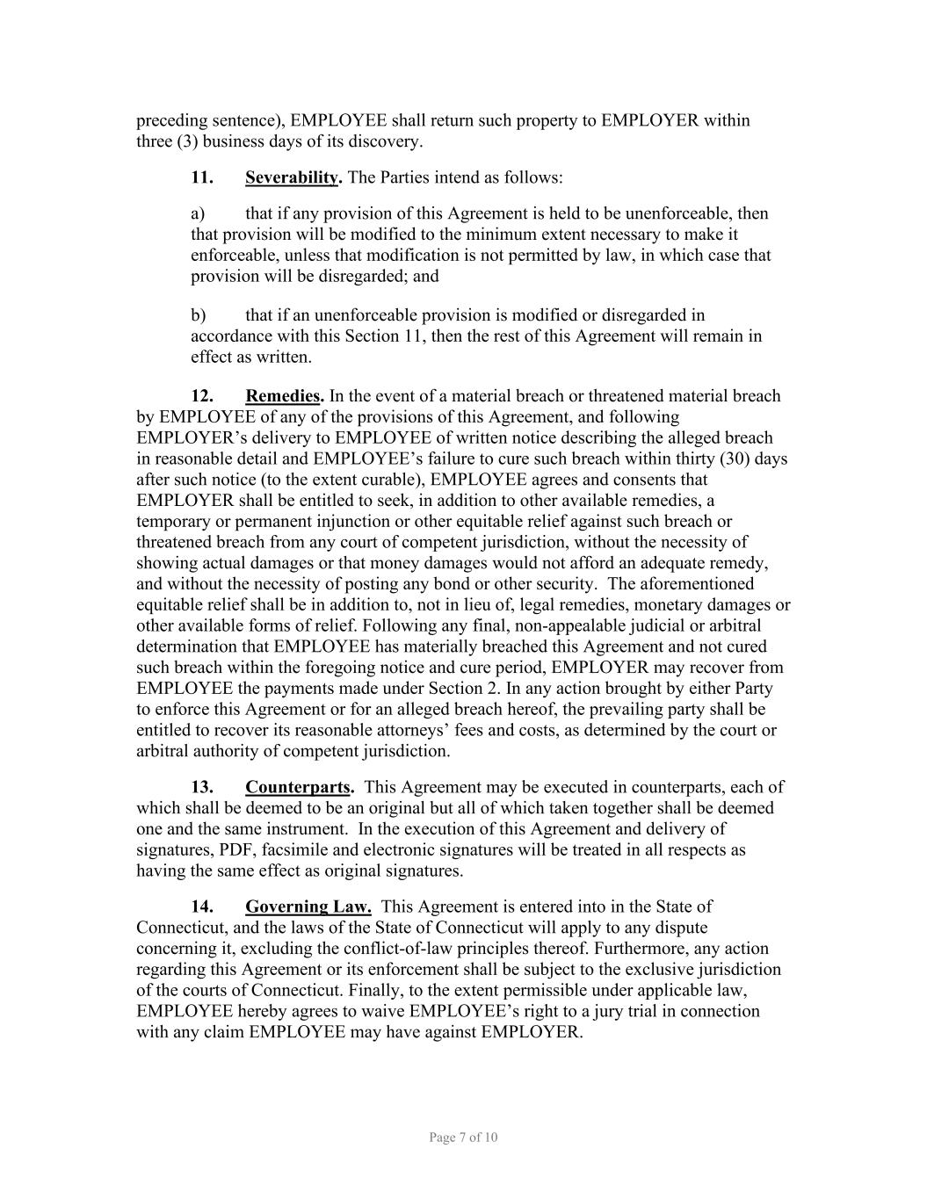
Page 7 of 10 preceding sentence), EMPLOYEE shall return such property to EMPLOYER within three (3) business days of its discovery. 11. Severability. The Parties intend as follows: a) that if any provision of this Agreement is held to be unenforceable, then that provision will be modified to the minimum extent necessary to make it enforceable, unless that modification is not permitted by law, in which case that provision will be disregarded; and b) that if an unenforceable provision is modified or disregarded in accordance with this Section 11, then the rest of this Agreement will remain in effect as written. 12. Remedies. In the event of a material breach or threatened material breach by EMPLOYEE of any of the provisions of this Agreement, and following EMPLOYER’s delivery to EMPLOYEE of written notice describing the alleged breach in reasonable detail and EMPLOYEE’s failure to cure such breach within thirty (30) days after such notice (to the extent curable), EMPLOYEE agrees and consents that EMPLOYER shall be entitled to seek, in addition to other available remedies, a temporary or permanent injunction or other equitable relief against such breach or threatened breach from any court of competent jurisdiction, without the necessity of showing actual damages or that money damages would not afford an adequate remedy, and without the necessity of posting any bond or other security. The aforementioned equitable relief shall be in addition to, not in lieu of, legal remedies, monetary damages or other available forms of relief. Following any final, non-appealable judicial or arbitral determination that EMPLOYEE has materially breached this Agreement and not cured such breach within the foregoing notice and cure period, EMPLOYER may recover from EMPLOYEE the payments made under Section 2. In any action brought by either Party to enforce this Agreement or for an alleged breach hereof, the prevailing party shall be entitled to recover its reasonable attorneys’ fees and costs, as determined by the court or arbitral authority of competent jurisdiction. 13. Counterparts. This Agreement may be executed in counterparts, each of which shall be deemed to be an original but all of which taken together shall be deemed one and the same instrument. In the execution of this Agreement and delivery of signatures, PDF, facsimile and electronic signatures will be treated in all respects as having the same effect as original signatures. 14. Governing Law. This Agreement is entered into in the State of Connecticut, and the laws of the State of Connecticut will apply to any dispute concerning it, excluding the conflict-of-law principles thereof. Furthermore, any action regarding this Agreement or its enforcement shall be subject to the exclusive jurisdiction of the courts of Connecticut. Finally, to the extent permissible under applicable law, EMPLOYEE hereby agrees to waive EMPLOYEE’s right to a jury trial in connection with any claim EMPLOYEE may have against EMPLOYER.

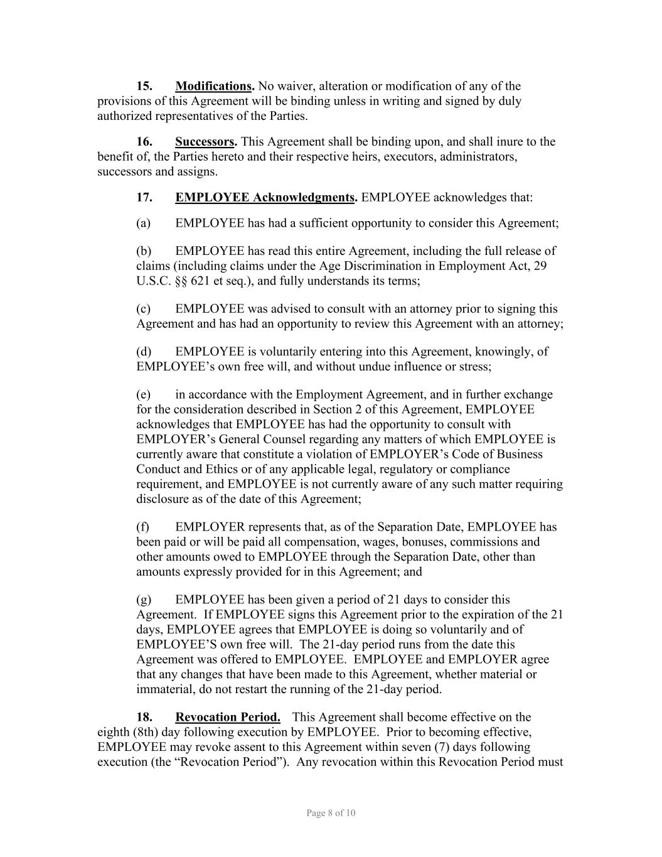
Page 8 of 10 15. Modifications. No waiver, alteration or modification of any of the provisions of this Agreement will be binding unless in writing and signed by duly authorized representatives of the Parties. 16. Successors. This Agreement shall be binding upon, and shall inure to the benefit of, the Parties hereto and their respective heirs, executors, administrators, successors and assigns. 17. EMPLOYEE Acknowledgments. EMPLOYEE acknowledges that: (a) EMPLOYEE has had a sufficient opportunity to consider this Agreement; (b) EMPLOYEE has read this entire Agreement, including the full release of claims (including claims under the Age Discrimination in Employment Act, 29 U.S.C. §§ 621 et seq.), and fully understands its terms; (c) EMPLOYEE was advised to consult with an attorney prior to signing this Agreement and has had an opportunity to review this Agreement with an attorney; (d) EMPLOYEE is voluntarily entering into this Agreement, knowingly, of EMPLOYEE’s own free will, and without undue influence or stress; (e) in accordance with the Employment Agreement, and in further exchange for the consideration described in Section 2 of this Agreement, EMPLOYEE acknowledges that EMPLOYEE has had the opportunity to consult with EMPLOYER’s General Counsel regarding any matters of which EMPLOYEE is currently aware that constitute a violation of EMPLOYER’s Code of Business Conduct and Ethics or of any applicable legal, regulatory or compliance requirement, and EMPLOYEE is not currently aware of any such matter requiring disclosure as of the date of this Agreement; (f) EMPLOYER represents that, as of the Separation Date, EMPLOYEE has been paid or will be paid all compensation, wages, bonuses, commissions and other amounts owed to EMPLOYEE through the Separation Date, other than amounts expressly provided for in this Agreement; and (g) EMPLOYEE has been given a period of 21 days to consider this Agreement. If EMPLOYEE signs this Agreement prior to the expiration of the 21 days, EMPLOYEE agrees that EMPLOYEE is doing so voluntarily and of EMPLOYEE’S own free will. The 21-day period runs from the date this Agreement was offered to EMPLOYEE. EMPLOYEE and EMPLOYER agree that any changes that have been made to this Agreement, whether material or immaterial, do not restart the running of the 21-day period. 18. Revocation Period. This Agreement shall become effective on the eighth (8th) day following execution by EMPLOYEE. Prior to becoming effective, EMPLOYEE may revoke assent to this Agreement within seven (7) days following execution (the “Revocation Period”). Any revocation within this Revocation Period must

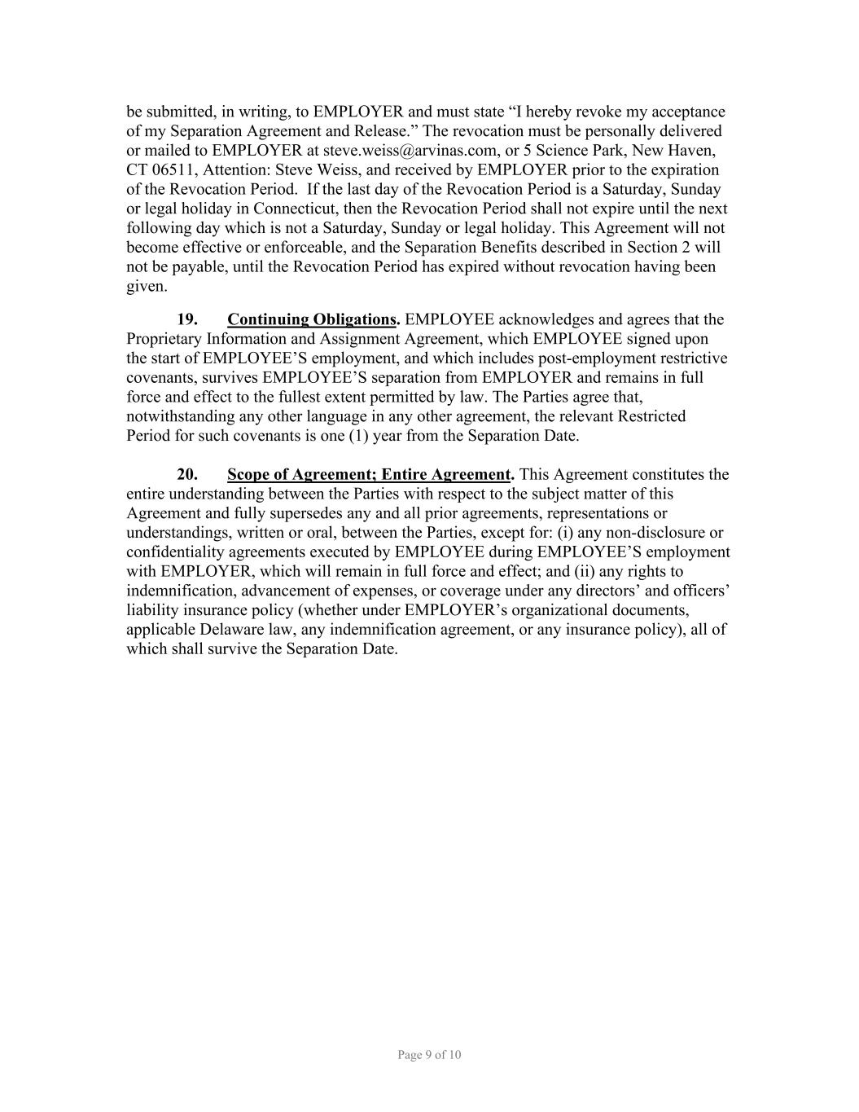
Page 9 of 10 be submitted, in writing, to EMPLOYER and must state “I hereby revoke my acceptance of my Separation Agreement and Release.” The revocation must be personally delivered or mailed to EMPLOYER at steve.weiss@arvinas.com, or 5 Science Park, New Haven, CT 06511, Attention: Steve Weiss, and received by EMPLOYER prior to the expiration of the Revocation Period. If the last day of the Revocation Period is a Saturday, Sunday or legal holiday in Connecticut, then the Revocation Period shall not expire until the next following day which is not a Saturday, Sunday or legal holiday. This Agreement will not become effective or enforceable, and the Separation Benefits described in Section 2 will not be payable, until the Revocation Period has expired without revocation having been given. 19. Continuing Obligations. EMPLOYEE acknowledges and agrees that the Proprietary Information and Assignment Agreement, which EMPLOYEE signed upon the start of EMPLOYEE’S employment, and which includes post-employment restrictive covenants, survives EMPLOYEE’S separation from EMPLOYER and remains in full force and effect to the fullest extent permitted by law. The Parties agree that, notwithstanding any other language in any other agreement, the relevant Restricted Period for such covenants is one (1) year from the Separation Date. 20. Scope of Agreement; Entire Agreement. This Agreement constitutes the entire understanding between the Parties with respect to the subject matter of this Agreement and fully supersedes any and all prior agreements, representations or understandings, written or oral, between the Parties, except for: (i) any non-disclosure or confidentiality agreements executed by EMPLOYEE during EMPLOYEE’S employment with EMPLOYER, which will remain in full force and effect; and (ii) any rights to indemnification, advancement of expenses, or coverage under any directors’ and officers’ liability insurance policy (whether under EMPLOYER’s organizational documents, applicable Delaware law, any indemnification agreement, or any insurance policy), all of which shall survive the Separation Date.

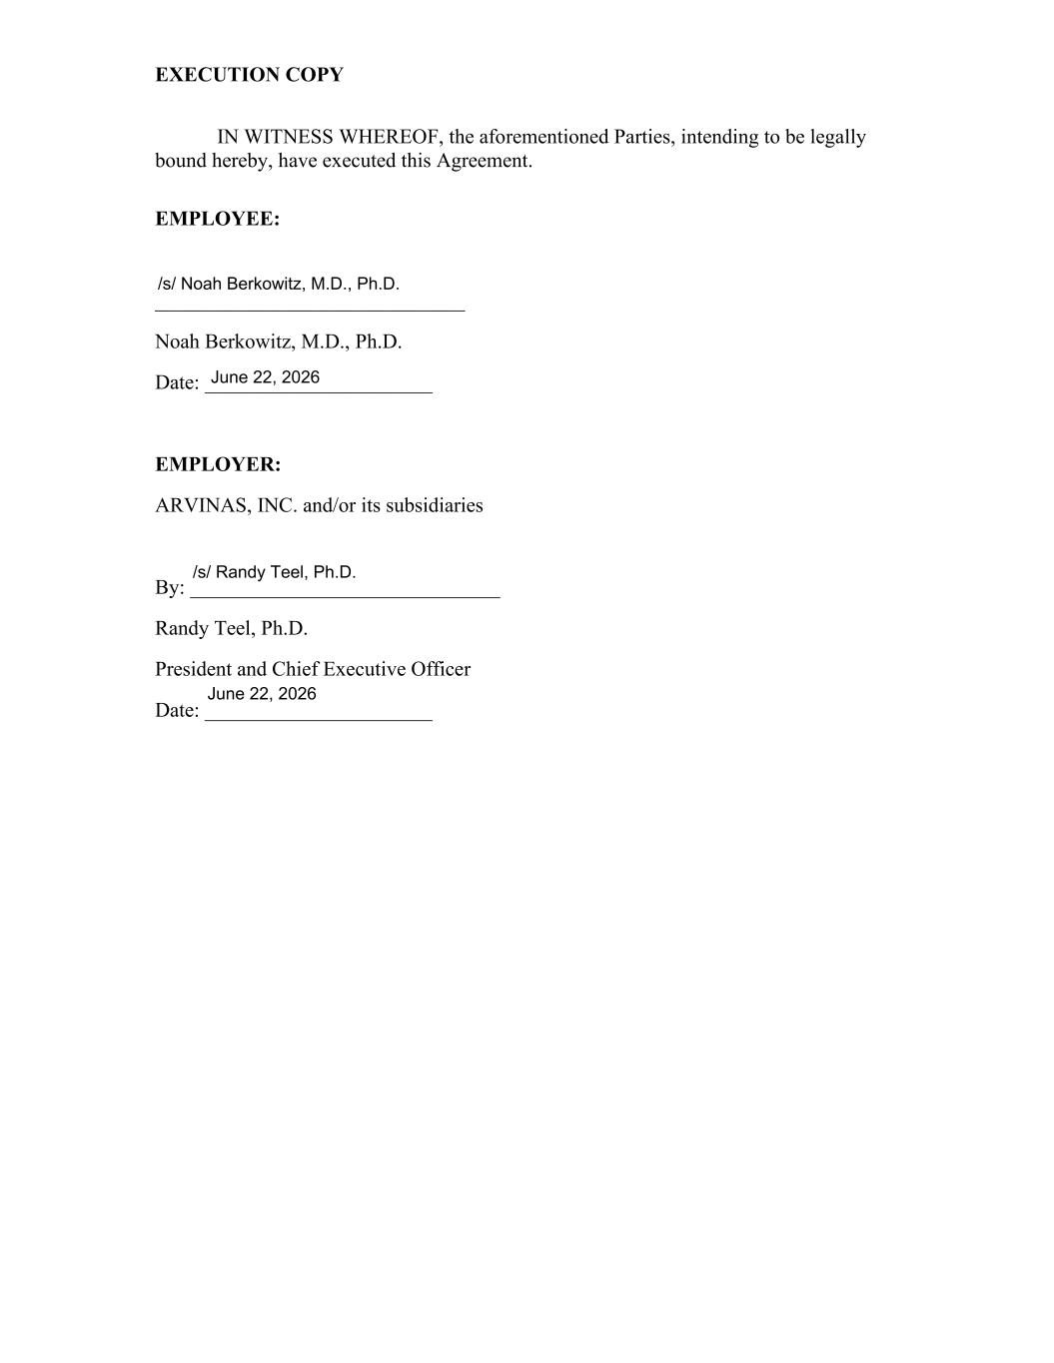
EXECUTION COPY IN WITNESS WHEREOF, the aforementioned Parties, intending to be legally bound hereby, have executed this Agreement. EMPLOYEE: ______________________________ Noah Berkowitz, M.D., Ph.D. Date: ______________________ EMPLOYER: ARVINAS, INC. and/or its subsidiaries By: ______________________________ Randy Teel, Ph.D. President and Chief Executive Officer Date: ______________________ /s/ Noah Berkowitz, M.D., Ph.D. June 22, 2026 June 22, 2026 /s/ Randy Teel, Ph.D.

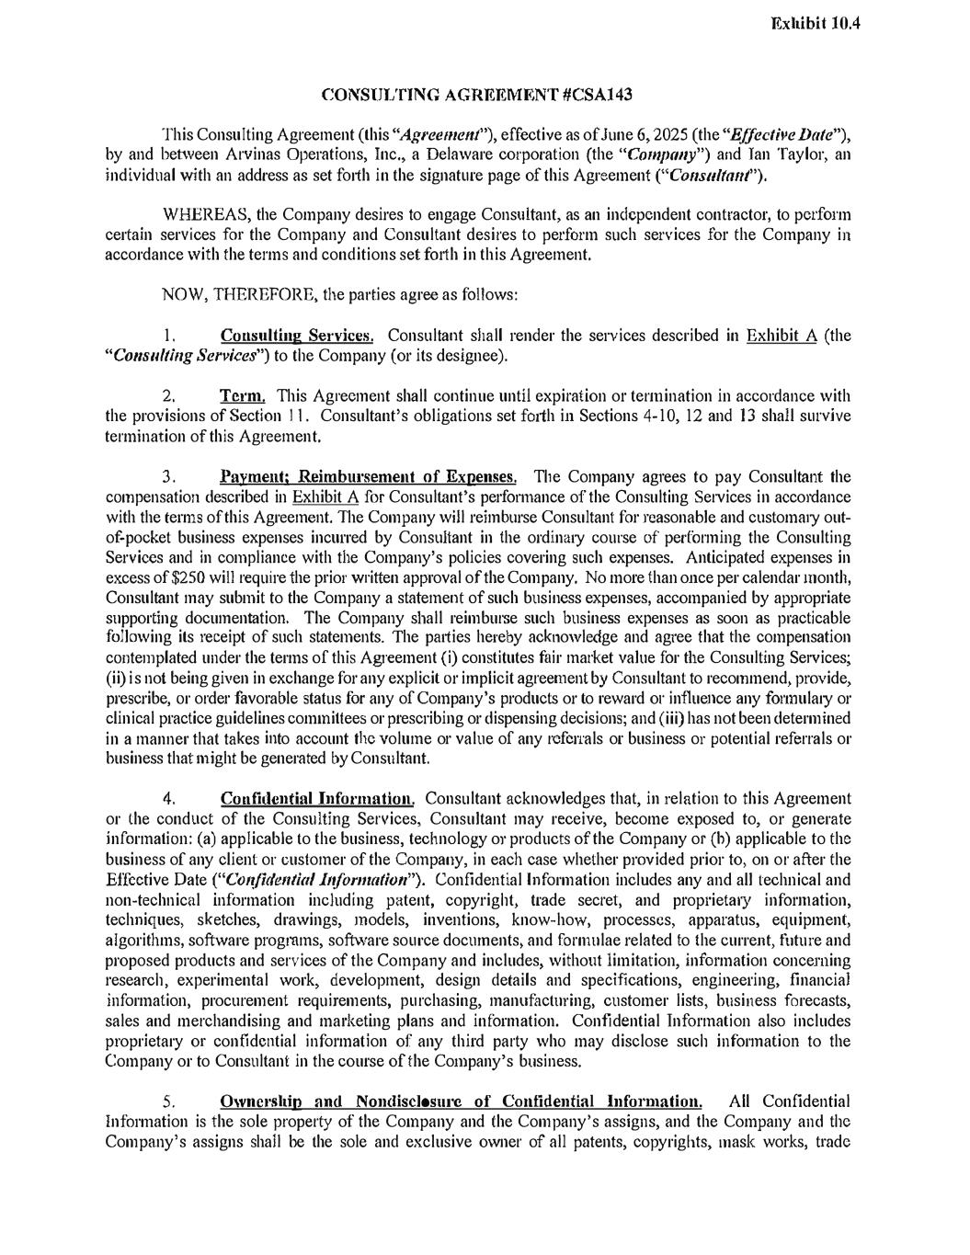
CONSULTING AGREEMENT #CSA143 This Consulting Agreement (this "Agreemetll"), effective as of June 6, 2025 (the "Effective Date"), by and between Arvinas Operations, Inc., a Delaware corporation (the "Compo11y") and Jan Taylor, an individual with an address as set fo1ih in the signature page of this Agreement ("Co11s11/ta11t"). WHEREAS, the Company desires to engage Consultant, as an independent contractor, to petform certain services for the Company and Consultant desires to pe1form such services for the Company in accordance with the terms and conditions set forth in this Agreement. NOW, THEREFORE, the parties agree as follows: 1. Consulting Services. Consultant shall render the services described in Exhibit A (the "Cou.sulting Services") to the Company (or its designee). 2. Te1·m. This Agreement shall continue until expiration or termination in accordance with the provisions of Section 11. Consultant's obligations set fo1ih in Sections 4-10, 12 and 13 shall survive termination of this Agreement. 3. Payment; Reimbul'sement of Expenses. TI1e Company agrees to pay Consultant the compensation described in Exhibit A for Consultant's perfomiance of the Consulting Services in accordance with the tenns of this Agreement. The Company will reimburse Consultant for reasonable and customary out of-pocket business expenses incurred by Consultant in the ordinaty course of performing the Consulting Services and in compliance with the Company's policies covering such expenses. Anticipated expenses in excess of $250 will require the prior written approval of the Company. No more than once per calendar month, Consultant may submit to the Company a statement of such business expenses, accompanied by appropriate supporting documentation. The Company shall reimburse such business expenses as soon as practicable following its receipt of such statements. The patiies hereby acknowledge and agree that the compensation contemplated under the terms of this Agreement (i) constitutes fair market value for the Consulting Services; (ii) is not being given in exchange for any explicit or implicit agreement by Consultant to recommend, provide, prescribe, or order favorable status for any of Company's products or to reward or influence any fonnulary or clinical practice guidelines committees or prescribing or dispensing decisions; and (iii) has not been determined in a manner that takes into account the volume or value of any referrals or business or potential referrals or business that might be generated by Consultant. 4. Confidential Infonnation. Consultant acknowledges that, in relation to this Agreement or the conduct of the Consulting Services, Consultant may receive, become exposed to, or generate information: (a) applicable to the business, technology or products of the Company or (b) applicable to the business of any client or customer of the Company, in each case whether provided prior to, on or after the Effective Date ("Co11jidential I11formalio11"). Confidential Information includes any and all technical and non-technical information including patent, copyright, trade secret, and proprieta1y information, techniques, sketches, drawings, models, inventions, know-how, processes, apparatus, equipment, algorithms, software programs, software source documents, and formulae related to the current, future and proposed products and services of the Company and includes, without limitation, information concerning research, experimental work, development, design details and specifications, engineering, financial information, procurement requirements, purchasing, manufacturing, customer lists, business forecasts, sales and merchandising and marketing plans and infonnation. Confidential Information also includes proprietary or confidential information of any third party who may disclose such information to the Company or to Consultant in the course of the Company's business. 5. Ownership and NondiscJosure of Confidential Information. All Confidential Information is the sole property of the Company and the Company's assigns, and the Company and the Company's assigns shall be the sole and exclusive owner of all patents, copyrights, mask works, trade Exhibit 10.4

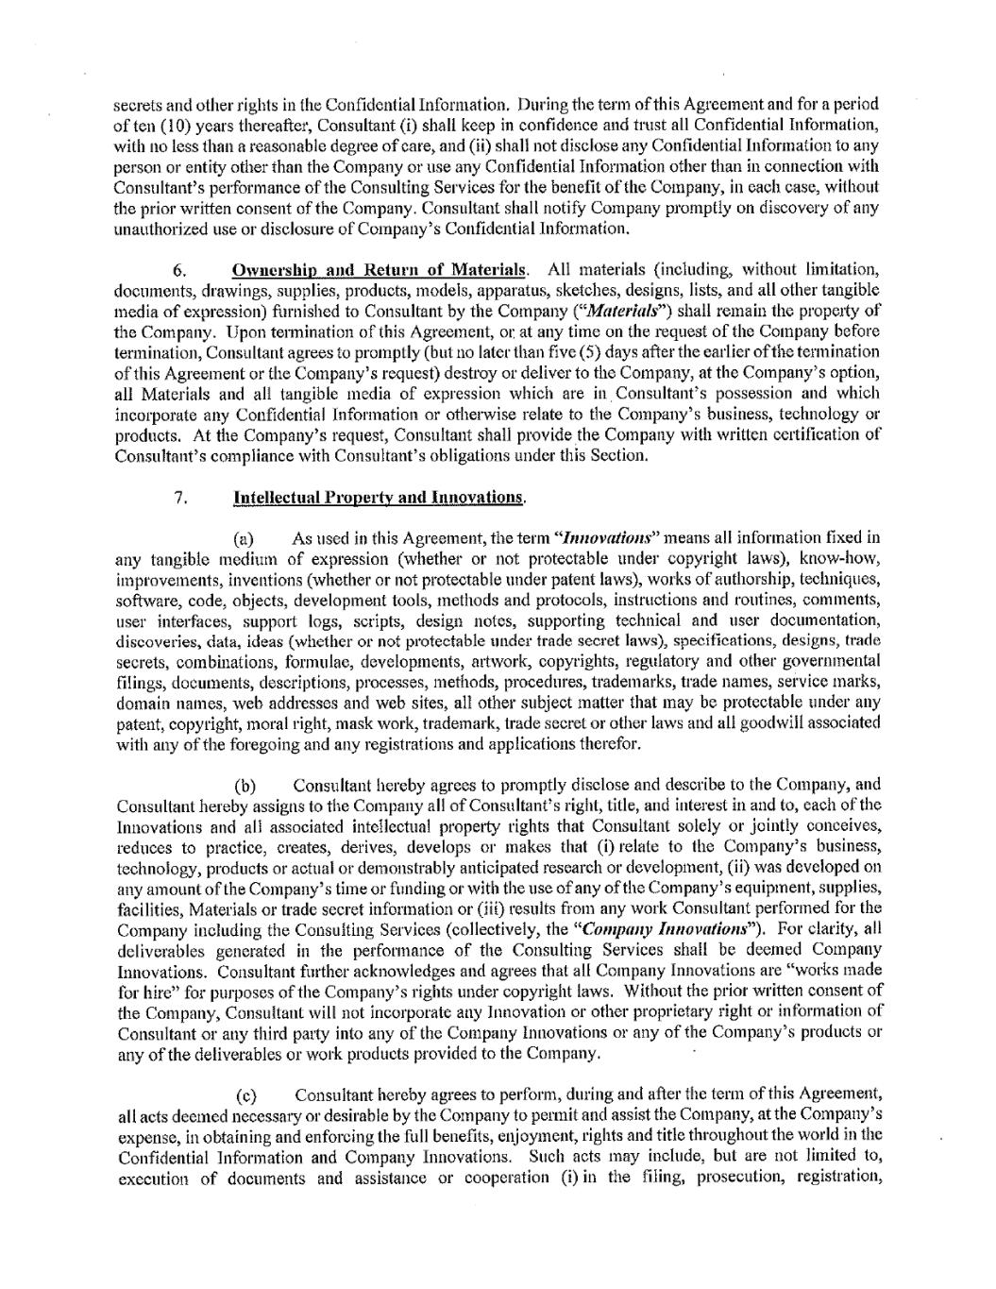

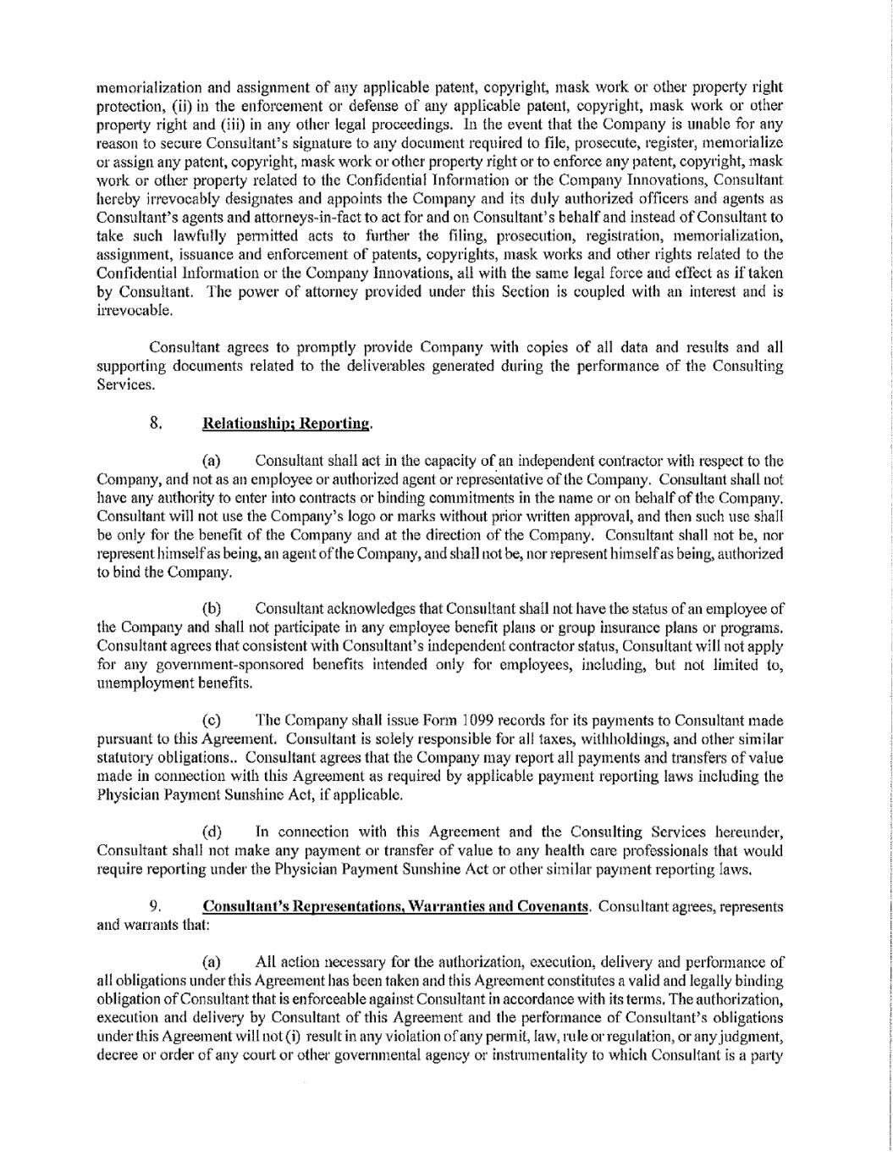

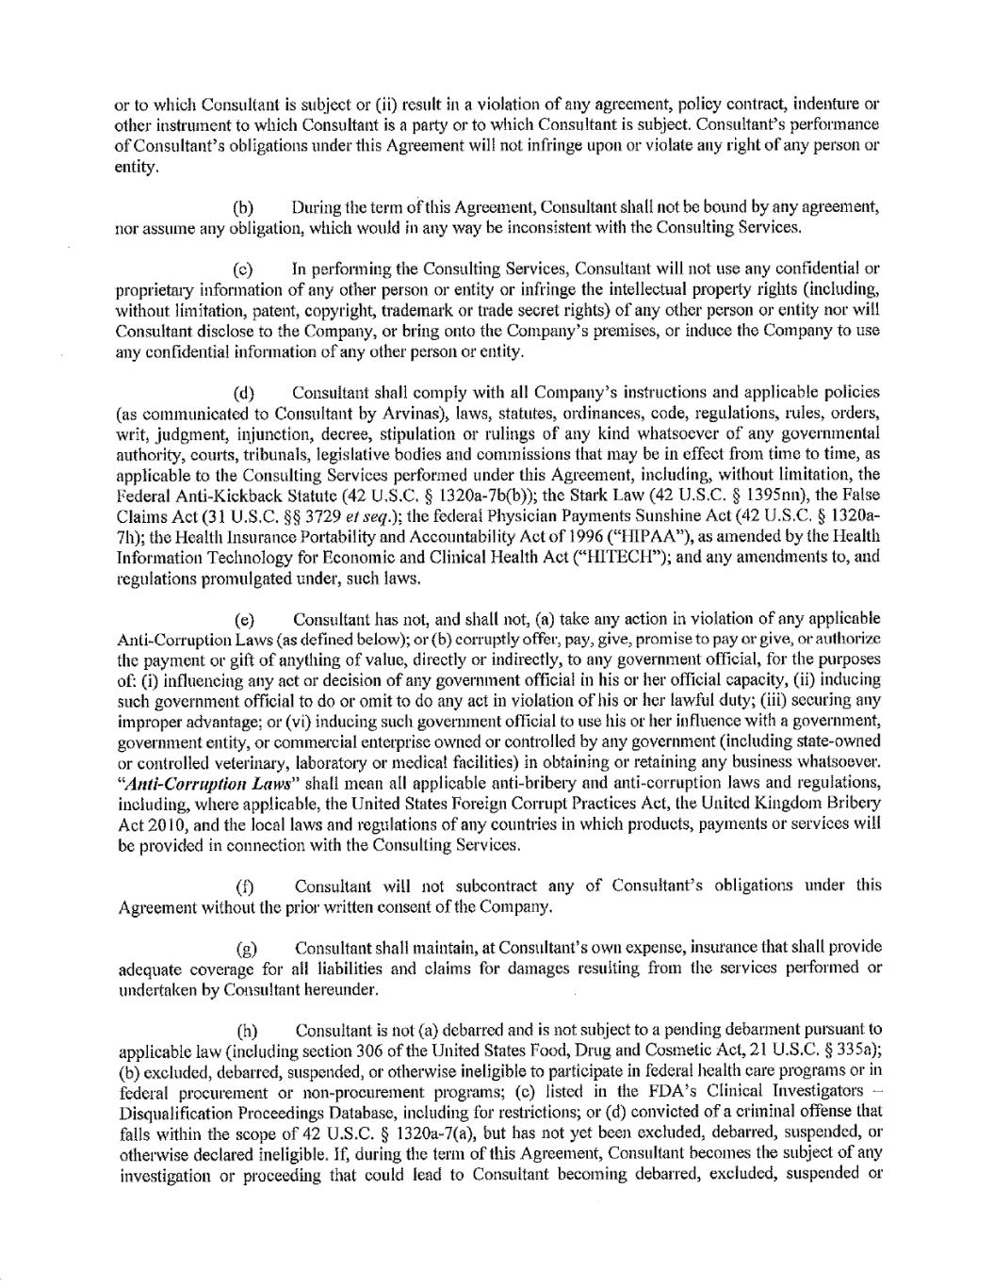

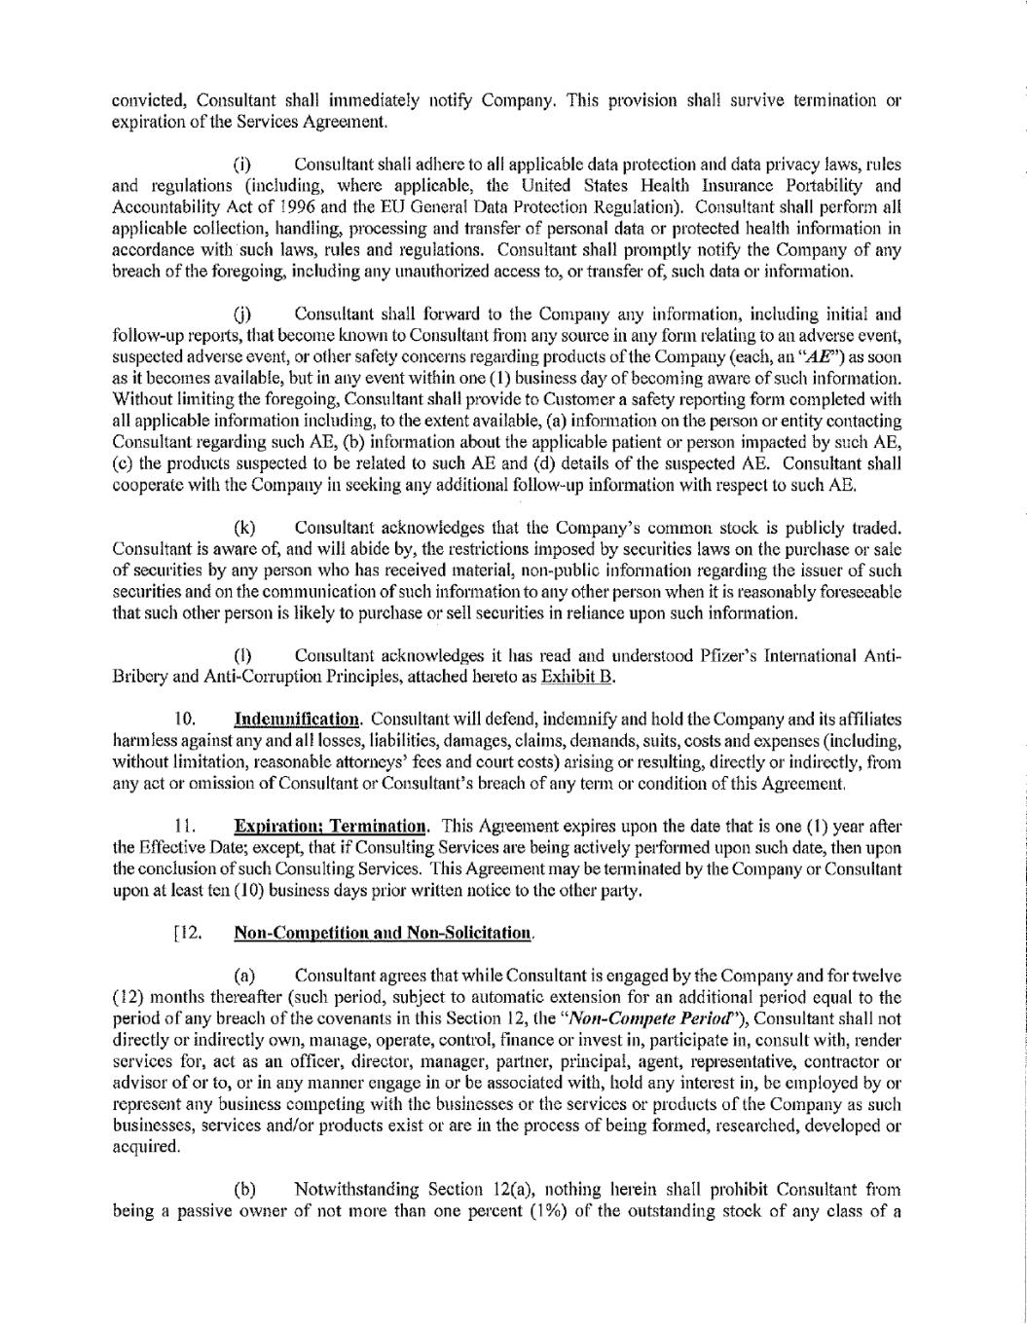

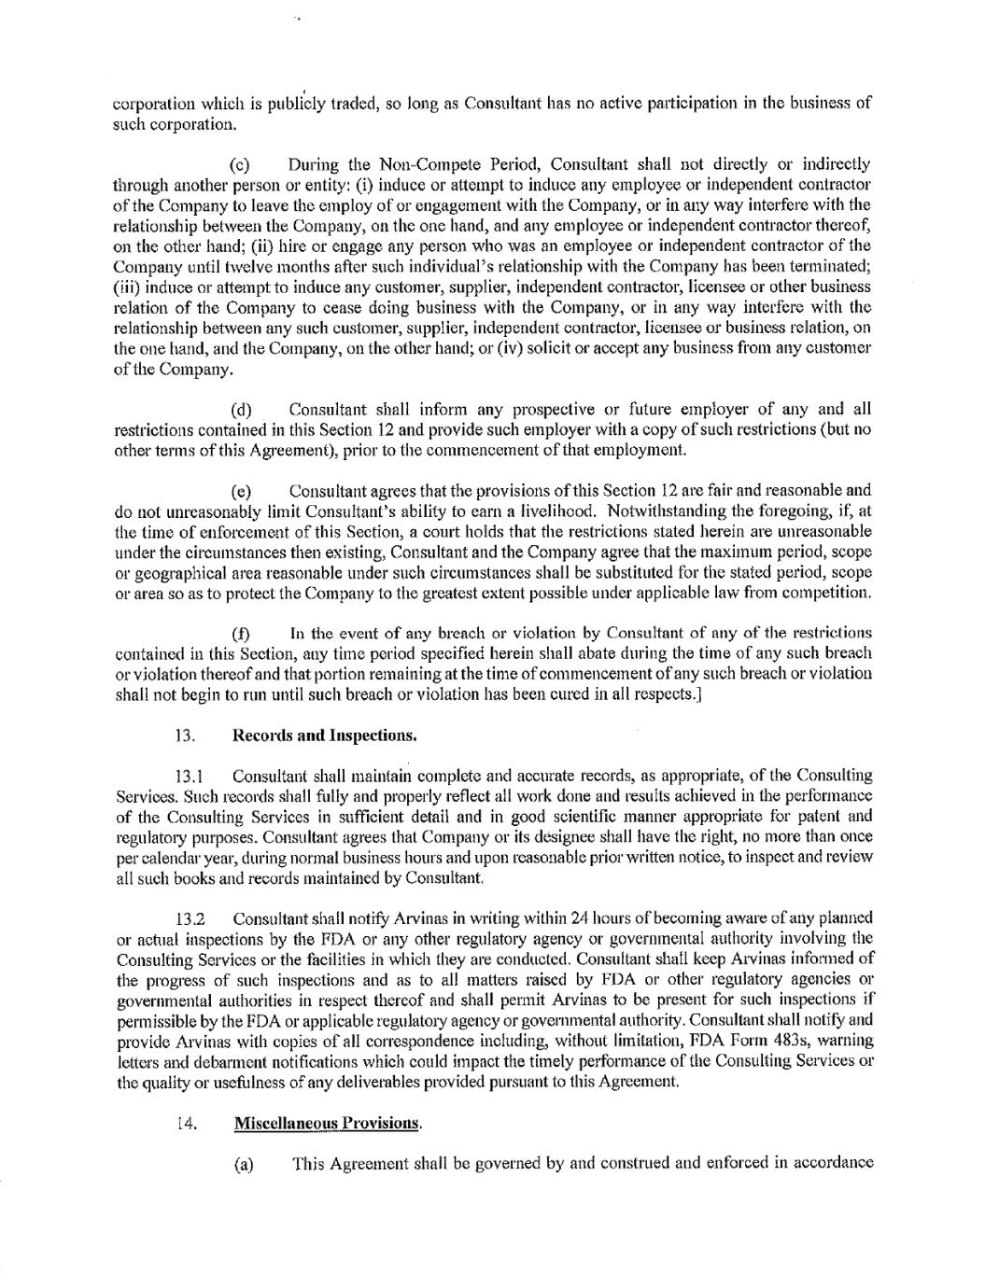

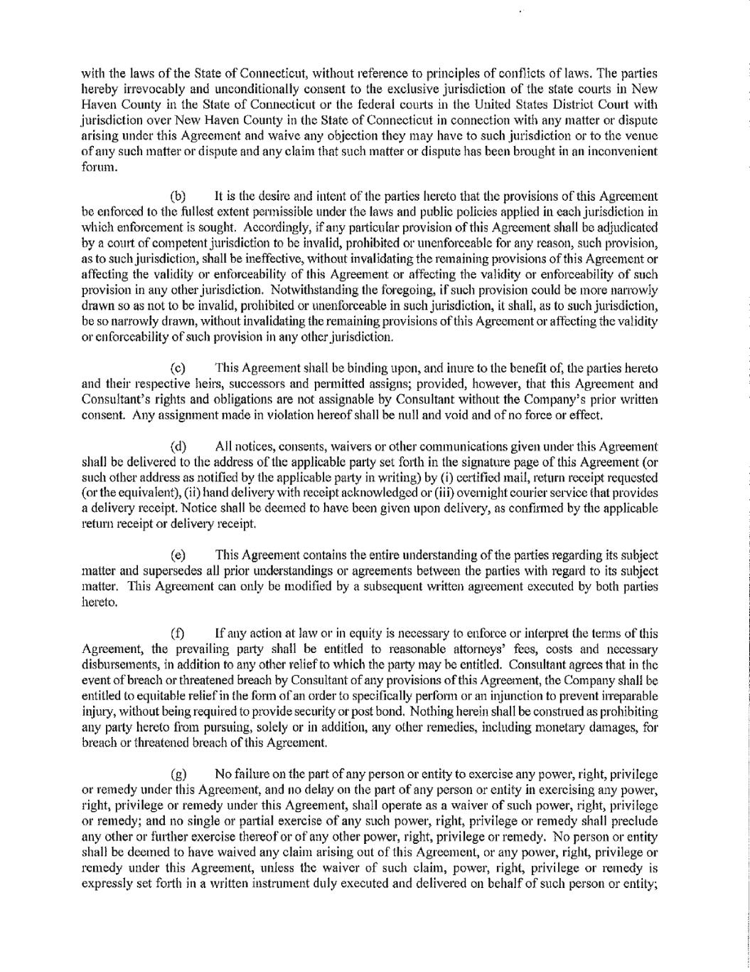

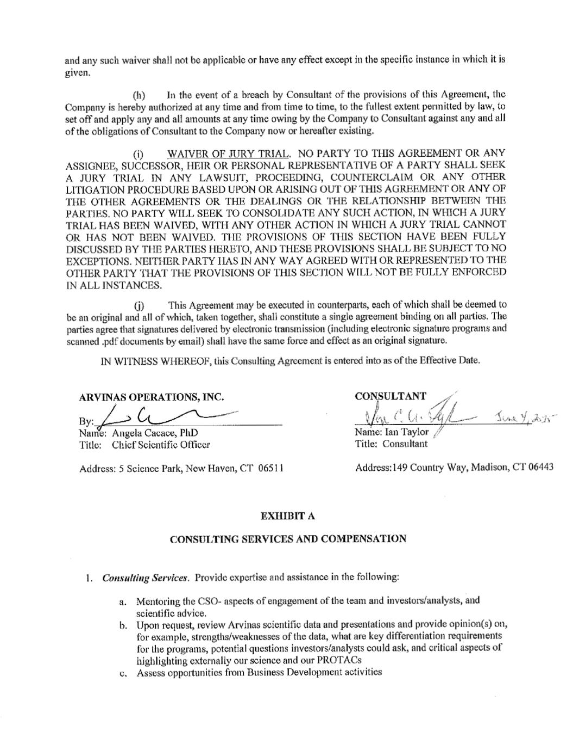

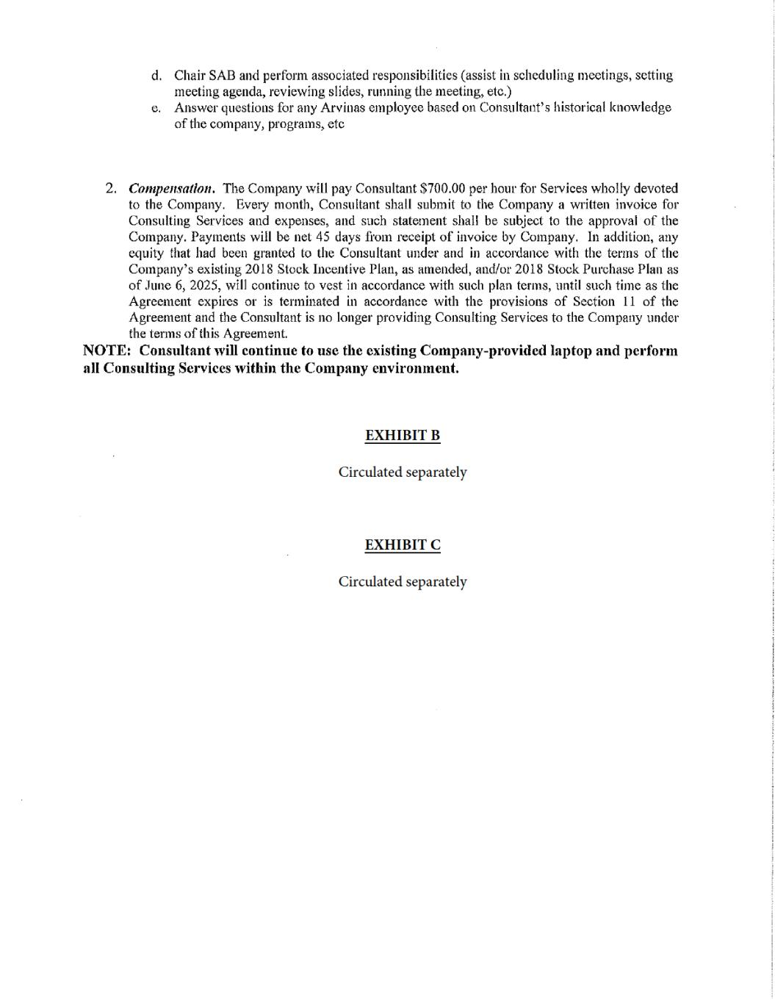

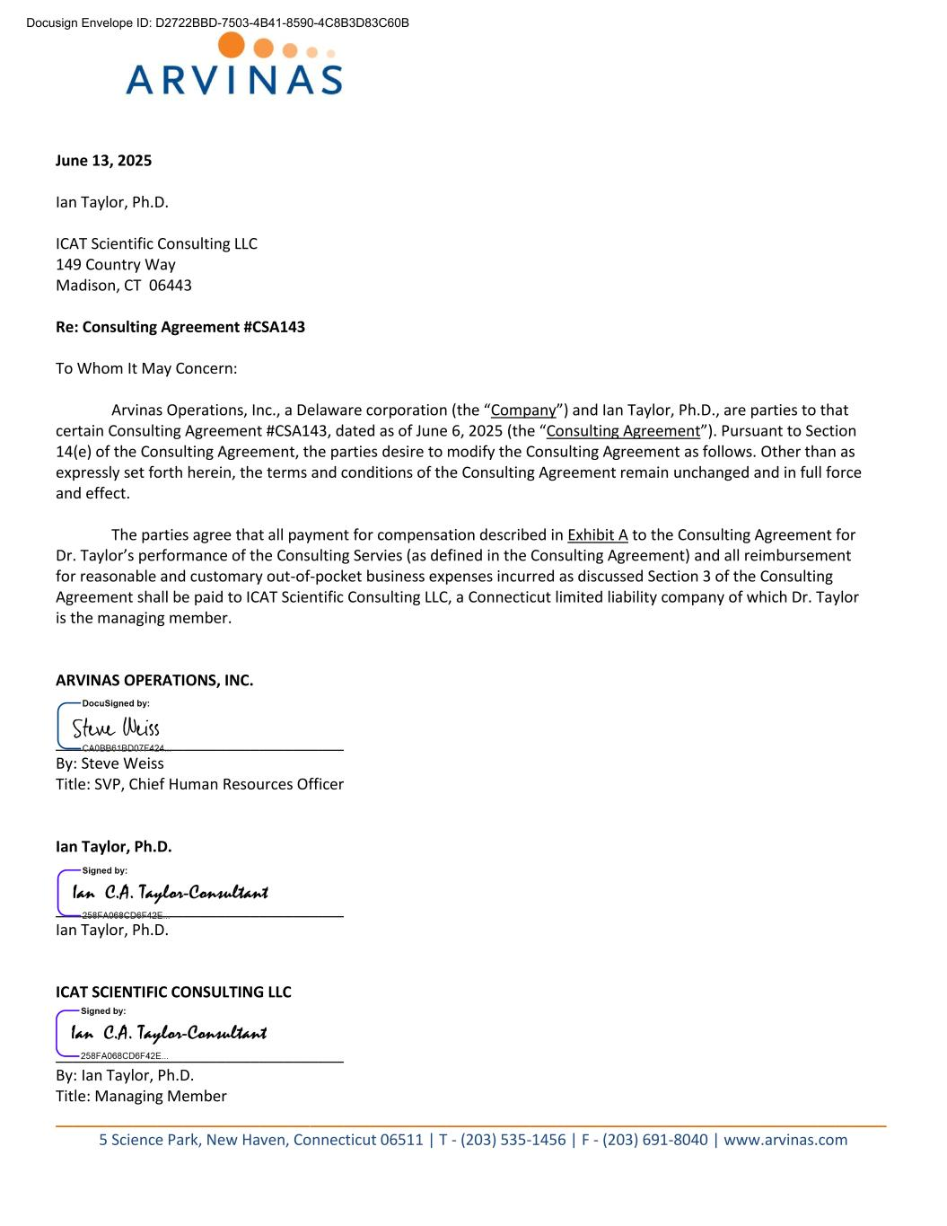
__________________________________________________________________________________________________ 5 Science Park, New Haven, Connecticut 06511 | T - (203) 535-1456 | F - (203) 691-8040 | www.arvinas.com June 13, 2025 Ian Taylor, Ph.D. ICAT Scientific Consulting LLC 149 Country Way Madison, CT 06443 Re: Consulting Agreement #CSA143 To Whom It May Concern: Arvinas Operations, Inc., a Delaware corporation (the “Company”) and Ian Taylor, Ph.D., are parties to that certain Consulting Agreement #CSA143, dated as of June 6, 2025 (the “Consulting Agreement”). Pursuant to Section 14(e) of the Consulting Agreement, the parties desire to modify the Consulting Agreement as follows. Other than as expressly set forth herein, the terms and conditions of the Consulting Agreement remain unchanged and in full force and effect. The parties agree that all payment for compensation described in Exhibit A to the Consulting Agreement for Dr. Taylor’s performance of the Consulting Servies (as defined in the Consulting Agreement) and all reimbursement for reasonable and customary out-of-pocket business expenses incurred as discussed Section 3 of the Consulting Agreement shall be paid to ICAT Scientific Consulting LLC, a Connecticut limited liability company of which Dr. Taylor is the managing member. ARVINAS OPERATIONS, INC. __________________________________ By: Steve Weiss Title: SVP, Chief Human Resources Officer Ian Taylor, Ph.D. __________________________________ Ian Taylor, Ph.D. ICAT SCIENTIFIC CONSULTING LLC __________________________________ By: Ian Taylor, Ph.D. Title: Managing Member Docusign Envelope ID: D2722BBD-7503-4B41-8590-4C8B3D83C60B

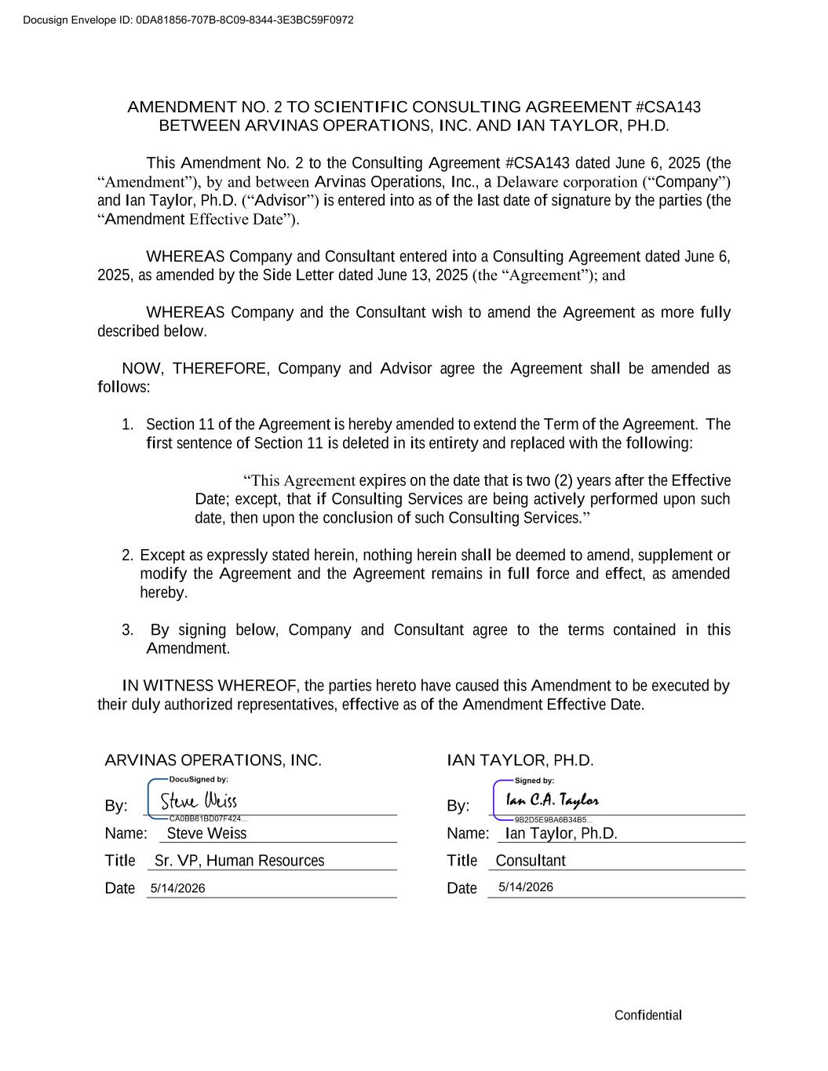
Confidential AMENDMENT NO. 2 TO SCIENTIFIC CONSULTING AGREEMENT #CSA143 BETWEEN ARVINAS OPERATIONS, INC. AND IAN TAYLOR, PH.D. This Amendment No. 2 to the Consulting Agreement #CSA143 dated June 6, 2025 (the “Amendment”), by and between Arvinas Operations, Inc., a Delaware corporation (“Company”) and Ian Taylor, Ph.D. (“Advisor”) is entered into as of the last date of signature by the parties (the “Amendment Effective Date”). WHEREAS Company and Consultant entered into a Consulting Agreement dated June 6, 2025, as amended by the Side Letter dated June 13, 2025 (the “Agreement”); and WHEREAS Company and the Consultant wish to amend the Agreement as more fully described below. NOW, THEREFORE, Company and Advisor agree the Agreement shall be amended as follows: 1. Section 11 of the Agreement is hereby amended to extend the Term of the Agreement. The first sentence of Section 11 is deleted in its entirety and replaced with the following: “This Agreement expires on the date that is two (2) years after the Effective Date; except, that if Consulting Services are being actively performed upon such date, then upon the conclusion of such Consulting Services.” 2. Except as expressly stated herein, nothing herein shall be deemed to amend, supplement or modify the Agreement and the Agreement remains in full force and effect, as amended hereby. 3. By signing below, Company and Consultant agree to the terms contained in this Amendment. IN WITNESS WHEREOF, the parties hereto have caused this Amendment to be executed by their duly authorized representatives, effective as of the Amendment Effective Date. ARVINAS OPERATIONS, INC. IAN TAYLOR, PH.D. By: By: Name: Steve Weiss Name: Ian Taylor, Ph.D. Title Sr. VP, Human Resources Title Consultant Date Date Docusign Envelope ID: 0DA81856-707B-8C09-8344-3E3BC59F0972 5/14/20265/14/2026

Exhibit 31.1
CERTIFICATION PURSUANT TO
RULES 13a-14(a) AND 15d-14(a) UNDER THE SECURITIES EXCHANGE ACT OF 1934,
AS ADOPTED PURSUANT TO SECTION 302 OF THE SARBANES-OXLEY ACT OF 2002
I, Randy Teel, Ph.D., certify that:
1.I have reviewed this Quarterly Report on Form 10-Q of Arvinas, Inc.;
2.Based on my knowledge, this report does not contain any untrue statement of a material fact or omit to state a material fact necessary to make the statements made, in light of the circumstances under which such statements were made, not misleading with respect to the period covered by this report;
3.Based on my knowledge, the financial statements, and other financial information included in this report, fairly present in all material respects the financial condition, results of operations and cash flows of the registrant as of, and for, the periods presented in this report;
4.The registrant's other certifying officer and I are responsible for establishing and maintaining disclosure controls and procedures (as defined in Exchange Act Rules 13a-15(e) and 15d-15(e)) and internal control over financial reporting (as defined in Exchange Act Rules 13a-15(f) and 15d-15(f)) for the registrant and have:
(a)Designed such disclosure controls and procedures, or caused such disclosure controls and procedures to be designed under our supervision, to ensure that material information relating to the registrant, including its consolidated subsidiaries, is made known to us by others within those entities, particularly during the period in which this report is being prepared;
(b)Designed such internal control over financial reporting, or caused such internal control over financial reporting to be designed under our supervision, to provide reasonable assurance regarding the reliability of financial reporting and the preparation of financial statements for external purposes in accordance with generally accepted accounting principles;
(c)Evaluated the effectiveness of the registrant's disclosure controls and procedures and presented in this report our conclusions about the effectiveness of the disclosure controls and procedures, as of the end of the period covered by this report based on such evaluation; and
(d)Disclosed in this report any change in the registrant's internal control over financial reporting that occurred during the registrant's most recent fiscal quarter (the registrant's fourth fiscal quarter in the case of an annual report) that has materially affected, or is reasonably likely to materially affect, the registrant's internal control over financial reporting; and
5.The registrant's other certifying officer and I have disclosed, based on our most recent evaluation of internal control over financial reporting, to the registrant's auditors and the audit committee of the registrant's board of directors (or persons performing the equivalent functions):
(a)All significant deficiencies and material weaknesses in the design or operation of internal control over financial reporting which are reasonably likely to adversely affect the registrant's ability to record, process, summarize and report financial information; and
(b)Any fraud, whether or not material, that involves management or other employees who have a significant role in the registrant's internal control over financial reporting.
Date: August 4, 2026 |  |  | By: |  |  | /s/ Randy Teel, Ph.D.
 |  |  |  |  |  | Randy Teel, Ph.D.
President and Chief Executive Officer
(Principal Executive Officer)

Exhibit 31.2
CERTIFICATION PURSUANT TO
RULES 13a-14(a) AND 15d-14(a) UNDER THE SECURITIES EXCHANGE ACT OF 1934,
AS ADOPTED PURSUANT TO SECTION 302 OF THE SARBANES-OXLEY ACT OF 2002
I, Andrew Saik, certify that:
1.I have reviewed this Quarterly Report on Form 10-Q of Arvinas, Inc.;
2.Based on my knowledge, this report does not contain any untrue statement of a material fact or omit to state a material fact necessary to make the statements made, in light of the circumstances under which such statements were made, not misleading with respect to the period covered by this report;
3.Based on my knowledge, the financial statements, and other financial information included in this report, fairly present in all material respects the financial condition, results of operations and cash flows of the registrant as of, and for, the periods presented in this report;
4.The registrant's other certifying officer and I are responsible for establishing and maintaining disclosure controls and procedures (as defined in Exchange Act Rules 13a-15(e) and 15d-15(e)) and internal control over financial reporting (as defined in Exchange Act Rules 13a-15(f) and 15d-15(f)) for the registrant and have:
(a)Designed such disclosure controls and procedures, or caused such disclosure controls and procedures to be designed under our supervision, to ensure that material information relating to the registrant, including its consolidated subsidiaries, is made known to us by others within those entities, particularly during the period in which this report is being prepared;
(b)Designed such internal control over financial reporting, or caused such internal control over financial reporting to be designed under our supervision, to provide reasonable assurance regarding the reliability of financial reporting and the preparation of financial statements for external purposes in accordance with generally accepted accounting principles;
(c)Evaluated the effectiveness of the registrant’s disclosure controls and procedures and presented in this report our conclusions about the effectiveness of the disclosure controls and procedures, as of the end of the period covered by this report based on such evaluation; and
(d)Disclosed in this report any change in the registrant's internal control over financial reporting that occurred during the registrant's most recent fiscal quarter (the registrant's fourth fiscal quarter in the case of an annual report) that has materially affected, or is reasonably likely to materially affect, the registrant's internal control over financial reporting; and
5.The registrant's other certifying officer and I have disclosed, based on our most recent evaluation of internal control over financial reporting, to the registrant's auditors and the audit committee of the registrant's board of directors (or persons performing the equivalent functions):
(a)All significant deficiencies and material weaknesses in the design or operation of internal control over financial reporting which are reasonably likely to adversely affect the registrant's ability to record, process, summarize and report financial information; and
(b)Any fraud, whether or not material, that involves management or other employees who have a significant role in the registrant's internal control over financial reporting.
Date: August 4, 2026 |  |  | By: |  |  | /s/ Andrew Saik
 |  |  |  |  |  | Andrew Saik
Chief Financial Officer and Treasurer
(Principal Financial Officer)

Exhibit 32.1
CERTIFICATION PURSUANT TO
18 U.S.C. SECTION 1350, AS ADOPTED PURSUANT TO
SECTION 906 OF THE SARBANES-OXLEY ACT OF 2002
In connection with the Quarterly Report of Arvinas, Inc. (the “Company”) on Form 10-Q for the period ended June 30, 2026 as filed with the Securities and Exchange Commission on the date hereof (the “Report”), I certify, pursuant to 18 U.S.C. § 1350, as adopted pursuant to § 906 of the Sarbanes-Oxley Act of 2002, that:
(1)The Report fully complies with the requirements of section 13(a) or 15(d) of the Securities Exchange Act of 1934; and
(2)The information contained in the Report fairly presents, in all material respects, the financial condition and result of operations of the Company.
Date: August 4, 2026 |  |  | By: |  |  | /s/ Randy Teel, Ph.D.
 |  |  |  |  |  | Randy Teel, Ph.D.
President and Chief Executive Officer
(Principal Executive Officer)

Exhibit 32.2
CERTIFICATION PURSUANT TO
18 U.S.C. SECTION 1350, AS ADOPTED PURSUANT TO
SECTION 906 OF THE SARBANES-OXLEY ACT OF 2002
In connection with the Quarterly Report of Arvinas, Inc. (the “Company”) on Form 10-Q for the period ended June 30, 2026 as filed with the Securities and Exchange Commission on the date hereof (the “Report”), I certify, pursuant to 18 U.S.C. § 1350, as adopted pursuant to § 906 of the Sarbanes-Oxley Act of 2002, that:
(1)The Report fully complies with the requirements of section 13(a) or 15(d) of the Securities Exchange Act of 1934; and
(2)The information contained in the Report fairly presents, in all material respects, the financial condition and result of operations of the Company.
Date: August 4, 2026 |  |  | By: |  |  | /s/ Andrew Saik
 |  |  |  |  |  | Andrew Saik
Chief Financial Officer and Treasurer
(Principal Financial Officer)

