Table o f Contents

UNITED STATES
SECURITIES AND EXCHANGE COMMISSION
Washington, D.C. 20549
__________________________________________
FORM 10-Q
__________________________________________
(Mark One)
☒ |  |  | QUARTERLY REPORT PURSUANT TO SECTION 13 OR 15(d) OF THE SECURITIES EXCHANGE ACT OF 1934
For the quarterly period ended September 30, 2025
OR
o |  |  | TRANSITION REPORT PURSUANT TO SECTION 13 OR 15(d) OF THE SECURITIES EXCHANGE ACT OF 1934
For the transition period from to .
Commission File Number: 001-38672
__________________________________________
ARVINAS, INC.
(Exact name of registrant as specified in its Charter)
__________________________________________
Delaware |  |  | 47-2566120
(State or other jurisdiction of  incorporation or organization) |  |  | (I.R.S. Employer  Identification No.)
5 Science Park  395 Winchester Ave.  New Haven, Connecticut |  |  | 06511
(Address of principal executive offices) |  |  | (Zip Code)
Registrant’s telephone number, including area code: (203) 535-1456
__________________________________________
Securities registered pursuant to Section 12(b) of the Act:
Title of each class |  |  |  |  |  | Trading  Symbol(s) |  |  |  |  |  | Name of each exchange on which registered
Common stock, par value $0.001 per share |  |  |  |  |  | ARVN |  |  |  |  |  | The Nasdaq Stock Market LLC
Indicate by check mark whether the registrant: (1) has filed all reports required to be filed by Section 13 or 15(d) of the Securities Exchange Act of 1934 during the preceding 12 months (or for such shorter period that the registrant was required to file such reports), and (2) has been subject to such filing requirements for the past 90 days. Yes ☒ No o
Indicate by check mark whether the registrant has submitted electronically every Interactive Data File required to be submitted pursuant to Rule 405 of Regulation S-T (§232.405 of this chapter) during the preceding 12 months (or for such shorter period that the registrant was required to submit such files). Yes ☒ No o
Indicate by check mark whether the registrant is a large accelerated filer, an accelerated filer, a non-accelerated filer, a smaller reporting company, or an emerging growth company. See the definitions of “large accelerated filer,” “accelerated filer,” “smaller reporting company,” and “emerging growth company” in Rule 12b-2 of the Exchange Act.
Large accelerated filer |  |  | ☒ |  |  | Accelerated filer |  |  | o
Non-accelerated filer |  |  | o |  |  | Smaller reporting company |  |  | o
 |  |  |  |  |  | Emerging growth company |  |  | o
If an emerging growth company, indicate by check mark if the registrant has elected not to use the extended transition period for complying with any new or revised financial accounting standards provided pursuant to Section 13(a) of the Exchange Act. o
Indicate by check mark whether the registrant is a shell company (as defined in Rule 12b-2 of the Exchange Act). Yes ☐ No ☒
As of October 31, 2025, the registrant had 64,224,294 shares of common stock, $0.001 par value per share, outstanding.

Table o f Contents
Table of Contents
 |  |  |  |  |  | Page
PART I. |  |  | FINANCIAL INFORMATION |  |  | 2
Item 1. |  |  | Financial Statements (Unaudited) |  |  | 2
 |  |  | Condensed Consolidated Balance Sheets |  |  | 2
 |  |  | Condensed Consolidated Statements of Operations and Comprehensive Loss |  |  | 3
 |  |  | Condensed Consolidated Statements of Changes in Stockholders’ Equity |  |  | 4
 |  |  | Condensed Consolidated Statements of Cash Flows |  |  | 6
 |  |  | Notes to Condensed Consolidated Financial Statements |  |  | 7
Item 2. |  |  | Management’s Discussion and Analysis of Financial Condition and Results of Operations |  |  | 23
Item 3. |  |  | Quantitative and Qualitative Disclosures About Market Risk |  |  | 46
Item 4. |  |  | Controls and Procedures |  |  | 46
PART II. |  |  | OTHER INFORMATION |  |  | 48
Item 1. |  |  | Legal Proceedings |  |  | 48
Item 1A. |  |  | Risk Factors |  |  | 48
Item 2. |  |  | Unregistered Sales of Equity Securities and Use of Proceeds |  |  | 55
Item 5. |  |  | Other Information |  |  | 55
Item 6. |  |  | Exhibits |  |  | 57
Signatures |  |  |  |  |  | 58

i
Table o f Contents
CAUTIONARY NOTE REGARDING FORWARD-LOOKING STATEMENTS
Forward-Looking Statements
This Quarterly Report on Form 10-Q contains forward-looking statements that involve substantial risks and uncertainties. All statements, other than statements of historical facts, contained in this Quarterly Report on Form 10-Q, including statements regarding our strategy, future operations, future financial position, future revenues, projected costs, prospects, plans and objectives of management, are forward-looking statements. The words “anticipate,” “believe,” “estimate,” “expect,” “intend,” “may,” “might,” “plan,” “predict,” “project,” “target,” “potential,” “goals,” “will,” "can," “would,” “could,” “should,” “continue” and similar expressions are intended to identify forward-looking statements, although not all forward-looking statements contain these identifying words.
The forward-looking statements in this Quarterly Report on Form 10-Q include, among other things, statements about:
•the initiation, timing, progress and results of our current and any future clinical trials of ARV-393, ARV-102, ARV-806, and vepdegestrant, including statements regarding the period during which the results of the clinical trials will become available or the forum in which we will present such results;
•the initiation, timing, progress and results of our current preclinical studies and any future preclinical studies or clinical trials of our other programs, including ARV-027 and ARV-6723, including statements regarding the period during which the results of preclinical studies or clinical trials will become available or the forum in which we will present such results;
•our plans to pursue research and development of other product candidates;
•our belief that our targeted protein degradation approach is a therapeutic modality that may provide distinct advantages over existing modalities;
•the extent to which our scientific approach and platform technology may potentially address a broad range of diseases and disease targets;
•the timing of, and our ability to obtain, marketing approval of our product candidates and the ability of our product candidates to meet existing or future regulatory standards;
•our belief that our leucine-rich repeat kinase 2 ("LRRK2") degraders are particularly well positioned to be evaluated in two diseases where there are no disease modifying therapies, including Parkinson's disease ("PD") and progressive supranuclear palsy ("PSP");
•our belief that the data we presented at 2025 International Congress of Parkinson’s Disease and Movement Disorders highlight the potential PROTAC-mediated LRRK2 degradation, which supports the development of ARV-102 in ongoing studies of patients with PD, and potential future studies of patients with PSP;
•our belief that ARV-393 PROTAC-mediated degradation of the B-cell lymphoma 6 protein may provide an important novel therapeutic option for patients with non-Hodgkin Lymphoma;
•our belief that ARV-393 can be an attractive combination partner for development of novel therapies for lymphoma;
•our belief that the totality of our preclinical data for ARV-393 provides a compelling rationale to evaluate ARV-393 in combination with bi-specifics, oral pathway inhibitors, and potentially other standards of care, in the larger diffuse large B-cell lymphoma indication;
•our belief that ARV-806 has the potential to be a best-in-class therapy for kristen rat sarcoma G12D mutated cancers;
•our belief that data for ARV-806 presented at AACR-NCI-EORTC International Conference on Molecular Targets and Cancer Therapeutics supports intermittent clinical dosing;
•our belief that vepdegestrant has the potential to be a best-in-class monotherapy treatment for patients in the second-line estrogen receptor 1 mutant setting;
ii
Table o f Contents
•our plans with respect to market preparations for vepdegestrant and our plans, together with Pfizer Inc., jointly select a third party for the commercialization and potential further development of vepdegestrant;
•the potential receipt of payments based on achievement of milestones under our collaborations, including our collaboration with Pfizer Inc. entered into in July 2021;
•potential receipt of payments based on the achievement of milestones related to luxdegalutamide (ARV-766) and future royalties under our license agreement with Novartis Pharma AG;
•the potential receipt of revenue from future sales of our product candidates;
•the rate and degree of potential market acceptance and clinical utility of our product candidates and our estimates regarding the potential market opportunity for our product candidates;
•our ability to manage the transition of a new chief executive officer, once identified;
•our sales, marketing and distribution capabilities and strategy;
•our ability to establish and maintain arrangements for manufacture of our product candidates;
•our ability to enter into additional collaborations with third parties;
•our intellectual property position;
•our estimates regarding expenses, future revenues, capital requirements and needs for additional financing, and statements regarding our cash, cash equivalents and marketable securities, including their sufficiency to fund planned operating expenses and capital expenditure requirements into the second half of 2028;
•our belief that non-GAAP financial information, when taken collectively, may be helpful to investors because it provides consistency and comparability with past financial performance;
•the impact of government laws and regulations; and
•our competitive position.
We may not actually achieve the plans, intentions or expectations disclosed in our forward-looking statements, and you should not place undue reliance on our forward-looking statements. Actual results or events could differ materially from the plans, intentions and expectations disclosed in the forward-looking statements we make. We have included important factors in the cautionary statements included in our Annual Report on Form 10-K for the year ended December 31, 2024, filed on February 11, 2025, and this Quarterly Report on Form 10-Q, particularly in the “Risk Factors” sections, that we believe could cause actual results or events to differ materially from the forward-looking statements that we make. Our forward-looking statements do not reflect the potential impact of any future acquisitions, mergers, dispositions, joint ventures or investments we may make.
You should read this Quarterly Report on Form 10-Q and the documents that we have filed as exhibits to this Quarterly Report on Form 10-Q completely and with the understanding that our actual future results may differ materially from what we expect. We do not assume any obligation to update any forward-looking statements except as required by applicable law.
Throughout this Quarterly Report on Form 10-Q, references to the “Company,” “Arvinas,” “we,” “us,” and “our,” refer to Arvinas, Inc. and its consolidated subsidiaries, except where the context requires otherwise, or any one or more of them as the context may require, and “board of directors” refers to the board of directors of Arvinas, Inc.
The Arvinas name and logo are our trademarks. This Quarterly Report on Form 10-Q contains references to our trademarks and service marks and to those belonging to other entities. Solely for convenience, trademarks and trade names referred to in this Quarterly Report on Form 10-Q, including logos, artwork and other visual displays, may appear without the ® or ™ symbols, but such references are not intended to indicate in any way that we will not assert, to the fullest extent under applicable law, our rights or the rights of the applicable licensor to these trademarks and trade names. We do not intend our use or display of other entities’ trade names, trademarks or service marks to imply a relationship with, or endorsement or sponsorship of us by, any other entity.

iii
Table o f Contents
PART I—FINANCIAL INFORMATION

Item 1. Financial Statements.

ARVINAS, INC. AND SUBSIDIARIES
Condensed Consolidated Balance Sheets (unaudited)
(dollars and shares in millions, except per share amounts) |  |  | September 30,  2025 |  |  |  |  |  | December 31,  2024
Assets
Current assets:
Cash and cash equivalents |  |  | $ | 101.5 |  |  |  |  | $ | 100.5
Marketable securities |  |  | 686.1 |  |  |  |  |  | 938.9
Accounts receivable |  |  | 20.3 |  |  |  |  |  | 5.7
Other receivables |  |  | 6.5 |  |  |  |  |  | 8.0
Prepaid expenses and other current assets |  |  | 11.9 |  |  |  |  |  | 14.2
Total current assets |  |  | 826.3 |  |  |  |  |  | 1,067.3
Property, equipment and leasehold improvements, net |  |  | 5.4 |  |  |  |  |  | 7.0
Operating lease right-of-use assets |  |  | 8.7 |  |  |  |  |  | 9.0
Collaboration contract asset and other assets |  |  | 3.9 |  |  |  |  |  | 8.1
Total assets |  |  | $ | 844.3 |  |  |  |  | $ | 1,091.4
Liabilities and stockholders' equity
Current liabilities:
Accounts payable and accrued liabilities |  |  | $ | 55.5 |  |  |  |  | $ | 71.8
Deferred revenue |  |  | 87.7 |  |  |  |  |  | 156.2
Current portion of operating lease liabilities |  |  | 1.7 |  |  |  |  |  | 1.8
Total current liabilities |  |  | 144.9 |  |  |  |  |  | 229.8
Deferred revenue |  |  | 127.4 |  |  |  |  |  | 292.0
Long-term debt |  |  | 0.4 |  |  |  |  |  | 0.6
Operating lease liabilities |  |  | 7.2 |  |  |  |  |  | 7.3
Total liabilities |  |  | 279.9 |  |  |  |  |  | 529.7
Commitments and Contingencies (Note 13)
Stockholders’ equity:
Preferred stock, $0.001 par value, zero shares issued and outstanding as of September 30, 2025 and December 31, 2024, respectively |  |  | — |  |  |  |  |  | —
Common stock, $0.001 par value; 73.4 shares issued, 70.8 shares outstanding as of September 30, 2025 and 68.8 shares issued and outstanding as of December 31, 2024 |  |  | 0.1 |  |  |  |  |  | 0.1
Accumulated deficit |  |  | (1,545.0) |  |  |  |  |  | (1,531.6)
Additional paid-in capital |  |  | 2,128.2 |  |  |  |  |  | 2,092.2
Accumulated other comprehensive income |  |  | 1.4 |  |  |  |  |  | 1.0
Treasury Stock, at cost (2.6 and zero shares at September 30, 2025 and December 31, 2024, respectively) |  |  | (20.3) |  |  |  |  |  | —
Total stockholders’ equity |  |  | 564.4 |  |  |  |  |  | 561.7
Total liabilities and stockholders’ equity |  |  | $ | 844.3 |  |  |  |  | $ | 1,091.4
See accompanying notes to the condensed consolidated financial statements

2
Table o f Contents
ARVINAS, INC. AND SUBSIDIARIES
Condensed Consolidated Statements of Operations and Comprehensive Loss (unaudited)
(dollars and shares in millions, except per share amounts) |  |  | For the Three Months Ended  September 30, |  |  |  |  |  |  |  |  |  |  |  | For the Nine Months Ended  September 30,
Consolidated Statements of Operations |  |  | 2025 |  |  |  |  |  | 2024 |  |  |  |  |  | 2025 |  |  |  |  |  | 2024
Revenue |  |  | $ | 41.9 |  |  |  |  | $ | 102.4 |  |  |  |  | $ | 253.1 |  |  |  |  | $ | 204.2
Operating expenses:
Research and development |  |  | 64.7 |  |  |  |  |  | 86.9 |  |  |  |  |  | 224.1 |  |  |  |  |  | 264.9
General and administrative |  |  | 21.0 |  |  |  |  |  | 75.8 |  |  |  |  |  | 72.9 |  |  |  |  |  | 131.3
Total operating expenses |  |  | 85.7 |  |  |  |  |  | 162.7 |  |  |  |  |  | 297.0 |  |  |  |  |  | 396.2
Loss from operations |  |  | (43.8) |  |  |  |  |  | (60.3) |  |  |  |  |  | (43.9) |  |  |  |  |  | (192.0)
Other income
Other expense, net |  |  | — |  |  |  |  |  | (2.6) |  |  |  |  |  | (0.4) |  |  |  |  |  | (2.7)
Interest income, net |  |  | 9.0 |  |  |  |  |  | 14.3 |  |  |  |  |  | 31.0 |  |  |  |  |  | 41.9
Total other income |  |  | 9.0 |  |  |  |  |  | 11.7 |  |  |  |  |  | 30.6 |  |  |  |  |  | 39.2
Net loss before income taxes |  |  | (34.8) |  |  |  |  |  | (48.6) |  |  |  |  |  | (13.3) |  |  |  |  |  | (152.8)
Income tax expense |  |  | (0.3) |  |  |  |  |  | (0.6) |  |  |  |  |  | (0.1) |  |  |  |  |  | (1.0)
Net loss |  |  | $ | (35.1) |  |  |  |  | $ | (49.2) |  |  |  |  | $ | (13.4) |  |  |  |  | $ | (153.8)
Loss per common share
Basic and diluted |  |  | $ | (0.48) |  |  |  |  | $ | (0.68) |  |  |  |  | $ | (0.18) |  |  |  |  | $ | (2.14)
Weighted average common shares outstanding
Basic and diluted |  |  | 73.2 |  |  |  |  |  | 72.1 |  |  |  |  |  | 72.9 |  |  |  |  |  | 71.9

(dollars in millions) |  |  | For the Three Months Ended  September 30, |  |  |  |  |  |  |  |  |  |  |  | For the Nine Months Ended  September 30,
Consolidated Statements of Comprehensive Loss |  |  | 2025 |  |  |  |  |  | 2024 |  |  |  |  |  | 2025 |  |  |  |  |  | 2024
Net loss |  |  | $ | (35.1) |  |  |  |  | $ | (49.2) |  |  |  |  | $ | (13.4) |  |  |  |  | $ | (153.8)
Other comprehensive loss:
Unrealized gain on available-for-sale securities |  |  | 0.4 |  |  |  |  |  | 7.9 |  |  |  |  |  | 0.4 |  |  |  |  |  | 7.2
Comprehensive loss |  |  | $ | (34.7) |  |  |  |  | $ | (41.3) |  |  |  |  | $ | (13.0) |  |  |  |  | $ | (146.6)
See accompanying notes to the condensed consolidated financial statements

3
Table o f Contents
ARVINAS, INC. AND SUBSIDIARIES
Condensed Consolidated Statements of Changes in Stockholders’ Equity (unaudited)
(dollars and shares in millions) |  |  | Common |  |  |  |  |  |  |  |  |  |  |  | Accumulated  Deficit |  |  |  |  |  | Additional  Paid-in  Capital |  |  |  |  |  | Accumulated  Other  Comprehensive  Income (Loss) |  |  |  |  |  | Treasury |  |  |  |  |  |  |  |  |  |  |  | Total  Stockholders'  Equity
For the Three Months Ended September 30, 2025 and 2024 |  |  | Shares |  |  |  |  |  | Amount |  |  |  |  |  |  |  |  |  |  |  |  |  |  |  |  |  |  |  |  |  |  |  | Shares |  |  |  |  |  | Amount
Balance as of June 30, 2025 |  |  | 73.2 |  |  |  |  |  | $ | 0.1 |  |  |  |  | $ | (1,509.9) |  |  |  |  | $ | 2,118.1 |  |  |  |  | $ | 1.0 |  |  |  |  | — |  |  |  |  |  | $ | — |  |  |  |  | $ | 609.3
Stock-based compensation |  |  | — |  |  |  |  |  | — |  |  |  |  |  | — |  |  |  |  |  | 10.1 |  |  |  |  |  | — |  |  |  |  |  | — |  |  |  |  |  | — |  |  |  |  |  | 10.1
Net loss |  |  | — |  |  |  |  |  | — |  |  |  |  |  | (35.1) |  |  |  |  |  | — |  |  |  |  |  | — |  |  |  |  |  | — |  |  |  |  |  | — |  |  |  |  |  | (35.1)
Issuance of common stock under equity incentive plans |  |  | 0.2 |  |  |  |  |  | — |  |  |  |  |  | — |  |  |  |  |  | — |  |  |  |  |  | — |  |  |  |  |  | — |  |  |  |  |  | — |  |  |  |  |  | —
Share repurchases (treasury stock) |  |  | — |  |  |  |  |  | — |  |  |  |  |  | — |  |  |  |  |  | — |  |  |  |  |  | — |  |  |  |  |  | 2.6 |  |  |  |  |  | (20.3) |  |  |  |  |  | (20.3)
Unrealized gain on available-for-sale securities |  |  | — |  |  |  |  |  | — |  |  |  |  |  | — |  |  |  |  |  | — |  |  |  |  |  | 0.4 |  |  |  |  |  | — |  |  |  |  |  | — |  |  |  |  |  | 0.4
Balance as of September 30, 2025 |  |  | 73.4 |  |  |  |  |  | $ | 0.1 |  |  |  |  | $ | (1,545.0) |  |  |  |  | $ | 2,128.2 |  |  |  |  | $ | 1.4 |  |  |  |  | 2.6 |  |  |  |  |  | $ | (20.3) |  |  |  |  | $ | 564.4
Balance as of June 30, 2024 |  |  | 68.6 |  |  |  |  |  | $ | 0.1 |  |  |  |  | $ | (1,437.3) |  |  |  |  | $ | 2,041.2 |  |  |  |  | $ | (3.8) |  |  |  |  | — |  |  |  |  |  | $ | — |  |  |  |  | $ | 600.2
Stock-based compensation |  |  | — |  |  |  |  |  | — |  |  |  |  |  | — |  |  |  |  |  | 24.7 |  |  |  |  |  | — |  |  |  |  |  | — |  |  |  |  |  | — |  |  |  |  |  | 24.7
Net loss |  |  | — |  |  |  |  |  | — |  |  |  |  |  | (49.2) |  |  |  |  |  | — |  |  |  |  |  | — |  |  |  |  |  | — |  |  |  |  |  | — |  |  |  |  |  | (49.2)
Issuance of common stock under equity incentive plans |  |  | 0.1 |  |  |  |  |  | — |  |  |  |  |  | — |  |  |  |  |  | 2.4 |  |  |  |  |  | — |  |  |  |  |  | — |  |  |  |  |  | — |  |  |  |  |  | 2.4
Unrealized gain on available-for-sale securities |  |  | — |  |  |  |  |  | — |  |  |  |  |  | — |  |  |  |  |  | — |  |  |  |  |  | 7.9 |  |  |  |  |  | — |  |  |  |  |  | — |  |  |  |  |  | 7.9
Balance as of September 30, 2024 |  |  | 68.7 |  |  |  |  |  | $ | 0.1 |  |  |  |  | $ | (1,486.5) |  |  |  |  | $ | 2,068.3 |  |  |  |  | $ | 4.1 |  |  |  |  | — |  |  |  |  |  | $ | — |  |  |  |  | $ | 586.0
See accompanying notes to the condensed consolidated financial statements
4
Table o f Contents
ARVINAS, INC. AND SUBSIDIARIES
Condensed Consolidated Statements of Changes in Stockholders’ Equity (unaudited), continued
(dollars and shares in millions) |  |  | Common |  |  |  |  |  |  |  |  |  |  |  | Accumulated  Deficit |  |  |  |  |  | Additional  Paid-in  Capital |  |  |  |  |  | Accumulated  Other  Comprehensive  Income (Loss) |  |  |  |  |  | Treasury |  |  |  |  |  |  |  |  |  |  |  | Total  Stockholders'  Equity
For the Nine Months Ended September 30, 2025 and 2024 |  |  | Shares |  |  |  |  |  | Amount |  |  |  |  |  |  |  |  |  |  |  |  |  |  |  |  |  |  |  |  |  |  |  | Shares |  |  |  |  |  | Amount
Balance as of December 31, 2024 |  |  | 68.8 |  |  |  |  |  | $ | 0.1 |  |  |  |  | $ | (1,531.6) |  |  |  |  | $ | 2,092.2 |  |  |  |  | $ | 1.0 |  |  |  |  | — |  |  |  |  |  | $ | — |  |  |  |  | $ | 561.7
Stock-based compensation |  |  | — |  |  |  |  |  | — |  |  |  |  |  | — |  |  |  |  |  | 35.5 |  |  |  |  |  | — |  |  |  |  |  | — |  |  |  |  |  | — |  |  |  |  |  | 35.5
Net loss |  |  | — |  |  |  |  |  | — |  |  |  |  |  | (13.4) |  |  |  |  |  | — |  |  |  |  |  | — |  |  |  |  |  | — |  |  |  |  |  | — |  |  |  |  |  | (13.4)
Issuance of common stock under equity incentive plans |  |  | 1.2 |  |  |  |  |  | — |  |  |  |  |  | — |  |  |  |  |  | 0.5 |  |  |  |  |  | — |  |  |  |  |  | — |  |  |  |  |  | — |  |  |  |  |  | 0.5
Issuance of common stock for pre-funded warrants |  |  | 3.4 |  |  |  |  |  | — |  |  |  |  |  | — |  |  |  |  |  | — |  |  |  |  |  | — |  |  |  |  |  | — |  |  |  |  |  | — |  |  |  |  |  | —
Share repurchases (treasury stock) |  |  | — |  |  |  |  |  | — |  |  |  |  |  | — |  |  |  |  |  | — |  |  |  |  |  | — |  |  |  |  |  | 2.6 |  |  |  |  |  | (20.3) |  |  |  |  |  | (20.3)
Unrealized gain on available-for-sale securities |  |  | — |  |  |  |  |  | — |  |  |  |  |  | — |  |  |  |  |  | — |  |  |  |  |  | 0.4 |  |  |  |  |  | — |  |  |  |  |  | — |  |  |  |  |  | 0.4
Balance as of September 30, 2025 |  |  | 73.4 |  |  |  |  |  | $ | 0.1 |  |  |  |  | $ | (1,545.0) |  |  |  |  | $ | 2,128.2 |  |  |  |  | $ | 1.4 |  |  |  |  | 2.6 |  |  |  |  |  | $ | (20.3) |  |  |  |  | $ | 564.4
Balance as of December 31, 2023 |  |  | 68.0 |  |  |  |  |  | $ | 0.1 |  |  |  |  | $ | (1,332.7) |  |  |  |  | $ | 1,995.7 |  |  |  |  | $ | (3.1) |  |  |  |  | — |  |  |  |  |  | $ | — |  |  |  |  | $ | 660.0
Stock-based compensation |  |  | — |  |  |  |  |  | — |  |  |  |  |  | — |  |  |  |  |  | 64.9 |  |  |  |  |  | — |  |  |  |  |  | — |  |  |  |  |  | — |  |  |  |  |  | 64.9
Net loss |  |  | — |  |  |  |  |  | — |  |  |  |  |  | (153.8) |  |  |  |  |  | — |  |  |  |  |  | — |  |  |  |  |  | — |  |  |  |  |  | — |  |  |  |  |  | (153.8)
Issuance of common stock under equity incentive plans |  |  | 0.7 |  |  |  |  |  | — |  |  |  |  |  | — |  |  |  |  |  | 7.7 |  |  |  |  |  | — |  |  |  |  |  | — |  |  |  |  |  | — |  |  |  |  |  | 7.7
Unrealized gain on available-for-sale securities |  |  | — |  |  |  |  |  | — |  |  |  |  |  | — |  |  |  |  |  | — |  |  |  |  |  | 7.2 |  |  |  |  |  | — |  |  |  |  |  | — |  |  |  |  |  | 7.2
Balance as of September 30, 2024 |  |  | 68.7 |  |  |  |  |  | $ | 0.1 |  |  |  |  | $ | (1,486.5) |  |  |  |  | $ | 2,068.3 |  |  |  |  | $ | 4.1 |  |  |  |  | — |  |  |  |  |  | $ | — |  |  |  |  | $ | 586.0
See accompanying notes to the condensed consolidated financial statements

5
Table o f Contents
ARVINAS, INC. AND SUBSIDIARIES
Condensed Consolidated Statements of Cash Flows (unaudited)
For the Nine Months Ended
September 30,
(dollars in millions) |  |  | 2025 |  |  |  |  |  | 2024
Cash flows from operating activities:
Net loss |  |  | $ | (13.4) |  |  |  |  | $ | (153.8)
Adjustments to reconcile net loss to net cash used in operating activities:
Depreciation and amortization |  |  | 2.3 |  |  |  |  |  | 3.5
Net accretion of bond discounts/premiums |  |  | (10.4) |  |  |  |  |  | (17.1)
Amortization of right-of-use assets |  |  | 1.7 |  |  |  |  |  | 1.5
Amortization of collaboration contract asset |  |  | 4.1 |  |  |  |  |  | 3.6
Net loss on disposal of property, plant and equipment |  |  | — |  |  |  |  |  | 2.6
Stock-based compensation |  |  | 35.5 |  |  |  |  |  | 64.9
Changes in operating assets and liabilities:
Accounts receivable |  |  | (14.6) |  |  |  |  |  | (7.3)
Other receivables |  |  | 1.5 |  |  |  |  |  | (0.3)
Prepaid expenses and other assets |  |  | 2.3 |  |  |  |  |  | (6.4)
Collaboration contract asset |  |  | — |  |  |  |  |  | (3.0)
Accounts payable and accrued liabilities |  |  | (17.7) |  |  |  |  |  | (16.3)
Operating lease liability |  |  | (1.6) |  |  |  |  |  | (1.6)
Deferred revenue |  |  | (233.1) |  |  |  |  |  | (45.5)
Net cash used in operating activities |  |  | (243.4) |  |  |  |  |  | (175.2)
Cash flows from investing activities:
Purchases of marketable securities |  |  | (347.6) |  |  |  |  |  | (600.8)
Maturities of marketable securities |  |  | 611.1 |  |  |  |  |  | 538.0
Purchases of property, equipment and leasehold improvements |  |  | (1.7) |  |  |  |  |  | (1.5)
Proceeds from disposal of property, equipment and leaseholds improvements |  |  | — |  |  |  |  |  | 0.1
Net cash provided by (used in) investing activities |  |  | 261.8 |  |  |  |  |  | (64.2)
Cash flows from financing activities:
Repayments of long-term debt |  |  | (0.1) |  |  |  |  |  | (0.3)
Repurchase of common shares |  |  | (17.8) |  |  |  |  |  | —
Proceeds from exercise of stock options and issuance of ESPP shares |  |  | 0.5 |  |  |  |  |  | 7.7
Net cash (used in) provided by financing activities |  |  | (17.4) |  |  |  |  |  | 7.4
Net increase (decrease) in cash and cash equivalents |  |  | 1.0 |  |  |  |  |  | (232.0)
Cash, cash equivalents and restricted cash, beginning of the period |  |  | 100.5 |  |  |  |  |  | 317.2
Cash and cash equivalents, end of the period |  |  | $ | 101.5 |  |  |  |  | $ | 85.2
Supplemental disclosure of cash flow information:
Repurchases of common shares unpaid at period end |  |  | $ | 2.5 |  |  |  |  | $ | —
Cash paid for taxes |  |  | $ | 0.3 |  |  |  |  | $ | 1.6
See accompanying notes to the condensed consolidated financial statements

6
Table o f Contents
ARVINAS, INC. AND SUBSIDIARIES
Notes to Condensed Consolidated Financial Statements (unaudited)

1. Nature of Business and Basis of Presentation
Arvinas, Inc. and its subsidiaries (“Arvinas” or the "Company”) is a clinical-stage biotechnology company dedicated to improving the lives of patients suffering from debilitating and life-threatening diseases.
The accompanying unaudited condensed consolidated financial statements include the accounts of Arvinas, Inc. and its subsidiaries. The financial statements have been prepared in accordance with accounting principles generally accepted in the United States of America (“U.S. GAAP”) for interim financial information and the instructions to Form 10-Q and Article 10 of Regulation S-X under the Securities Exchange Act of 1934, as amended (“Exchange Act”). Certain information and footnote disclosures normally included in annual financial statements prepared in accordance with U.S. GAAP have been condensed or omitted pursuant to U.S. Securities and Exchange Commission (“SEC”) rules. In the opinion of management, all adjustments (consisting of normal recurring adjustments) necessary for a fair presentation have been included. The condensed consolidated balance sheet as of December 31, 2024 has been derived from the Company's audited consolidated financial statements as of that date. The financial statements should be read in conjunction with the audited consolidated financial statements and notes thereto for the year ended December 31, 2024, forming part of Arvinas’ 2024 Annual Report on Form 10-K filed with the SEC on February 11, 2025.
The preparation of the Company’s unaudited condensed consolidated financial statements in conformity with U.S. GAAP requires management to make certain estimates and assumptions that affect the reported amount of assets, liabilities, revenue and expenses. These estimates include assumptions and judgments based on historical experience, current conditions, future expectations and other factors the Company considers reasonable. These estimates are reviewed on an ongoing basis and revised as necessary. Actual results could differ from these estimates.
Risks and Uncertainties
The Company is subject to a number of risks similar to other biotechnology companies in a similar stage, including, but not limited to, the need to obtain adequate additional funding, possible failure of preclinical testing or clinical trials, the need to obtain marketing approval for its product candidates, competitors developing new technological innovations, and the need to successfully commercialize and gain market acceptance of the Company’s products and to protect its proprietary technology. If the Company does not successfully obtain regulatory approval of its product candidates, it will be unable to generate revenue from product sales or achieve profitability.
To date, the Company has not generated any revenue from product sales and expects to incur additional operating losses and negative operating cash flows for the foreseeable future. The Company has financed its operations primarily through sales of assets and equity interests, proceeds from collaborations and a licensing arrangement, grant funding and debt financing. The Company had cash, cash equivalents and marketable securities of approximately $787.6 million as of September 30, 2025.

2. Summary of Accounting Pronouncements and Significant Accounting Policies
Accounting Pronouncements
Recently Adopted Accounting Pronouncements
There have been no recently adopted accounting pronouncements that have had a material impact on the Company's unaudited condensed consolidated financial statements.
Recently Issued Accounting Pronouncements Not Yet Adopted
Income Statement - Reporting Comprehensive Income - Expense Disaggregation Disclosures (Subtopic 220-40) - In November 2024, the Financial Accounting Standards Board (“FASB”) issued Accounting Standards Update (“ASU”) No. 2024-03, "Disaggregation of Income Statement Expenses," which requires
7
Table o f Contents
disclosures of certain disaggregated income statement expense captions into specified categories within the footnotes to the financial statements. The requirements of the ASU are effective for annual periods beginning after December 15, 2026 and interim reporting periods beginning after December 15, 2027, with early adoption permitted. The requirements will be applied prospectively with the option for retrospective application. The Company is currently evaluating the impact ASU No. 2024-03 will have on its condensed consolidated financial statements.
Income Taxes (Topic 740) - In December 2023, the FASB issued ASU No. 2023-09, "Improvements to Income Tax Disclosures," which requires enhanced income tax disclosures, including specific categories and disaggregation of information in the effective tax rate reconciliation, disaggregated information related to income taxes paid, income or loss from continuing operations before income tax expense or benefit and income tax expense or benefit from continuing operations. The requirements of the ASU are effective for annual periods beginning after December 15, 2024, with early adoption permitted. The Company is currently evaluating the impact ASU No. 2023-09 will have on its condensed consolidated financial statements.
Significant Accounting Policies
There were no changes to the Company’s significant accounting policies during the nine months ended September 30, 2025.

3. Research Collaboration and License Agreements
Vepdegestrant (ARV-471) Collaboration Agreement
In July 2021, the Company entered into a Collaboration Agreement with Pfizer Inc. (“Pfizer”) (the “Vepdegestrant (ARV-471) Collaboration Agreement”) pursuant to which the Company granted Pfizer worldwide co-exclusive rights to develop and commercialize products containing the Company’s proprietary compound vepdegestrant (the “Licensed Products”). Under the Vepdegestrant (ARV-471) Collaboration Agreement, the Company received an upfront, non-refundable payment of $650.0 million. In addition, the Company is eligible to receive up to an additional $1.4 billion in contingent payments based on specific regulatory and sales-based milestones for the Licensed Products. Of the total contingent payments, $400.0 million in regulatory milestones are related to marketing approvals and $1.0 billion are related to sales-based milestones. There were no regulatory or sales-based milestone payments received through September 30, 2025.
The Company and Pfizer share equally all development costs for the Licensed Products, subject to certain exceptions. Except for certain regions described below, the parties will also share equally all profits and losses in commercialization and medical affairs activities for the Licensed Products in all other countries, subject to certain exceptions.
Pursuant to the terms of the Vepdegestrant (ARV-471) Collaboration Agreement, the Company will be the marketing authorization holder in the United States and, subject to marketing approval, book sales in the United States, while Pfizer will hold marketing authorizations outside the United States. The parties will determine which, if any, regions within the world will be solely commercialized by one party, and in such region the parties will adjust their share of profits and losses for the Licensed Products based on the role each party will be performing.
As a direct result of the Company’s entry into the Vepdegestrant (ARV-471) Collaboration Agreement, the Company incurred direct and incremental costs to obtain the contract, paid to a financial advisor, totaling $12.9 million. In accordance with Accounting Standards Codification ("ASC") 340, Other Assets and Deferred Costs, the Company recognized an asset of $12.9 million in collaboration contract asset and other assets in the condensed consolidated balance sheet at inception of the Vepdegestrant (ARV-471) Collaboration Agreement, which is being amortized as general and administrative expense over the total estimated period of performance under the Vepdegestrant (ARV-471) Collaboration Agreement.
In September 2025, the Company announced that the Company and Pfizer have agreed to jointly select a third party for the commercialization and potential further development of vepdegestrant.
8
Table o f Contents
Pfizer Research Collaboration Agreement
In December 2017, the Company entered into a Research Collaboration and License Agreement with Pfizer (the “Pfizer Research Collaboration Agreement”). Under the terms of the Pfizer Research Collaboration Agreement, the Company received an upfront, non-refundable payment and certain additional payments totaling $28.0 million in 2018 in exchange for use of the Company’s technology license and to fund Pfizer-related research as defined within the Pfizer Research Collaboration Agreement. These payments are being recognized over the total estimated period of performance. As of September 30, 2025, there remains a single target under the Pfizer Research Collaboration Agreement, and, in accordance with the terms of such Agreement, the Company is eligible to receive up to an additional $3.8 million in non-refundable option payments if Pfizer exercises its option for such target protein.
The Company is also entitled to receive up to $225.0 million in development milestone payments and up to $550.0 million in sales-based milestone payments for all designated target proteins under the Pfizer Research Collaboration Agreement, as well as tiered royalties based on sales. There were no sales-based milestone payments or royalties received through September 30, 2025.
Novartis License and Asset Agreements
In April 2024, the Company entered into a transaction (the "Novartis Transaction"), including both a license agreement (the "Novartis License Agreement") and an asset purchase agreement (the "Novartis Asset Agreement") with Novartis Pharma AG ("Novartis") for the worldwide development, manufacture and commercialization of luxdegalutamide (ARV-766), the Company's second generation PROTAC androgen receptor (AR) degrader for patients with prostate cancer and for the sale of the Company's preclinical AR-V7 program. Under the terms of the agreements, Novartis is responsible for worldwide clinical development and commercialization of luxdegalutamide (ARV-766) and has all research, development, manufacturing, and commercialization rights with respect to the Company’s PROTAC protein degrader targeting AR-V7, a splice variant of the AR.

In May 2024, Novartis paid to the Company a one-time, upfront payment in the aggregate amount of $150.0 million in accordance with the terms of the Novartis License Agreement and the Novartis Asset Agreement. Under the terms of the Novartis License Agreement, the Company is eligible to receive up to an additional $1.01 billion as contingent payments based on specified development, regulatory and commercial milestones for luxdegalutamide (ARV-766) being met, as well as tiered royalties based on worldwide net sales of luxdegalutamide (ARV-766), subject to reduction under certain circumstances as provided in the Novartis License Agreement. During the three and nine months ended September 30, 2025, the Company recognized as revenue $20.0 million upon the achievement of a development milestone pursuant to the terms of the Novartis License Agreement. There were no development, regulatory or commercial milestone payments, or sales-based royalties received during the three and nine months ended September 30, 2024.
The Novartis License Agreement will continue on a country-by-country basis (or, in certain cases, a region-by-region basis) until the expiration of the applicable royalty term for such country (or region, as applicable). The Novartis License Agreement contains customary termination provisions, including that either party may terminate the Novartis License Agreement (a) upon the material breach of the other party or (b) in the event the other party experiences an insolvency event. Additionally, Novartis may terminate the Novartis License Agreement for convenience or upon a safety or regulatory issue.
The Company determined that the Novartis License Agreement and the Novartis Asset Agreement entered into with Novartis concurrently should be accounted for as a combined contract in accordance with ASC 606, Revenue from Contracts with Customers. The Company determined the fair value of the assets sold under the Novartis Asset Agreement to be $20.0 million, which was recognized at the time of sale as revenue, and the fair value of the Novartis License Agreement to be $130.0 million, which was recognized as revenue over the total estimated period of performance during the technology transfer period, as defined in the agreement, based on the cost incurred input method. Under the Novartis License Agreement, Novartis also reimbursed the Company for development costs incurred during the technology transfer period, which was recognized as revenue as costs were incurred. As of December 31, 2024, the technology transfer period ended as the Company completed the transition of its ongoing and planned clinical trials of luxdegalutamide (ARV-766) to Novartis.
As a direct result of the Company’s entry into the Novartis Transaction, the Company incurred direct and incremental costs to obtain the contract, paid to a financial advisor, totaling $3.0 million. In accordance with
9
Table o f Contents
ASC 340, Other Assets and Deferred Costs, the Company recognized an asset of $3.0 million in collaboration contract asset and other assets in the condensed consolidated balance sheet at inception of the Novartis License Agreement and the Novartis Asset Agreement, which was amortized as general and administrative expense over the total estimated period of performance under the Novartis License Agreement and the Novartis Asset Agreement.
Bayer Collaboration Agreement
In June 2019, the Company and Bayer AG entered into a Collaboration and License Agreement (the “Bayer Collaboration Agreement”) setting forth the Company’s collaboration with Bayer AG to identify or optimize proteolysis targeting chimeras ("PROTAC targeted protein degraders") that mediate the degradation of target proteins. Under the terms of the Bayer Collaboration Agreement, the Company received an upfront, non-refundable payment of $17.5 million in exchange for the use of the Company’s technology license. The Company also received an additional $12.0 million from Bayer AG from inception through 2023. These payments were recognized over the total estimated period of performance.
Pursuant to notice from Bayer AG in accordance with the terms of the Bayer Collaboration Agreement, the Bayer Collaboration Agreement was terminated effective August 12, 2024.
The Company was eligible to receive up to $197.5 million in development milestone payments and up to $490.0 million in sales-based milestone payments for all designated target proteins. In addition, the Company was eligible to receive, on net sales of PROTAC targeted protein degrader-related products, mid-single digit to low-double digit tiered royalties, which were subject to reductions. There were no development or sales-based milestone payments or royalties received through August 12, 2024, the termination date of the agreement.
Restated Genentech Agreement
In November 2017, the Company entered into an Amended and Restated Option, License, and Collaboration Agreement (the “Restated Genentech Agreement”) with Genentech, Inc. and F. Hoffman-La Roche Ltd. (together "Genentech"), amending a previous Genentech agreement entered into in September 2015. Under the Restated Genentech Agreement, the Company received additional upfront, non-refundable payments of $34.5 million (in addition to $11.0 million received under the previous agreement in 2015) to fund Genentech-related research. Upfront non-refundable payments were recognized as revenue over the performance period, which concluded during the first quarter of 2023.
The Company is eligible to receive up to $44.0 million per target protein in development milestone payments, $52.5 million in regulatory milestone payments and $60.0 million in commercial milestone payments based on sales as well as tiered royalties based on sales. There were no development, regulatory or commercial milestone payments or royalties received through September 30, 2025.
10
Table o f Contents
Changes in the Company's contract balances for the nine months ended September 30, 2025 and 2024 were as follows:
(dollars in millions) |  |  | September 30,  2025 |  |  |  |  |  | September 30,  2024
Accounts receivable related to collaborations
Beginning balance |  |  | $ | 5.7 |  |  |  |  | $ | —
Additions |  |  | 20.4 |  |  |  |  |  | 8.7
Payments received |  |  | (5.8) |  |  |  |  |  | (1.4)
Ending balance |  |  | $ | 20.3 |  |  |  |  | $ | 7.3
Accounts payable related to collaborations
Beginning balance |  |  | $ | 5.4 |  |  |  |  | $ | 13.1
Additions |  |  | 39.3 |  |  |  |  |  | 43.5
Payments made |  |  | (34.9) |  |  |  |  |  | (42.3)
Ending balance |  |  | $ | 9.8 |  |  |  |  | $ | 14.3
Contract assets: Collaboration contract asset
Beginning balance |  |  | $ | 7.8 |  |  |  |  | $ | 9.4
Additions |  |  | — |  |  |  |  |  | 3.0
Amortization |  |  | (4.1) |  |  |  |  |  | (3.6)
Ending balance |  |  | $ | 3.7 |  |  |  |  | $ | 8.8
Contract liabilities: Deferred revenue
Beginning balance |  |  | $ | 448.2 |  |  |  |  | $ | 549.2
Additions to collaboration agreements |  |  | — |  |  |  |  |  | 130.0
Revenue recognized from balances held at the beginning of the period |  |  | (233.1) |  |  |  |  |  | (82.0)
Revenue recognized from new collaborations |  |  | — |  |  |  |  |  | (93.5)
Ending balance |  |  | $ | 215.1 |  |  |  |  | $ | 503.7
During the nine months ended September 30, 2025, the Company updated its estimate to satisfy the performance obligations under the Vepdegestrant (ARV-471) Collaboration Agreement due to the removal of the first-line Phase 3 combination trial with Pfizer’s novel investigational CDK4 inhibitor, atirmociclib, and the removal of the second-line Phase 3 combination trial with a CDK4/6 inhibitor from the development plan. The change in accounting estimate resulted in an increase in revenue of $150.2 million, an increase in operating expenses of $2.6 million, a decrease in net loss of $147.6 million, and an increase in basic and diluted loss per share of $2.02 for the nine months ended September 30, 2025.
During the nine months ended September 30, 2025, the Company also changed its estimate of the duration of the performance period under the Pfizer Research Collaboration Agreement as a result of updated research timelines. The change in accounting estimate resulted in a decrease of $2.5 million in revenue, an increase in net loss, and an increase in basic and diluted loss per share of $0.03 for the nine months ended September 30, 2025. The reversed revenue will continue to be recognized in future periods as the Company continues to advance on the performance obligation under the updated collaboration timeline.
During the three months ended September 30, 2025 and 2024 and the nine months ended September 30, 2024, no changes in accounting estimates related to the Company's collaborations were recorded.
11
Table o f Contents
The aggregate amount of the transaction price allocated to performance obligations that were unsatisfied as of September 30, 2025 totaled $215.1 million, which is expected to be recognized in the following periods:
(dollars in millions)
Remainder of 2025 |  |  | $ | 37.7
2026 |  |  | 66.6
2027 |  |  | 20.3
2028 |  |  | 90.5
Total |  |  | $ | 215.1

4. Marketable Securities and Fair Value Measurements
The following is a summary of the Company’s available-for-sale marketable securities measured at fair value on a recurring basis.
 |  |  |  |  |  | September 30, 2025
(dollars in millions) |  |  |  |  |  | Valuation  Hierarchy |  |  |  |  |  | Amortized  Cost |  |  |  |  |  | Gross  Unrealized  Gains |  |  |  |  |  | Gross  Unrealized  Losses |  |  |  |  |  | Fair Value
Corporate bonds |  |  |  |  |  | Level 2 |  |  |  |  |  | $ | 621.1 |  |  |  |  | $ | 1.5 |  |  |  |  | $ | (0.2) |  |  |  |  | $ | 622.4
Government securities |  |  |  |  |  | Level 2 |  |  |  |  |  | 63.6 |  |  |  |  |  | 0.1 |  |  |  |  |  | — |  |  |  |  |  | 63.7
Total |  |  |  |  |  |  |  |  |  |  |  | $ | 684.7 |  |  |  |  | $ | 1.6 |  |  |  |  | $ | (0.2) |  |  |  |  | $ | 686.1
 |  |  |  |  |  | December 31, 2024
(dollars in millions) |  |  |  |  |  | Valuation  Hierarchy |  |  |  |  |  | Amortized  Cost |  |  |  |  |  | Gross  Unrealized  Gains |  |  |  |  |  | Gross  Unrealized  Losses |  |  |  |  |  | Fair Value
Corporate bonds |  |  |  |  |  | Level 2 |  |  |  |  |  | $ | 934.4 |  |  |  |  | $ | 1.7 |  |  |  |  | $ | (0.7) |  |  |  |  | $ | 935.4
Government securities |  |  |  |  |  | Level 2 |  |  |  |  |  | 3.5 |  |  |  |  |  | — |  |  |  |  |  | — |  |  |  |  |  | 3.5
Total |  |  |  |  |  |  |  |  |  |  |  | $ | 937.9 |  |  |  |  | $ | 1.7 |  |  |  |  | $ | (0.7) |  |  |  |  | $ | 938.9
The Company generally does not intend to sell any investments prior to recovery of their amortized cost basis for any investment in an unrealized loss position. As such, the Company has classified these losses as temporary in nature.
The carrying values of cash and cash equivalents, accounts receivable and accounts payable and accrued liabilities approximate their fair values due to the short-term nature of these assets and liabilities.

5. Property, Equipment and Leasehold Improvements
Property, equipment and leasehold improvements consist of the following:
(dollars in millions) |  |  | September 30,  2025 |  |  |  |  |  | December 31,  2024
Laboratory equipment |  |  | $ | 20.9 |  |  |  |  | $ | 20.6
Leasehold improvements |  |  | 9.1 |  |  |  |  |  | 9.3
Office equipment |  |  | 2.9 |  |  |  |  |  | 2.7
Total property, equipment and leasehold improvements |  |  | 32.9 |  |  |  |  |  | 32.6
Less: accumulated depreciation and amortization |  |  | (27.5) |  |  |  |  |  | (25.6)
Property, equipment and leasehold improvements, net |  |  | $ | 5.4 |  |  |  |  | $ | 7.0
12
Table o f Contents
During the three months ended September 30, 2025 and 2024, the Company recognized depreciation and amortization expense of $0.8 million and $1.1 million, respectively. During the nine months ended September 30, 2025 and 2024, the Company recognized depreciation and amortization expense of $2.3 million and $3.5 million, respectively.
During the three and nine months ended September 30, 2024, the Company wrote-off leasehold improvements totaling $2.4 million resulting from the termination of the lease for its laboratory and office space at 101 College Street, as discussed below in Note 6, Right-of-Use Assets and Liabilities.

6. Right-of-Use Assets and Liabilities
Operating lease liabilities and their corresponding right-of-use ("ROU") assets are recorded based on the present value of lease payments over the expected remaining lease term. The interest rate implicit in lease contracts is typically not readily determinable. As a result, the Company utilizes its incremental borrowing rate, which reflects the fixed rate at which it could borrow on a collateralized basis the amount of the lease payments in the same currency, for a similar term, in a similar economic environment. The Company's weighted average incremental borrowing rate at September 30, 2025 totaled 7.0%. Lease expense is recognized on a straight-line basis over the lease term.
In August 2024, the Company entered into a Lease Termination Agreement with 101 College Street LLC (the "Landlord"). Under the terms of the Lease Termination Agreement, the lease, by and between the Company and the Landlord, dated May 4, 2021 (as amended, the "Terminated Lease"), was terminated in full, effective August 15, 2024. In connection with the Lease Termination Agreement and as consideration for the Landlord’s agreement to terminate the lease for its laboratory and office space at 101 College Street in full, the Company agreed to pay to the Landlord a one-time cash termination fee in the amount of $41.5 million and wrote-off $1.9 million of prepaid rent, both of which were recognized in general and administrative expenses on the condensed consolidated statement of operations.
The Company has operating leases for its corporate office, laboratories and certain equipment, which expire no later than December 2029. The leases have a weighted average remaining term of approximately 4.2 years.
The components of lease expense were as follows:
 |  |  | Three Months Ended  September 30, |  |  |  |  |  |  |  |  |  |  |  | Nine Months Ended  September 30,
(dollars in millions) |  |  | 2025 |  |  |  |  |  | 2024 |  |  |  |  |  | 2025 |  |  |  |  |  | 2024
Operating lease cost |  |  | $ | 0.7 |  |  |  |  | $ | 0.5 |  |  |  |  | $ | 2.2 |  |  |  |  | $ | 1.5
Supplemental cash flow information related to leases was as follows:
Nine Months Ended
September 30,
(dollars in millions) |  |  | 2025 |  |  |  |  |  | 2024
Cash paid for amounts included in the measurement of lease liabilities:
Operating cash flows from operating leases |  |  | $ | 1.6 |  |  |  |  | $ | 1.6
Supplemental non-cash information:
Right-of-use assets obtained in exchange for new lease obligations |  |  | $ | 1.5 |  |  |  |  | $ | —
In December 2024, the Company, entered into a Seventh Amendment and an Eighth Amendment, and in February 2025, the Company entered into a Ninth Amendment to its lease (collectively the “Building 5 Lease Amendments") with Science Park Development Corporation for certain premises in New Haven, Connecticut (the “Building 5 Premises”). The Building 5 Lease Amendments extended the term of the original lease to December 31, 2029, and expanded the Building 5 Premises to include approximately 10,900 square feet of additional laboratory and office space in the first quarter of 2025, resulting in an increase in the Company's ROU assets of $1.5 million.
13
Table o f Contents
Maturities of operating lease liabilities as of September 30, 2025, were as follows:
(dollars in millions)
Remainder of 2025 |  |  | $ | 0.6
2026 |  |  | 2.3
2027 |  |  | 2.4
2028 |  |  | 2.5
2029 |  |  | 2.6
Total lease payments |  |  | 10.4
Less: imputed interest |  |  | (1.5)
Total |  |  | $ | 8.9

7. Accounts Payable and Accrued Liabilities
Accounts payable and accrued liabilities consisted of the following:
(dollars in millions) |  |  | September 30,  2025 |  |  |  |  |  | December 31,  2024
Accounts payable |  |  | $ | 18.0 |  |  |  |  | $ | 13.4
Accrued liabilities
Research and development expenses |  |  | 16.6 |  |  |  |  |  | 25.9
Employee expenses |  |  | 12.9 |  |  |  |  |  | 22.4
Income taxes |  |  | 3.8 |  |  |  |  |  | 3.2
General and administrative and commercial expenses |  |  | 3.2 |  |  |  |  |  | 5.1
Professional fees |  |  | 1.0 |  |  |  |  |  | 1.8
Total accounts payable and accrued liabilities |  |  | $ | 55.5 |  |  |  |  | $ | 71.8

8. Long-Term Debt
Debt obligations consisted of the following:
(dollars in millions) |  |  | Maturity Date |  |  |  |  |  | Interest Rate |  |  |  |  |  | September 30,  2025 |  |  |  |  |  | December 31,  2024
2018 Assistance Agreement Debt |  |  | 09/28 |  |  |  |  |  | 3.25% |  |  |  |  |  | $ | 0.6 |  |  |  |  | $ | 0.8
Less: current installments |  |  |  |  |  |  |  |  |  |  |  |  |  |  | (0.2) |  |  |  |  |  | (0.2)
Total long-term debt |  |  |  |  |  |  |  |  |  |  |  |  |  |  | $ | 0.4 |  |  |  |  | $ | 0.6
In June 2018, the Company entered into an assistance agreement with the State of Connecticut (the "2018 Assistance Agreement") to provide funding for the expansion and renovation of laboratory and office space. The Company borrowed $2.0 million under the 2018 Assistance Agreement in September 2018, of which $1.0 million was forgiven upon meeting certain employment conditions. Borrowings under the 2018 Assistance Agreement bear an interest rate of 3.25% per annum, with interest-only payments required for the first 60 months, and mature in September 2028. The 2018 Assistance Agreement requires that the Company be located in the State of Connecticut through September 2028, with a default penalty of repayment of the full original funding amount of $2.0 million plus liquidated damages of 7.5% of the total amount of funding received.
14
Table o f Contents
Minimum future principal payments on long-term debt as of September 30, 2025 are as follows:
(dollars in millions)
Remainder of 2025 |  |  | $ | —
2026 |  |  | 0.2
2027 |  |  | 0.2
2028 |  |  | 0.2
Total |  |  | $ | 0.6
During the three and nine months ended September 30, 2025 and 2024, interest expense was immaterial.

9. Equity
Equity Distribution Agreements
In November 2023, the Company amended and restated the Equity Distribution Agreement with Piper Sandler & Company (“Piper Sandler”) and Cantor Fitzgerald & Co. (“Cantor”), as agents, pursuant to which the Company may offer and sell from time to time, through the agents, up to approximately $262.8 million of the common stock registered under a universal shelf registration statement pursuant to one or more “at-the-market” offerings. During the nine months ended September 30, 2025, no shares were issued under this agreement.
Share Repurchase Program
On September 17, 2025, the Company announced that its board of directors authorized and approved a share repurchase program for the repurchase of up to $100.0 million of the then-currently outstanding shares of the Company’s common stock. Share repurchases under the share repurchase program may be made from time to time through a variety of methods, which may include open market purchases, privately negotiated block trades, accelerated share repurchases, other privately negotiated transactions or any combination of these methods. Repurchases may also be made under a Rule 10b5-1 plan, which would permit shares to be repurchased when the Company might otherwise be precluded from doing so under insider trading laws. The share repurchase program is funded using the Company's working capital. The share repurchase program has no time limit and can be modified, suspended or discontinued at any time without prior notice. Repurchased shares are recorded as treasury stock, at cost, and are eligible to be reissued under the Company's stock plans and for other corporate purposes.
During the three and nine months ended September 30, 2025, the Company repurchased 2,560,030 shares of its common stock, at an average price of $7.91 per share, for an aggregate purchase price of $20.2 million, plus commissions and excise tax of $0.1 million. As of September 30, 2025, the Company had $79.8 million remaining under its current $100.0 million share repurchase authorization.
Stock-based Compensation
2018 Employee Stock Purchase Plan
In September 2018, the Company adopted the 2018 Employee Stock Purchase Plan (the “2018 ESPP”), with the first offering period under the 2018 ESPP commencing on January 1, 2020, by initially providing participating employees with the opportunity to purchase an aggregate of 311,850 shares of the Company’s common stock. The number of shares of the Company’s common stock reserved for issuance under the 2018 ESPP increased, pursuant to the terms of the 2018 ESPP, by additional shares equal to 1% of the Company’s then-outstanding common stock, effective as of January 1 of each year. As of September 30, 2025, 3,601,429 shares remained available for purchase. During the nine months ended September 30, 2025 and 2024, the Company issued 86,008 and 85,119 shares of common stock, respectively, under the 2018 ESPP.
2018 Stock Incentive Plan
In September 2018, the Company’s board of directors adopted, and the Company’s stockholders approved, the 2018 Stock Incentive Plan (the “2018 Plan”), which became effective upon the effectiveness of
15
Table o f Contents
the registration statement on Form S-1 for the Company’s initial public offering. The number of shares of common stock initially available for issuance under the 2018 Plan equaled the sum of (1) 4,067,007 shares of common stock; plus (2) the number of shares of common stock (up to 1,277,181 shares) issued in respect of incentive units granted under the Fourth Amendment to the Company’s Incentive Share Plan, which was terminated in September 2018, that were subject to vesting immediately prior to the effectiveness of the registration statement that expire, terminate or are otherwise surrendered, canceled, forfeited or repurchased by the Company at their original issuance price pursuant to a contractual repurchase right; plus (3) an annual increase on the first day of each fiscal year beginning with the fiscal year ended December 31, 2019 and continuing to, and including, the fiscal year ending December 31, 2028, equal to the lesser of 4,989,593 shares of the Company’s common stock, 4% of the number of shares of the Company’s common stock outstanding on the first day of the year or an amount determined by the Company’s board of directors. As of September 30, 2025, 2,797,459 shares remained available for issuance under the 2018 Plan. Shares of common stock subject to outstanding equity awards that expire or are terminated, surrendered or canceled without having been fully exercised or are forfeited in whole or in part are available for future grants of awards.
Compensation Expense
In connection with the strategic restructuring actions initiated by the Company in the second and third quarters of 2025, as further discussed below in Note 14, Restructuring Activity, the Company modified the vesting terms of certain restricted stock units previously granted to employees. The incremental impact of the modification for the three and nine months ended September 30, 2025 totaled $3.6 million and $5.3 million,respectively, as decreases to compensation expense.
During the three months ended September 30, 2025 and 2024, the Company recognized compensation expense of $10.1 million and $24.7 million, respectively, related to the issuance of incentive awards, including $0.1 million related to the 2018 ESPP in each period presented.
During the nine months ended September 30, 2025 and 2024, the Company recognized compensation expense of $35.5 million and $64.9 million, respectively, relating to the issuance of incentive awards, including $0.4 million and $0.6 million, respectively, related to the 2018 ESPP.
As of September 30, 2025, there was $41.7 million of total unrecognized compensation expense that is expected to be amortized over a weighted average period of approximately 1.5 years.
Stock Options
The fair value of the stock options granted during the nine months ended September 30, 2025 and 2024 was determined using the Black-Scholes option pricing model with the following assumptions:
 |  |  | September 30,  2025 |  |  |  |  |  | September 30,  2024
Expected volatility (1) |  |  | 72.1 - 80.4% |  |  |  |  |  | 72.8 - 75.6%
Expected term (years) (2) |  |  | 5.5 - 5.7 |  |  |  |  |  | 5.4 - 5.5
Risk free interest rate (3) |  |  | 3.7% - 4.4% |  |  |  |  |  | 3.5% - 4.6%
Expected dividend yield |  |  | 0 |  | % |  |  |  | 0 |  | %
Exercise price |  |  | $6.61 - $17.70 |  |  |  |  |  | $24.85 - $47.00
(1) Expected volatility is calculated by utilizing the Company's historical volatility of its stock price over a period equal to the expected term.
(2) Expected term is calculated based on the Company's historical experience.
(3) Risk free interest rate is based on an interpolation of U.S. Treasury rates to reflect the expected term at the date of grant.
A summary of the stock option activity during the nine months ended September 30, 2025 is presented below. Included in the table are stock options granted to employees and directors under the 2018 Plan, as well
16
Table o f Contents
as options to purchase 255,611 shares of common stock granted to certain employees pursuant to the Nasdaq inducement grant exception in accordance with Nasdaq Listing Rule 5635(c)(4).
(dollars in millions,  except weighted average exercise price) |  |  |  |  |  | Options |  |  |  |  |  | Weighted Average  Exercise Price |  |  |  |  |  | Weighted Average  Remaining Contractual  Term (Years) |  |  |  |  |  | Aggregate Intrinsic Value
Outstanding as of December 31, 2024 |  |  |  |  |  | 7,892,330 |  |  |  |  |  | $ | 44.16 |  |  |  |  | 6.7 |  |  |  |  |  | $ | 3.2
Granted |  |  |  |  |  | 2,202,904 |  |  |  |  |  | $ | 12.46
Cancelled / Forfeited |  |  |  |  |  | (1,407,437) |  |  |  |  |  | $ | 46.85
Outstanding as of September 30, 2025 |  |  |  |  |  | 8,687,797 |  |  |  |  |  | $ | 36.04 |  |  |  |  | 6.7 |  |  |  |  |  | $ | 1.7
Vested and exercisable  as of September 30, 2025 |  |  |  |  |  | 5,513,745 |  |  |  |  |  | $ | 44.35 |  |  |  |  | 5.5 |  |  |  |  |  | $ | —
Vested and expected to vest  as of September 30, 2025 |  |  |  |  |  | 8,407,310 |  |  |  |  |  | $ | 36.64 |  |  |  |  | 6.7 |  |  |  |  |  | $ | 1.5
The weighted-average grant date fair value per share of options granted during the nine months ended September 30, 2025 and 2024 was $12.46 and $27.69, respectively. There were no options exercised during the nine months ended September 30, 2025. The total intrinsic value of options exercised during the nine months ended September 30, 2024 was $3.6 million.
Restricted Stock Units ("RSUs")
A summary of RSU activity during the nine months ended September 30, 2025 is presented below. Included in the table are RSUs granted to employees and directors under the 2018 Plan, as well as RSUs representing 170,365 shares of common stock granted to certain employees pursuant to the Nasdaq inducement grant exception in accordance with Nasdaq Listing Rule 5635(c)(4).
 |  |  |  |  |  | Shares |  |  |  |  |  | Weighted Average  Grant Date  Fair Value Per  Share
Unvested RSUs as of December 31, 2024 |  |  |  |  |  | 2,311,291 |  |  |  |  |  | $ | 42.25
Granted |  |  |  |  |  | 3,407,294 |  |  |  |  |  | $ | 13.93
Vested |  |  |  |  |  | (1,177,135) |  |  |  |  |  | $ | 41.78
Cancelled / Forfeited |  |  |  |  |  | (728,745) |  |  |  |  |  | $ | 26.00
Unvested RSUs as of September 30, 2025 |  |  |  |  |  | 3,812,705 |  |  |  |  |  | $ | 20.27
The weighted-average grant date fair value per share of RSUs granted during the nine months ended September 30, 2025 and 2024 was $13.93 and $44.69, respectively. The total intrinsic value of RSUs released during the nine months ended September 30, 2025 and 2024 was $16.9 million and $12.7 million, respectively. The total fair value of RSUs vested during the nine months ended September 30, 2025 and 2024 was $43.3 million and $12.3 million, respectively.

10. Income Taxes
For the three months ended September 30, 2025, the Company recognized income tax expense of $0.3 million, resulting in an effective tax rate of (1.0)%, as compared to income tax expense of $0.6 million, resulting in an effective tax rate of (1.3)%, in the same period for 2024. The primary reconciling items between the federal statutory rate of 21.0% for the three months ended September 30, 2025 and the Company’s overall effective tax rate of (1.0)% was the effect of equity compensation and the valuation allowance recorded against the full amount of its net deferred tax assets. The primary reconciling items between the federal statutory rate of 21.0% for the three months ended September 30, 2024 and the Company’s overall effective tax rate of (1.3)% was the
17
Table o f Contents
effect of equity compensation and the valuation allowance recorded against the full amount of its net deferred tax assets.
For the nine months ended September 30, 2025, the Company recognized income tax expense of $0.1 million, resulting in an effective tax rate of (0.8)%, as compared to income tax expense of $1.0 million resulting in an effective tax rate of (0.6)% in the same period for 2024. The primary reconciling items between the federal statutory rate of 21.0% for the nine months ended September 30, 2025 and the Company’s overall effective tax rate of (0.8)% was the effect of equity compensation and the valuation allowance recorded against the full amount of its net deferred tax assets. The primary reconciling items between the federal statutory rate of 21.0% for the nine months ended September 30, 2024 and the Company’s overall effective tax rate of (0.6)% was the effect of equity compensation and the valuation allowance recorded against the full amount of its net deferred tax assets.
A valuation allowance is established when it is more likely than not that some portion or all of a deferred tax asset will not be realized. The realization of deferred tax assets depends on the generation of future taxable income during the period in which related temporary differences become deductible. The Company continues to establish a valuation allowance against the full amount of its net deferred tax assets since it is more likely than not that benefits will not be realized, including those benefits created in the current year. This assessment is based on the Company's historical cumulative losses, which provide strong objective evidence that cannot be overcome with projections of income, as well as the fact the Company expects continuing losses in the future.
On July 4, 2025, the “One Big Beautiful Bill Act” (the “OBBB Act”) was enacted into law. The OBBB Act includes changes to U.S. tax law with multiple effective dates starting in 2025. These changes include provisions allowing accelerated tax deductions for qualified property and research expenditures. Although the Company does not expect the OBBB Act to have a material impact on its estimated annual effective tax rate in 2025, it continues to assess the impact of the OBBB Act on subsequent periods.

11. Loss Per Common Share
Basic and diluted loss per common share was calculated as follows:
 |  |  | For the Three Months Ended  September 30, |  |  |  |  |  |  |  |  |  |  |  | For the Nine Months Ended  September 30,
(dollars and shares in millions, except per share amounts) |  |  | 2025 |  |  |  |  |  | 2024 |  |  |  |  |  | 2025 |  |  |  |  |  | 2024
Net loss |  |  | $ | (35.1) |  |  |  |  | $ | (49.2) |  |  |  |  | $ | (13.4) |  |  |  |  | $ | (153.8)
Weighted average common shares outstanding - basic and diluted |  |  | 73.2 |  |  |  |  |  | 72.1 |  |  |  |  |  | 72.9 |  |  |  |  |  | 71.9
Loss per common share
Basic and diluted |  |  | $ | (0.48) |  |  |  |  | $ | (0.68) |  |  |  |  | $ | (0.18) |  |  |  |  | $ | (2.14)
Treasury shares are not considered outstanding and are excluded from the calculation of basic and diluted loss per common share.
The weighted average number of common shares included in the computation of basic and diluted net loss per common share for the three and nine months ended September 30, 2024 gives effect to pre-funded warrants issued in November 2023 which allowed holders to acquire up 3,422,380 shares of common stock at a nominal exercise price of $0.001 per share and were classified as equity. The shares underlying the pre-funded warrants were exercisable for little or no consideration and therefore the underlying shares were considered outstanding at the issuance of the pre-funded warrants for purposes of calculating the weighted average number of common shares outstanding in basic and diluted net loss per common share. As of September 30, 2025, all outstanding pre-funded warrants had been cashless exercised for no consideration and the Company issued 3,422,186 shares of common stock to the holders.
18
Table o f Contents
The Company reported net losses for each of the three and nine months ended September 30, 2025 and therefore excluded all stock options and RSUs from the calculation of diluted net loss per common share as their inclusion would have had an anti-dilutive effect, as summarized below:
For the Three and Nine Months Ended
September 30,
 |  |  | 2025 |  |  |  |  |  | 2024
Stock options |  |  | 8.7 |  |  |  |  |  | 8.0
RSUs |  |  | 3.8 |  |  |  |  |  | 2.4
 |  |  | 12.5 |  |  |  |  |  | 10.4

12. Equity Method Investments
In July 2019, the Company and Bayer CropScience LP (“Bayer LP”) formed Oerth Bio LLC ("Oerth Bio"), a joint venture to research, develop and commercialize PROTAC targeted protein degraders for applications in the field of agriculture. The Company and Bayer LP each held an initial ownership interest in Oerth Bio of 50%. A 15% ownership interest of Oerth Bio was reserved for the future grants of incentive units to employees and service providers and, as a result, the Company's ownership interest totaled 43.3% and 44.3% as of September 30, 2025 and 2024, respectively, as a result of vested incentive units.
Net income (loss) of Oerth Bio for the three months ended September 30, 2025 and 2024 totaled $0.2 million and $(1.2) million, respectively. Net loss of Oerth Bio for the nine months ended September 30, 2025 and 2024 totaled $0.0 million and $2.7 million, respectively.
As of September 30, 2025 and 2024, the Company’s carrying value of the investment was zero.
The Company also provides Oerth Bio with compensated research, development and administrative services through a separate agreement. The services rendered by the Company during the three and nine months ended September 30, 2025 and 2024 were immaterial. The Company does not anticipate rendering services in future periods.

13. Commitments and Contingencies
Clinical and Preclinical Development and Licensing Arrangements
From time to time, the Company enters into contracts in the normal course of business with various third parties who support its clinical trials, preclinical research studies and other services related to its development activities. The scope of the services under these agreements can generally be modified at any time, and the agreement can be terminated by either party after a period of notice and receipt of written notice.
In addition, under licensing and related arrangements to which the Company is a party, the Company may be obligated to make milestone payments to third parties. The payment obligations under these arrangements are contingent upon future events, such as achievement of specified milestones or generation of product sales, and the amount, timing and likelihood of such payments are not known.
Yale University License Agreement
In June 2024, the Company entered into an Amended and Restated License Agreement (the “Amended License Agreement”) with Yale pursuant to which the parties amended and restated the license agreement dated July 5, 2013, as amended to date (the "Original Agreement"). In connection with the signing of the Amended License Agreement, the Company made a payment of $14.95 million to Yale in June 2024, comprising both an upfront payment connected to the Amended License Agreement and an amount related to the collaboration income under the Novartis License Agreement and Novartis Asset Agreement (see Note 3, Research Collaboration and License Agreements, for a description of the agreements) and the Company made another $5.0 million payment to Yale in June 2025 on the first anniversary of signing. Thereafter, the Company will also pay to Yale (1) up to $15.0 million if it secures approval of the first and second royalty products (as
19
Table o f Contents
defined in the Amended License Agreement), (2) a low single digit percentage royalty on certain, more narrowly defined “collaboration products,” and (3) a lower single digit royalty on its aggregate worldwide net sales of certain newly defined “meaningfully involved products.”
The Company’s obligations under the Original Agreement to pay Yale minimum annual royalties and certain other annual fees have been eliminated and Yale has agreed to release all claims arising previously under the Original Agreement. Other provisions of the Original Agreement remain materially unchanged under the Amended License Agreement, including the requirement to pay to Yale a minimum license maintenance royalty totaling $0.1 million per year until the first sale to a third party of any licensed product, followed by success-based milestones for the first two licensed products for the development of the protein degradation technologies totaling approximately $3.0 million for the first licensed product and approximately $1.5 million for the second licensed product, certain of which milestones have already been satisfied, and low single-digit royalties on aggregate worldwide net sales of certain licensed products, which may be subject to reductions, and subject to minimum royalty payments that range from $0.2 million to $0.5 million. During the three and nine months ended September 30, 2025, the Company recorded a liability of $0.7 million as a result of payments due to Yale pursuant to the terms of the Amended License Agreement. There were no such liabilities to Yale recorded during the three and nine months ended September 30, 2024.

14. Restructuring Activity
In the second quarter of 2025, the Company committed to and approved a reduction of the Company’s workforce by approximately 33% across all areas of the Company, as part of the Company’s decision to streamline operations across the organization and enable the efficient progression of the Company’s portfolio. This decision was made following a strategic review aimed at reducing internal costs while minimally impacting the Company's targeted clinical stage programs to drive value over the next several years by aligning the Company's operations with long-term program development objectives. As of June 30, 2025, these restructuring activities were substantially completed.
In September 2025, the Company announced an update on its collaboration with Pfizer and further actions to support value creation by optimizing organizational and cost structures and streamlining operations in advance of multiple anticipated upcoming value inflection points, including: further limiting additional expenditures on the vepdegestrant program to support activities required for commercialization readiness and identification, with Pfizer, of a third party for the commercialization and potential further development of vepdegestrant; reducing the Company's workforce by an additional 15% to streamline operations, with the most significant reductions being roles related to vepdegestrant commercialization; and proactively managing pipeline cost by seeking strategic business development opportunities and by identifying further efficiencies across the business. The September 2025 workforce reduction is expected to be substantially completed by the first quarter of 2026.
Components of Restructuring Charges
During the three months ended September 30, 2025, the Company recognized net restructuring related reversal of previously recognized expense of $0.2 million, including $4.1 million of severance and other one-time employee related termination benefit charges related to the workforce reduction, offset by a reversal of $4.3 million of non-cash stock compensation, of which $0.4 million of charges are reflected in research and development expenses and $0.6 million of a reversal of previously recognized expense is reflected in general and administrative expenses in the accompanying unaudited condensed consolidated financial statements.
During the nine months ended September 30, 2025, the Company recognized net restructuring charges of $0.7 million, including $11.4 million of cash severance and other one-time employee related termination benefit related to the workforce reduction, offset by a reversal of $10.7 million of non-cash stock compensation and bonus expenses, of which $1.0 million of charges are reflected in research and development expenses and $0.3 million of a reversal of previously recognized expense reflected in general and administrative expenses in the accompanying unaudited condensed consolidated financial statements.
The Company's restructuring accrual totaled $4.1 million and zero as of September 30, 2025 and December 31, 2024, respectively.

20
Table o f Contents
15. Segment Information
The Company's operations are organized into one operating and reportable segment focused on the discovery, development and commercialization of therapies that degrade disease-causing proteins. The segment develops protein degradation therapies designed to harness the body's natural protein disposal system to selectively and efficiently degrade and remove disease-causing protein through the Company's PROTAC (PROteolysis TArgeting Chimera) protein degrader platform. The Company is progressing multiple product candidates through clinical development programs, including ARV-102, targeting LRRK2 for neurodegenerative disorders; ARV-393, targeting BCL6 for relapsed/refractory non-Hodgkin Lymphoma; ARV-806, targeting Kirsten rat sarcoma, or KRAS, G12D for mutated cancers, including pancreatic and colorectal cancers; and vepdegestrant, targeting the estrogen receptor for patients with locally advanced or metastatic ER+/HER2- breast cancer. The Company's tangible assets are held in the United States and all of the Company's revenue has been generated in the United States. The Company manages all business activities on a consolidated basis. The Company's chief operating decision maker is the Chief Executive Officer.
The operating segment's revenue is primarily generated through research collaborations and licensing arrangements with pharmaceutical partners. The terms of these agreements contain multiple goods and services which may include (i) licenses, (ii) research and development activities, and (iii) participation in joint research and development steering committees. The terms of these agreements may include non-refundable, upfront license or option fees, payments for research and development activities, payments upon the achievement of certain milestones and royalty payments based on product sales derived from the collaboration. Revenue is recognized ratably over the Company’s expected performance period under each respective arrangement. The Company has also generated revenue through the sale of assets based on fair value. The Company does not have intra-entity sales or transfers.
The accounting policies of the operating segment are the same as those described in the Company's Annual Report on Form 10-K for the year ended December 31, 2024 and in Note 2, Summary of Accounting Pronouncements and Significant Accounting Policies. The chief operating decision maker evaluates the performance of the operating segment and allocates resources based on net income/loss that also is reported on the consolidated income statement as net income (loss). The measure of the operating segment assets is reported on the consolidated balance sheet as total assets.
The chief operating decision maker uses net loss to monitor budget versus actual results and to analyze cash flows in assessing performance of the segment and allocating resources.
21
Table o f Contents
The following table summarizes the reportable segment's financial information:
 |  |  | Three Months Ended  September 30, |  |  |  |  |  |  |  |  |  |  |  | Nine Months Ended  September 30,
(dollars in millions) |  |  | 2025 |  |  |  |  |  | 2024 |  |  |  |  |  | 2025 |  |  |  |  |  | 2024
Revenue |  |  | $ | 41.9 |  |  |  |  | $ | 102.4 |  |  |  |  | $ | 253.1 |  |  |  |  | $ | 204.2
Less:
Research and development expense
Vepdegestrant (ARV-471) (*) |  |  | 14.2 |  |  |  |  |  | 19.6 |  |  |  |  |  | 53.4 |  |  |  |  |  | 63.8
ARV-102 |  |  | 5.0 |  |  |  |  |  | 4.5 |  |  |  |  |  | 15.3 |  |  |  |  |  | 7.5
ARV-806 |  |  | 5.1 |  |  |  |  |  | 0.8 |  |  |  |  |  | 7.7 |  |  |  |  |  | 1.1
ARV-393 |  |  | 2.6 |  |  |  |  |  | 1.7 |  |  |  |  |  | 7.7 |  |  |  |  |  | 4.6
Bavdegalutamide (ARV-110) |  |  | 0.3 |  |  |  |  |  | 2.7 |  |  |  |  |  | 2.3 |  |  |  |  |  | 6.8
Luxdegalutamide (ARV-766) |  |  | — |  |  |  |  |  | 4.7 |  |  |  |  |  | — |  |  |  |  |  | 17.9
Other programs |  |  | 0.3 |  |  |  |  |  | — |  |  |  |  |  | 2.8 |  |  |  |  |  | —
Non program-specific external expense |  |  | 12.8 |  |  |  |  |  | 13.7 |  |  |  |  |  | 37.9 |  |  |  |  |  | 43.4
Compensation and related personnel expense  (including stock-based compensation) |  |  | 21.6 |  |  |  |  |  | 35.8 |  |  |  |  |  | 88.6 |  |  |  |  |  | 110.4
Other research and development expense |  |  | 2.8 |  |  |  |  |  | 3.4 |  |  |  |  |  | 8.4 |  |  |  |  |  | 9.4
Total research and development expense |  |  | 64.7 |  |  |  |  |  | 86.9 |  |  |  |  |  | 224.1 |  |  |  |  |  | 264.9
General and administrative expense |  |  | 21.0 |  |  |  |  |  | 75.8 |  |  |  |  |  | 72.9 |  |  |  |  |  | 131.3
Other segment expense, net (**) |  |  | — |  |  |  |  |  | 2.6 |  |  |  |  |  | 0.4 |  |  |  |  |  | 2.7
Income tax expense |  |  | 0.3 |  |  |  |  |  | 0.6 |  |  |  |  |  | 0.1 |  |  |  |  |  | 1.0
Plus:
Interest income, net |  |  | 9.0 |  |  |  |  |  | 14.3 |  |  |  |  |  | 31.0 |  |  |  |  |  | 41.9
Segment net loss |  |  | $ | (35.1) |  |  |  |  | $ | (49.2) |  |  |  |  | $ | (13.4) |  |  |  |  | $ | (153.8)
(*) Includes net reimbursement to and from Pfizer pursuant to the Vepdegestrant (ARV-471) Collaboration Agreement which are accounted for pursuant to ASC 808 and are recorded as an offset or an increase to research and development expenses.
(**) Includes primarily a write-off of leasehold improvements resulting from the termination of the lease for the Company's laboratory and office space at 101 College Street and realized foreign exchange gains/ losses.
During the three months ended September 30, 2025 and 2024, the Company recognized depreciation and amortization expense of $0.8 million and $1.1 million, respectively. During the nine months ended September 30, 2025 and 2024, the Company recognized depreciation and amortization expense of $2.3 million and $3.5 million, respectively.

22
Table o f Contents
Item 2. Management’s Discussion and Analysis of Financial Condition and Results of Operations.
The following discussion and analysis is meant to provide material information relevant to an assessment of the financial condition and results of operations of our company, including an evaluation of the amount and certainty of cash flows from operations and from outside sources, so as to allow investors to better view our company from management’s perspective. You should read the following discussion and analysis of financial condition and results of operations together with our unaudited condensed consolidated financial statements and the related notes appearing elsewhere in this Quarterly Report on Form 10-Q and the consolidated financial statements and the related notes and discussion and analysis of financial condition and results of operations in our Annual Report on Form 10-K for the year ended December 31, 2024 filed on February 11, 2025. This discussion contains forward-looking statements that involve risks and uncertainties. As a result of many factors, such as those set forth in the section titled “Risk Factors” in our Annual Report on Form 10-K for the year ended December 31, 2024, filed on February 11, 2025 and elsewhere in this Quarterly Report on Form 10-Q, our actual results may differ materially from those anticipated in or implied by these forward-looking statements.

Business Overview
Our Business
We are a clinical-stage biotechnology company dedicated to improving the lives of patients suffering from debilitating and life-threatening diseases. Through our PROteolysis TArgeting Chimera, or PROTAC, degrader platform, we are pioneering the development of protein degradation therapies designed to harness the body’s own natural protein disposal system to selectively and efficiently degrade and remove disease-causing proteins. We believe that our targeted protein degradation approach is a therapeutic modality that may provide distinct advantages over existing modalities, including traditional small molecule therapies and gene-based medicines. We are currently progressing multiple product candidates through clinical development programs, including ARV-102, targeting the leucine-rich repeat kinase 2, or LRRK2, protein for the treatment of neurodegenerative disorders; ARV-393, targeting the B-cell lymphoma 6, or BCL6, protein for the treatment of relapsed/refractory non-Hodgkin Lymphoma, or NHL; ARV-806, targeting Kirsten rat sarcoma, or KRAS, G12D for mutated cancers, including pancreatic and colorectal cancers; and vepdegestrant, targeting the estrogen receptor, or ER, for the treatment of locally advanced or metastatic ER positive / human epidermal growth factor receptor 2, or HER2, negative, or ER+/HER2-, breast cancer. We are also progressing several preclinical candidates through early stage development.
Our pipeline, which includes an overview of our clinical and preclinical programs, is summarized below.
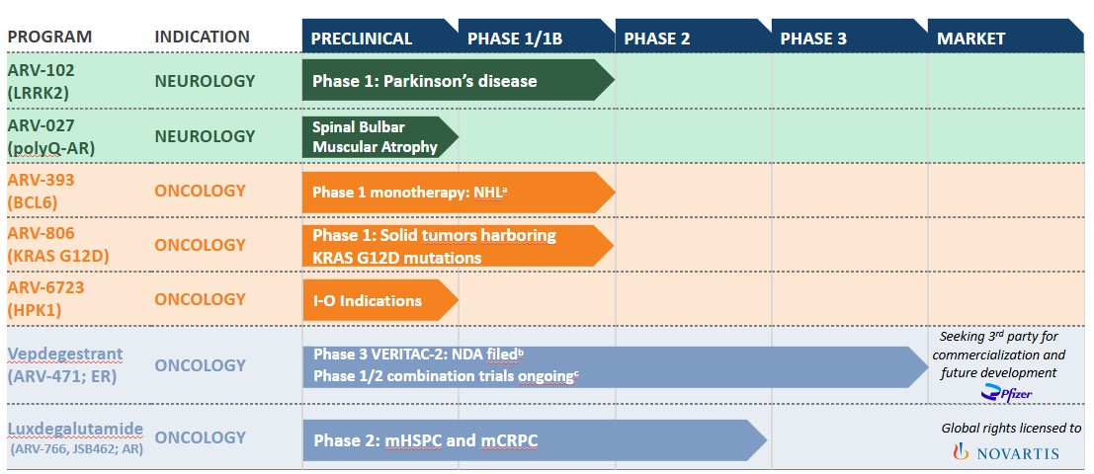
•These agents included in the graphic above are currently under investigation; their safety and effectiveness for these investigational uses have not been established.
•Defined terms used in the graphic above include: AR, androgen receptor; BCL6, B-cell lymphoma 6; ER, estrogen receptor; HPK1, Hematopoietic Progenitor Kinase 1; I-O, immuno-oncology; KAT6, lysine acetyltransferase 6; KRAS, Kirsten rat
23
Table o f Contents
sarcoma viral oncogene homolog; LRRK2, leucine-rich repeat kinase 2; mCRPC, metastatic castration resistant prostate cancer; mHSPC, metastatic hormone sensitive prostate cancer; NDA, new drug application; NHL, non-Hodgkin lymphoma; polyQ, expanded polyglutamine.
•Footnotes in graphic above: a. Includes relapsed/refractory angioimmunoblastic T-cell lymphoma (AITL) and relapsed/refractory mature B cell NHL; b. Prescription Drug User Fee Act (PDUFA) target action date of June 5, 2026; and c. Phase 1/2 combination trials with palbociclib, atirmociclib, abemaciclib, ribociclib, samuraciclib, everolimus.
In addition to the programs above and our early-stage collaborations, including with Pfizer Inc., or Pfizer, and Genentech, Inc. and F. Hoffman-La Roche Ltd., or Genentech, we are conducting exploratory research and development work on multiple other undisclosed targets.
Clinical Stage Programs: ARV-102, ARV-393, ARV-806 and vepdegestrant
ARV-102: Oral PROTAC LRRK2 degrader
ARV-102 is an investigational, orally bioavailable and brain-penetrant investigational PROTAC designed to specifically target and degrade LRRK2, which is a large, multidomain scaffolding kinase with GTPase activity. ARV-102 is our first oral PROTAC protein degrader in development to treat neurodegenerative diseases.
In preclinical studies, ARV-102 has been shown to cross the blood-brain barrier and degrade LRRK2. Unlike traditional small molecule inhibitors, or SMIs, that only block LRRK2’s kinase activity, LRRK2 degraders eliminate pathologic scaffolding function, GTPase activity and the kinase activity of LRRK2 implicated in disease. We believe our LRRK2 degraders are particularly well positioned to be evaluated in two diseases where there are no disease modifying therapies available:
•Parkinson’s Disease, or PD, where increased LRRK2 expression and activity contributes to neurodegeneration and pathogenesis of PD; and
•Progressive Supranuclear Palsy, or PSP, where genetic variations in LRRK2 are associated with PSP progression. Additionally, we have published data associating the tau pathology of PSP with LRRK2-mediated endolysosomal dysfunction.
We are currently conducting an ongoing Phase 1 clinical trial with ARV-102 in patients with PD. We have completed the single ascending dose, or SAD, and multiple ascending dose, or MAD cohorts of the ARV-102 Phase 1 clinical trial in healthy volunteers. We completed enrollment in the SAD cohort of the ARV-102 Phase 1 clinical trial in patients with PD in the second quarter of 2025. We received Clinical Trial Application approval in the Netherlands to initiate a multiple dose cohort of the Phase 1 clinical trial in patients with PD in the second quarter of 2025, and we initiated this multiple dose cohort in the third quarter of 2025.
In the second quarter of 2025, we presented data from the first-in-human clinical trial of ARV-102 at the 2025 International Conference on Alzheimer’s and Parkinson’s Diseases, or AD/PD™ 2025, including results from the randomized, double-blind, placebo-controlled SAD cohort, and initial results from the MAD cohort, of the Phase 1 healthy volunteer clinical trial. The ARV-102 Phase 1 clinical trial is designed to assess the safety, pharmacokinetics, and pharmacodynamics of orally administered ARV-102 in healthy male volunteers. This clinical trial is a single-center, randomized, double-blind, placebo-controlled trial evaluating outcomes in both SAD and MAD cohorts. In the SAD cohort, volunteers were randomized three to one, to either placebo or a single dose of ARV-102 (10 mg, 30 mg, 60 mg, 90 mg, 150 mg, or 200 mg) on day 1 with follow-up until day 10. In the MAD cohort, volunteers were randomized to either placebo or a once daily dose of ARV-102 (10 mg, 20 mg, 40 mg, or 80 mg) for 14 days with follow-up until day 28.
In the clinical trial data presented in the second quarter of 2025, ARV-102 demonstrated substantial reduction of LRRK2 in cerebral spinal fluid, or CSF, with a promising safety/tolerability profile and favorable pharmacodynamic outcomes. Key findings from the clinical trial indicated brain penetration, substantial central and peripheral LRRK2 protein degradation, and signified downstream LRRK2 pathway engagement. The specific data presented at AD/PD™ 2025 are outlined below.
24
Table o f Contents
Safety Profile
•At the time of data cutoff (March 13, 2025), the SAD cohort of the Phase 1 clinical trial was completed and the MAD cohort was ongoing. Based on evaluation of the available data from single and multiple oral doses, ARV-102 was well tolerated in healthy volunteers.
•Of the 47 volunteers across all SAD dose levels, the primary treatment related adverse events were headache and fatigue. Headaches occurred in 17.1% (6/35) of treated individuals compared to 0% (0/12) in placebo controls. Fatigue occurred in 8.6% (3/35) of the treated individuals compared to 25% (3/12) in placebo controls.
•Procedural pain associated with the lumbar puncture occurred in 28.6% (10/35) of treated individuals compared to 41.7% (5/12) in placebo controls. Post lumbar puncture syndrome was only observed in the treated cohort, at a rate of 17.1% (6/35).
•No serious adverse events were reported in either the SAD or MAD cohorts.
ARV-102 Exposure in Plasma and CSF
•ARV-102 exhibited median maximum concentration six hours after oral administration.
•The area under the concentration-time curve in the first 24 hours post dosing and the maximum plasma concentration increased in a dose-dependent manner and the median terminal plasma half-life was 73 hours.
•ARV-102 levels in CSF increased in a dose dependent manner in both the SAD and MAD cohorts.
Pharmacodynamic Evaluation
•At single doses of greater than or equal to 60 mg and repeated doses of greater than or equal to 20 mg, LRRK2 reduction of greater than 90% in peripheral blood mononuclear cells was observed.
•ARV-102 at single doses of greater than or equal to 30 mg induced greater than 50% decreases in peripheral phospho-Rab10T73, a LRRK2 substrate and biomarker for downstream LRRK2 activity; data for this endpoint in the MAD cohort is pending.
•ARV-102 at single doses of greater than or equal to 30 mg resulted in greater than 90% decrease of bis(monoacylglycerol)phosphate in urine, a biomarker of lysosomal function; data for this endpoint in the MAD cohort is pending.
•In CSF, ARV-102 induced dose-dependent LRRK2 reduction, with greater than 50% LRRK2 reduction at single doses of greater than or equal to 60 mg and repeated doses of greater than or equal to 20 mg.
In the fourth quarter of 2025, we presented late breaking positive Phase 1 data from our first-in-human clinical trial of ARV-102 in healthy volunteers, and from the SAD cohort of our Phase 1 clinical trial of ARV-102 in patients with PD at the 2025 International Congress of Parkinson’s Disease and Movement Disorders®, or MDS. Data presented at MDS included the following:
Data from the Phase 1 SAD and MAD Clinical Trial in Healthy Volunteers
•Safety: ARV-102 was generally well tolerated at single doses up to 200 mg and multiple daily doses up to 80 mg, with no discontinuations due to adverse events, or AEs, or serious adverse events, or SAEs, observed in the study population.
•Pharmacokinetics: ARV-102 exposure increased in a dose-dependent manner in plasma and CSF, the latter indicating brain penetration.
•Pharmacodynamics: Repeated daily doses of greater than or equal to 20 mg resulted in greater than 90% reductions of LRRK2 protein in peripheral blood mononuclear cells, or PBMCs, and greater than 50% reductions in CSF.
•Pathway Biomarkers: Repeated daily doses of ARV-102 resulted in reduced plasma concentrations of phospho-Rab10T73 and urine concentrations of bis(monoacylglycerol)phosphate, a sensitive biomarker for modulation of the lysosomal pathway downstream of LRRK2.
25
Table o f Contents
Interim SAD Data from the Phase 1 Clinical Trial in Patients with PD and CSF Proteomic Data from the Phase 1 Trial in Healthy Volunteers
•Safety: The Phase 1 clinical trial in patients with PD included 15 patients treated with ARV-102 and 4 patients treated with placebo. In the trial, single doses of ARV-102 (50 mg or 200 mg) were well tolerated with only mild treatment-related AEs including headache, diarrhea, and nausea; no SAEs occurred.
•Pharmacokinetics: In patients with PD, ARV-102 exposure increased in a dose-dependent manner in both plasma and CSF, the latter indicating brain penetration.
•Pharmacodynamics: In patients with PD, treatment with ARV-102 resulted in median PBMC LRRK2 protein reductions of 86% with the 50 mg dose and 97% with the 200 mg dose.
•CSF Proteomics: In healthy volunteers treated with ARV-102 at 80 mg once daily for 14 days, unbiased proteomic analyses of CSF showed significant decreases in lysosomal pathway markers and neuroinflammatory microglial markers previously shown to be elevated in patients with PD harboring LRRK2 variants.
We believe these data presented at MDS highlight the potential PROTAC-mediated LRRK2 degradation, which supports the development of ARV-102 in ongoing studies of patients with PD, and potential future studies of patients with PSP.
We plan to present initial data from the multiple dose cohort of the Phase 1 clinical trial of ARV-102 in patients with PD in 2026. Pending regulatory feedback, we plan to initiate a Phase 1b clinical trial of ARV-102 in patients with PSP in the first half of 2026.
ARV-393: Oral PROTAC BCL6 degrader
ARV-393 is an investigational, orally bioavailable PROTAC designed to specifically target and degrade BCL6, a transcriptional repressor and a key regulator of normal B-cell maturation and differentiation processes. Deregulation of BCL6 function (e.g., via chromosomal translocation, mutations) may lead to malignant transformation and development of NHL. During B-cell development, tightly controlled BCL6 protein expression regulates more than 600 genes to facilitate rapid B-cell proliferation and tolerance of somatic hypermutation and gene recombination for antibody generation. Deregulated BCL6 expression is common in B-cell lymphoma and promotes cancer cell survival, proliferation, and genomic instability. We believe that PROTAC-mediated degradation has the potential to address the historically undruggable nature of BCL6 and that ARV-393 PROTAC-mediated degradation of BCL6 may provide an important novel therapeutic option for patients with NHL. Furthermore, we believe current preclinical data suggest that ARV-393 has the potential to be an attractive combination partner for development of novel therapies for lymphoma, including chemo-free combination regimens and/or “all oral” treatment options.
In the second quarter of 2025, we presented preclinical data of ARV-393 in combination with standard of care, or SOC, chemotherapy and biologic agents, as well as oral, investigational small molecule inhibitors in high grade and aggressive diffuse large B-cell lymphoma, or DLBCL, in vivo models at the American Association for Cancer Research Annual Meeting. Based on these preclinical data, in aggressive DLBCL models, ARV-393 showed strong synergistic antitumor activity, including complete regressions, in combination with SOC chemotherapy and biologics, as well as investigational oral small molecule inhibitors. In particular:

•ARV-393 in combination with SOC chemotherapy (rituximab, cyclophosphamide, doxorubicin, vincristine, and prednisone, or R-CHOP), induced significantly greater tumor growth inhibition, or TGI, compared with rituximab, CHOP, R-CHOP, or ARV-393 alone, with complete tumor regressions in all mice treated with the ARV-393 and R-CHOP combination;
•ARV-393 in combination with SOC biologics targeting CD20 (rituximab), CD19 (tafasitamab), or CD79b (polatuzumab vedotin), resulted in tumor regressions and demonstrated significantly stronger TGI compared with either agent alone;
•in preclinical models, ARV-393 increased CD20 expression, providing additional support for the exploration of combinations with CD20-targeted agents and in the context of low or loss of CD20 expression; and
26
Table o f Contents
•ARV-393 in combination with investigational small molecule inhibitors targeting clinically validated oncogenic drivers of lymphoma, such as BTK (acalabrutinib), BCL2 (venetoclax), or EZH2 (tazemetostat), resulted in superior tumor growth inhibition compared with each agent alone, with tumor regressions in all mice treated with the combinations.
In addition, in the second quarter of 2025, we presented new data from preclinical studies of ARV-393 at the European Hematology Association 2025 Congress in Milan, Italy. In these preclinical studies, ARV-393 demonstrated significant single-agent activity in a patient derived xenograft, or PDX, model of nodal T-follicular helper cell lymphoma, angioimmunoblastic-type, or nTFHL-AI (which is also known and referred to as AITL), and PDX models of transformed follicular lymphoma, or tFL. In addition, in these preclinical studies, in combination with oral SMIs, ARV-393 demonstrated enhanced antitumor activity, including tumor regressions, in cell line-derived xenograft, or CDX, models of high-grade B-cell lymphoma, or HGBCL, and DLBCL. We believe these preclinical data potentially suggest the broad utility of ARV-393 across NHL subtypes with unmet need beyond DLBCL and provide a compelling rationale for considering combination strategies including chemotherapy-free approaches. Key findings from these preclinical studies included:
•Single-agent ARV-393 significantly reduced tumor burden in peripheral blood, bone marrow and spleen in a systemic PDX model of nTFHL-AI derived from a patient who relapsed post chemotherapy.
•ARV-393 monotherapy treatment resulted in robust (≥95%) tumor growth inhibition, or TGI, in two PDX models of tFL.
•ARV-393 in combination with five classes of SMIs targeting potentially cooperative oncogenic drivers (tazemetostat, palbociclib, everolimus, acalabrutinib, or venetoclax) demonstrated increased TGI in CDX models of HGBCL and aggressive DLBCL compared with the respective monotherapy treatments. Tumor regressions were observed when ARV-393 was combined with tazemetostat, palbociclib, acalabrutinib, or venetoclax.
•RNA sequencing studies carried out to further characterize downstream mechanism of action suggested that ARV-393 inhibits tumor cell cycle progression and promotes differentiation, driving antitumor activity and broad combinability in preclinical models.
We plan to share preclinical data for ARV-393 in combination with glofitamab, a CD20xCD3 bispecific antibody and an emerging SOC option for DLBCL, in models of aggressive high grade DLBCL in the fourth quarter of 2025 at the American Society of Hematology 2025 annual meeting. We believe ARV-393 has the potential to increase CD20 expression, which provides rationale for the exploration of ARV-393 with CD20-targeted agents and in the context of low or loss of CD20 expression. Further, we believe the totality of our preclinical data provides a compelling rationale to evaluate ARV-393 in combination with bi-specifics, oral pathway inhibitors, and potentially other standards of care, in the larger DLBCL indication. We intend to initiate enrollment in a Phase 1 clinical trial of ARV-393 in combination trial with glofitamab in patients with DLBCL in 2026.
We are currently enrolling a Phase 1 first-in-human clinical trial of ARV-393 in patients with relapsed/refractory NHL. This is an open-label, multicenter, Phase 1 dose escalation study to evaluate the safety, tolerability and preliminary anti-tumor activity of ARV-393 as a single agent in adult patients with relapsed/refractory NHL. We announced that there have been multiple responses in early cohorts in both B- and T-cell lymphomas in the first-in-human Phase 1 clinical trial in patients with NHL. The anticipated effective exposure level has not been achieved, and dose escalation in the trial is ongoing. We believe that the safety profile of ARV-393 supports continuing to dose escalate. We also believe these early data support an emerging, and differentiated, therapeutic benefit of ARV-393. We plan to share updated clinical data from the ongoing Phase 1 clinical trial in patients with NHL at a medical congress in 2026.
27
Table o f Contents
ARV-806: Novel PROTAC KRAS G12D degrader
ARV-806 is a novel, investigational PROTAC designed to selectively target and degrade mutant KRAS G12D. KRAS is one of the most frequently mutated human oncogenes and G12D is the most common mutation of the KRAS protein. ARV-806 is designed to target both the ON and OFF forms of KRAS G12D, and has the potential to address high unmet need in solid tumors, such as pancreatic, colorectal and non-small cell lung cancer.
In the preclinical setting, ARV-806 demonstrated high potency and selectivity, with robust antitumor activity through dose-responsive degradation of KRAS G12D in KRAS G12D mutated cancers, including pancreatic and colorectal cancers. ARV-806 bound to both the active and inactive forms of KRAS G12D, achieving potent and durable elimination rather than inhibition of the target in all models tested. In addition, as shown below, in preclinical studies, ARV-806 achieved in vitro potency approximately 25 times greater than KRAS inhibitors and 40 times greater than the leading clinical-stage degrader.
In the fourth quarter of 2025, we presented preclinical data for ARV-806 at the AACR-NCI-EORTC International Conference on Molecular Targets and Cancer Therapeutics, or the 2025 Triple Meeting, in Boston, Massachusetts. Key highlights from the presentation at the 2025 Triple Meeting include the following:
•In vitro, ARV-806 degraded KRAS G12D with picomolar potency across pancreatic, colorectal, and lung cancer cell lines, but did not induce degradation of wild-type and other mutant rat sarcoma, or RAS, isoforms.
•ARV-806 is differentiated from other KRAS G12D targeting agents in development and we believe has potential to be a best-in-class therapy for KRAS G12D mutated cancers due to:
◦Catalytic activity, which allows it to overcome upregulation, a common mechanism of resistance to inhibitor treatment.
◦Compared with clinical-stage KRAS G12D ON and OFF inhibitors and another clinical-stage G12D degrader, ARV-806 demonstrated:
▪more than 25-fold greater potency in reducing cancer cell proliferation;
▪more than 40-fold higher potency in degrading KRAS G12D protein (versus the comparable clinical-stage G12D degrader); and
▪more than 10-fold lower concentrations required to induce pro-apoptotic BIM (Bcl-2-interacting mediator of cell death, a pro-apoptotic factor) expression.
•Following a single intravenous dose in a colorectal tumor xenograft model, ARV-806 degraded greater than 90% of KRAS G12D for seven days, with parallel suppression of c-MYC (a key driver of cancer cell proliferation) and induction of BIM for greater than or equal to 5 days.
•ARV-806 demonstrated robust efficacy responses at low doses in tumor models including: greater than or equal to 30% tumor volume reductions in pancreatic and colorectal cell line-derived xenograft models and a patient-derived xenograft model of lung cancer.
These data demonstrate sustained pharmacodynamic activity consistent with long-lasting target degradation, which we believe supports intermittent clinical dosing.
In addition, the poster shown at the 2025 Triple Meeting showed that orally bioavailable pan-KRAS degraders have been identified that potently degrade multiple variants of KRAS and spare other RAS isoforms. A tool pan-KRAS PROTAC demonstrated robust single-agent activity and superior combination efficacy with immune checkpoint blockade compared with a pan-RAS ON inhibitor (7 complete responses compared with 2 complete responses).
28
Table o f Contents
We filed an investigational new drug application with the FDA for ARV-806 in the first quarter of 2025 and received a safe-to-proceed letter from the FDA in the second quarter of 2025. We initiated enrollment in a Phase 1 clinical trial of ARV-806 in patients with advanced solid tumors harboring KRAS G12D mutations in the second quarter of 2025 and this trial is currently ongoing. We anticipate sharing initial clinical data from this Phase 1 clinical trial in 2026.
Vepdegestrant: Oral PROTAC ER Degrader
Vepdegestrant is an investigational orally bioavailable PROTAC protein degrader designed to harness the body’s natural protein disposal system to specifically target and degrade the ER for the treatment of locally advanced or metastatic ER+/HER2- breast cancer. We are co-developing vepdegestrant with Pfizer, pursuant to a collaboration agreement that we and Pfizer entered into in July 2021. We granted Pfizer worldwide co-exclusive rights to develop and commercialize vepdegestrant.
In preclinical studies, vepdegestrant demonstrated near-complete ER degradation in tumor cells, induced robust tumor shrinkage when dosed as a single agent in multiple ER-driven xenograft models and showed superior anti-tumor activity when compared to a standard of care agent, fulvestrant, both as a single agent and in combination with a cyclin-dependent kinase, or CDK, 4/6 inhibitor.
We, along with Pfizer, have several ongoing clinical trials of vepdegestrant, for which enrollment of patients is complete, which are summarized below.
•VERITAC-2, a Phase 3 clinical trial of vepdegestrant as a monotherapy, targeting metastatic breast cancer previously treated with endocrine based therapy;
•VERITAC, a Phase 2 dose expansion clinical trial of vepdegestrant as a monotherapy, targeting previously treated metastatic breast cancer;
•TACTIVE-K, a Phase 1b/2 clinical trial of vepdegestrant in combination with Pfizer's cyclin-dependent kinase 4, or CDK4, inhibitor, atirmociclib; and
•TACTIVE-U, a Phase 1b/2 clinical trial of vepdegestrant in combination with multiple targeted therapies including abemaciclib, ribociclib or Carrick Therapeutics, Inc.'s, or Carrick, cyclin-dependent kinase 7, or CDK7, inhibitor, samuraciclib.

We, along with Pfizer, also have completed two clinical trials of vepdegestrant:
•TACTIVE-N, a Phase 2 clinical trial of vepdegestrant as a monotherapy in the neoadjuvant setting; and
•TACTIVE-E, a Phase 1 clinical trial of vepdegestrant in combination with everolimus.
VERITAC-2 Clinical Trial, New Drug Application
In the first quarter of 2025, we, along with Pfizer, announced positive topline results from the Phase 3 VERITAC-2 clinical trial in the estrogen receptor 1-mutant, or ESR1m, population, and in the second quarter of 2025, we, along with Pfizer announced detailed results from this clinical trial. These detailed results, which are included below, were presented in a late-breaking oral presentation at the American Society of Clinical Oncology, or ASCO, 2025 Annual Meeting and were highlighted in the ASCO press briefing and selected for Best of ASCO, and were also simultaneously published in the New England Journal of Medicine.
Based on the results from VERITAC-2, in the second quarter of 2025, we and Pfizer submitted a new drug application to the U.S. Food and Drug Administration, or FDA, for vepdegestrant for the treatment of patients with ER+/HER2- ESR1-mutated advanced or metastatic breast cancer previously treated with endocrine-based therapy. This represents the first NDA submitted for a PROTAC. In the third quarter of 2025, we announced that the FDA accepted the NDA for vepdegestrant and assigned a Prescription Drug User Fee Act action date of June 5, 2026.
Clinical Trial Design
The Phase 3 VERITAC-2 clinical trial is a global randomized study evaluating the efficacy and safety of vepdegestrant as a monotherapy compared to fulvestrant in patients with ER+/HER2- advanced or metastatic breast cancer. The trial enrolled 624 patients at sites in 26 countries who had previously received treatment with
29
Table o f Contents
a CDK4/6 inhibitor plus endocrine therapy. Patients were randomized to receive either vepdegestrant once daily, orally on a 28-day continuous dosing schedule, or fulvestrant, administered intramuscularly on Days 1 and 15 of Cycle 1 and then on Day 1 of each 28-day cycle starting from Day 1 of Cycle 2. The primary endpoint was progression-free survival, or PFS, in the intent-to-treat, or ITT, and ESR1 mutation populations as determined by blinded independent central review, or BICR. Overall survival, or OS, was the key secondary endpoint.
Clinical Trial Results
The Phase 3 VERITAC-2 trial met its primary endpoint in the ESR1m population, demonstrating a statistically significant and clinically meaningful improvement in PFS compared to fulvestrant. The results exceeded the pre-specified target hazard ratio of 0.60 in the ESR1m population. The trial did not reach statistical significance in improvement in PFS in the ITT population.
Overall survival was not mature at the time of the analysis of data, with less than a quarter of the required number of events having occurred. The trial will continue to assess overall survival as a key secondary endpoint. In the trial, vepdegestrant was generally well tolerated and its safety profile was consistent with what has been observed in previous studies.
Detailed results from the Phase 3 VERITAC-2 clinical trial included the following:
•PFS
•Vepdegestrant demonstrated a statistically significant and clinically meaningful improvement in PFS among ESR1m patients, reducing the risk of disease progression or death by 43% compared to fulvestrant [Hazard Ratio, or HR=0.57 (95% CI 0.42–0.77); 2-sided P<0.001].
•The median PFS, as assessed by BICR, was 5.0 months with vepdegestrant versus 2.1 months with fulvestrant.
•Investigator-assessed PFS was consistent with the BICR-assessed PFS.
•In ESR1m patients, vepdegestrant demonstrated a consistent PFS benefit over fulvestrant across all pre-specified subgroups.
•The trial did not reach statistical significance in improvement in PFS in the ITT population, with a median PFS of 3.7 months for vepdegestrant versus 3.6 for fulvestrant [HR=0.83 (95% CI 0.68–1.02); 2-sided P=0.07].
•Tolerability and Safety Profile
◦Vepdegestrant was generally well tolerated in the clinical trial, with a safety profile consistent with what has been observed in previous studies, and mostly low-grade treatment-emergent adverse events, or TEAEs, were reported.
◦Rates and severity of gastrointestinal adverse events were low with vepdegestrant (nausea, 13.5%; vomiting, 6.4%; diarrhea, 6.4%). Grade 4 TEAEs were reported in five patients (1.6%) in the vepdegestrant arm versus nine patients (2.9%) in the fulvestrant arm.
◦The three most common TEAEs observed with vepdegestrant were fatigue (26.6%), increased alanine transaminase (ALT) (14.4%) and increased aspartate aminotransferase (AST) (14.4%).
◦TEAEs leading to treatment discontinuation occurred in 2.9% of patients taking vepdegestrant versus 0.7% of patients taking fulvestrant.
•Other Data Points
◦Additional secondary endpoints include clinical benefit rate, or CBR, and objective response rate, or ORR, and duration of response by BICR. In patients with an ESR1 mutation, CBR was 42.1% with vepdegestrant versus 20.2% with fulvestrant [odds ratio 2.88 (95% CI: 1.57–5.39); nominal P<0.001] and ORR was 18.6% with vepdegestrant versus 4.0% with fulvestrant [odds ratio 5.45 (95% CI: 1.69–22.73); nominal P=0.001]. The median duration of response was not reached.
30
Table o f Contents
We believe that, based on these strong data from VERITAC-2, vepdegestrant has the potential to be a best-in-class monotherapy treatment for patients in the second-line ESR1m setting.
As part of our global collaboration with Pfizer, we and Pfizer presented patient reported outcomes, or PRO, data from the VERITAC-2 clinical trial evaluating vepdegestrant versus fulvestrant for previously treated patients with ESR1 mutated- ER+/HER2- advanced breast cancer in the fourth quarter of 2025 at the European Society for Medical Oncology 2025 Congress. In the VERITAC-2 clinical trial, in patients with ESR1-mutated disease, vepdegestrant demonstrated a reduced risk of deterioration compared to fulvestrant which was statistically significant in several PRO domains including overall health status, pain severity, and functioning (including role, cognitive, emotional, and social functioning), and vepdegestrant consistently showed reduced risk of deterioration versus fulvestrant across all PRO domains. These PRO data from the VERITAC-2 clinical trial support the clinical benefit of vepdegestrant in patients with ESR1-mutated, ER+/HER2- advanced or metastatic breast cancer previously treated with endocrine-based therapy.
Other Clinical Trials and Information
In the second quarter of 2025, we announced that we and Pfizer removed two planned Phase 3 combination trials of vepdegestrant from the agreed-upon joint development plan: a first-line Phase 3 combination trial with Pfizer’s novel investigational CDK4 inhibitor, atirmociclib, and a second-line Phase 3 combination trial with a CDK4/6 inhibitor.
Additionally, in the second quarter of 2025, Pfizer added a vepdegestrant combination cohort to its ongoing Phase 1 clinical trial evaluating Pfizer’s investigational KAT6 inhibitor in combination with endocrine therapies following CDK4/6 inhibitor treatment. This clinical trial is being operationalized and funded solely by Pfizer.
As part of our global collaboration with Pfizer, we and Pfizer presented results of the TACTIVE-N Phase 2 clinical trial which evaluated neoadjuvant vepdegestrant in postmenopausal women with ER+/HER2– localized breast cancer in the fourth quarter of 2025 at the European Society for Medical Oncology 2025 Congress. The results presented showed that neoadjuvant vepdegestrant demonstrated biological and clinical activity in this treatment-naïve, predominantly ESR1 wild-type population of postmenopausal women with ER+/HER2- localized breast cancer.
We, along with Pfizer, continue market preparations for vepdegestrant in advance of the Prescription Drug User Fee Action date. While we continue to believe that vepdegestrant has the potential to be a best-in-class monotherapy treatment for patients in the second-line ESR1m setting, given our and Pfizer’s decision to remove the two planned Phase 3 combination trials of vepdegestrant from the agreed-upon joint development plan as noted above, we have determined that it is no longer viable for us to build out our commercial infrastructure as we had previously planned. As such, in the third quarter of 2025, we announced that we and Pfizer have agreed to jointly select a third party for the commercialization and potential future development of vepdegestrant.
Preclinical and Other Programs
ARV-027: Oral PROTAC polyQ-AR degrader
ARV-027, is an oral, peripherally restricted investigational PROTAC designed to selectively target and eliminate the polyglutamine-expanded androgen receptor, or polyQ-AR, in skeletal muscle. ARV-027 is a clinical candidate specifically selected for potent in vitro reduction of cytosolic and nuclear polyQ-AR and for favorable skeletal muscle exposure following oral administration.

The polyQ-AR protein is the pathogenic driver of spinal and bulbar muscular atrophy, or SBMA, a rare, X-linked, genetically defined neuromuscular disease caused by a CAG trinucleotide repeat expansion in the androgen receptor, or AR, gene. SBMA leads to progressive muscle weakness, dysphagia, and functional decline, and currently has no approved disease-modifying therapies, representing a significant unmet medical need.

In the fourth quarter of 2025 at the International Congress of the World Muscle Society, we presented new preclinical data demonstrating robust degradation of polyQ-AR in human myotubes derived from SBMA
31
Table o f Contents
patient induced pluripotent stem cells. The preclinical ARV-027 data presented also showed dose-dependent degradation of AR in mouse muscle that was sustained for more than 24 hours (single oral dose), and reductions in muscle monomeric polyQ-AR levels between 40-60%, improved muscle grip strength, and restored muscle endurance to wild-type levels in SBMA mouse model.

Pending regulatory feedback, we expect to initiate a first-in-human Phase 1 clinical trial in ARV-027 in healthy volunteers in 2026.
ARV-6723: Oral PROTAC HPK1 degrader
ARV-6723 is an oral investigational PROTAC designed to degrade hematopoietic progenitor kinase 1, or HPK1. ARV-6723 is our first clinical candidate in the immuno-oncology space. Preclinically, ARV-6723 has shown potent, selective HPK1 degradation and strong anti-tumor immune responses with superior tumor control in low- and high- immunogenic tumor models. HPK1 acts as a negative regulator in T-cell signaling. Degrading HPK1 and its scaffolding function has the potential to unleash an immune response with potent anti-tumor effects and minimum off-target toxicity.
We plan to present preclinical data at the Society for Immunotherapy of Cancer annual meeting in the fourth quarter of 2025. In addition, pending regulatory feedback, we plan to initiate a Phase 1 clinical trial of ARV-6723 in patients with advanced solid tumors in 2026.
Bavdegalutamide (ARV-110)
Bavdegalutamide is an investigational orally bioavailable PROTAC protein degrader designed to target and degrade the androgen receptor, or AR, for the treatment of men with metastatic castration resistant prostate cancer. Clinical trials for bavdegalutamide (ARV-110-101 and ARV-110-103) were completed in the second quarter of 2025.
Our Operations
We commenced operations in 2013. Our operations to date have been limited to organizing and staffing our company, business planning, raising capital, conducting discovery and research activities, filing patent applications, identifying potential product candidates, undertaking preclinical studies and clinical trials and establishing collaborations with third parties and for the manufacture of initial quantities of our product candidates and preparing for commercialization, including by beginning to build a commercial infrastructure. To date, we have not generated any revenue from product sales and have financed our operations primarily through sales of assets and equity interests, proceeds from our collaborations and a licensing arrangement, grant funding and debt financing. Since inception through September 30, 2025, we raised approximately $1.7 billion in gross proceeds from the sale of assets and equity interests and the exercise of stock options and had received an aggregate of $913.1 million in payments primarily from collaboration partners and a licensing arrangement.
We are a clinical-stage company, with product candidates in clinical development and other drug discovery activities in the research and preclinical development stages. Our ability to generate revenue from product sales sufficient to achieve profitability will depend heavily on the successful development and eventual commercialization of one or more of our product candidates and our ability to manage our expenses.
In April 2025, we committed to and approved a reduction of our workforce by approximately 33% across all areas of our company, as part of our decision to streamline operations across our organization and enable the efficient progression of our portfolio. The workforce reduction was aimed at reducing internal costs while minimally impacting our targeted clinical stage programs to drive value over the next several years by aligning our operations with long-term program development objectives. The workforce reduction was substantially completed by the end of the second quarter of 2025.
In September 2025, we announced an update on our collaboration with Pfizer and further actions to support value creation by optimizing organizational and cost structures and streamlining operations in advance of multiple anticipated upcoming value inflection points, including: further limiting additional expenditures on the vepdegestrant program to support activities required for commercialization readiness and identification, with Pfizer, of a third party for the commercialization and potential further development of vepdegestrant; reducing
32
Table o f Contents
our workforce by an additional 15% to streamline operations, with the most significant reductions being roles related to vepdegestrant commercialization; and proactively managing pipeline cost by seeking strategic business development opportunities and by identifying further efficiencies across the business. The September 2025 workforce reduction is expected to be substantially completed by the first quarter of 2026.
We recognized restructuring charges of $0.7 million related to the two actions noted above, including $11.4 million of cash severance and other one-time employee related termination benefit related to the workforce reductions, partially offset by a reversal of $10.7 million of non-cash stock compensation and bonus expenses. We expect to achieve annual operating cost savings of $100.0 million, on a run-rate basis. Refer to Note 14, Restructuring Activity, in this Quarterly Report on Form 10-Q for further details.
Since inception, we have incurred significant operating losses and, even in light of our workforce reductions and cost optimization decisions, we expect to continue to incur increasing operating losses for at least the next several years. In addition to any additional costs not currently contemplated due to the events associated with or resulting from our workforce reduction, our ability to achieve profitability and our financial position will depend, in part, on the rate of our future expenditures, potential collaboration revenue, our ability to successfully implement cost avoidance measures and reduce overhead costs and our ability to obtain additional funding. We expect to continue to incur significant expenses associated with: our ongoing and anticipated preclinical and clinical activities, development activities, research activities in oncology, neuroscience and other disease areas, managing our employees and retaining key talent in research, clinical trials, quality and other functional areas, increased expenses incurred with CMOs to supply us with product for our preclinical and clinical studies, and expenses incurred with contract research organizations, or CROs, for the synthesis of compounds in our preclinical development activities, as well as other associated costs including those related to partnering with us on our clinical trial portfolio and the management of our intellectual property portfolio.
We do not expect to generate any revenue from product sales in the near future, if ever. Accordingly, we will need to obtain substantial additional funding in connection with our continuing operations. If we are unable to raise capital when needed or on attractive terms, we could be forced to delay, reduce or eliminate our research or product development programs or any future commercialization efforts, or to relinquish valuable rights to our technologies, future revenue streams, research programs or product candidates or to grant licenses on terms that may not be favorable to us.

Financial Operations Overview
Revenue
To date, we have not generated any revenue from product sales and do not expect to generate any revenue from the sale of products in the near future. Our revenues to date have been generated through research collaborations, a licensing arrangement and an asset sale. Revenue is recognized ratably over our expected performance period under each agreement. We expect that any revenue recognized in the near term will be derived from our current collaboration agreements and licensing arrangement and any additional arrangements that we may enter into in the future. To date, we have not received any development, regulatory and commercial milestone payments or royalties under any of the collaboration agreements or licensing arrangement.
Pfizer Vepdegestrant (ARV-471) Collaboration Agreement
In July 2021, we entered into a Collaboration Agreement with Pfizer, or the Vepdegestrant (ARV-471) Collaboration Agreement, pursuant to which we granted Pfizer worldwide co-exclusive rights to develop and commercialize products containing our proprietary compound vepdegestrant (ARV-471), or the Licensed Products.
Under the Vepdegestrant (ARV-471) Collaboration Agreement, we received an upfront, non-refundable payment of $650.0 million. In addition, we are eligible to receive up to an additional $1.4 billion in contingent payments based on specified regulatory and sales-based milestones for the Licensed Products. Of the total contingent payments, $400.0 million in regulatory milestones are related to marketing approvals and $1.0 billion are related to sales-based milestones.
33
Table o f Contents
We and Pfizer share equally (50/50) all development costs for the Licensed Products, subject to certain exceptions. Except for certain regions described below, we will also share equally (50/50) all profits and losses in commercialization and medical affairs activities for the Licensed Products in all other countries, subject to certain exceptions.
Pursuant to the terms of the Vepdegestrant (ARV-471) Collaboration Agreement, we will be the marketing authorization holder and, subject to marketing approval, book sales in the United States, while Pfizer will hold marketing authorizations outside the United States. We will determine with Pfizer which, if any, regions within the world will be solely commercialized by one party, and in such region the parties will adjust their share of all profits and losses for the Licensed Products based on the role each party will be performing.
Unless earlier terminated in accordance with its terms, the Vepdegestrant (ARV-471) Collaboration Agreement will expire on a Licensed Product-by-Licensed Product and country-by-country basis when such Licensed Products are no longer commercialized or developed for commercialization in such country. Pfizer may terminate the Vepdegestrant (ARV-471) Collaboration Agreement for convenience in its entirety or on a region-by-region basis subject to certain notice periods. Either party may terminate the Vepdegestrant (ARV-471) Collaboration Agreement for the other party’s uncured material breach or insolvency. Subject to applicable terms of the Vepdegestrant (ARV-471) Collaboration Agreement, including certain payments to Pfizer upon termination for our uncured material breach, effective upon termination of the Vepdegestrant (ARV-471) Collaboration Agreement, we are entitled to retain specified licenses to be able to continue to exploit the Licensed Products.
Subject to specified exceptions, we and Pfizer have each agreed not to directly or indirectly research, develop, or commercialize any competing products outside of the Vepdegestrant (ARV-471) Collaboration Agreement anywhere in the world during the term of the Vepdegestrant (ARV-471) Collaboration Agreement.
In the third quarter of 2025, we announced that we and Pfizer have agreed to jointly select a third party for the commercialization and potential future development of vepdegestrant.
Pfizer Research Collaboration Agreement
In December 2017, we entered into a Research Collaboration and License Agreement with Pfizer, setting forth our collaboration to identify or optimize PROTAC targeted protein degraders that mediate for degradation of target proteins, using our proprietary platform technology that are identified in the agreement or subsequently selected by Pfizer, subject to certain exclusions. We refer to this agreement as the Pfizer Research Collaboration Agreement.
Under the Pfizer Research Collaboration Agreement, Pfizer has designated a number of initial target proteins. For each identified target protein, we and Pfizer will conduct a separate research program pursuant to a research plan. Pfizer may make substitutions for any of the initial target protein candidates, subject to the stage of research for such target protein.
In the year ended December 31, 2018, we received an upfront non-refundable payment and certain additional payments totaling $28.0 million in exchange for use of our technology license and to fund Pfizer-related research, as defined within the Pfizer Research Collaboration Agreement. We are eligible to receive up to an additional $3.8 million in non-refundable option payments if Pfizer exercises its option for the single target protein remaining under the Pfizer Research Collaboration Agreement. We are also entitled to receive up to $225.0 million in development milestone payments and up to $550.0 million in sales-based milestone payments for all designated target proteins under the Pfizer Research Collaboration Agreement, as well as mid- to high-single digit tiered royalties, which may be subject to reductions, on net sales of PROTAC targeted protein degrader-related products.
Novartis Transaction
In April 2024, we entered into a transaction, or the Novartis Transaction, including both a license agreement, or the Novartis License Agreement, and an asset agreement, or the Novartis Asset Agreement, with Novartis Pharma AG, or Novartis. The Novartis Transaction closed in May 2024 upon the expiration of the
34
Table o f Contents
waiting period under the Hart-Scott-Rodino Antitrust Improvements Act of 1976, at which time the Novartis License Agreement and the Novartis Asset Agreement became effective.
Pursuant to the Novartis License Agreement, we granted Novartis an exclusive worldwide license for the development, manufacture and commercialization of luxdegalutamide (ARV-766), our second generation PROTAC AR degrader for patients with prostate cancer. Pursuant to the Novartis Asset Agreement, we sold to Novartis all of our rights, title and interest in our PROTAC protein degrader targeting AR-V7, a splice variant of the AR.
Under the terms of and as consideration for entering into the Novartis Transaction, we received a one-time, upfront payment in the aggregate amount of $150.0 million from Novartis. Under the Novartis License Agreement, we are also eligible to receive up to an additional $1.01 billion as contingent payments based on specified development, regulatory, and commercial milestones for luxdegalutamide (ARV-766) being met, as well as tiered royalties based upon worldwide net sales of luxdegalutamide (ARV-766), subject to reduction under certain circumstances as provided in the Novartis License Agreement. Novartis announced the recent initiation of two Phase 2 combination clinical trials - one in metastatic castration resistant prostate cancer, and the other is metastatic hormone sensitive prostate cancer - which will both identify recommended Phase 3 doses and, we believe, further validate our ability to develop potentially best-in-class protein degraders. During the three months ended September 30, 2025, we recognized as revenue $20.0 million upon the achievement of a development milestone pursuant to the terms of the Novartis License Agreement.
The Novartis License Agreement will expire on a country-by-country basis (or, in certain cases, a region-by-region basis) until the expiration of the applicable royalty term for such country (or region, as applicable). The Novartis License Agreement contains customary termination provisions, including that either party may terminate the Novartis License Agreement (a) upon the material breach of the other party or (b) in the event the other party experiences an insolvency event. Additionally, Novartis may terminate the Novartis License Agreement for convenience or upon a safety or regulatory issue.
Bayer Collaboration Agreement
In June 2019, we entered into a Collaboration and License Agreement, or the Bayer Collaboration Agreement, with Bayer, setting forth our collaboration to identify or optimize PROTAC targeted protein degraders that mediate for degradation of target proteins, using our proprietary platform technology, that are selected by Bayer, subject to certain exclusions and limitations. The Bayer Collaboration Agreement became effective in July 2019.
Under the Bayer Collaboration Agreement, we and Bayer conducted a research program pursuant to separate research plans mutually agreed to by us and Bayer and tailored to each target protein selected by Bayer. During the term of the Bayer Collaboration Agreement, we were not permitted, either directly or indirectly, to design, identify, discover or develop any small molecule pharmacologically-active agent whose primary mechanism of action is, by design, directed to the inhibition or degradation of any target protein selected or reserved by Bayer, or grant any license, covenant not to sue or other right to any third party in the field of human disease under the licensed intellectual property for the conduct of such activities.
Under the terms of the Bayer Collaboration Agreement, we received an aggregate upfront non-refundable payment of $17.5 million and an additional $12.0 million in aggregate from inception through 2023. We were also eligible to receive up to $197.5 million in development milestone payments and up to $490.0 million in sales-based milestone payments for all designated target proteins. In addition, we were eligible to receive, on net sales of PROTAC targeted protein degrader-related products, mid-single digit to low-double digit tiered royalties, which were subject to reductions.
Pursuant to notice from Bayer AG in accordance with the terms of the Bayer Collaboration Agreement, the Bayer Collaboration Agreement was terminated, effective August 12, 2024.
Genentech License Agreement
In September 2015, we entered into an Option and License Agreement with Genentech focused on PROTAC targeted protein degrader discovery and research for target proteins based on our proprietary platform technology, other than excluded target proteins as described below. This collaboration was expanded in
35
Table o f Contents
November 2017 through an Amended and Restated Option, License and Collaboration Agreement, which we refer to as the Restated Genentech Agreement.
Under the Restated Genentech Agreement, Genentech had the right to designate up to ten target proteins for further discovery and research utilizing our PROTAC platform technology and also had the right to remove a target protein from the collaboration and substitute a different target protein that was not an excluded target protein at any time prior to us commencing research on such target protein or in certain circumstances following commencement of research by us. The research phase of the collaboration with Genentech has ended. Genentech is no longer able to nominate new target proteins into the collaboration, and there are no active targets in the collaboration for which we were conducting research activities.
At the time we entered into the original agreement with Genentech, we received an upfront payment of $11.0 million, and at the time we entered into the Restated Genentech Agreement, we received an additional $34.5 million in upfront and expansion target payments. We are eligible to receive payments aggregating up to $44.0 million per target protein upon the achievement of specified development milestones; payments aggregating up to $52.5 million per target protein (assuming approval of two indications) subject to the achievement of specified regulatory milestones; and payments aggregating up to $60.0 million per PROTAC targeted protein degrader directed against the applicable target protein, subject to the achievement of specified sales milestones. These milestone payments are subject to reduction if we do not have a valid patent claim covering the licensed PROTAC targeted protein degrader at the time the milestone is achieved. We are also eligible to receive, on net sales of licensed PROTAC targeted protein degraders, mid-single digit royalties, which may be subject to reductions.
Operating Expenses
Our operating expenses since inception have consisted solely of research and development costs and general and administrative costs.
Research and Development Expenses
Research and development expenses consist primarily of costs incurred for our research activities, including our discovery efforts, and the development of our product candidates, and include:
•employee related expenses, including salaries, benefits, stock-based compensation expense and travel, for personnel engaged in research and development functions;
•expenses incurred under agreements with third parties, including CROs and other third parties that conduct research, preclinical and clinical activities on our behalf as well as third parties that manufacture our product candidates for use in our preclinical studies and clinical trials;
•costs of outside consultants, including their fees, stock-based compensation and related travel expenses;
•the costs of laboratory supplies and developing preclinical studies and clinical trial materials;
•facility-related expenses, which include direct depreciation costs of equipment and allocated expenses for rent and maintenance of facilities and other operating costs;
•costs incurred in the development of intellectual property; and
•third-party licensing fees.
We expense research and development costs as incurred.
36
Table o f Contents
We typically use our employee and infrastructure resources across our development programs, and as such, do not track all of our internal research and development expenses on a program-by-program basis. The following table summarizes our research and development expenses for the three and nine months ended September 30, 2025 and 2024:
 |  |  | For the Three Months Ended  September 30, |  |  |  |  |  |  |  |  |  |  |  | For the Nine Months Ended  September 30,
(dollars in millions) |  |  | 2025 |  |  |  |  |  | 2024 |  |  |  |  |  | 2025 |  |  |  |  |  | 2024
Program-specific external expense:
Vepdegestrant (ARV-471) (*) |  |  | 14.2 |  |  |  |  |  | 19.6 |  |  |  |  |  | 53.4 |  |  |  |  |  | 63.8
ARV-102 |  |  | 5.0 |  |  |  |  |  | 4.5 |  |  |  |  |  | 15.3 |  |  |  |  |  | 7.5
ARV-806 |  |  | 5.1 |  |  |  |  |  | 0.8 |  |  |  |  |  | 7.7 |  |  |  |  |  | 1.1
ARV-393 |  |  | 2.6 |  |  |  |  |  | 1.7 |  |  |  |  |  | 7.7 |  |  |  |  |  | 4.6
Bavdegalutamide (ARV-110) |  |  | 0.3 |  |  |  |  |  | 2.7 |  |  |  |  |  | 2.3 |  |  |  |  |  | 6.8
Luxdegalutamide (ARV-766) |  |  | — |  |  |  |  |  | 4.7 |  |  |  |  |  | — |  |  |  |  |  | 17.9
Other programs |  |  | 0.3 |  |  |  |  |  | — |  |  |  |  |  | 2.8 |  |  |  |  |  | —
Total program-specific external expense |  |  | 27.5 |  |  |  |  |  | 34.0 |  |  |  |  |  | 89.2 |  |  |  |  |  | 101.7
Non program-specific external expense |  |  | 12.8 |  |  |  |  |  | 13.7 |  |  |  |  |  | 37.9 |  |  |  |  |  | 43.4
Unallocated internal expense
Compensation and related personnel expense  (including stock-based compensation) |  |  | 21.6 |  |  |  |  |  | 35.8 |  |  |  |  |  | 88.6 |  |  |  |  |  | 110.4
Other research and development expense |  |  | 2.8 |  |  |  |  |  | 3.4 |  |  |  |  |  | 8.4 |  |  |  |  |  | 9.4
Total unallocated internal expense |  |  | 24.4 |  |  |  |  |  | 39.2 |  |  |  |  |  | 97.0 |  |  |  |  |  | 119.8
Total research and development expense |  |  | $ | 64.7 |  |  |  |  | $ | 86.9 |  |  |  |  | $ | 224.1 |  |  |  |  | $ | 264.9
(*) Includes net reimbursement to and from Pfizer pursuant to the Vepdegestrant (ARV-471) Collaboration Agreement which are accounted for pursuant to ASC 808 and are recorded as an offset or an increase to research and development expenses.
Research and development activities are central to our business model. We expect that our research and development expenses will continue to increase substantially for the foreseeable future as we continue to conduct our ongoing clinical trials of vepdegestrant, ARV-102, ARV-393 and ARV-806, and continue to discover and develop additional product candidates. Research and development expenses related to vepdegestrant are shared equally with Pfizer since July 22, 2021, the effective date of the Vepdegestrant (ARV-471) Collaboration Agreement. We may receive reimbursement from, or make payments to, Pfizer to satisfy the cost sharing requirements. These payments are accounted for pursuant to ASC 808, Collaborative Arrangements, which are recorded as an offset or an increase to research and development expenses.
We cannot determine with certainty the duration and costs of ongoing and future clinical trials and launch and commercialization preparations of vepdegestrant, ARV-102, ARV-393, ARV-806, or any other product candidate we may develop or if, when, or to what extent we will generate revenue from the commercialization and sale of any product candidate for which we obtain marketing approval. We may never succeed in obtaining marketing approval for any product candidate. The successful development and commercialization of our product candidates is highly uncertain. This is due to the numerous risks and uncertainties associated with developing drugs, including the uncertainty of:
•successfully completing preclinical studies and clinical trials;
•receiving marketing approvals, and any related terms, from applicable regulatory authorities;
•obtaining and maintaining patent and trade secret protection and regulatory exclusivity for our product candidates;
•making or maintaining arrangements with third-party manufacturers, or establishing manufacturing capabilities, for both clinical and commercial supplies of our product candidates;
37
Table o f Contents
•establishing sales, marketing, market access and distribution capabilities and launching commercial sales of our products, if and when approved, whether alone or in collaboration with others;
•acceptance of our products, if and when approved, by patients, the medical community and third-party payors;
•obtaining and maintaining third-party coverage and adequate reimbursement;
•maintaining a continued acceptable safety profile of the products following approval; and
•effectively competing with other therapies.
A change in the outcome of any of these variables with respect to the development of a product candidate could mean a significant change in the costs and timing associated with the development of that product candidate. For example, if the FDA or another regulatory authority were to require us to conduct clinical trials beyond those that we anticipate will be required for the completion of clinical development of a product candidate, or if we experience significant delays in our clinical trials due to patient enrollment or other reasons, we would be required to expend significant additional financial resources and time on the completion of clinical development.
General and Administrative Expenses
General and administrative expenses consist primarily of salaries and other related costs, including stock-based compensation for personnel in our executive, finance, business development and administrative functions. General and administrative expenses also include legal fees relating to intellectual property and corporate matters; professional fees for accounting, auditing, tax and consulting services; insurance costs; travel expenses; and facility-related expenses, which include direct depreciation costs and allocated expenses for rent and maintenance of facilities and other operating costs.
We expect that our general and administrative expenses will increase in the future as we manage our personnel, including retaining or hiring of key employees, and, as a result of any future need to increase our headcount to support research and development activities relating to our product candidates, develop our infrastructure and build out commercial operations for any potential launch of commercial sales of our products. We also expect to incur increased expenses associated with being a public company, including costs of accounting, audit, legal, regulatory and tax-related services associated with maintaining compliance with the Nasdaq Stock Market and U.S. Securities and Exchange Commission requirements; director and officer insurance costs; and investor and public relations costs.
Other Income
Other income consists primarily of interest income from marketable securities and money market accounts.
Income Taxes
Since our inception in 2013, we have not recorded any U.S. federal or state income tax benefits for the net losses we have incurred in any year or for our federal or state earned research and development tax credits, due to our uncertainty of realizing a benefit from those items.
As of December 31, 2024, we had $111.0 million of federal net operating loss carryforwards, all of which may be carried forward indefinitely, but the deductibility of such carryforwards is limited to 80% of our taxable income in the year in which carryforwards are used, $129.0 million of state and local net operating loss carryforwards which expire at various dates beginning in 2035, $37.7 million of federal tax credit carryforwards and $22.4 million of state tax credit carryforwards as of December 31, 2024 which expire at various dates beginning in 2040.
We expect to generate federal and state net operating losses and credit carryforwards in 2025 and future periods. The revenue recognition and capitalization of research expenses are timing differences for tax purposes and deferred tax assets were established. We have provided a valuation allowance against the full amount of the deferred tax assets since, in the opinion of management, based upon our earnings history, it is more likely than not that the benefits will not be realized.
38
Table o f Contents
As of September 30, 2025, Arvinas, Inc. had four wholly owned subsidiaries organized as C-corporations: Arvinas Operations, Inc., Arvinas Androgen Receptor, Inc., Arvinas Estrogen Receptor, Inc., and Arvinas Winchester, Inc.

Critical Accounting Estimates
Our management’s discussion and analysis of financial condition and results of operations is based on our unaudited condensed consolidated financial statements, which have been prepared in accordance with generally accepted accounting principles in the United States. The preparation of our unaudited condensed consolidated financial statements and related disclosures requires us to make estimates and assumptions that affect the reported amounts of assets and liabilities, costs and expenses and the disclosure of contingent assets and liabilities in our unaudited condensed consolidated financial statements. We base our estimates on historical experience, known trends and events and various other factors that we believe are reasonable under the circumstances, the results of which form the basis for making judgments about the carrying values of assets and liabilities that are not readily apparent from other sources. We evaluate our estimates and assumptions on an ongoing basis. Our actual results may differ from these estimates under different assumptions or conditions.
There have been no material changes to our critical accounting estimates from those described in “Management’s Discussion and Analysis of Financial Condition and Results of Operations” in our Annual Report on Form 10-K for the year ended December 31, 2024, filed with the Securities and Exchange Commission on February 11, 2025.

39
Table o f Contents
Results of Operations
Comparison of the Three and Nine Months Ended September 30, 2025 and 2024
 |  |  | For the Three Months Ended  September 30, |  |  |  |  |  |  |  |  |  |  |  |  |  |  |  |  |  | For the Nine Months Ended  September 30,
(dollars in millions) |  |  | 2025 |  |  |  |  |  | 2024 |  |  |  |  |  | $ change |  |  |  |  |  | 2025 |  |  |  |  |  | 2024 |  |  |  |  |  | $ change
Revenue |  |  | $ | 41.9 |  |  |  |  | $ | 102.4 |  |  |  |  | $ | (60.5) |  |  |  |  | $ | 253.1 |  |  |  |  | $ | 204.2 |  |  |  |  | $ | 48.9
Research and development expenses |  |  | (64.7) |  |  |  |  |  | (86.9) |  |  |  |  |  | 22.2 |  |  |  |  |  | (224.1) |  |  |  |  |  | (264.9) |  |  |  |  |  | 40.8
General and administrative expenses |  |  | (21.0) |  |  |  |  |  | (75.8) |  |  |  |  |  | 54.8 |  |  |  |  |  | (72.9) |  |  |  |  |  | (131.3) |  |  |  |  |  | 58.4
Other income |  |  | 9.0 |  |  |  |  |  | 11.7 |  |  |  |  |  | (2.7) |  |  |  |  |  | 30.6 |  |  |  |  |  | 39.2 |  |  |  |  |  | (8.6)
Income tax expense |  |  | (0.3) |  |  |  |  |  | (0.6) |  |  |  |  |  | 0.3 |  |  |  |  |  | (0.1) |  |  |  |  |  | (1.0) |  |  |  |  |  | 0.9
Net loss |  |  | $ | (35.1) |  |  |  |  | $ | (49.2) |  |  |  |  | $ | 14.1 |  |  |  |  | $ | (13.4) |  |  |  |  | $ | (153.8) |  |  |  |  | $ | 140.4
Reconciliation of GAAP and Non-GAAP Information
 |  |  | For the Three Months Ended  September 30, |  |  |  |  |  |  |  |  |  |  |  | For the Nine Months Ended  September 30,
(dollars in millions) |  |  | 2025 |  |  |  |  |  | 2024 |  |  |  |  |  | 2025 |  |  |  |  |  | 2024
Research and development reconciliation
GAAP research and development expenses |  |  | $ | 64.7 |  |  |  |  | $ | 86.9 |  |  |  |  | $ | 224.1 |  |  |  |  | $ | 264.9
Less: restructuring expense |  |  | 0.4 |  |  |  |  |  | — |  |  |  |  |  | 1.0 |  |  |  |  |  | —
Less: stock-based compensation expense (*) |  |  | 7.4 |  |  |  |  |  | 13.7 |  |  |  |  |  | 27.4 |  |  |  |  |  | 36.8
Non-GAAP research and development expenses |  |  | $ | 56.9 |  |  |  |  | $ | 73.2 |  |  |  |  | $ | 195.7 |  |  |  |  | $ | 228.1
General and administrative reconciliation
GAAP general and administrative expenses |  |  | $ | 21.0 |  |  |  |  | $ | 75.8 |  |  |  |  | $ | 72.9 |  |  |  |  | $ | 131.3
Less: restructuring expense |  |  | (0.6) |  |  |  |  |  | — |  |  |  |  |  | (0.3) |  |  |  |  |  | —
Less: stock-based compensation expense (*) |  |  | 7.0 |  |  |  |  |  | 11.0 |  |  |  |  |  | 17.3 |  |  |  |  |  | 28.2
Non-GAAP general and administrative expenses |  |  | $ | 14.6 |  |  |  |  | $ | 64.8 |  |  |  |  | $ | 55.9 |  |  |  |  | $ | 103.1
(*) Excludes restructuring related stock-based compensation. See Note 14, Restructuring Activity, to the unaudited condensed consolidated financial statements for further details.
Revenue

Revenue for the three months ended September 30, 2025 totaled $41.9 million, compared to $102.4 million for the three months ended September 30, 2024. The decrease of $60.5 million was primarily due to $76.7 million of decreased revenue from the Novartis License Agreement and the Novartis Asset Agreement, both of which were entered into during the three months ended June 30, 2024 and were completed by December 31, 2024 as the technology transfer of our ongoing and planned clinical trials of luxdegalutamide (ARV-766) were transitioned to Novartis. Revenue from the Vepdegestrant (ARV-471) Collaboration Agreement with Pfizer decreased by $3.1 million and revenue from the Bayer Collaboration Agreement decreased by $0.5 million as a result of the termination of the Bayer Collaboration Agreement in August 2024. The overall decrease was offset by the recognition of $20.0 million for achievement of a development milestone pursuant to the terms of the Novartis License Agreement.
40
Table o f Contents
Revenue for the nine months ended September 30, 2025 totaled $253.1 million, compared to $204.2 million for the nine months ended September 30, 2024. The increase of $48.9 million was primarily due to an increase in revenue from the Vepdegestrant (ARV-471) Collaboration Agreement with Pfizer of $157.9 million related primarily to changes in total program cost estimates resulting from the removal of the first-line Phase 3 combination trial with Pfizer’s novel investigational CDK4 inhibitor, atirmociclib, and the removal of the second-line Phase 3 combination trial with a CDK4/6 inhibitor from the development plan and the recognition of $20.0 million for achievement of a development milestone pursuant to the terms of the Novartis License Agreement, offset by a decrease of $122.1 million of revenue from the Novartis License Agreement and the Novartis Asset Agreement as we completed the technology transfer of our ongoing and planned clinical trials of luxdegalutamide (ARV-766) to Novartis in 2024, a decrease of $3.0 million of revenue from the Pfizer Research Collaboration Agreement due to changes in estimates of the performance period duration under the agreement resulting from updated research timelines and a decrease of $3.8 million in revenue from the Bayer Collaboration Agreement as a result of the termination of the Bayer Collaboration Agreement in August 2024.
Research and Development Expenses
Research and development expenses for the three months ended September 30, 2025 totaled $64.7 million, compared to $86.9 million for the three months ended September 30, 2024. The decrease of $22.2 million was primarily due to a decrease in external expenses of $7.4 million and a decrease in compensation and related personnel expenses of $14.2 million, which are not allocated by program. External expenses include (i) program-specific expenses, which decreased by $6.5 million, primarily driven by decreases in our vepdegestrant (ARV-471), luxdegalutamide (ARV-766) and bavdegalutamide (ARV-110) programs of $5.4 million, $4.7 million and $2.4 million, respectively, partially offset by increases in our ARV-806 and ARV-393 programs of $4.3 million and $0.9 million, respectively, and (ii) our non-program specific expenses, which decreased by $0.9 million.
Non-GAAP research and development expenses for the three months ended September 30, 2025 totaled $56.9 million, compared to $73.2 million for the three months ended September 30, 2024, excluding $0.4 million of restructuring expense for the three months ended September 30, 2025, and $7.4 million and $13.7 million of non-cash stock-based compensation expense for the three months ended September 30, 2025 and 2024, respectively. We define non-GAAP research and development expenses as GAAP research and development expenses excluding restructuring and stock-based compensation expense.
Research and development expenses for the nine months ended September 30, 2025 totaled $224.1 million, compared to $264.9 million for the nine months ended September 30, 2024. The decrease of $40.8 million was primarily due to a decrease in external expenses of $18.0 million and a decrease in compensation and related personnel expenses of $21.8 million, which are not allocated by program. External expenses include (i) program-specific expenses, which decreased by $12.5 million, primarily driven by decreases in our luxdegalutamide (ARV-766), vepdegestrant (ARV-471) and bavdegalutamide (ARV-110) programs of $17.9 million, $10.4 million and $4.5 million, respectively, partially offset by increases in our ARV-102, ARV-806, ARV-393 and other programs of $7.8 million, $6.6 million, $3.1 million and $2.8 million, respectively, and (ii) our non-program specific expenses, which decreased by $5.5 million.
Non-GAAP research and development expenses for the nine months ended September 30, 2025 totaled $195.7 million, compared to $228.1 million for the nine months ended September 30, 2024, excluding $1.0 million of restructuring expense for the nine months ended September 30, 2025, and $27.4 million and $36.8 million of non-cash stock-based compensation expense for the nine months ended September 30, 2025 and 2024, respectively. We define non-GAAP research and development expenses as GAAP research and development expenses excluding restructuring and stock-based compensation expense.
General and Administrative Expenses
General and administrative expenses totaled $21.0 million for the three months ended September 30, 2025, compared to $75.8 million for the three months ended September 30, 2024. The decrease of $54.8 million was primarily due to a loss on the termination of our laboratory and office space lease with 101 College Street LLC in August 2024 of $43.4 million, a decrease in personnel and infrastructure related costs of $7.3 million, professional fees of $3.6 million and a decrease in costs related to developing our commercial operations of $0.8 million.
41
Table o f Contents
Non-GAAP general and administrative expenses for the three months ended September 30, 2025 totaled $14.6 million, compared to $64.8 million for the three months ended September 30, 2024, excluding $0.6 million of restructuring related reversal of previously recognized expense for the three months ended September 30, 2025, and $7.0 million and $11.0 million of non-cash stock-based compensation expense for the three months ended September 30, 2025 and 2024, respectively. We define non-GAAP general and administrative expenses as GAAP general and administrative expenses excluding restructuring and stock-based compensation expense.
General and administrative expenses totaled $72.9 million for the nine months ended September 30, 2025, compared to $131.3 million for the nine months ended September 30, 2024. The decrease of $58.4 million was primarily due to a loss on the termination of our laboratory and office space lease with 101 College Street LLC in August 2024 of $43.4 million, decrease in personnel and infrastructure related costs of $14.5 million and a decrease in professional fees of $3.4 million, partially offset by an increase in costs related to developing our commercial operations of $2.5 million.
Non-GAAP general and administrative expenses for the nine months ended September 30, 2025 totaled $55.9 million, compared to $103.1 million for the nine months ended September 30, 2024, excluding $0.3 million of restructuring related reversal of previously recognized expense for the nine months ended September 30, 2025, and $17.3 million and $28.2 million of non-cash stock-based compensation expense for the nine months ended September 30, 2025 and 2024, respectively. We define non-GAAP general and administrative expenses as GAAP general and administrative expenses excluding restructuring and stock-based compensation expense.
Other Income
Other income totaled $9.0 million for the three months ended September 30, 2025, compared to $11.7 million for the three months ended September 30, 2024. The decrease of $2.7 million was primarily due to a decrease in interest income on our marketable securities of $5.2 million, offset by a loss on the disposal of fixed assets of $2.5 million related the termination of our laboratory and office space lease with 101 College Street LLC in August 2024.
Other income totaled $30.6 million for the nine months ended September 30, 2025, compared to $39.2 million for the nine months ended September 30, 2024. The decrease of $8.6 million was primarily due to a decrease in interest income of $10.9 million on our marketable securities, offset by a loss on the disposal of fixed assets of $2.5 million related the termination of our laboratory and office space lease with 101 College Street LLC in August 2024.
Income Tax
Income tax expense totaled $0.3 million for the three months ended September 30, 2025, compared to an income tax expense of $0.6 million for the three months ended September 30, 2024. The current and prior income tax totals were driven by the effect of equity compensation and the valuation allowance recorded against the full amount of our net deferred tax assets.
Income tax expense totaled $0.1 million for the nine months ended September 30, 2025, compared to an income tax expense of $1.0 million for the nine months ended September 30, 2024. The current and prior year income tax totals were driven by the effect of equity compensation and the valuation allowance recorded against the full amount of our net deferred tax assets.
Non-GAAP Financial Information
We use the non-GAAP financial measures non-GAAP research and development expense and non-GAAP general and administrative expense, to evaluate our ongoing operations and for internal planning and forecasting purposes. We believe that non-GAAP financial information, when taken collectively, may be helpful to investors because it provides consistency and comparability with past financial performance. However, non-GAAP financial information is presented for supplemental informational purposes only, has limitations as an analytical tool, and should not be considered in isolation or as a substitute for financial information presented in accordance with GAAP. Other companies, including companies in our industry, may calculate similarly titled non-GAAP measures differently or may use other measures to evaluate their performance, all of which could reduce the usefulness of our non-GAAP financial measures as tools for comparison. Investors are encouraged
42
Table o f Contents
to review the related GAAP financial measures and the reconciliation of these non-GAAP financial measures to their most directly comparable GAAP financial measures and not rely on any single financial measure to evaluate our business.

Liquidity and Capital Resources
Overview
We do not currently have any approved products and have never generated any revenue from product sales. To date, we have financed our operations primarily through the sales of assets and equity interests, proceeds from our collaborations and a license arrangement, grant funding and debt financing. Since inception through September 30, 2025, we had received an aggregate of $913.1 million in payments from collaboration partners and a licensing arrangement, grant funding and forgivable and partially forgivable loans from the State of Connecticut, and raised approximately $1.7 billion in gross proceeds from the sale of assets and equity interests, and the exercise of stock options, including:
•October 2018: completion of our initial public offering in which we issued and sold an aggregate of 7,700,482 shares of common stock, for aggregate gross proceeds of $123.2 million before fees and expenses;
•July 2019: sale of 1,346,313 shares of common stock to Bayer AG for aggregate gross proceeds of $32.5 million;
•November 2019: completion of a follow-on offering in which we issued and sold 5,227,273 shares of common stock for aggregate gross proceeds of $115.0 million before fees and expenses;
•September – December 2020: sale of 2,593,637 shares of common stock in an “at-the-market offering” for aggregate gross proceeds of $65.6 million before fees and expenses;
•December 2020: completion of a follow-on offering in which we issued and sold 6,571,428 shares of common stock for aggregate gross proceeds of $460.0 million before fees and expenses;
•September 2021: issuance of 3,457,815 shares of common stock to Pfizer for aggregate gross proceeds of $350.0 million;
•July - September 2023: sale of 1,449,275 shares of common stock in an “at-the-market offering” for aggregate gross proceeds of $37.2 million before fees and expenses;
•November 2023: sale of 12,963,542 shares of common stock and pre-funded warrants to purchase 3,422,380 shares of common stock in a private placement for aggregate gross proceeds of $350.0 million before fees and expenses; and
•April 2024: sale of AR-V7 to Novartis under the Novartis Asset Agreement for $20.0 million.
In November 2023, we amended and restated the Equity Distribution Agreement with Piper Sandler & Company and Cantor Fitzgerald & Co., pursuant to which we may offer and sell from time to time, through the agents, up to approximately $262.8 million of the common stock registered under our universal shelf registration statement pursuant to one or more “at-the-market" offerings. During the nine months ended September 30, 2025, no shares were issued under the amended and restated agreement.
Cash Flows
Our cash, cash equivalents, and marketable securities totaled $787.6 million and $1.0 billion as of September 30, 2025 and December 31, 2024, respectively. We had an outstanding loan balance of $0.6 million and $0.8 million as of September 30, 2025 and December 31, 2024, respectively.
43
Table o f Contents
The following table summarizes our sources and uses of cash for the period presented:
For the Nine Months Ended
September 30,
(dollars in millions) |  |  | 2025 |  |  |  |  |  | 2024 |  |  |  |  |  | $ change
Net cash used in operating activities |  |  | $ | (243.4) |  |  |  |  | $ | (175.2) |  |  |  |  | $ | (68.2)
Net cash provided by (used in) investing activities |  |  | 261.8 |  |  |  |  |  | (64.2) |  |  |  |  |  | 326.0
Net cash (used in) provided by financing activities |  |  | (17.4) |  |  |  |  |  | 7.4 |  |  |  |  |  | (24.8)
Net increase (decrease) in cash and cash equivalents |  |  | $ | 1.0 |  |  |  |  | $ | (232.0) |  |  |  |  | $ | 233.0
Operating Activities
Net cash used in operating activities for the nine months ended September 30, 2025 increased by $68.2 million, compared with the nine months ended September 30, 2024, primarily due to a decrease in deferred revenue of $187.6 million, driven by changes in total Vepdegestrant (ARV-471) Collaboration Agreement program cost estimates resulting from the removal of two Phase 3 combination trials from the development plan, a decrease in non-cash charges of $25.8 million, as well as an increase in accounts receivable of $7.3 million, partially offset by a decrease in our net loss of $140.4 million, changes in prepaid expenses and other assets of $8.7 million and collaboration contract asset of $3.0 million which was recognized during the nine months ended September 30, 2024. The change in non-cash charges was primarily due to a decrease in stock-based compensation of $29.4 million, partially offset by net accretion of bond discounts/premiums of $6.7 million.
Investing Activities
Net cash provided by investing activities for the nine months ended September 30, 2025 increased by $326.0 million, compared with the nine months ended September 30, 2024, primarily due to a net increase in maturities over a net decrease in purchases of marketable securities of $326.3 million.
Financing Activities
Net cash used in financing activities for the nine months ended September 30, 2025 decreased by $24.8 million, compared with the nine months ended September 30, 2024, primarily due to repurchases of common shares of $17.8 million, including commissions and excise tax, under our share repurchase plan and a decrease in proceeds from the exercise of stock options and issuance of ESPP shares of $7.2 million.
Share Repurchase Activities
On September 17, 2025, we announced that our board of directors authorized and approved a share repurchase program for the repurchase of up to $100.0 million of the currently outstanding shares of our common stock. Share repurchases under the share repurchase program may be made from time to time through a variety of methods, which may include open market purchases, privately negotiated block trades, accelerated share repurchases, other privately negotiated transactions or any combination of these methods. Repurchases may also be made under a Rule 10b5-1 plan, which would permit shares to be repurchased when we might otherwise be precluded from doing so under insider trading laws. The share repurchase program is funded using our working capital. The share repurchase program has no time limit and can be modified, suspended or discontinued at any time without prior notice.
As of September 30, 2025, we have utilized approximately $20.2 million to repurchase shares of our outstanding common stock pursuant to our authorized share repurchase program.
Funding Requirements
Since our inception, we have incurred significant operating losses. Even following our workforce reductions, where we have recognized and expect to recognize cost savings, and other cost optimization
44
Table o f Contents
decisions, we expect to continue to incur significant expenses and increasing operating losses for the foreseeable future as we advance the preclinical and clinical development of our product candidates.
Specifically, we anticipate that our expenses will increase substantially if and as we:
•continue our ongoing and planned clinical trials of our product candidates, including ARV-102, our PROTAC protein degrader designed to target the LRRK2 protein, ARV-393, our PROTAC protein degrader designed to target the BCL6 protein, ARV-806, our PROTAC protein degrader designed to target KRAS G12D for mutated cancers, and vepdegestrant, for the treatment of patients with locally advanced or metastatic ER+/HER2- breast cancer;
•progress our preclinical programs, including ARV-027 and ARV-6723;
•progress additional PROTAC protein degrader programs into IND- or CTA-enabling studies;
•apply our PROTAC Discovery Engine to advance additional product candidates into preclinical and clinical development;
•expand the capabilities of our PROTAC Discovery Engine;
•seek marketing approvals for any product candidates that successfully complete clinical trials;
•utilize our share repurchase program;
•make decisions with respect to our personnel, including retention or future hiring of key employees, and establishment of a sales, marketing, market access, and distribution infrastructure to launch commercial sales of our products, if and when approved, whether alone or in collaboration with others;
•make decisions with respect to our infrastructure and capabilities, including to support our operations as a public company and our research, product development and future commercialization efforts;
•make or maintain arrangements with third-party manufacturers, or establish manufacturing capabilities, for both clinical and commercial supplies of our product candidates; and
•expand, maintain and protect our intellectual property portfolio.
We had cash, cash equivalents and marketable securities totaling approximately $787.6 million as of September 30, 2025. We believe that our cash, cash equivalents and marketable securities as of September 30, 2025 will enable us to fund our planned operating expenses and capital expenditure requirements into the second half of 2028. We have based this estimate on assumptions that may prove to be wrong, and we could use our capital resources sooner than we currently expect. Our future capital requirements will depend on many factors, including:
•the progress, scope, costs and results of our ongoing and planned clinical trials of ARV-102, ARV-393, ARV-806 and vepdegestrant;
•the progress, scope, costs and results of preclinical and clinical development for our other product candidates and development programs, including ARV-027 and ARV-6723;
•the number of, and development requirements for, other product candidates that we pursue, including our other oncology and neurodegenerative research programs;
•our utilization of our share repurchase program;
•the success of our collaborations, including with Pfizer and Genentech;
•the costs, timing and outcome of regulatory review of our product candidates;
•the costs and timing of future commercialization activities, including product manufacturing, marketing, sales and distribution, for any of our product candidates for which we receive marketing approval;
•the revenue, if any, received from commercial sales of our product candidates for which we receive marketing approval;
45
Table o f Contents
•the costs and timing of preparing, filing and prosecuting patent applications, maintaining and enforcing our intellectual property rights and defending any intellectual property-related claims; and
•our ability to establish additional collaboration arrangements with other biotechnology or pharmaceutical companies on favorable terms, if at all, or enter into license, marketing and royalty arrangements, and similar transactions for the development or commercialization of our product candidates.
As a result of these anticipated expenditures, we will need to obtain substantial additional financing in connection with our continuing operations. Until such time, if ever, as we can generate substantial revenue from product sales, we expect to finance our cash needs through a combination of equity offerings, debt financings, collaborations, strategic alliances and marketing, distribution or licensing arrangements. Although we may receive potential future payments under our collaborations, including with Pfizer and Genentech and our out-license to Novartis, we do not currently have any committed external source of funds. Adequate additional funds may not be available to us on acceptable terms, or at all. If we are unable to raise capital when needed or on attractive terms, we may be required to delay, limit, reduce or terminate our research, product development programs or any future commercialization efforts or grant rights to develop and market product candidates that we would otherwise prefer to develop and market ourselves.
To the extent that we raise additional capital through the sale of equity or convertible debt securities, the terms of these securities may include liquidation or other preferences that adversely affect the rights of our common stockholders. Debt financing and preferred equity financing, if available, may involve agreements that include covenants limiting or restricting our ability to take specific actions, such as incurring additional debt, making acquisitions or capital expenditures or declaring dividends.
If we raise additional funds through collaborations, strategic alliances or marketing, distribution or licensing arrangements with third parties, we may have to relinquish valuable rights to our technologies, future revenue streams, research programs or product candidates or grant licenses on terms that may not be favorable to us.
Borrowings
In June 2018, we entered into an additional assistance agreement with the State of Connecticut, or the 2018 Assistance Agreement, to provide funding for the expansion and renovation of laboratory and office space. We borrowed $2.0 million under the 2018 Assistance Agreement in September 2018, of which $1.0 million was forgiven upon meeting certain employment conditions. Borrowings under the agreement bear an interest rate of 3.25% per annum, with interest only payments required for the first 60 months, and mature in September 2028. The 2018 Assistance Agreement requires that we be located in the State of Connecticut through September 2028 with a default penalty of repayment of the full original funding amount of $2.0 million plus liquidated damages of 7.5% of the total amount of funding received. As of September 30, 2025, $0.6 million remains outstanding under the 2018 Assistance Agreement.

Item 3. Quantitative and Qualitative Disclosures About Market Risk.
We are exposed to market risks in the ordinary course of our business. These risks primarily include interest rate sensitivities. Our interest-earning assets consist of cash, cash equivalents and marketable securities. Interest income earned on these assets totaled $31.0 million and $41.9 million for the nine months ended September 30, 2025 and 2024, respectively. Our interest income is sensitive to changes in the general level of interest rates, primarily U.S. interest rates. As of September 30, 2025, our cash equivalents consisted of bank deposits and money market funds, and our marketable securities included interest-earning securities. Our outstanding debt totaled $0.6 million and $0.8 million as of September 30, 2025 and December 31, 2024, respectively, and carries a fixed interest rate of 3.25% per annum.

Item 4. Controls and Procedures.
Evaluation of Disclosure Controls and Procedures
Our management, with the participation of our Chief Executive Officer and Chief Financial Officer (our principal executive officer and principal financial officer, respectively), evaluated the effectiveness of our
46
Table o f Contents
disclosure controls and procedures as of September 30, 2025. The term “disclosure controls and procedures,” as defined in Rules 13a-15(e) and 15d-15(e) under the Securities Exchange Act of 1934, as amended, or the Exchange Act, means controls and other procedures of a company that are designed to ensure that information required to be disclosed by the company in the reports that it files or submits under the Exchange Act is recorded, processed, summarized and reported, within the time periods specified in the Securities and Exchange Commission’s rules and forms. Disclosure controls and procedures include, without limitation, controls and procedures designed to ensure that information required to be disclosed by a company in the reports that it files or submits under the Exchange Act is accumulated and communicated to the company’s management, including its principal executive and principal financial officers, or persons performing similar functions, as appropriate to allow timely decisions regarding required disclosure. Our management recognizes that any controls and procedures, no matter how well designed and operated, can provide only reasonable assurance of achieving their objectives and our management necessarily applies its judgment in evaluating the cost-benefit relationship of possible controls and procedures. Based on the evaluation of our disclosure controls and procedures as of September 30, 2025, our Chief Executive Officer and Chief Financial Officer concluded that, as of such date, our disclosure controls and procedures were effective at the reasonable assurance level.
Changes in Internal Control over Financial Reporting
No change in our internal control over financial reporting (as defined in Rules 13a-15(f) and 15d-15(f) under the Exchange Act) occurred during the fiscal quarter ended September 30, 2025 that has materially affected, or is reasonably likely to materially affect, our internal control over financial reporting.

47
Table o f Contents
PART II—OTHER INFORMATION

Item 1. Legal Proceedings.
From time to time, we may become involved in litigation or other legal proceedings arising in the ordinary course of business and regardless of outcome, litigation can have an adverse impact on our business, financial condition, results of operations and prospects because of defense and settlement costs, diversion of management resources and other factors. We are not currently a party to any material litigation or legal proceedings.

Item 1A. Risk Factors.
Investing in our common stock involves a high degree of risk. You should carefully consider the risks and uncertainties discussed in “Part I, Item 1A, Risk Factors,” in our Annual Report on Form 10-K for the year ended December 31, 2024 filed with the U.S. Securities and Exchange Commission, or SEC, on February 11, 2025, together with all of the other information contained in this Quarterly Report on Form 10-Q, including our unaudited condensed consolidated financial statements and the related notes appearing elsewhere in this Quarterly Report on Form 10-Q. New or revised risk factors can emerge from time to time, and it is not possible to predict the impact that any factor or combination of factors may have on our business, prospects, financial condition and results of operations. The risk factor disclosures in our Annual Report on Form 10-K for the year ended December 31, 2024 are qualified by the information that is described in this Quarterly Report on Form 10-Q. If any of the risks in our Annual Report on Form 10-K for the year ended December 31, 2024 actually occur, our business, prospects, operating results and financial condition could suffer materially. In such an event, the trading price of our common stock could decline and you might lose all or part of your investment. The new and revised risks described below and the risks described in our Annual Report on Form 10-K for the year ended December 31, 2024 are not our only risks. Additional risks and uncertainties not currently known to us or that we currently deem to be immaterial also may materially adversely affect our business, financial condition or future results.
New Risk Factors
In addition to the risks included in our Annual Report on Form 10-K for the year ended December 31, 2024, the following risks may also affect our business:
Our cost savings plan and the associated workforce reductions implemented in April 2025 and September 2025 may not result in anticipated savings, could result in total costs and expenses that are greater than expected and could disrupt our business.
In April 2025, we committed to and approved a reduction in our workforce by approximately 33% across all areas of our company, as part of our decision to streamline operations across the organization and enable the efficient progression of our portfolio. In addition, in September 2025, we announced further reductions to our workforce by an additional 15% to streamline operations, with the most significant reductions being roles related to vepdegestrant commercialization. We may not realize, in full or in part, the anticipated benefits, savings and improvements in our cost structure from our cost savings plan and associated workforce reductions due to unforeseen difficulties, delays or unexpected costs. If we are unable to realize the expected operational efficiencies and cost savings from our cost savings plan and associated workforce reductions, our operating results and financial condition would be adversely affected. We also cannot guarantee that we will not have to undertake additional workforce reductions or restructuring activities in the future. Furthermore, our cost savings plan may be disruptive to our operations, including conducting clinical trials and potentially commercializing our product candidates, including vepdegestrant, which could affect our ability to generate product revenue. In addition, our reductions in workforce could yield unanticipated consequences, such as attrition beyond planned staff reductions, or disruptions in our day-to-day operations. Our workforce reductions could also harm our ability to attract and retain qualified management, scientific, clinical, manufacturing and sales and marketing personnel who are critical to our business. Any failure to attract or retain qualified personnel could prevent us from successfully developing and commercializing, if approved, our product candidates, including ARV-102, ARV-393, ARV-806 and vepdegestrant, in the future.
Disruptions at the U.S. Food and Drug Administration, or FDA, and other government agencies from funding cuts, personnel losses, regulatory reform, government shutdowns and other
48
Table o f Contents
developments could hinder our ability to obtain guidance from the FDA regarding our clinical development program and develop and secure approval of our product candidates in a timely manner, which would negatively impact our business.
The FDA and comparable regulatory agencies in foreign jurisdictions, such as the European Medicines Agency, or EMA, play an important role in the development of our product candidates by providing guidance on our clinical development programs and reviewing our regulatory submissions, including investigational new drug applications, or INDs, requests for special designations and marketing applications. If these oversight and review activities are disrupted, then correspondingly our ability to develop and secure timely approval of our product candidates could be impacted in a negative manner.
For example, the loss and retirement of FDA leadership and personnel could lead to disruptions and delays in FDA guidance, review and approval of our product candidates. Pursuant to President Trump's Executive Order, or E.O., 14210, “Implementing the President’s ‘Department of Government Efficiency’ Workforce Optimization Initiative,” the Secretary of Health and Human Services, or HHS, announced on March 27, 2025, a reorganization and reduction in force, or RIF, across the Department of HHS of approximately 20,000 employees (82,000 to 62,000), with FDA’s workforce of approximately 20,000 to decrease by 3,500 full-time employees. Shortly thereafter, thousands of employees at the FDA were fired on April 1, 2025. Subsequently, the FDA indicated that roughly a quarter of those employees who received RIF notices had been reinstated. On July 14, 2025, following litigation reaching the U.S. Supreme Court, the administration began to carry out these layoffs across HHS, including the FDA. There are also ongoing deliberations within the administration and Congress over potentially substantial proposed cuts to the overall budget for HHS and funding of the FDA for the 2026 federal fiscal year.
While the FDA’s review of marketing applications and other activities for new drugs and biologics is largely funded through the user fee program established under the Prescription Drug User Fee Act, or PDUFA, it remains unclear how the administration’s RIF and budget cuts will impact this program and the ability of the FDA to provide guidance and review our product candidates in a timely manner. For example, while the FDA RIF did not reportedly specifically target FDA reviewers, many operations, administrative and policy staff that help support such reviews were affected and those losses could lead to delays in PDUFA reviews and related activities. There has been at least one report in which the FDA failed to meet a PDUFA goal date for approval of an NDA due to heavy workload and limited resources. In addition, while currently unclear, there is a risk that the RIF and budget cutbacks could threaten the integrity of the PDUFA program itself. That is because, for the FDA to obligate user fees collected under PDUFA in the first place, a certain amount of non-user fee appropriations must be spent on the process for the review of applications plus certain other costs during the same fiscal year.
There is also substantial uncertainty as to how regulatory reform measures being implemented by the Trump Administration across the government will impact the FDA and other federal agencies with jurisdiction over our activities. For example, since taking office, the President has issued a number of executive orders that could have a significant impact on the manner in which the FDA conducts its operations and engages in regulatory and oversight activities. These include E.O. 14192, “Unleashing Prosperity Through Deregulation,” January 31, 2025; E.O. 14212, “Establishing the President’s Make America Healthy Again Commission,” February 13, 2025; and E.O. 14219, Ensuring Lawful Governance and Implementing the President’s ‘Department of Government Efficiency” Deregulatory Initiative,” February 21, 2025. If these or other orders or executive actions impose constraints on the FDA’s ability to engage in oversight and implementation activities in the normal course, our business may be negatively impacted.
Similarly, actions by the U.S. government have significantly disrupted the operations of U.S. government agencies such as the National Institutes of Health, National Science Foundation, Centers for Disease Control and Prevention, and FDA, which have traditionally provided funding for basic research, research and development, and clinical testing. These U.S. government actions have included, among other things, suspending, terminating and withholding of disbursements of funds owed under ongoing contracts, grants, and other financial assistance agreements; declining to continue multi-year research projects for additional annual budget periods; canceling or delaying solicitations for new contract, grant and other financial assistance awards; canceling or delaying proposal evaluation processes and issuance of such new awards; substantially reducing federal agency staff responsible for managing contract and financial assistance programs; eliminating agency information and resources for facilitating research activity; delaying or terminating federal agency procedures for authorizing international transactions; initiating aggressive enforcement actions that may disrupt the operations of major research universities that are significant contributors to life sciences
49
Table o f Contents
research in the U.S., and threatening access to federal agency contracts and other funding awards based on companies’ otherwise lawful corporate policies and choice of counsel. These U.S. government actions could, directly or indirectly, significantly disrupt, delay, prevent, or increase the costs of our research and product commercialization programs, including our ability to develop new product candidates, conduct clinical trials, implement research collaborations with other companies or institutions, and obtain approvals to market and sell new products.
In addition, government funding of the SEC and other government agencies on which our operations may rely, including those that fund research and development activities, is subject to the political process, which is inherently fluid and unpredictable. Over the last several years, the U.S. government has shut down several times and certain regulatory agencies, such as the FDA and the SEC, have had to furlough critical FDA, SEC and other government employees and stop critical activities. If a prolonged government shutdown occurs, it could significantly impact the ability of the FDA to timely review and process our regulatory submissions and could impact our ability to access the public markets and obtain necessary capital in order to properly capitalize and continue our operations.
For example, the federal government shut down on October 1, 2025, and as of November 5, 2025, it has not reopened. On October 1, 2025, the FDA issued a public notice stating that agency operations would continue to the extent permitted by law, such as activities necessary to address imminent threats to the safety of human life and activities funded by carryover user fee funds. At the same time, the FDA declared that, during the shutdown period, it does not have legal authority to accept user fees assessed for fiscal year 2026 until a fiscal year 2026 appropriation or continuing resolution for the FDA is enacted. As a result, the FDA will not be able to accept any regulatory submissions for fiscal year 2026 that require a fee payment and that are submitted during the lapse period.
At the same time, disruptions at the FDA and other government agencies may result from public health events similar to the COVID-19 pandemic. For example, during the pandemic, a number of companies announced receipt of complete response letters due to the FDA’s inability to complete required inspections for their applications. In the event of a similar public health emergency in the future, the FDA may not be able to continue its current pace and review timelines could be extended. Regulatory authorities outside the United States facing similar circumstances may adopt similar restrictions or other policy measures in response to a similar public health emergency and may also experience delays in their regulatory activities.
Accordingly, if any of the foregoing developments and others impact the ability of the FDA to provide us with guidance regarding our clinical development programs or delay the agency’s review and processing of our regulatory submissions, including INDs and new drug applications or biologic license applications, our business would be negatively impacted. Further, any future government shutdown could impact our ability to access the public markets and obtain necessary capital in order to properly capitalize and continue our operations.
Though we may repurchase shares of our common stock pursuant to our share repurchase program, we are not obligated to do so and if we do, we may purchase only a limited number of shares of our common stock.
In September 2025, we announced a share repurchase program under which we are authorized to repurchase, in the aggregate, up to $100.0 million of our outstanding common stock. Though in September 2025 we repurchased 2,560,030 shares of our common stock, we are not obligated to acquire any shares of our common stock, and holders of our common stock should not rely on the share repurchase program to increase their liquidity. Our utilization of the share repurchase program depends upon a variety of factors, including the trading price of our common stock, liquidity, securities laws restrictions, tax and other regulatory restrictions, alternative uses of capital, and market and economic conditions. Any share repurchase would be through open market transactions or in privately negotiated transactions, in accordance with applicable securities laws and regulatory limitations. We may reduce or eliminate our share repurchase program in the future. The reduction or elimination of our share repurchase program, particularly if we do not repurchase the full number of shares authorized under the program, could adversely affect the market price of our common stock.
Amended Risk Factors
The risks listed below, which were included in our Annual Report on Form 10-K for the year ended December 31, 2024, are replaced in their entirety by the following.
50
Table o f Contents
We have incurred significant losses since our inception. We expect to incur losses over at least the next several years and may never achieve or maintain profitability.
Our net losses totaled $198.9 million, $367.3 million and $282.5 million for the years ended December 31, 2024, 2023, and 2022, respectively. As of December 31, 2024, we had an accumulated deficit of $1,531.6 million. We have historically incurred losses, and expect to continue to incur losses in the future. To date, we have not generated any revenue from product sales and have financed our operations primarily through sales of our assets and equity interests, proceeds from our collaborations, grant funding and debt financing. We are still in the early stages of development of our product candidates, and we have not completed development of any product candidates.
Our ability to achieve profitability also depends on our ability to manage our expenses. For example, in April 2025, we committed to and approved a reduction in our workforce by approximately 33% across all areas of our company, as part of our decision to streamline operations across the organization and enable the efficient progression of our portfolio, which workforce reduction was substantially completed by the end of the second quarter of 2025. In addition, in September 2025, we committed to and approved an additional reduction in our workforce of approximately 15% to streamline operations, with the most significant reductions being roles related to vepdegestrant commercialization, which workforce reduction is expected to be substantially completed by the first quarter of 2026. Additionally, the workforce reductions could impact our operations, which could affect our ability to generate future revenue.
We expect to continue to incur significant expenses and increasing operating losses for at least the next several years. In addition to any additional costs not currently contemplated due to events associated with or resulting from the workforce reduction noted above, our ability to achieve profitability and our financial position will depend, in part, on the rate of our future expenditures, on product revenue, if any, collaboration revenue, if any, and our ability to obtain additional funding. We expect to continue to incur significant expenses and anticipate that our expenses will increase substantially if and as we:
•continue our ongoing and planned clinical trials of our product candidates, including ARV-102, our PROTAC protein degrader designed to target the LRRK2 protein, ARV-393, our PROTAC protein degrader designed to target the BCL6 protein, ARV-806, our PROTAC protein degrader designed to target KRAS G12D for mutated cancers, and vepdegestrant, for the treatment of patients with locally advanced or metastatic ER+/HER2- breast cancer;
•progress our preclinical programs, including ARV-027 and ARV-6723;
•progress additional PROTAC protein degrader programs into IND- or CTA-enabling studies;
•apply our PROTAC Discovery Engine to advance additional product candidates into preclinical and clinical development;
•expand the capabilities of our PROTAC Discovery Engine;
•seek marketing approvals for any product candidates that successfully complete clinical trials;
•utilize our share repurchase program;
•make decisions with respect to our personnel, including retention or future hiring of key employees, and establishment of a sales, marketing, market access, and distribution infrastructure to launch commercial sales of our products, if and when approved, whether alone or in collaboration with others;
•make decisions with respect to our infrastructure and capabilities, including to support our operations as a public company and our research, product development and future commercialization efforts;
•make or maintain arrangements with third-party manufacturers, or establish manufacturing capabilities, for both clinical and commercial supplies of our product candidates; and
•expand, maintain and protect our intellectual property portfolio.
Our expenses could increase beyond our expectations if we are required by the FDA, EMA, or other regulatory authorities to perform trials in addition to those that we currently expect or anticipate, or if there are
51
Table o f Contents
any delays in establishing appropriate manufacturing arrangements for or in completing our clinical trials or the development of any of our current or future product candidates.
Because of the numerous risks and uncertainties associated with pharmaceutical product development, we are unable to accurately predict the timing or amount of increased expenses we will incur or when, if ever, we will be able to achieve profitability. Even if we do achieve profitability, we may not be able to sustain or increase profitability on a quarterly or annual basis. Our failure to become and remain profitable would depress the value of our company and could impair our ability to raise capital, expand our business, maintain our research and development efforts, diversify our product offerings or even continue our operations. A decline in the value of our company could also cause our stockholders to lose all or part of their investment.
We will need substantial additional funding to continue our operations. If we are unable to raise capital when needed, we may be required to delay, limit, reduce or terminate our research or product development programs or future commercialization efforts.
We expect our expenses to continue to increase substantially in connection with our ongoing activities, particularly as we continue our ongoing and initiate our planned clinical trials of our product candidates, including ARV-102, ARV-393, ARV-102, ARV-806 and vepdegestrant, advance our other oncology programs and neurodegenerative programs and other preclinical programs, including ARV-027 and ARV-6723, continue research and development and initiate additional clinical trials of and potentially seek marketing approval for our lead programs and our other product candidates. In addition, if we obtain marketing approval for any of our product candidates, we expect to incur significant commercialization expenses related to product manufacturing, marketing, sales and distribution. We continue to incur significant costs associated with operating as a public company. In addition, we will incur certain costs in connection with our reductions in workforce, and may incur additional costs not currently contemplated due to events associated with or resulting from the reductions in workforce and the charge that we expect to incur in connection with the workforce reductions is an estimate and subject to a number of assumptions, and actual results may differ materially. Accordingly, we will need to obtain substantial additional funding in connection with our continuing operations. If we are unable to raise capital when needed or on acceptable terms or not at all, we may be required to delay, limit, reduce or terminate our research, product development programs or any future commercialization efforts or grant rights to develop and market product candidates that we would otherwise prefer to develop and market ourselves.
We had cash, cash equivalents and marketable securities totaling approximately $787.6 million as of September 30, 2025. Based on our current operating plan, we believe that our cash, cash equivalents and marketable securities as of September 30, 2025 will enable us to fund our planned operating expenses and capital expenditure requirements into the second half of 2028. We have based this estimate on assumptions that may prove to be wrong, and we could use our capital resources sooner than we currently expect. Our future capital requirements will depend on many factors, including:
•the progress, scope, costs and results of our ongoing and planned clinical trials of ARV-102, ARV-393, ARV-806 and vepdegestrant;
•the progress, scope, costs and results of preclinical and clinical development for our other product candidates and development programs, including ARV-027 and ARV-6723;
•the number of, and development requirements for, other product candidates that we pursue, including our other oncology and neurodegenerative research programs;
•the success of our collaborations, including with Pfizer and Genentech;
•our utilization of our share repurchase program;
•the costs, timing and outcome of regulatory review of our product candidates;
•the costs and timing of future commercialization activities, including product manufacturing, marketing, sales and distribution, for any of our product candidates for which we receive marketing approval;
•the revenue, if any, received from commercial sales of our product candidates for which we receive marketing approval;
52
Table o f Contents
•the costs and timing of preparing, filing and prosecuting patent applications, maintaining and enforcing our intellectual property rights and defending any intellectual property-related claims; and
•our ability to establish additional collaboration arrangements with other biotechnology or pharmaceutical companies on favorable terms, if at all, or enter into license, marketing and royalty arrangements, and similar transactions for the development or commercialization of our product candidates.
Identifying potential product candidates and conducting preclinical testing and clinical trials is a time-consuming, expensive and uncertain process that takes years to complete, and we may never generate the necessary data or results required to obtain marketing approval and achieve product sales. In addition, our product candidates, if approved, may not achieve commercial success. Our commercial revenues, if any, will be derived from sales of products that we do not expect to be commercially available for many years, if at all. Accordingly, we will need to obtain substantial additional funds to achieve our business objectives. Adequate additional funds may not be available to us on acceptable terms, or at all. In addition, we may seek additional capital due to favorable market conditions or strategic considerations, even if we believe we have sufficient funds for our current or future operating plans.
We may expend our limited resources to pursue a particular product candidate or indication and fail to capitalize on product candidates or indications that may be more profitable or for which there is a greater likelihood of success.
Because we have limited financial and managerial resources, we focus on research programs and product candidates that we identify for specific indications. As a result, we may forego or delay pursuit of opportunities with other product candidates or for other indications that later prove to have greater commercial potential. For example, though we have since out-licensed JSC462 (previously luxdegalutamide (ARV-766) to Novartis and completed our clinical trials for bavdegalutamide, in 2023, we announced that we planned to prioritize the initiation of a Phase 3 clinical trial with luxdegalutamide (ARV-766) in metastatic castration resistant prostate cancer instead of the previously planned Phase 3 clinical trial for bavdegalutamide. In addition, in September 2025, we announced that, with Pfizer, we have agreed to jointly select a third party for the commercialization and potential further development of vepdegestrant. Our resource allocation decisions may cause us to fail to capitalize on viable commercial products or profitable market opportunities. In addition, our April 2025 and September 2025 workforce reductions may cause us to reprioritize our portfolio and evaluate future strategic decisions.
Our spending on current and future research and development programs and product candidates for specific indications may not yield any commercially viable products. If we do not accurately evaluate the commercial potential or target market for a particular product candidate, we may relinquish valuable rights to that product candidate through collaboration, licensing, marketing or other royalty arrangements or similar transactions in cases in which it would have been more advantageous for us to retain sole development and commercialization rights to such product candidate.
Our future success depends on our ability to retain key employees, consultants and advisors and our ability to manage the search for and appointment of a new chief executive officer, as well as our ability to attract, train, retain and motivate qualified personnel.
Our ability to compete in the highly competitive biopharmaceuticals industry depends upon our ability to attract, retain and motivate highly skilled and experienced personnel with scientific, medical, regulatory, manufacturing and management skills and experience. Although we have employment agreements with each of our executive officers, each of them may terminate their employment with us at any time. We do not maintain “key person” insurance for any of our executives or other employees.
Recruiting and retaining qualified scientific, clinical, manufacturing, sales, marketing and market access personnel has been and will continue to be critical to our success. The loss of the services of our executive officers or other key employees could impede the achievement of our research, development and commercialization objectives and seriously harm our ability to successfully implement our business strategy. For example, in July 2025, we announced that our chairperson, president and chief executive officer notified us of his plans to retire from his role as our president and chief executive officer following the search for, and the appointment of, a new chief executive officer. In addition, in June 2025, we announced that our president of
53
Table o f Contents
research and development notified us of his retirement. Any significant leadership change or executive management transition, such as our transition to a new chief executive officer, once identified, involves inherent risk and can be difficult to manage. Initially, such changes could be disruptive to our daily operations or relationships with employees and collaborators, make it more difficult to hire and retain key employees or impact our public or market perception, any of which could have a negative impact on our business or share price. In addition, management transitions inherently cause some loss of institutional knowledge, which could negatively affect strategy and operation execution during the transitional phase. Management transitions may also create uncertainty and involve a diversion of resources and management attention, which could negatively impact our ability to operate effectively or execute our strategies.
We may also need to grow the size of our organization in the future based on how our organization evolves and managing future growth will involve implementation and improvement of our managerial, operational and financial systems and procedures and recruitment and training of additional qualified personnel. Any inability to manage growth could delay the execution of our business plans or disrupt our operations.
Furthermore, attracting or replacing executive officers and key employees, consultants and advisors may be difficult and may take an extended period of time because of the limited number of individuals in our industry with the breadth of skills and experience required to successfully develop, gain marketing approval of and commercialize products. For example, we may have difficulty identifying and attracting a qualified candidate to serve as our new chief executive officer which may materially impact our corporate strategy and business.
Our April 2025 and September 2025 workforce reductions could also harm our ability to attract and retain qualified management, scientific, clinical, manufacturing and sales and marketing personnel who are critical to our business. In addition, we may not be able to retain our existing employees or hire new employees quickly enough to meet our needs. At the same time, we may face high turnover, requiring us to expend time and resources to source, train and integrate new employees.
While we offer remote and hybrid work arrangements, allowing us to seek talent from outside our New Haven headquarters area, we still may not be able to attract or retain qualified personnel in the future due to the intense competition for a limited number of qualified personnel among biopharmaceutical companies. Many of the other biopharmaceutical companies against which we compete have greater financial and other resources, different risk profiles and a longer history in the industry than we do. Our competitors may provide higher compensation, more diverse opportunities and/or better opportunities for career advancement. We also experience competition for the hiring of scientific and clinical personnel from universities and research institutions. Any or all of these competing factors may limit our ability to continue to attract and retain high quality personnel, which could negatively affect our ability to successfully develop and commercialize our investigational products and to grow our business and operations as currently contemplated.
In addition, we rely on consultants and advisors, including scientific and clinical advisors, to assist us in formulating our research and development and commercialization strategies. These consultants and advisors may be employed by employers other than us and may have commitments under consulting or advisory contracts with other entities that may limit their availability to us. If we are unable to continue to attract, train, retain and motivate high quality personnel, our ability to pursue our corporate growth strategy will be limited.
Changes in tax laws or in their implementation or interpretation may adversely affect our business and financial condition.
Income, sales, use or other tax laws, statutes, rules, or regulations could be enacted or amended at any
time, which could affect our business or financial condition, including causing potentially adverse impacts to our effective tax rate, tax liabilities, and cash tax obligations. For example, the Inflation Reduction Act, or IRA, was signed into law in August 2022, and the One Big Beautiful Bill Act, or OBBB Act, was signed into law in July 2025. The IRA introduced new tax provisions, including a 1% excise tax imposed on certain stock repurchases by publicly traded corporations. The 1% excise tax generally applies to any acquisition by the publicly traded corporation (or certain of its affiliates) of stock of the publicly traded corporation in exchange for money or other property (other than stock of the corporation itself), subject to a de minimis exception. Thus, the excise tax could apply to certain transactions that are not traditional stock repurchases. The OBBB Act contains numerous tax provisions that we are currently in the process of evaluating. While at this time, the OBBB Act is not expected to have a material impact on our business or financial condition, this could change in the future and we will continue to assess the impact of the OBBB Act on subsequent periods. The recent changes under the OBBB
54
Table o f Contents
Act include tax rate extensions and changes to the business interest deduction limitation, the expensing of domestic research and development expenditures (in contrast to the continued capitalization and amortization of foreign research and development expenditures), the bonus depreciation deduction rules, and the international tax framework. Regulatory guidance under the IRA, the OBBB Act, and other tax-related legislation is and continues to be forthcoming, and such guidance could ultimately increase or lessen the impact of these laws on our business and financial condition. In addition, it is uncertain if and to what extent various states will conform to the IRA, the OBBB Act and additional tax legislation.
Deleted Risk Factor
The risk factor included in our Annual Report on Form 10-K for the year ended December 31, 2024 "We will need to grow the size of our organization, and we may experience difficulties in managing this growth, which could disrupt our operations." is hereby deleted in its entirety.

Item 2. Unregistered Sales of Equity Securities and Use of Proceeds.
Sales of Unregistered Securities
We did not issue any securities that were not registered under the Securities Act during the three months ended September 30, 2025.
Share Repurchases
The following table provides information about purchases by us during the three months ended September 30, 2025 of equity securities that are registered by the company pursuant to Section 12 of the Exchange Act.
Period |  |  |  |  |  | (a)  Total Number of Shares (or Units) Purchased (1) |  |  |  |  |  | (b)  Average Price Paid per Share (or Unit) |  |  |  |  |  | (c)  Total Number of Shares (or Units) Purchased as Part of Publicly Announced Plans or Programs (2) |  |  |  |  |  | (d)  Maximum Number (or Approximate Dollar Value) of Shares (or Units) that May Yet Be Purchased Under the Plans or Programs  (millions)
September 1, 2025 - September 30, 2025 |  |  |  |  |  | 2,560,030 |  |  |  |  |  | $ | 7.91 |  |  |  |  | 2,560,030 |  |  |  |  |  | $ | 79.8
(1) We repurchased an aggregate of 2,560,030 shares of our common stock pursuant to the repurchase program that we publicly announced on September 17, 2025, or the Program.
(2) In September 2025, our board of directors approved the repurchase by us of shares of our common stock having a value of up to $100.0 million in the aggregate. Share repurchases under the Program may be made from time to time through a variety of methods, which may include open market purchases, privately negotiated block trades, accelerated share repurchases, other privately negotiated transactions or any combination of these methods. Repurchases may also be made under a Rule 10b5-1 plan, which would permit shares to be repurchased when we might otherwise be precluded from doing so under insider trading laws. The Program is funded using our working capital. The Program has no time limit and can be modified, suspended or discontinued at any time without prior notice. Repurchased shares are recorded as treasury stock, at cost, and are eligible to be reissued under our stock plans and for other corporate purposes.

Item 5. Other Information
Director and Officer Trading Arrangements
From time to time, our directors and officers (as defined in Rule 16a-1(f) under the Exchange Act), engage in open-market transactions with respect to our securities, including to satisfy tax withholding obligations when equity awards vest or are exercised, and for diversification or other personal reasons.
Transactions in our securities by directors and officers are required to be made in accordance with our insider trading policy, which requires that the transactions be in accordance with applicable U.S. federal securities laws that prohibit trading while in possession of material nonpublic information. Rule 10b5-1 under the Exchange Act provides an affirmative defense that enables directors and officers to prearrange transactions in
55
Table o f Contents
our securities in a manner that avoids concerns about initiating transactions while in possession of material nonpublic information.
None of our directors or officers adopted or terminated a Rule 10b5-1 trading arrangement or a non-Rule 10b5-1 trading arrangement (as defined in Item 408(c) of Regulation S-K) during the quarterly period covered by this Quarterly Report on Form 10-Q.
Amended and Restated Employment Agreements
On November 4, 2025, we entered into amended and restated employment agreements with each of Angela Cacace, Ph.D., our Chief Scientific Officer, and Randy Teel, Ph.D., our Chief Business Officer. Each of Dr. Cacace and Dr. Teel is a named executive officer in our definitive proxy statement for our 2025 annual meeting of stockholders filed with the SEC on April 29, 2025, or our 2025 Proxy.
The original employment agreements with each of Dr. Cacace and Dr. Teel were each entered into with us on January 2, 2019. The employment agreements for Dr. Cacace and Dr. Teel were amended and restated primarily so that the agreements would appropriately reflect the current title and level of compensation of each of Dr. Teel and Dr. Cacace, each as previously reported and detailed in our 2025 Proxy, in addition to certain other non-material updates.

56
Table o f Contents
Item 6. Exhibits.
Exhibit  Number |  |  |  |  |  | Description
3.1 |  |  |  |  |  | Restated Certificate of Incorporation of the Registrant (incorporated by reference to Exhibit 3.1 to the Registrant’s Current Report on Form 8-K (File No. 001-38672) filed with the SEC on October 1, 2018).
3.2 |  |  |  |  |  | Second Amended and Restated Bylaws of the Registrant (incorporated by reference to Exhibit 3.1 to the Registrant’s Current Report on Form 8-K (File No. 001-38672) filed with the SEC on June 21, 2023).
10.1*+ |  |  |  |  |  | Amended and Restated Employment Agreement, dated November 4, 2025, by and between the Registrant and Angela Cacace, Ph.D.
10.2*+ |  |  |  |  |  | Amended and Restated Employment Agreement, dated November 4, 2025, by and between the Registrant and Randy Teel, Ph.D.
31.1* |  |  |  |  |  | Certification of Principal Executive Officer Pursuant to Rules 13a-14(a) and 15d-14(a) under the Securities Exchange Act of 1934, as Adopted Pursuant to Section 302 of the Sarbanes-Oxley Act of 2002.
31.2* |  |  |  |  |  | Certification of Principal Financial Officer Pursuant to Rules 13a-14(a) and 15d-14(a) under the Securities Exchange Act of 1934, as Adopted Pursuant to Section 302 of the Sarbanes-Oxley Act of 2002.
32.1** |  |  |  |  |  | Certification of Principal Executive Officer Pursuant to 18 U.S.C. Section 1350, as Adopted Pursuant to Section 906 of the Sarbanes-Oxley Act of 2002.
32.2** |  |  |  |  |  | Certification of Principal Financial Officer Pursuant to 18 U.S.C. Section 1350, as Adopted Pursuant to Section 906 of the Sarbanes-Oxley Act of 2002.
101.INS* |  |  |  |  |  | Inline XBRL Instance Document - the instance document does not appear in the Interactive Data File because its XBRL tags are embedded within the Inline XBRL document.
101.SCH* |  |  |  |  |  | Inline XBRL Taxonomy Extension Schema Document.
101.CAL* |  |  |  |  |  | Inline XBRL Taxonomy Extension Calculation Linkbase Document.
101.DEF* |  |  |  |  |  | Inline XBRL Taxonomy Extension Definition Linkbase Document.
101.LAB* |  |  |  |  |  | Inline XBRL Taxonomy Extension Label Linkbase Document.
101.PRE* |  |  |  |  |  | Inline XBRL Taxonomy Extension Presentation Linkbase Document.
104.00 |  |  |  |  |  | Cover Page Interactive Date File (formatted as Inline XBRL and contained in Exhibit 101).
__________________________________________________
* Filed herewith.
** Furnished herewith.
+ Management contract or compensatory plan or arrangement

57
Table o f Contents
SIGNATURES
Pursuant to the requirements of the Securities Exchange Act of 1934, the registrant has duly caused this report to be signed on its behalf by the undersigned thereunto duly authorized.
 |  |  | Arvinas, Inc.
Date: November 5, 2025 |  |  | By: |  |  | /s/ John Houston, Ph.D.
John Houston, Ph.D.
President and Chief Executive Officer
(Principal Executive Officer)
Date: November 5, 2025 |  |  | By: |  |  | /s/ Andrew Saik
 |  |  |  |  |  | Andrew Saik
Chief Financial Officer and Treasurer
(Principal Financial Officer)
Date: November 5, 2025 |  |  | By: |  |  | /s/ David K. Loomis
 |  |  |  |  |  | David K. Loomis
Vice President and Chief Accounting Officer
(Principal Accounting Officer)
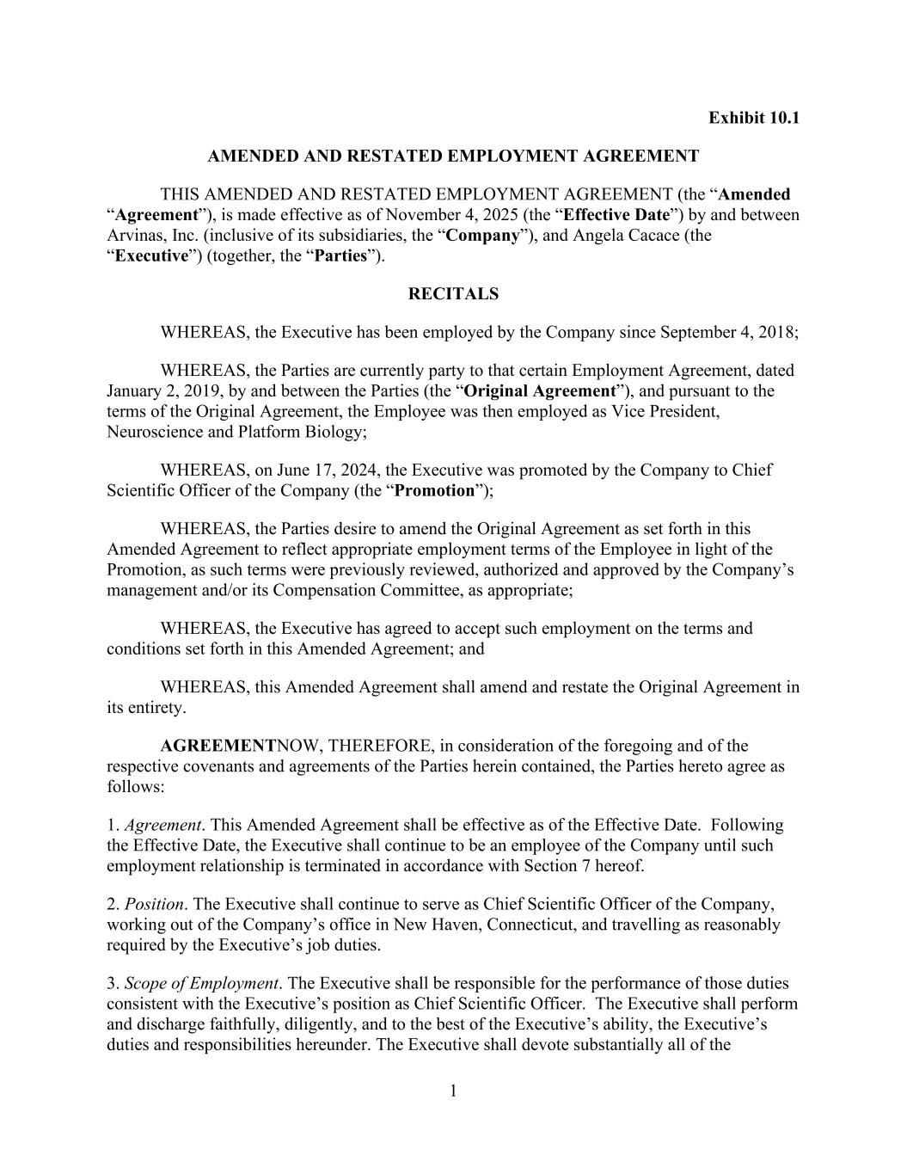
58
1 Exhibit 10.1 AMENDED AND RESTATED EMPLOYMENT AGREEMENT THIS AMENDED AND RESTATED EMPLOYMENT AGREEMENT (the “Amended “Agreement”), is made effective as of November 4, 2025 (the “Effective Date”) by and between Arvinas, Inc. (inclusive of its subsidiaries, the “Company”), and Angela Cacace (the “Executive”) (together, the “Parties”). RECITALS WHEREAS, the Executive has been employed by the Company since September 4, 2018; WHEREAS, the Parties are currently party to that certain Employment Agreement, dated January 2, 2019, by and between the Parties (the “Original Agreement”), and pursuant to the terms of the Original Agreement, the Employee was then employed as Vice President, Neuroscience and Platform Biology; WHEREAS, on June 17, 2024, the Executive was promoted by the Company to Chief Scientific Officer of the Company (the “Promotion”); WHEREAS, the Parties desire to amend the Original Agreement as set forth in this Amended Agreement to reflect appropriate employment terms of the Employee in light of the Promotion, as such terms were previously reviewed, authorized and approved by the Company’s management and/or its Compensation Committee, as appropriate; WHEREAS, the Executive has agreed to accept such employment on the terms and conditions set forth in this Amended Agreement; and WHEREAS, this Amended Agreement shall amend and restate the Original Agreement in its entirety. AGREEMENTNOW, THEREFORE, in consideration of the foregoing and of the respective covenants and agreements of the Parties herein contained, the Parties hereto agree as follows: 1. Agreement. This Amended Agreement shall be effective as of the Effective Date. Following the Effective Date, the Executive shall continue to be an employee of the Company until such employment relationship is terminated in accordance with Section 7 hereof. 2. Position. The Executive shall continue to serve as Chief Scientific Officer of the Company, working out of the Company’s office in New Haven, Connecticut, and travelling as reasonably required by the Executive’s job duties. 3. Scope of Employment. The Executive shall be responsible for the performance of those duties consistent with the Executive’s position as Chief Scientific Officer. The Executive shall perform and discharge faithfully, diligently, and to the best of the Executive’s ability, the Executive’s duties and responsibilities hereunder. The Executive shall devote substantially all of the

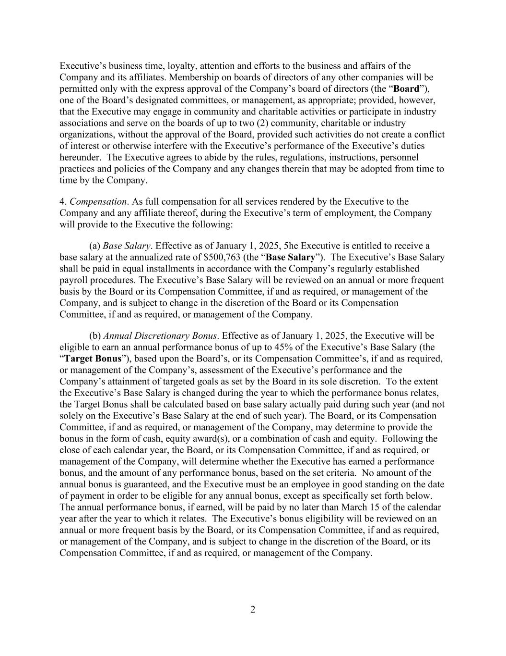
2 Executive’s business time, loyalty, attention and efforts to the business and affairs of the Company and its affiliates. Membership on boards of directors of any other companies will be permitted only with the express approval of the Company’s board of directors (the “Board”), one of the Board’s designated committees, or management, as appropriate; provided, however, that the Executive may engage in community and charitable activities or participate in industry associations and serve on the boards of up to two (2) community, charitable or industry organizations, without the approval of the Board, provided such activities do not create a conflict of interest or otherwise interfere with the Executive’s performance of the Executive’s duties hereunder. The Executive agrees to abide by the rules, regulations, instructions, personnel practices and policies of the Company and any changes therein that may be adopted from time to time by the Company. 4. Compensation. As full compensation for all services rendered by the Executive to the Company and any affiliate thereof, during the Executive’s term of employment, the Company will provide to the Executive the following: (a) Base Salary. Effective as of January 1, 2025, 5he Executive is entitled to receive a base salary at the annualized rate of $500,763 (the “Base Salary”). The Executive’s Base Salary shall be paid in equal installments in accordance with the Company’s regularly established payroll procedures. The Executive’s Base Salary will be reviewed on an annual or more frequent basis by the Board or its Compensation Committee, if and as required, or management of the Company, and is subject to change in the discretion of the Board or its Compensation Committee, if and as required, or management of the Company. (b) Annual Discretionary Bonus. Effective as of January 1, 2025, the Executive will be eligible to earn an annual performance bonus of up to 45% of the Executive’s Base Salary (the “Target Bonus”), based upon the Board’s, or its Compensation Committee’s, if and as required, or management of the Company’s, assessment of the Executive’s performance and the Company’s attainment of targeted goals as set by the Board in its sole discretion. To the extent the Executive’s Base Salary is changed during the year to which the performance bonus relates, the Target Bonus shall be calculated based on base salary actually paid during such year (and not solely on the Executive’s Base Salary at the end of such year). The Board, or its Compensation Committee, if and as required, or management of the Company, may determine to provide the bonus in the form of cash, equity award(s), or a combination of cash and equity. Following the close of each calendar year, the Board, or its Compensation Committee, if and as required, or management of the Company, will determine whether the Executive has earned a performance bonus, and the amount of any performance bonus, based on the set criteria. No amount of the annual bonus is guaranteed, and the Executive must be an employee in good standing on the date of payment in order to be eligible for any annual bonus, except as specifically set forth below. The annual performance bonus, if earned, will be paid by no later than March 15 of the calendar year after the year to which it relates. The Executive’s bonus eligibility will be reviewed on an annual or more frequent basis by the Board, or its Compensation Committee, if and as required, or management of the Company, and is subject to change in the discretion of the Board, or its Compensation Committee, if and as required, or management of the Company.

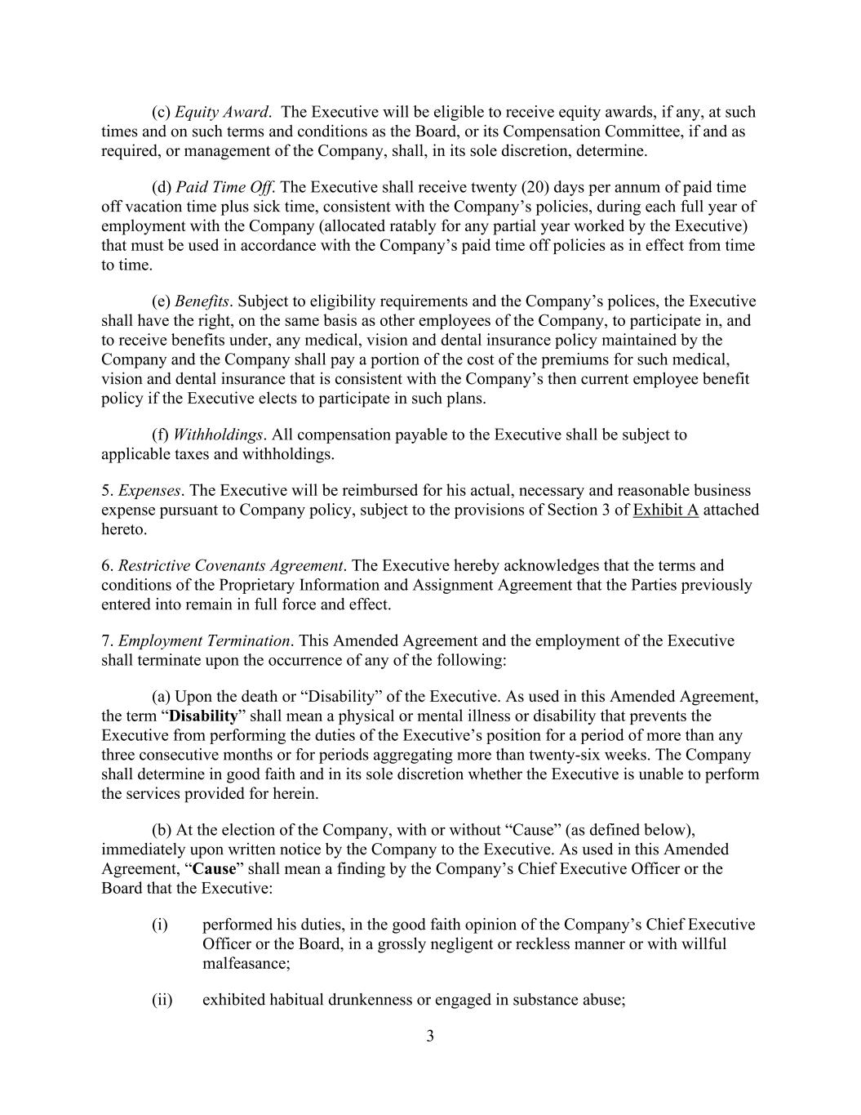
3 (c) Equity Award. The Executive will be eligible to receive equity awards, if any, at such times and on such terms and conditions as the Board, or its Compensation Committee, if and as required, or management of the Company, shall, in its sole discretion, determine. (d) Paid Time Off. The Executive shall receive twenty (20) days per annum of paid time off vacation time plus sick time, consistent with the Company’s policies, during each full year of employment with the Company (allocated ratably for any partial year worked by the Executive) that must be used in accordance with the Company’s paid time off policies as in effect from time to time. (e) Benefits. Subject to eligibility requirements and the Company’s polices, the Executive shall have the right, on the same basis as other employees of the Company, to participate in, and to receive benefits under, any medical, vision and dental insurance policy maintained by the Company and the Company shall pay a portion of the cost of the premiums for such medical, vision and dental insurance that is consistent with the Company’s then current employee benefit policy if the Executive elects to participate in such plans. (f) Withholdings. All compensation payable to the Executive shall be subject to applicable taxes and withholdings. 5. Expenses. The Executive will be reimbursed for his actual, necessary and reasonable business expense pursuant to Company policy, subject to the provisions of Section 3 of Exhibit A attached hereto. 6. Restrictive Covenants Agreement. The Executive hereby acknowledges that the terms and conditions of the Proprietary Information and Assignment Agreement that the Parties previously entered into remain in full force and effect. 7. Employment Termination. This Amended Agreement and the employment of the Executive shall terminate upon the occurrence of any of the following: (a) Upon the death or “Disability” of the Executive. As used in this Amended Agreement, the term “Disability” shall mean a physical or mental illness or disability that prevents the Executive from performing the duties of the Executive’s position for a period of more than any three consecutive months or for periods aggregating more than twenty-six weeks. The Company shall determine in good faith and in its sole discretion whether the Executive is unable to perform the services provided for herein. (b) At the election of the Company, with or without “Cause” (as defined below), immediately upon written notice by the Company to the Executive. As used in this Amended Agreement, “Cause” shall mean a finding by the Company’s Chief Executive Officer or the Board that the Executive: (i) performed his duties, in the good faith opinion of the Company’s Chief Executive Officer or the Board, in a grossly negligent or reckless manner or with willful malfeasance; (ii) exhibited habitual drunkenness or engaged in substance abuse;

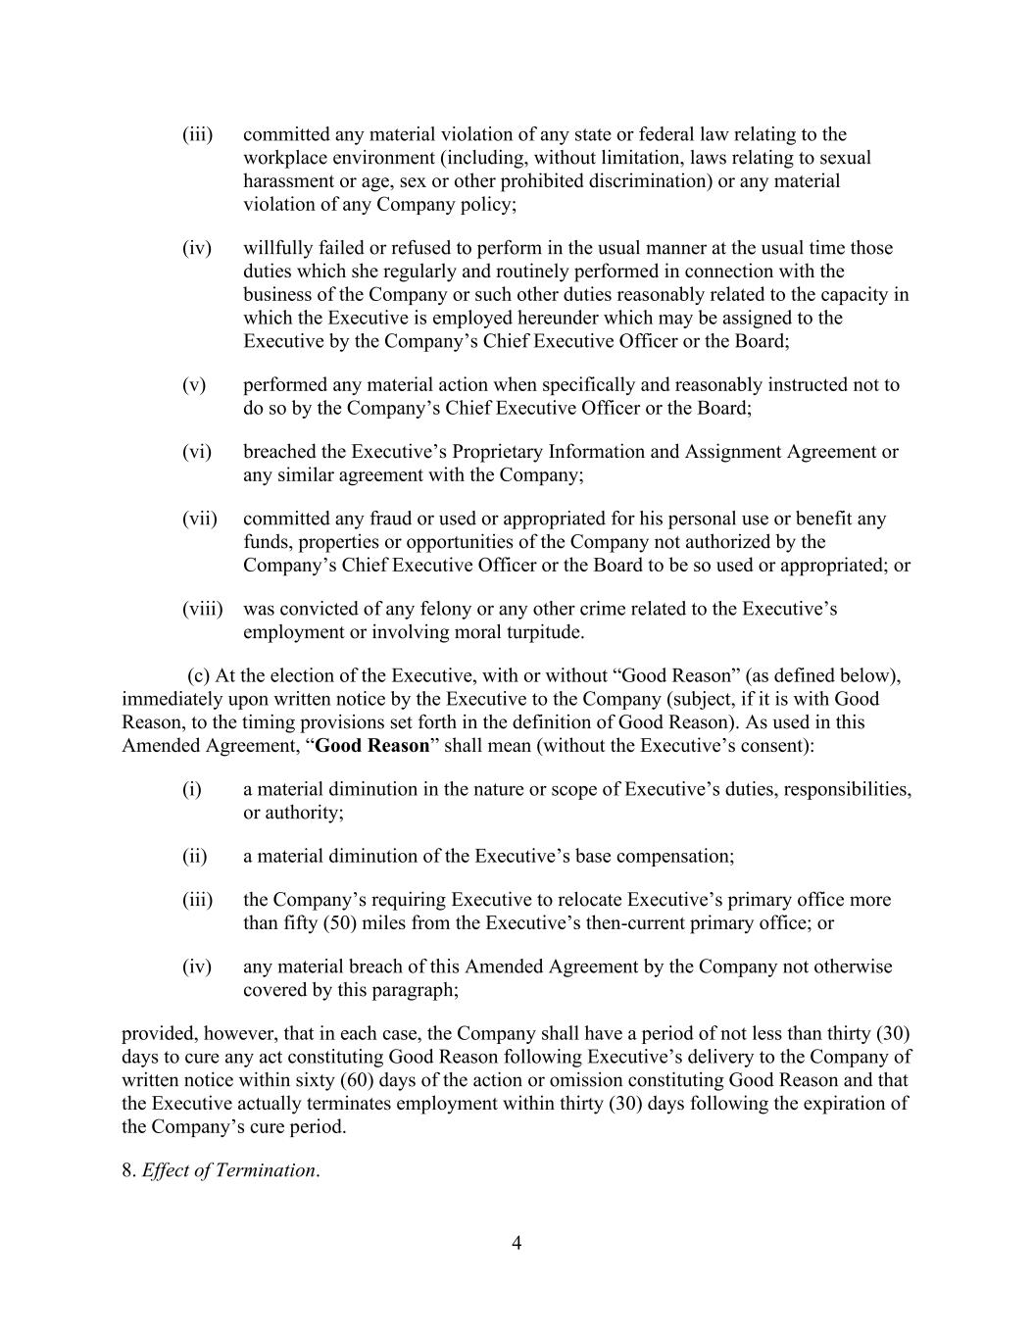
4 (iii) committed any material violation of any state or federal law relating to the workplace environment (including, without limitation, laws relating to sexual harassment or age, sex or other prohibited discrimination) or any material violation of any Company policy; (iv) willfully failed or refused to perform in the usual manner at the usual time those duties which she regularly and routinely performed in connection with the business of the Company or such other duties reasonably related to the capacity in which the Executive is employed hereunder which may be assigned to the Executive by the Company’s Chief Executive Officer or the Board; (v) performed any material action when specifically and reasonably instructed not to do so by the Company’s Chief Executive Officer or the Board; (vi) breached the Executive’s Proprietary Information and Assignment Agreement or any similar agreement with the Company; (vii) committed any fraud or used or appropriated for his personal use or benefit any funds, properties or opportunities of the Company not authorized by the Company’s Chief Executive Officer or the Board to be so used or appropriated; or (viii) was convicted of any felony or any other crime related to the Executive’s employment or involving moral turpitude. (c) At the election of the Executive, with or without “Good Reason” (as defined below), immediately upon written notice by the Executive to the Company (subject, if it is with Good Reason, to the timing provisions set forth in the definition of Good Reason). As used in this Amended Agreement, “Good Reason” shall mean (without the Executive’s consent): (i) a material diminution in the nature or scope of Executive’s duties, responsibilities, or authority; (ii) a material diminution of the Executive’s base compensation; (iii) the Company’s requiring Executive to relocate Executive’s primary office more than fifty (50) miles from the Executive’s then-current primary office; or (iv) any material breach of this Amended Agreement by the Company not otherwise covered by this paragraph; provided, however, that in each case, the Company shall have a period of not less than thirty (30) days to cure any act constituting Good Reason following Executive’s delivery to the Company of written notice within sixty (60) days of the action or omission constituting Good Reason and that the Executive actually terminates employment within thirty (30) days following the expiration of the Company’s cure period. 8. Effect of Termination.

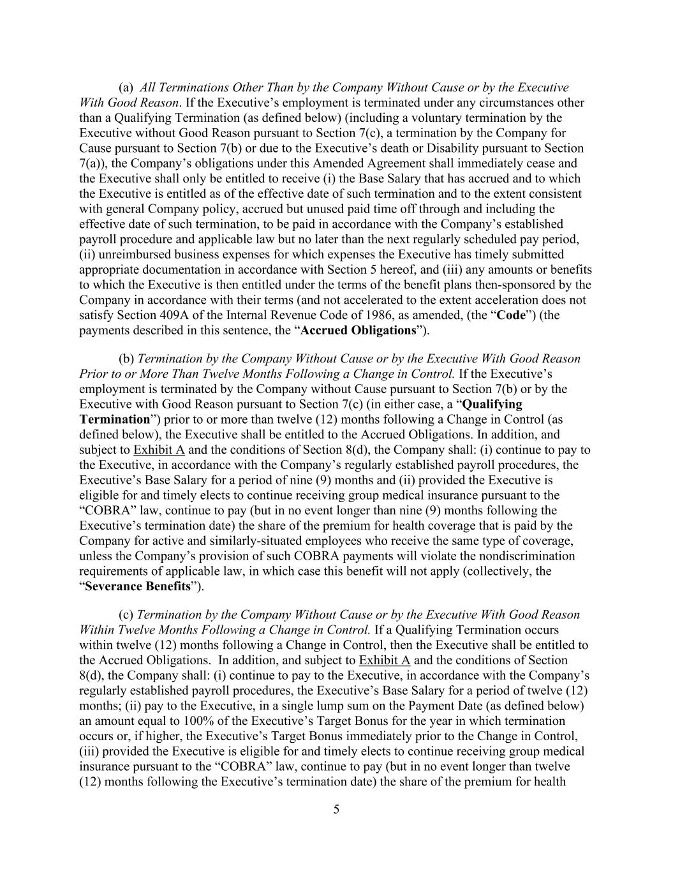
5 (a) All Terminations Other Than by the Company Without Cause or by the Executive With Good Reason. If the Executive’s employment is terminated under any circumstances other than a Qualifying Termination (as defined below) (including a voluntary termination by the Executive without Good Reason pursuant to Section 7(c), a termination by the Company for Cause pursuant to Section 7(b) or due to the Executive’s death or Disability pursuant to Section 7(a)), the Company’s obligations under this Amended Agreement shall immediately cease and the Executive shall only be entitled to receive (i) the Base Salary that has accrued and to which the Executive is entitled as of the effective date of such termination and to the extent consistent with general Company policy, accrued but unused paid time off through and including the effective date of such termination, to be paid in accordance with the Company’s established payroll procedure and applicable law but no later than the next regularly scheduled pay period, (ii) unreimbursed business expenses for which expenses the Executive has timely submitted appropriate documentation in accordance with Section 5 hereof, and (iii) any amounts or benefits to which the Executive is then entitled under the terms of the benefit plans then-sponsored by the Company in accordance with their terms (and not accelerated to the extent acceleration does not satisfy Section 409A of the Internal Revenue Code of 1986, as amended, (the “Code”) (the payments described in this sentence, the “Accrued Obligations”). (b) Termination by the Company Without Cause or by the Executive With Good Reason Prior to or More Than Twelve Months Following a Change in Control. If the Executive’s employment is terminated by the Company without Cause pursuant to Section 7(b) or by the Executive with Good Reason pursuant to Section 7(c) (in either case, a “Qualifying Termination”) prior to or more than twelve (12) months following a Change in Control (as defined below), the Executive shall be entitled to the Accrued Obligations. In addition, and subject to Exhibit A and the conditions of Section 8(d), the Company shall: (i) continue to pay to the Executive, in accordance with the Company’s regularly established payroll procedures, the Executive’s Base Salary for a period of nine (9) months and (ii) provided the Executive is eligible for and timely elects to continue receiving group medical insurance pursuant to the “COBRA” law, continue to pay (but in no event longer than nine (9) months following the Executive’s termination date) the share of the premium for health coverage that is paid by the Company for active and similarly-situated employees who receive the same type of coverage, unless the Company’s provision of such COBRA payments will violate the nondiscrimination requirements of applicable law, in which case this benefit will not apply (collectively, the “Severance Benefits”). (c) Termination by the Company Without Cause or by the Executive With Good Reason Within Twelve Months Following a Change in Control. If a Qualifying Termination occurs within twelve (12) months following a Change in Control, then the Executive shall be entitled to the Accrued Obligations. In addition, and subject to Exhibit A and the conditions of Section 8(d), the Company shall: (i) continue to pay to the Executive, in accordance with the Company’s regularly established payroll procedures, the Executive’s Base Salary for a period of twelve (12) months; (ii) pay to the Executive, in a single lump sum on the Payment Date (as defined below) an amount equal to 100% of the Executive’s Target Bonus for the year in which termination occurs or, if higher, the Executive’s Target Bonus immediately prior to the Change in Control, (iii) provided the Executive is eligible for and timely elects to continue receiving group medical insurance pursuant to the “COBRA” law, continue to pay (but in no event longer than twelve (12) months following the Executive’s termination date) the share of the premium for health

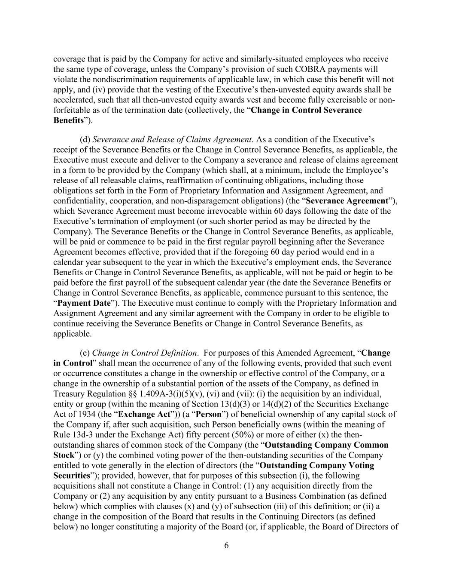
6 coverage that is paid by the Company for active and similarly-situated employees who receive the same type of coverage, unless the Company’s provision of such COBRA payments will violate the nondiscrimination requirements of applicable law, in which case this benefit will not apply, and (iv) provide that the vesting of the Executive’s then-unvested equity awards shall be accelerated, such that all then-unvested equity awards vest and become fully exercisable or non- forfeitable as of the termination date (collectively, the “Change in Control Severance Benefits”). (d) Severance and Release of Claims Agreement. As a condition of the Executive’s receipt of the Severance Benefits or the Change in Control Severance Benefits, as applicable, the Executive must execute and deliver to the Company a severance and release of claims agreement in a form to be provided by the Company (which shall, at a minimum, include the Employee’s release of all releasable claims, reaffirmation of continuing obligations, including those obligations set forth in the Form of Proprietary Information and Assignment Agreement, and confidentiality, cooperation, and non-disparagement obligations) (the “Severance Agreement”), which Severance Agreement must become irrevocable within 60 days following the date of the Executive’s termination of employment (or such shorter period as may be directed by the Company). The Severance Benefits or the Change in Control Severance Benefits, as applicable, will be paid or commence to be paid in the first regular payroll beginning after the Severance Agreement becomes effective, provided that if the foregoing 60 day period would end in a calendar year subsequent to the year in which the Executive’s employment ends, the Severance Benefits or Change in Control Severance Benefits, as applicable, will not be paid or begin to be paid before the first payroll of the subsequent calendar year (the date the Severance Benefits or Change in Control Severance Benefits, as applicable, commence pursuant to this sentence, the “Payment Date”). The Executive must continue to comply with the Proprietary Information and Assignment Agreement and any similar agreement with the Company in order to be eligible to continue receiving the Severance Benefits or Change in Control Severance Benefits, as applicable. (e) Change in Control Definition. For purposes of this Amended Agreement, “Change in Control” shall mean the occurrence of any of the following events, provided that such event or occurrence constitutes a change in the ownership or effective control of the Company, or a change in the ownership of a substantial portion of the assets of the Company, as defined in Treasury Regulation §§ 1.409A-3(i)(5)(v), (vi) and (vii): (i) the acquisition by an individual, entity or group (within the meaning of Section 13(d)(3) or 14(d)(2) of the Securities Exchange Act of 1934 (the “Exchange Act”)) (a “Person”) of beneficial ownership of any capital stock of the Company if, after such acquisition, such Person beneficially owns (within the meaning of Rule 13d-3 under the Exchange Act) fifty percent (50%) or more of either (x) the then- outstanding shares of common stock of the Company (the “Outstanding Company Common Stock”) or (y) the combined voting power of the then-outstanding securities of the Company entitled to vote generally in the election of directors (the “Outstanding Company Voting Securities”); provided, however, that for purposes of this subsection (i), the following acquisitions shall not constitute a Change in Control: (1) any acquisition directly from the Company or (2) any acquisition by any entity pursuant to a Business Combination (as defined below) which complies with clauses (x) and (y) of subsection (iii) of this definition; or (ii) a change in the composition of the Board that results in the Continuing Directors (as defined below) no longer constituting a majority of the Board (or, if applicable, the Board of Directors of

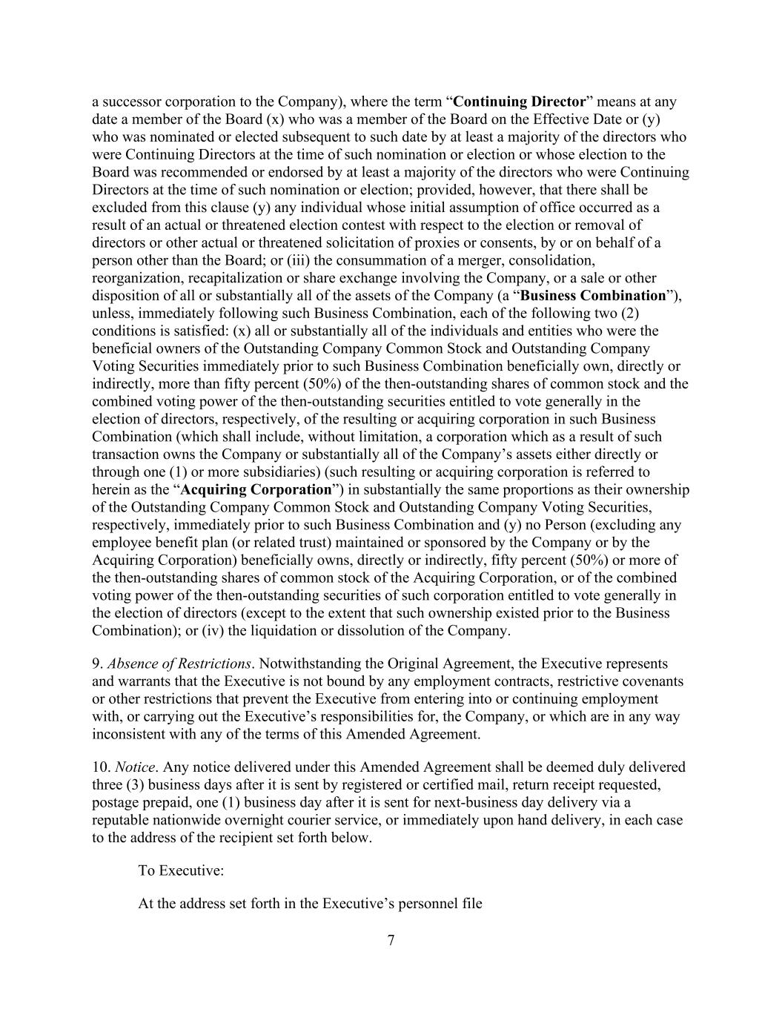
7 a successor corporation to the Company), where the term “Continuing Director” means at any date a member of the Board (x) who was a member of the Board on the Effective Date or (y) who was nominated or elected subsequent to such date by at least a majority of the directors who were Continuing Directors at the time of such nomination or election or whose election to the Board was recommended or endorsed by at least a majority of the directors who were Continuing Directors at the time of such nomination or election; provided, however, that there shall be excluded from this clause (y) any individual whose initial assumption of office occurred as a result of an actual or threatened election contest with respect to the election or removal of directors or other actual or threatened solicitation of proxies or consents, by or on behalf of a person other than the Board; or (iii) the consummation of a merger, consolidation, reorganization, recapitalization or share exchange involving the Company, or a sale or other disposition of all or substantially all of the assets of the Company (a “Business Combination”), unless, immediately following such Business Combination, each of the following two (2) conditions is satisfied: (x) all or substantially all of the individuals and entities who were the beneficial owners of the Outstanding Company Common Stock and Outstanding Company Voting Securities immediately prior to such Business Combination beneficially own, directly or indirectly, more than fifty percent (50%) of the then-outstanding shares of common stock and the combined voting power of the then-outstanding securities entitled to vote generally in the election of directors, respectively, of the resulting or acquiring corporation in such Business Combination (which shall include, without limitation, a corporation which as a result of such transaction owns the Company or substantially all of the Company’s assets either directly or through one (1) or more subsidiaries) (such resulting or acquiring corporation is referred to herein as the “Acquiring Corporation”) in substantially the same proportions as their ownership of the Outstanding Company Common Stock and Outstanding Company Voting Securities, respectively, immediately prior to such Business Combination and (y) no Person (excluding any employee benefit plan (or related trust) maintained or sponsored by the Company or by the Acquiring Corporation) beneficially owns, directly or indirectly, fifty percent (50%) or more of the then-outstanding shares of common stock of the Acquiring Corporation, or of the combined voting power of the then-outstanding securities of such corporation entitled to vote generally in the election of directors (except to the extent that such ownership existed prior to the Business Combination); or (iv) the liquidation or dissolution of the Company. 9. Absence of Restrictions. Notwithstanding the Original Agreement, the Executive represents and warrants that the Executive is not bound by any employment contracts, restrictive covenants or other restrictions that prevent the Executive from entering into or continuing employment with, or carrying out the Executive’s responsibilities for, the Company, or which are in any way inconsistent with any of the terms of this Amended Agreement. 10. Notice. Any notice delivered under this Amended Agreement shall be deemed duly delivered three (3) business days after it is sent by registered or certified mail, return receipt requested, postage prepaid, one (1) business day after it is sent for next-business day delivery via a reputable nationwide overnight courier service, or immediately upon hand delivery, in each case to the address of the recipient set forth below. To Executive: At the address set forth in the Executive’s personnel file

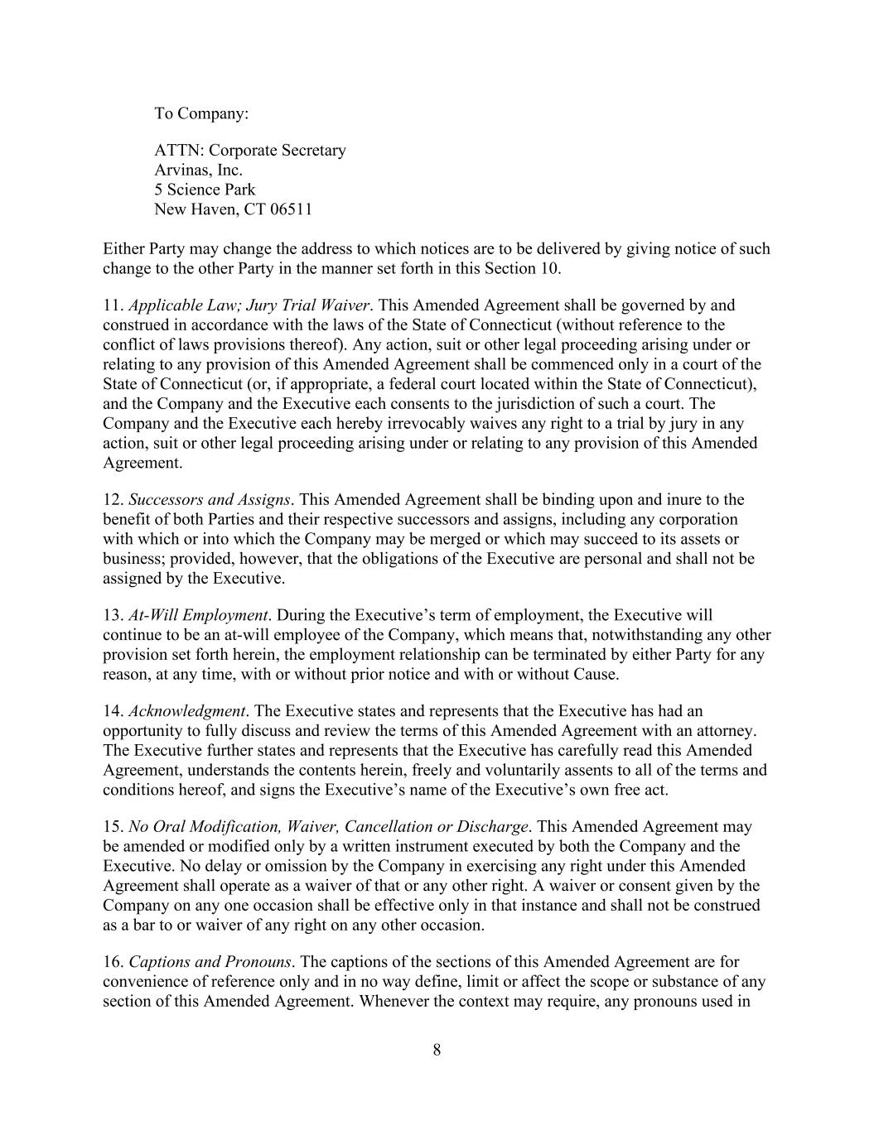
8 To Company: ATTN: Corporate Secretary Arvinas, Inc. 5 Science Park New Haven, CT 06511 Either Party may change the address to which notices are to be delivered by giving notice of such change to the other Party in the manner set forth in this Section 10. 11. Applicable Law; Jury Trial Waiver. This Amended Agreement shall be governed by and construed in accordance with the laws of the State of Connecticut (without reference to the conflict of laws provisions thereof). Any action, suit or other legal proceeding arising under or relating to any provision of this Amended Agreement shall be commenced only in a court of the State of Connecticut (or, if appropriate, a federal court located within the State of Connecticut), and the Company and the Executive each consents to the jurisdiction of such a court. The Company and the Executive each hereby irrevocably waives any right to a trial by jury in any action, suit or other legal proceeding arising under or relating to any provision of this Amended Agreement. 12. Successors and Assigns. This Amended Agreement shall be binding upon and inure to the benefit of both Parties and their respective successors and assigns, including any corporation with which or into which the Company may be merged or which may succeed to its assets or business; provided, however, that the obligations of the Executive are personal and shall not be assigned by the Executive. 13. At-Will Employment. During the Executive’s term of employment, the Executive will continue to be an at-will employee of the Company, which means that, notwithstanding any other provision set forth herein, the employment relationship can be terminated by either Party for any reason, at any time, with or without prior notice and with or without Cause. 14. Acknowledgment. The Executive states and represents that the Executive has had an opportunity to fully discuss and review the terms of this Amended Agreement with an attorney. The Executive further states and represents that the Executive has carefully read this Amended Agreement, understands the contents herein, freely and voluntarily assents to all of the terms and conditions hereof, and signs the Executive’s name of the Executive’s own free act. 15. No Oral Modification, Waiver, Cancellation or Discharge. This Amended Agreement may be amended or modified only by a written instrument executed by both the Company and the Executive. No delay or omission by the Company in exercising any right under this Amended Agreement shall operate as a waiver of that or any other right. A waiver or consent given by the Company on any one occasion shall be effective only in that instance and shall not be construed as a bar to or waiver of any right on any other occasion. 16. Captions and Pronouns. The captions of the sections of this Amended Agreement are for convenience of reference only and in no way define, limit or affect the scope or substance of any section of this Amended Agreement. Whenever the context may require, any pronouns used in

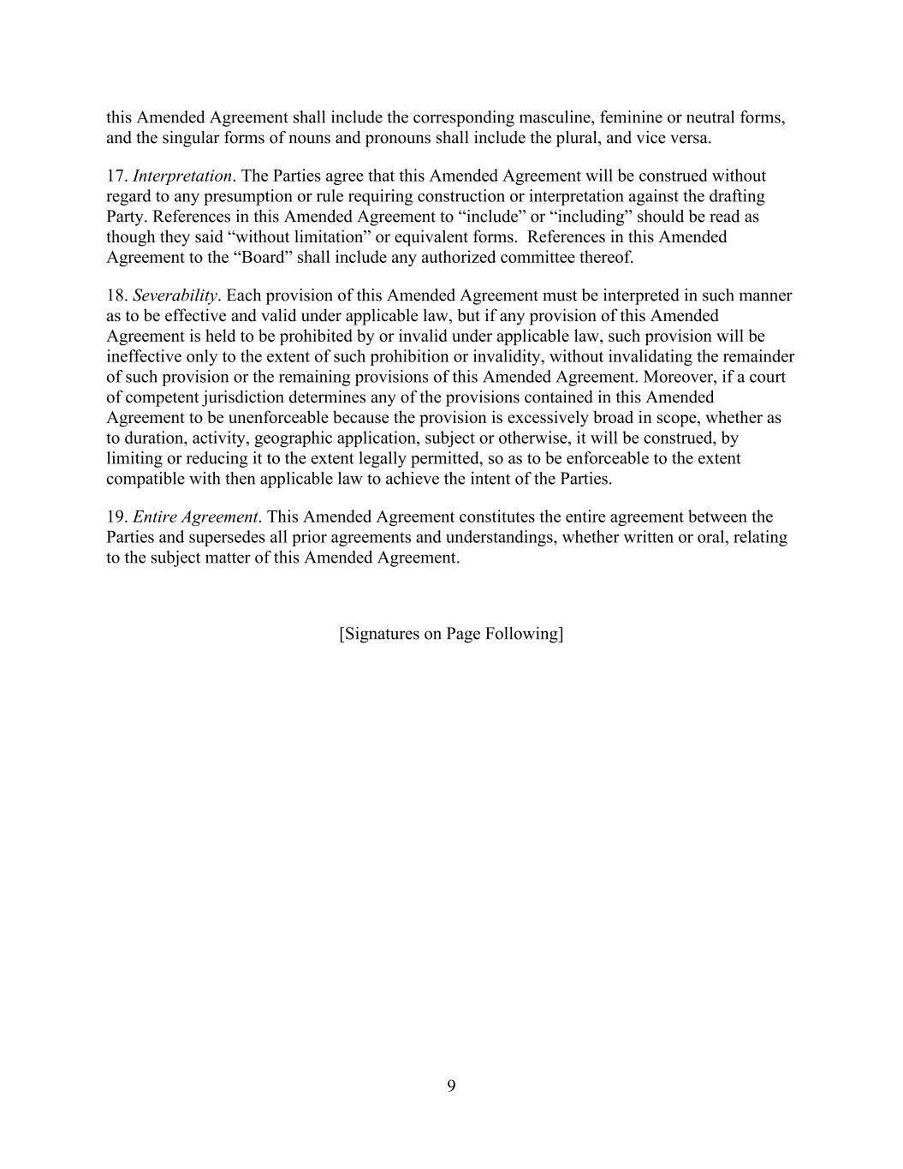
9 this Amended Agreement shall include the corresponding masculine, feminine or neutral forms, and the singular forms of nouns and pronouns shall include the plural, and vice versa. 17. Interpretation. The Parties agree that this Amended Agreement will be construed without regard to any presumption or rule requiring construction or interpretation against the drafting Party. References in this Amended Agreement to “include” or “including” should be read as though they said “without limitation” or equivalent forms. References in this Amended Agreement to the “Board” shall include any authorized committee thereof. 18. Severability. Each provision of this Amended Agreement must be interpreted in such manner as to be effective and valid under applicable law, but if any provision of this Amended Agreement is held to be prohibited by or invalid under applicable law, such provision will be ineffective only to the extent of such prohibition or invalidity, without invalidating the remainder of such provision or the remaining provisions of this Amended Agreement. Moreover, if a court of competent jurisdiction determines any of the provisions contained in this Amended Agreement to be unenforceable because the provision is excessively broad in scope, whether as to duration, activity, geographic application, subject or otherwise, it will be construed, by limiting or reducing it to the extent legally permitted, so as to be enforceable to the extent compatible with then applicable law to achieve the intent of the Parties. 19. Entire Agreement. This Amended Agreement constitutes the entire agreement between the Parties and supersedes all prior agreements and understandings, whether written or oral, relating to the subject matter of this Amended Agreement. [Signatures on Page Following]

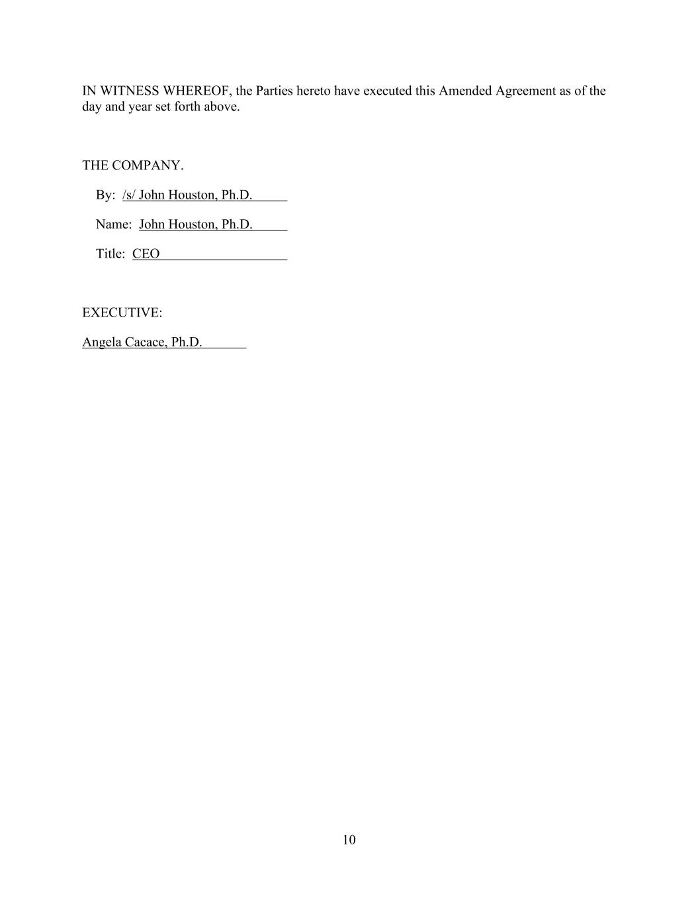
10 IN WITNESS WHEREOF, the Parties hereto have executed this Amended Agreement as of the day and year set forth above. THE COMPANY. By: /s/ John Houston, Ph.D. Name: John Houston, Ph.D. Title: CEO EXECUTIVE: Angela Cacace, Ph.D.

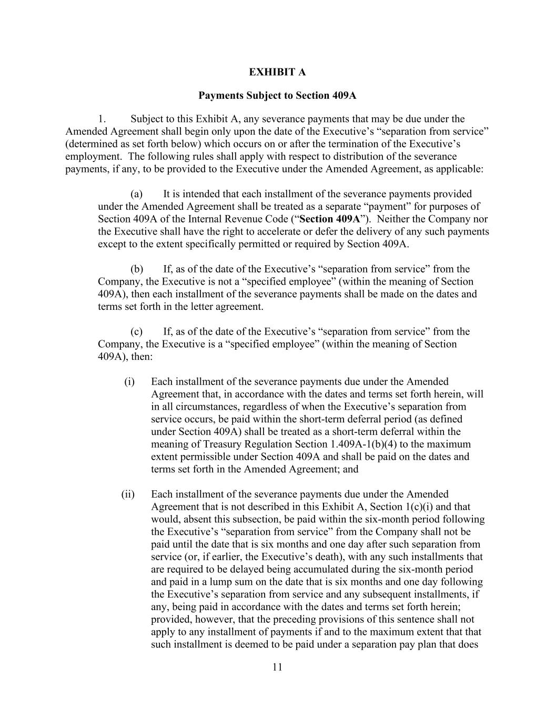
11 EXHIBIT A Payments Subject to Section 409A 1. Subject to this Exhibit A, any severance payments that may be due under the Amended Agreement shall begin only upon the date of the Executive’s “separation from service” (determined as set forth below) which occurs on or after the termination of the Executive’s employment. The following rules shall apply with respect to distribution of the severance payments, if any, to be provided to the Executive under the Amended Agreement, as applicable: (a) It is intended that each installment of the severance payments provided under the Amended Agreement shall be treated as a separate “payment” for purposes of Section 409A of the Internal Revenue Code (“Section 409A”). Neither the Company nor the Executive shall have the right to accelerate or defer the delivery of any such payments except to the extent specifically permitted or required by Section 409A. (b) If, as of the date of the Executive’s “separation from service” from the Company, the Executive is not a “specified employee” (within the meaning of Section 409A), then each installment of the severance payments shall be made on the dates and terms set forth in the letter agreement. (c) If, as of the date of the Executive’s “separation from service” from the Company, the Executive is a “specified employee” (within the meaning of Section 409A), then: (i) Each installment of the severance payments due under the Amended Agreement that, in accordance with the dates and terms set forth herein, will in all circumstances, regardless of when the Executive’s separation from service occurs, be paid within the short-term deferral period (as defined under Section 409A) shall be treated as a short-term deferral within the meaning of Treasury Regulation Section 1.409A-1(b)(4) to the maximum extent permissible under Section 409A and shall be paid on the dates and terms set forth in the Amended Agreement; and (ii) Each installment of the severance payments due under the Amended Agreement that is not described in this Exhibit A, Section 1(c)(i) and that would, absent this subsection, be paid within the six-month period following the Executive’s “separation from service” from the Company shall not be paid until the date that is six months and one day after such separation from service (or, if earlier, the Executive’s death), with any such installments that are required to be delayed being accumulated during the six-month period and paid in a lump sum on the date that is six months and one day following the Executive’s separation from service and any subsequent installments, if any, being paid in accordance with the dates and terms set forth herein; provided, however, that the preceding provisions of this sentence shall not apply to any installment of payments if and to the maximum extent that that such installment is deemed to be paid under a separation pay plan that does

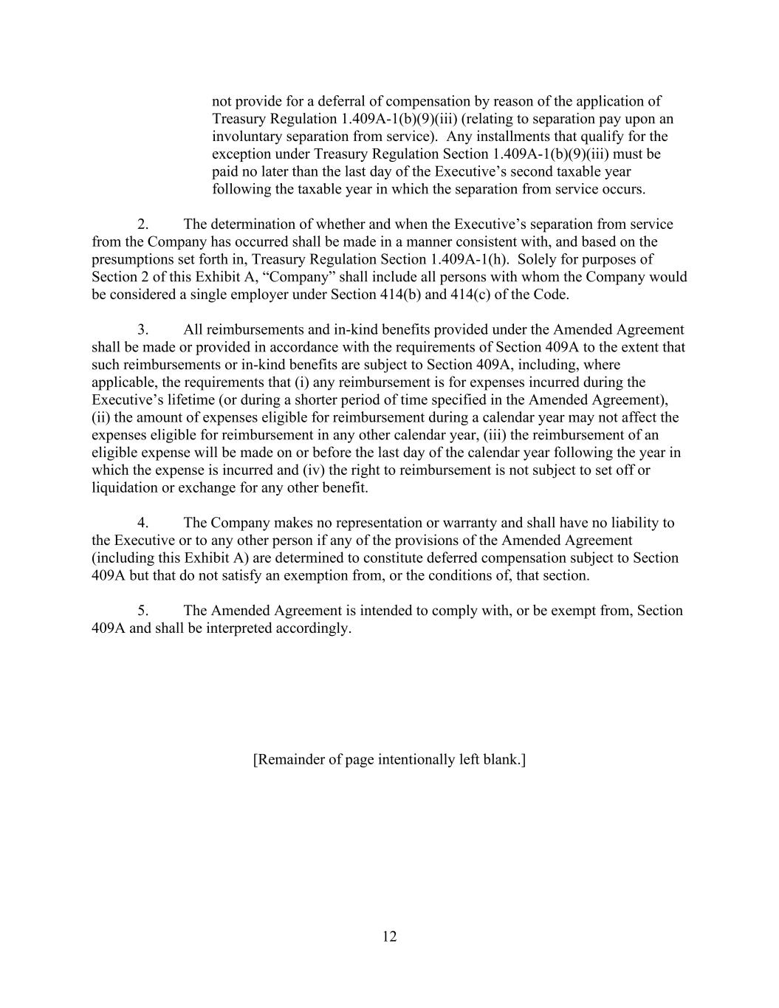
12 not provide for a deferral of compensation by reason of the application of Treasury Regulation 1.409A-1(b)(9)(iii) (relating to separation pay upon an involuntary separation from service). Any installments that qualify for the exception under Treasury Regulation Section 1.409A-1(b)(9)(iii) must be paid no later than the last day of the Executive’s second taxable year following the taxable year in which the separation from service occurs. 2. The determination of whether and when the Executive’s separation from service from the Company has occurred shall be made in a manner consistent with, and based on the presumptions set forth in, Treasury Regulation Section 1.409A-1(h). Solely for purposes of Section 2 of this Exhibit A, “Company” shall include all persons with whom the Company would be considered a single employer under Section 414(b) and 414(c) of the Code. 3. All reimbursements and in-kind benefits provided under the Amended Agreement shall be made or provided in accordance with the requirements of Section 409A to the extent that such reimbursements or in-kind benefits are subject to Section 409A, including, where applicable, the requirements that (i) any reimbursement is for expenses incurred during the Executive’s lifetime (or during a shorter period of time specified in the Amended Agreement), (ii) the amount of expenses eligible for reimbursement during a calendar year may not affect the expenses eligible for reimbursement in any other calendar year, (iii) the reimbursement of an eligible expense will be made on or before the last day of the calendar year following the year in which the expense is incurred and (iv) the right to reimbursement is not subject to set off or liquidation or exchange for any other benefit. 4. The Company makes no representation or warranty and shall have no liability to the Executive or to any other person if any of the provisions of the Amended Agreement (including this Exhibit A) are determined to constitute deferred compensation subject to Section 409A but that do not satisfy an exemption from, or the conditions of, that section. 5. The Amended Agreement is intended to comply with, or be exempt from, Section 409A and shall be interpreted accordingly. [Remainder of page intentionally left blank.]

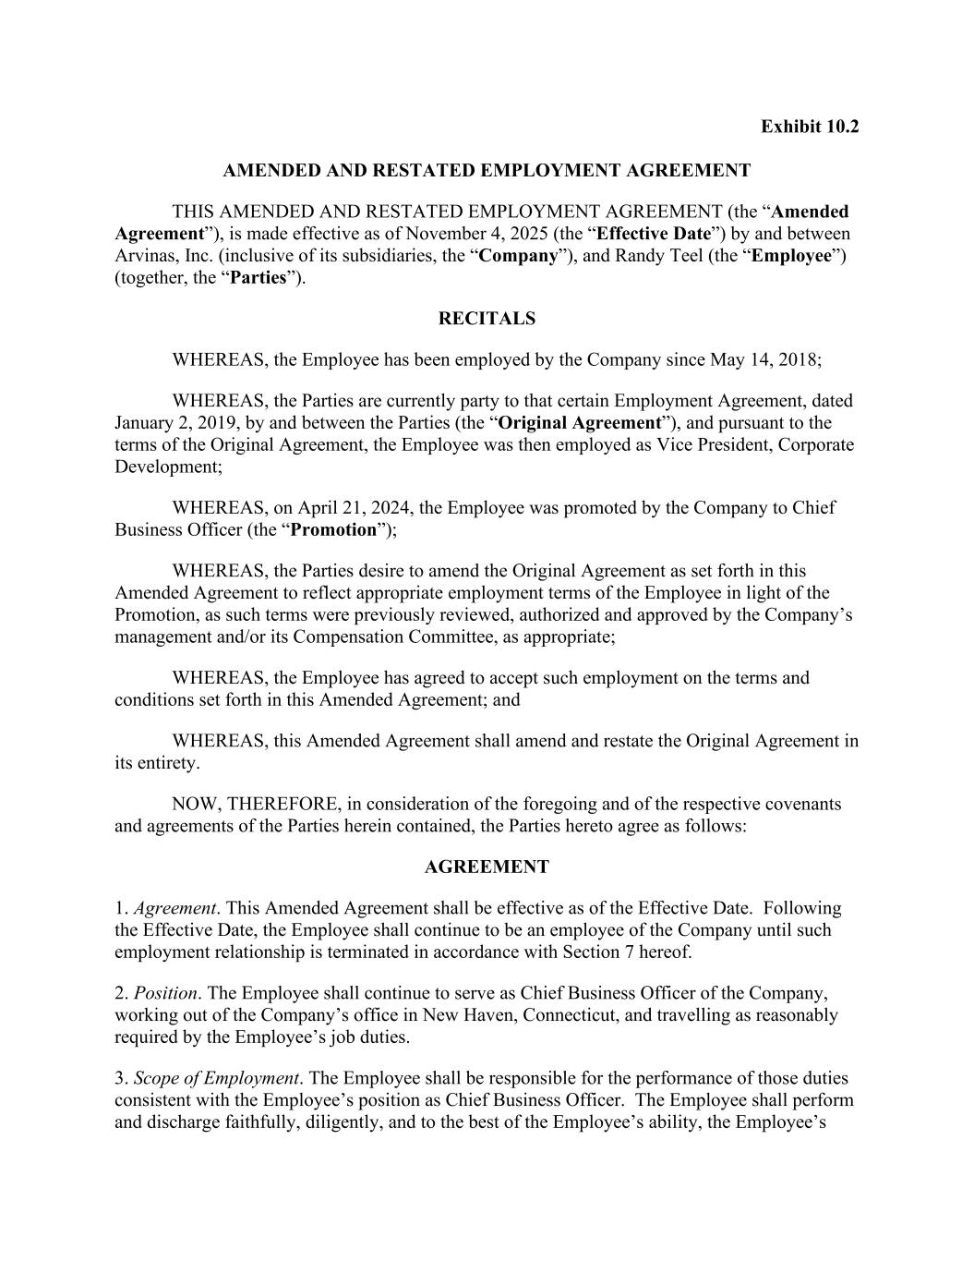
Exhibit 10.2 AMENDED AND RESTATED EMPLOYMENT AGREEMENT THIS AMENDED AND RESTATED EMPLOYMENT AGREEMENT (the “Amended Agreement”), is made effective as of November 4, 2025 (the “Effective Date”) by and between Arvinas, Inc. (inclusive of its subsidiaries, the “Company”), and Randy Teel (the “Employee”) (together, the “Parties”). RECITALS WHEREAS, the Employee has been employed by the Company since May 14, 2018; WHEREAS, the Parties are currently party to that certain Employment Agreement, dated January 2, 2019, by and between the Parties (the “Original Agreement”), and pursuant to the terms of the Original Agreement, the Employee was then employed as Vice President, Corporate Development; WHEREAS, on April 21, 2024, the Employee was promoted by the Company to Chief Business Officer (the “Promotion”); WHEREAS, the Parties desire to amend the Original Agreement as set forth in this Amended Agreement to reflect appropriate employment terms of the Employee in light of the Promotion, as such terms were previously reviewed, authorized and approved by the Company’s management and/or its Compensation Committee, as appropriate; WHEREAS, the Employee has agreed to accept such employment on the terms and conditions set forth in this Amended Agreement; and WHEREAS, this Amended Agreement shall amend and restate the Original Agreement in its entirety. NOW, THEREFORE, in consideration of the foregoing and of the respective covenants and agreements of the Parties herein contained, the Parties hereto agree as follows: AGREEMENT 1. Agreement. This Amended Agreement shall be effective as of the Effective Date. Following the Effective Date, the Employee shall continue to be an employee of the Company until such employment relationship is terminated in accordance with Section 7 hereof. 2. Position. The Employee shall continue to serve as Chief Business Officer of the Company, working out of the Company’s office in New Haven, Connecticut, and travelling as reasonably required by the Employee’s job duties. 3. Scope of Employment. The Employee shall be responsible for the performance of those duties consistent with the Employee’s position as Chief Business Officer. The Employee shall perform and discharge faithfully, diligently, and to the best of the Employee’s ability, the Employee’s

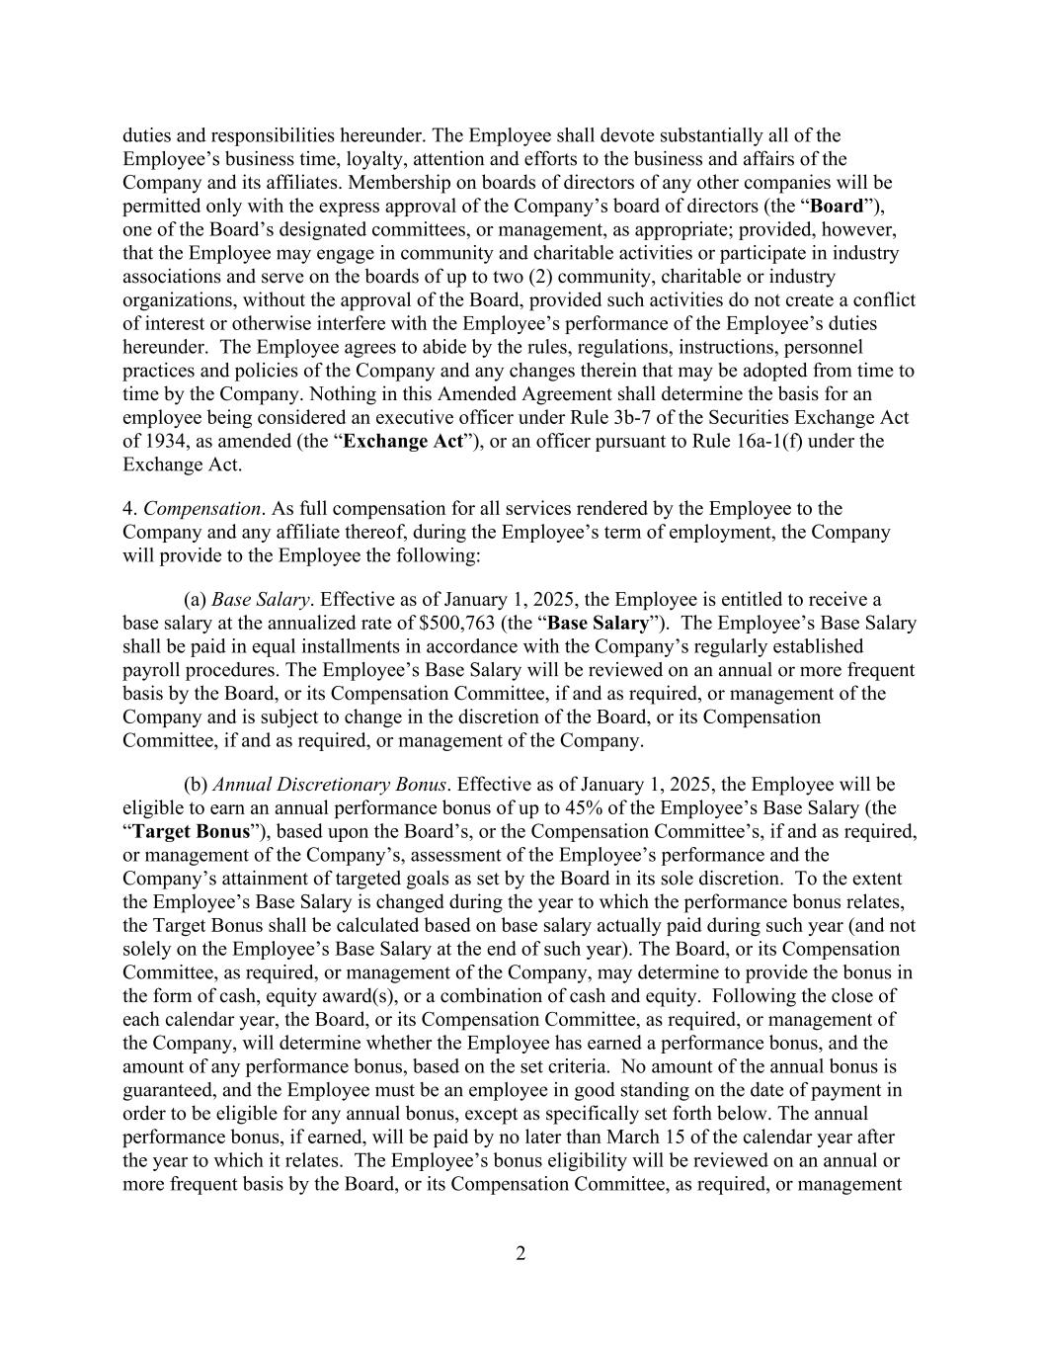
2 duties and responsibilities hereunder. The Employee shall devote substantially all of the Employee’s business time, loyalty, attention and efforts to the business and affairs of the Company and its affiliates. Membership on boards of directors of any other companies will be permitted only with the express approval of the Company’s board of directors (the “Board”), one of the Board’s designated committees, or management, as appropriate; provided, however, that the Employee may engage in community and charitable activities or participate in industry associations and serve on the boards of up to two (2) community, charitable or industry organizations, without the approval of the Board, provided such activities do not create a conflict of interest or otherwise interfere with the Employee’s performance of the Employee’s duties hereunder. The Employee agrees to abide by the rules, regulations, instructions, personnel practices and policies of the Company and any changes therein that may be adopted from time to time by the Company. Nothing in this Amended Agreement shall determine the basis for an employee being considered an executive officer under Rule 3b-7 of the Securities Exchange Act of 1934, as amended (the “Exchange Act”), or an officer pursuant to Rule 16a-1(f) under the Exchange Act. 4. Compensation. As full compensation for all services rendered by the Employee to the Company and any affiliate thereof, during the Employee’s term of employment, the Company will provide to the Employee the following: (a) Base Salary. Effective as of January 1, 2025, the Employee is entitled to receive a base salary at the annualized rate of $500,763 (the “Base Salary”). The Employee’s Base Salary shall be paid in equal installments in accordance with the Company’s regularly established payroll procedures. The Employee’s Base Salary will be reviewed on an annual or more frequent basis by the Board, or its Compensation Committee, if and as required, or management of the Company and is subject to change in the discretion of the Board, or its Compensation Committee, if and as required, or management of the Company. (b) Annual Discretionary Bonus. Effective as of January 1, 2025, the Employee will be eligible to earn an annual performance bonus of up to 45% of the Employee’s Base Salary (the “Target Bonus”), based upon the Board’s, or the Compensation Committee’s, if and as required, or management of the Company’s, assessment of the Employee’s performance and the Company’s attainment of targeted goals as set by the Board in its sole discretion. To the extent the Employee’s Base Salary is changed during the year to which the performance bonus relates, the Target Bonus shall be calculated based on base salary actually paid during such year (and not solely on the Employee’s Base Salary at the end of such year). The Board, or its Compensation Committee, as required, or management of the Company, may determine to provide the bonus in the form of cash, equity award(s), or a combination of cash and equity. Following the close of each calendar year, the Board, or its Compensation Committee, as required, or management of the Company, will determine whether the Employee has earned a performance bonus, and the amount of any performance bonus, based on the set criteria. No amount of the annual bonus is guaranteed, and the Employee must be an employee in good standing on the date of payment in order to be eligible for any annual bonus, except as specifically set forth below. The annual performance bonus, if earned, will be paid by no later than March 15 of the calendar year after the year to which it relates. The Employee’s bonus eligibility will be reviewed on an annual or more frequent basis by the Board, or its Compensation Committee, as required, or management

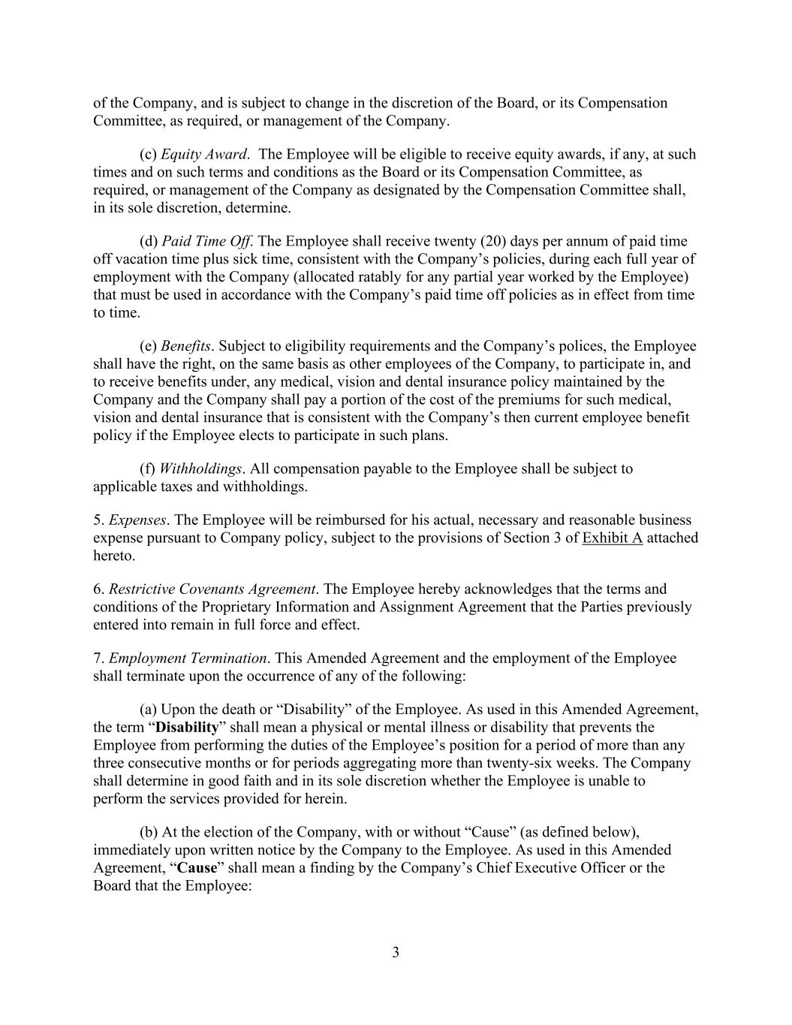
3 of the Company, and is subject to change in the discretion of the Board, or its Compensation Committee, as required, or management of the Company. (c) Equity Award. The Employee will be eligible to receive equity awards, if any, at such times and on such terms and conditions as the Board or its Compensation Committee, as required, or management of the Company as designated by the Compensation Committee shall, in its sole discretion, determine. (d) Paid Time Off. The Employee shall receive twenty (20) days per annum of paid time off vacation time plus sick time, consistent with the Company’s policies, during each full year of employment with the Company (allocated ratably for any partial year worked by the Employee) that must be used in accordance with the Company’s paid time off policies as in effect from time to time. (e) Benefits. Subject to eligibility requirements and the Company’s polices, the Employee shall have the right, on the same basis as other employees of the Company, to participate in, and to receive benefits under, any medical, vision and dental insurance policy maintained by the Company and the Company shall pay a portion of the cost of the premiums for such medical, vision and dental insurance that is consistent with the Company’s then current employee benefit policy if the Employee elects to participate in such plans. (f) Withholdings. All compensation payable to the Employee shall be subject to applicable taxes and withholdings. 5. Expenses. The Employee will be reimbursed for his actual, necessary and reasonable business expense pursuant to Company policy, subject to the provisions of Section 3 of Exhibit A attached hereto. 6. Restrictive Covenants Agreement. The Employee hereby acknowledges that the terms and conditions of the Proprietary Information and Assignment Agreement that the Parties previously entered into remain in full force and effect. 7. Employment Termination. This Amended Agreement and the employment of the Employee shall terminate upon the occurrence of any of the following: (a) Upon the death or “Disability” of the Employee. As used in this Amended Agreement, the term “Disability” shall mean a physical or mental illness or disability that prevents the Employee from performing the duties of the Employee’s position for a period of more than any three consecutive months or for periods aggregating more than twenty-six weeks. The Company shall determine in good faith and in its sole discretion whether the Employee is unable to perform the services provided for herein. (b) At the election of the Company, with or without “Cause” (as defined below), immediately upon written notice by the Company to the Employee. As used in this Amended Agreement, “Cause” shall mean a finding by the Company’s Chief Executive Officer or the Board that the Employee:

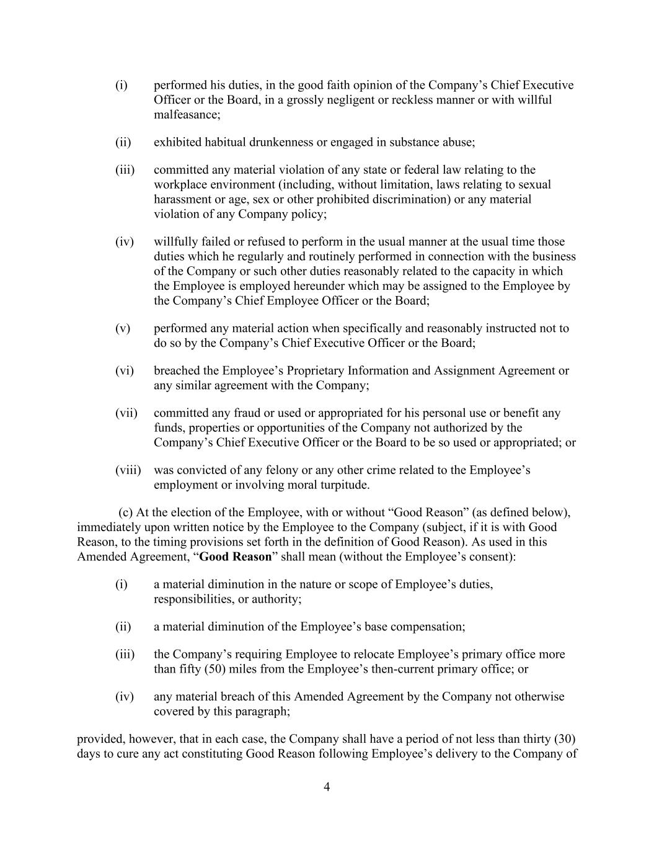
4 (i) performed his duties, in the good faith opinion of the Company’s Chief Executive Officer or the Board, in a grossly negligent or reckless manner or with willful malfeasance; (ii) exhibited habitual drunkenness or engaged in substance abuse; (iii) committed any material violation of any state or federal law relating to the workplace environment (including, without limitation, laws relating to sexual harassment or age, sex or other prohibited discrimination) or any material violation of any Company policy; (iv) willfully failed or refused to perform in the usual manner at the usual time those duties which he regularly and routinely performed in connection with the business of the Company or such other duties reasonably related to the capacity in which the Employee is employed hereunder which may be assigned to the Employee by the Company’s Chief Employee Officer or the Board; (v) performed any material action when specifically and reasonably instructed not to do so by the Company’s Chief Executive Officer or the Board; (vi) breached the Employee’s Proprietary Information and Assignment Agreement or any similar agreement with the Company; (vii) committed any fraud or used or appropriated for his personal use or benefit any funds, properties or opportunities of the Company not authorized by the Company’s Chief Executive Officer or the Board to be so used or appropriated; or (viii) was convicted of any felony or any other crime related to the Employee’s employment or involving moral turpitude. (c) At the election of the Employee, with or without “Good Reason” (as defined below), immediately upon written notice by the Employee to the Company (subject, if it is with Good Reason, to the timing provisions set forth in the definition of Good Reason). As used in this Amended Agreement, “Good Reason” shall mean (without the Employee’s consent): (i) a material diminution in the nature or scope of Employee’s duties, responsibilities, or authority; (ii) a material diminution of the Employee’s base compensation; (iii) the Company’s requiring Employee to relocate Employee’s primary office more than fifty (50) miles from the Employee’s then-current primary office; or (iv) any material breach of this Amended Agreement by the Company not otherwise covered by this paragraph; provided, however, that in each case, the Company shall have a period of not less than thirty (30) days to cure any act constituting Good Reason following Employee’s delivery to the Company of

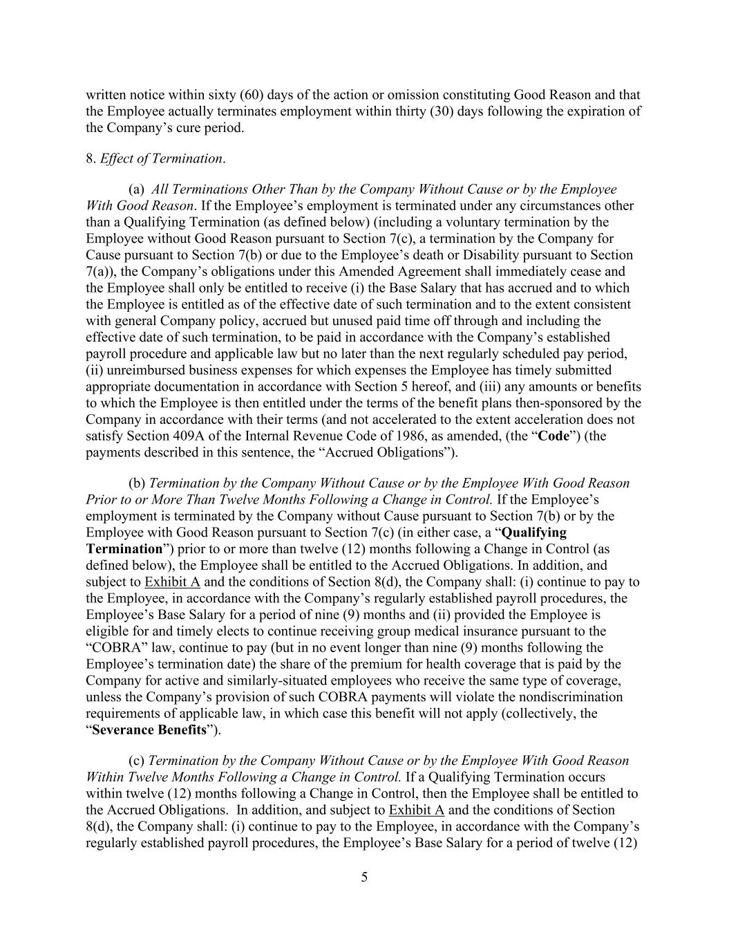
5 written notice within sixty (60) days of the action or omission constituting Good Reason and that the Employee actually terminates employment within thirty (30) days following the expiration of the Company’s cure period. 8. Effect of Termination. (a) All Terminations Other Than by the Company Without Cause or by the Employee With Good Reason. If the Employee’s employment is terminated under any circumstances other than a Qualifying Termination (as defined below) (including a voluntary termination by the Employee without Good Reason pursuant to Section 7(c), a termination by the Company for Cause pursuant to Section 7(b) or due to the Employee’s death or Disability pursuant to Section 7(a)), the Company’s obligations under this Amended Agreement shall immediately cease and the Employee shall only be entitled to receive (i) the Base Salary that has accrued and to which the Employee is entitled as of the effective date of such termination and to the extent consistent with general Company policy, accrued but unused paid time off through and including the effective date of such termination, to be paid in accordance with the Company’s established payroll procedure and applicable law but no later than the next regularly scheduled pay period, (ii) unreimbursed business expenses for which expenses the Employee has timely submitted appropriate documentation in accordance with Section 5 hereof, and (iii) any amounts or benefits to which the Employee is then entitled under the terms of the benefit plans then-sponsored by the Company in accordance with their terms (and not accelerated to the extent acceleration does not satisfy Section 409A of the Internal Revenue Code of 1986, as amended, (the “Code”) (the payments described in this sentence, the “Accrued Obligations”). (b) Termination by the Company Without Cause or by the Employee With Good Reason Prior to or More Than Twelve Months Following a Change in Control. If the Employee’s employment is terminated by the Company without Cause pursuant to Section 7(b) or by the Employee with Good Reason pursuant to Section 7(c) (in either case, a “Qualifying Termination”) prior to or more than twelve (12) months following a Change in Control (as defined below), the Employee shall be entitled to the Accrued Obligations. In addition, and subject to Exhibit A and the conditions of Section 8(d), the Company shall: (i) continue to pay to the Employee, in accordance with the Company’s regularly established payroll procedures, the Employee’s Base Salary for a period of nine (9) months and (ii) provided the Employee is eligible for and timely elects to continue receiving group medical insurance pursuant to the “COBRA” law, continue to pay (but in no event longer than nine (9) months following the Employee’s termination date) the share of the premium for health coverage that is paid by the Company for active and similarly-situated employees who receive the same type of coverage, unless the Company’s provision of such COBRA payments will violate the nondiscrimination requirements of applicable law, in which case this benefit will not apply (collectively, the “Severance Benefits”). (c) Termination by the Company Without Cause or by the Employee With Good Reason Within Twelve Months Following a Change in Control. If a Qualifying Termination occurs within twelve (12) months following a Change in Control, then the Employee shall be entitled to the Accrued Obligations. In addition, and subject to Exhibit A and the conditions of Section 8(d), the Company shall: (i) continue to pay to the Employee, in accordance with the Company’s regularly established payroll procedures, the Employee’s Base Salary for a period of twelve (12)

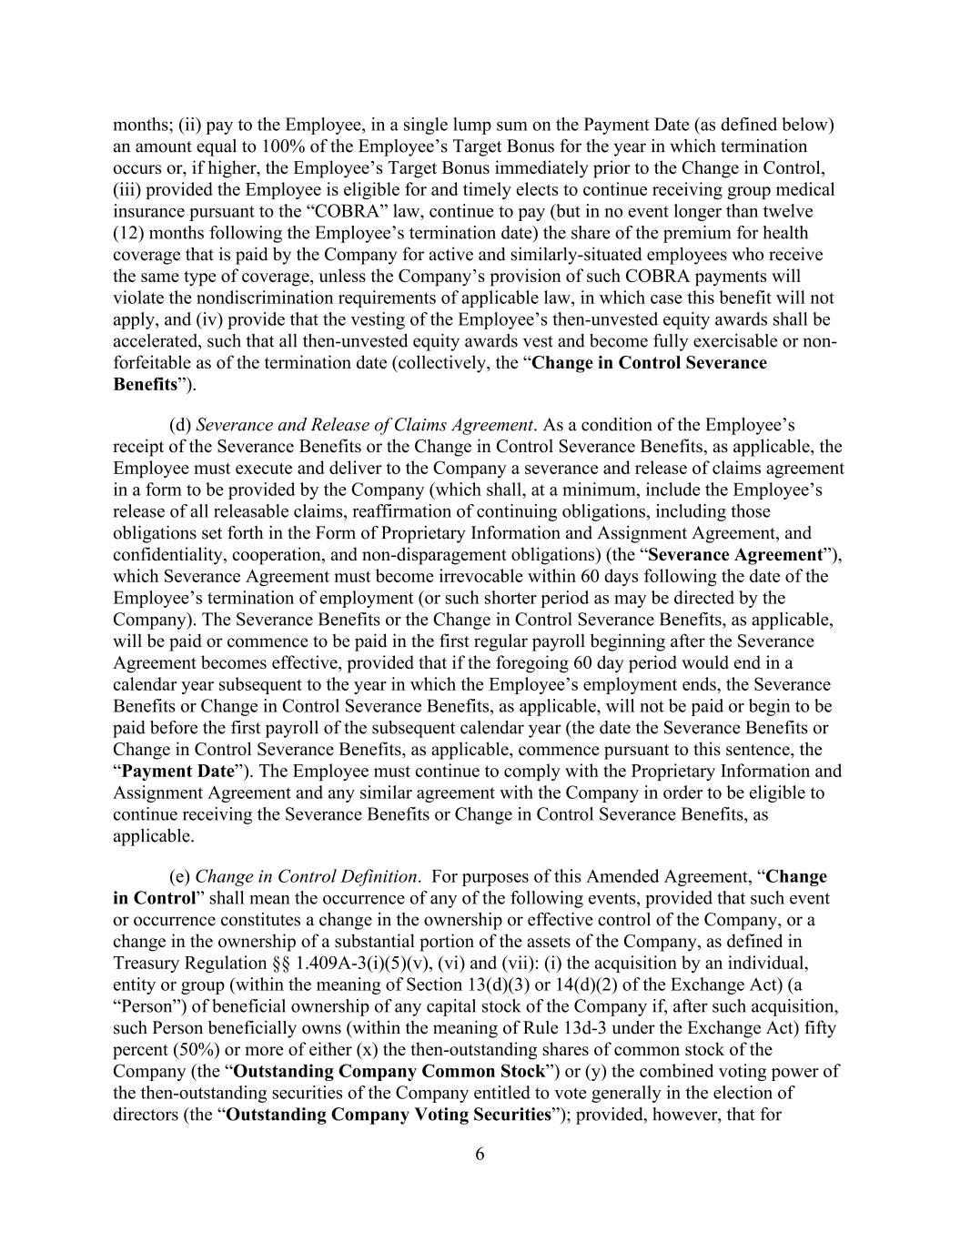
6 months; (ii) pay to the Employee, in a single lump sum on the Payment Date (as defined below) an amount equal to 100% of the Employee’s Target Bonus for the year in which termination occurs or, if higher, the Employee’s Target Bonus immediately prior to the Change in Control, (iii) provided the Employee is eligible for and timely elects to continue receiving group medical insurance pursuant to the “COBRA” law, continue to pay (but in no event longer than twelve (12) months following the Employee’s termination date) the share of the premium for health coverage that is paid by the Company for active and similarly-situated employees who receive the same type of coverage, unless the Company’s provision of such COBRA payments will violate the nondiscrimination requirements of applicable law, in which case this benefit will not apply, and (iv) provide that the vesting of the Employee’s then-unvested equity awards shall be accelerated, such that all then-unvested equity awards vest and become fully exercisable or non- forfeitable as of the termination date (collectively, the “Change in Control Severance Benefits”). (d) Severance and Release of Claims Agreement. As a condition of the Employee’s receipt of the Severance Benefits or the Change in Control Severance Benefits, as applicable, the Employee must execute and deliver to the Company a severance and release of claims agreement in a form to be provided by the Company (which shall, at a minimum, include the Employee’s release of all releasable claims, reaffirmation of continuing obligations, including those obligations set forth in the Form of Proprietary Information and Assignment Agreement, and confidentiality, cooperation, and non-disparagement obligations) (the “Severance Agreement”), which Severance Agreement must become irrevocable within 60 days following the date of the Employee’s termination of employment (or such shorter period as may be directed by the Company). The Severance Benefits or the Change in Control Severance Benefits, as applicable, will be paid or commence to be paid in the first regular payroll beginning after the Severance Agreement becomes effective, provided that if the foregoing 60 day period would end in a calendar year subsequent to the year in which the Employee’s employment ends, the Severance Benefits or Change in Control Severance Benefits, as applicable, will not be paid or begin to be paid before the first payroll of the subsequent calendar year (the date the Severance Benefits or Change in Control Severance Benefits, as applicable, commence pursuant to this sentence, the “Payment Date”). The Employee must continue to comply with the Proprietary Information and Assignment Agreement and any similar agreement with the Company in order to be eligible to continue receiving the Severance Benefits or Change in Control Severance Benefits, as applicable. (e) Change in Control Definition. For purposes of this Amended Agreement, “Change in Control” shall mean the occurrence of any of the following events, provided that such event or occurrence constitutes a change in the ownership or effective control of the Company, or a change in the ownership of a substantial portion of the assets of the Company, as defined in Treasury Regulation §§ 1.409A-3(i)(5)(v), (vi) and (vii): (i) the acquisition by an individual, entity or group (within the meaning of Section 13(d)(3) or 14(d)(2) of the Exchange Act) (a “Person”) of beneficial ownership of any capital stock of the Company if, after such acquisition, such Person beneficially owns (within the meaning of Rule 13d-3 under the Exchange Act) fifty percent (50%) or more of either (x) the then-outstanding shares of common stock of the Company (the “Outstanding Company Common Stock”) or (y) the combined voting power of the then-outstanding securities of the Company entitled to vote generally in the election of directors (the “Outstanding Company Voting Securities”); provided, however, that for

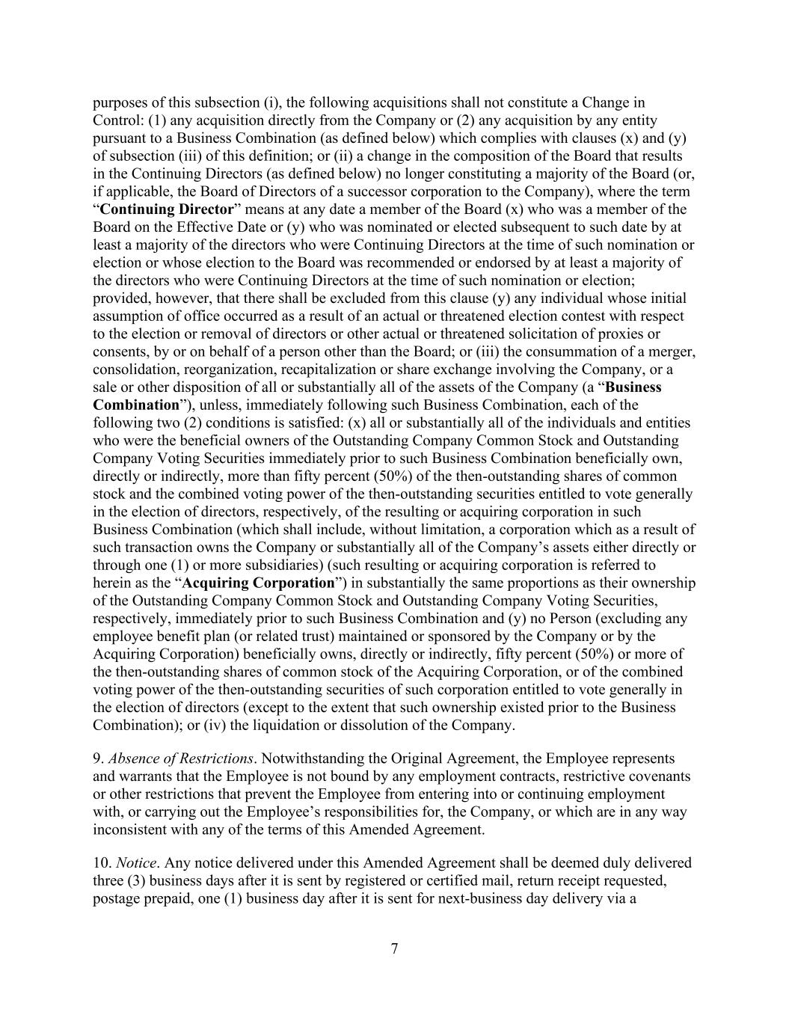
7 purposes of this subsection (i), the following acquisitions shall not constitute a Change in Control: (1) any acquisition directly from the Company or (2) any acquisition by any entity pursuant to a Business Combination (as defined below) which complies with clauses (x) and (y) of subsection (iii) of this definition; or (ii) a change in the composition of the Board that results in the Continuing Directors (as defined below) no longer constituting a majority of the Board (or, if applicable, the Board of Directors of a successor corporation to the Company), where the term “Continuing Director” means at any date a member of the Board (x) who was a member of the Board on the Effective Date or (y) who was nominated or elected subsequent to such date by at least a majority of the directors who were Continuing Directors at the time of such nomination or election or whose election to the Board was recommended or endorsed by at least a majority of the directors who were Continuing Directors at the time of such nomination or election; provided, however, that there shall be excluded from this clause (y) any individual whose initial assumption of office occurred as a result of an actual or threatened election contest with respect to the election or removal of directors or other actual or threatened solicitation of proxies or consents, by or on behalf of a person other than the Board; or (iii) the consummation of a merger, consolidation, reorganization, recapitalization or share exchange involving the Company, or a sale or other disposition of all or substantially all of the assets of the Company (a “Business Combination”), unless, immediately following such Business Combination, each of the following two (2) conditions is satisfied: (x) all or substantially all of the individuals and entities who were the beneficial owners of the Outstanding Company Common Stock and Outstanding Company Voting Securities immediately prior to such Business Combination beneficially own, directly or indirectly, more than fifty percent (50%) of the then-outstanding shares of common stock and the combined voting power of the then-outstanding securities entitled to vote generally in the election of directors, respectively, of the resulting or acquiring corporation in such Business Combination (which shall include, without limitation, a corporation which as a result of such transaction owns the Company or substantially all of the Company’s assets either directly or through one (1) or more subsidiaries) (such resulting or acquiring corporation is referred to herein as the “Acquiring Corporation”) in substantially the same proportions as their ownership of the Outstanding Company Common Stock and Outstanding Company Voting Securities, respectively, immediately prior to such Business Combination and (y) no Person (excluding any employee benefit plan (or related trust) maintained or sponsored by the Company or by the Acquiring Corporation) beneficially owns, directly or indirectly, fifty percent (50%) or more of the then-outstanding shares of common stock of the Acquiring Corporation, or of the combined voting power of the then-outstanding securities of such corporation entitled to vote generally in the election of directors (except to the extent that such ownership existed prior to the Business Combination); or (iv) the liquidation or dissolution of the Company. 9. Absence of Restrictions. Notwithstanding the Original Agreement, the Employee represents and warrants that the Employee is not bound by any employment contracts, restrictive covenants or other restrictions that prevent the Employee from entering into or continuing employment with, or carrying out the Employee’s responsibilities for, the Company, or which are in any way inconsistent with any of the terms of this Amended Agreement. 10. Notice. Any notice delivered under this Amended Agreement shall be deemed duly delivered three (3) business days after it is sent by registered or certified mail, return receipt requested, postage prepaid, one (1) business day after it is sent for next-business day delivery via a

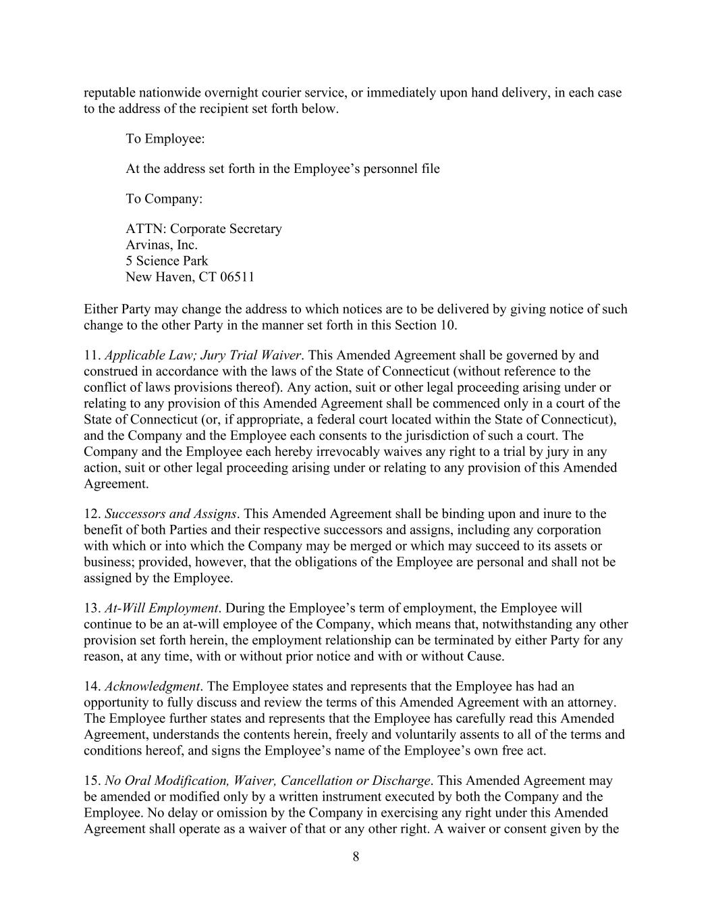
8 reputable nationwide overnight courier service, or immediately upon hand delivery, in each case to the address of the recipient set forth below. To Employee: At the address set forth in the Employee’s personnel file To Company: ATTN: Corporate Secretary Arvinas, Inc. 5 Science Park New Haven, CT 06511 Either Party may change the address to which notices are to be delivered by giving notice of such change to the other Party in the manner set forth in this Section 10. 11. Applicable Law; Jury Trial Waiver. This Amended Agreement shall be governed by and construed in accordance with the laws of the State of Connecticut (without reference to the conflict of laws provisions thereof). Any action, suit or other legal proceeding arising under or relating to any provision of this Amended Agreement shall be commenced only in a court of the State of Connecticut (or, if appropriate, a federal court located within the State of Connecticut), and the Company and the Employee each consents to the jurisdiction of such a court. The Company and the Employee each hereby irrevocably waives any right to a trial by jury in any action, suit or other legal proceeding arising under or relating to any provision of this Amended Agreement. 12. Successors and Assigns. This Amended Agreement shall be binding upon and inure to the benefit of both Parties and their respective successors and assigns, including any corporation with which or into which the Company may be merged or which may succeed to its assets or business; provided, however, that the obligations of the Employee are personal and shall not be assigned by the Employee. 13. At-Will Employment. During the Employee’s term of employment, the Employee will continue to be an at-will employee of the Company, which means that, notwithstanding any other provision set forth herein, the employment relationship can be terminated by either Party for any reason, at any time, with or without prior notice and with or without Cause. 14. Acknowledgment. The Employee states and represents that the Employee has had an opportunity to fully discuss and review the terms of this Amended Agreement with an attorney. The Employee further states and represents that the Employee has carefully read this Amended Agreement, understands the contents herein, freely and voluntarily assents to all of the terms and conditions hereof, and signs the Employee’s name of the Employee’s own free act. 15. No Oral Modification, Waiver, Cancellation or Discharge. This Amended Agreement may be amended or modified only by a written instrument executed by both the Company and the Employee. No delay or omission by the Company in exercising any right under this Amended Agreement shall operate as a waiver of that or any other right. A waiver or consent given by the

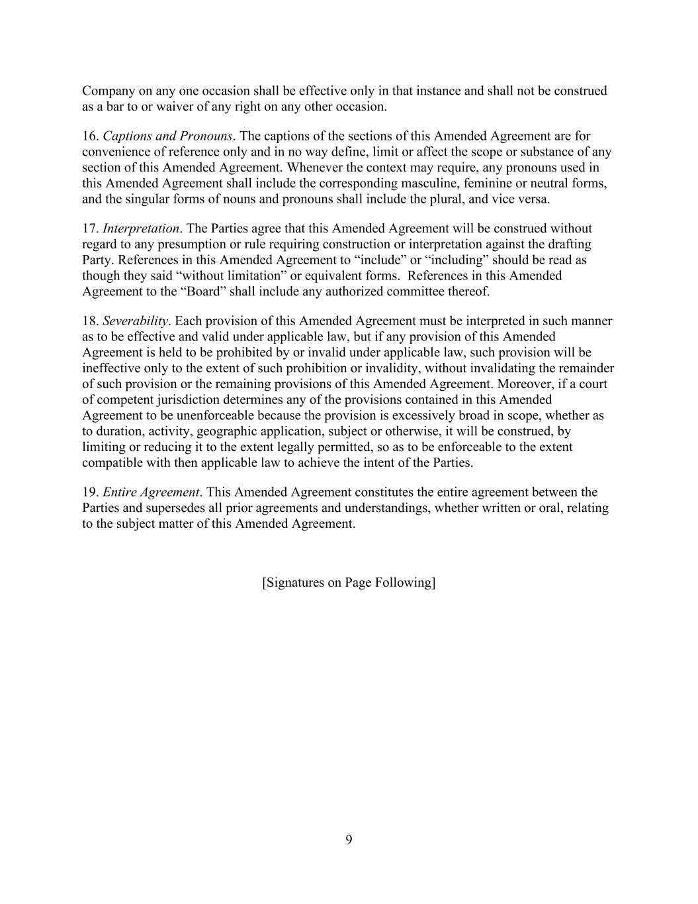
9 Company on any one occasion shall be effective only in that instance and shall not be construed as a bar to or waiver of any right on any other occasion. 16. Captions and Pronouns. The captions of the sections of this Amended Agreement are for convenience of reference only and in no way define, limit or affect the scope or substance of any section of this Amended Agreement. Whenever the context may require, any pronouns used in this Amended Agreement shall include the corresponding masculine, feminine or neutral forms, and the singular forms of nouns and pronouns shall include the plural, and vice versa. 17. Interpretation. The Parties agree that this Amended Agreement will be construed without regard to any presumption or rule requiring construction or interpretation against the drafting Party. References in this Amended Agreement to “include” or “including” should be read as though they said “without limitation” or equivalent forms. References in this Amended Agreement to the “Board” shall include any authorized committee thereof. 18. Severability. Each provision of this Amended Agreement must be interpreted in such manner as to be effective and valid under applicable law, but if any provision of this Amended Agreement is held to be prohibited by or invalid under applicable law, such provision will be ineffective only to the extent of such prohibition or invalidity, without invalidating the remainder of such provision or the remaining provisions of this Amended Agreement. Moreover, if a court of competent jurisdiction determines any of the provisions contained in this Amended Agreement to be unenforceable because the provision is excessively broad in scope, whether as to duration, activity, geographic application, subject or otherwise, it will be construed, by limiting or reducing it to the extent legally permitted, so as to be enforceable to the extent compatible with then applicable law to achieve the intent of the Parties. 19. Entire Agreement. This Amended Agreement constitutes the entire agreement between the Parties and supersedes all prior agreements and understandings, whether written or oral, relating to the subject matter of this Amended Agreement. [Signatures on Page Following]

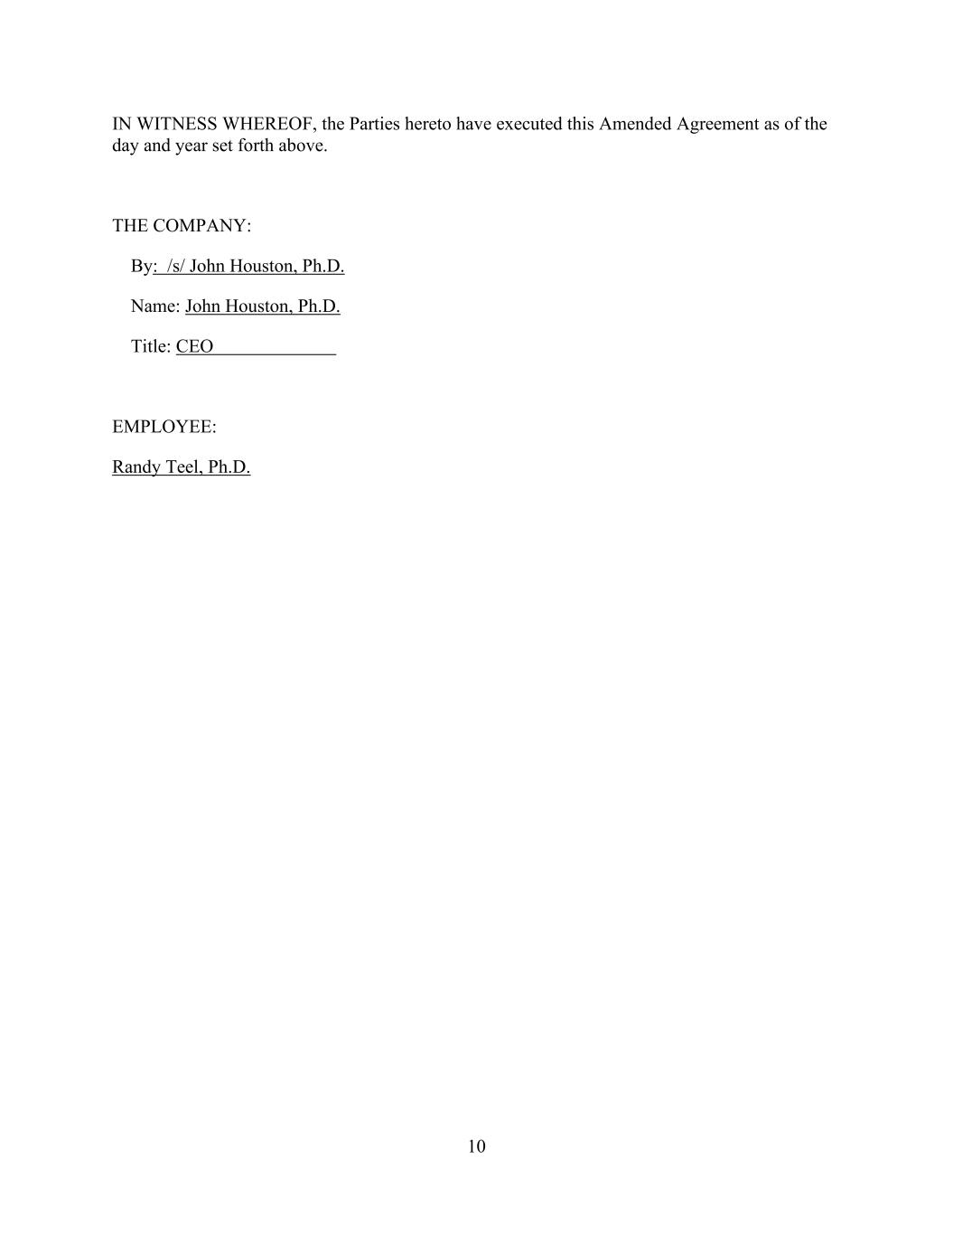
10 IN WITNESS WHEREOF, the Parties hereto have executed this Amended Agreement as of the day and year set forth above. THE COMPANY: By: /s/ John Houston, Ph.D. Name: John Houston, Ph.D. Title: CEO EMPLOYEE: Randy Teel, Ph.D.

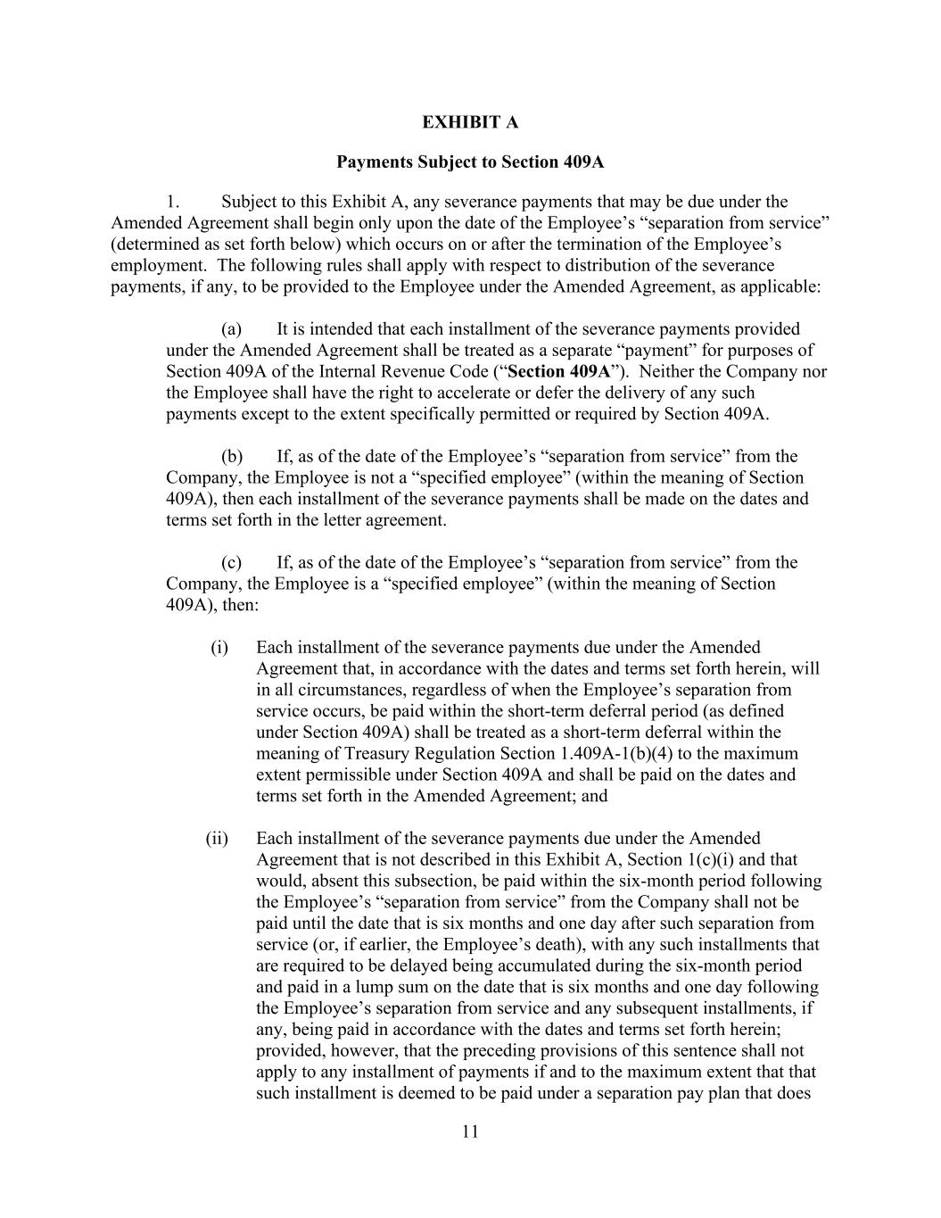
11 EXHIBIT A Payments Subject to Section 409A 1. Subject to this Exhibit A, any severance payments that may be due under the Amended Agreement shall begin only upon the date of the Employee’s “separation from service” (determined as set forth below) which occurs on or after the termination of the Employee’s employment. The following rules shall apply with respect to distribution of the severance payments, if any, to be provided to the Employee under the Amended Agreement, as applicable: (a) It is intended that each installment of the severance payments provided under the Amended Agreement shall be treated as a separate “payment” for purposes of Section 409A of the Internal Revenue Code (“Section 409A”). Neither the Company nor the Employee shall have the right to accelerate or defer the delivery of any such payments except to the extent specifically permitted or required by Section 409A. (b) If, as of the date of the Employee’s “separation from service” from the Company, the Employee is not a “specified employee” (within the meaning of Section 409A), then each installment of the severance payments shall be made on the dates and terms set forth in the letter agreement. (c) If, as of the date of the Employee’s “separation from service” from the Company, the Employee is a “specified employee” (within the meaning of Section 409A), then: (i) Each installment of the severance payments due under the Amended Agreement that, in accordance with the dates and terms set forth herein, will in all circumstances, regardless of when the Employee’s separation from service occurs, be paid within the short-term deferral period (as defined under Section 409A) shall be treated as a short-term deferral within the meaning of Treasury Regulation Section 1.409A-1(b)(4) to the maximum extent permissible under Section 409A and shall be paid on the dates and terms set forth in the Amended Agreement; and (ii) Each installment of the severance payments due under the Amended Agreement that is not described in this Exhibit A, Section 1(c)(i) and that would, absent this subsection, be paid within the six-month period following the Employee’s “separation from service” from the Company shall not be paid until the date that is six months and one day after such separation from service (or, if earlier, the Employee’s death), with any such installments that are required to be delayed being accumulated during the six-month period and paid in a lump sum on the date that is six months and one day following the Employee’s separation from service and any subsequent installments, if any, being paid in accordance with the dates and terms set forth herein; provided, however, that the preceding provisions of this sentence shall not apply to any installment of payments if and to the maximum extent that that such installment is deemed to be paid under a separation pay plan that does

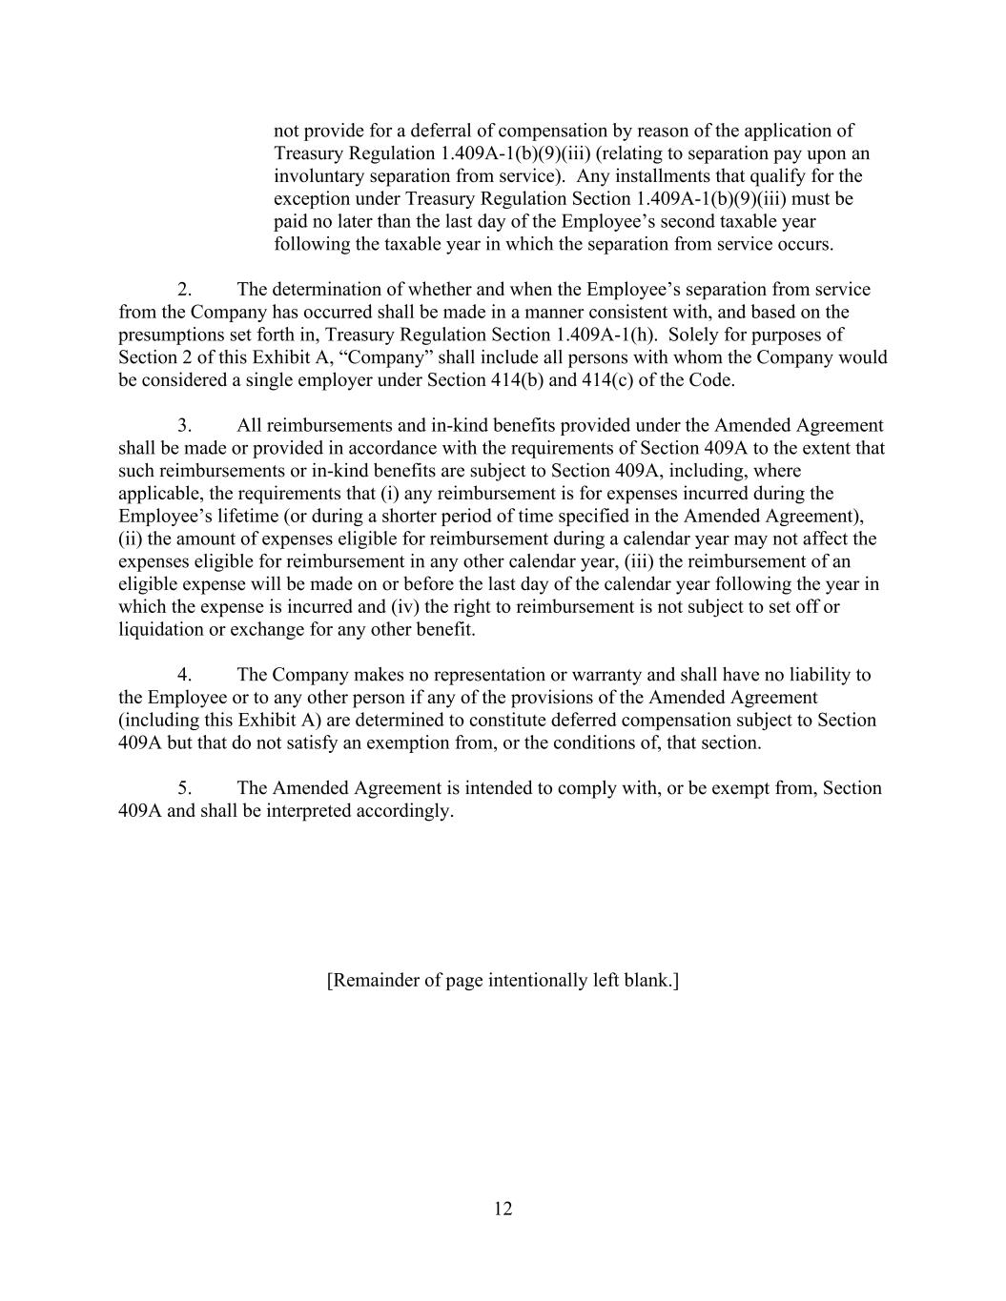
12 not provide for a deferral of compensation by reason of the application of Treasury Regulation 1.409A-1(b)(9)(iii) (relating to separation pay upon an involuntary separation from service). Any installments that qualify for the exception under Treasury Regulation Section 1.409A-1(b)(9)(iii) must be paid no later than the last day of the Employee’s second taxable year following the taxable year in which the separation from service occurs. 2. The determination of whether and when the Employee’s separation from service from the Company has occurred shall be made in a manner consistent with, and based on the presumptions set forth in, Treasury Regulation Section 1.409A-1(h). Solely for purposes of Section 2 of this Exhibit A, “Company” shall include all persons with whom the Company would be considered a single employer under Section 414(b) and 414(c) of the Code. 3. All reimbursements and in-kind benefits provided under the Amended Agreement shall be made or provided in accordance with the requirements of Section 409A to the extent that such reimbursements or in-kind benefits are subject to Section 409A, including, where applicable, the requirements that (i) any reimbursement is for expenses incurred during the Employee’s lifetime (or during a shorter period of time specified in the Amended Agreement), (ii) the amount of expenses eligible for reimbursement during a calendar year may not affect the expenses eligible for reimbursement in any other calendar year, (iii) the reimbursement of an eligible expense will be made on or before the last day of the calendar year following the year in which the expense is incurred and (iv) the right to reimbursement is not subject to set off or liquidation or exchange for any other benefit. 4. The Company makes no representation or warranty and shall have no liability to the Employee or to any other person if any of the provisions of the Amended Agreement (including this Exhibit A) are determined to constitute deferred compensation subject to Section 409A but that do not satisfy an exemption from, or the conditions of, that section. 5. The Amended Agreement is intended to comply with, or be exempt from, Section 409A and shall be interpreted accordingly. [Remainder of page intentionally left blank.]

Exhibit 31.1
CERTIFICATION PURSUANT TO
RULES 13a-14(a) AND 15d-14(a) UNDER THE SECURITIES EXCHANGE ACT OF 1934,
AS ADOPTED PURSUANT TO SECTION 302 OF THE SARBANES-OXLEY ACT OF 2002
I, John Houston, Ph.D., certify that:
1.I have reviewed this Quarterly Report on Form 10-Q of Arvinas, Inc.;
2.Based on my knowledge, this report does not contain any untrue statement of a material fact or omit to state a material fact necessary to make the statements made, in light of the circumstances under which such statements were made, not misleading with respect to the period covered by this report;
3.Based on my knowledge, the financial statements, and other financial information included in this report, fairly present in all material respects the financial condition, results of operations and cash flows of the registrant as of, and for, the periods presented in this report;
4.The registrant's other certifying officer and I are responsible for establishing and maintaining disclosure controls and procedures (as defined in Exchange Act Rules 13a-15(e) and 15d-15(e)) and internal control over financial reporting (as defined in Exchange Act Rules 13a-15(f) and 15d-15(f)) for the registrant and have:
(a)Designed such disclosure controls and procedures, or caused such disclosure controls and procedures to be designed under our supervision, to ensure that material information relating to the registrant, including its consolidated subsidiaries, is made known to us by others within those entities, particularly during the period in which this report is being prepared;
(b)Designed such internal control over financial reporting, or caused such internal control over financial reporting to be designed under our supervision, to provide reasonable assurance regarding the reliability of financial reporting and the preparation of financial statements for external purposes in accordance with generally accepted accounting principles;
(c)Evaluated the effectiveness of the registrant's disclosure controls and procedures and presented in this report our conclusions about the effectiveness of the disclosure controls and procedures, as of the end of the period covered by this report based on such evaluation; and
(d)Disclosed in this report any change in the registrant's internal control over financial reporting that occurred during the registrant's most recent fiscal quarter (the registrant's fourth fiscal quarter in the case of an annual report) that has materially affected, or is reasonably likely to materially affect, the registrant's internal control over financial reporting; and
5.The registrant's other certifying officer and I have disclosed, based on our most recent evaluation of internal control over financial reporting, to the registrant's auditors and the audit committee of the registrant's board of directors (or persons performing the equivalent functions):
(a)All significant deficiencies and material weaknesses in the design or operation of internal control over financial reporting which are reasonably likely to adversely affect the registrant's ability to record, process, summarize and report financial information; and
(b)Any fraud, whether or not material, that involves management or other employees who have a significant role in the registrant's internal control over financial reporting.
Date: November 5, 2025 |  |  | By: |  |  | /s/ John Houston, Ph.D.
John Houston, Ph.D.
President and Chief Executive Officer
(Principal Executive Officer)

Exhibit 31.2
CERTIFICATION PURSUANT TO
RULES 13a-14(a) AND 15d-14(a) UNDER THE SECURITIES EXCHANGE ACT OF 1934,
AS ADOPTED PURSUANT TO SECTION 302 OF THE SARBANES-OXLEY ACT OF 2002
I, Andrew Saik, certify that:
1.I have reviewed this Quarterly Report on Form 10-Q of Arvinas, Inc.;
2.Based on my knowledge, this report does not contain any untrue statement of a material fact or omit to state a material fact necessary to make the statements made, in light of the circumstances under which such statements were made, not misleading with respect to the period covered by this report;
3.Based on my knowledge, the financial statements, and other financial information included in this report, fairly present in all material respects the financial condition, results of operations and cash flows of the registrant as of, and for, the periods presented in this report;
4.The registrant's other certifying officer and I are responsible for establishing and maintaining disclosure controls and procedures (as defined in Exchange Act Rules 13a-15(e) and 15d-15(e)) and internal control over financial reporting (as defined in Exchange Act Rules 13a-15(f) and 15d-15(f)) for the registrant and have:
(a)Designed such disclosure controls and procedures, or caused such disclosure controls and procedures to be designed under our supervision, to ensure that material information relating to the registrant, including its consolidated subsidiaries, is made known to us by others within those entities, particularly during the period in which this report is being prepared;
(b)Designed such internal control over financial reporting, or caused such internal control over financial reporting to be designed under our supervision, to provide reasonable assurance regarding the reliability of financial reporting and the preparation of financial statements for external purposes in accordance with generally accepted accounting principles;
(c)Evaluated the effectiveness of the registrant’s disclosure controls and procedures and presented in this report our conclusions about the effectiveness of the disclosure controls and procedures, as of the end of the period covered by this report based on such evaluation; and
(d)Disclosed in this report any change in the registrant's internal control over financial reporting that occurred during the registrant's most recent fiscal quarter (the registrant's fourth fiscal quarter in the case of an annual report) that has materially affected, or is reasonably likely to materially affect, the registrant's internal control over financial reporting; and
5.The registrant's other certifying officer and I have disclosed, based on our most recent evaluation of internal control over financial reporting, to the registrant's auditors and the audit committee of the registrant's board of directors (or persons performing the equivalent functions):
(a)All significant deficiencies and material weaknesses in the design or operation of internal control over financial reporting which are reasonably likely to adversely affect the registrant's ability to record, process, summarize and report financial information; and
(b)Any fraud, whether or not material, that involves management or other employees who have a significant role in the registrant's internal control over financial reporting.
Date: November 5, 2025 |  |  | By: |  |  | /s/ Andrew Saik
Andrew Saik
Chief Financial Officer and Treasurer
(Principal Financial Officer)

Exhibit 32.1
CERTIFICATION PURSUANT TO
18 U.S.C. SECTION 1350, AS ADOPTED PURSUANT TO
SECTION 906 OF THE SARBANES-OXLEY ACT OF 2002
In connection with the Quarterly Report of Arvinas, Inc. (the “Company”) on Form 10-Q for the period ended September 30, 2025 as filed with the Securities and Exchange Commission on the date hereof (the “Report”), I certify, pursuant to 18 U.S.C. § 1350, as adopted pursuant to § 906 of the Sarbanes-Oxley Act of 2002, that:
(1)The Report fully complies with the requirements of section 13(a) or 15(d) of the Securities Exchange Act of 1934; and
(2)The information contained in the Report fairly presents, in all material respects, the financial condition and result of operations of the Company.
Date: November 5, 2025 |  |  | By: |  |  | /s/ John Houston, Ph.D.
John Houston, Ph.D.
President and Chief Executive Officer
(Principal Executive Officer)

Exhibit 32.2
CERTIFICATION PURSUANT TO
18 U.S.C. SECTION 1350, AS ADOPTED PURSUANT TO
SECTION 906 OF THE SARBANES-OXLEY ACT OF 2002
In connection with the Quarterly Report of Arvinas, Inc. (the “Company”) on Form 10-Q for the period ended September 30, 2025 as filed with the Securities and Exchange Commission on the date hereof (the “Report”), I certify, pursuant to 18 U.S.C. § 1350, as adopted pursuant to § 906 of the Sarbanes-Oxley Act of 2002, that:
(1)The Report fully complies with the requirements of section 13(a) or 15(d) of the Securities Exchange Act of 1934; and
(2)The information contained in the Report fairly presents, in all material respects, the financial condition and result of operations of the Company.
Date: November 5, 2025 |  |  | By: |  |  | /s/ Andrew Saik
Andrew Saik
Chief Financial Officer and Treasurer
(Principal Financial Officer)

