UNITED STATES

SECURITIES AND EXCHANGE COMMISSION

Washington, D.C. 20549

________________________________________________

FORM 10-K

________________________________________________

(Mark One)

- ANNUAL REPORT PURSUANT TO SECTION 13 OR 15(d) OF THE SECURITIES EXCHANGE ACT OF 1934

For the fiscal year ended December 31, 2025

OR

- TRANSITION REPORT PURSUANT TO SECTION 13 OR 15(d) OF THE SECURITIES EXCHANGE ACT OF 1934 FOR THE TRANSITION PERIOD FROM

TO.

Commission File Number: 001-38672
________________________________________________
ARVINAS, INC.
(Exact name of registrant as specified in its Charter)
________________________________________________
Delaware | 47-2566120
(State or other jurisdiction of | (I.R.S. Employer
incorporation or organization) | Identification No.)
5 Science Park
395 Winchester Ave.
New Haven, Connecticut | 06511
(Address of principal executive offices) | (Zip Code)

Registrant’s telephone number, including area code: (203) 535-1456

________________________________________________
Securities registered pursuant to Section 12(b) of the Act:

Title of each class | Trading | Name of each exchange on which registered
Title of each class | Symbol(s) | Name of each exchange on which registered
Common stock, par value $0.001 per share | ARVN | The Nasdaq Global Select Market

Securities registered pursuant to Section 12(g) of the Act:

None

(Title of class)

Indicate by check mark if the registrant is a well-known seasoned issuer, as defined in Rule 405 of the Securities Act. Yes x No o Indicate by check mark if the registrant is not required to file reports pursuant to Section 13 or 15(d) of the Act. Yes o No x
Indicate by check mark whether the registrant: (1) has filed all reports required to be filed by Section 13 or 15(d) of the Securities Exchange Act of 1934 during the preceding 12 months (or for such shorter period that the registrant was required to file such reports), and (2) has been subject to such filing requirements for the past 90 days. Yes x No o

Indicate by check mark whether the registrant has submitted electronically every Interactive Data File required to be submitted pursuant to Rule 405 of Regulation S-T (§232.405 of this chapter) during the preceding 12 months (or for such shorter period that the registrant was required to submit such files). Yes x No o

Indicate by check mark whether the registrant is a large accelerated filer, an accelerated filer, a non-accelerated filer, a smaller reporting company, or an emerging growth company. See the definitions of “large accelerated filer,” “accelerated filer,” “smaller reporting company,” and “emerging growth company” in Rule 12b-2 of the Exchange Act.

Large Accelerated Filer | o | Accelerated filer | x
Non-accelerated filer | o | Smaller reporting company | o
 |  | Emerging growth company | o

If an emerging growth company, indicate by check mark if the registrant has elected not to use the extended transition period for complying with any new or revised financial accounting standards provided pursuant to Section 13(a) of the Exchange Act. o

Indicate by check mark whether the registrant has filed a report on and attestation to its management’s assessment of the effectiveness of its internal control over financial reporting under Section 404(b) of the Sarbanes-Oxley Act (15 U.S.C. 7262(b)) by the registered public accounting firm that prepared or issued its audit report.☒
If securities are registered pursuant to Section 12(b) of the Act, indicate by check mark whether the financial statements of the registrant included in the filing reflect the correction of an error to previously issued financial statements. □

Indicate by check mark whether any of those error corrections are restatements that required a recovery analysis of incentive-based compensation received by any of the registrant’s executive officers during the relevant recovery period pursuant to § 240.10D-1(b). □
Indicate by check mark whether the registrant is a shell company (as defined in Rule 12b-2 of the Exchange Act). Yes ☐ No x

As of June 30, 2025, the last business day of the registrant’s most recently completed second fiscal quarter, the aggregate market value of the Common Stock held by non-affiliates of the registrant was approximately $469.0 million, based on the closing price of the registrant’s Common Stock on such date. The number of shares of registrant’s Common Stock, $0.001 par value per share, outstanding as of February 20, 2026 was 63,960,997.

DOCUMENTS INCORPORATED BY REFERENCE

Part III of this Annual Report incorporates by reference information from the definitive Proxy Statement for the registrant’s 2026 Annual Meeting of Stockholders, which is expected to be filed with the Securities and Exchange Commission not later than 120 days after the registrant’s fiscal year ended December 31, 2025.

 |  |  |  |  |  |  |  |  |  |  |  |  |  |  |  |  |  |  |  | Table of Contents
 |  |  |  |  |  |  |  |  |  |  |  |  |  |  |  |  |  |  |  |  |  |  |  |  |  |  |  | Page
 | PART I
 | Item 1. |  |  |  | Business |  |  |  |  |  |  |  |  |  |  |  |  |  |  |  |  |  |  |  |  |  |  | 7
 | Item 1A. |  |  |  | Risk Factors |  |  |  |  |  |  |  |  |  |  |  |  |  |  |  |  |  |  |  |  |  |  | 65
 | Item 1B. |  |  |  | Unresolved Staff Comments |  |  |  |  |  |  |  |  |  |  |  |  |  |  |  |  |  |  |  |  |  |  | 117
 | Item 1C |  |  |  | Cybersecurity |  |  |  |  |  |  |  |  |  |  |  |  |  |  |  |  |  |  |  |  |  |  | 118
 | Item 2. |  |  |  | Properties |  |  |  |  |  |  |  |  |  |  |  |  |  |  |  |  |  |  |  |  |  |  | 119
 | Item 3. |  |  |  | Legal Proceedings |  |  |  |  |  |  |  |  |  |  |  |  |  |  |  |  |  |  |  |  |  |  | 119
 | Item 4. |  |  |  | Mine Safety Disclosures |  |  |  |  |  |  |  |  |  |  |  |  |  |  |  |  |  |  |  |  |  |  | 119
 | PART II
 | Item 5. |  |  |  | Market for Registrant’s Common Equity, Related Stockholder Matters and Issuer Purchases of Equity Securities |  |  |  |  |  |  |  |  |  |  |  |  |  |  |  |  |  |  |  |  |  |  | 120
 | Item 6. |  |  |  | [Reserved] |  |  |  |  |  |  |  |  |  |  |  |  |  |  |  |  |  |  |  |  |  |  | 122
 | Item 7. |  |  |  | Management’s Discussion and Analysis of Financial Condition and Results of Operations |  |  |  |  |  |  |  |  |  |  |  |  |  |  |  |  |  |  |  |  |  |  | 122
 | Item 7A. |  |  |  | Quantitative and Qualitative Disclosures About Market Risk |  |  |  |  |  |  |  |  |  |  |  |  |  |  |  |  |  |  |  |  |  |  | 143
 | Item 8. |  |  |  | Financial Statements and Supplementary Data |  |  |  |  |  |  |  |  |  |  |  |  |  |  |  |  |  |  |  |  |  |  | 143
 | Item 9. |  |  |  | Changes in and Disagreements With Accountants on Accounting and Financial Disclosure |  |  |  |  |  |  |  |  |  |  |  |  |  |  |  |  |  |  |  |  |  |  | 143
 | Item 9A. |  |  |  | Controls and Procedures |  |  |  |  |  |  |  |  |  |  |  |  |  |  |  |  |  |  |  |  |  |  | 143
 | Item 9B. |  |  |  | Other Information |  |  |  |  |  |  |  |  |  |  |  |  |  |  |  |  |  |  |  |  |  |  | 146
 | Item 9C. |  |  |  | Disclosure Regarding Foreign Jurisdictions That Prevent Inspection |  |  |  |  |  |  |  |  |  |  |  |  |  |  |  |  |  |  |  |  |  |  | 146
 | PART III
 | Item 10. |  |  |  | Directors, Executive Officers and Corporate Governance |  |  |  |  |  |  |  |  |  |  |  |  |  |  |  |  |  |  |  |  |  |  | 147
 | Item 11. |  |  |  | Executive Compensation |  |  |  |  |  |  |  |  |  |  |  |  |  |  |  |  |  |  |  |  |  |  | 147
 | Item 12. |  |  |  | Security Ownership of Certain Beneficial Owners and Management and Related Stockholder Matters |  |  |  |  |  |  |  |  |  |  |  |  |  |  |  |  |  |  |  |  |  |  | 147
 | Item 13. |  |  |  | Certain Relationships and Related Transactions, and Director Independence |  |  |  |  |  |  |  |  |  |  |  |  |  |  |  |  |  |  |  |  |  |  | 147
 | Item 14. |  |  |  | Principal Accountant Fees and Services |  |  |  |  |  |  |  |  |  |  |  |  |  |  |  |  |  |  |  |  |  |  | 147
 | PART IV
 | Item 15. |  |  |  | Exhibits, Financial Statement Schedules |  |  |  |  |  |  |  |  |  |  |  |  |  |  |  |  |  |  |  |  |  |  | 148
 | Item 16. |  |  |  | Form 10-K Summary |  |  |  |  |  |  |  |  |  |  |  |  |  |  |  |  |  |  |  |  |  |  | 152
 |  |  |  |  | 1

CAUTIONARY NOTE REGARDING FORWARD-LOOKING STATEMENTS AND RISK FACTOR SUMMARY

Forward-Looking Statements

This Annual Report on Form 10-K contains forward-looking statements that involve substantial risks and uncertainties. All statements, other than statements of historical facts, contained in this Annual Report on Form 10-K, including statements regarding our strategy, future operations, future financial position, future revenues, projected costs, prospects, plans and objectives of management, are forward-looking statements. The words “anticipate,” “believe,” “estimate,” “expect,” “intend,” “may,” “might,” “plan,” “predict,” “project,” “target,” “potential,” “goals,” “will,” “would,” “could,” “should,” “continue” and similar expressions are intended to identify forward-looking statements, although not all forward-looking statements contain these identifying words.

The forward-looking statements in this Annual Report on Form 10-K include, among other things, statements about:

- the initiation, timing, progress and results of our current and/or future clinical trials of ARV-102, ARV-806, ARV-393 and ARV-027, including statements regarding the period during which the results of the clinical trials will become available or the forum in which we will present such results;

- the initiation, timing, progress and results of our current preclinical studies and any future preclinical studies or clinical trials of our other programs, including ARV-6723 and our pan-KRAS degrader, including statements regarding the period during which the results of preclinical studies or clinical trials will become available or the forum in which we will present such results;

- our belief, based on data from our preclinical studies and clinical trials, that PROTAC protein degraders may have distinct advantages over traditional small molecule inhibitors, antibodies and gene-based medicines;

- our belief that PROTAC degraders offer distinct advantages that enable perturbation of protein targets traditionally considered undruggable by conventional therapeutics;

- our plans with respect to market preparations for vepdegestrant and our plans, together with Pfizer Inc., jointly select a third party for the commercialization and potential further development of vepdegestrant;

- the timing of, and our ability to obtain, marketing approval of our product candidates, including vepdegestrant, and the ability of our product candidates, including vepdegestrant, to meet existing or future regulatory standards;

- our plans to pursue research and development of other product candidates;

- the potential advantages of our platform technology and potential advantages and therapeutic benefits of our product candidates;

- our belief that and the extent to which our targeted protein degradation approach may provide distinct advantages over existing therapies and address a broad range of targets, including historically undruggable proteins, in areas of significant unmet need;

- the potential achievement of milestones and receipt of payments under our collaborations, including our collaboration with Pfizer Inc. entered into in July 2021;

- the potential receipt of payments based on the achievement of milestones related to luxdegalutamide (ARV-766) and future royalties under our license agreement with Novartis Pharma AG;

- favorable clinical trial results in our ongoing oncology and neurology programs providing further validation of our platform as a new therapeutic modality for the potential treatment of diseases caused by dysregulated intracellular proteins;

- our belief that our leucine-rich repeat kinase 2 ("LRRK2") degraders are particularly well positioned to be evaluated in neurodegenerative diseases where there are currently no disease modifying therapies available, including Parkinson's disease ("PD") and progressive supranuclear palsy ("PSP");

2

- our belief that the data from our preclinical studies of ARV-102 further support the potential of PROTAC-induced LRRK2 degradation as a treatment for patients with neurodegenerative disease;

- our belief that ARV-806 has the potential to address high unmet need in solid tumors, such as pancreatic, colorectal and non-small cell lung cancer ("NSCLC"), with KRAS G12D mutation;

- our belief that ARV-806 has the potential to be developed as a monotherapy and in combination with chemotherapy in pancreatic ductal adenocarcinoma and in combination with standard of care ("SOC") treatments in colorectal and non-small cell lung cancer;

- our belief that preclinical data for ARV-806 supports intermittent clinical dosing;

- our belief that PROTAC-mediated degradation has the potential to address the historically undruggable nature of the B-cell lymphoma 6 protein ("BCL6") and that ARV-393 PROTAC-mediated degradation of BCL6 may provide an important novel therapeutic option for patients with non-Hodgkin lymphoma;

- our belief that ARV-393 can be an attractive combination partner for development of novel therapies for lymphoma, including chemo-free combination regimens and/or “all oral” treatment options;

- our belief that the totality of our preclinical data for ARV-393 provides a compelling rationale to evaluate ARV-393 in combination with bi-specifics, oral pathway inhibitors, and potentially other standards of care, in the larger diffuse large B-cell lymphoma indication;

- our belief that vepdegestrant has the potential to be a best-in-class monotherapy treatment for advanced/metastatic breast cancer patients in the second-line estrogen receptor 1 mutant setting;

- the potential receipt of revenue from future sales of our product candidates;

- the rate and degree of market acceptance and clinical utility of our product candidates;

- our estimates regarding the potential market opportunity for our product candidates;

- our ability to manage the transition of a new chief executive officer;

- our commercialization plans, and sales, marketing and distribution capabilities and strategy;

- our ability to establish and maintain arrangements for manufacture and testing of our product candidates;

- our ability to enter into additional collaborations with third parties;

- our intellectual property position;

- our plans with respect to our strategy;

- our estimates regarding expenses, future revenues, capital requirements and needs for additional financing, and statements regarding our cash, cash equivalents and marketable securities, including their sufficiency to fund planned operating expenses and capital expenditure requirements into the second half of 2028;

- our belief that the One Big Beautiful Bill Act,is not expected to have a material impact on our business or financial condition;

- our belief that there are not currently any risks from known cybersecurity threats that have materially affected or are reasonably likely to materially affect us;

- our belief that our facilities are sufficient to meet our current needs and that suitable additional or alternative space will be available as and when needed on commercially reasonable terms for any future growth;

- our belief that non-GAAP financial information, when taken collectively, may be helpful to investors because it provides consistency and comparability with past financial performance;

- the impact of government laws and regulations; and

- our competitive position.

You should read this Annual Report on Form 10-K and the documents that we have filed as exhibits to this Annual Report on Form 10-K completely and with the understanding that we may not actually achieve the

3

plans, intentions or expectations disclosed in our forward-looking statements, and you should not place undue reliance on our forward-looking statements. Actual results or events could differ materially from the plans, intentions and expectations disclosed in the forward-looking statements we make. We have included important factors in the cautionary statements included in this Annual Report on Form 10-K, particularly in the “Risk Factors” section, that we believe could cause actual results or events to differ materially from the forward-looking statements that we make. Our forward-looking statements do not reflect the potential impact of any future acquisitions, mergers, dispositions, joint ventures or investments we may make.

We do not assume any obligation to update any forward-looking statements except as required by applicable law.

This Annual Report on Form 10-K also contains estimates and other statistical data made by independent parties and by us relating to market size and other data about our industry. This data involves a number of assumptions and limitations, and you are cautioned not to give undue weight to such data and estimates. In addition, projections, assumptions and estimates of our future performance and the future performance of the markets in which we operate are necessarily subject to a high degree of uncertainty and risk. Cross-trial comparisons are not based on head-to-head studies and no direct comparisons can be made.

Throughout this Annual Report on Form 10-K, the “Company,” “Arvinas,” “we,” “us,” and “our,” except where the context requires otherwise, refer to Arvinas, Inc. and its consolidated subsidiaries, or any one or more of them as the context may require, and “our board of directors” refers to the board of directors of Arvinas, Inc.

The Arvinas name and logo are our trademarks. This Annual Report on Form 10-K contains references to our trademarks and service marks and to those belonging to other entities. Solely for convenience, trademarks and trade names referred to in this Annual Report on Form 10-K, including logos, artwork and other visual displays, may appear without the ® or ™ symbols, but such references are not intended to indicate in any way that we will not assert, to the fullest extent under applicable law, our rights or the rights of the applicable licensor to these trademarks and trade names. We do not intend our use or display of other entities’ trade names, trademarks or service marks to imply a relationship with, or endorsement or sponsorship of us by, any other entity.

Risk Factor Summary

Our business is subject to a number of risks that if realized could materially affect our business, prospects, operating results and financial condition. These risks are discussed more fully in the “Risk Factors” section of this Annual Report on Form 10-K. These risks include the following:

- We have incurred significant losses since our inception. We expect to incur expenses and operating losses over at least the next several years and may never achieve or maintain profitability. Our net losses totaled $80.8 million, $198.9 million and $367.3 million for the years ended December 31, 2025, 2024, and 2023, respectively.

- We have never generated revenue from product sales and may never be profitable.

- We will need substantial additional funding to continue our operations. If we are unable to raise capital when needed, we may be required to delay, limit, reduce or terminate our research, product development programs or future commercialization efforts.

- Raising additional capital may cause dilution to our stockholders, restrict our operations or require us to relinquish rights to our technologies or product candidates.

- Our approach to the discovery and development of product candidates based on our PROTAC technology platform is unproven, which makes it difficult to predict the time, cost of development and likelihood of successfully developing any products.

- We do not have any product candidates that have been approved for commercialization. If we are unable to commercialize our product candidates or experience significant delays in doing so, our business will be materially harmed.

- Drug development involves a lengthy and expensive process, with an uncertain outcome. We may incur unexpected costs or experience delays in completing, or ultimately be unable to complete, the development and commercialization of our product candidates.

4

- Positive data from preclinical or early clinical studies of our product candidates are not necessarily predictive of the results of later clinical studies and any future clinical trials of our product candidates. If we cannot replicate the positive data from our preclinical or early clinical studies of our product candidates in our future clinical trials, we will be unable to successfully develop, obtain regulatory approval for and commercialize our product candidates.

- We may expend our limited resources to pursue a particular product candidate or indication and fail to capitalize on product candidates or indications that may be more profitable or for which there is a greater likelihood of success.

- We are developing and plan to continue to develop our product candidates in combination with other drugs. If the FDA or similar regulatory authorities outside of the United States do not approve these other drugs, or revoke their approval of such drugs, or if safety, efficacy, manufacturing or supply issues arise with the drugs we choose to evaluate in combination with our product candidates, we may be unable to obtain approval of or market our products.

- We face substantial competition, which may result in others discovering, developing or commercializing products before or more successfully than we do.

- We have an ongoing collaboration with Pfizer related to vepdegestrant, but have announced that we and Pfizer have agreed to jointly select a third party for the commercialization and potential future development of vepdegestrant. If our collaboration with Pfizer or another party is not successful, we may not be able to capitalize on the market potential of vepdegestrant.

- We currently depend, and expect to continue to depend, on collaborations, license arrangements, and other strategic alliances with third parties for the research, development, and the potential future commercialization of certain of the product candidates we may develop. If any such collaborations are not successful, we may not be able to capitalize on the market potential of those product candidates.

- We rely and expect to continue to rely on third parties to conduct our clinical trials, and those third parties may not perform satisfactorily, including failing to meet deadlines for the completion of such trials.

- We rely on third-party CMOs or CDMOs for the manufacture and testing of both drug substance and finished drug product for our product candidates for preclinical testing and clinical trials and expect to continue to do so for commercialization. This reliance on third parties may increase the risk that we will not have sufficient quantities of our product candidates or products or such quantities at an acceptable cost or quality, which could delay, prevent or impair our development or commercialization efforts.

- Changes in U.S. and international trade policies, particularly with respect to China, may adversely impact our business and operating results.

- Even if any of our product candidates receives marketing approval, it may fail to achieve the degree of market acceptance by physicians, patients, third-party payors and others in the medical community necessary for commercial success.

- Even if we are able to commercialize any product candidates, the products may become subject to unfavorable pricing regulations, third-party reimbursement practices or healthcare reform initiatives, which would harm our business.

- If we are unable to obtain and maintain patent protection for our technology and products or if the scope of the patent protection obtained is not sufficiently broad, our competitors could develop and commercialize technology and products similar or identical to ours, and our ability to successfully commercialize our technology and products may be impaired, and we may not be able to compete effectively in our market.

- Even if we complete the necessary preclinical studies and clinical trials, the marketing approval process is expensive, time-consuming and uncertain and may prevent us from obtaining approvals for the commercialization of any or all of our product candidates. If we are not able to obtain, or if there are delays in obtaining, required regulatory approvals, we will not be able to commercialize our product candidates, and our ability to generate revenue will be materially impaired.

5

- Compliance with global privacy and data security requirements could result in additional costs and liabilities to us or inhibit our ability to collect and process data globally, and our failure or the failure of our collaborators,CROs, CDMOs, contractors, consultants and other third parties to comply with such requirements could subject us to significant fines and penalties, which may have a material adverse effect on our business, financial condition or results of operations.

- Our future success depends on our ability to retain key employees, consultants and advisors and to attract, train, retain and motivate qualified personnel.

- Our internal computer systems and those of our collaborators, CROs, CDMOs, contractors, consultants and other third parties are vulnerable to cyber attacks, cyber intrusions and security breaches, which could not only materially disrupt our business operations and result in the loss of confidential information, but also damage the integrity of our clinical trials, impact our regulatory filings, compromise our ability to protect our intellectual property, and subject us to regulatory actions that could result in significant fines or other penalties.

- The price of our common stock is volatile and may fluctuate substantially, which could result in the loss of all or part of our stockholders’ investment.

6

PART I

Item 1. Business.

Overview

We are a clinical-stage biotechnology company dedicated to improving the lives of patients suffering from debilitating and life-threatening diseases. Through our PROteolysis TArgeting Chimera, or PROTAC, protein degradation platform, we are pioneering the development of a new class of therapeutics designed to harness the body’s own natural protein disposal system to selectively and efficiently degrade and remove disease-causing proteins. We have designed and optimized our proprietary PROTAC Discovery Engine for the discovery of PROTAC therapeutics to address diseases caused by abnormal proteins or aberrant protein expression. We believe that our targeted protein degradation approach is a novel therapeutic modality that may provide distinct advantages over existing therapies and address a broad range of targets, including historically undruggable proteins, in areas of significant unmet need.

In the past five years, seven of the programs developed using our PROTAC protein degradation platform have progressed to clinical trials in oncology and neurology indications after demonstrating potent and selective protein degradation in our preclinical studies. The U.S. Food and Drug Administration, or FDA, has accepted our New Drug Application, or NDA, for vepdegestrant, our most advanced product candidate from the platform, for the treatment of patients with estrogen receptor-positive (ER+)/human epidermal growth factor receptor 2-negative (HER2-), or ER+/HER2-, estrogen receptor 1, or ESR1,-mutated advanced or metastatic breast cancer who have previously received endocrine-based therapy, and has assigned a Prescription Drug User Fee Act, or PDUFA, action date of June 5, 2026. We believe favorable clinical trial results in our ongoing oncology and neurology programs would further validate our platform as a new therapeutic modality for the potential treatment of diseases caused by dysregulated intracellular proteins.

We are currently progressing the following product candidates through clinical development programs:

- ARV-102, targeting the leucine-rich repeat kinase 2, or LRRK2, protein for the treatment of neurodegenerative diseases, including Parkinson's disease, or PD, and progressive supranuclear palsy, or PSP;

- ARV-806, targeting Kirsten rat sarcoma, or KRAS, -G12D protein for cancers with the G12D mutation, including pancreatic, colorectal and non-small cell lung cancer;

- ARV-393, targeting the B-cell lymphoma 6, or BCL6, protein for the treatment of relapsed/refractory non-Hodgkin lymphoma, or NHL;

- ARV-027, targeting the polyglutamine-expanded androgen receptor, or polyQ-AR, in skeletal muscle; and

- vepdegestrant, targeting the estrogen receptor, or ER, for the treatment of locally advanced or metastatic ER+/HER2- breast cancer.

We are also advancing several preclinical candidates through early stage development, in a broad range of intracellular disease targets, including proteins that currently cannot be addressed by existing small molecule therapies, commonly referred to as “undruggable” or under-drugged targets. These preclinical candidates include ARV-6723 targeting hematopoietic progenitor kinase 1, or HPK1, and a pan-KRAS degrader targeting multiple variants of KRAS while sparing other RAS isoforms.

In addition to the programs above and our early-stage collaborations, including with Pfizer, Inc., or Pfizer, and Genentech, Inc. and F. Hoffman-La Roche Ltd., or Genentech, we are conducting exploratory research and development work on multiple other undisclosed targets.

Our Strategy

Our mission is to improve the lives of patients suffering from debilitating and life-threatening diseases through the discovery, development, and commercialization of novel protein degraders.

7

We are currently developing PROTAC degraders to address targets within oncology and neurology, and we believe there is the potential for applicability in other therapeutic areas as well. The key elements of our strategy are to:

- Advance our current oncology and neurology pipeline through anticipated data milestones to evaluate safety, efficacy, and biological activity, with the objective of demonstrating therapeutic differentiation to existing therapies. These clinical data will inform development priorities, resource allocation, and subsequent clinical and regulatory strategies.

- Create medicines using new therapeutic modalities that have potential benefits over current modalities. We aim to develop therapies with the potential to deliver meaningful benefits relative to traditional small molecule inhibitors, or SMIs, antibodies, and gene-based medicines.

- Utilize our PROTAC Discovery Engine to expand our pipeline with a focus on historically undruggable and difficult-to-drug targets. This approach is designed to leverage targeted protein degraders to address disease biology that may not be amenable to traditional small-molecule or biologic approaches.

- Selectively collaborate to realize the full value of our pipeline and platform. As our preclinical and clinical programs advance, we continue to assess opportunities where a partner may be able to accelerate any such program's development, enhance such program's probability of success, or expand such program's commercial potential.

- Expand the capabilities of our PROTAC Discovery Engine and the breadth of our intellectual property portfolio to support the discovery and optimization of next-generation targeted protein degraders. We seek to broaden and strengthen our intellectual property portfolio to protect platform innovations, novel targets, and product candidates, supporting long-term value creation.

Our Focus - PROTAC Degradation and its Potential Benefits

Our disciplined target selection and proprietary discovery platform aim to enable the rational design of innovative degrader medicines across major protein classes. We focus on potential first- and best-in-class target opportunities in areas of high unmet need, particularly where we believe targeted protein degradation, or TPD, may offer the most effective or only path to potentially meaningful clinical outcomes. This includes addressing genetically defined targets or those under-drugged targets that are key regulatory points within pathways that are clinically validated targets, such as transcription factors and scaffolding proteins. With our integrated capabilities we aim to accelerate discovery of TPD therapeutics, translating biological insight into efficient drug design.

Areas of Unmet Need and PROTAC Capabilities

We are seeking to address areas of significant unmet need for patients, including neurology and oncology, with PROTAC targeted protein degrader therapeutics as further described in "Our Clinical Programs" section.

PROTAC protein degraders are small molecule therapeutic agents consisting of two ligands joined by a chemical linker. One ligand binds to an E3 ligase and the other ligand binds to a disease-causing protein of interest. PROTAC protein degraders facilitate formation of a ternary complex, leading to transfer of ubiquitin to the protein of interest and subsequent degradation by the proteasome, as shown in Figure 1 below:

8

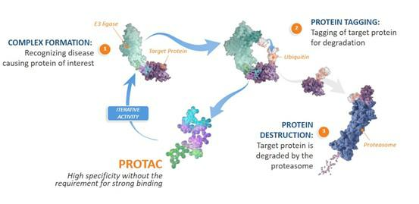

Figure 1

PROTACs have the potential to bring together certain useful features of SMIs, antibodies and gene-based medicines, while also having an iterative mechanism of action, which is referred to as “event-based pharmacology,” allowing one PROTAC to potentially lead to the degradation of many molecules of the protein of interest. Based on data from our preclinical studies and clinical trials, we believe that PROTAC protein degraders may have distinct advantages over traditional SMIs, antibodies and gene-based medicines, as shown below:
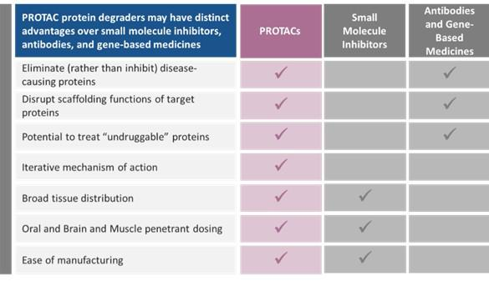

We believe PROTAC degraders offer distinct advantages that enable perturbation of protein targets traditionally considered undruggable by conventional therapeutics. Unlike inhibitors, degraders can eliminate proteins such as scaffolding proteins, transcription factors, oncoproteins, and oligomer-forming proteins using PROTACs with the potential for oral dosing and systemic distribution, in contrast to genomic and antibody modalities that only work extracellularly. Because degradation is a catalytic and durable process, PROTACs have the potential to achieve therapeutic effect with lower drug exposure and less frequent dosing than traditional approaches. PROTAC molecules are also compatible with established small-molecule manufacturing

9

processes, offering potential advantages in scalability and cost. Importantly, PROTACs can be chemically engineered to selectively degrade disease-relevant proteins, including mutant or pathogenic isoforms, while sparing wild-type or healthy proteins, and can overcome challenges posed by protein amplification or overexpression. We believe these capabilities support therapeutic strategies aimed at oncoprotein removal and immune reactivation within the tumor microenvironment in oncology, as well as the removal of key amplified scaffolding and pathologic proteins in the brain and muscle in neurodegenerative and neuromuscular diseases.

Our Discovery Platform — PROTAC Discovery Engine

Our PROTAC Discovery Engine is an interlocking suite of tools and expertise that assists with our goal of creating and advancing clinical-stage programs with the potential to help patients, as shown below:
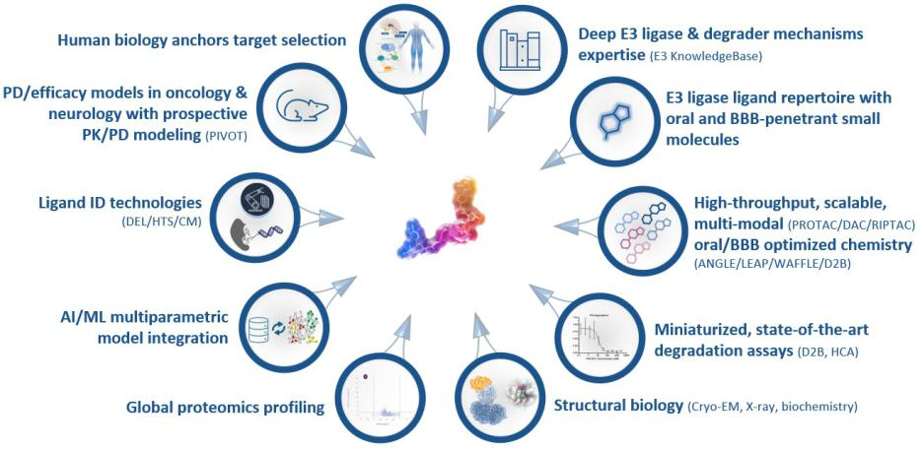

Defined terms used in the figure above include: PROTAC, proteolysis targeting chimera; ANGLE, Arvinas Next Generation Linker Enablement; LEAP (Library-Enabled ANGLE PROTACs; EM, electron microscopy; AI/ML, artificial intelligence/machine learning; HTS, high throughput screening; DEL, DNA-encoded libraries; CADD, computer-aided/assisted drug design; PK/PD, pharmacokinetics/pharmacodynamics; and cryoEM, cryogenic electron microscopy.

Additional details regarding certain tools we use in our PROTAC Discovery Engine are included below.

- Target Selection: We focus on targets that we believe are poised to make a PROTAC protein degrader that has the potential to provide benefits over SMIs, antibodies and gene-based medicines, and address unmet need for patients with cancer and neurodegenerative diseases. These targets are selected because they are genetically defined targets or are under-drugged targets that are key regulatory points within pathways that are clinically validated. We focus on differential target biology that drives disease via scaffolding functions, gene amplification and protein overexpression, isoform expression or mis-localization, protein oligomers, resistance mutation, and where targets have been underdrugged due to incomplete target coverage, inadequate biodistribution, or lack catalytic binding pockets.

- E3 KnowledgeBase: We have deep and long-standing experience in understanding and exploiting E3 ligase mechanisms in order to match the right E3 ligase to the right target. The human body has more than 600 E3 ligases, and we select ligands for E3 ligases from our growing proprietary ligand library, E3KnowledgeBase, for incorporation into our PROTAC targeted protein degraders. We are expanding our capabilities to include the development of novel PROTACs that recruit E3 ligases with targeted expression patterns, such as tumor or central nervous system, or CNS, localized E3 ligases, that may be beneficial for the development of targeted oncologic and neurologic therapies.

10

- Advanced Screening Capabilities: We have high-throughput and DNA-encoded library, or DEL, screening abilities, that power our ability to identify new domains, which are the building blocks of proteins, including domains for the “undruggable” targets, and new binders for E3 ligases. Unlike traditional libraries, our DEL is designed specifically to facilitate incorporation into PROTACs and optimize their drug-like properties.

- ANGLE: Arvinas Next Generation Linker Evolution: Our chemical linkers incorporate learnings from our long history of designing PROTACs, allowing increased potency and selectivity, as well as desirable pharmacokinetic properties to drive oral absorption and blood-brain barrier penetration, right from the start.

- LEAP: Library-Enabled ANGLE PROTACs: We have enhanced our ability to deploy ANGLE on our projects by evolving it into a library format, where we can now make hundreds of PROTACs at one time and screen them all in a direct-to-biology format. We have also created a proprietary software tool to accelerate LEAP library design.

- PROTACify: We have built PROTACify, a proprietary computational, machine-learning, or ML, solution for modeling PROTAC ternary complexes to enable selection of the best PROTAC designs for synthesis. With our deep experience in trimer structure-based computational modeling and design algorithms, we frequently create potent degraders in the first chemical series.

- Proteomics Capabilities: PROTACs are often far more selective than the protein-binding domain within the targeted protein. Our proteomics capabilities enable us to understand that specificity in precise detail and iterate quickly to optimize the selectivity of our degraders for the drug target.

- Arvinas Rules: PROTACs are not intrinsically "drug-like" and frequently do not following classical guidance for probable oral absorption, such as the "Rule of 5". We have established and refined our own "beyond the Rule of 5" Arvinas Rules to discover PROTACs that have the potential for oral bioavailability and crossing the blood-brain barrier. We have consolidated our large, proprietary preclinical pharmacokinetic, or PK, data set into ML models in order to enhance our potential for success in finding PROTACs with the desired pharmacokinetic properties from the outset of the process.

- PIVOT (PROTAC In Vivo Optimization Tool): In contrast to traditional small molecule agents, which follow an occupancy-driven mechanism of action, PROTACs are event-driven, and as such can display profound nonlinear PK, pharmacodynamic responses. We have developed PIVOT as a desktop tool to enable our scientists to develop a deep, intuitive understanding of relationships among PK, pharmacodynamic and efficacy. We believe our understanding of molecular features that impact PROTAC biodistribution and target degradation kinetics in the body enables us to create PROTACs with drug-like properties and activities.

11

Our Pipeline

Our pipeline, which includes an overview of our most advanced clinical and preclinical programs, is summarized below.
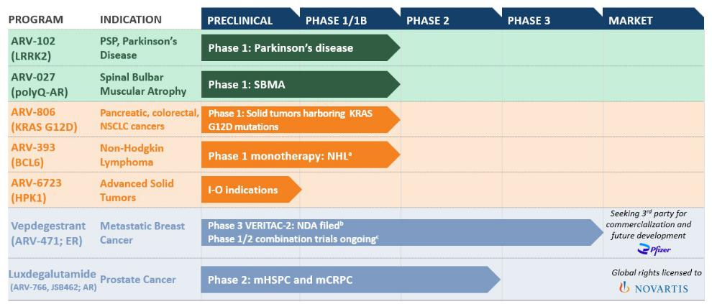

- The agents included in the graphic above are currently under investigation; their safety and effectiveness for these investigational uses have not been established.

- Defined terms included in the graphic above: AR, androgen receptor; BCL6, B-cell lymphoma 6; ER, estrogen receptor; HPK1, Hematopoietic Progenitor Kinase 1; I-O, immuno-oncology; KRAS, Kirsten rat sarcoma viral oncogene homolog; LRRK2, leucine-rich repeat kinase 2; mCRPC, metastatic castration resistant prostate cancer; mHSPC, metastatic hormone sensitive prostate cancer; NSCLC, non small cell lung cancer; NDA, new drug application; NHL, non-Hodgkin lymphoma; polyQ, expanded polyglutamine; PSP, progressive supranuclear palsy; SBMA, spinal bulbar muscular atrophy.

- Footnotes included in the graphic above: (a) Includes relapsed/refractory angioimmunoblastic T-cell lymphoma, or AITL, and relapsed/refractory mature B cell NHL; (b) PDUFA date of June 5, 2026; and (c) Phase 1/2 combination clinical trials with palbociclib, atirmociclib, abemaciclib, ribociclib, samuraciclib, everolimus.

Our Clinical Stage Programs

ARV-102: Oral PROTAC LRRK2 Degrader Program

ARV-102 is an investigational, orally bioavailable PROTAC designed to cross the blood-brain barrier and specifically target and degrade LRRK2, which is a large, multi-domain scaffolding kinase with GTPase activity. ARV-102 is our first oral PROTAC protein degrader in clinical development to treat neurodegenerative diseases.

Traditional SMIs only block LRRK2’s kinase activity, and thus only modify disease processes regulated by the LRRK2 kinase. By degrading the entire protein, LRRK2 degraders are designed to eliminate all of the ways LRRK2 interacts with disease pathology: the scaffolding function, GTPase activity, as well as kinase activity. We believe our LRRK2 degraders are particularly well positioned to be evaluated in neurodegenerative diseases where there are currently no disease modifying therapies available, including:

- PD, where increased LRRK2 expression and activity contributes to neurodegeneration and pathogenesis of PD; and

- PSP, where genetic variations in LRRK2 are associated with PSP progression and accelerated time to death. PSP is a primary tau-driven disease, and tau uptake by human neurons requires LRRK2 activity. Additionally, we have published data associating the tau pathology of PSP with LRRK2-mediated endolysosomal dysfunction.

12

Patient Population and Market Opportunity

PD is the second most common neurodegenerative disease after Alzheimer's disease. It is estimated that PD affects approximately 1.1 million people in the U.S. and more than 10 million people worldwide. Approximately 90,000 people in the U.S. are estimated to be diagnosed with PD each year. PD is a neurodegenerative disease characterized by a complex array of motor and non-motor symptoms. It is commonly thought of as a movement disorder because patients can experience tremors, slowness of movement, stiffness and difficulty with walking and balance. In addition, PD patients can have other non-motor type problems such as constipation, depression, sleep disorders and cognitive decline. PD is a progressive brain disorder that damages dopamine-producing neurons and is likely caused by a combination of genetic and environmental risk factors. Current management for PD is limited to symptomatic interventions and there is no approved disease modifying agents.

Mutations in the LRRK2 gene are one of the most common genetic risk factors for PD. LRRK2 is a multidomain GTPase/kinase that acts, in part, as a scaffolding protein to interact with components of downstream signaling pathways regulating lysosomal function, mitochondrial processes, neuroinflammation and alpha-synuclein accumulation to negatively impact neuronal survival. Human genetics in the form of a protective PD variant (N551K/R1398H), produces approximately half the levels of LRRK2 in the CSF and reduces the risk of developing PD. Preclinical animal model data suggest that a reduction of 50% of LRRK2 protein, but not kinase inhibition, may impact pathology and dysfunction in PD. Therefore, reduction of LRRK2 in the brain may be beneficial for the treatment of PD.

PSP is a rare, progressive neurodegenerative disease that affects brain cells that control balance and coordination, eye movement, speech, swallowing and thinking. Emerging research suggests that LRRK2 plays a role in PSP by contributing to disease mechanisms such as neuroinflammation and cellular dysfunction. LRRK2 is involved in immune system regulation and may influence tau protein accumulation, a hallmark of PSP. It also plays a role in autophagy and inflammation, which could contribute to neurodegeneration seen in PSP. Additionally, variants in the LRRK2 gene have been associated with PSP progression and survival. PSP has an estimated annual prevalence of approximately five to seven per 100,000 persons globally. It is estimated that approximately 20,000 to 25,000 people are in the U.S. living with PSP each year, based on data from 2023. There are currently no FDA-approved disease-modifying therapies that halt or delay PSP progression and which often leads to patients progressing with a time to death of five to seven years following diagnosis. Based on 2021 published data, genome wide association studies have identified LRRK2 variants that are significantly associated with reduced survival in PSP. Based on data from a third party study in 2025 comparing PSP and control participants, higher levels of baseline monocyte LRRK2 levels were associated with a greater one-year change in PSP rating scale scores. We believe these data support a role for LRRK2 variants that impact its expression levels in modulating survival in PSP.

Preclinical and Clinical Development

Preclinical Development

In preclinical studies, ARV-102 was shown to cross the blood-brain barrier and degrade LRRK2 in cerebrospinal fluid, or CSF, in non-human primates, or NHPs. Our preclinical studies also showed that ARV-102 and other similar LRRK2 PROTAC degrader molecules pharmacologically enhanced lysosomal degradative capacity and number, and reduced pathologic forms of tau in vitro and in vivo. We believe the data from our preclinical studies of ARV-102 further support the potential of PROTAC-induced LRRK2 degradation as a treatment for patients with neurodegenerative diseases.

Clinical Development

We have been evaluating ARV-102 in Phase 1 clinical trials in healthy volunteers and patients with PD.

- Healthy Volunteers: We initiated the first-in-human Phase 1 clinical trial for ARV-102 in the first quarter of 2024. We completed the single ascending dose, or SAD, and multiple ascending dose, or MAD, cohorts of the ARV-102 Phase 1 clinical trial in healthy volunteers.

- Patients with PD: We completed enrollment in the SAD cohort of the ARV-102 Phase 1 clinical trial in patients with PD in the second quarter of 2025. We received Clinical Trial Application approval in the Netherlands to initiate a multiple dose cohort of the Phase 1 clinical trial in patients with PD in

13

the second quarter of 2025, and we initiated this multiple dose cohort in the third quarter of 2025. In the fourth quarter of 2025, we completed enrollment in the multiple dose cohort.

In the second quarter of 2025, we presented data from the first-in-human Phase 1 healthy volunteer clinical trial of ARV-102 at the 2025 International Conference on Alzheimer’s and Parkinson’s Diseases, or AD/PD, 2025, including results from the randomized, double-blind, placebo-controlled SAD cohort, and initial results from the MAD cohort. The ARV-102 Phase 1 clinical trial was designed to assess the safety, PK, and pharmacodynamics of orally administered ARV-102 in healthy male volunteers. This clinical trial was a single-center, randomized, double-blind, placebo-controlled trial evaluating outcomes in both SAD and MAD cohorts. In the SAD cohort, volunteers were randomized three to one, to either placebo or a single dose of ARV-102 (10 mg, 30 mg, 60 mg, 90 mg, 150 mg, or 200 mg) on day 1 with follow-up until day 10. In the MAD cohort, volunteers were randomized to either placebo or a once daily dose of ARV-102 (10 mg, 20 mg, 40 mg, or 80 mg) for 14 days with follow-up until day 28.

The ARV-102 Phase 1 clinical data in healthy volunteers demonstrated substantial reduction of LRRK2 in CSF with a promising safety/tolerability profile and favorable pharmacodynamic outcomes. Key findings from the clinical trial indicated brain penetration, substantial central and peripheral LRRK2 protein degradation, and downstream LRRK2 pathway engagement. The specific data presented at AD/PD 2025 are outlined below.

Safety Profile

- At the time of data cutoff (March 13, 2025), the SAD cohort of the Phase 1 clinical trial was completed and the MAD cohort was ongoing. Based on evaluation of the available data from single and multiple oral doses, ARV-102 was well tolerated in healthy volunteers.

- Of the 47 volunteers across all SAD dose levels, the primary treatment related adverse events, or AEs, were headache and fatigue. Headaches occurred in 17.1% (6/35) of treated individuals compared to 0% (0/12) in placebo controls. Fatigue occurred in 8.6% (3/35) of the treated individuals compared to 25% (3/12) in placebo controls.

- Procedural pain associated with the lumbar puncture occurred in 28.6% (10/35) of treated individuals compared to 41.7% (5/12) in placebo controls. Post lumbar puncture syndrome was only observed in the treated cohort, at a rate of 17.1% (6/35).

- No serious adverse events, or SAEs, were reported in either the SAD or MAD cohorts.

ARV-102 Exposure in Plasma and CSF

- ARV-102 exhibited median maximum concentration six hours after oral administration.

- The area under the concentration-time curve in the first 24 hours post dosing and the maximum plasma concentration increased in a dose-dependent manner and the median terminal plasma half-life was 73 hours.

- ARV-102 levels in CSF increased in a dose dependent manner in both the SAD and MAD cohorts.

Pharmacodynamic Evaluation

- At single doses of greater than or equal to 60 mg and repeated doses of greater than or equal to 20 mg, LRRK2 reduction of greater than 90% in peripheral blood mononuclear cells was observed.

- ARV-102 at single doses of greater than or equal to 30 mg induced greater than 50% decreases in peripheral phospho-Rab10T73, a LRRK2 substrate and biomarker for downstream LRRK2 activity; as of the date of presentation, data for this endpoint in the MAD cohort was pending.

- ARV-102 at single doses of greater than or equal to 30 mg resulted in greater than 90% decrease of bis(monoacylglycerol)phosphate in urine, a biomarker of lysosomal function; data for this endpoint in the MAD cohort is pending.

- In CSF, ARV-102 induced dose-dependent LRRK2 reduction, with greater than 50% LRRK2 reduction at single doses of greater than or equal to 60 mg and repeated doses of greater than or equal to 20 mg.

In the fourth quarter of 2025, we presented late breaking positive Phase 1 data from our clinical trial of ARV-102 in healthy volunteers, and from the SAD cohort of our Phase 1 clinical trial of ARV-102 in patients with

14

PD, as well as CSF Proteomic Data from the Phase 1 clinical trial of ARV-102 in healthy volunteers at the 2025 International Congress of Parkinson’s Disease and Movement Disorders, or MDS. Data presented at MDS included the following:

Data from the Phase 1 SAD and MAD Clinical Trial in Healthy Volunteers

- Safety: ARV-102 was generally well tolerated at single doses up to 200 mg and multiple daily doses up to 80 mg, with no discontinuations due to AEs or SAEs observed in the study population.

- Pharmacokinetics: ARV-102 exposure increased in a dose-dependent manner in plasma and CSF, the latter indicating brain penetration.

- Pharmacodynamics: Repeated daily doses of greater than or equal to 20 mg resulted in greater than 90% reductions of LRRK2 protein in peripheral blood mononuclear cells, or PBMCs, and greater than 50% reductions in CSF.

- Pathway Biomarkers: Repeated daily doses of ARV-102 resulted in reduced plasma concentrations of phospho-Rab10T73 and urine concentrations of bis(monoacylglycerol)phosphate, a sensitive biomarker for modulation of the lysosomal pathway downstream of LRRK2.

Interim SAD Data from the Phase 1 Clinical Trial in Patients with PD and CSF Proteomic Data from a Phase 1 Trial in Healthy Volunteers

- Safety: The SAD cohort of the Phase 1 clinical trial in patients with PD included 15 patients treated with ARV-102 and 4 patients treated with placebo. In the trial, single doses of ARV-102 (50 mg or 200 mg) were well tolerated with only mild treatment-related AEs including headache, diarrhea, and nausea; no SAEs occurred.

- Pharmacokinetics: In patients with PD, ARV-102 exposure increased in a dose-dependent manner in both plasma and CSF, the latter indicating brain penetration.

- Pharmacodynamics: In patients with PD, treatment with ARV-102 resulted in median PBMC LRRK2 protein reductions of 86% with the 50 mg dose and 97% with the 200 mg dose.

- CSF Proteomics: In healthy volunteers treated with ARV-102 at 80 mg once daily for 14 days, unbiased proteomic analyses of CSF showed significant decreases in lysosomal pathway markers and neuroinflammatory microglial markers previously shown to be elevated in patients with PD harboring LRRK2 variants.

We believe these data presented at MDS highlight the potential of PROTAC-mediated LRRK2 degradation, which supports the development of ARV-102 in ongoing studies of patients with PD and we plan to present data from the multiple dose cohort of the Phase 1 clinical trial of ARV-102 in patients with PD in the first quarter of 2026 in an oral presentation at 2026 AD/PD.

We also believe these data support development in PSP, and pending regulatory feedback, we plan to initiate a Phase 1b clinical trial of ARV-102 in patients with PSP in the first half of 2026 and have the potential to initiate a registrational trial of ARV-102 in PSP in late 2026, pending regulatory feedback.

ARV-806: Novel PROTAC KRAS G12D Degrader Program

ARV-806 is an investigational novel PROTAC designed to selectively target and degrade mutant KRAS G12D in solid tumors. KRAS is one of the most frequently mutated human oncogenes and G12D is the most common mutation of the KRAS protein. In normal cells, the KRAS protein regulates cell growth and functions as

a molecular switch, cycling between a baseline “OFF” state and only turning “ON” when conditions are appropriate for growth. Mutations, including G12D, lock KRAS in the “ON” form, leading to uncontrolled cell growth and cancer. ARV-806 is designed to degrade both the ON and OFF forms of KRAS G12D and by removing this oncogenic protein, has the potential to shut down the constitutive growth signal and lead to death of the cancer cells. We believe ARV-806 has the potential to address high unmet need in solid tumors, such as pancreatic, colorectal and non-small cell lung cancer, or NSCLC, with KRAS G12D mutation.

15

Patient Population and Market Opportunity

Patients with metastatic cancers harboring KRAS G12D mutations have poor survival outcomes with no approved KRAS G12D-targeted therapy. Key tumors harboring KRAS G12D mutations include pancreatic ductal adenocarcinoma, or PDAC, colorectal carcinoma, and NSCLC with respective prevalence of KRAS G12D mutations of 35-40% for PDAC, 12-15% for colorectal carcinoma and 3-4% for NSCLC, based on published data from 2021 and 2022.

There are approximately 60,000 newly diagnosed PDAC patients per year in the U.S., based on 2026 estimates, with only an approximate 3% five-year survival rate in metastatic setting, based on data from the Surveillance, Epidemiology, and End Results, or SEER, Program, part of the National Cancer Institute. There are approximately 158,000 newly diagnosed colorectal cancer patients each year in the U.S., based on 2026 estimates, with only an approximate 16% five-year survival rate in metastatic setting, based on data from SEER. There are approximately 195,000 newly diagnosed NSCLC patients per year in the U.S., based on 2026 estimates, with only an approximate 10% five year survival rate in metastatic setting, based on data from SEER, as reported for combined NSCLC and small-cell lung cancer.

Due to the high unmet need of these patient populations, we believe ARV-806 has the potential to be developed as a monotherapy and in combination with chemotherapy in PDAC and in combination with SOC treatments in colorectal and non-small cell lung cancer.

Preclinical and Clinical Development

Preclinical Development

In the preclinical setting, ARV-806 demonstrated high potency and selectivity, with robust antitumor activity through dose-responsive degradation of KRAS G12D in KRAS G12D mutated cancer models, including pancreatic and colorectal models. ARV-806 formed a ternary complex with both the active "ON" and inactive "OFF" forms of KRAS G12D, achieving potent and durable elimination rather than inhibition of the target. As a result, in preclinical studies, ARV-806 achieved in vitro potency more than 25 times greater than clinical stage KRAS G12D "ON" and "OFF" inhibitors and more than 40 times greater than the leading KRAS G12D clinical-stage degrader.

In the fourth quarter of 2025, we presented preclinical data for ARV-806 at the AACR-NCI-EORTC International Conference on Molecular Targets and Cancer Therapeutics, or the 2025 Triple Meeting. Key highlights from the presentation at the 2025 Triple Meeting include the following:

- In vitro, ARV-806 degraded KRAS G12D with picomolar potency across pancreatic, colorectal, and lung cancer cell lines, but did not induce degradation of wild-type KRAS or other RAS isoforms.

- The preclinical data demonstrated that ARV-806 is differentiated from other KRAS G12D targeting agents in development and we believe ARV-806 has potential to be a best-in-class therapy for KRAS G12D mutated cancers due to:

  - Catalytic activity, which may allow it to overcome upregulation of KRAS G12D, a common mechanism of resistance to inhibitor treatment.

  - Compared with clinical-stage KRAS G12D ON and OFF inhibitors and another clinical-stage KRAS G12D degrader, ARV-806 demonstrated:

    - more than 25-fold greater potency in reducing cancer cell proliferation (versus clinical-stage KRAS G12D “ON” and “OFF” inhibitors);

    - more than 40-fold greater potency in degrading KRAS G12D protein (versus the comparable clinical-stage KRAS G12D degrader); and

    - more than 10-fold lower concentrations required to induce pro-apoptotic BIM (Bcl-2-interacting mediator of cell death, a pro-apoptotic factor) expression.

16

- Following a single intravenous dose in a colorectal tumor xenograft model, ARV-806 degraded greater than 90% of KRAS G12D for seven days, with parallel suppression of c-MYC (a key driver of cancer cell proliferation) and induction of BIM for greater than or equal to five days.

- ARV-806 demonstrated robust efficacy responses at low doses in tumor models including: ≥30% tumor volume reductions in pancreatic and colorectal cell line-derived xenograft (CDX) models and a patient-derived xenograft (PDX) model of lung cancer.

These preclinical data demonstrate sustained pharmacodynamic activity consistent with long-lasting target degradation, which we believe supports intermittent clinical

dosing.

Clinical Development

We filed an investigational new drug application, or IND, with the FDA for ARV-806 in the first quarter of 2025 and received a safe-to-proceed letter from the FDA in the second quarter of 2025. We initiated enrollment in a Phase 1 clinical trial of ARV-806 in patients with advanced solid tumors harboring KRAS G12D mutations in the second quarter of 2025 and this trial is currently ongoing.

In the first quarter of 2026, we announced that we had completed dose escalation for once-weekly administration ahead of plan based on faster-than-anticipated enrollment of the Phase 1 clinical trial evaluating ARV-806 in patients with solid tumors harboring KRAS G12D mutations. We plan to continue enrollment in this clinical trial and anticipate sharing initial clinical data in patients with solid tumors harboring KRAS G12D mutations in 2026.

ARV-393: Oral PROTAC BCL6 Degrader Program

ARV-393 is an investigational, orally bioavailable PROTAC designed to specifically target and degrade BCL6, a transcriptional repressor and a key regulator of normal B-cell maturation and differentiation processes. Deregulation of BCL6 function (e.g., via chromosomal translocation, mutations) may lead to malignant transformation and development of NHL. Also as a lineage defining transcription factor of T-follicular helper cells, BCL6 has been implicated in nodal T-follicular helper cell lymphoma, or nTFHL, including the angioimmunoblastic type, formerly angioimmunoblastic T-cell lymphoma, or AITL.

During B-cell development, tightly controlled BCL6 protein expression regulates more than 600 genes to facilitate rapid B-cell proliferation and tolerance of somatic hypermutation and gene recombination for antibody generation. Deregulated BCL6 expression is common in B-cell lymphoma and promotes cancer cell survival, proliferation, and genomic instability. We believe that PROTAC-mediated degradation has the potential to address the historically undruggable nature of BCL6 and that ARV-393 PROTAC-mediated degradation of BCL6 may provide an important novel therapeutic option for patients with NHL. Furthermore, we believe current preclinical data suggest that ARV-393 has the potential to be an attractive combination partner for development of novel therapies for lymphoma, including chemo-free combination regimens and/or “all oral” treatment options.

Patient Population and Market Opportunity

It is estimated that there were approximately 80,000 new cases and approximately 19,300 deaths in the U.S. related to NHL annually in 2025 based on data from SEER. NHL is a heterogeneous group of diseases, with large B-cell lymphoma, or LBCL, and follicular lymphoma, or FL, being the most common subtypes. Diffuse large B-cell lymphoma, or DLBCL, is another subtype of NHL, often associated with deregulated BCL6 expression and/or functions. It is estimated that approximately 30,000 to 33,000 patients are diagnosed with DLBCL each year in the U.S., based on data from 2025 and 2026. Treatment for DLBCL is largely devoid of oral options and there are currently no approved BCL6-targeted therapies on the market in the U.S.

Each subtype has a distinct biologic and clinical characteristics and requires different approaches to treatment. Despite significant progress made with treating B-cell NHL and nTFHL, many patients will ultimately experience disease progression or relapse. Thus, there remains unmet need, including managing aggressive subtypes, treatment resistance, and improving outcomes for older patients.

We believe our PROTAC BCL6 degrader could be a potential therapy for many NHLs, including FL and nTFHL (formerly AITL). NHL originates from B cells, T cells, and/or natural killer cells, with those of B-cell origin

17

constituting approximately 80%–85% of all NHL cases. BCL6 may also be a clinically relevant therapeutic target in other hematologic malignancies, some solid tumors and B-cell driven autoimmune diseases.

Preclinical and Clinical Development

Preclinical Development

Based on our NHL preclinical studies, complete tumor stasis, which correlates with 90%-100% degradation of measurable BCL6, was achieved when ARV-393 was dosed as an oral monotherapy at low daily concentrations. This robust activity was seen in models of multiple NHL subtypes including multiple DLBCLs representing various genomic backgrounds of activated B-cell and germinal center B-cell lymphomas, Burkitt's lymphoma, and transformed FLs. In addition, ARV-393 significantly reduced tumor burden in a CHOP-relapsed patient derived xenograft, or PDX, model of AITL (now known as nTFHL), a cancer that has no standard of care, or SOC, and high unmet need. This is the first demonstration, to our knowledge, of preclinical evidence of BCL6 as a tractable therapeutic target in a human-derived model of this type. In our preclinical studies, we have also demonstrated that ARV-393 combines well with SOC therapies including CHOP, R-CHOP or rituximab, and with the newer biologics glofitamab, tafasitamab, and the antibody drug conjugates loncastuximab tesirine and polatuzumab vedotin. This potential for broad combinability extends further to investigational SMIs that target BCL2 (anti-apoptosis), EZH2 (chromatin regulation) and BTK (B-cell receptor signaling pathway). Combinations such as these that target multiple oncogenic drivers, have the potential to provide benefits for patients with lymphomas that progress aggressively with the acquisition of multiple genetic or epigenetic aberrations.

In the second quarter of 2024, we presented preclinical data for ARV-393 at the European Hematology Association 2024 Annual Congress, which showed anti-tumor activity in preclinical models of B-cell lymphoma. In these preclinical models, ARV-393 potently and rapidly degraded the BCL6 protein and inhibited cell growth in DLBCL and Burkitt cell lines. ARV-393 showed tumor growth inhibition, or TGI, including tumor regression, in various DLBCL cell line-derived xenograft models and in multiple patient-derived xenograft models of NHL including germinal center B-cell-like, or GCB, activated B-cell, or ABC, GCB/ABC, and BCL not otherwise specified subtypes of DLBCL, and Burkitt lymphoma.

In the second quarter of 2025, we presented preclinical data of ARV-393 in combination with SOC chemotherapy and biologic agents, as well as oral, investigational SMIs in high grade and aggressive DLBCL in vivo models at the American Association for Cancer Research, or AACR, Annual Meeting. Based on these preclinical data, in aggressive DLBCL models, ARV-393 showed strong synergistic antitumor activity, including complete regressions, in combination with SOC chemotherapy and biologics, as well as investigational oral SMIs. In particular:

- ARV-393 in combination with SOC chemotherapy (rituximab, cyclophosphamide, doxorubicin, vincristine, and prednisone, or R-CHOP), induced significantly greater TGI, compared with rituximab, CHOP, R-CHOP, or ARV-393 alone, with complete tumor regressions in all mice treated with the ARV-393 and R-CHOP combination;

- ARV-393 in combination with SOC biologics targeting CD20 (rituximab), CD19 (tafasitamab), or CD79b (polatuzumab vedotin), resulted in tumor regressions and demonstrated significantly stronger TGI compared with either agent alone;

- In preclinical models, ARV-393 increased CD20 expression, providing additional support for the exploration of combinations with CD20-targeted agents and in the context of low or loss of CD20 expression; and

- ARV-393 in combination with investigational SMIs targeting clinically validated oncogenic drivers of lymphoma, such as BTK (acalabrutinib), BCL2 (venetoclax), or EZH2 (tazemetostat), resulted in superior TGI compared with each agent alone, with tumor regressions in all mice treated with the combinations.

In addition, in the second quarter of 2025, we presented new data from preclinical studies of ARV-393 at the European Hematology Association 2025 Congress in Milan, Italy. In these preclinical studies, ARV-393 demonstrated significant single-agent activity in a PDX, model of nodal T-follicular helper cell lymphoma, angioimmunoblastic-type, or nTFHL-AI (which is also known and referred to as AITL), and PDX models of transformed follicular lymphoma, or tFL. In addition, in these preclinical studies, in combination with oral SMIs,

18

ARV-393 demonstrated enhanced antitumor activity, including tumor regressions, in cell line-derived xenograft, or CDX, models of high-grade B-cell lymphoma, or HGBCL, and DLBCL. We believe these preclinical data potentially suggest the broad utility of ARV-393 across NHL subtypes with unmet need beyond DLBCL and provide a compelling rationale for considering combination strategies including chemotherapy-free approaches. Key findings from these preclinical studies included:

- Single-agent ARV-393 significantly reduced tumor burden in peripheral blood, bone marrow and spleen in a systemic PDX model of nTFHL-AI derived from a patient who relapsed post chemotherapy.

- ARV-393 monotherapy treatment resulted in robust (≥95%) TGI in two PDX models of tFL.

- ARV-393 in combination with five classes of SMIs targeting potentially cooperative oncogenic drivers (tazemetostat, palbociclib, everolimus, acalabrutinib, or venetoclax) demonstrated increased TGI in CDX models of HGBCL and aggressive DLBCL compared with the respective monotherapy treatments. Tumor regressions were observed when ARV-393 was combined with tazemetostat, palbociclib, acalabrutinib, or venetoclax.

- RNA sequencing studies carried out to further characterize downstream mechanism of action suggested that ARV-393 inhibits tumor cell cycle progression and promotes differentiation, driving antitumor activity and broad combinability in preclinical models.

In the fourth quarter of 2025, we presented preclinical data for ARV-393 in combination with glofitamab, a CD20xCD3 bispecific antibody and an emerging SOC option for DLBCL, in models of aggressive high grade DLBCL at the 67th American Society of Hematology 2025 Annual Meeting and Exposition.

These preclinical data showed that in a humanized high-grade B-cell lymphoma, or HGBCL, CDX model, the combination of ARV-393 and glofitamab resulted in significantly enhanced TGI and increased rates of tumor regression compared with either agent alone. These preclinical data suggest mechanistic synergies between BCL6 degradation with ARV-393 and T-cell engagement.

Specifically, key highlights from the poster presentation included the following:

- In a humanized HGBCL CDX model, ARV-393 (3 mg/kg) combined with glofitamab (0.15 mg/kg) achieved 81% TGI with concomitant dosing and 91% TGI with sequential dosing (ARV-393 followed by glofitamab), versus 38% for single-agent ARV-393 and 36% for glofitamab alone.

- At a higher ARV-393 dose (6 mg/kg) combined with glofitamab (0.15 mg/kg), an increase in tumor regressions was observed with concomitant (10 of 10 mice) and sequential dosing (7 of 8 mice) versus single-agent ARV-393 (5 of 11 mice) or glofitamab (0 of 11 mice).

- RNA sequencing and biomarker analyses revealed that ARV-393 upregulated CD20 expression and genes that promote interferon signaling and antigen presentation, while downregulating proliferation-associated gene sets. We believe these collective effects likely contributed to the observed synergistic antitumor activity.

We believe the totality of our ARV-393 preclinical data provides a compelling rationale to evaluate ARV-393 in combination with bi-specifics, oral pathway inhibitors, and potentially other SOCs, in the larger DLBCL indication.

Clinical Development

We initiated the monotherapy cohort of our first-in-human Phase 1 clinical trial of ARV-393 in patients with relapsed or refractory NHL in the second quarter of 2024 and are currently recruiting patients for this clinical trial. This is an open-label, multicenter, Phase 1 dose escalation trial to evaluate the safety, tolerability PK, pharmacodynamics, and preliminary anti-tumor activity of ARV-393 as a single agent in adult patients with relapsed/refractory NHL. We announced previously that there have been multiple responses in early cohorts in both B- and T-cell lymphomas in the first-in-human Phase 1 clinical trial. Dose escalation in the trial is ongoing and the safety profile of ARV-393 supports continuing dose escalation. We also believe these early data support an emerging, and differentiated, therapeutic benefit of ARV-393. We plan to share updated clinical data from the

19

ongoing Phase 1 clinical trial of ARV-393 in patients with relapsed/refractory NHL at a medical congress in the second half of 2026.

We also plan to initiate enrollment of a glofitamab combination cohort in patients with DLBCL in the ongoing Phase 1 clinical trial of ARV-393 in the first half of 2026. ARV-027: Oral PROTAC polyQ-AR Degrader Program

ARV-027 is an investigational, oral, peripherally restricted PROTAC designed to selectively target and eliminate the polyQ-AR in skeletal muscle. ARV-027 is a product candidate specifically selected for potent in vitro reduction of cytosolic and nuclear polyQ-AR and for favorable skeletal muscle exposure following oral administration.

The polyQ-AR protein is the pathogenic driver of spinal bulbar muscular atrophy, or SBMA, a rare, X-linked, genetically defined neuromuscular disease caused by a CAG trinucleotide repeat expansion in the androgen receptor, or AR, gene, causing protein misfolding and leading to progressive degeneration of the neuromuscular system in men. SBMA leads to progressive muscle weakness, dysphagia, and functional decline, and currently has no disease-modifying therapies approved by the FDA or EMA, representing a significant unmet medical need.

Patient Population and Market Opportunity

Due to limited disease awareness, historical underdiagnoses, and the absence of approved therapies, few large-scale epidemiologic studies have been conducted in SBMA. Published data estimates suggest that SBMA has an estimated population prevalence of approximately one to two per 100,000 individuals worldwide. Based on those estimated prevalence rates, roughly 3,500 to 7,500 individuals are currently living with SBMA in the U.S.

Preclinical and Clinical Development

In the fourth quarter of 2025 at the International Congress of the World Muscle Society, we presented new preclinical data demonstrating induced robust degradation of polyQ-AR in human myotubes derived from SBMA patient-induced pluripotent stem cells. The preclinical ARV-027 data presented also showed dose-dependent degradation of AR in mouse skeletal muscle that was sustained for more than 24 hours (single oral dose), and reductions in muscle monomeric polyQ-AR levels between 40-60%, improved muscle grip strength, and restored muscle endurance to wild-type levels in SBMA mouse model.

We initiated a first-in-human Phase 1 clinical trial in ARV-027 in healthy volunteers in the first quarter of 2026.

Vepdegestrant: Oral PROTAC ER Degrader Program

Vepdegestrant is an investigational, orally bioavailable PROTAC ER degrader being developed for the treatment of ER+/HER2- locally advanced or metastatic breast cancer. We chose ER degradation as a therapeutic focus given the well-documented biology of ER signaling as a principal driver in a high percentage of breast cancers. In July 2021, we announced a global collaboration with Pfizer for the co-development and co-commercialization of vepdegestrant.

The FDA has accepted our NDA for vepdegestrant for the treatment of patients with ER+/HER2-, ESR1-mutated advanced or metastatic breast cancer who have previously received endocrine-based therapy, and has assigned a PDUFA date of June 5, 2026.

Patient Population and Market Opportunity

Breast cancer is the most commonly diagnosed cancer diagnosed in women in the United States, excluding non-melanoma skin cancers, and the second leading cause of cancer death among women, based on 2026 estimates. Approximately one in eight women in the United States will develop invasive breast cancer in their lifetime. For 2026, the American Cancer Society estimates that there will be approximately 322,000 new cases of invasive breast cancer diagnosed in women in the United States. Approximately 70% of all breast cancer cases, including males, are ER+, based on SEER data. In addition, there are approximately 20,000

20

patients in the U.S. with ESR1 mutated, ER+/HER2- advanced or metastatic breast cancer in the second line plus setting, based on SEER data from 2023.

Treatment options for breast cancer depend on many different factors, including the stage of the cancer and whether the cancer cells contain hormone receptors. Patients with locally advanced or metastatic breast cancer are treated with systemic therapy, including hormone therapy, chemotherapy and targeted therapy, either as single-agents or in combination. Patients with locally advanced or metastatic ER+/HER2- breast cancer are often treated with hormone therapy, such as an aromatase inhibitor, typically in combination with targeted drugs such as CDK4/6 inhibitors. In patients with aggressive disease or whose disease continues to progress with a hormonal treatment regimen, chemotherapy may be prescribed. Treatment with chemotherapy is generally postponed for as long as possible due to the potential for severe side effects including neuropathies, nausea, diarrhea, decreased mental capacity and increased risk of infections.

A current standard of care for patients with ER+/HER2- locally advanced or metastatic breast cancer who experience progression on first-line therapy is fulvestrant, a selective ER degrader, or SERD, administered as a monthly intramuscular injection, either as a single-agent or in combination with another targeted therapy. While fulvestrant has validated the importance of ER degradation as a therapeutic intervention, up to 50% of ER can remain when compared to baseline levels after six months of treatment with fulvestrant, providing an opportunity for more potent ER degraders. In January 2023, the FDA approved elacestrant, a SERD, for postmenopausal women or adult men with ER+/HER2-, ESR1-mutated advanced or metastatic breast cancer with disease progression following at least one line of endocrine therapy. In September 2025, the FDA approved imlunestrant, a SERD, for adults with ER+/HER2-, ESR1 mutated advanced or metastatic breast cancer with disease progression following at least one line of endocrine therapy.

Clinical Development

We, along with Pfizer, have several ongoing clinical trials of vepdegestrant, for which enrollment of patients is complete, which are summarized below.

- VERITAC-2, a Phase 3 clinical trial of vepdegestrant as a monotherapy, for the treatment of patients with metastatic breast cancer previously treated with endocrine based therapy;

- VERITAC, a Phase 2 dose expansion clinical trial of vepdegestrant as a monotherapy, for the treatment of patients with previously treated metastatic breast cancer;

- TACTIVE-K, a Phase 1b/2 clinical trial of vepdegestrant in combination with Pfizer's cyclin-dependent kinase 4, or CDK4, inhibitor, atirmociclib; and

- TACTIVE-U, a group of Phase 1b/2 clinical trials of vepdegestrant in combination with multiple targeted therapies including abemaciclib, ribociclib or Carrick Therapeutics, Inc.'s, or Carrick, cyclin-dependent kinase 7, or CDK7, inhibitor, samuraciclib.

We, along with Pfizer, also have completed two clinical trials of vepdegestrant:

- TACTIVE-N, a Phase 2 clinical trial of vepdegestrant as a monotherapy in the neoadjuvant setting; and

- TACTIVE-E, a Phase 1 clinical trial of vepdegestrant in combination with everolimus.

Additionally, VERITAC-3 a clinical trial with a study lead-in of vepdegestrant in combination with palbociclib for the treatment of patients with first-line metastatic breast cancer, is ongoing and enrollment of patients is complete. As previously disclosed, VERITAC-3 will not proceed beyond the study lead-in.

VERITAC-2 Clinical Trial, New Drug Application

In the first quarter of 2025, we, along with Pfizer, announced positive topline results from the Phase 3 VERITAC-2 clinical trial in the estrogen receptor 1-mutant, or ESR1m, population, and in the second quarter of 2025, we, along with Pfizer announced detailed results from this clinical trial. These detailed results, which are included below, were presented in a late-breaking oral presentation at the American Society of Clinical Oncology, or ASCO, 2025 Annual Meeting and were highlighted in the ASCO press briefing and selected for Best of ASCO, and were also simultaneously published in the New England Journal of Medicine.

21

Based on the results from VERITAC-2, in the second quarter of 2025, we and Pfizer submitted an NDA to the FDA for vepdegestrant for the treatment of patients with ER+/HER2-ESR1-mutated advanced or metastatic breast cancer previously treated with endocrine-based therapy. This represents the first NDA submitted for a PROTAC. In the third quarter of 2025, we announced that the FDA accepted the NDA for vepdegestrant and assigned a PDUFA date of June 5, 2026.

Clinical Trial Design

The Phase 3 VERITAC-2 clinical trial is a global randomized study evaluating the efficacy and safety of vepdegestrant as a monotherapy compared to fulvestrant in patients with ER+/HER2- advanced or metastatic breast cancer. The trial enrolled 624 patients at sites in 26 countries who had previously received treatment with a CDK4/6 inhibitor plus endocrine therapy. Patients were randomized to receive either vepdegestrant once daily, orally on a 28-day continuous dosing schedule, or fulvestrant, administered intramuscularly on Days 1 and 15 of Cycle 1 and then on Day 1 of each 28-day cycle starting from Day 1 of Cycle 2. The primary endpoint was progression-free survival, or PFS, in the intent-to-treat, or ITT, and ESR1-m populations as determined by blinded independent central review, or BICR. Overall survival, or OS, was the key secondary endpoint.

Clinical Trial Results

The Phase 3 VERITAC-2 trial met its primary endpoint in the ESR1m population, demonstrating a statistically significant and clinically meaningful improvement in PFS compared to fulvestrant. The results exceeded the pre-specified target hazard ratio of 0.60 in the ESR1m population. The trial did not reach statistical significance in improvement in PFS in the ITT population.

OS was not mature at the time of the analysis of data, with less than a quarter of the required number of events having occurred. The trial has continued to assess OS as a key secondary endpoint. In the trial, vepdegestrant was generally well tolerated and its safety profile was consistent with what has been observed in previous studies.

Detailed results from the Phase 3 VERITAC-2 clinical trial included the following:

- PFS

  - Vepdegestrant demonstrated a statistically significant and clinically meaningful improvement in PFS among ESR1m patients, reducing the risk of disease progression or death by 43% compared to fulvestrant [Hazard Ratio, or HR=0.57 (95% CI 0.42–0.77); 2-sided P<0.001]. The median PFS, as assessed by BICR, was 5.0 months with vepdegestrant versus 2.1 months with fulvestrant in the ESR1-m population.

  - Investigator-assessed PFS was consistent with the BICR-assessed PFS.

  - In ESR1m patients, vepdegestrant demonstrated a consistent PFS benefit over fulvestrant across all pre-specified subgroups.

  - The trial did not reach statistical significance in improvement in PFS in the ITT population, with a median PFS of 3.7 months for vepdegestrant versus 3.6 for fulvestrant [HR=0.83 (95% CI 0.68–1.02); 2-sided P=0.07].

- Tolerability and Safety Profile

  - Vepdegestrant was generally well tolerated in the clinical trial, with a safety profile consistent with what has been observed in previous studies, and mostly low-grade treatment-emergent adverse events, or TEAEs, were reported.

  - Rates and severity of gastrointestinal treatment emergent AEs were low with vepdegestrant (nausea, 13.5%; vomiting, 6.4%; diarrhea, 6.4%). Grade 4 TEAEs were reported in five patients (1.6%) in the vepdegestrant arm versus nine patients (2.9%) in the fulvestrant arm.

  - The three most common TEAEs observed with vepdegestrant were fatigue (26.6%), increased alanine transaminase (ALT) (14.4%) and increased aspartate aminotransferase (AST) (14.4%).

  - TEAEs leading to treatment discontinuation occurred in 2.9% of patients taking vepdegestrant versus 0.7% of patients taking fulvestrant.

22

- Other Data Points

  - Additional secondary endpoints include clinical benefit rate, or CBR, and objective response rate, or ORR, and duration of response by BICR. In patients with an ESR1 mutation, CBR was 42.1% with vepdegestrant versus 20.2% with fulvestrant [odds ratio 2.88 (95% CI: 1.57–5.39); nominal P<0.001] and ORR was 18.6% with vepdegestrant versus 4.0% with fulvestrant [odds ratio 5.45 (95% CI: 1.69–22.73); nominal P=0.001]. The median duration of response was not reached.

We believe that, based on these strong data from VERITAC-2, vepdegestrant has the potential to be a best-in-class monotherapy treatment for advanced/metastatic breast cancer patients in the second-line ESR1m setting.

As part of our global collaboration with Pfizer, we and Pfizer presented patient reported outcomes, or PRO, data from the VERITAC-2 clinical trial in the fourth quarter of 2025 at the European Society for Medical Oncology, or ESMO, 2025 Congress. In the VERITAC-2 clinical trial, in patients with ESR1-m disease, vepdegestrant demonstrated a reduced risk of deterioration compared to fulvestrant which was statistically significant in several PRO domains including overall health status, pain severity, and functioning (including role, cognitive, emotional, and social functioning), and vepdegestrant consistently showed reduced risk of deterioration versus fulvestrant across all PRO domains. These PRO data from the VERITAC-2 clinical trial support the clinical benefit of vepdegestrant in patients with ESR1-m, ER+/HER2- advanced or metastatic breast cancer previously treated with endocrine-based therapy.

Other Clinical Trials and Information

In the second quarter of 2025, we announced that we and Pfizer removed two planned Phase 3 combination trials of vepdegestrant from the agreed-upon joint development plan: a first-line Phase 3 combination trial with Pfizer’s novel investigational CDK4 inhibitor, atirmociclib, and a second-line Phase 3 combination trial with a CDK4/6 inhibitor.

Additionally, in the second quarter of 2025, Pfizer added a vepdegestrant combination cohort to its ongoing Phase 1 clinical trial evaluating Pfizer’s investigational KAT6 inhibitor in combination with endocrine therapies following CDK4/6 inhibitor treatment. This clinical trial is being operationalized and funded solely by Pfizer.

As part of our global collaboration with Pfizer, we and Pfizer presented results of the TACTIVE-N Phase 2 clinical trial which evaluated neoadjuvant vepdegestrant in postmenopausal women with ER+/HER2– localized breast cancer in the fourth quarter of 2025 at the ESMO 2025 Congress. The results presented showed that neoadjuvant vepdegestrant demonstrated biological and clinical activity in this treatment-naïve, predominantly ESR1 wild-type population of postmenopausal women with ER+/HER2- localized breast cancer.

In addition, as part of our global collaboration with Pfizer, we presented five posters at the San Antonio Breast Cancer Symposium further supporting the potential of vepdegestrant as a potential treatment option for patients with ESR1-mutated ER+/HER2- advanced or metastatic breast cancer previously treated with endocrine-based therapy potential.

We, along with Pfizer, continue market preparations for vepdegestrant in advance of the PDUFA date. While we continue to believe that vepdegestrant has the potential to be a best-in-class monotherapy treatment for advanced/metastatic breast cancer patients in the second-line ESR1m setting, given our and Pfizer’s decision to remove the two planned Phase 3 combination trials of vepdegestrant from the agreed-upon joint development plan as noted above, we determined that it is no longer viable for us to build out our commercial infrastructure as we had previously planned. As such, in the third quarter of 2025, we announced that we and Pfizer have agreed to jointly select a third party for the commercialization and potential future development of vepdegestrant.

Our Preclinical Programs

We have active preclinical programs in neurology and oncology. We aim to take a disciplined target selection approach and leverage our proprietary discovery platform to rationally design innovative degrader molecules across major protein classes. Our focus is on potential first- and best-in-class opportunities in high unmet need areas where targeted protein degradation may provide the most effective, or only, path to

23

meaningful impact to the target that is either genetically defined or historically an under-drugged regulatory target or target protein that contains non-enzymatic sites involved in the disease causation.

Our exploratory and research activities in neurology focus on programs aimed at degrading proteins with strong human and mouse genetic validation demonstrating that protein mutation potentially drives disease pathology. Examples include Tau in Frontal temporal dementia with expansion into Alzheimer's disease, alpha-synuclein gene amplification in accelerated forms of Parkinson's disease and Multiple System Atrophy, and mutant Huntingtin protein in Huntington's disease.

Our exploratory and research activities in oncology focus on degrading oncogenic drivers, such as pan-KRAS, as well as tackling key immune regulatory targets like HPK1, a negative regulator of the tumor microenvironment and T cell activation.

Neurologic Diseases

Neurologic diseases, in particular, neurodegenerative diseases, are generally progressive in nature and result in the degeneration and often death of neurons in the periphery and the brain, leading to cognitive decline, functional impairment and eventually death. These diseases affect a rapidly growing patient population and represent one of the largest unmet medical needs of our time. Alzheimer’s and PD encompass the largest patient populations among the neurodegenerative diseases. The Alzheimer’s Association estimated that 7.2 million Americans aged 65 and older, about one in nine individuals, were living with Alzheimer’s dementia in 2026, with 74% aged 75 or older, and the Parkinson’s Foundation estimated in 2026 that approximately 1.1 million Americans are living with PD and approximately 90,000 people are newly diagnosed every year. Alzheimer’s disease is marked by the progressive accumulation of aggregated tau protein, while aggregation of alpha-synuclein is thought to cause PD.

Antibody-based therapies targeting only extracellular forms of these proteins thought to be the cause of these neurodegenerative diseases have failed to show clinically meaningful benefit to date. While some existing products provide symptomatic relief to Alzheimer’s and PD patients, they have significant side effect risks and over time gradually lose their effectiveness in treating the symptoms of the disease. Further, while there are now amyloid-directed antibody therapies that modestly impact extracellular A-beta with vascular side effects that can be severe, there are no approved disease-modifying treatments targeting intracellular tau or alpha-synuclein for Alzheimer’s or PD.

Developing PROTAC Targeted Protein Degraders that Cross the Blood Brain Barrier

Engineering PROTAC degraders that cross the blood-brain barrier is necessary to achieve targeted elimination of disease-causing intracellular proteins from within the CNS. The ability of a targeted therapy to cross the blood-brain barrier is a highly desirable characteristic in developing effective therapeutics for patients with neurodegenerative diseases as compared with therapies delivered directly into the CNS via invasive intrathecal delivery. Any product candidates for neurodegenerative disease must reach their intended intracellular targets in the brain at exposure levels that will provide a therapeutic effect, while having an acceptable safety profile.

Importantly, we have achieved brain penetration in preclinical models following parenteral administration of PROTAC degrader molecules. These PROTAC degrader molecules achieved concentrations in the brain sufficient to induce degradation of the aggregated proteins, widespread penetration into different parts of the brain, and brain/plasma ratios of 0.5 to 5.0, comparable to approved therapeutics with CNS activity. Our research efforts are aimed at designing PROTAC degraders to either specifically target pathologic oligomers or monomers of mutant huntingtin, tau, and alpha-synuclein, for the treatment of Huntington's disease, Alzheimer’s disease (tauopathies) and PD (synucleinopathies), respectively, or to impact pathway proteins contributing to their pathology in these diseases.

In addition to our tau and alpha-synuclein programs, our neuroscience pipeline includes a program directed to mutant huntingtin, or mHTT, a key protein target for Huntington’s disease. In preclinical studies, we have identified ligands that bind to mutant mHTT protein without binding to wild-type HTT protein in preclinical studies. This selectivity differentiates these ligands from other small molecule splice modulators that reduce

24

both mHTT and wild-type HTT protein. We believe that our discovery of selective mHTT PROTAC degraders has the potential to eliminate the toxic mHTT protein.

Oncology, ARV-6723: Oral PROTAC HPK1 Degrader Program, and pan-KRAS Degrader Programs

In addition to neurological preclinical programs, we are exploring oncology and immuno-oncology preclinical programs.

ARV-6723 is an investigational, preclinical oral PROTAC designed to degrade HPK1 in solid malignancies. Preclinically, ARV-6723 has shown potent, selective HPK1 degradation and strong anti-tumor immune responses with superior tumor control in low- and high- immunogenic murine syngeneic tumor models. In solid tumor malignancies, such as NSCLC, melanoma, and renal cell carcinoma, or RCC, HPK1 acts as a negative regulator in T-cell receptor signaling, contributing to T-cell exhaustion and suppressing antitumor immunity. In addition, HPK1 has a regulatory role in other immune cell types that can be co-opted by tumors, thus enabling these cancers to resist immuno-oncology therapy. Degrading HPK1 and thus eliminating both its kinase and scaffolding functions has the potential to unleash an immune response with potent anti-tumor effects and minimum off-target toxicity.

We presented preclinical data at the Society for Immunotherapy of Cancer annual meeting in the fourth quarter of 2025 that we believe supports the potential of ARV-6723 to provide sustained anti-tumor immune response as a single agent or in combination with standards of care with improved clinical benefits, including that: ARV-6723, as a single agent, demonstrates anti-tumor efficacy superior to anti-PD1 or a clinical HPK1 inhibitor and combines with anti-PD1 to further enhance response; and ARV-6723 single agent activity outperforms the HPK1 inhibitor and anti-PD-1 efficacy and reinstitutes the tumor microenvironment. We believe these preclinical results support future investigation of ARV-6723 alone or in combination with other agents in patients with high- or low-immunogenic tumors.

In addition, we presented preclinical data for ARV-6723 at the AACR Immuno-Oncology Conference in the first quarter of 2026 that support clinical investigation of ARV-6723 in patients with solid tumors harboring high- or low-immunogenic tumor microenvironments, or TME, including immune checkpoint inhibitor-resistant tumor settings. This preclinical data showed robust single-agent antitumor and proinflammatory activity in multiple syngeneic tumor models, including those with immunosuppressive TMEs, and showed greater preclinical activity than an investigational HPK1 inhibitor or an anti-PD-1 antibody.

Pending regulatory feedback, we plan to initiate a Phase 1 clinical trial of ARV-6723 in patients with advanced solid tumors in mid-2026. Upon initiation of the clinical trial,

ARV-6723 will be our first clinical candidate in immuno-oncology. Additionally, we plan to present preclinical data evaluating antitumor and unique immunomodulatory activity of ARV-6723 in immuno-oncology-resistant models compared to SOC checkpoint inhibition in the first half of 2026.

Our preclinical oral pan-KRAS program targets multiple variants of KRAS that drive solid tumors such as PDAC, colorectal cancer, NSCLC, and esophageal cancer, while sparing other RAS isoforms. We believe selectively targeting KRAS for removal may have benefits to tolerability compared with a pan-RAS approach. The poster presented at the 2025 Triple Meeting in the fourth quarter of 2025 showed that orally bioavailable pan-KRAS degraders have been identified that potently degrade multiple variants of KRAS and spare other RAS isoforms. A tool pan-KRAS PROTAC demonstrated robust single-agent activity and superior combination efficacy with immune checkpoint blockade compared with a pan-RAS ON inhibitor (seven complete responses compared with two complete responses). We plan to present preclinical data evaluating the activity and selectivity of a novel pan-KRAS degrader in multiple KRAS mutants and differentiation over RAS (ON) or pan-KRAS inhibitors in the first quarter of 2026 at the AACR Special Conference in Cancer Research: RAS Oncogenesis and Therapeutics. We also plan to present preclinical data evaluating the efficacy of a novel pan-KRAS degrader in a KRAS syngeneic model, as well as associated immune microenvironment changes in the first half of 2026.

Other Programs: Luxdegalutamide (ARV-766) and bavdegalutamide (ARV-110)

We had been developing luxdegalutamide and bavdegalutamide, each an investigational, orally bioavailable, AR degrading PROTAC targeted protein degrader, for the treatment of men with metastatic castration-resistant prostate cancer, or mCRPC. Both luxdegalutamide and bavdegalutamide demonstrated

25

activity in preclinical models of AR overexpression and AR mutations, both common mechanisms of resistance to current standard-of-care agents in men with prostate cancer. We believed that the differentiated PROTAC pharmacology of luxdegalutamide and bavdegalutamide, including their iterative activity, had the potential to translate into significantly improved clinical outcomes over current SOC agents. However, a comparison of clinical data from separate studies of luxdegalutamide and bavdegalutamide showed that luxdegalutamide’s tolerability and efficacy was more promising than that of bavdegalutamide. As a result, early in the fourth quarter of 2023, we determined to prioritize the initiation of a Phase 3 clinical trial with luxdegalutamide in mCRPC instead of the previously planned Phase 3 clinical trial for bavdegalutamide. Clinical trials for bavdegalutamide (ARV-110-101 and ARV-110-103) were completed in the second quarter of 2025.

In the second quarter of 2024, we completed a transaction with Novartis Pharma AG, or Novartis, which comprised a license agreement, or the Novartis License Agreement, and an asset agreement, or the Novartis Asset Agreement. Pursuant to the Novartis License Agreement, we granted Novartis an exclusive worldwide license for the development, manufacture and commercialization of luxdegalutamide, and we completed the transition of our ongoing and planned clinical trials of luxdegalutamide to Novartis in the fourth quarter of 2024. Pursuant to the Novartis Asset Agreement, we sold Novartis all of our rights, title and interest in our PROTAC protein degrader targeting AR-V7, a splice variant of the AR.

Intellectual Property

Our commercial success depends in part upon our ability to secure and maintain patent and other proprietary protection for our platform protein degradation technologies, including our PROTAC degrader programs, product candidates, and know-how related to our business, defend and enforce our intellectual property rights, in particular our patent rights, preserve the confidentiality of our trade secrets, and operate without infringing valid and enforceable intellectual property rights of others.

The patent positions for biotechnology companies like us are generally uncertain and can involve complex legal, scientific and factual issues. In addition, the coverage claimed in a patent application can be significantly reduced before a patent is issued, and its scope can be reinterpreted and even challenged after issuance. As a result, we cannot guarantee that any of our product candidates will be protected or remain protectable by enforceable patents. We cannot predict whether the patent applications we are currently pursuing will issue as patents in any particular jurisdiction or whether the claims of any issued patents will provide sufficient proprietary protection from competitors. Any patents that we hold may be challenged, circumvented or invalidated by third parties.

As of December 31, 2025, our patent estate that we own, co-own and in-license includes 71 issued U.S. patents, 318 granted foreign patents, and 620 pending patent applications (118 U.S. and 502 foreign). All dates noted for patent term expiration below exclude any potential patent term extensions or adjustments, assuming all appropriate maintenance fees are paid.

ARV-102

As of December 31, 2025, we have three families in our LRRK2 patent portfolio directed, in part, to the composition of matter of ARV-102, as well as other LRRK2 PROTAC degraders. These families include granted U.S. and foreign patents as well as pending U.S. and foreign applications. Any granted patent in these families will expire between 2041 and 2044. In addition, the LRRK2 portfolio includes pending U.S. and PCT applications directed to manufacturing methods for and crystalline forms of PROTAC LRRK2 degraders. These additional applications, if issued, will expire between 2044 and 2045.

ARV-806 and KRAS G12D

As of December 31, 2025, our KRAS G12D patent portfolio, including ARV-806, includes a composition of matter patent family, which includes a granted U.S. patent as well as pending U.S. and foreign applications. In addition, the KRAS G12D portfolio includes a pending U.S. method of treatment application. Any granted patents in this family will expire between 2044 and 2045.

ARV-393

26

As of December 31, 2025, our ARV-393 patent portfolio includes a composition of matter patent family, which includes an issued U.S. patent and an issued foreign patent, as well as pending applications in the U.S. and certain foreign jurisdictions including Europe, China, and Japan, and a method of treatment patent family with pending U.S. and PCT applications, as well as one pending foreign application. Any granted patents in these families will expire between 2042 and 2045. In addition, the ARV-393 BCL6 portfolio includes pending U.S. applications directed to drug treatment combinations, and drug formulation. These additional families, if issued, will expire in 2045.

ARV-027

As of December 31, 2025, our ARV-027 patent portfolio includes two patent families, one directed to a composition of matter and one directed to a method of treating SBMA, both of which have issued in the United States and are pending in select foreign jurisdictions. If issued, these families will have a natural patent expiry between 2037 and 2044.

Vepdegestrant

As of December 31, 2025, our vepdegestrant patent portfolio includes a family with issued composition of matter patents in the U.S. and in foreign jurisdictions, including China, Japan and Europe, as well as pending applications in U.S. and certain foreign jurisdictions. Any granted patents in this family will expire in 2037. This patent portfolio also includes patent families with pending applications directed to methods of treatment with a combination of vepdegestrant and palbociclib; methods of treating breast cancer with ER mutations; crystalline forms; formulations; manufacturing methods; dosage regimens; drug treatment combinations; and drug-drug interactions in the U.S. and certain foreign jurisdictions. Patents from these additional families, if issued, will expire between 2040 and 2046.

ARV-6723

As of December 31, 2025, our HPK1 patent portfolio includes two composition of matter patent families, which includes pending US and PCT patent applications. Patents from these families, if granted, will expire between 2044 and 2045.

Luxdegalutamide (ARV-766)

The intellectual property rights related to ownership of inventions, patent prosecution and maintenance of licensed patents, as defined in the Novartis License Agreement, are outlined in the Novartis License Agreement, including that, we own the licensed patents and Novartis has first right to file, prosecute and maintain all licensed patents and joint patents specified in the Novartis License Agreement, throughout the world. The luxdegalutamide patent portfolio includes a patent family directed to the luxdegalutamide composition of matter, which includes an issued U.S. patent and two foreign patents, including China. In addition, there are pending composition of matter pending applications in the U.S. and certain foreign jurisdictions including Europe, Japan, and China. Any granted patent in this family will expire in 2040. This patent portfolio also includes pending method of treatment applications in the U.S. and one foreign country, as well as a pending PCT application. This additional family, if issued, will expire in 2043. In addition, this portfolio includes patent families directed to crystalline forms, drug formulation, manufacturing, and drug-drug interaction, in the U.S. and one foreign jurisdiction, as well as pending PCT applications.

PROTAC Platform

Our PROTAC platform patent estate that we own, and in-license, covers constructs that have ligands for the Von Hippel Lindau, or VHL, E3 ubiquitin ligase, the cereblon, or CRBN, E3 ubiquitin ligase, the inhibitor apoptosis protein, or IAP, E3 ubiquitin ligase, and the human mouse double minute homolog (MDM2) E3 ubiquitin ligase. As of December 31, 2025, the VHL patent portfolio, which we exclusively license from Yale University, or Yale, includes composition-of-matter patents in the U.S., as well as certain foreign jurisdictions, as well as pending applications in the U.S. and foreign jurisdictions including Europe, China, and Japan. Any granted patents in this family will expire in 2033. As of December 31, 2025, the CRBN patent portfolio that we own includes issued composition of matter patents in in certain foreign jurisdictions including Europe China, and Japan, as well as pending applications in the U.S. and certain foreign jurisdictions. Any patents in this family will

27

expire in 2035. As of December 31, 2025, the IAP patent portfolio that we own has pending composition of matter applications in the U.S. and Europe. Any granted patents in this family will expire in 2036.

As of December 31, 2025, the MDM2 patent portfolio that we own includes an issued composition of matter foreign patent, and pending composition of matter applications in the U.S. and Europe. Any granted patents in this family will expire in 2036.

Co-Owned Patent Portfolios

We co-own with Yale six patent families describing composition of matter claims of PROTAC targeted protein degrader compounds addressing certain discovery and other potential protein targets, and associated methods of use. As of December 31, 2025, one or more U.S. patents have been issued in all of these families, and one or more patents have been issued in certain foreign jurisdictions for two of these families. There are also pending patent applications in the U.S. and/or certain foreign jurisdictions in four of these

families. We also co-own with Yale a composition of matter patent family that covers constructs that have ligands for the VHL E3 ubiquitin ligase. This family includes issued patents in the U.S. and certain foreign jurisdictions including Japan, and pending patent applications in the U.S. and certain foreign jurisdictions. Our rights to several of these patent applications are governed by the Amended Yale License Agreement described below in "Item 1. Business—Licenses and Strategic Collaborations".

We co-own four patent families with Genentech directed to PROTAC targeted protein degrader compounds addressing a specific protein. Our rights to these patent applications are governed by the Genentech License Agreement described below in "Item 1. Business—Licenses and Strategic Collaborations".

The term of individual patents depends upon the legal term of the patents in the countries in which they are obtained. In most countries in which we file, the patent term is 20 years from the earliest date of filing a non-provisional patent application. In the United States, the term of a patent covering a drug approved by the FDA may be eligible for a patent term extension under the Hatch-Waxman Act as compensation for the loss of patent term during the FDA regulatory review process. The period of extension may be up to five years beyond the expiration of the patent but cannot extend the remaining term of a patent beyond a total of 14 years from the date of product approval. Only one patent among those eligible for an extension may be extended. Similar provisions are available in Europe and in certain other jurisdictions to extend the term of a patent that covers an approved drug. It is possible that issued U.S. patents covering vepdegestrant and others may be entitled to patent term extensions. If our product candidates receive FDA approval, we intend to apply for patent term extensions, if available, to extend the term of patents that cover the approved product candidates. We also intend to seek patent term extensions in any jurisdiction where they are available; however, there is no guarantee that the applicable authorities, including the FDA, will agree with our assessment of whether such extensions should be granted, and if granted, the length of such extensions.

The United States also offers Patent Term Adjustment, or PTA, whereby a particular patent’s term is automatically extended beyond the 20-year term if the United States Patent and Trademark Office caused delays during the underlying patent application’s examination. However, potentially available PTA will be reduced by any amount of delay caused by the applicant.

Trade Secrets

We also rely on trade secrets, technical know-how and continuing innovation to develop and maintain our competitive advantage. Our policy requires inventors who are identified on any company-owned patent applications to assign rights to us. We also rely on confidentiality agreements with our employees, consultants and other advisors to protect our proprietary information. Our policy is to require third parties that receive material confidential information to enter into confidentiality agreements with us.

28

Trademarks

We own U.S. trademark and service mark registrations for ARVINAS in word and logo form for pharmaceutical preparations and pharmaceutical products development of cellular proteins for treatment in the fields of oncology, immunology, inflammatory diseases, and central nervous system disorders. The ARVINAS word mark is registered for pharmaceutical products development services in Australia, China, the EU, Japan, Norway, South Korea, and Switzerland, and is pending registration in several other countries. The ARVINAS word mark is also registered for pharmaceutical products in Australia, Brazil, China, Colombia, the EU, Hong Kong, India, Indonesia, Israel, Japan, Mexico, New Zealand, Norway, Singapore, South Africa, South Korea, Switzerland, Taiwan, and the United Kingdom, and is pending registration in several other countries. The ARVINAS logo mark is registered for pharmaceutical products development services in China, the EU, and the United Kingdom, and is pending registration in several other countries. The ARVINAS logo mark is registered for pharmaceutical products development services in Australia, China, the EU, Japan, Norway, Switzerland, and the United Kingdom, and is pending registration in several other countries. The ARVINAS logo mark is also registered for pharmaceutical products in Australia, Brazil, Colombia, the EU, Hong Kong, Indonesia, Israel, Japan, Mexico, New Zealand, Norway, Singapore, South Korea, Switzerland, Taiwan, and the United Kingdom, and is pending registration in several other countries.

We also own U.S. service mark registrations for our “degrading dots” logo mark in both black and white and color form for pharmaceutical products development of new small molecules aimed at degrading disease-causing cellular proteins for treatment in the fields of oncology, immunology, inflammatory diseases, and central nervous system disorders.

In connection with our vepdegestrant pipeline product, we have filed trademark applications in the U.S. and internationally for a number of brand name candidates.

Licenses and Strategic Collaborations

Pfizer Vepdegestrant (ARV-471) Collaboration Agreement

In July 2021, we entered into a collaboration agreement with Pfizer, or the Vepdegestrant (ARV-471) Collaboration Agreement, pursuant to which we granted Pfizer worldwide co-exclusive rights to develop and commercialize products containing our proprietary compound vepdegestrant (ARV-471), or the Licensed Products.

Under the Vepdegestrant (ARV-471) Collaboration Agreement, we received an upfront, non-refundable payment of $650 million. In addition, we are eligible to receive up to an additional $1.4 billion in contingent payments based on specified regulatory and sales-based milestones for the Licensed Products. Of the total contingent payments, $400 million in regulatory milestones are related to marketing approvals and $1.0 billion are related to sales-based milestones.

We and Pfizer share equally (50/50) all development costs (including costs for conducting any clinical trials) for the Licensed Products, subject to certain exceptions.

Unless earlier terminated in accordance with its terms, the Vepdegestrant (ARV-471) Collaboration Agreement will expire on a Licensed Product-by-Licensed Product and country-by-country basis when such Licensed Product is no longer commercialized or developed for commercialization in such country. Pfizer may terminate the Vepdegestrant (ARV-471) Collaboration Agreement for convenience in its entirety or on a region-by-region basis subject to certain notice periods. Either party may terminate the Vepdegestrant
(ARV-471) Collaboration Agreement for the other party’s uncured material breach or insolvency. Subject to applicable terms of the Vepdegestrant (ARV-471) Collaboration Agreement, including certain payments to Pfizer upon termination for our uncured material breach, effective upon termination of the Vepdegestrant (ARV-471) Collaboration Agreement, we are entitled to retain specified licenses to be able to continue to exploit the Licensed Products.

Subject to specified exceptions, we and Pfizer have each agreed not to directly or indirectly research, develop, or commercialize any competing products outside of the Vepdegestrant (ARV-471) Collaboration Agreement anywhere in the world during the term of the Vepdegestrant (ARV-471) Collaboration Agreement.

29

In the third quarter of 2025, we announced that we and Pfizer have agreed to jointly select a third party for the commercialization and potential future development of vepdegestrant.

Pfizer Research Collaboration Agreement

In December 2017, we entered into a Research Collaboration and License Agreement with Pfizer setting forth our collaboration to identify or optimize PROTAC targeted protein degraders that mediate for degradation of targets, referred to in this section as Targets, using our proprietary platform technology that are identified in the agreement or subsequently selected by Pfizer, subject to certain exclusions. We refer to this agreement as the Pfizer Research Collaboration Agreement.

Under the Pfizer Research Collaboration Agreement, Pfizer has designated a number of initial Targets. For each identified Target, we and Pfizer will conduct a separate research program pursuant to a research plan. Pfizer may make substitutions for any of the initial Target candidates, which substitutions are limited subject to the stage of research for such Target.

We and Pfizer are obligated to use commercially reasonable efforts to complete our respective activities set forth in a research plan, including, in our case, the obligation to provide certain deliverables at the end of each stage. Under the research plan, we are required to provide compound formulation and conduct pharmacokinetic/pharmacodynamic and drug safety research and development activities in support of screening and other activities conducted by Pfizer relating to a Target. Following the provision of the deliverables by us for a stage, we will suspend the conduct of any further activities until Pfizer has exercised its right to proceed. If Pfizer does not exercise such right within the applicable time period, we will cease activities for such Target and such Target will no longer be part of the collaboration. Each party will bear its own costs in the conduct of such activities, except that any additional work that we agree with Pfizer to perform outside of the research plan will be paid for by Pfizer.

Pfizer has the right to exercise an option to obtain an exclusive worldwide license with respect to each Target for a specified period of time after receipt of the applicable deliverables for such Target. If Pfizer does not exercise its option for a Target, such Target is no longer subject to the Pfizer Research Collaboration Agreement. If Pfizer exercises such option, Pfizer will have an exclusive license to develop and commercialize compounds directed against such Target, subject to certain diligence obligations.

During the term of the Pfizer Research Collaboration Agreement, we and our affiliates are not permitted, either directly or indirectly, to develop or commercialize any pharmacologically-active agent whose primary mechanism of action is, by design, directed to a Target, or grant any license, covenant not to sue or other right to any third party for the conduct of such activities. There are no restrictions on Pfizer from developing, manufacturing or commercializing products, programs, technologies or processes that are similar to or may compete with any covered by the Pfizer Research Collaboration Agreement, subject to certain limitations on Pfizer’s right to use our confidential information or know-how.

In the year ended December 31, 2018, we received an upfront, non -refundable payment and certain additional payments totaling $28.0 million in exchange for use of our technology license and to fund Pfizer-related research as defined within the Pfizer Research Collaboration Agreement. We are eligible to receive up to an additional $ 3.8 million in non-refundable option payments if Pfizer exercises its options for all targets under the Pfizer Research Collaboration Agreement. We are also entitled to receive up to $225.0 million in development milestone payments and up to $550.0 million in sales-based milestone payments for all designated targets under the Pfizer Research Collaboration Agreement, as well as mid- to high-single digit tiered royalties, which may be subject to reductions, on net sales of PROTAC targeted protein degrader-related products. Pfizer selected additional targets and initiated additional services totaling $1.0 million and $3.5 million in December 2022 and 2021, respectively.

30

Unless earlier terminated, the Pfizer Research Collaboration Agreement will expire upon the expiration of all royalty obligations thereunder. The royalty period for each product developed under the Pfizer Research Collaboration Agreement will expire on a country-by-country basis upon the later of (1) the expiration of the last-to-expire valid patent claim that claims or covers the composition of matter of a compound contained within such product or (2) ten years after the first commercial sale with respect to such product. Pfizer has the right to terminate the Pfizer Research Collaboration Agreement for convenience in its entirety or with respect to a specific target on 60 days’ prior notice. Either we or Pfizer may terminate the Pfizer Research Collaboration Agreement, in its entirety or with respect to a specific target, if the other party is in material breach and such breach is not cured within the specified cure period. In addition, either we or Pfizer may terminate the Pfizer Research Collaboration Agreement in the event of specified insolvency events involving the other party. If Pfizer terminates the agreement in its entirety or as a result of our uncured material breach or our insolvency, Pfizer retains its license with respect to Targets for which it has exercised an option (unless Pfizer elects otherwise), subject to reduced payment obligations.

Novartis Transaction

In April 2024, we entered into the Novartis License Agreement and the Novartis Asset Agreement collectively referred to as the Novartis Transaction. The Novartis Transaction closed in May 2024 upon the expiration of the waiting period under the Hart-Scott-Rodino Antitrust Improvements Act of 1976, at which time the Novartis License Agreement and the Novartis Asset Agreement became effective.

Pursuant to the Novartis License Agreement, we granted Novartis an exclusive worldwide license for the development, manufacture and commercialization of luxdegalutamide (ARV-766), our second generation PROTAC AR degrader for patients with prostate cancer. Pursuant to the Novartis Asset Agreement, we sold to Novartis all of our rights, title and interest in our PROTAC protein degrader targeting AR-V7, a splice variant of the AR.

Under the terms of and as consideration for entering into the Novartis Transaction, we received a one-time, upfront payment in the aggregate amount of $150.0 million from Novartis. Under the Novartis License Agreement, we are also eligible to receive up to an additional $1.01 billion as contingent payments based on specified development, regulatory, and commercial milestones for luxdegalutamide (ARV-766) being met, as well as tiered royalties based upon worldwide net sales of luxdegalutamide (ARV-766), subject to reduction under certain circumstances as provided in the Novartis License Agreement. During the year ended December 31, 2025, we received $20.0 million upon the achievement of a development milestone pursuant to the terms of the Novartis License Agreement.

The Novartis License Agreement will expire on a country-by-country basis (or, in certain cases, a region-by-region basis) until the expiration of the applicable royalty term for such country (or region, as applicable). The Novartis License Agreement contains customary termination provisions, including that either party may terminate the Novartis License Agreement (a) upon the material breach of the other party or (b) in the event the other party experiences an insolvency event. Additionally, Novartis may terminate the Novartis License Agreement for convenience or upon a safety or regulatory issue.

Amended Yale University License Agreement

In June 2024, we entered into an Amended and Restated License Agreement, or the Amended License Agreement, with Yale, pursuant to which the parties amended and restated the license agreement dated July 5, 2013, as amended to such date, or the Original Yale Agreement. Pursuant to the Original Yale Agreement, Yale granted us an exclusive, worldwide license under specified intellectual property rights for the treatment or prevention of any human or animal disease in which a product mediates degradation of one or more target proteins, which we refer to as the Field, subject to certain exceptions. These licensed intellectual property rights arose from the research conducted by Dr. Craig Crews at Yale.

31

Pursuant to the Original Yale Agreement, we paid to Yale an upfront payment of $0.1 million and we were responsible for paying Yale an annual license maintenance fee in varying amounts (ranging from the low tens-thousands of dollars to the mid to high tens-thousands of dollars) until the first sale to a third party of any licensed product, which is creditable against our royalty obligations for the given year. As of December 31, 2023, we paid a total of $0.7 million in license maintenance fees to Yale. In connection with the signing of the Amended License Agreement, our obligations under the Original Yale Agreement to pay Yale minimum annual royalties and certain other annual fees were eliminated, and Yale agreed to release all claims arising previously under the Original Yale Agreement.

Also in connection with the signing of the Amended License Agreement, we made a payment of $14.95 million to Yale, comprising both an upfront payment connected to the Amended License Agreement and an amount related to the collaboration income under the Novartis License Agreement and Novartis Asset Agreement (see Note 3, Research Collaboration and License Agreements, for a description of the agreements). We made another $5.0 million payment in June 2025 on the first anniversary of signing. Thereafter, we will also pay to Yale (1) up to $15.0 million if it secures approval of the first and second royalty products (as defined in the Amended License Agreement), (2) a low single digit percentage royalty on certain, more narrowly defined “collaboration products,” and (3) a lower single digit royalty on its aggregate worldwide net sales of certain newly defined “meaningfully involved products.”

Other provisions of the Original Yale Agreement remain materially unchanged under the Amended License Agreement, including the requirement to pay to Yale a minimum license maintenance royalty totaling $0.1 million per year until the first sale to a third party of any licensed product, followed by success-based milestones for the first two licensed products for the development of the protein degradation technologies totaling approximately $3.0 million for the first licensed product and approximately $1.5 million for the second licensed product, certain of which milestones have already been satisfied. We are also required to pay to Yale low single-digit royalties on aggregate worldwide net sales of certain licensed products, which may be subject to reductions, and subject to minimum royalty payments that range from $0.2 million to $0.5 million. We are also responsible for costs relating to the prosecution and maintenance of the licensed patents. Finally, subject to certain conditions, all payments made by us to Yale (except patent costs) will be tripled during the pendency of any patent challenge made by us against Yale.

The Amended License Agreement remains in effect until (a) for certain products, the date on which the last claim of the licensed patents expires; and (b) for certain products, 10 years after the sale of such products. The expiration of the last to expire patent right licensed from Yale, if it issues as a patent and all appropriate maintenance fees are paid, is currently expected be in 2039. Either we or Yale may terminate the agreement for the other party’s uncured material breach of certain provisions, we may terminate the agreement for convenience upon six months’ prior notice, and Yale may terminate the agreement if we fail to make a payment when due, fail to obtain or maintain adequate insurance coverage or fail to achieve specified financing or regulatory milestone events. The agreement will automatically terminate if we become insolvent.

Genentech License Agreement

In September 2015, we entered into an Option and License Agreement with Genentech focused on PROTAC targeted protein degrader discovery and research for target proteins, referred to in this section as Targets, based on our proprietary platform technology, other than excluded Targets as described below. Pursuant to this agreement, Genentech had an option to obtain an exclusive worldwide license to the applicable PROTAC targeted protein degraders directed against an applicable Target, which we refer to as Licensed PROTACs. Each such option was required to be exercised within a specified time after we deliver the data package for such Licensed PROTAC to Genentech. Once Genentech exercises an option, it is responsible, at its cost, to use diligent efforts to develop and commercialize the Licensed PROTAC through first commercial sale in the United States, the European Union, or EU, and Japan. This collaboration was expanded in November 2017 through an Amended and Restated Option, License and Collaboration Agreement, which we refer to as the Restated Genentech Agreement. Simultaneous with entering into the Restated Genentech Agreement, Genentech exercised its exclusive option with respect to a PROTAC targeted protein degrader. We receive annual updates on research and development activities related to this option.

Under the Restated Genentech Agreement, Genentech had the right to designate up to ten Targets for further discovery and research utilizing our PROTAC platform technology and also had the right to remove a

32

Target from the collaboration and substitute a different Target that is not an excluded Target at any time prior to us commencing research on such Target or in certain circumstances following commencement of research by us. The research phase of the collaboration with Genentech has ended. As such, Genentech is no longer able to nominate new Targets into the collaboration, and there are no active Targets in the collaboration for which we are conducting research activities. The only Target that remains part of the collaboration is the PROTAC targeted protein degrader for which Genentech exercised its exclusive option for as noted above.

Under the terms of the Restated Genentech Agreement, we received $11.0 million in 2015 and an additional $34.5 million in 2017 in upfront payments and expansion target payments. We are also eligible to receive payments aggregating up to $44.0 million per Target subject to the achievement of specified development milestones; payments aggregating up to $52.5 million per Target (assuming approval of two indications) subject to the achievement of specified regulatory milestones; and payments aggregating up to $60 million per Licensed PROTAC subject to the achievement of specified sales milestones. These milestone payments are subject to reduction if we do not have a valid patent claim covering the Licensed PROTAC at the time the milestone is achieved. We are also eligible to receive, on net sales of Licensed PROTACs, mid-single digit royalties, which may be subject to reductions.

Unless earlier terminated, the Restated Genentech Agreement will expire upon the expiration of all royalty periods for any Licensed PROTACs. The royalty period for each Licensed PROTAC expires on a country-by-country basis upon either (1) the expiration of the last-to-expire valid patent claim covering such Licensed PROTAC or (2) ten years after the first commercial sale with respect to such Licensed PROTAC, depending on whether the sale of the Licensed PROTAC is covered by an applicable valid claim. The expiration of the last to expire patent right licensed to Genentech, if it issues as a patent and all appropriate maintenance fees are paid, is currently expected be in 2042. We could also obtain rights to additional patents, including through the issuance of pending patent applications, with later expiration dates, or new Licensed PROTACs could be added to the agreement that are subject to additional royalty terms with later expiration dates, which in either case could extend the term of the Restated Genentech Agreement. Genentech has the right to terminate the Restated Genentech Agreement for convenience in its entirety or with respect to a specific Target on 60 days’ prior notice. Either we or Genentech may terminate the agreement, in its entirety or with respect to a specific Target, if the other party is in material breach and such breach is not cured within the specified cure period. In addition, either we or Genentech may terminate the agreement in the event of specified insolvency events involving the other party. If Genentech terminates the agreement for convenience or if we terminate the agreement as a result of Genentech’s uncured material breach or Genentech’s insolvency, all licenses we granted to Genentech terminate (either in its entirety or with respect to a specific Target, as applicable based on the nature of the termination). If Genentech terminates the agreement as a result of our uncured material breach or our insolvency, all licenses that we granted to Genentech terminate (either in its entirety or with respect to a specific Target, as applicable based on the nature of the termination), except that Genentech has the right to elect to retain its licenses, in which case it would no longer be obligated to use diligent efforts to develop and commercialize the applicable Licensed PROTACs and its payment obligations to us would be reduced.

Competition

The biotechnology and pharmaceutical industries are characterized by rapidly advancing technologies, intense competition and a strong emphasis on intellectual property and proprietary products. While we believe that our technology, expertise, scientific knowledge and intellectual property estate provide us with competitive advantages, we face potential competition from many different sources, including major pharmaceutical, specialty pharmaceutical and biotechnology companies, academic institutions, governmental agencies and public and private research institutions that conduct research, seek patent protection, and establish collaborative arrangements for research, development, manufacturing, and commercialization. Not only must we compete with other companies that are focused on protein degradation, but any product candidates that we successfully develop and commercialize will compete with existing therapies and new therapies that may become available in the future. Moreover, our industry is characterized by the existence of large numbers of patents and frequent allegations of patent infringement.

Our platform and product focus is the discovery and development of protein degradation therapies using our small molecule PROTAC targeted protein degraders. Other companies researching chimeric small molecules for protein degradation include Accutar Biotechnology, Inc., C4 Therapeutics, Inc., Cullgen Inc.,

33

Foghorn Therapeutics, Inc., Kymera Therapeutics, Inc., Nurix Therapeutics, Inc. and Proteovant Therapeutics, Inc. Further, several large pharmaceutical companies have disclosed preclinical or clinical investments in this field, including AbbVie Inc., Amgen Inc., Astellas Pharma, Inc., AstraZeneca plc, BeOne Medicines Ltd., Boehringer Ingelheim, Bristol Myers Squibb Company, GlaxoSmithKline plc, Genentech, Novartis AG, Pfizer and Sanofi. Since 2020, some of these biotechnology and pharmaceutical companies have announced the initiation of clinical trials for targeted protein degraders. In addition to competition from other protein degradation therapies, any products that we develop may also face competition from other types of therapies, such as small molecule, antibody, or gene therapies. Additionally, other novel targeting mechanisms could ultimately address similar patient populations, such as SERDs, in breast cancer.

Additional competitive information related to our specific product candidates is summarized below:

ARV-102

Our product candidate, ARV-102, is a PROTAC LRRK2 degrader and in development to treat PD and PSP. With respect to PD, we are aware that several companies have candidates in the clinic designed to degrade or inhibit LRRK2, including IONIS Pharmaceuticals, Inc., Brenig Therapeutics, Inc., Biogen Inc. and Denali Therapeutics, Inc., Neuron 23, Inc. and Oncodesign Precision Medicine. There are also several companies who are developing product candidates to treat PD that are not LRRK2 inhibitors or degraders, including Genentech, a member of the Roche Group, Ventyx Biosciences, Inc., and Prevail Therapeutics, Inc.. No LRRK-2 targeted therapy is currently in the clinic for PSP. However, several companies do have product candidates in the clinic to treat PSP, including Novartis AG, Aprinoia Therapeutics, Inc., Transponson Therapeutics, Inc., Ferrer Internacionale, S.A., , Alzprotect SAS and GemVax & KAEL Co., Ltd.

ARV-393

Our product candidate, ARV-393 is a PROTAC BCL6 degrader and in development to treat relapsed/refractory NHL. We are aware of four companies with BCL6 degraders or inhibitors in the clinic, including Bristol Myers Squibb Company, Treeline Biosciences, Inc., Haisco Pharmaceutical Group, and Eli Lilly and Company. We also believe there may be several non-BCL6 degrader or inhibitor companies with product candidates to treat relapsed/refractory NHL, including F. Hoffman-La Roche Ltd. and AbbVie and its partner, Genmab.

ARV-806

Our product candidate, ARV-806, is a PROTAC KRAS G12D degrader in development to treat cancers with the G12D mutation, including pancreatic, colorectal and non-small cell lung cancers. We are aware that several companies have KRAS G12D or related inhibitors or degraders in the clinic, including Astellas Pharma, Inc., Incyte Corp., Genfleet Therapeutics, Inc., Verastem, Inc., Revolution Medicines, Inc., and Kumquat Biosciences Inc.

ARV-027

Our product candidate, ARV-027, is a PROTAC poly-Q AR degrader targeting polyQ-AR in skeletal muscle. We are aware that several companies have poly-Q AR or related inhibitors or degraders in the clinic, including AnnJi Pharmaceutical Co., Ltd.

Vepdegestrant

Our product candidate, vepdegestrant, targets breast cancer. In the second quarter of 2025, we and Pfizer submitted an NDA to the FDA, for vepdegestrant for the treatment of patients with ER+/HER2- ESR1-mutated advanced or metastatic breast cancer previously treated with endocrine-based therapy. This represents the first NDA submitted for a PROTAC. In the third quarter of 2025, we announced that the FDA accepted the NDA for vepdegestrant and assigned a PDUFA date of June 5, 2026.

The most common methods of treating patients in oncologic indications, including breast cancer, are surgery, radiation and drug therapy, including chemotherapy, hormone therapy and targeted drug therapy. There are a variety of available drug therapies marketed for cancer, including breast cancer. In many cases, these drugs are administered in combination to enhance efficacy. Some of the currently approved drug therapies are branded and subject to patent protection, and others are available on a generic basis. Many of these approved drugs are well established therapies and are widely accepted by physicians, patients and third-party payors. In general, although there has been considerable progress over the past few decades in the treatment of cancer

34

and the currently marketed therapies provide benefits to many patients, these therapies all are limited to some extent in their efficacy and frequency of adverse events, and none of them are successful in treating all patients. As a result, the level of morbidity and mortality from cancer remains high.

In addition to currently marketed drugs, including elacestrant, an oral SERD, imlunestrant, an oral SERD, and fulvestrant, a first-generation SERD, there are also several product candidates in late stage clinical development for the treatment of metastatic ER+/HER2- breast cancer. These products in development include, in the case of metastatic ER+/HER2- breast cancer, SERDs, including camizestrant, giredestrant, and may provide efficacy, safety, convenience and other benefits that are not provided by currently marketed therapies. As a result, they may provide significant competition for vepdegestrant for which we obtain market approval.

If any of our product candidates are approved for the indications for which we expect to conduct clinical trials, they will compete with the foregoing therapies and the currently marketed drugs and potentially any drugs in development. It is also possible that we will face competition from other biologic or pharmaceutical approaches as well as from other types of therapies.

The key competitive factors affecting the success of all our programs, if approved, are likely to be their efficacy, safety, convenience, price, level of generic competition and availability of reimbursement.

Commercialization Plans

Our product candidates are still in preclinical and clinical development. Other than our discovery collaboration agreements, to date, we have retained commercialization rights for all of our development programs including global co-commercialization rights for vepdegestrant through our collaboration with Pfizer.

In past years, we had begun the process of establishing our own focused, specialized sales, marketing, and market access organization to support the commercialization of our product candidates, including vepdegestrant, in the United States. However, in September 2025, we announced that, with Pfizer, we have agreed to jointly select a third party for the commercialization and potential further development of vepdegestrant.

As our other product candidates progress through clinical development, we will revisit our commercial plans. We would expect to utilize a variety of types of collaboration, co-promotion, distribution and other marketing arrangements with one or more third parties to commercialize our product candidates in markets outside the United States or for situations in which a larger sales and marketing organization is required. However, as product candidates advance through our pipeline, our commercial plans may change. In particular, some of our research programs target potentially larger indications. Data, the size of the development programs, the size of the target market, the size of a commercial infrastructure and manufacturing needs may all influence our strategies in the United States, Europe and the rest of the world.

Manufacturing and Supply

We do not own or operate, and currently have no plans to establish, any manufacturing facilities. We rely on and expect to continue to rely on third-party contract manufacturing organizations, or CMOs, and contract development and manufacturing organizations, or CDMOs, for both drug substance and finished drug product as well as for the synthesis of compounds in our preclinical research and development activities. We have engaged third-party manufacturers to supply the building blocks and drug substances for ARV-102, ARV-806, ARV-393, and vepdegestrant, as well as ARV-027, and we have also engaged third-party manufacturers to develop and manufacture finished drug product for ARV-102, ARV-393, ARV-806 and vepdegestrant, as well as ARV-027, that we are using and plan to use in our ongoing and planned Phase 1/2 and pivotal clinical trials, as well as for part of our IND-enabling plan. We currently obtain our supplies from these manufacturers on a purchase order basis and do not have long-term supply arrangements in place. Should any of these manufacturers become unavailable to us for any reason, we believe that there are a number of potential replacements, although we may incur some delay in identifying and qualifying such replacements. Pursuant to the Vepdegestrant (ARV-471) Collaboration Agreement with Pfizer, Pfizer has primary responsibility to manufacture the commercial supply of vepdegestrant.

All of our product candidates are organic compounds of low molecular weight, generally called small molecules, but which are larger than traditional small molecule therapeutics. We have selected these

35

compounds not only on the basis of their potential efficacy and safety, but also for their ease of synthesis and reasonable cost of goods. In particular, our lead product candidates are manufactured using reliable and reproducible synthetic processes from readily available starting materials. The chemistry is amenable to scale up and does not require unusual equipment in the manufacturing process. We expect to continue to develop product candidates that can be produced cost-effectively at contract manufacturing facilities or with partners.

Government Regulation and Product Approvals

Government authorities in the United States, at the federal, state and local level, and in other countries and jurisdictions, such as the EU, extensively regulate, among other things, the research, development, testing, manufacture, pricing, quality control, approval, packaging, storage, recordkeeping, labeling, advertising, promotion, distribution, marketing, sales, reimbursement, post-approval monitoring and reporting, and import and export of pharmaceutical products. The processes for obtaining marketing approvals in the United States and in foreign countries and jurisdictions, along with compliance with applicable statutes and regulations and other regulatory authorities, require the expenditure of substantial time and financial resources.

Approval and Regulation of Drugs in the United States

In the United States, drug products are regulated under the Federal Food, Drug, and Cosmetic Act, or FDCA, and applicable implementing regulations and guidance. A company, institution, or organization which takes responsibility for the initiation and management of a clinical development program for investigational products, and for their

regulatory approval, is typically referred to as a sponsor. The failure of a sponsor to comply with the applicable regulatory requirements at any time during the product development process, including nonclinical testing, clinical testing, the approval process or post-approval process, may result in delays to the conduct of a study, regulatory review and approval and/or administrative or judicial sanctions.

A sponsor seeking approval to market and distribute a new drug product in the United States generally must satisfactorily complete each of the following steps before the product candidate will be approved by the FDA:

- preclinical testing including laboratory tests, animal studies and formulation studies, which must be performed in accordance with the FDA’s good laboratory practice, or GLP, regulations and standards;

- completion of the manufacture, under current Good Manufacturing Practices, or cGMP, conditions, of the drug substance and drug product that the sponsor intends to use in human clinical trials along with required analytical and stability testing;

- design of a clinical protocol and submission to the FDA of an IND for human clinical testing, which must become effective before human clinical trials may begin;

- approval by an independent institutional review board, or IRB, representing each clinical site before each clinical trial may be initiated;

- performance of adequate and well-controlled human clinical trials to establish the safety and efficacy of the product candidate for each proposed indication, in accordance with good clinical practices, or GCP;

- preparation and submission to the FDA of an NDA for a drug product which includes not only the results of the clinical trials, but also, detailed information on the chemistry, manufacturing and controls, or CMC, for the product candidate and proposed labeling for one or more proposed indication(s);

- review of the product candidate by an FDA advisory committee, where appropriate or if applicable;

- satisfactory completion of an FDA inspection of the manufacturing facility or facilities, including those of third parties, at which the product candidate or components thereof are manufactured to assess compliance with cGMP requirements and to assure that the facilities, methods and controls are adequate to preserve the product’s identity, strength, quality and purity;

- satisfactory completion of any FDA audits of the clinical trial sites to assure compliance with GCP and the integrity of clinical data in support of the NDA;

36

- payment of user fees pursuant to the PDUFA and securing FDA approval of the NDA to allow marketing of the new drug product; and

- compliance with any post-marketing requirements.

Preclinical Studies

Before a sponsor begins testing a product candidate with potential therapeutic value in humans, the product candidate enters the preclinical testing stage, including in vitro and animal studies to assess the safety and activity of the drug for initial testing in humans and to establish rationale for therapeutic use. Preclinical tests include laboratory evaluations of product chemistry, formulation and stability, as well as other studies to evaluate, among other things, the toxicity of the product candidate. These studies are typically referred to as IND-enabling studies. The conduct of the preclinical tests and formulation of the compounds for testing must comply with federal regulations and requirements, including GLP regulations and standards and the United States Department of Agriculture’s Animal Welfare Act, if applicable. With passage of the FDA’s Modernization Act 2.0 in December 2022, Congress eliminated provisions in the FDCA that required animal testing in support of an NDA. In April 2025, the FDA released a roadmap to replace animal

testing in preclinical safety studies with scientifically validated new approach methodologies, such as organ-on-a-chip systems, computational modeling, and advanced in vitro assays. Some long-term preclinical testing, such as animal tests of reproductive adverse events and carcinogenicity, and long-term toxicity studies, may continue after the IND is

submitted.

The IND and IRB Processes

An IND is a request for FDA authorization to administer an investigational product to humans. Such authorization must be secured prior to interstate shipment and administration to a trial subject of any product candidate that is not the subject of an approved NDA. In support of a request for an IND, sponsors must submit a protocol for each clinical trial and any subsequent protocol amendments must be submitted to the FDA as part of the IND. In addition, the results of the preclinical tests, together with manufacturing information, analytical data, any available clinical data or literature and plans for clinical trials, among other things, must be submitted to the FDA as part of an IND.

The FDA requires a 30-day waiting period after the filing of each original IND before clinical trials may begin. This waiting period is designed to allow the FDA to review the IND to determine whether human research subjects will be exposed to unreasonable health risks. The FDA’s primary objectives in reviewing an IND are to assure the safety and rights of patients and subjects in the study, and to help assure that the quality of the investigation will be adequate to permit an evaluation of the investigational product’s safety and efficacy. At any time during this 30-day period, the FDA may raise concerns or questions about the conduct of the trials as outlined in the IND and impose a clinical hold or partial clinical hold. In this case, the IND sponsor and the FDA must resolve any outstanding concerns before clinical trials may begin.

Following commencement of a clinical trial under an IND, the FDA may also place a clinical hold or partial clinical hold on that trial. The FDA imposes clinical holds whenever there is concern for patient safety and may be a result of new data, findings, or developments in clinical, nonclinical, and/or CMC. Thus, occasionally, clinical holds are imposed due to manufacturing issues that may present safety issues for the clinical study subjects. A clinical hold is an order issued by the FDA to the sponsor to delay a proposed clinical investigation or to suspend an ongoing investigation. A partial clinical hold is a delay or suspension of only part of the clinical work requested under the IND. For example, a specific protocol or part of a protocol is not allowed to proceed, while other protocols may do so.

No more than 30 days after imposition of a clinical hold or partial clinical hold, the FDA will provide the sponsor a written explanation of the basis for the hold. Following issuance of a clinical hold or partial clinical hold, an investigation may only resume after the FDA has notified the sponsor that the investigation may proceed. The FDA will base that determination on information provided by the sponsor correcting the deficiencies previously cited or otherwise demonstrating to the satisfaction of the FDA that the investigation can proceed.

In addition to the foregoing IND requirements, an IRB representing each institution participating in the clinical trial must review and approve the plan for any clinical trial before it commences at that institution, and

37

the IRB must conduct continuing review and reapprove the study at least annually. The IRB must review and approve, among other things, the study protocol and informed consent information to be provided to study subjects. An IRB must operate in compliance with FDA regulations. An IRB can suspend or terminate approval of a clinical trial at its institution, or an institution it represents, if the clinical trial is not being conducted in accordance with the IRB’s requirements or if the product candidate has been associated with unexpected serious harm to patients.

Once an IND application takes effect, the sponsor of the IND may amend the application as needed to ensure that the clinical investigations are conducted according to protocols included in the IND. The FDA has indicated that sponsors are expected to submit amendments for new protocols or changes to existing protocols before implementation of the respective changes. However, there is no official timeline for an IND amendment. New studies may begin, however, when the sponsor has submitted the change to FDA for its review and the new protocol or changes to the existing protocol have been approved by the IRB with the responsibility for review and approval of the studies.

Additionally, some trials are overseen by an independent group of qualified experts organized by the trial sponsor, known as a data monitoring committee, or DMC. This group provides authorization for whether a trial may move forward at designated check points based on access that only the DMC maintains of available data. Suspension or termination of development during any phase of clinical trials can occur if it is determined that the participants or patients are being exposed to an unacceptable health risk or for other reasons.

Expanded Access to an Investigational Drug

Expanded access, sometimes called “compassionate use,” is the use of investigational drug products outside of clinical trials to treat patients with serious or immediately life-threatening diseases or conditions when there are no comparable or satisfactory alternative treatment options. The rules and regulations related to expanded access are intended to improve access to investigational drugs for patients who may benefit from investigational therapies. FDA regulations allow access to investigational drug products under an IND by the company or the treating physician for treatment purposes on a case-by-case basis for: individual patients (single-patient IND applications for treatment in emergency settings and non-emergency settings); intermediate-size patient populations; and larger populations for use of the investigational drug product under a treatment protocol or Treatment IND application.

When considering an IND application for expanded access to an investigational product with the purpose of treating a patient or a group of patients, the sponsor and treating physicians or investigators will determine suitability when all of the following criteria apply: patient(s) have a serious or immediately life-threatening disease or condition, and there is no comparable or satisfactory alternative therapy to diagnose, monitor, or treat the disease or condition; the potential patient benefit justifies the potential risks of the treatment and the potential risks are not unreasonable in the context or condition to be treated; and the expanded use of the investigational drug for the requested treatment will not interfere initiation, conduct, or completion of clinical investigations that could support marketing approval of the product or otherwise compromise the potential development of the product.

There is no obligation for a sponsor to make its drug products available for expanded access. However, if a sponsor has a policy regarding how it responds to expanded access requests, it must make that policy publicly available. Specifically, sponsors are required to make such policies publicly available upon the earlier of initiation of a Phase 2 or Phase 3 clinical trial; or 15 days after the investigational drug or biologic product receives designation as a breakthrough therapy, fast track product, or regenerative medicine advanced therapy. We received Fast Track designation for bavdegalutamide for mCRPC in 2019 and for vepdegestrant for ER+/HER2- breast cancer in the first quarter of 2024. In October 2025, the FDA issued final guidance further clarifying the statutory and regulatory requirements governing expanded access.

In addition to and separate from expanded access, the Right to Try Act was signed into law on May 30, 2018. The law, among other things, provides a federal framework for certain patients to access certain investigational new drug products that have completed a Phase 1 clinical trial and that are undergoing investigation for FDA approval. Under certain circumstances, eligible patients can seek treatment without enrolling in clinical trials and without needing FDA permission under the FDA expanded access program. There is no obligation for a drug manufacturer to make its investigational drug products available to eligible patients under the Right to Try Act.

38

Human Clinical Trials in Support of an NDA

Clinical trials involve the administration of an investigational product to human subjects under the supervision of a qualified investigator in accordance with GCP requirements which include, among other things, the requirement that all research subjects provide their informed consent in writing before their participation in any clinical trial. Clinical trials are conducted under written clinical trial protocols detailing, among other things, the objectives of the study, inclusion and exclusion criteria, the parameters to be used in monitoring safety and the effectiveness criteria to be evaluated.

Human clinical trials are typically conducted in three sequential phases, but the phases may overlap or be combined. Additional studies may also be required after approval.

The FDA has issued regulations that define the three principal types of trials.

Phase 1 clinical trials are initially conducted in a limited population to test the product candidate for safety, including adverse effects, dose tolerance, absorption, metabolism, distribution, excretion and pharmacodynamics in healthy humans or in patients. During Phase 1 clinical trials, information about the investigational drug product’s pharmacokinetics and pharmacological effects may be obtained to permit the design of well-controlled and scientifically valid Phase 2 clinical trials.

Phase 2 clinical trials are generally conducted in a limited patient population to identify possible adverse effects and safety risks, evaluate the efficacy of the product candidate for specific targeted indications and determine dose tolerance and optimal dosage. Multiple Phase 2 clinical trials may be conducted by the sponsor to obtain information prior to beginning larger and more costly Phase 3 clinical trials. Phase 2 clinical trials are well controlled, closely monitored and conducted in a limited patient population.

Phase 3 clinical trials proceed if the Phase 2 clinical trials demonstrate that a dose range of the product candidate is potentially effective and has an acceptable safety profile. Phase 3 clinical trials are undertaken within an expanded patient population to further evaluate dosage, provide substantial evidence of clinical efficacy and further test for safety in an expanded and diverse patient population at multiple, geographically dispersed clinical trial sites. A well-controlled, statistically robust Phase 3 clinical trial may be designed to deliver the data that regulatory authorities will use to decide whether or not to approve the drug product, and, if approved, how to appropriately label the drug product: such Phase 3 studies are typically referred to as “pivotal studies” or "registrational studies."

A clinical trial may combine the elements of more than one phase and the FDA often requires more than one Phase 3 trial to support marketing approval of a product candidate. A company’s designation of a clinical trial as being of a particular phase is not necessarily indicative that the study will be sufficient to satisfy the FDA requirements of that phase because this determination cannot be made until the protocol and data have been submitted to and reviewed by the FDA. Moreover, a pivotal trial is a clinical trial that is believed to satisfy FDA requirements for the evaluation of a product candidate’s safety and efficacy such that it can be used, alone or with other pivotal or non-pivotal trials, to support regulatory approval. Generally, pivotal trials are Phase 3 trials, but they may be Phase 2 trials if the design provides a well-controlled and reliable assessment of clinical benefit, particularly in an area of unmet medical need.

In some cases, the FDA may approve an NDA for a product candidate but require the sponsor to conduct additional clinical trials to further assess the product candidate’s safety and effectiveness after approval. Such post-approval trials are also referred to as post-marketing clinical trials. These studies are used to gain additional experience from the treatment of a larger number of patients in the intended treatment group and to further document a clinical benefit in the case of drugs approved under accelerated approval regulations. Failure to exhibit due diligence with regard to conducting these clinical trials could result in withdrawal of approval for products.

The FDA has issued numerous guidance documents to specify how particular types of clinical trials should be conducted. This includes, but is not limited to, the guidance

below:

- In March 2022, the FDA finalized guidance entitled “Expansion Cohorts: Use in First-In-Human Clinical Trials to Expedite Development of Oncology Drugs and Biologics,” which outlines how sponsors can utilize an adaptive trial design in the early stages of oncology product development (i.e., the first-in-human clinical trial) to compress the traditional three phases of trials into one

39

continuous trial called an expansion cohort trial. Information to support the design of individual expansion cohorts are included in IND applications and assessed by FDA. Expansion cohort trials can potentially bring efficiency to product development and reduce developmental costs and time.

- In December 2022, with the passage of Food and Drug Omnibus Reform Act, or FDORA, Congress required sponsors to develop and submit a Diversity Action Plan, or DAP, for each Phase 3 clinical trial or any other “pivotal study” of a new drug or biological product. These plans are meant to encourage the enrollment of more diverse patient populations in late-stage clinical trials of FDA-regulated products. In June 2024, as mandated by FDORA, the FDA issued draft guidance outlining the general requirements for DAPs. Unlike most guidance documents issued by the FDA, the DAP guidance when finalized will have the force of law because FDORA specifically dictates that the form and manner for submission of DAPs are specified in FDA guidance.

- On January 27, 2025, in response to an executive order issued on January 21, 2025, relating to Diversity, Equity and Inclusion programs, the FDA removed the draft DAP guidance from its website. That action, along with similar actions by the Administration to remove many other healthcare webpages, is currently the subject of ongoing litigation. On July 3, 2025, the U.S. District Court for the District of Columbia ruled that the actions to remove these webpages, including the draft DAP guidance, are unlawful under the Administrative Procedure Act. The court ordered the restoration of many of these webpages. In late July 2025, the FDA restored the draft DAP guidance to its website with a statement that “information on this page may be modified and/or removed in the future subject to the terms of the court’s order and implemented consistent with applicable law.” Accordingly, in light of these ongoing actions, there is considerable uncertainty surrounding the draft DAP guidance and how the FDA will consider DAPs in connection with its review of NDAs.

- In September 2025, the FDA issued final guidance with updated recommendations for GCPs aimed at modernizing the design and conduct of clinical trials. The updates are intended to help pave the way for more efficient clinical trials to facilitate the development of medical products. The final guidance is adopted from the International Council for Harmonization’s recently updated E6(R3) guideline that was developed to enable the incorporation of rapidly developing technological and methodological innovations into the clinical trial enterprise.

- In October 2025, the FDA issued final guidance that focuses on patient-focused drug development. The guidance outlines how stakeholders, such as patients, caregivers, researchers and medical product developers, can submit patient experience data in support of the development and approval of drug products. To that end, the guidance provides an overview of clinical outcome assessments, or COAs, in clinical trials, and the role that COAs may play in in evaluating the clinical benefit of a medical product.

Clinical Studies Outside the United States in Support of FDA Approval

In connection with a clinical development program, a sponsor may conduct trials at sites outside the United States. When a foreign clinical study is conducted under an IND, all IND requirements must be met unless waived. When a foreign clinical study is not conducted under an IND, the sponsor must ensure that the study complies with certain regulatory requirements of the FDA in order to use the study as support for an IND or application for marketing approval in the U.S. Specifically, the studies must be conducted in accordance with GCP, including undergoing review and receiving approval by an independent ethics committee, or IEC, and seeking and receiving informed consent from subjects. GCP requirements encompass both ethical and data integrity standards for clinical studies. The FDA’s regulations are intended to help ensure the protection of human subjects enrolled in non-IND foreign clinical studies, as well as the quality and integrity of the resulting data. They further help ensure that non-IND foreign studies are conducted in a manner comparable to that required for IND studies.

The acceptance by the FDA of study data from clinical trials conducted outside the United States in support of U.S. approval may be subject to certain conditions or may not be accepted at all. In cases where data from foreign clinical trials are intended to serve as the sole basis for marketing approval in the U.S., the FDA will generally not approve the application on the basis of foreign data alone unless (i) the data are applicable to the U.S. population and U.S. medical practice; (ii) the trials were performed by clinical

40

investigators of recognized competence and pursuant to GCP regulations; and (iii) the data may be considered valid without the need for an on-site inspection by the FDA, or if the FDA considers such inspection to be necessary, the FDA is able to validate the data through an on-site inspection or other appropriate means.

In addition, even where the foreign study data are not intended to serve as the sole basis for approval, the FDA will not accept the data as support for an application for marketing approval unless the study is well-designed and well-conducted in accordance with GCP requirements and the FDA is able to validate the data from the study through an onsite inspection if deemed necessary. Many foreign regulatory authorities have similar approval requirements. In addition, such foreign trials are subject to the applicable local laws of the foreign jurisdictions where the trials are conducted.

In December 2025, in the context of negotiations involving reauthorization of PDUFA, the FDA proposed cutting fees for companies conducting clinical development programs in the United States, rather than abroad. It is unclear whether and how this proposal will be adopted and finalized.

Interactions with the FDA During the Clinical Development Program

Following the clearance of an IND and the commencement of clinical trials, the sponsor will continue to have interactions with the FDA. Progress reports detailing the results of clinical trials must be submitted annually within 60 days of the anniversary dates that the IND went into effect and more frequently if serious adverse events occur. These reports must include a development safety update report. In addition, IND safety reports must be submitted to the FDA for any of the following: serious and unexpected suspected adverse reactions; findings from other trials or animal or in vitro testing that suggest a significant risk in humans exposed to the product; and any clinically important increase in the occurrence of a serious suspected adverse reaction over that listed in the protocol or investigator brochure.

In addition, a sponsor is given the opportunity to meet with the FDA at certain points in the clinical development program. Meetings at other times may also be requested. There are five types of meetings that occur between sponsors and the FDA. Type A meetings are those that are necessary for an otherwise stalled product development program to proceed or to address an important safety issue. Type B meetings include pre-IND and pre-NDA meetings as well as end of phase meetings, such as end-of-phase 2 meetings. A Type C meeting is any meeting other than a Type A or Type B meeting regarding the development and review of a product. A Type D meeting is focused on a narrow set of issues and should not require input from more than three disciplines or Divisions. Finally, INTERACT meetings are intended for novel products and development programs that present unique challenges in the early development of an investigational product.

The FDA has indicated that its responses, as conveyed in meeting minutes and advice letters, only constitute mere recommendations and/or advice made to a sponsor and, as such, sponsors are not bound by such recommendations and/or advice. Nonetheless, from a practical perspective, a sponsor’s failure to follow the FDA’s recommendations for design of a clinical program may put the program at significant risk of failure.

Manufacturing and Other Regulatory Requirements

Concurrent with clinical trials, companies often complete additional animal studies and must also develop additional information about the chemistry and physical characteristics of the drug as well as finalize a process for manufacturing the product in commercial quantities in accordance with cGMP requirements. The manufacturing process must be capable of consistently producing quality batches of the drug candidate and, among other things, must develop methods for testing the identity, strength, quality, purity, and potency of the final drug. Additionally, appropriate packaging must be selected and tested and stability studies must be conducted to demonstrate that the drug candidate does not undergo unacceptable deterioration over its shelf life.

Specifically, the FDA’s regulations require that pharmaceutical products be manufactured in specific approved facilities and in accordance with cGMPs. The cGMP regulations include requirements relating to organization of personnel, buildings and facilities, equipment, control of components and product containers and closures, production and process controls, packaging and labeling controls, holding and distribution, laboratory controls, records and reports and returned or salvaged products. Manufacturers and other entities involved in the manufacture and distribution of approved pharmaceuticals are required to register their establishments with

41

the FDA and some state agencies, and they are subject to periodic unannounced inspections by the FDA for compliance with cGMPs and other requirements. Inspections must follow a “risk-based schedule” that may result in certain establishments being inspected more frequently. Manufacturers may also have to provide, on request, electronic or physical

records regarding their establishments. Delaying, denying, limiting, or refusing inspection by the FDA may lead to a product being deemed to be adulterated. Changes to the manufacturing process, specifications or container closure system for an approved product are strictly regulated and often require prior FDA approval before being implemented. The FDA’s regulations also require, among other things, the investigation and correction of any deviations from cGMP and the imposition of reporting and documentation requirements upon the sponsor and any third-party manufacturers involved in producing the approved product.

The PREVENT Pandemics Act, which was enacted in December 2022, clarifies that foreign drug manufacturing establishments are subject to registration and listing requirements even if a drug undergoes further manufacture, preparation, propagation, compounding, or processing at a separate establishment outside the U.S. prior to being imported or offered for import into the U.S. In May 2025, the FDA disclosed plans to expand its use of unannounced inspections of foreign manufacturing facilities that produce
drugs and biologics distributed in the U.S. Subsequently, in August 2025, the FDA introduced a “PreCheck” program with the intention of supporting companies as they build new facilities in the U.S. The PreCheck program provides manufacturers with more frequent FDA communication at critical development stages, including facility design, construction, and pre-production. These FDA initiatives flow from an executive order issued on May 5, 2025, calling for actions to reduce regulatory barriers to pharmaceutical manufacturing in the U.S.

Pediatric Studies

We do not currently conduct any pediatric studies. In the event that we ever do conduct pediatric studies, we will be subject to additional government regulation, including compliance with the Pediatric Research Equity Act of 2003, or PREA, and the FDA Reauthorization Act of 2017.

Expedited Review Programs

The FDA is authorized to expedite the review of applications in several ways. Under the Fast Track program, the sponsor of a product candidate may request the FDA to designate the product for a specific indication as a Fast Track product concurrent with or after the filing of the IND. Candidate products are eligible for Fast Track designation if they are intended to treat a serious or life-threatening condition and demonstrate the potential to address unmet medical needs for the condition. Fast Track designation applies to the combination of the product candidate and the specific indication for which it is being studied. In addition to other benefits, such as the ability to have greater interactions with the FDA, the FDA may initiate review of sections of a Fast Track application before the application is complete, a process known as rolling review.

Any product candidate submitted to the FDA for marketing, including under a Fast Track program, may be eligible for other types of FDA programs intended to expedite development and review, such as breakthrough therapy designation, priority review and accelerated approval.

- Breakthrough therapy designation. To qualify for the breakthrough therapy program, product candidates must be intended to treat a serious or life-threatening disease or condition and preliminary clinical evidence must indicate that such product candidates may demonstrate substantial improvement on one or more clinically significant endpoints over existing therapies. The FDA will seek to ensure the sponsor of a breakthrough therapy product candidate receives intensive guidance on an efficient development program, intensive involvement of senior managers and experienced staff on a proactive, collaborative and cross-disciplinary review and rolling review.

- Priority review. A product candidate is eligible for priority review if it treats a serious condition and, if approved, it would be a significant improvement in the safety or effectiveness of the treatment, diagnosis or prevention compared to marketed products. FDA aims to complete its review of priority review applications within six months as opposed to 10 months for standard review.

- Accelerated approval. Drug products studied for their safety and effectiveness in treating serious or life-threatening illnesses and that provide meaningful therapeutic benefit over existing treatments may receive accelerated approval. Accelerated approval means that a product candidate may be approved on the basis of adequate and well controlled clinical trials establishing that the product candidate has an effect on a surrogate endpoint that is reasonably likely to predict a clinical benefit,

42

or on the basis of an effect on a clinical endpoint other than survival or irreversible morbidity or mortality or other clinical benefit, taking into account the severity, rarity and prevalence of the condition and the availability or lack of alternative treatments. As a condition of approval, the FDA may require that a sponsor of a drug product candidate receiving accelerated approval perform adequate and well controlled post-marketing clinical trials. In addition, the FDA currently requires as a condition for accelerated approval pre-approval of promotional materials.

- With the passage of FDORA in December 2022, Congress modified certain provisions governing accelerated approval of drug and biologic products. Specifically, the new legislation authorized the FDA to: require a sponsor to have its confirmatory clinical trial underway before accelerated approval is awarded, require a sponsor of a product granted accelerated approval to submit progress reports on its post-approval studies to FDA every six months (until the study is completed); and use expedited procedures to withdraw accelerated approval of an NDA or biologics license application after the confirmatory trial fails to verify the product’s clinical benefit. Further, FDORA requires the agency to publish on its website “the rationale for why a post-approval study is not appropriate or necessary” whenever it decides not to require such a study upon granting accelerated approval.

- In March 2023, the FDA issued draft guidance that outlines its current thinking and approach to accelerated approval. The agency indicated that the accelerated approval pathway is commonly used for approval of oncology drugs due to the serious and life-threatening nature of cancer. Although single-arm trials have been commonly used to support accelerated approval, a randomized controlled trial is the preferred approach as it provides a more robust efficacy and safety assessment and allows for direct comparisons to an available therapy. To that end, the FDA outlined considerations for designing, conducting, and analyzing data for trials intended to support accelerated approvals of oncology therapeutics. Subsequently, in December 2024, the FDA issued additional draft guidance relating to accelerated approval. While these guidance documents are currently only in draft form and will ultimately not be legally binding even when finalized, sponsors typically observe the FDA’s guidance closely to ensure that their investigational products qualify for accelerated approval and comport with FDA’s current thinking.

- Commissioner’s National Priority Voucher Program. On June 17, 2025, the FDA announced the creation of a new voucher program to expedite the development and approval of new drug products. Vouchers issued under the new program, which is known as the Commissioner’s National Priority Voucher, or CNPV, Program, may reportedly be redeemed by sponsors to shorten the review time of an NDA from approximately 10-12 months to 1-2 months. The FDA has indicated that the new CNPV process will convene experts from the FDA’s offices for a team-based review rather than using the standard review system of a drug application being sent to numerous FDA offices. Clinical information will be reviewed by a multidisciplinary team of physicians and scientists who will pre-review the submitted information and convene for a 1-day meeting. Vouchers under this program will reportedly be given to companies aligned with U.S. national priorities. As with the FDA’s other programs for expediting review and approval of new drug products, there is no guarantee it would result in approval of our marketing applications or that such approval, if granted, would be on an expedited basis.

- Rare Disease Evidence Principles. In September 2025, the FDA introduced a framework intended to streamline the approval of new therapies for ultrarare diseases. The Rare Disease Evidence Principles, or RDEP, are intended to allow sponsors to rely on a single-arm trial in support of approval of drugs and biologics that treat rare diseases with very small patient populations and where the disease is linked to a known genetic defect and characterized by progressive functional deterioration leading to disability or death in a short period of time. The targeted diseases should also lack adequate alternative therapies.

None of these expedited programs changes the standards for approval but they may help expedite the development or approval process of product candidates.

Review and Approval of an NDA

In order to obtain approval to market a drug product in the United States, an NDA must be submitted to the FDA that provides sufficient data establishing the safety and efficacy of the proposed drug product for its

43

intended indication. The application includes all relevant data available from pertinent preclinical studies and clinical trials, including negative or ambiguous results as well as positive findings, together with detailed information relating to the product’s CMC and proposed labeling, among other things. Data can come from company-sponsored clinical trials intended to test the safety and effectiveness of a use of a product, or from a number of alternative sources, including studies initiated by investigators. To support marketing approval, the data submitted must be sufficient in quality and quantity to establish the safety and efficacy of the drug product to the satisfaction of the FDA.

The NDA is a vehicle through which sponsors formally propose that the FDA approve a new product for marketing and sale in the United States for one or more indications. Every new drug product candidate must be the subject of an approved NDA before it may be commercialized in the United States. Under federal law, the submission of most NDAs is subject to an application user fee, which for federal fiscal year 2026 is $4,682,003 million for an application requiring clinical data. The sponsor of an approved NDA is also subject to an annual prescription drug product program fee, which for federal fiscal year 2026 is approximately $442,213. Certain exceptions and waivers are available for some of these fees, such as an exception from the application fee for products with orphan designation, an exception from the program fee when the program does not engage in manufacturing the drug during a particular fiscal year and a waiver for certain small businesses.

Following submission of an NDA, the FDA conducts a preliminary review of the application within 60 calendar days of its receipt and it must inform the sponsor by that time or before whether the application is sufficiently complete to permit substantive review. In the event that FDA determines that an application does not satisfy this standard, it will issue a Refuse to File, or RTF, determination to the sponsor. The FDA may request additional information rather than accept the application for filing. In this event, the application must be resubmitted with the additional information. The resubmitted application is also subject to review before the FDA accepts it for filing. In October 2025, the FDA issued internal
guidance clarifying that “materially incomplete or inadequately organized” applications that would not permit timely, efficient and complete review will be the subject of an RTF. The internal guidance also provides that the agency will issue an RTF for an application that relies on a single adequate and well-controlled investigation to support approval if prior communications with the FDA determined the need for more than one clinical study and any justification for a single investigation is inadequate.

Once the submission is accepted for filing, the FDA begins an in-depth substantive review. The FDA has agreed to specified performance goals in the review process of NDAs. Under that agreement, 90% of applications seeking approval of New Molecular Entities, or NMEs, are meant to be reviewed within ten months from the date on which the FDA accepts the application for filing, and 90% of applications for NMEs that have been designated for “priority review” are meant to be reviewed within six months of the filing date. For applications seeking approval of products that are not NMEs, the ten-month and six-month review periods run from the date that the FDA receives the application. The review process and PDUFA target action date may be extended by the FDA for three additional months to consider new information or clarification provided by the sponsor to address an outstanding deficiency identified by the FDA following the original submission.

In connection with its review of an application, the FDA typically will inspect the facility or facilities where the product is or will be manufactured. These pre-approval inspections may cover all facilities associated with an NDA submission, including component manufacturing, finished product manufacturing and control testing laboratories. The FDA will not approve an application unless it determines that the manufacturing processes and facilities are in compliance with cGMP requirements and adequate to assure consistent production of the product within required specifications.

Additionally, before approving an NDA, the FDA will typically inspect one or more clinical sites to assure compliance with GCP. Under the FDA Reauthorization Act of 2017, the FDA must implement a protocol to expedite review of responses to inspection reports pertaining to certain applications, including applications for products in shortage or those for which approval is dependent on remediation of conditions identified in the inspection report. Moreover, with passage of FDORA, Congress clarified FDA’s authority to conduct inspections by expressly permitting inspection of facilities involved in the preparation, conduct, or analysis of clinical and non-clinical studies submitted to FDA as well as other persons holding study records or involved in the study process.

In addition, as a condition of approval, the FDA may require a sponsor to develop a Risk Evaluation Mitigation Strategies, or REMS. REMS use risk minimization strategies beyond the professional labeling to

44

ensure that the benefits of the product outweigh the potential risks. To determine whether a REMS is needed, the FDA will consider the size of the population likely to use the product, seriousness of the disease, expected benefit of the product, expected duration of treatment, seriousness of known or potential adverse events and whether the product is a new molecular entity.

The FDA may refer an application for a novel product to an advisory committee or explain why such referral was not made. Typically, an advisory committee is a panel of independent experts, including clinicians and other scientific experts, that reviews, evaluates and provides a recommendation as to whether the application should be approved and under what conditions. The FDA is not bound by the recommendations of an advisory committee, but it considers such recommendations carefully when making decisions.

The FDA’s Decision on an NDA

After evaluating the application and all related information, including the advisory committee recommendations, if any, and inspection reports of manufacturing facilities and

clinical trial sites, the FDA will issue either a Complete Response Letter, or CRL, or an approval letter. To reach this determination, the FDA must determine that the drug is safe and effective and that its expected benefits outweigh its potential risks to patients. This “benefit-risk” assessment is informed by the extensive body of evidence about the product’s safety and efficacy in the NDA. This assessment is also informed by other factors, including: the severity of the underlying condition and how well patients’ medical needs are addressed by currently available therapies; uncertainty about how the premarket clinical trial evidence will extrapolate to real-world use of the product in the post-market setting; and

whether risk management tools are necessary to manage specific risks. In connection with this assessment, the FDA review team will assemble all individual reviews and other documents into an “action package,” which becomes the record for FDA review. The review team then issues a recommendation, and a senior FDA official makes a decision. In connection with this assessment, the FDA review team will assemble all individual reviews and other documents into an “action package,” which becomes the record for FDA review. The review team then issues a recommendation, and a senior FDA official makes a decision.

The FDA reviews an application to determine, among other things, whether the product is safe and whether it is effective for its intended use(s), with the latter determination being made on the basis of substantial evidence. The FDA has historically interpreted this evidentiary standard to require at least two adequate and well-controlled clinical investigations to establish effectiveness of a new product. In February 2026, however, the Commissioner of FDA and the Director of Center for Biologics Evaluation and Research published an editorial in the New England Journal of Medicine in which they declared that, in most cases, the new default requirement for FDA approval of a new product will be one
adequate and well-controlled pivotal clinical trial plus confirmatory evidence, rather than two pivotal clinical trials. In determining whether to rely on one trial, the FDA will focus on the single trial’s quality, including magnitude of effect, appropriateness of control arms, endpoint selection, statistical power, blinding, handling of missing data, biological plausibility

and alignment with intermediate biomarkers. The FDA has long had authority to approve new products on the basis of one trial plus confirmatory evidence and, in recent years, the agency has exercised that authority with respect to certain types of products. The FDA now takes the position that this will be the new official default standard for most product candidates.

A CRL indicates that the review cycle of the application is complete, and the application will not be approved in its present form. A CRL generally outlines the deficiencies in the submission and may require substantial additional testing or information in order for the FDA to reconsider the application. The CRL may require additional clinical or other data,

additional pivotal Phase 3 clinical trial(s) and/or other significant and time-consuming requirements related to clinical trials, preclinical studies or manufacturing. If a CRL is issued, the sponsor will have one year to respond to the deficiencies identified by the FDA, at which time the FDA can deem the application withdrawn or, in its discretion, grant the sponsor

an additional six month extension to respond. The FDA has committed to reviewing resubmissions in response to an issued CRL in either two or six months depending on the type of information included. Even with the submission of this additional information, however, the FDA ultimately may decide that the application does not satisfy the regulatory criteria for approval. For those seeking to challenge the FDA’s CRL decision, the agency has indicated that sponsors may request a formal hearing on the CRL or they may file a request for reconsideration or a request for a formal dispute resolution. The FDA has taken the position that a CRL is not final agency action making the determination subject to judicial review. While CRLs were previously treated by the FDA as confidential and were only disclosed in action packages for approved products, the agency announced in September 2025 that it will now release CRLs promptly after they are issued to sponsors. Since that announcement, the FDA has posted a number of CRLs on its website.

45

An approval letter, on the other hand, authorizes commercial marketing of the product with specific prescribing information for specific indications. That is, the approval will be limited to the conditions of use (e.g., patient population, indication) described in the FDA-approved labeling. Further, depending on the specific risk(s) to be addressed, the FDA may require that contraindications, warnings or precautions be included in the product labeling, require that post-approval trials be conducted to further assess a product’s safety after approval, require testing and surveillance programs to monitor the product after commercialization or impose other conditions, including distribution and use restrictions or other risk management mechanisms under a REMS which can materially affect the potential market and profitability of the product. The FDA may prevent or limit further marketing of a product based on the results of post-marketing trials or surveillance programs. After approval, some types of changes to the approved product, such as adding new indications, manufacturing changes and additional labeling claims, are subject to further testing requirements and FDA review and approval.

Post-Approval Regulation

If regulatory approval for marketing of a product or new indication for an existing product is obtained, the sponsor will be required to comply with all regular post-approval regulatory requirements as well as any post-approval requirements that the FDA may have imposed as part of the approval process. The sponsor will be required to report, among other things, certain adverse reactions and manufacturing problems to the FDA, provide updated safety and efficacy information and comply with requirements concerning advertising and promotional labeling requirements. Manufacturers and certain of their subcontractors are required to register their establishments with the FDA and certain state agencies, and are subject to periodic unannounced inspections by the FDA and certain state agencies for compliance with ongoing regulatory requirements, including cGMP regulations, which impose certain procedural and documentation requirements upon manufacturers. Changes to the manufacturing process are strictly regulated and often require prior FDA approval before being implemented. Accordingly, the sponsor and its third-party manufacturers must continue to expend time, money and effort in the areas of production and quality control to maintain compliance with cGMP regulations and other regulatory requirements.

Once an approval is granted, the FDA may withdraw the approval if compliance with regulatory requirements is not maintained or if problems occur after the product reaches the market. Later discovery of previously unknown problems with a product, including adverse events of unanticipated severity or frequency, or with manufacturing processes, or failure to comply with regulatory requirements, may result in revisions to the approved labeling to add new safety information; imposition of post-market studies or clinical trials to assess safety risks; or imposition of distribution or other restrictions under a REMS program. Other potential consequences include, among other things:

- restrictions on the marketing or manufacturing of the product, complete withdrawal of the product from the market or product recalls;

- fines, warning letters or holds on post-approval clinical trials;

- refusal of the FDA to approve pending applications or supplements to approved applications, or withdrawal of product approvals;

- product seizure or detention, or refusal to permit the import or export of products; or

- injunctions or the imposition of civil or criminal penalties.

The FDA strictly regulates the marketing, labeling, advertising and promotion of prescription drug products placed on the market. This regulation includes, among other things, standards and regulations for direct-to-consumer advertising, communications regarding unapproved uses, industry-sponsored scientific and educational activities, and promotional activities involving the Internet and social media. Promotional claims about a drug’s safety or effectiveness are prohibited before the drug is approved. After approval, a drug product generally may not be promoted for uses that are not approved by the FDA, as reflected in the product’s prescribing information. In the United States, health care professionals are generally permitted to prescribe drugs for such uses not described in the drug’s labeling, known as off-label uses, because the FDA does not regulate the practice of medicine. However, FDA regulations impose rigorous restrictions on manufacturers’ communications, prohibiting the promotion of an approved drug product for any off-label uses. In September 2021, the FDA published final regulations which describe the types of evidence that the agency will consider in determining the intended use of a drug product.

46

On September 9, 2025, the President issued a Memorandum directing the Department of Health and Human Services, or HHS, to “ensure transparency and accuracy in direct-to-consumer, or DTC, prescription drug advertising, including by increasing the amount of information regarding any risks associated with the use of any such prescription drug required to be provided in prescription drug advertisements.” To that end, the FDA announced that it is initiating a rulemaking process “to eliminate the ‘adequate provision’ loophole that allows pharmaceutical advertisements to hide safety information by placing it in another format or location.” In this context, the FDA declared that it will no longer tolerate what it characterized as “deceptive practices” in prescription drug advertising and that the agency would “aggressively deploy” its available enforcement tools, with “heightened scrutiny” of fair balance and disclosures in social media promotions. The FDA also issued a generic “notice letter” directing companies to “remove any noncompliant advertising and bring all promotional communications into compliance.”

It may be permissible, under very specific, narrow conditions, for a manufacturer to engage in nonpromotional, non-misleading communication regarding off-label information, such as distributing scientific or medical journal information. With passage of the Pre-Approval Information Exchange Act in December 2022, sponsors of products that have not been approved may proactively communicate to payors certain information about products in development to help expedite patient access upon product approval. Previously, such communications were permitted under FDA guidance but the new legislation explicitly provides protection to sponsors who convey certain information about products in development to payors, including unapproved uses of approved products. In addition, in January 2025, the FDA published final guidance outlining the agency’s non-binding policies governing the distribution of scientific information on unapproved uses of approved products to healthcare providers. This final guidance calls for such communications to be truthful, non-misleading, factual, and unbiased and include all information necessary for healthcare providers to interpret the strengths and weaknesses and validity and utility of the information about the unapproved use.

Violations of the FDCA and other statutes, including the False Claims Act, relating to the promotion and advertising of prescription drugs may lead to investigations and enforcement actions alleging violations of federal and state healthcare fraud and abuse laws, as well as state consumer protection laws. If a company is found to have promoted off-label uses, it may become subject to adverse public relations and administrative and judicial enforcement by the FDA, the Department of Justice, or the Office of the Inspector General of HHS, as well as state authorities. This could subject a company to a range of penalties that could have a significant commercial impact, including civil and criminal fines and agreements that materially restrict the manner in which a company promotes or distributes drug products. The federal government has levied large civil and criminal fines against companies for alleged improper promotion, and has also requested that companies enter into consent decrees or permanent injunctions under which specified promotional conduct is changed or curtailed.

In addition, the distribution of prescription pharmaceutical products is subject to a variety of federal and state laws, the most recent of which is still in the process of being phased into the U.S. supply chain and regulatory framework. The Prescription Drug Marketing Act, or PDMA, was the first federal law to set minimum standards for the registration and regulation of drug distributors by the states and to regulate the distribution of drug samples. Today, both the PDMA and state laws limit the distribution of prescription pharmaceutical product samples and impose requirements to ensure accountability in distribution. Congress enacted the Drug Supply Chain Security Act, or DSCSA, which made

significant amendments to the FDCA, including by replacing certain provisions from the PDMA pertaining to wholesale distribution of prescription drugs with a more comprehensive statutory scheme. The DSCSA now requires uniform national standards for wholesale distribution and, for the first time, for third-party logistics providers; it also provides for
preemption of certain state laws in the areas of licensure and prescription drug traceability. For wholesale drug distributors, the final DSCSA deadline was August 27, 2025, marking the date for mandatory transition to a fully electronic, interoperable system for tracking prescription drugs at the package level throughout the United States.

47

Section 505(b)(2) NDAs

NDAs for most new drug products are based on two full clinical studies which must contain substantial evidence of the safety and efficacy of the new product for the

proposed use. These applications are submitted under Section 505(b)(1) of the FDCA. The FDA is, however, authorized to approve an alternative type of NDA under Section 505(b)

- of the FDCA. This type of application allows the sponsor to rely, in part, on the FDA’s previous findings of safety and efficacy for a similar product, or published literature. Specifically, Section 505(b)(2) applies to NDAs for a drug for which the investigations made to show whether or not the drug is safe for use and effective in use and relied upon by the sponsor for approval of the application “were not conducted by or for the sponsor and for which the sponsor has not obtained a right of reference or use from the person by or for whom the investigations were conducted.”

Section 505(b)(2) authorizes the FDA to approve an NDA based on safety and effectiveness data that were not developed by the sponsor. NDAs filed under Section 505(b)

- may provide an alternate and potentially more expeditious pathway to FDA approval for new or improved formulations or new uses of previously approved products. If the Section 505(b)(2) sponsor can establish that reliance on the FDA’s previous approval is scientifically appropriate, the sponsor may eliminate the need to conduct certain preclinical or clinical studies of the new product. The FDA may also require companies to perform additional studies or measurements to support the change from the approved product. The FDA may then approve the new drug candidate for all or some of the label indications for which the referenced product has been approved, as well as for any new indication sought by the Section 505(b)(2) sponsor.

Abbreviated New Drug Applications for Generic Drugs

In 1984, with passage of the Hatch-Waxman Amendments to the FDCA, Congress established an abbreviated regulatory scheme authorizing the FDA to approve generic drugs that are shown to contain the same active ingredients as, and to be bioequivalent to, drugs previously approved by the FDA pursuant to NDAs. To obtain approval of a generic drug, a sponsor must submit an abbreviated new drug application, or ANDA, to the agency. An ANDA is a comprehensive submission that contains, among other things, data and information pertaining to the active pharmaceutical ingredient, bioequivalence, drug product formulation, specifications and stability of the generic drug, as well as analytical methods, manufacturing process validation data and quality control procedures. ANDAs are “abbreviated” because they generally do not include preclinical and clinical data to demonstrate safety and effectiveness. Instead, in support of such applications, a generic manufacturer may rely on the preclinical and clinical testing previously conducted for a drug product previously approved under an NDA, known as the reference-listed drug, or RLD.

Specifically, in order for an ANDA to be approved, the FDA must find that the generic version is identical to the RLD with respect to the active ingredients, the route of administration, the dosage form, the strength of the drug and the conditions of use of the drug. At the same time, the FDA must also determine that the generic drug is “bioequivalent” to the innovator drug. Under the statute, a generic drug is bioequivalent to a RLD if “the rate and extent of absorption of the drug do not show a significant difference from the rate and extent of absorption of the listed drug.” Upon approval of an ANDA, the FDA indicates whether the generic product is “therapeutically equivalent” to the RLD in its publication “Approved Drug Products with Therapeutic Equivalence Evaluations,” also referred to as the “Orange Book.” Physicians and pharmacists consider a therapeutic equivalent generic drug to be fully substitutable for the RLD. In addition, by operation of certain state laws and numerous health insurance programs, the FDA’s designation of therapeutic equivalence often results in substitution of the generic drug without the knowledge or consent of either the prescribing physician or patient.

Under the Hatch-Waxman Amendments, the FDA may not approve an ANDA until any applicable period of non-patent exclusivity for the RLD has expired. The FDCA provides a period of five years of non-patent data exclusivity for a new drug containing a new chemical entity, or NCE. For the purposes of this provision, a NCE is a drug that contains no active moiety that has previously been approved by the FDA in any other NDA. This interpretation was confirmed with enactment of the Ensuring Innovation Act in April 2021. An active moiety is the molecule or ion responsible for the physiological or pharmacological action of the drug substance. In cases where such NCE exclusivity has been granted, an ANDA may not be filed with the FDA until the expiration of five years unless the submission is accompanied by a Paragraph IV certification, in which case the sponsor may submit its application four years following the original product approval.

48

The FDCA also provides for a period of three years of exclusivity if the NDA includes reports of one or more new clinical investigations, other than bioavailability or bioequivalence studies, that were conducted by or for the applicant and are essential to the approval of the application. This three-year exclusivity period often protects changes to a previously approved drug product, such as a new dosage form, route of administration, combination or indication. Three-year exclusivity would be available for a drug product that contains a previously approved active moiety, provided the statutory requirement for a new clinical investigation is satisfied. Unlike five-year NCE exclusivity, an award of three-year exclusivity does not block the FDA from accepting ANDAs seeking approval for generic versions of the drug as of the date of approval of the original drug product. The FDA typically makes decisions about awards of data exclusivity shortly before a product is approved.

The FDA must establish a priority review track for certain generic drugs, requiring the FDA to review a drug application within eight (8) months for a drug that has three (3) or fewer approved drugs listed in the Orange Book and is no longer protected by any patent or regulatory exclusivities, or is on the FDA’s drug shortage list. The FDA is also authorized to expedite review of “competitor generic therapies” or drugs with inadequate generic competition, including holding meetings with or providing advice to the drug sponsor prior to submission of the application.

In October 2025, the FDA introduced a new program to expedite review of ANDAs and approval of generic drug products. Under this new initiative, a sponsor of an ANDA would qualify for faster review and approval if it conducts bioequivalence studies in the U.S., exclusively sources the active pharmaceutical ingredient in the U.S. and manufactures the finished drug product within the country, as well.

Hatch-Waxman Patent Certification and the 30-Month Stay

Upon approval of an NDA or a supplement thereto, NDA sponsors are required to list with the FDA each patent with claims that cover the sponsor’s product or an approved method of using the product. Each of the patents listed by the NDA sponsor is published in the Orange Book. The FDA’s regulations governing patient listings were largely codified into law with enactment of the Orange Book Modernization Act in January 2021.

When an ANDA sponsor files its application with the FDA, the sponsor is required to certify to the FDA concerning any patents listed for the reference product in the Orange Book, except for patents covering methods of use for which the ANDA sponsor is not seeking approval. To the extent that the Section 505(b)(2) sponsor is relying on studies conducted for an already approved product, the sponsor is required to certify to the FDA concerning any patents listed for the approved product in the Orange Book to the same extent that an ANDA sponsor would.

Specifically, the sponsor must certify with respect to each patent that:

- the required patent information has not been filed;

- the listed patent has expired;

- the listed patent has not expired, but will expire on a particular date and approval is sought after patent expiration; or

- the listed patent is invalid, unenforceable or will not be infringed by the new product.

A certification that the new product will not infringe the already approved product’s listed patents or that such patents are invalid or unenforceable is called a Paragraph IV certification. If the sponsor does not challenge the listed patents or indicates that it is not seeking approval of a patented method of use, the application will not be approved until all the listed patents claiming the referenced product have expired (other than method of use patents involving indications for which the sponsor is not seeking approval).

If the ANDA sponsor has provided a Paragraph IV certification to the FDA, the sponsor must also send notice of the Paragraph IV certification to the NDA and patent holders once the ANDA has been accepted for filing by the FDA. The NDA and patent holders may then initiate a patent infringement lawsuit in response to the notice of the Paragraph IV certification. The filing of a patent infringement lawsuit within 45 days after the receipt of a Paragraph IV certification automatically prevents the FDA from approving the ANDA until the earlier of 30 months after the receipt of the Paragraph IV notice, expiration of the patent, or a decision in the infringement case that is favorable to the ANDA sponsor.

49

To the extent that the Section 505(b)(2) sponsor is relying on studies conducted for an already approved product, the sponsor is required to certify to the FDA concerning any patents listed for the approved product in the Orange Book to the same extent that an ANDA sponsor would. As a result, approval of a Section 505(b)(2) NDA can be stalled until all the listed patents claiming the referenced product have expired, until any non-patent exclusivity, such as exclusivity for obtaining approval of a NCE, listed in the Orange Book for the referenced product has expired, and, in the case of a Paragraph IV certification and subsequent patent infringement suit, until the earlier of 30 months, settlement of the lawsuit or a decision in the infringement case that is favorable to the Section 505(b)(2) sponsor.

Pediatric Exclusivity

While we do not currently conduct any pediatric studies. pediatric exclusivity is another type of non-patent marketing exclusivity in the United States and, if granted, provides for the attachment of an additional six months of regulatory exclusivity to the term of any patent or existing regulatory exclusivity, including orphan exclusivity.

Orphan Drug Designation and Exclusivity

Under the Orphan Drug Act, the FDA may designate a drug product as an “orphan drug” if it is intended to treat a rare disease or condition, generally meaning that it affects fewer than 200,000 individuals in the United States, or more in cases in which there is no reasonable expectation that the cost of developing and making a product available in the United States for treatment of the disease or condition will be recovered from sales of the product. A company must seek orphan drug designation before submitting an NDA for the candidate product. If the request is granted, the FDA will disclose the identity of the therapeutic agent and its potential use. Orphan drug designation does not shorten the PDUFA goal dates for the regulatory review and approval process, although it does convey certain advantages such as tax benefits and exemption from the PDUFA application fee.

If a product with orphan designation receives the first FDA approval for the disease or condition for which it has such designation or for a select indication or use within the rare disease or condition for which it was designated, the product generally will receive orphan drug exclusivity. Orphan drug exclusivity means that the FDA may not approve another sponsor’s marketing application for the same drug for the same condition for seven years, except in certain limited circumstances. Orphan exclusivity does not block the approval of a different product for the same rare disease or condition, nor does it block the approval of the same product for different conditions. If a drug designated as an orphan drug ultimately receives marketing approval for an indication broader than what was designated in its orphan drug application, it may not be entitled to exclusivity.

The period of market exclusivity begins on the date that the marketing application is approved by the FDA and applies only to the disease or condition for which the product has been designated. Orphan drug exclusivity will not bar approval of another product under certain circumstances, including if the company with orphan drug exclusivity is not able to meet market demand or the subsequent product is shown to be clinically superior to the approved product on the basis of greater efficacy or safety, or providing a major contribution to patient care. This is the case despite an earlier court opinion holding that the Orphan Drug Act unambiguously required the FDA to recognize orphan drug exclusivity regardless of a showing of clinical superiority. Under Omnibus legislation signed by the President on December 27, 2020, the requirement for a product to show clinical superiority applies to drug products that received orphan drug designation before enactment of amendments to the FDCA in 2017 but have not yet been approved by FDA.

The FDA and the U.S. Congress may further reevaluate and revise the Orphan Drug Act and its regulations and policies. For example, in September 2021, the Court of Appeals for the 11th Circuit held that, for the purpose of determining the scope of orphan drug exclusivity, the term “same disease or condition” means the designated “rare disease or condition” and not the “indication or use” for which the product is approved. Subsequently, in another case, a federal district court in Washington, D.C. followed the reasoning of the 11th Circuit decision and that decision was appealed to the U.S. Court of Appeals for the D.C. Circuit. On February 3, 2026, the Consolidated Appropriations Act of 2026 was enacted into law. It overruled these court decisions and codified the FDA’s longstanding interpretation of the scope of orphan drug exclusivity to apply to “the same drug for the same approved use or indication within such [designated] rare disease or condition.” This change, which applies retroactively, expressly authorizes the FDA to approve multiple versions of the same orphan drug for

50

different sub-indications and subpopulations, such as adult and pediatric patients or multiple variations of the same disease that are caused by different genetic variants.

Patent Term Restoration and Extension

A patent claiming a new drug product, its method of use or its method of manufacture may be eligible for a limited patent term extension under the Hatch-Waxman Act, which permits a patent restoration of up to five years for patent term lost during product development and the FDA regulatory review. The restoration period granted on a patent covering a product is typically one-half the time between the effective date of the IND for the clinical investigation is begun and the submission date of an application, plus the time between the submission date of an application and the ultimate approval date. Patent term restoration cannot be used to extend the remaining term of a patent past a total of 14 years from the product’s approval date. Only one patent applicable to an approved product is eligible for the extension, and the application for the extension must be submitted prior to the expiration of the patent in question. A patent that covers multiple products for which approval is sought can only be extended in connection with one of the approvals. The United States Patent and Trademark Office reviews and approves the application for any patent term extension or restoration in consultation with the FDA.

Federal and State Data Privacy and Security Laws

There are multiple privacy and data security laws that may impact our business activities, in the United States and in other countries where we conduct trials or where we may do business in the future. These laws are evolving and may increase both our obligations and our regulatory risks in the future. In the health care industry generally, under the federal Health Insurance Portability and Accountability Act of 1996, or HIPAA, the HHS has issued regulations to protect the privacy and security of protected health information, or PHI, used or disclosed by covered entities including certain healthcare providers, health plans and healthcare clearinghouses. HIPAA also regulates standardization of data content, codes and formats used in healthcare transactions and standardization of identifiers for health plans and providers. HIPAA also imposes certain obligations on the business associates of covered entities that obtain protected health information in providing services to or on behalf of covered entities. HIPAA may apply to us in certain circumstances and may also apply to our business partners in ways that may impact our relationships with them. Our clinical trials are regulated by the Common Rule, which also includes specific privacy-related provisions. In addition to federal privacy regulations, there are a number of state laws governing confidentiality and security of health information that may be applicable to our business. In addition to possible federal civil and criminal penalties for HIPAA violations, state attorneys general are authorized to file civil actions for damages or injunctions in federal courts to enforce HIPAA and seek attorney’s fees and costs associated with pursuing federal civil actions. In addition, state attorneys general (along with private plaintiffs) have brought civil actions seeking injunctions and damages resulting from alleged violations of HIPAA’s privacy and security rules. State attorneys general also have authority to enforce state privacy and security laws. New laws and regulations governing privacy and security may be adopted in the future as well.

At the state level, California has enacted legislation that has been dubbed the first “GDPR-like” law in the United States. Known as the California Consumer Privacy Act, or CCPA, it creates new individual privacy rights for consumers (as that word is broadly defined in the law) and places increased privacy and security obligations on entities handling personal data of consumers or households. The CCPA went into effect on January 1, 2020, and requires covered companies to provide new disclosures to California consumers, provide such consumers new ways to opt-out of certain sales of personal information, and allow for a new cause of action for data breaches. In November 2020, California voters passed a ballot initiative for the California Privacy Rights Act, or the CPRA, which went into effect on January 1, 2023, and significantly expanded the CCPA to incorporate additional GDPR-like provisions including requiring that the use, retention, and sharing of personal information of California residents be reasonably necessary and proportionate to the purposes of collection or processing, granting additional protections for sensitive personal information, and requiring greater disclosures related to notice to residents regarding retention of information. The CPRA also created a new enforcement agency – the California Privacy Protection Agency – whose sole responsibility is to enforce the CPRA, which will further increase compliance risk. The provisions in the CPRA may apply to some of our business activities.

51

In addition to California, at least eighteen other states have passed comprehensive privacy laws similar to the CCPA and CPRA. These laws are either in effect or will go into effect sometime before the end of 2026. Like the CCPA and CPRA, these laws create obligations related to the processing of personal information, as well as special obligations for the processing of “sensitive” data, which includes health data in some cases. Some of the provisions of these laws may apply to our business activities. There are also states that are strongly considering additional laws that will go into effect that could go into effect in 2026 and beyond. Other states will be considering similar laws in the future, and Congress has also been debating passing a federal privacy law. There are also states that are specifically regulating health information that may affect our business. For example, the State of Washington passed the My Health My Data Act in 2023 which specifically regulated health information that is not otherwise regulated by the HIPAA rules, and the law also has a private right of action, which further increases the relevant compliance risk. Connecticut and Nevada have also passed similar laws regulating consumer health data, and more states are considering such legislation. These laws may impact our business activities, including our identification of research subjects, relationships with business partners and ultimately the marketing and distribution of our products.

Plaintiffs’ lawyers are also increasingly using privacy-related statutes at both the state and federal level to bring lawsuits against companies for their data-related practices. In particular, there have been a significant number of cases filed against companies for their use of pixels and other web trackers. These cases often allege violations of the California Invasion of Privacy Act and other state laws regulating wiretapping, as well as the federal Video Privacy Protection Act.

Because of the breadth of these laws and the narrowness of the statutory exceptions and regulatory safe harbors available under such laws, it is possible that some of our current or future business activities, including certain clinical research, sales and marketing practices and the provision of certain items and services to our customers, could be subject to challenge under one or more of such privacy and data security laws. The heightening compliance environment and the need to build and maintain robust and secure systems to comply with different privacy compliance and/or reporting requirements in multiple jurisdictions could increase the possibility that a healthcare company may fail to comply fully with one or more of these requirements. If our operations are found to be in violation of any of the privacy or data security laws or regulations described above that are applicable to us, or any other laws that apply to us, we may be subject to penalties, including potentially significant criminal, civil and administrative penalties, damages, fines, contractual damages, reputational harm, diminished profits and future earnings, additional reporting requirements and/or oversight if we become subject to a consent decree or similar agreement to resolve allegations of non-compliance with these laws, and the curtailment or restructuring of our operations, any of which could adversely affect our ability to operate our business and our results of operations. To the extent that any product candidates we may develop, once approved, are sold in a foreign country, we may be subject to similar foreign laws.

Health Care Law and Regulation

Health care providers and third-party payors play a primary role in the recommendation and prescription of drug products that are granted marketing approval. Arrangements with providers, consultants, third-party payors and customers are subject to broadly applicable state and federal fraud and abuse laws and regulations (including anti-kickback and false claims laws), patient privacy laws and regulations, and other health care laws and regulations that may constrain business and/or financial arrangements. Restrictions under applicable federal and state health care laws and regulations, include the following:

- the federal Anti-Kickback Statute, which prohibits, among other things, persons and entities from knowingly and willfully soliciting, offering, paying, or receiving remuneration, directly or indirectly, in cash or in kind, to induce or reward either the referral of an individual for, or the purchasing, ordering, leasing, arranging for, or recommending the purchasing, ordering, or leasing of, any good or service for which payment may be made, in whole or in part, under a federal health care program such as Medicare and Medicaid;

- the federal civil and criminal false claims laws, including the civil False Claims Act, and Civil Monetary Penalties Law, which prohibit individuals or entities from, among other things, knowingly presenting, or causing to be presented, to the federal government, false or fraudulent claims for payment or knowingly making, using or causing to made or used a false record or statement material to a false or fraudulent claim or to avoid, decrease or conceal an obligation to pay money to the federal government;

52

- the federal Health Insurance Portability and Accountability Act of 1996, or HIPAA, which created additional federal criminal laws that prohibit, among other things, knowingly and willfully executing, or attempting to execute, a scheme to defraud any health care benefit program or making false statements relating to health care matters;

- HIPAA, as amended by the Health Information Technology for Economic and Clinical Health Act, and the regulations promulgated thereunder, including 45 C.F.R. Parts 160 and 164, imposing rules regarding privacy, security, and data breach notifications;

- the FCPA, which prohibits companies and their intermediaries from making, or offering or promising to make improper payments to non-U.S. officials for the purpose of obtaining or retaining business or otherwise seeking favorable treatment;

- the federal physician transparency requirements known as the Physician Payments Sunshine Act, under the Patient Protection and Affordable Care Act, as amended by the Health Care Education Reconciliation Act, or the Affordable Care Act, or the ACA, which requires manufacturers of drugs, medical devices, biological and medical supplies covered by Medicare, Medicaid, or State Children’s Health Insurance Program to report annually to the Centers for Medicare & Medicaid Services, or CMS, within HHS, information related to payments and other transfers of value made by that entity to physicians, other healthcare providers and teaching hospitals, as well as ownership and investment interests held by physicians and their immediate family members; and

- analogous state and foreign laws and regulations, such as state anti-kickback and false claims laws, which may apply to health care items or services that are reimbursed by non-government third-party payors, including private insurers.

Further, some state laws require pharmaceutical companies to comply with the pharmaceutical industry’s voluntary compliance guidelines and the relevant compliance guidance promulgated by the federal government in addition to requiring manufacturers to report information related to payments to physicians and other health care providers or marketing expenditures. Additionally, some state and local laws require the registration of pharmaceutical sales representatives in the jurisdiction. State and foreign laws also govern the privacy and security of health information in some circumstances, many of which differ from each other in significant ways and often are not preempted by HIPAA, thus complicating compliance efforts.

Pharmaceutical Insurance Coverage and Health Care Reform

In the United States and other countries, patients who are prescribed treatments for their conditions and providers performing the prescribed services generally rely on third-party payors to reimburse all or part of the associated health care costs. Significant uncertainty exists as to the coverage and reimbursement status of products approved by the FDA and other government authorities. Thus, even if a product candidate is approved, sales of the product will depend, in part, on the extent to which third-party payors, including government health programs in the United States such as Medicare and Medicaid, commercial health insurers and managed care organizations, provide coverage and establish adequate reimbursement levels for the product. The process for determining whether a payor will provide coverage for a product may be separate from the process for setting the price or reimbursement rate that the payor will pay for the product once coverage is approved. Third-party payors are increasingly challenging the prices charged, examining the medical necessity and reviewing the cost-effectiveness of medical products and services and imposing controls to manage costs. Third-party payors may limit coverage to specific products on an approved list, also known as a formulary, which might not include all of the approved products for a particular indication.

In order to secure coverage and reimbursement for any product that might be approved for sale, a company may need to conduct expensive pharmacoeconomic studies in order to demonstrate the medical necessity and cost-effectiveness of the product, in addition to the costs required to obtain FDA or other comparable marketing approvals. Nonetheless, product candidates may not be considered medically necessary or cost effective. A decision by a third-party payor not to cover a product could reduce physician utilization once the product is approved and have a material adverse effect on sales, results of operations and financial condition. Additionally, a payor’s decision to provide coverage for a product does not imply that an adequate reimbursement rate will be approved. Further, one payor’s determination to provide coverage for a product does not assure that other payors will also provide coverage and reimbursement for the product, and the level of coverage and reimbursement can differ significantly from payor to payor.

53

The containment of health care costs also has become a priority of federal, state and foreign governments and the prices of products have been a focus in this effort. Governments have shown significant interest in implementing cost-containment programs, including price controls, restrictions on reimbursement and requirements for substitution of generic products. Adoption of price controls and cost-containment measures, and adoption of more restrictive policies in jurisdictions with existing controls and measures, could further limit a company’s revenue generated from the sale of any approved products. Coverage policies and third-party reimbursement rates may change at any time. Even if favorable coverage and reimbursement status is attained for one or more products for which a company or its collaborators receive marketing approval, less favorable coverage policies and reimbursement rates may be implemented in the future.

There have been a number of federal and state proposals during the last few years regarding the pricing of pharmaceutical and biopharmaceutical products, limiting coverage and reimbursement for drugs and biologics and other medical products, government control and other changes to the health care system in the United States.

In March 2010, the ACA was signed into law. In addition, other legislative changes have been proposed and adopted in the United States since the ACA was enacted. In August 2011, the Budget Control Act of 2011, among other things, created measures for spending reductions by Congress. A Joint Select Committee on Deficit Reduction, tasked with recommending a targeted deficit reduction of at least $1.2 trillion for the years 2013 through 2021, was unable to reach required goals, thereby triggering the legislation’s automatic reduction to several government programs. These changes included aggregate reductions of Medicare payments to providers of up to 2% per fiscal year, which went into effect in April 2013 and will remain in effect through 2030 under the Coronavirus Aid, Relief, and Economic Security Act, or the CARES Act.

The American Taxpayer Relief Act of 2012, among other things, reduced Medicare payments to several providers and increased the statute of limitations period for the government to recover overpayments to providers from three to five years.

The Consolidated Appropriations Act, which was signed into law in December 2022, made several changes to sequestration of the Medicare program. Section 1001 of the Consolidated Appropriations Act delays the 4% Statutory Pay-As-You-Go Act of 2010 (PAYGO) sequester for two years, through the end of calendar year 2024. Triggered by enactment of the American Rescue Plan Act of 2021, the 4% cut to the Medicare program would have taken effect in January 2023. The Consolidated Appropriations Act’s health care offset title includes Section 4163, which extends the 2% Budget Control Act of 2011 Medicare sequester for six months into fiscal year 2032 and lowers the payment reduction percentages in fiscal years 2030 and 2031.

Since enactment of the ACA, there have been, and continue to be, numerous legal challenges and Congressional actions to repeal and replace provisions of the law. For example, with enactment of the Tax Cuts and Jobs Act of 2017, which was signed by the President on December 22, 2017, Congress repealed the “individual mandate.” The repeal of this provision, which requires most Americans to carry a minimal level of health insurance, became effective in 2019. The U.S. Supreme Court, on June 17, 2021, dismissed an
action challenging the constitutionality of the ACA after finding that the plaintiffs do not have standing to bring the action. Litigation and legislation over the ACA are likely to continue, with unpredictable and uncertain results. Further, with adoption of the One Big Beautiful Bill Act, or OBBB Act, in July 2025, Congress further restricted certain provisions in the ACA by eliminating enhanced premium tax credits, halting provisional coverage, removing repayment caps, reducing subsidies for lawfully present migrants, and tightening enrollment verification requirements.

Pharmaceutical Price Reforms

The prices of prescription pharmaceuticals have also been the subject of considerable discussion in the United States. There have been several recent U.S. congressional inquiries, as well as proposed and enacted state and federal legislation designed to, among other things, bring more transparency to pharmaceutical pricing, review the relationship

between pricing and manufacturer patient programs, and reduce the costs of pharmaceuticals under Medicare and Medicaid. In 2020, the President issued several executive orders

intended to lower the costs of prescription products and certain provisions in these orders have been incorporated into regulations. These regulations include an interim final rule implementing a most favored nation

54

model for prices that would tie Medicare Part B payments for certain physician-administered pharmaceuticals to the lowest price paid in other economically advanced countries, effective January 1, 2021. That rule, however, has been subject to a nationwide preliminary injunction and, on December 29, 2021, CMS issued a final rule to rescind it. With issuance of this rule, CMS stated that it will explore all options to incorporate value into payments for Medicare Part B pharmaceuticals and improve beneficiaries' access to evidence-based care.

In addition, in October 2020, HHS and the FDA published a final rule allowing states and other entities to develop a Section 804 Importation Program to import certain prescription products from Canada into the United States. That regulation was challenged in a lawsuit by the Pharmaceutical Research and Manufacturers of America, or PhRMA, but the case was dismissed by a federal district court in February 2023 after the court found that PhRMA did not have standing to sue HHS. Several states have passed laws allowing for the importation of products from Canada. On January 5, 2023, the FDA approved Florida’s plan for Canadian product importation. That state now has authority to import certain products from Canada for a period of two years once certain conditions are met. Florida will first need to submit a pre-import request for each product selected for importation, which must be approved by the FDA. The state will also need to relabel the products and perform quality testing of the products to meet FDA standards. On May 21,

2025, the FDA announced that it would offer individual states the opportunity to submit a draft proposal for pre-review and meet with the agency to obtain initial feedback from the FDA prior to formally submitting their section 804 importation program, or
SIP, proposal. The intent of these meetings is to assist states in developing their proposals by further clarifying requirements, enhancing the quality of proposals submitted to the agency and ultimately shortening the review timeline.

Further, HHS finalized a regulation removing safe harbor protection for price reductions from pharmaceutical manufacturers to plan sponsors under Part D, either directly or through pharmacy benefit managers, unless the price reduction is required by law. The final rule would also eliminate the current safe harbor for Medicare drug rebates and create new safe harbors for beneficiary point-of-sale discounts and pharmacy benefit manager service fees. It originally was set to go into effect on January 1, 2022, but with passage of the Inflation Reduction Act of 2022, or IRA, has been delayed by Congress to January 1, 2032.

On August 16, 2022, the IRA was signed into law. The new legislation has implications for Medicare Part D, which is a program available to individuals who are entitled to Medicare Part A or enrolled in Medicare Part B to give them the option of enrolling in a plan providing outpatient prescription drug coverage. Among other things, the IRA requires manufacturers of certain drugs to engage in price negotiations with Medicare (beginning in 2026), with prices that can be negotiated subject to a cap; imposes rebates under Medicare Part B and Medicare Part D to penalize price increases that outpace inflation (first due in 2023); and replaces the Part D coverage gap discount program with a new discounting program (beginning in 2025). The IRA permits the Secretary of HHS to implement many of these provisions through guidance, as opposed to regulation, for the initial years.

Specifically, with respect to price negotiations, Congress authorized Medicare to negotiate lower prices for certain costly single-source drug and biologic products that do not have competing generics or biosimilars and are reimbursed under Medicare Part B and Part D. CMS may negotiate prices for ten high-cost drugs paid for by Medicare Part D starting in 2026, followed by 15 additional Part D drugs in 2027, 15 additional Part B or Part D drugs in 2028, and 20 additional Part B or Part D drugs in 2029 and beyond. Drugs and biologics that have been approved for a single rare disease or condition were originally categorically excluded from price negotiation. With passage of the One Big Beautiful Bill Act on July 3, 2025, which was signed into law on July 4, 2025, Congress extended this exemption to drugs and biologics with multiple orphan drug designations. Further, the legislation subjects drug manufacturers to civil monetary penalties and a potential excise tax for failing to comply with the legislation by offering a price that is not equal to or less than the negotiated “maximum fair price” under the law or for taking price increases that exceed inflation. The legislation also requires manufacturers to pay rebates for drugs in Medicare Part D whose price increases exceed inflation. The new law also caps Medicare beneficiaries' out-of-pocket drug costs at an estimated $4,000 a year in 2024 and, thereafter beginning in 2025, at $2,000 a year.

The first cycle of negotiations for the Medicare Drug Price Negotiation Program commenced in the summer of 2023. On August 15, 2024, HHS published the results of the first Medicare drug price negotiations for ten selected drugs that treat a range of conditions, including diabetes, chronic kidney disease, and rheumatoid arthritis. The prices of these ten drugs will become effective January 1, 2026. On January 17, 2025, CMS announced the selection of 15 additional drugs covered by Part D for the second cycle of negotiations.

55

This second cycle of negotiations with participating drug companies will occur during 2025, and any negotiated prices for this second set of drugs will be effective starting January 1, 2027.

On June 6, 2023, Merck & Co., Inc., filed a lawsuit against HHS and CMS asserting that, among other things, the IRA’s Drug Price Negotiation Program for Medicare constitutes an uncompensated taking in violation of the Fifth Amendment of the U.S. Constitution. Subsequently, other parties, including the U.S. Chamber of Commerce, or Chamber of Commerce, Bristol Myers Squibb Company, the PhRMA, Astellas Pharma US, Inc., Novo Nordisk Inc., Janssen Pharmaceuticals, Inc., Novartis Pharmaceutical Corporation, AstraZeneca L.P. and Boehringer Ingelheim Pharmaceuticals, Inc. also filed lawsuits in various courts with similar constitutional claims against HHS and CMS. HHS has generally won the substantive disputes in these cases or succeeded in getting claims dismissed for lack of standing. Most of these cases are now on appeal. On October 30, 2024, the U.S. Court of Appeals for the Third Circuit heard oral arguments in three of these cases. In April 2025, the U.S. Court of Appeals for the Second Circuit and the U.S. Court

of Appeals for the Third Circuit heard arguments in an additional three cases. On May 8, 2025, the U.S. Court of Appeals for the Third Circuit rejected AstraZeneca L.P.’s challenge to the Medicare price negotiation program, finding that the program did not violate the company’s due process rights under the Constitution since there is no protected property
interest in selling goods to Medicare beneficiaries at a price higher than what the government is willing to pay in reimbursement. Litigation involving these and other provisions of the IRA will continue with unpredictable and uncertain results.

On April 15, 2025, the President issued an executive order that directs HHS to take steps to reduce the prices of pharmaceutical products. The new executive order repeats many of the proposals advanced during the current President’s first term, including directing the FDA to streamline and improve its existing drug importation program so as to make it easier for states to obtain approval without sacrificing the safety or quality of drug products. Other provisions of the executive order relate to the 340B program. Specifically, one provision calls on the Secretary of HHS to determine the hospital acquisition cost for covered outpatient drugs at hospital outpatient departments and to consider and propose any appropriate adjustments for Medicare payment. The other provision directs HHS to condition grant funding to certain health centers on those centers passing through the 340B discounts they receive on insulin and injectable epinephrine products to patients who meet certain requirements. With respect to the IRA’s Medicare drug pricing program, the executive order, among other things, calls for alignment in “the treatment of small molecule prescription drugs with that of biological products, ending the distortion that undermines relative investment in small molecule prescription drugs, coupled with other reforms to prevent any increase in overall costs to Medicare and its beneficiaries.”

Further, on May 12, 2025, the President issued an additional executive order calling on pharmaceutical manufacturers to voluntarily reduce the prices of medicines in the

United States. The executive order directs the Secretary of HHS to communicate most-favored-nation, or MFN, price targets to pharmaceutical manufacturers to bring prices in line with comparably developed nations. The executive order further provides that if such actions do not lower the costs of pharmaceuticals, the Secretary of HHS would pursue other
actions, including proposing a rulemaking that imposes MFN pricing in the United States. Subsequently, on May 20, 2025, HHS indicated that the proposed MFN pricing will apply only to brand products without generic or biosimilar competition and the reference foreign countries will include only those in which the branded product similarly does not have generic or biosimilar competition. Second, HHS indicated that the MFN target price will be the lowest price in a country that is a member of the Organization for Economic Co-operation and Development, or OECD, with a gross domestic product, or GDP, per capita of at least 60% of the U.S. GDP per capita. Based on previous estimates, there are likely at least 22 OECD countries that would satisfy this criterion. The implications of these actions remain unclear and are likely to result in litigation if the administration pursues an MFN regulatory pricing requirement.

More recently, on July 31, 2025, the President issued letters to 17 pharmaceutical companies reiterating the requirements of the May 12, 2025 Executive Order and demanding that such companies extend MFN pricing to Medicaid patients, guarantee MFN pricing for newly-launched drug products, return increased revenues abroad to American patients and provide for direct purchasing at MFN pricing. The letters also urged these companies to stipulate that they will not offer other developed nations better prices for new drugs than the prices offered for such products in the U.S. The letters called for engagement with the FDA and CMS within 60 days to implement these changes and threatened to use “every tool in our arsenal” to address what the letter characterized as “abusive drug pricing practices.” Virtually all of these pharmaceutical companies have entered into

agreements with the administration to provide for lower prices on certain pharmaceuticals. On February 5, 2026, President Trump launched TrumpRx.gov, a website that directs individuals to pharmaceutical manufacturer websites that are offering price discounts based on the administration’s pricing agreements with pharmaceutical manufacturers.

56

On December 23, 2025, CMS, through its Center for Medicare and Medicaid Innovation, proposed two five-year pilot programs to implement a “reference pricing” regime for drugs paid for under Medicare for 25% of covered beneficiaries. The programs are referred to as the Global Benchmark for Efficient Drug Pricing Model for Medicare Part B drugs, referred to as GLOBE, and the Guarding U.S. Medicare Against Rising Drug Costs for Medicare Part D drugs, referred to as GUARD. Under the proposed pilot programs, a manufacturer would owe rebates to Medicare if prices for their drugs exceeded the prices paid by other economically comparable reference countries, defined in the proposed regulations as OECD countries with a GDP of $400 billion and a per capita GDP that is at least 60% of the U.S. per capita GDP (an initial list of 19 reference countries is included in the proposed rule). Comments are due on the proposed pilot program rules on or before February 23, 2026, and the pilot programs are proposed to go into effect beginning October 1, 2026 for GLOBE and January 1, 2027 for GUARD.

At the state level, individual states are increasingly aggressive in passing legislation and implementing regulations designed to control pharmaceutical product pricing, including price or patient reimbursement constraints, discounts, restrictions on certain product access and marketing cost disclosure and transparency measures, and, in some

cases, designed to encourage importation from other countries and bulk purchasing. A number of states, for example, require drug manufacturers and other entities in the drug

supply chain, including health carriers, pharmacy benefit managers, wholesale distributors, to disclose information about pricing of pharmaceuticals. In addition, regional healthcare organizations and individual hospitals are increasingly using bidding procedures to determine what pharmaceutical products and which suppliers will be included in their prescription pharmaceutical and other healthcare programs. These measures could reduce the ultimate demand for our products, once approved, or put pressure on our product pricing. We expect that additional state and federal healthcare reform measures will be adopted in the future, any of which could limit the amounts that federal and state governments will pay for healthcare products and services, which could result in reduced demand for our product candidates or additional pricing pressures.

Review and Approval of Medicinal Products in the EU

In order to market any product outside of the United States, a sponsor must also comply with numerous and varying regulatory requirements of other countries and jurisdictions regarding quality, safety and efficacy and governing, among other things, clinical trials, marketing authorization, commercial sales and distribution of products. Whether or not it obtains FDA approval for a product, a sponsor will need to obtain the necessary approvals by the comparable regulatory authorities of foreign countries or economic areas, such as the 27-member EU, before it can commence clinical trials or marketing of the product in those countries or jurisdictions. The approval process ultimately varies between countries and jurisdictions and can involve additional product testing and additional administrative review periods. The time required to obtain approval in other countries and jurisdictions might differ from and be longer than that required to obtain FDA approval. The EU/European Economic Area, or EEA, applies harmonized regulatory rules for medicinal products, for the approval process and requirements governing the conduct of clinical trials, and for the regulatory approval of medicinal products. However, pricing and reimbursement for medicinal products varies greatly between countries and jurisdictions and can involve additional testing for health technology assessments.

Regulatory approval in one country or jurisdiction does not ensure regulatory approval in another, but a failure or delay in obtaining regulatory approval in one country or jurisdiction may negatively impact the regulatory process in others. Specifically, however, the process governing approval of medicinal products in the EU generally follows the same lines as in the United States, as further detailed below. It entails satisfactory completion of preclinical studies and adequate and well-controlled clinical trials to establish the safety and efficacy of the product for each proposed indication. It also requires the submission to the relevant competent authorities of a marketing authorization application, or MAA, and granting of a marketing authorization by these authorities before the product can be marketed and sold in the EU.

Non-clinical Studies

Non-clinical studies are performed to demonstrate the health or environmental safety of new chemical or biological substances. Non-clinical (pharmaco-toxicological) studies must be conducted in compliance with the GLP principles as set forth in EU Directive 2004/10/EC (unless otherwise justified for certain particular medicinal products – e.g., radio-pharmaceutical precursors for radio-labeling purposes). In particular, non-clinical studies, both in vitro and in vivo, must be planned, performed, monitored, recorded, reported and

57

archived in accordance with the GLP principles, which define a set of rules and criteria for a quality system for the organizational process and the conditions for non-clinical studies.

These GLP standards reflect the Organization for Economic Co-operation and Development requirements.

Clinical Trial Approval

On January 31, 2022, the Clinical Trials Regulation (EU) No 536/2014, or CTR, became effective in the EU and replaced the prior Clinical Trials Directive 2001/20/EC, or CTD. The CTR aims at simplifying and streamlining the authorization, conduct and transparency of clinical trials in the EU. Under the new coordinated procedure for the approval of clinical trials, the sponsor of a clinical trial to be conducted in more than one Member State of the European Union, or EU Member State, is only required to submit a single application for approval. The submission is made through the Clinical Trials Information System, a new clinical trials portal overseen by the European Medicines Agency, or EMA, and available to clinical trial sponsors, competent authorities of the EU Member States and the public.

The main characteristics of the CTR include: a streamlined application procedure via a single entry point, the "EU Portal ad Database", a single set of documents to be prepared and submitted for the application as well as simplified reporting procedures for clinical trial sponsors, and a harmonized procedure for the assessment of applications for clinical trials, which is divided in two parts. Part I is assessed by the appointed reporting Member State, whose assessment report is submitted for review by the sponsor and all other competent authorities of all EU Member States in which an application for authorization of a clinical trial has been submitted, or concerned member states. Part II is assessed separately by each concerned member state. Strict deadlines have been established for the assessment of clinical trial applications. The role of the relevant ethics committees in the assessment procedure will continue to be governed by the national law of the concerned member state. However, overall related timelines will be defined by the CTR.

The CTR did not change the preexisting requirement that a sponsor must obtain prior approval from the competent national authority of the EU Member State in which the clinical trial is to be conducted. If the clinical trial is conducted in different EU Member States, the competent authorities in each of these EU Member States must provide their approval for the conduct of the clinical trial. Furthermore, the sponsor may only start a clinical trial at a specific study site after the applicable ethics committee has issued a favorable opinion.

The CTR foresees a three-year transition period. The extent to which ongoing and new clinical trials will be governed by the CTR varies. Clinical trials for which an application was submitted (i) prior to January 31, 2022 under the CTD, or (ii) between January 31, 2022 and January 31, 2023 and for which the sponsor has opted for the application of the CTD remain governed by said Directive until January 31, 2025. After this date, all clinical trials (including those which are ongoing) will become subject to the provisions of the CTR.

Parties conducting certain clinical trials must, as in the United States, post clinical trial information in the EU at the EU Clinical Trials Register.

PRIME Designation in the EU

In March 2016, the EMA launched an initiative to facilitate development of product candidates in indications, often rare, for which few or no therapies currently exist. The PRIority MEdicines, or PRIME, scheme is intended to encourage drug development in areas of unmet medical need and provides accelerated assessment of products representing substantial innovation reviewed under the centralized procedure. Products from small- and medium-sized enterprises, or SMEs, may qualify for earlier entry into the PRIME scheme than larger companies. Many benefits accrue to sponsors of product candidates with PRIME designation, including but not limited to, early and proactive regulatory dialogue with the EMA, frequent discussions on clinical trial designs and other development program elements, and accelerated marketing authorization application assessment once a dossier has been submitted. Importantly, a dedicated EMA contact and rapporteur from the EMA's Committee for Human Medicinal Products, or CHMP, or Committee for Advanced Therapies, or CAT, are appointed early in PRIME scheme facilitating increased understanding of the product at EMA’s Committee level. A kick-off meeting initiates these relationships and includes a team of multidisciplinary experts at the EMA to provide guidance on the overall development and regulatory strategies.

58

Pediatric Studies

We do not currently conduct any pediatric studies. In the event that we ever do conduct pediatric studies, additional regulation will apply. For example, prior to obtaining a marketing authorization in the European Union, sponsors must demonstrate compliance with all measures included in an EMA-approved Paediatric Investigation Plan, or PIP, covering all subsets of the pediatric population, unless the EMA has granted a product-specific waiver, a class waiver, or a deferral for one or more of the measures included in the PIP. The respective requirements for all marketing authorization procedures are laid down in Regulation (EC) No 1901/2006, the so-called Paediatric Regulation.

Marketing Authorization

To obtain marketing authorization for a product under EU regulatory systems, a sponsor must submit an MAA either under a centralized procedure administered by the EMA, or one of the procedures administered by competent authorities in the EU Member States (decentralized procedure or mutual recognition procedure, or MRP). A marketing authorization may be granted only to a sponsor established in the EU. Regulation (EC) No 1901/2006 provides that prior to obtaining a marketing authorization in the EU, sponsors have to demonstrate compliance with all measures included in an EMA-approved PIP covering all subsets of the pediatric population, unless the EMA has granted (1) a product-specific waiver, (2) a class waiver or (3) a deferral for one or more of the measures included in the PIP.

The centralized procedure provides for the grant of a single marketing authorization by the European Commission that is valid across the EEA (i.e. the EU as well as Iceland, Liechtenstein and Norway). Pursuant to Regulation (EC) No 726/2004, the centralized procedure is compulsory for specific products, including for medicines produced by certain biotechnological processes, products designated as orphan medicinal products, advanced therapy medicinal products and products with a new active substance indicated for the treatment of certain diseases, including products for the treatment of cancer. For products with a new active substance indicated for the treatment of other diseases and products that are highly innovative or for which a centralized process is in the interest of patients, the centralized procedure may be optional. The centralized procedure may at the request of the applicant also be used in certain other cases.

Under the centralized procedure, the CHMP is responsible for conducting the initial assessment of a product and for several post-authorization and maintenance activities, such as the assessment of modifications or extensions to an existing marketing authorization. Under the centralized procedure in the EU, the maximum timeframe for the evaluation of an MAA is 210 days, excluding clock stops, when additional information or written or oral explanation is to be provided by the applicant in response to questions of the CHMP. Accelerated evaluation might be granted by the CHMP in exceptional cases, when a medicinal product is of major interest from the point of view of public health and in particular from the viewpoint of therapeutic innovation. If the CHMP accepts such request, the time limit of 210 days will be reduced to 150 days but it is possible that the CHMP can revert to the standard time limit for the centralized procedure if it considers that it is no longer appropriate to conduct an accelerated assessment. At the end of this period, the CHMP provides a scientific opinion on whether or not a marketing authorization should be granted in relation to a medicinal product. Within 15 calendar days of receipt of a final opinion from the CHMP, the European Commission must prepare a draft decision concerning an application for marketing authorization. This draft decision must take the opinion and any relevant provisions of EU law into account. Before arriving at a final decision on an application for centralized authorization of a medicinal product the European Commission must consult the Standing Committee on Medicinal Products for Human Use. The Standing Committee is composed of representatives of the EU Member States and chaired by a non-voting European Commission representative.

The EU medicines rules expressly permit the EU Member States to adopt national legislation prohibiting or restricting the sale, supply or use of any medicinal product containing, consisting of or derived from a specific type of human or animal cell, such as embryonic stem cells. While the products we have in development do not make use of embryonic stem cells, it is possible that the national laws in certain EU Member States may prohibit or restrict us from commercializing our products, even if they have been granted an EU marketing authorization.

The decentralized marketing authorization procedure requires a separate application to, and leads to separate approval by, the competent authorities of each EU Member State in which the product is to be marketed. This application is identical to the application that would be submitted to the EMA for authorization through the centralized procedure. The reference Member State, or RMS, prepares a draft assessment and

59

drafts of the related materials within 120 days after receipt of a valid application. The resulting assessment report is submitted to the concerned EU Member States who, within 90 days of receipt, must decide whether to approve the assessment report and related materials. If a concerned EU Member State cannot approve the RMS's assessment report and related materials due to concerns relating to a potential serious risk to public health, disputed elements may be referred to the European Commission, whose decision is binding on all EU Member States.

The MRP similarly is based on the acceptance by the competent authorities of the EU Member States of the marketing authorization of a medicinal product by the competent authorities of other EU Member States. The holder of a national marketing authorization may submit an application to the competent authority of an EU Member State requesting that this authority recognize the marketing authorization delivered by the competent authority of another EU Member State.

Marketing Authorization under Exceptional Circumstances

The European Commission may grant a so-called “marketing authorization under exceptional circumstances” under Article 14(8) of Regulation (EC) No 726/2004. Such authorization is intended for products for which the sponsor can demonstrate that it is unable to provide comprehensive data on the efficacy and safety under normal conditions of use, because the indications for which the product in question is intended are encountered so rarely that the sponsor cannot reasonably be expected to provide comprehensive evidence, or in the present state of scientific knowledge, comprehensive information cannot be provided, or it would be contrary to generally accepted principles of medical ethics to collect such information. Consequently, marketing authorization under exceptional circumstances may be granted subject to certain specific obligations, which may include the following:

- the sponsor must complete an identified program of studies within a time period specified by the competent authority, the results of which form the basis of a reassessment of the benefit/risk profile;

- the medicinal product in question may be supplied on medical prescription only and may in certain cases be administered only under strict medical supervision, possibly in a hospital and in the case of a radiopharmaceutical, by an authorized person; and

- the package leaflet and any medical information must draw the attention of the medical practitioner to the fact that the particulars available concerning the medicinal product in question are as yet inadequate in certain specified respects.

A marketing authorization under exceptional circumstances is subject to annual review to reassess the risk-benefit balance in an annual reassessment procedure. Continuation of the authorization is linked to the annual reassessment and a negative assessment could potentially result in the marketing authorization being suspended or revoked. The renewal of a marketing authorization of a medicinal product under exceptional circumstances, however, follows the same rules as a “normal” marketing authorization. Thus, a marketing authorization under exceptional circumstances is granted for an initial five years, after which the authorization will become valid indefinitely, unless the EMA decides that safety grounds merit one additional five-year renewal.

Conditional Marketing Authorization

The European Commission may also grant a so-called “conditional marketing authorization” prior to obtaining the comprehensive clinical data required for an application for a full marketing authorization under Article 14-a of Regulation (EC) No 726/2004. Such conditional marketing authorizations may be granted for product candidates (including medicines designated as orphan medicinal products), if (i) the risk-benefit balance of the product candidate is positive, (ii) it is likely that the sponsor will be in a position to provide the required comprehensive clinical trial data, (iii) the product fulfills an unmet medical need and (iv) the benefit to public health of the immediate availability on the market of the medicinal product concerned outweighs the risk inherent in the fact that additional data are still required. A conditional marketing authorization may contain specific obligations to be fulfilled by the marketing authorization holder, including obligations with respect to the completion of ongoing or new studies, and with respect to the collection of pharmacovigilance data. Conditional marketing authorizations are valid for one year, and may be renewed annually, if the risk-benefit balance remains positive, and after an assessment of the need for additional or modified conditions and/or specific

60

obligations. The timelines for the centralized procedure described above also apply with respect to the review by the CHMP of applications for a conditional marketing authorization.

Regulatory Data Protection in the EU

In the EU, innovative medicinal products approved on the basis of a complete independent data package qualify for eight years of data exclusivity upon marketing authorization and an additional two years of market exclusivity pursuant to Directive 2001/83/EC. Regulation (EC) No 726/2004 repeats this entitlement for medicinal products authorized in accordance the centralized authorization procedure. Data exclusivity prevents sponsors for authorization of generics of these innovative products from referencing the innovator’s data to assess a generic (abridged) application for a period of eight years. During an additional two-year period of market exclusivity, a generic marketing authorization application can be submitted and authorized, and the innovator’s data may be referenced, but no generic medicinal product can be placed on the EU market until the expiration of the market exclusivity. The overall ten-year period will be extended to a maximum of 11 years if, during the first eight years of those ten years, the marketing authorization holder obtains an authorization for one or more new therapeutic indications which, during the scientific evaluation prior to their authorization, are held to bring a significant clinical benefit in comparison with existing therapies. Even if a compound is considered to be an NCE so that the innovator gains the prescribed period of data exclusivity, another company nevertheless could also market another version of the product if such company obtained marketing authorization based on an MAA with a complete independent data package of pharmaceutical tests, preclinical tests and clinical trials.

In this context, it should be noted that the EU pharmaceutical legislation is currently undergoing a complete review process, in the context of the Pharmaceutical Strategy for Europe initiative, launched by the European Commission in November 2020. The European Commission’s proposal for revision of several legislative instruments related to medicinal products was published in April 2023 and includes, among other things, provisions that would potentially reduce the duration of regulatory data protection. The European Parliament requested several amendments in April 2024. On December 11. 2025, the European Parliament and Council reached a provisional political agreement on the legislation which is expected to be adopted by mid-2026. Key changes include updating regulatory data exclusivity to a new system with 8 years data exclusivity and reduced market exclusivity period to 1 year which can be extended if specific conditions are fulfilled, adding launch/supply obligations, incentivizing antibiotic innovation with transferable vouchers,

and streamlining approval procedures in the EU. This measure, and others, are expected to be adopted by mid-2026 and, following a transition period of 24 months, will likely take effect in mid-2028.

Periods of Authorization and Renewals

A marketing authorization has an initial validity for five years in principle. The marketing authorization may be renewed after five years on the basis of a re-evaluation of the risk-benefit balance by the EMA or by the competent authority of the EU Member State. To this end, the marketing authorization holder must provide the EMA or the competent authority with a consolidated version of the file in respect of quality, safety and efficacy, including all variations introduced since the marketing authorization was granted, at least six months before the marketing authorization ceases to be valid. The European Commission or the competent authorities of the EU Member States may decide, on justified grounds relating to pharmacovigilance, to proceed with one further five-year period of marketing authorization. Once subsequently definitively renewed, the marketing authorization shall be valid for an unlimited period. Any authorization which is not followed by the actual placing of the medicinal product on the EU market (in case of centralized procedure) or on the market of the authorizing EU Member State within three years after authorization or if initially placed on the market, is no longer actually present on the market for three consecutive years, ceases to be valid (the so-called sunset clause).

Pediatric Exclusivity

We do not currently conduct any pediatric studies, and therefore regulations related to pediatric exclusivity do not currently apply

Orphan Drug Designation and Exclusivity

Regulation (EC) No. 141/2000, as implemented by Regulation (EC) No. 847/2000 provides that a drug can be designated as an orphan drug by the European Commission if its sponsor can establish: that the product

61

is intended for the diagnosis, prevention or treatment of (1) a life-threatening or chronically debilitating condition affecting not more than five in ten thousand persons in the EU when the application is made, or (2) a life-threatening, seriously debilitating or serious and chronic condition in the EU and that without incentives it is unlikely that the marketing of the drug in the EU would generate sufficient return to justify the necessary investment. For either of these conditions, the sponsor must demonstrate that there exists no satisfactory method of diagnosis, prevention or treatment of the condition in question that has been authorized in the EU or, if such method exists, the drug will be of significant benefit to those affected by that condition.

Once authorized, orphan medicinal products are entitled to 10 years of market exclusivity in all EU Member States and in addition a range of other benefits during the development and regulatory review process including scientific assistance for study protocols, authorization through the centralized marketing authorization procedure covering all member countries and a reduction or elimination of registration and marketing authorization fees. However, marketing authorization may be granted to a similar medicinal product with the same orphan indication during the 10-year period with the consent of the marketing authorization holder for the original orphan medicinal product or if the manufacturer of the original orphan medicinal product is unable to supply sufficient quantities. Marketing authorization may also be granted to a similar medicinal product with the same orphan indication if this product is safer, more effective or otherwise clinically superior to the original orphan medicinal product. The period of market exclusivity may, in addition, be reduced to six years if it can be demonstrated on the basis of available evidence that the original orphan medicinal product is sufficiently profitable not to justify maintenance of market exclusivity.

Patent Term Extensions in the EU and Other Jurisdictions

The EU also provides for patent term extension through SPCs. The rules and requirements for obtaining a SPC are set out in Regulation (EC) 469/2009 and are similar to those in the United States. An SPC may extend the term of a patent for up to five years after its originally scheduled expiration date and can provide up to a maximum of fifteen years of marketing exclusivity for a drug. These periods can be extended for six additional months if pediatric exclusivity is obtained, which is described in detail above. Although SPCs are available throughout the European Union, sponsors must apply on a country-by-country basis, and SPCs are valid. Similar patent term extension rights exist in certain other foreign jurisdictions outside the EU.

Regulatory Requirements after a Marketing Authorization has been Obtained

In case an authorization for a medicinal product in the EU is obtained, the holder of the marketing authorization is required to comply with a range of requirements applicable to the manufacturing, marketing, promotion and sale of medicinal products. These include:

- Compliance with the EU’s stringent pharmacovigilance or safety reporting rules must be ensured. These rules can impose post-authorization studies and additional monitoring obligations.

- The manufacturing of authorized medicinal products, for which a separate manufacturer’s license is mandatory, must also be conducted in strict compliance with the applicable EU laws, regulations and guidance, including Directive 2001/83/EC, Directive 2003/94/EC, Regulation (EC) No 726/2004 and the European Commission Guidelines for Good Manufacturing Practice. These requirements include compliance with EU cGMP standards when manufacturing medicinal products and active pharmaceutical ingredients, including the manufacture of active pharmaceutical ingredients outside of the EU with the intention to import the active pharmaceutical ingredients into the EU.

- The marketing and promotion of authorized drugs, including industry-sponsored continuing medical education and advertising directed toward the prescribers of drugs and/or the general public, are strictly regulated in the EU notably under Directive 2001/83EC, as amended, and are also subject to EU Member State laws. Direct-to-consumer advertising of prescription medicines is prohibited across the EU.

Pricing Decisions for Approved Products

In the EU, pricing and reimbursement schemes vary widely from country to country. Some countries provide that products may be marketed only after a reimbursement price has been agreed. Some countries may require the completion of additional studies that compare the cost-effectiveness of a particular product candidate to currently available therapies or so-called health technology assessments, in order to obtain

62

reimbursement or pricing approval. For example, EU Member States have the option to restrict the range of products for which their national health insurance systems provide reimbursement and to control the prices of medicinal products for human use. EU Member States may approve a specific price for a product or it may instead adopt a system of direct or indirect controls on the profitability of the company placing the product on the market. Other EU Member States allow companies to fix their own prices for products, but monitor and control prescription volumes and issue guidance to physicians to limit prescriptions. Recently, many countries in the EU have increased the amount of discounts required on pharmaceuticals and these efforts could continue as countries attempt to manage health care expenditures, especially in light of the severe fiscal and debt crises experienced by many countries in the EU. The downward pressure on health care costs in general, particularly prescription products, has become intense. As a result, increasingly high barriers are being erected to the entry of new products. Political, economic and regulatory developments may further complicate pricing negotiations, and pricing negotiations may continue after reimbursement has been obtained. Reference pricing used by various EU Member States, and parallel trade, i.e., arbitrage between low-priced and high-priced EU Member States, can further reduce prices. There can be no assurance that any country that has price controls or reimbursement limitations for pharmaceutical products will allow favorable reimbursement and pricing arrangements for any products, if approved in those countries.

Brexit and the Regulatory Framework in the United Kingdom

As of January 1, 2025, the Medicines and Healthcare Products Regulatory Agency, or the MHRA, is responsible for approving all medicinal products destined for the UK market (Great Britain and Northern Ireland), and the EMA will no longer have any role in approving medicinal products destined for Northern Ireland. The MHRA relies on the Human Medicines Regulations 2012 (SI 2012/1916) (as amended), or the HMR, as the basis for regulating medicines. The HMR has incorporated into domestic law the body of EU law instruments governing medicinal products that pre-existed prior to the United Kingdom’s withdrawal from the EU. On April 28, 2025, the UK Parliament adopted amendments to improve and strengthen the UK’s clinical trials regulatory regime; they will take effect on April 28, 2026. These changes were needed since the current UK requirements are based upon the now-repealed EU Clinical Trials Directive (2001/20/EC), which has been replaced by the European Clinical Trials Regulation (Regulation EU No 536/2014). Since the UK left the EU prior to the date on which the EU CTR took effect, the UK legal framework did not benefit from the same revisions as occurred at EU level.

As of January 1, 2024, a new international recognition procedure, or the IRP, applies which intends to facilitate approval of pharmaceutical products in the United Kingdom. The IRP is open to applicants that have already received an authorization for the same product from one of the MHRA’s specified Reference Regulators, or RRs. The RRs notably include EMA and regulators in the EEA member states for approvals in the EU centralized procedure and MRP as well as the FDA (for product approvals granted in the United States). The RR assessment must have undergone a full and standalone review. RR assessments based on reliance or recognition cannot be used to support an IRP application. A CHMP positive opinion or a mutual recognition and decentralized procedure positive end of procedure outcome is an RR authorization for the purposes of IRP.

General Data Protection Regulation

There are significant privacy and data security laws that apply in Europe and other countries. The collection, use, disclosure, transfer, or other processing of personal data, including personal health data, regarding individuals who are located in the EEA, and the processing of personal data that takes place in the EEA, is subject to the EU’s GDPR which became effective on May 25, 2018. The GDPR is wide-ranging in scope and imposes numerous requirements on companies that process personal data, and it imposes heightened requirements on companies that process health and other sensitive data, such as requiring in many situations that a company obtain the consent of the individuals to whom the sensitive personal data relate before processing such data. Examples of obligations imposed by the GDPR on companies processing personal data that fall within the scope of the GDPR include providing information to individuals regarding data processing activities, implementing safeguards to protect the security and confidentiality of personal data, appointing a data protection officer, providing notification of data breaches, and taking certain measures when engaging third-party processors. The GDPR also imposes strict rules on the transfer of personal data to countries outside the EEA, including the U.S., and permits data protection authorities to impose large penalties for violations of the GDPR, including potential fines of up to €20 million or 4% of annual global revenues, whichever is greater. The GDPR also confers a private right of action on data subjects and consumer

63

associations to lodge complaints with supervisory authorities, seek judicial remedies, and obtain compensation for damages resulting from violations of the GDPR. Compliance with the GDPR is a rigorous and time-intensive process that may increase the cost of doing business or require companies to change their business practices to ensure full compliance.

Following the July 2020 Court of Justice of the European Union judgment invalidating the so-called EU-U.S. Privacy Shield, the European Commission adopted an adequacy decision for the EU-U.S. Data Privacy Framework in July 2023. This adequacy decision permits U.S. companies who self-certify under the EU-U.S. Data Privacy Framework to rely on it as a valid data transfer mechanism for data transfers from the European Union to the United States. However, some privacy advocacy groups have already suggested that they will be challenging the EU-U.S. Data Privacy Framework, and there is currently one pending litigation against the EU-U.S. Data Privacy Framework before the

Court of Justice of the European Union, or the CJEU, C-703/25 P – Latombe v. Commission. If these challenges are successful, they may not only impact the EU-U.S. Data Privacy Framework, but also further limit the viability of the so-called standard contractual clauses and other data transfer mechanisms. The uncertainty around this issue has the potential to impact our business.

On June 23, 2016, the electorate in the United Kingdom voted in favor of leaving the EU, commonly referred to as Brexit. Following the withdrawal of the United Kingdom from the EU, the U.K. Data Protection Act 2018 applies to the processing of personal data that takes place in the United Kingdom and includes parallel obligations to those set forth by GDPR. The United Kingdom government has already determined that it considers all European Union 27 and EEA member states to be adequate for the purposes of data protection, ensuring that data flows from the United Kingdom to the EU/EEA remain unaffected. The European Commission decided in June 2021 that the level of data protection in the United Kingdom is “essentially adequate” for purposes of data transfer from the EU to the United Kingdom. On December 19, 2025, the European Commission renewed this decision until December 27, 2031. The United Kingdom and the U.S. have also agreed to a U.S.- United Kingdom “Data Bridge,” which functions similarly to the EU-U.S. Data Privacy Framework and provides an additional legal mechanism for companies to transfer personal data from the United Kingdom to the U.S. Switzerland has also taken an adequacy decision in relation to the Swiss-U.S. Data Privacy Framework (which functions similarly to the EU-U.S. Data Privacy Framework and the U.S.-UK Data Bridge in relation to data transfers from Switzerland to the U.S.). Any changes or updates to these developments have the potential to impact our business.

Beyond the GDPR, there are privacy and data security laws in a growing number of countries around the world. While many loosely follow the GDPR as a model, other laws contain different or conflicting provisions. These laws will impact our ability to conduct our business activities, including both our clinical trials and any eventual sale and distribution of commercial products.

Employees and Human Capital Management

As of December 31, 2025, we had approximately 246 full-time employees. Of these full-time employees, 188 employees were engaged in research and development activities, with over 167 employees possessing advanced degrees, and approximately 50 employees were engaged in general and administrative activities. None of our employees is represented by a labor union or covered by a collective bargaining agreement. We believe that we maintain good relations with our employees.

We recognize that identifying, attracting, incentivizing, integrating, retaining and promoting talented employees is vital to our success. We aim to create an equitable, inclusive and empowering environment in which our employees can grow and advance their careers, with the overall goal of developing and retaining our workforce to support our current pipeline and future business goals. Our efforts to recruit and retain a talented, passionate and inclusive workforce with different experiences, perspectives, and backgrounds include providing competitive compensation, including equity incentive compensation, and comprehensive benefits that provide resources to help employees and covered dependents manage their health, finances and life outside of work. Our aspiration and efforts to represent the communities we serve also extend to the leadership of the Company, including the board of directors and our senior leaders.

Training and educating our employees is key to our organizational success. We endeavor to provide in person and virtual trainings, as well as experiential learning through cross-functional exposure via presentations or shadowing opportunities. In addition, we value our employee's opinions and thoughts and provide virtual and onsite forums where our employees can provide feedback on corporate initiatives, recognize each other’s contributions and accomplishments, and provide other suggestions for improving our evolving workplace. We

64

prioritize employee feedback, and conduct an employee survey to measure employee engagement and to inform future talent initiatives. Similarly, we have introduced technology that enables employees to provide anonymous real-time feedback.

In addition, we are committed to our employees’ health, safety and well-being. In March 2020, initially in response to the COVID-19 pandemic, we adjusted our workplace policies to allow employees to work from home and we remodeled our work paradigm to one that is flexible and designed to accommodate a range of work profiles from office based to hybrid to fully remote, allowing us to maximize productivity and performance. We have, and plan to continue to, leverage remote hiring supported by virtual processes through which we provided a high level of interpersonal engagement and continued to expand our robust onboarding program to ensure all new hires are grounded in our business and culture.

With the goal of ensuring every employee is included, supported, and treated equitably, our employees have formed various employee resource groups which help to support and guide us as an inclusive, and culturally intelligent workplace. These groups are comprised of a mix of employees from various functions and positions and have worked to identify areas for growth and education in order for the company to develop processes, systems and actions that will enable us to continue to build an inclusive and welcoming workplace.

We also believe in the importance of our employees engaging in our community. In past years, we have hosted an IMPACT day, a company-wide community service day benefiting organizations in the Greater New Haven area and beyond. Giving back to the communities in which we work and live is an integral part of our corporate values and over half of our employees participated in person or virtually. The activities selected supported important priorities for Arvinas, including science, technology, engineering, and math, or STEM, initiatives, and the Greater New Haven and patient communities. We plan to continue IMPACT day in future years.

Available Information

Our principal executive offices are located at 5 Science Park, New Haven, Connecticut 06511. Our telephone number is (203) 535-1456. Our website address is www.arvinas.com.

We make available, through our website and free of charge, our Annual Reports on Form 10-K, Quarterly Reports on Form 10-Q, Current Reports on Form 8-K and any amendments to those reports filed or furnished pursuant to Sections 13(a) and 15(d) of the Exchange Act of 1934, as amended, or the Exchange Act, as soon as reasonably practicable after we electronically file such reports with, or furnish such reports to, the U.S. Securities and Exchange Commission, or the SEC. In addition, we regularly use our website to post information regarding our business, product development programs and governance, and we encourage investors to use our website, particularly the information in the section entitled “Investors and Media,” as a source of information about us. The information on our website is not incorporated by reference into this Annual Report on Form 10-K and should not be considered to be a part of this Annual Report on Form 10-K.

65

Item 1A. Risk Factors.

We face a variety of risks and uncertainties in our business and investing in our common stock involves a high degree of risk. You should carefully consider the risks and uncertainties described below together with all of the other information contained in this Annual Report on Form 10-K, including our consolidated financial statements and the related notes appearing elsewhere in this Annual Report on Form 10-K, before deciding to invest in our common stock. Additional risks and uncertainties not presently known to us or that we currently believe to be immaterial may also become important factors that affect our business. If any of the following risks actually occur, our business, prospects, operating results and financial condition could suffer materially. In such event, the trading price of our common stock could decline and you might lose all or part of your investment.

Risks Related to Our Financial Position and Need For Additional Capital

We have incurred significant losses since our inception. We expect to incur expenses and operating losses over at least the next several years and may never achieve or maintain profitability.

Our net losses totaled $80.8 million, $198.9 million and $367.3 million for the years ended December 31, 2025, 2024, and 2023, respectively. As of December 31, 2025, we had an accumulated deficit of $1,612.4 million. We have historically incurred losses, and expect to continue to incur losses in the future. To date, we have not generated any revenue from product sales and have financed our operations primarily through sales of our equity, proceeds from our collaborations, grant funding and debt financing. We are still developing our product candidates, and we have not completed development of any product candidates. We expect to continue to incur significant expenses and operating losses for at least the next several years if and as we:

- continue our ongoing and planned clinical trials of our product candidates, including ARV-102, our PROTAC protein degrader designed to target the LRRK2 protein, ARV-806, our PROTAC protein degrader designed to target KRAS G12D for mutated cancers, ARV-393, our PROTAC protein degrader designed to target the BCL6 protein, ARV-027, our PROTAC protein degrader designed to target the polyQ-AR protein, and vepdegestrant, for the treatment of patients with locally advanced or metastatic ER+/HER2- breast cancer;

- progress our preclinical programs, including ARV-6723 and our pan-KRAS degrader program;

- progress additional PROTAC protein degrader programs into IND- or CTA-enabling studies;

- apply our PROTAC Discovery Engine to advance additional product candidates into preclinical and clinical development;

- expand the capabilities of our PROTAC Discovery Engine;

- seek marketing approvals for any product candidates that successfully complete clinical trials;

- make decisions with respect to our personnel, including retention or future hiring of key employees, and establishment of a sales, marketing, market access, and distribution infrastructure to launch commercial sales of our products, if and when approved, whether alone or in collaboration with others;

- make decisions with respect to our infrastructure and capabilities, including to support our operations as a public company and our research, product development and future commercialization efforts;

- make or maintain arrangements with third-party manufacturers, or establish manufacturing capabilities, for both clinical and commercial supplies of our product candidates; and

- expand, maintain and protect our intellectual property portfolio.

Our expenses could increase beyond our expectations if we are required by the FDA, the EMA, or other regulatory authorities to perform trials in addition to those that we currently expect or anticipate, or if there are any delays in establishing appropriate manufacturing arrangements for or in completing our clinical trials or the development of any of our current or future product candidates.

66

Because of the numerous risks and uncertainties associated with pharmaceutical product development, we are unable to accurately predict the timing or amount of increased expenses we will incur or when, if ever, we will be able to achieve profitability. Even if we do achieve profitability, we may not be able to sustain or increase profitability on a quarterly or annual basis. Our failure to become and remain profitable would depress the value of our company and could impair our ability to raise capital, expand our business, maintain our research and development efforts, diversify our product offerings or even continue our operations. A decline in the value of our company could also cause our stockholders to lose all or part of their investment.

We have never generated revenue from product sales and may never be profitable.

We have never generated revenue from product sales. Our ability to generate revenue from product sales and achieve profitability depends on our ability, alone or with collaboration partners, to successfully complete the development of, and obtain the regulatory approvals necessary to commercialize, product candidates we may identify for development. We do not anticipate generating revenues from product sales for the next several years, if ever. We may never succeed in these activities and, even if we do, may never generate revenues that are significant enough to achieve profitability. To become and remain profitable, we must succeed in developing, obtaining marketing approval for and commercializing, either alone or with collaboration partners, products that generate significant revenue. This will require us to be successful in a range of challenging activities, including completing preclinical testing and clinical trials of our product candidates, discovering additional product candidates, establishing arrangements with third parties for the manufacture of clinical supplies of our product candidates, obtaining marketing approval for our product candidates and manufacturing, marketing and selling any products for which we may obtain marketing approval, either alone or with collaboration partners.

If one or more of the product candidates that we develop is approved for commercial sale and we decide to commercialize such products ourselves, we anticipate incurring significant costs associated with commercializing any approved product candidate. Even if we are able to generate revenues from the sale of any approved products, we may not become profitable and may need to obtain additional funding to continue operations.

We will need substantial additional funding to continue our operations. If we are unable to raise capital when needed, we may be required to delay, limit, reduce or terminate our research or product development programs or future commercialization efforts.

We expect to continue to incur significant expenses in connection with our ongoing activities, particularly as we continue our ongoing and initiate our planned clinical trials of ARV-102, ARV-806, ARV-393, ARV-027 and vepdegestrant, advance our other oncology programs and neurodegenerative programs and other preclinical programs, including ARV-6723 and our pan-KRAS degrader program, continue research and development and initiate additional clinical trials of and potentially seek marketing approval for our lead programs and our other product candidates and decide to commercialize such products ourselves. In the third quarter of 2025, we announced that we and Pfizer have agreed to jointly select a third party for the commercialization and potential future development of vepdegestrant. However, if we decide to commercialize any other product candidates ourselves, and obtain marketing approval for any of these product candidates, we expect to incur significant commercialization expenses related to product manufacturing, marketing, sales and distribution. We continue to incur significant costs associated with operating as a public company. Accordingly, we will need to obtain substantial additional funding in connection with our continuing operations. If we are unable to raise capital when needed or on acceptable terms or not at all, we may be required to delay, limit, reduce or terminate our research, product development programs or any future commercialization efforts or grant rights to develop and market product candidates that we would otherwise prefer to develop and market ourselves.

We had cash, cash equivalents and marketable securities of approximately $685.4 million as of December 31, 2025. Based on our current operating plan, we believe that our cash, cash equivalents and marketable securities as of December 31, 2025 will enable us to fund our planned operating expenses and capital expenditure requirements into the second half of 2028. We have based this estimate on assumptions

67

that may prove to be wrong, and we could use our capital resources sooner than we currently expect. Our future capital requirements will depend on many factors, including:

- the progress, scope, costs and results of our ongoing and planned clinical trials of ARV-102, ARV-806, ARV-393, ARV-027 and vepdegestrant;

- the progress, scope, costs and results of preclinical and clinical development for our other product candidates and development programs, including ARV-6723 and our pan-KRAS degrader program;

- the number of, and development requirements for, other product candidates that we pursue, including our other oncology and neurology research programs;

- the success of our collaborations, including with Pfizer and Genentech;

- the costs, timing and outcome of regulatory review of our product candidates;

- the costs and timing of future commercialization activities, including product manufacturing, marketing, sales and distribution, for any of our product candidates for which we receive marketing approval and which we choose to commercialize ourselves;

- the revenue, if any, received from commercial sales of our product candidates for which we receive marketing approval;

- the costs and timing of preparing, filing and prosecuting patent applications, maintaining and enforcing our intellectual property rights and defending any intellectual property-related claims; and

- our ability to establish additional collaboration arrangements with other biotechnology or pharmaceutical companies on favorable terms, if at all, or enter into license, marketing and royalty arrangements, and similar transactions for the development or commercialization of our product candidates.

Identifying potential product candidates and conducting preclinical testing and clinical trials is a time-consuming, expensive and uncertain process that takes years to complete, and we may never generate the necessary data or results required to obtain marketing approval and achieve product sales. In addition, our product candidates, if approved, may not achieve commercial success. Our commercial revenues, if any, will be derived from sales of products that we do not expect to be commercially available for many years, if at all. Accordingly, we will need to obtain substantial additional funds to achieve our business objectives. Adequate additional funds may not be available to us on acceptable terms, or at all. In addition, we may seek additional capital due to favorable market conditions or strategic considerations, even if we believe we have sufficient funds for our current or future operating plans.

Raising additional capital may cause dilution to our stockholders, restrict our operations or require us to relinquish rights to our technologies or product candidates.

Until such time, if ever, as we can generate substantial revenue from product sales, we expect to finance our cash needs through a combination of equity offerings, debt financings, collaborations, strategic alliances and marketing, distribution or licensing arrangements. Although we may receive potential future payments under our collaborations with Pfizer and Genentech and our out-license of luxdegalutamide to Novartis, we do not currently have any committed external source of funds.

To the extent that we raise additional capital through the sale of equity or convertible debt securities, our stockholders’ ownership interests will be diluted, and the terms of these securities may include liquidation or other preferences that adversely affect our stockholders’ rights as common stockholders. Debt financing and equity financing, if available, may involve agreements that include covenants limiting or restricting our ability to take specific actions, such as incurring additional debt, making acquisitions or capital expenditures or declaring dividends.

If we raise additional funds through collaborations, strategic alliances or marketing, distribution or licensing arrangements with third parties, we may have to relinquish valuable rights to our technologies, future revenue streams, research programs or product candidates or grant licenses on terms that may not be acceptable or favorable to us.

68

Our limited operating history may make it difficult for our stockholders to evaluate the success of our business to date and to assess our future viability.

Our operations to date have been limited to organizing and staffing our company, business planning, raising capital, conducting discovery and research activities, filing patent applications, identifying potential product candidates, undertaking preclinical studies, establishing arrangements with third parties for the manufacture of initial quantities of our product candidates, conducting Phase 1, Phase 2 and Phase 3 clinical trials for our product candidates, and preparing for commercialization. However, we have not yet demonstrated our ability to successfully complete any clinical trials, obtain marketing approvals, manufacture a commercial scale product, or arrange for a third party to do so on our behalf, or conduct sales, marketing and distribution activities necessary for successful product commercialization, or arrange for a third party to do so on our behalf. Consequently, any predictions stockholders make about our future success or viability may not be as accurate as they could be if we had a longer operating history.

In addition, as a business with limited operating experience and no history of revenue-generating commercial activity, we may encounter unforeseen expenses, difficulties, complications, delays and other known and unknown factors. If we choose to commercialize any of our approved products ourselves, we will need to transition at some point from a company with a research and development focus to a company capable of supporting commercial activities.

We expect our financial condition and operating results to continue to fluctuate significantly from quarter to quarter and year to year due to a variety of factors, many of which are beyond our control. Accordingly, stockholders should not rely upon the results of any quarterly or annual periods as indications of future operating performance.

Our cost savings plan and the associated workforce reductions implemented in April 2025 and September 2025 may not result in anticipated savings, could result in total costs and expenses that are greater than expected and could disrupt our business.

In April 2025, we committed to and approved a reduction in our workforce by approximately 33% across all areas of our company, as part of our decision to streamline operations across the organization and enable the efficient progression of our portfolio. In addition, in September 2025, we announced further reductions to our workforce by an additional 15% to streamline operations, with the most significant reductions being roles related to vepdegestrant commercialization. We may not realize, in full or in part, the anticipated benefits, savings and improvements in our cost structure from our cost savings plan and associated workforce reductions due to unforeseen difficulties, delays or unexpected costs. If we are unable to realize the expected operational efficiencies and cost savings from our cost savings plan and associated workforce reductions, our operating results and financial condition would be adversely affected. We also cannot guarantee that we will not have to undertake additional workforce reductions or restructuring activities in the future. Furthermore, our cost savings plan may be disruptive to our operations, including conducting clinical trials and potentially commercializing our product candidates, including vepdegestrant, which could affect our ability to generate product revenue. In addition, our reductions in workforce could yield unanticipated consequences, such as attrition beyond planned staff reductions, or disruptions in our day-to-day operations. Our workforce reductions could also harm our ability to attract and retain qualified management, scientific, clinical, manufacturing and sales and marketing personnel who are critical to our business. Any failure to attract or retain qualified personnel could prevent us from successfully developing and commercializing, if approved, our product candidates, including ARV-102, ARV-806, ARV-393, ARV-027 and vepdegestrant, in the future.

Changes in tax laws or in their implementation or interpretation may adversely affect our business and financial condition.

Income, sales, use or other tax laws, statutes, rules, or regulations could be enacted or amended at any

time, which could affect our business or financial condition, including causing potentially adverse impacts to our effective tax rate, tax liabilities, and cash tax obligations. For example, the Inflation Reduction Act, or IRA, was signed into law in August 2022, and the One Big Beautiful Bill Act, or OBBB Act, was signed into law in July 2025. The IRA introduced new tax provisions, including a 1% excise tax imposed on certain stock repurchases by publicly traded corporations. The 1% excise tax generally applies to any acquisition by the publicly traded corporation (or certain of its affiliates) of stock of the publicly traded corporation in exchange for money or other property (other than stock of the corporation itself), subject to certain exceptions. Thus, the excise tax could

69

apply to certain transactions that are not traditional stock repurchases. The OBBB Act is not expected to have a material impact on our business or financial condition, however, this could change in the future and we will continue to assess the impact of the OBBB Act on subsequent periods. The recent changes under the OBBB Act include tax rate extensions and changes to the business interest deduction limitation, the expensing of domestic research and development expenditures (in contrast to the continued capitalization and amortization of foreign research and development expenditures), the bonus depreciation deduction rules, and the international tax framework. Regulatory guidance under the IRA, the OBBB Act, and other tax-related legislation is and continues to be forthcoming, and such guidance could ultimately increase or lessen the impact of these laws on our business and financial condition. In addition, it is uncertain if and to what extent various states will conform to the IRA, the OBBB Act and additional tax legislation.

In the future, we might not be able to utilize a significant portion of any net operating loss carryforwards and research and development tax credit carryforwards we may have.

As of December 31, 2025, we had $533.6 million of federal net operating loss carryforwards, $563.2 million of state and local net operating loss carryforwards, $44.7 million federal tax credit carryforwards and $22.3 million of state tax credit carryforwards. To the extent they expire unused, these net operating loss and tax credit carryforwards arising after 2017 will not be available to offset our future income tax liabilities. Federal net operating loss carryforwards may be carried forward indefinitely, but the deductibility of such carryforwards is limited to 80% of our taxable income in the year in which carryforwards are used.

In addition, under Sections 382 and 383 of the Code, and corresponding provisions of state law, if a corporation undergoes an “ownership change,” which is generally defined as a greater than 50% change, by value, in its equity ownership by certain stockholders over a three-year period, the corporation’s ability to use its pre-change net operating loss carryforwards and other pre-change tax attributes to offset its post-change income may be limited. We may experience ownership changes in the future as a result of subsequent changes in our stock ownership, some of which may be outside of our control. If we determine that an ownership change has occurred and our ability to use our historical net operating loss and research and development tax credit carryforwards is materially limited, it would harm our future operating results by effectively increasing our future tax obligations.

There is also a risk that due to regulatory changes, such as suspensions on the use of net operating losses, or other unforeseen reasons, our existing and any future net operating losses could expire or otherwise become unavailable to offset future income tax liabilities. In addition, state net operating losses generated in one state cannot be used to offset income generated in another state. For these reasons, even if we attain profitability, we may be unable to use a material portion of our net operating losses and other tax attributes.

Risks Related to the Discovery and Development of Our Product Candidates

Our approach to the discovery and development of product candidates based on our PROTAC technology platform is unproven, which makes it difficult to predict the time, cost of development and likelihood of successfully developing any products.

Our PROTAC technology platform is still a relatively new technology. Our future success depends on the successful development of this novel therapeutic approach. Prior to the initiation of our Phase 1 clinical trial for bavdegalutamide in 2019, no product candidates that use a chimeric small molecule approach to protein degradation, such as our PROTAC targeted protein degraders, had been tested in humans. No product candidates of this type have been approved in the United States or Europe, and the data underlying the feasibility of developing chimeric small molecule-based therapeutic products is both preliminary and limited. We have not yet succeeded and may not succeed in obtaining marketing approvals of our product candidates. There may be adverse effects from treatment with any of our current or future product candidates that we cannot predict at this time.

As a result of these factors, it is more difficult for us to predict the time and cost of product candidate development, and we cannot predict whether the application of our PROTAC Discovery Engine, or any similar or competitive protein degradation platforms, will result in the development, and marketing approval of any products. Any development problems we experience in the future related to our PROTAC Discovery Engine or any of our research programs may cause significant delays or unanticipated costs or may prevent the

70

development of a commercially viable product. Any of these factors may prevent us from completing our current or future preclinical studies or clinical trials or from commercializing any product candidates we may develop on a timely or profitable basis, if at all.

We do not have any product candidates that have been approved for commercialization. If we are unable to commercialize our product candidates or experience significant delays in doing so, our business will be materially harmed.

All of our product candidates are in clinical or preclinical development. We are developing ARV-102, an investigational PROTAC designed to degrade the LRRK2 protein, ARV-806, designed to degrade the KRAS G12D, ARV-393, designed to degrade the BCL6 protein, ARV-027, designed to degrade the poly-Q AR protein, and vepdegestrant, designed to degrade the ER protein. In the second quarter of 2025, we and Pfizer submitted an NDA to the FDA for vepdegestrant for the treatment of patients with ER+/HER2-ESR1-mutated advanced or metastatic breast cancer previously treated with endocrine-based therapy. In the third quarter of 2025, we announced that the FDA accepted the NDA for vepdegestrant and assigned a PDUFA date of June 5, 2026. We also announced in the third quarter of 2025, that we and Pfizer have agreed to jointly select a third party for the commercialization and potential future development of vepdegestrant.

Our ability to generate revenue from product sales, which we do not expect will occur for several years, if ever, will depend heavily on the successful development and eventual commercialization of one or more of our product candidates. The success of our product candidates will depend on several factors, including the following:

- successfully completing preclinical studies and clinical trials;

- receipt and related terms of marketing approvals from applicable regulatory authorities;

- obtaining and maintaining patent and trade secret protection and regulatory exclusivity for our product candidates;

- making or maintaining arrangements with third-party manufacturers, or establishing manufacturing capabilities, for both clinical and commercial supplies of our product candidates;

- for products we choose to commercialize ourselves, establishing sales, marketing, market access and distribution capabilities and launching commercial sales of our products, if and when approved, whether alone or in collaboration with others;

- acceptance of our products, if and when approved, by patients, the medical community and third-party payors;

- obtaining and maintaining third-party coverage and adequate reimbursement;

- maintaining a continued acceptable safety profile of the products following approval; and

- effectively competing with other therapies.

With respect to vepdegestrant, success will depend on our and Pfizer's ability to identify and successfully execute a commercialization arrangement with a third party and on the terms of any such deal.

If we do not achieve one or more of these factors in a timely manner or at all, we could experience significant delays or an inability to successfully commercialize our product candidates, which would materially harm our business.

Drug development involves a lengthy and expensive process, with an uncertain outcome. We may incur unexpected costs or experience delays in completing, or ultimately be unable to complete, the development and commercialization of our product candidates.

We have product candidates in clinical development and preclinical development. The risk of failure for each of our product candidates is high. We are unable to predict when or if any of our product candidates will prove effective or safe in humans or will receive marketing approval. Before obtaining marketing approval from regulatory authorities for the sale of any product candidate, we must conduct extensive clinical trials to demonstrate the safety and efficacy of our product candidates in humans. Before we can commence clinical trials for a product candidate, we must complete extensive preclinical testing and studies that support our

71

planned INDs in the United States or similar applications in other jurisdictions. We cannot be certain of the timely completion or outcome of our preclinical testing and studies and cannot predict if the FDA or similar regulatory authorities outside the United States will accept our proposed clinical programs or if the outcome of our preclinical testing and studies will ultimately support the further development of our programs.

Clinical testing is expensive, difficult to design and implement, can take many years to complete and is uncertain as to the outcome. A failure of one or more clinical trials can occur at any stage of testing. We may experience numerous unforeseen events during, or as a result of, clinical trials that could delay or prevent our ability to receive marketing approval or commercialize our product candidates, including:

- regulators or IRBs may not authorize us or our investigators to commence a clinical trial or conduct a clinical trial at a prospective trial site;

- we may experience delays in reaching, or fail to reach, agreement on acceptable clinical trial contracts or clinical trial protocols with prospective trial sites;

- clinical trials of our product candidates may produce negative or inconclusive results, and we may decide, or regulators may require us, to conduct additional clinical trials or abandon product development programs;

- the number of patients required for clinical trials of our product candidates may be larger than we anticipate, enrollment in these clinical trials may be slower than we anticipate or participants may drop out of these clinical trials at a higher rate than we anticipate;

- our third-party contractors may fail to comply with regulatory requirements or meet their contractual obligations to us in a timely manner, or at all;

- we may have to suspend or terminate clinical trials of our product candidates for various reasons, including a finding that the participants are being exposed to unacceptable health risks;

- regulators or institutional review boards may require that we or our investigators suspend or terminate clinical trials for various reasons, including noncompliance with regulatory requirements;

- our product candidates may have undesirable side effects or other unexpected characteristics, causing us or our investigators, regulators or IRBs to suspend or terminate the trials;

- unforeseen global instability, including political instability or instability from an outbreak of pandemic or contagious disease, such as the COVID-19 pandemic, in or around the countries in which we conduct our clinical trials, could delay the commencement or timing of completion of our clinical trials;

- the cost of clinical trials of our product candidates may be greater than we anticipate and could be exacerbated by macroeconomic conditions such as inflation; and

- the supply or quality of our product candidates or other materials necessary to conduct clinical trials of our product candidates may be insufficient or inadequate, or their cost could increase dramatically making them financially infeasible.

If we are required to conduct additional clinical trials or other testing of our product candidates beyond those that we currently contemplate, if we are unable to successfully complete clinical trials of our product candidates or other testing, if the results of these trials or tests are not positive or are only modestly positive or if there are safety concerns, we may:

- be delayed in obtaining marketing approval for our product candidates;

- not obtain marketing approval at all;

- obtain approval for indications or patient populations that are not as broad as intended or desired;

- obtain approval with labeling that includes significant use or distribution restrictions or safety warnings;

- be subject to additional post-marketing testing requirements; or

- have the product removed from the market after obtaining marketing approval.

72

Our product development costs will also increase if we experience delays in preclinical studies or clinical trials or in obtaining marketing approvals. We do not know whether any of our preclinical studies or clinical trials will begin as planned, will need to be restructured or will be completed on schedule, or at all. Significant preclinical study or clinical trial delays also could shorten any periods during which we may have the exclusive right to commercialize our product candidates or allow our competitors to bring products to market before we do and impair our ability to successfully commercialize our product candidates and may harm our business and results of operations.

Further, cancer therapies are sometimes characterized as first-line, second-line, or third-line, and the FDA often approves new therapies initially only for third-line use. When cancer is detected early enough, first-line therapy, usually hormone therapy, surgery, radiation therapy or a combination of these, is sometimes adequate to cure the cancer or prolong life without a cure. Second- and third-line therapies are administered to patients when prior therapy is not effective. Our current clinical trials for ARV-393 and ARV-806 are in both first- and second-line settings. Subsequently, for those products that prove to be sufficiently beneficial, if any, we would expect to seek approval potentially as a first-line therapy, but any product candidates we develop, even if approved, may not be approved for first-line therapy, and, prior to any such approvals, we may have to conduct additional clinical trials.

Further, we do not know whether clinical trials will begin as planned, will need to be restructured or will be completed on schedule, or at all. In addition, if we are slow or unable to adapt to changes in existing requirements or the adoption of new requirements or policies governing clinical trials, our development plans may be impacted. For example, in December 2022, with the passage of FDORA, Congress required sponsors to develop and submit a DAP for each Phase 3 clinical trial or any other “pivotal study” of a new drug or biological product. These plans are meant to encourage the enrollment of more diverse patient populations in late-stage clinical trials of FDA-regulated products. In June 2024, as mandated by FDORA, the FDA issued draft guidance outlining the general requirements for DAPs. Unlike most guidance documents issued by the FDA, the DAP guidance when finalized will have the force of law because FDORA specifically dictates that the form and manner for submission of DAPs are specified in FDA guidance. On January 27, 2025, in

response to an Executive Order issued by the President on January 21, 2025, on Diversity, Equity and Inclusion programs, the FDA removed this draft guidance from its website; however, they have since been restored with a note that they could in the future be modified or removed. In light of these ongoing actions, there is considerable uncertainty. This
action raises questions about the applicability of statutory obligations to submit DAPs and the agency’s current thinking on best practices for clinical development.

Similarly, the regulatory landscape related to clinical trials in the EU evolved. The CTR, which was adopted in April 2014 and repeals the EU Clinical Trials Directive, became applicable on January 31, 2022. While the Clinical Trials Directive required a separate clinical trial application to be submitted in each member state, to both the competent national health authority and an independent ethics committee, the CTR introduces a centralized process and only requires the submission of a single application to all member states concerned. If we are not able to fulfill these new requirements, our ability to conduct clinical trials may be delayed or halted.

Any of these events could prevent us or our collaborators from achieving or maintaining market acceptance of the affected product candidate, if approved, or could substantially increase costs and expenses of development or commercialization, which could delay or prevent us from generating sufficient revenue from the sale of our products and harm our business and results of operations. Significant clinical trial delays also could shorten any periods during which we may have the exclusive right to commercialize our products, allow our competitors to bring products to market before we do or impair our ability to successfully commercialize our products, which would harm our business and results of operations. In addition, many of the factors that cause, or lead to, clinical trial delays may ultimately lead to the denial of regulatory approval of our product candidates.

If SAEs, undesirable side effects, or unexpected characteristics are identified during the development of any product candidates we may develop, we may need to abandon or limit our further clinical development of those product candidates.

If any product candidates we develop are associated with SAEs, or undesirable side effects, or have characteristics that are unexpected, we may need to abandon their development or limit development to certain uses or subpopulations in which the AEs, undesirable side effects or other characteristics are less prevalent, less severe, or more acceptable from a risk-benefit perspective, any of which would have a material adverse effect on our business, financial condition, results of operations, and prospects. Many product candidates that

73

initially showed promise in early-stage testing for treating cancer or other diseases have later been found to cause side effects that prevented further clinical development of the product candidates or limited their competitiveness in the market. It is impossible to predict when or if any product candidates we may develop will prove safe in humans. There can be no assurance that our PROTAC technology will not cause undesirable side effects.

A potential risk in any protein degradation product is that healthy proteins or proteins not targeted for degradation will be degraded or that the degradation of the targeted protein in itself could cause adverse events, undesirable side effects, or unexpected characteristics. It is possible that healthy proteins or proteins not targeted for degradation could be degraded using our PROTAC technology in any of our ongoing, planned or future clinical studies. There is also the potential risk of delayed AEs following treatment using our PROTAC technology.

Positive data from preclinical or early clinical studies of our product candidates are not necessarily predictive of the results of later clinical studies and any future clinical trials of our product candidates. If we cannot replicate the positive data from our preclinical or early clinical studies of our product candidates in our future clinical trials, we will be unable to successfully develop, obtain regulatory approval for and commercialize our product candidates.

The results of preclinical studies may not be predictive of the results of clinical trials, and the results of early-stage clinical trials may not be predictive of the results of the later-stage clinical trials. In addition, initial success in clinical trials may not be indicative of results obtained when such trials are completed. In particular, the small number of patients in our ongoing early clinical trials may make the results of these trials less predictive of the outcome of later clinical trials. For example, even if successful, the results of the ongoing and planned clinical trials of ARV-102, ARV-806, ARV-393, ARV-027 and vepdegestrant, may not be predictive of the results of any future clinical trials of these product candidates or any of our other product candidates. Moreover, preclinical and clinical data are often susceptible to varying interpretations and analyses, and many companies that have believed their product candidates performed satisfactorily in preclinical studies and clinical trials have nonetheless failed to obtain marketing approval of their products. Our current or future preclinical studies and clinical trials may not ultimately be successful or support further clinical development of any of our product candidates. There is a high failure rate for product candidates proceeding through clinical trials. A number of companies in the pharmaceutical and biotechnology industries have suffered significant setbacks in clinical development even after achieving encouraging results in earlier studies. Any such setbacks in our clinical development could materially harm our business and results of operations.

Interim top-line and preliminary data from our clinical trials that we announce or publish from time to time may change as more patient data become available and are subject to audit and verification procedures that could result in material changes in the final data.

From time to time, we have published and may in the future publish interim top-line or preliminary data from our clinical trials. Interim data from clinical trials are subject to the risk that one or more of the clinical outcomes may materially change as patient enrollment continues and more patient data become available. For example, the initial safety, tolerability, PK and efficacy data that we have disclosed in connection with our ongoing clinical trials of ARV-102, ARV-806, ARV-393, and vepdegestrant may not be indicative of the full results of those trials obtained upon completion. Preliminary or top-line data also remain subject to audit and verification procedures that may result in the final data being materially different from the preliminary data we previously published. As a result, interim and preliminary data should be viewed with caution until the final data are available. Adverse differences between preliminary or interim data and final data could significantly harm our reputation and business prospects.

If we experience delays or difficulties in the enrollment of patients in clinical trials, our receipt of necessary marketing approvals could be delayed or prevented.

We may not be able to initiate or continue clinical trials for our product candidates if we are unable to locate and enroll a sufficient number of eligible patients to participate in these trials as required by the FDA or similar regulatory authorities outside of the United States. In particular, we are conducting and planning several clinical trials of ARV-102, ARV-806, ARV-393, ARV-027 and vepdegestrant. We cannot predict how difficult it will be to enroll patients for trials in these indications. Therefore, our ability to identify and enroll eligible patients for

74

our clinical trials may be limited or may result in slower enrollment than we anticipate. In addition, some of our competitors have ongoing clinical trials for product candidates that treat the same indications as our product candidates, and patients who would otherwise be eligible for our clinical trials may instead enroll in clinical trials of our competitors’ product candidates. Patient enrollment is affected by other factors including:

- the prevalence and severity of the disease under investigation;

- the eligibility criteria for the trial in question;

- the requirements of the trial protocols;

- the perceived risks and benefits of the product candidates under study;

- the efforts to facilitate timely enrollment in clinical trials;

- the availability of competing therapies;

- the patient referral practices of physicians;

- the burden on patients due to inconvenient procedures;

- the ability to monitor patients adequately during and after treatment; and

- the proximity and availability of clinical trial sites for prospective patients.

For example, in April 2020, we announced that, as a result of the COVID-19 pandemic, two trial sites for our ongoing Phase 1/2 clinical trial of bavdegalutamide had publicly announced pauses in patient enrollment for clinical trials, including our trials. In addition, one trial site for our ongoing Phase 1/2 clinical trial of vepdegestrant had a pause in patient enrollment for clinical trials, including our trial. We also experienced a short delay in the enrollment for one cohort of one of our vepdegestrant trials as a result of screening slowdowns attributable to COVID-19. In addition, we may engage in conversations with regulators regarding clinical trial protocols, which could result in delays to our anticipated timing to enroll patients in our studies.

Our inability to enroll a sufficient number of patients for our clinical trials would result in significant delays and could require us to abandon one or more clinical trials altogether. Enrollment delays in our clinical trials may result in increased development costs for our product candidates, which would cause the value of our company to decline and limit our ability to obtain additional financing.

We may expend our limited resources to pursue a particular product candidate or indication and fail to capitalize on product candidates or indications that may be more profitable or for which there is a greater likelihood of success.

Because we have limited financial and managerial resources, we focus on research programs and product candidates that we identify for specific indications. As a result, we may forego or delay pursuit of opportunities with other product candidates or for other indications that later prove to have greater commercial potential. In addition, our resource allocation decisions may cause us to fail to capitalize on viable commercial products or profitable market opportunities. For example, in September 2025, we announced that, with Pfizer, we have agreed to jointly select a third party for the commercialization and potential further development of vepdegestrant instead of commercializing ourselves. Furthermore, our April 2025 and September 2025 workforce reductions may cause us to reprioritize our portfolio and evaluate future strategic decisions.

Our spending on current and future research and development programs and product candidates for specific indications may not yield any commercially viable products. If we do not accurately evaluate the commercial potential or target market for a particular product candidate, we may relinquish valuable rights to that product candidate through collaboration, licensing, marketing or other royalty arrangements or similar transactions in cases in which it would have been more advantageous for us to retain sole development and commercialization rights to such product candidate.

75

We are developing and plan to continue to develop our product candidates in combination with other drugs. If the FDA or similar regulatory authorities outside of the United States do not approve these other drugs, or revoke their approval of such drugs, or if safety, efficacy, manufacturing or supply issues arise with the drugs we choose to evaluate in combination with our product candidates, we may be unable to obtain approval of or market our products.

We are currently conducting clinical trials of ARV-102, ARV-393, ARV-806, ARV-027 and vepdegestrant and intend to conduct other clinical trials for each of these and potentially other product candidates. We may conduct clinical trials in combination with other therapies, and have conducted combination clinical trials of vepdegestrant and preclinical combination studies of ARV-393. We are planning to initiate enrollment of a combination cohort of ARV-393 with glofitamab in patients with DLBCL in the ongoing Phase 1 clinical trial in the first half of 2026. We did not develop or obtain marketing approval for, nor do we manufacture or sell, any of the currently approved drugs or therapies that we are or may study in combination with our product candidates. If the FDA or similar regulatory authorities outside of the United States revoke their approval of the drug or drugs in combination with which we determine to develop with our product candidates, including ARV-102, ARV-806, ARV-393, ARV-027 or vepdegestrant, we will not be able to market our product candidates, including ARV-102, ARV-806, ARV-393, ARV-027 or vepdegestrant, in combination with such revoked drugs.

If safety or efficacy issues arise with any of these drugs, we could experience significant regulatory delays, and the FDA or similar regulatory authorities outside of the United States may require us to redesign or terminate the applicable clinical trials. If the drugs we use are replaced as the SOC for the indications we choose for ARV-393, ARV-102, ARV-806 or vepdegestrant, the FDA or similar regulatory authorities outside of the United States may require us to conduct additional clinical trials. In addition, if manufacturing or other issues result in a shortage of supply of the drugs with which we determine to combine with ARV-102, ARV-806, ARV-393, ARV-027 or vepdegestrant, we may not be able to complete clinical development of ARV-102, ARV-806, ARV-393, ARV-027 or vepdegestrant on our current timeline or at all.

Even if any of our product candidates, including ARV-102, ARV-806, ARV-393, ARV-027 or vepdegestrant, were to receive marketing approval or be commercialized for use in combination with other existing drugs, we would continue to be subject to the risks that the FDA or similar regulatory authorities outside of the United States could revoke approval of the drug used in combination with our product candidates, including ARV-102, ARV-806, ARV-393, ARV-027 or vepdegestrant, or that safety, efficacy, manufacturing or supply issues could arise with these existing drugs. Combination therapies are commonly used for the treatment of cancer, and we would be subject to similar risks if we develop any of our other product candidates for use in combination with other drugs or for indications other than cancer. This could result in our own products being removed from the market or being less successful commercially.

We have conducted, and may in the future conduct, clinical trials for product candidates at sites outside the United States, and the FDA may not accept data from trials conducted in such locations.

We have conducted, and may in the future choose to conduct, one or more of our clinical trials outside the United States. To date, we have conducted clinical trials in the United States and Spain, Germany, France, Georgia, the United Kingdom, the Netherlands, Canada and Denmark. Although the FDA may accept data from clinical trials conducted outside the United States, acceptance of these data is subject to conditions imposed by the FDA. In cases where data from foreign clinical trials are intended to serve as the sole basis for marketing approval in the United States, the FDA will generally not approve the application on the basis of foreign data alone unless (i) the data are applicable to the U.S. population and U.S. medical practice; (ii) the trials were performed by clinical investigators of recognized competence and pursuant to GCP regulations; and (iii) the data may be considered valid without the need for an on-site inspection by the FDA, or if the FDA considers such inspection to be necessary, the FDA is able to validate the data through an on-site inspection or other appropriate means.

In addition, even where the foreign trial data are not intended to serve as the sole basis for approval, the FDA will not accept the data as support for an application for marketing approval unless the trial satisfies certain conditions. For example, the clinical trial must be well designed and conducted and performed by qualified investigators in accordance with ethical principles. The trial population must also adequately represent the U.S. population, and the data must be applicable to the U.S. population and U.S. medical practice in ways that the FDA deems clinically meaningful. In addition, while these clinical trials are subject to the applicable local laws, FDA acceptance of the data will depend on its determination that the trials also complied with all

76

applicable U.S. laws and regulations. If the FDA does not accept the data from any trial we conduct outside the United States, it would likely result in the need for additional trials, which would be costly and time-consuming and would delay or permanently halt our development of the applicable product candidates. Even if the FDA accepted such data, it could require us to modify our planned clinical trials to receive clearance to initiate such trials in the United States or to continue such trials once initiated.

Other risks inherent in conducting international clinical trials or using international trial sites include:

- foreign regulatory requirements, differences in healthcare services, and differences in cultural customs that could restrict or limit our ability to conduct our clinical trials;

- the administrative burden of complying with a variety of foreign laws, medical standards and regulatory requirements, including the regulation of pharmaceutical and biotechnology products and treatment;

- the failure of enrolled patients to adhere to clinical protocols or inadequate collection and assessment of clinical data as a result of differences in healthcare services or cultural customs;

- foreign exchange fluctuations;

- diminished or loss of protection of intellectual property in the relevant jurisdiction; and

- political, economic, environmental, and health risks relevant to specific foreign countries, including risks related to natural disasters or disease outbreaks.

We may not be successful in our efforts to identify or discover additional potential product candidates.

A key element of our strategy is to apply our PROTAC Discovery Engine to address a broad array of targets and new therapeutic areas. The therapeutic discovery activities that we are conducting may not be successful in identifying product candidates that are useful in treating cancer or other diseases. Our research programs may initially show promise in identifying potential product candidates, yet fail to yield product candidates for clinical development for a number of reasons, including:

- potential product candidates may, on further study, be shown to have harmful side effects or other characteristics that indicate that they are unlikely to be drugs that will receive marketing approval or achieve market acceptance; or

- potential product candidates may not be effective in treating their targeted diseases.

Research programs to identify new product candidates require substantial technical, financial and human resources. We may choose to focus our efforts and resources on a potential product candidate that ultimately proves to be unsuccessful. If we are unable to identify suitable product candidates for preclinical and clinical development, we will not be able to obtain revenues from sale of products in future periods, which likely would result in significant harm to our financial position and adversely impact our stock price.

We face substantial competition, which may result in others discovering, developing or commercializing products before or more successfully than we do.

The biotechnology and pharmaceutical industries are characterized by rapidly advancing technologies, intense competition and a strong emphasis on proprietary products. We face and will continue to face competition from third parties that use protein degradation, antibody therapy, inhibitory nucleic acid, gene editing or gene therapy development platforms and from companies focused on more traditional therapeutic modalities, such as SMIs. The competition is likely to come from multiple sources, including major pharmaceutical, specialty pharmaceutical and biotechnology companies, academic institutions, government agencies and public and private research institutions.

For specific information regarding competition to our product candidates, see “Item 1. Business—Competition” in this Annual Report on Form 10-K.

Many of our current or potential competitors, either alone or with their collaboration partners, have significantly greater financial resources and expertise in research and development, manufacturing, preclinical testing, conducting clinical trials, obtaining regulatory approvals and marketing approved products than we do. These competitors also compete with us in recruiting and retaining qualified scientific and management

77

personnel and establishing clinical trial sites and patient registration for clinical trials, as well as in acquiring technologies complementary to, or necessary for, our programs. Mergers and acquisitions in the pharmaceutical and biotechnology industries may result in even more resources being concentrated among a smaller number of our competitors. Smaller or early-stage companies may also prove to be significant competitors, particularly through collaborative arrangements with large and established companies. These competitors also compete with us in recruiting and retaining qualified scientific and management personnel and establishing clinical trial sites and patient registration for clinical trials, as well as in acquiring technologies complementary to, or necessary for, our programs. Our commercial opportunity could be reduced or eliminated if our competitors develop and commercialize products that are safer, more effective, have fewer or less severe side effects, are more convenient or are less expensive than any products that we may develop. Our competitors also may obtain FDA or other regulatory approval for their products more rapidly than we may obtain approval for ours, which could result in our competitors establishing a strong market position before we are able to enter the market. In addition, our ability to compete may be affected in many cases by insurers or other third-party payors seeking to encourage the use of generic products. There are generic products currently on the market for certain of the indications that we are pursuing, and additional products are expected to become available on a generic basis over the coming years. If our product candidates are approved, we expect that they will be priced at a significant premium over competitive generic products.

Risks Related to Dependence on Third Parties

We have an ongoing collaboration with Pfizer related to vepdegestrant, but have announced that we and Pfizer have agreed to jointly select a third party for the commercialization and potential future development of vepdegestrant. If our collaboration with Pfizer or another party is not successful, we may not be able to capitalize on the market potential of vepdegestrant.

In July 2021, we entered into a collaboration agreement with Pfizer, or the Vepdegestrant (ARV-471) Collaboration Agreement, pursuant to which we granted Pfizer worldwide co-exclusive rights to develop and commercialize products containing our proprietary compound vepdegestrant, or the Licensed Products. Although pursuant to the terms of the Vepdegestrant (ARV-471) Collaboration Agreement, we and Pfizer share equally (50/50) all development costs, including costs for conducting clinical trials, for the Licensed Products, subject to certain exceptions, our control over the amount and timing of resources that Pfizer dedicates to the development or commercialization of the Licensed Products is limited, including with respect to oversight and management of CMOs, CDMOs and CROs. Our ability to generate revenues from the Vepdegestrant (ARV-471) Collaboration Agreement will depend, in part, on Pfizer’s ability to successfully perform the functions assigned to it in such agreement.

While our agreement with Pfizer is ongoing, and we, along with Pfizer, continue market preparations for vepdegestrant in advance of the June 5, 2026 PDUFA date, in the third quarter of 2025, we announced that we and Pfizer have agreed to jointly select a third party for the commercialization and potential future development of vepdegestrant.

We cannot predict the success of our collaboration with Pfizer, or any efforts by Pfizer and us to engage a third party for commercialization of vepdegestrant. We cannot guarantee that our collaboration with Pfizer or the engagement of a third party commercialization partner, if we and Pfizer are successful in doing so, will lead to development or commercialization of the Licensed Products in the most efficient manner or at all. We have yet to determine how any potential transaction with a third party commercialization partner will impact us under the existing terms of the Vepdegestrant (ARV-471) Collaboration Agreement. Further, we cannot predict the potential terms of any third party arrangement with respect to the commercialization of vepdegestrant. In addition, Pfizer has a right to terminate the Vepdegestrant (ARV-471) Collaboration Agreement for convenience, subject to certain notice periods. As a result of any of the above, we may not receive any of the $1.4 billion in contingent payments based on specified regulatory and sales-based milestones for the Licensed Products under the Vepdegestrant (ARV-471) Collaboration Agreement.

We currently depend, and expect to continue to depend, on collaborations, license arrangements, and other strategic alliances with third parties for the research, development, and the potential future commercialization of certain of the product candidates we may develop. If any such collaborations are not successful, we may not be able to capitalize on the market potential of those product candidates.

78

We currently have, and anticipate in the future seeking additional, third-party collaborators for the research, development, and potential future commercialization of some of our PROTAC programs. For example, in September 2015 we entered into a research collaboration with Genentech, which we amended and restated in November 2017; in December 2017 we entered into a research collaboration with Pfizer; in July 2021 we entered into a development and commercialization collaboration with Pfizer; and in April 2024 we entered into an out-license agreement with Novartis. In addition, in the third quarter of 2025, we announced that we and Pfizer have agreed to jointly select a third party for the commercialization and potential future development of vepdegestrant.

Our likely collaborators for any other collaboration arrangements include large and mid-size pharmaceutical companies and biotechnology companies. Any such arrangements with third parties will likely limit our control over the amount and timing of resources that our collaborators dedicate to the development or commercialization of any product candidates we may seek to develop with them. Our ability to generate revenues from these arrangements will depend on our collaborators’ abilities to successfully perform the functions assigned to them in these arrangements. We are unable to predict when, if ever, we will enter into any additional strategic collaborations because of the numerous risks and uncertainties associated with establishing them, and we cannot predict the success of any collaboration that we enter into. We may enter into strategic collaborations that we subsequently no longer wish to pursue, and we may not be able to negotiate strategic collaborations on acceptable terms, or at all. At the current time, we cannot predict what form any future strategic collaboration might take, and we are likely to face significant competition in seeking appropriate strategic collaborators, and strategic collaborations can be complicated and time consuming to negotiate and document.

Any collaborations involving our research programs or any product candidates we may develop, including our current collaborations with Pfizer and Genentech and out-license to Novartis pose the following risks to us:

- Collaborators and licensees have significant discretion in determining the efforts and resources that they will apply to these collaborations or licenses. For example, our research collaboration with Pfizer are managed by a joint research committee composed of an equal number of representatives from us and our respective collaborative partners, with the collaborative partner having final decision-making authority. In addition, following our out-license of luxdegalutamide (ARV-766) to Novartis, Novartis is responsible for worldwide clinical development and commercialization of ARV-766 and therefore has full decision-making authority with respect to the luxdegalutamide (ARV-766) program.

- Collaborators or licensees may not pursue development and commercialization of any product candidates we may develop or may elect not to continue or renew development or commercialization programs based on clinical trial results, changes in the collaborator’s or licensee's strategic focus or available funding or external factors such as an acquisition or business combination that diverts resources or creates competing priorities.

- Collaborators have broad rights to select any target for protein degradation development on an exclusive basis, even as to us, so long as not excluded by us under the terms of each collaboration and may select targets we are considering but have not taken sufficient action to exclude under the collaboration.

- Collaborators and licensees may delay clinical trials, provide insufficient funding for a clinical trial program, stop a clinical trial or abandon a product candidate, repeat or conduct new clinical trials, or require a new formulation of a product candidate for clinical testing.

- Collaborators and licensees could independently develop, or develop with third parties, products that compete directly or indirectly with our products or product candidates if the collaborators believe that competitive products are more likely to be successfully developed or can be commercialized under terms that are more economically attractive than ours.

- Collaborators with marketing and distribution rights to one or more products may not commit sufficient resources to the marketing and distribution of such product or products.

- Collaborators and licensees may not properly obtain, maintain, enforce, or defend our intellectual property or proprietary rights or may use our proprietary information in such a way that could jeopardize or invalidate our proprietary information or expose us to potential litigation. For example,

79

Pfizer, Genentech and Novartis have the first right to enforce or defend certain intellectual property rights under the applicable collaboration arrangement or license agreement with respect to particular licensed programs, and although we may have the right to assume the enforcement and defense of such intellectual property rights if the collaborator does not, our ability to do so may be compromised by their actions.

- Disputes may arise between the collaborators or licensees and us that result in the delay or termination of the research, development, or commercialization of our products or product candidates or that result in costly litigation or arbitration that diverts management attention and resources.

- We may lose certain valuable rights under circumstances identified in our collaborations and licenses, including if we undergo a change of control.

- Collaborations and licenses may be terminated and, if terminated, may result in a need for additional capital to pursue further development or commercialization of the applicable product candidates. For example, each of Genentech and Pfizer can terminate its agreement with us in its entirety or with respect to a specific target for convenience subject to specified notice periods, in certain cases as short as 60 days, or in connection with a material breach of the agreement by us that remains uncured for a specified period of time. Novartis may terminate its agreement with us upon our material breach or for convenience or upon a safety or regulatory issue, subject to specified notice periods.

- Collaboration or license agreements may not lead to development or commercialization of product candidates in the most efficient manner or at all. If a present or future collaborator or licensee of ours were to be involved in a business combination, the continued pursuit and emphasis on our product development or commercialization program under such collaboration or license could be delayed, diminished, or terminated.

If our collaborations and licenses do not result in the successful development and commercialization of products, or if one of our collaborators or licensees terminates its agreement with us, we may not receive any future research funding or milestone or royalty payments under the collaboration or license, as appropriate. If we do not receive the funding we expect under these agreements, our development of product candidates could be delayed, and we may need additional resources to develop product candidates. In addition, if one of our collaborators or licensees terminates its agreement with us, we may find it more difficult to find a suitable replacement collaborator or licensee or attract new collaborators or licensees, and our development programs may be delayed or the perception of us in the business and financial communities could be adversely affected. All of the risks relating to product development, marketing approval, and commercialization described in this Annual Report on Form 10-K apply to the activities of our collaborators.

We may seek to establish additional collaborations or out-license the development of our product candidates. If we are not able to establish collaborations or enter into these out-licenses on commercially reasonable terms, we may have to alter our business development plans or product development and commercialization plans.

To realize the full potential of our PROTAC Discovery Engine and accelerate the development of our PROTAC programs, we plan to continue to selectively pursue collaborations with companies with particular experience, including development and commercial expertise and capabilities. For example,

in the third quarter of 2025, we announced that we and Pfizer have agreed to jointly seek a third party collaborator for the commercialization and potential future development of vepdegestrant. We face significant competition in attracting appropriate collaborators to advance the development of any product candidates for which we may seek a collaboration. We also may choose to out-license product candidates at any time. Whether we reach a definitive agreement for a collaboration or out-license will depend, among other things, upon our assessment of the potential collaborator’s or licensee's resources and expertise, the terms and conditions of the proposed collaboration or license, and the proposed

collaborator’s or licensee's evaluation of a number of factors. Those factors may include the design or results of clinical trials, the likelihood of approval by the FDA or other regulatory authorities, the potential market for the subject product candidate, the costs and complexities of manufacturing and delivering such product candidate to patients, the
potential of competing products, the existence of uncertainty with respect to our ownership of technology, which can exist if there is a challenge to such ownership without regard to the merits of the challenge, the terms of any existing collaboration or license agreements, and industry and market conditions generally. The collaborator or licensee

80

may also have the opportunity to collaborate on other product candidates or technologies for similar indications and will have to evaluate whether such a collaboration could be more attractive than one with us.

Collaborations and licenses are complex and time-consuming to negotiate, document and execute. In addition, consolidation among large pharmaceutical companies has reduced the number of potential future collaborators. Our existing collaboration and license agreements limit our ability to enter into future agreements on certain terms with potential collaborators. For example, we have granted exclusive rights to Genentech and Pfizer for the discovery, development and commercialization of PROTAC targeted protein degraders directed to certain protein targets, and during the terms of those agreements, we will be restricted from granting rights to other parties to use our PROTAC technology for those targets. In addition, we granted an exclusive worldwide license for the development, manufacture and commercialization of luxdegalutamide (ARV-766) to Novartis and during the term of the Novartis License Agreement, are restricted from granting rights to other parties related to luxdegalutamide (ARV-766). Any collaboration or license we enter into may limit our ability to enter into future agreements on particular terms or covering similar target indications with other potential collaborators or licensees.

We may not be able to negotiate collaborations or licenses on a timely basis, on acceptable terms or at all, including the collaboration we are seeking to establish with a third party for the commercialization and potential future development of vepdegestrant. If we are unable to do so, we may have to curtail the development of the product candidate for which we are seeking to collaborate or license, reduce or delay its development program or one or more of our other development programs, delay its potential commercialization or reduce the scope of any sales or marketing activities, or increase our expenditures and undertake development or commercialization activities at our own expense. If we elect to fund development or commercialization activities on our own, we may need to obtain additional capital, which may not be available to us on acceptable terms or at all. If we do not have sufficient funds, we may not be able to further develop our product candidates or bring them to market and generate revenue from product sales, which could have an adverse effect on our business, prospects, financial condition and results of operations.

We rely and expect to continue to rely on third parties, including CROs, to conduct our clinical trials, and those third parties may not perform satisfactorily, including failing to meet deadlines for the completion of such trials.

We currently rely and expect to continue to rely on third-party CROs and other third parties to conduct our ongoing and planned clinical trials. We currently do not plan to independently conduct any clinical trials of ARV-102 or ARV-806, ARV-393, ARV-027 as well as ARV-6723 and our pan-KRAS degrader program, and have not independently conducted any clinical trials of our product candidates, including vepdegestrant, to date. Agreements with these third parties might terminate for a variety of reasons, including a failure to perform by the third parties. If we need to enter into alternative arrangements, that would delay our product development activities.

Our reliance on these third parties for research and development activities reduces our control over these activities but does not relieve us of our responsibilities. For example, we will remain responsible for ensuring that each of our clinical trials is conducted in accordance with the general investigational plan and protocols in the applicable IND. Moreover, the FDA requires compliance with GCPs for conducting, recording and reporting the results of clinical trials to assure that data and reported results are credible and accurate and that the rights, integrity and confidentiality of trial participants are protected.

Furthermore, these third parties may have relationships with other entities, some of which may be our competitors. If these third parties do not successfully carry out their contractual duties (including those governing confidentiality and privacy), meet expected deadlines or conduct our clinical trials in accordance with regulatory requirements or our stated protocols, we will not be able to obtain, or may be delayed in obtaining, marketing approvals for our product candidates and will not be able to, or may be delayed in our efforts to, successfully commercialize our product candidates.

We rely on third-party CMOs or CDMOs for the manufacture and testing of both drug substance and finished drug product for our product candidates for preclinical testing and clinical trials and expect to continue to do so for commercialization. This reliance on third parties may increase the risk that we will

81

not have sufficient quantities of our product candidates or products or such quantities at an acceptable cost or quality, which could delay, prevent or impair our development or commercialization efforts.

We do not own or operate, and currently have no plans to establish, any manufacturing facilities. We rely on and expect to continue to rely on third-party CMOs or CDMOs for both drug substance and finished drug product as well as the building blocks used to manufacture drug substance and the testing of the same. This reliance on third parties may increase the risk that we will not have sufficient quantities of our product candidates or products or such quantities at an acceptable cost or quality, which could delay, prevent or impair our development or commercialization efforts.

We may be unable to establish agreements with third-party manufacturers or to do so on acceptable terms. Even if we are able to establish agreements with third-party manufacturers, reliance on third-party manufacturers entails additional risks, including:

- reliance on the third party for regulatory, compliance and quality assurance;

- the possible breach of the manufacturing agreement by the third party;

- the possible misappropriation of our proprietary information, including our trade secrets and know-how; and

- the possible termination or non-renewal of the agreement by the third party at a time that is costly or inconvenient for us.

We have development and supply agreements in place with respect to our clinical product candidates, and these arrangements do not extend to commercial supply. We acquire many key materials on a purchase order basis. As a result, we do not have long term committed arrangements with respect to our product candidates and other materials. If we receive marketing approval for any of our product candidates, we will need to establish an agreement for commercial manufacture with a third party.

Third-party manufacturers may not be able to comply with cGMP regulations or similar regulatory requirements outside of the United States. Our failure, or the failure of our third-party manufacturers, to comply with applicable regulations could result in sanctions being imposed on us, including clinical holds, fines, injunctions, civil penalties, delays, suspension or withdrawal of approvals, license revocation, seizures or recalls of product candidates or products, operating restrictions and criminal prosecutions, any of which could significantly and adversely affect supplies of our products.

Our product candidates and any products that we may develop may compete with other product candidates and products for access to manufacturing facilities. As a result, we may not obtain access to these facilities on a priority basis or at all. There are a limited number of manufacturers that operate under cGMP regulations and that might be capable of manufacturing for us.

Any performance failure on the part of our existing or future manufacturers could delay clinical development or marketing approval. Some of our manufacturers are based outside of the United States, including the manufacturers of the building blocks for our drug substances which are based in China and India. For example, as a result of the COVID-19 pandemic, in the first quarter of 2020, the production of certain building blocks for the drug substance used in the manufacture of vepdegestrant was delayed at one of our China-based manufacturers. While this production delay did not delay the overall clinical development of our product candidates, other delays in the manufacture of building blocks, drug substance or drug products for our product candidates could arise, which could have a material adverse effect on our clinical development.

If our current contract manufacturers cannot perform as agreed, we may be required to replace such manufacturers. Although we believe that there are several potential alternative manufacturers who could manufacture our product candidates, we may incur added costs and delays in identifying and qualifying any such replacement manufacturer or be unable to reach agreement with any alternative manufacturer.

Our current and anticipated future dependence upon others for the manufacture of our product candidates or products may adversely affect our future profit margins and our ability to commercialize any products that receive marketing approval on a timely and competitive basis.

82

Disruptions at the FDA and other government agencies from funding cuts, personnel losses, regulatory reform, government shutdowns, leadership changes and other developments could hinder our ability to obtain guidance from the FDA regarding our clinical development programs and develop and secure approval of our product candidates in a timely manner, which would negatively impact our business.

The FDA and comparable regulatory agencies in foreign jurisdictions, such as the EMA and Committee for Medicinal Products for Human Use, play an important role in the development of our product candidates by providing guidance on our clinical development programs and reviewing our regulatory submissions, including INDs, requests for special designations and marketing applications. If these oversight and review activities are disrupted, then correspondingly our ability to develop and secure timely approval of our product candidates could be impacted in a negative manner.

For example, the recent loss, replacement and retirement of FDA leadership and personnel could lead to disruptions and delays in FDA guidance, or review and approval of our product candidates. Pursuant to an executive order, on March 27, 2025, the Secretary of HHS announced a reorganization and an approximately 24% reduction in force at HHS

and an approximately 18% reduction in force at the FDA. Subsequently, the FDA indicated that roughly a quarter of those employees who received reduction in force notices had been reinstated. On July 14, 2025, following litigation reaching the U.S. Supreme Court, the administration began to carry out these layoffs across HHS, including the FDA. There
are also ongoing deliberations within the administration and Congress over potentially substantial proposed cuts to the overall budget for HHS and funding of the FDA for the 2026 federal fiscal year.

Further, while the FDA’s review of marketing applications and other activities for new drugs and biologics is largely funded through the user fee program established under the PDUFA, it remains unclear how the administration’s reduction in force and budget cuts will impact this program and the ability of the FDA to provide guidance and review our product candidates in a timely manner. For example, while the FDA reduction in force did not reportedly specifically target FDA reviewers, many operations, administrative and policy staff that help support such reviews were affected and those losses could lead to delays in PDUFA reviews and related activities. There have been several reports in which the FDA failed to meet a PDUFA goal date for approval of an NDA, or Biologics License Application due to heavy workload and limited resources. In addition, while currently unclear, there is a risk that the reduction in force and budget cutbacks could threaten the integrity of the PDUFA program itself. That is because, for the FDA to obligate user fees to be collected under PDUFA in the first place, a certain amount of non-user fee appropriations must be spent on the process for the review of applications plus certain other costs during the same fiscal year.

There is also substantial uncertainty as to how regulatory reform measures and leadership changes being implemented by the current administration across the government

— and in particular at the HHS and FDA — will impact the FDA and other federal agencies with jurisdiction over our activities. For example, since taking office in January 2025, the President has issued a number of executive orders that could have a significant impact on the manner in which the FDA conducts its operations and engages in regulatory and oversight activities. If these orders or executive actions impose constraints on the FDA’s ability to engage in oversight and implementation activities in the normal course, our business may be negatively impacted.

Similarly, actions by the U.S. government have significantly disrupted the operations of U.S. government agencies such as the National Institutes of Health, National Science Foundation, Centers for Disease Control and Prevention and FDA, which have traditionally provided funding for basic research, research and development, and clinical testing. These and other future U.S. government actions could, directly or indirectly, significantly disrupt, delay, prevent, or increase the costs of our research and product commercialization programs, including our ability to develop new product candidates, conduct clinical trials, implement research collaborations with other companies or institutions, and obtain approvals to market and sell new products.

In addition, government funding of the SEC and other government agencies on which our operations may rely, including those that fund research and development activities, is subject to the political process, which is inherently fluid and unpredictable. During the last several years, the U.S. government has shut down several times and certain regulatory agencies, such as the FDA and the SEC, have had to furlough critical FDA, SEC and other government employees and stop critical activities. If a prolonged government shutdown
occurs, it could significantly impact the ability of the FDA to timely review and process our regulatory submissions and could impact our ability to access the public markets and obtain necessary capital to properly capitalize and continue our operations.

At the same time, disruptions at the FDA and other government agencies may result from public health events similar to the COVID-19 pandemic. For example, during the pandemic, a number of companies

83

announced receipt of CRLs due to the FDA’s inability to complete required inspections for their applications. In the event of a similar public health or other emergency in the future, the FDA may not be able to continue its current pace and review timelines could be extended. Regulatory authorities outside the U.S. facing similar circumstances may adopt similar restrictions or other policy measures in response to a similar public health emergency and may also experience delays in their regulatory activities.

Accordingly, if any of the foregoing developments and others impact the ability of the FDA to provide us with guidance regarding our clinical development programs or delay the agency’s review and processing of our regulatory submissions, including INDs and NDAs, our business would be negatively impacted. Further, any future government shutdown could impact our ability to access the public markets and obtain necessary capital to properly capitalize and continue our operations.

Changes in U.S. and international trade policies, particularly with respect to China, may adversely impact our business and operating results.

In 2025, the current administration initiated a series of tariff-related actions on U.S. trading partners, including China and India, where the building blocks of our drug substances are manufactured. The current tariff on goods from China is 20%, which may be increased in November 2026, and the current tariff on goods from India is 18%. There are certain product exemptions for pharmaceutical-related products, including an exemption relating to pharmaceutical-related products for clinical use.

On September 25, 2025, the President announced that, beginning October 1, 2025, all branded or patented drugs imported in the U.S. would face a 100% tariff. The President indicated that the tariffs could be avoided by building pharmaceutical manufacturing facilities in the U.S. Thereafter, the President delayed the October 1st effective date of the tariffs and announced that the administration had begun preparing tariffs on manufacturers that do not build in the U.S. or enter into an MFN drug pricing agreement with the current administration. Certain trading partners, including the European Union, South Korea and Japan, negotiated exemptions from the Section 232 tariffs on pharmaceuticals.

A host of other U.S. tariff actions remain possible, including an additional 25% tariff on products from countries that do business with Iran. In February 2026, the U.S. Supreme Court held that the International Emergency Economic Powers Act does not authorize the President to impose tariffs, invalidating both the “reciprocal” tariffs and certain country-specific tariffs. However, the President announced plans to impose new tariffs under other authorities.

As a result of changes in tariffs that have been announced and/or implemented, and the underlying uncertainty currently surrounding international trade, we could experience a negative impact to our costs of materials and production processes, and supply chain disruptions and delays as a result of any new tariff policies or trade restrictions. If we are unable to obtain necessary raw materials or product components in sufficient quantity and in a timely manner due to disruptions in the global supply chain caused by macroeconomic events and conditions, the development, testing and clinical trials of our product candidates may be delayed or infeasible, and regulatory approval or commercial launch of any resulting product may be delayed or not obtained, which could significantly harm our business. We cannot yet predict the effect of U.S. tariffs on imports, or the extent to which other countries will impose quotas, duties, tariffs, taxes or other similar restrictions upon imports or exports in the future, nor can we predict future trade policy or the terms of any renegotiated trade agreements and their impact on our business.

Further, some of our manufacturers and suppliers are located in China. Trade tensions and conflicts between the United States and China have been escalated in recent years and, as such, we are exposed to the possibility of product supply disruption and increased costs and expenses in the event of changes to the laws, rules, regulations and policies of the governments of the United States or China, or due to geopolitical unrest and unstable economic conditions. Certain Chinese biotechnology companies may become subject to trade restrictions, sanctions, other regulatory requirements or proposed legislation by the U.S. government, which could restrict or even prohibit our ability to work with such entities, thereby potentially disrupting their supply of material to us. For example, the U.S. Department of Commerce’s Bureau of Industry and Security, or BIS, published an interim final rule in September 2025, referred to as the “Affiliates Rule,” which expands the scope of BIS export restrictions to include entities with 50% or greater ownership, in the aggregate, by one or more entities listed on the BIS entity list. While the Affiliates Rule has been suspended until November 10, 2026 as

84

part of the U.S.-China tentative framework agreement, escalating tensions between the United States and China may prevent or hinder the export of materials or technical information between us and Chinese manufacturers and suppliers, and other Chinese third parties we may interact with in the future. In addition, other third parties with which we interact may require voluntary compliance or supply chain requirements that go above and beyond potential legislation to address perceived risk of “pass through,” which could make it difficult for us to operate our business.

In addition, on December 18, 2025, as part of the National Defense Authorization Act for Fiscal Year 2026, the President signed into law the BIOSECURE Act which limits U.S. government procurement from and grants to biotechnology companies of concern, or BCCs. Under the BIOSECURE Act, U.S. government agencies cannot (i) buy or obtain biotechnology equipment or services provided by a BCC; (ii) enter into, extend, or renew a contract with any entity using biotechnology equipment or services provided by a BCC to perform a government contract; or (iii) expend loan or grant funds for biotechnology equipment or services provided by a BCC. The BIOSECURE Act does not name specific companies as BCCs but treats any company on the U.S. Department of Defense 1260H list of Chinese Military Companies as a BCC. This list currently includes BGI Group, BGI Genomics Co., Ltd., Forensic Genomics International, and MGI Tech Co., Ltd., but does not include the WuXi entities. The legislation allows for other biotechnology companies,

possibly including WuXi entities, to be added to the federal funding prohibitions at a later time. The 1260H list was updated by the Department of Defense in January 2024 and January 2025. On February 13, 2026, the Department published an updated list, which included WuXi AppTec but then abruptly withdrew the list. The implications of this action
remain unclear. This law could have the potential to severely restrict the ability of companies like ours to contract with certain Chinese biotechnology companies of concern without losing the ability to contract with, or otherwise receive funding from, the U.S. government. It is possible some of our contractual counterparties could be adversely impacted by these or similar supply chain restrictions.

Any unfavorable government policies on international trade, such as export controls, capital controls or tariffs, may increase the cost of manufacturing our product candidates and platform materials, affect the demand for our product candidates (if and once approved), the competitive position of our product candidates, and import or export of raw materials and finished product candidates used in our preclinical studies and clinical trials, particularly with respect to any product candidates and materials that we import from China, including pursuant to our manufacturing service arrangements with WuXi.

If any new tariffs, export controls, legislation and/or regulations are implemented, or if existing trade agreements are renegotiated or, in particular, if the U.S. or Chinese governments take retaliatory trade actions due to the recent trade tensions, such changes could have an adverse effect on our business, financial condition and results of operations.

Risks Related to the Commercialization of Our Product Candidates

Even if any of our product candidates receives marketing approval, it may fail to achieve the degree of market acceptance by physicians, patients, third-party payors and others in the medical community necessary for commercial success.

If any of our product candidates receives marketing approval, it may nonetheless fail to gain sufficient market acceptance by physicians, patients, third-party payors and others in the medical community. For example, current cancer treatments, such as chemotherapy and radiation therapy, are well established in the medical community, and doctors may continue to rely on these treatments. If our product candidates do not achieve an adequate level of acceptance, we may not generate significant revenue from product sales and we may not become profitable. The degree of market acceptance of our product candidates, if approved for commercial sale, will depend on a number of factors, including, but not limited to:

- the efficacy and potential advantages as compared to alternative treatments;

- the prevalence and severity of any side effects of our product candidates, in particular as compared to alternative treatments;

- our ability to offer our products for sale at competitive prices;

- the convenience and ease of administration compared to alternative treatments;

- the willingness of the target patient population to try new therapies and of physicians to prescribe these therapies;

85

- the strength of marketing, sales and distribution support;

- the availability of third-party coverage and adequate reimbursement;

- the timing of any marketing approval in relation to other product approvals;

- support from patient advocacy groups; and

- any restrictions on the use of our products together with other medications.

If we are unable to establish sales and marketing capabilities, we may not be successful in commercializing our product candidates if and when they are approved.

We do not currently have a sales or marketing infrastructure and have no experience in the sale, marketing or distribution of biopharmaceutical products. To achieve commercial success for any product for which we obtain marketing approval, we will need to establish sales, marketing and distribution capabilities, either ourselves or through collaboration or other arrangements with third parties. In past years, we had begun the process of establishing our own focused, specialized sales, marketing, and market access organization to support the commercialization of our product candidates, including vepdegestrant, in the United States. However, in September 2025, we announced that we and Pfizer have agreed to jointly select a third party for the commercialization and potential further development of vepdegestrant.

Other than with respect to vepdegestrant, we currently expect that we would build our own focused, specialized sales, marketing and market access organization to support the commercialization of our product candidates in the United States for which we receive marketing approval and that can be commercialized with such capabilities. There are risks involved with establishing our own sales and marketing capabilities. For example, recruiting and training a sales force is expensive and time-consuming and could delay any product launch. If the commercial launch of a product candidate for which we recruit a sales force and establish marketing capabilities is delayed or does not occur for any reason, we would have prematurely or unnecessarily incurred these commercialization expenses. These efforts may be costly, and our investment would be lost if we cannot retain or reposition our sales and marketing personnel.

Factors that may inhibit our efforts to commercialize our products on our own include:

- our inability to recruit, train and retain adequate numbers of effective, knowledgeable and experienced sales and marketing personnel;

- the inability of such sales personnel to obtain access to physicians or persuade adequate numbers of physicians to prescribe any future products;

- the lack of complementary products to be offered by sales personnel, which may put us at a competitive disadvantage to companies with more extensive product lines; and

- unforeseen costs and expenses associated with creating an independent sales and marketing organization.

If we are unable to establish our own sales and marketing capabilities and, therefore, we enter into arrangements with third parties to perform these services, our revenue from product sales and our profitability, if any, are likely to be lower than if we were to market and sell any products that we develop ourselves. In addition, we may not be successful in entering into arrangements with third parties to market and sell our product candidates or may be unable to do so on terms that are acceptable to us. We likely will have little control over such third parties, and any of these third parties may fail to devote the necessary resources and attention to sell and market our products effectively. If we do not establish sales and marketing capabilities successfully, either on our own or in collaboration with third parties, we will not be successful in commercializing our product candidates.

Even if we are able to commercialize any product candidates, the products may become subject to unfavorable pricing regulations, third-party reimbursement practices or healthcare reform initiatives, which would harm our business.

The regulations that govern marketing approvals, pricing, coverage and reimbursement for new drug products vary widely from country to country. Current and future legislation may significantly change the

86

approval requirements in ways that could involve additional costs and cause delays in obtaining approvals. Some countries require approval of the sale price of a drug before it can be marketed. In many countries, the pricing review period begins after marketing or product licensing approval is granted. To obtain reimbursement or pricing approval in some countries, we may be required to conduct a clinical trial that compares the cost-effectiveness of our product candidate to other available therapies. In some foreign markets, prescription pharmaceutical pricing remains subject to continuing governmental control even after initial approval is granted. As a result, we might obtain marketing approval for a product candidate in a particular country, but then be subject to price regulations that delay our commercial launch of the product, possibly for lengthy time periods, and negatively impact the revenues, if any, we are able to generate from the sale of the product in that country. Adverse pricing limitations may hinder our ability to recoup our investment in one or more product candidates, even if our product candidates obtain marketing approval.

Our ability to commercialize any product candidates successfully also will depend in part on the extent to which coverage and adequate reimbursement for these products and related treatments will be available from government healthcare programs, private health insurers and other organizations. Government authorities and third-party payors, such as private health insurers and health maintenance organizations, decide which medications they will pay for and establish reimbursement levels. A primary trend in the U.S. healthcare industry and elsewhere is cost containment. Government authorities and third-party payors have attempted to control costs by limiting coverage and the amount of reimbursement for particular medications. Increasingly, government authorities and third-party payors are requiring that drug companies provide them with predetermined discounts from list prices and are challenging the prices charged for medical products. Coverage and reimbursement may not be available for any product that we commercialize and, even if these are available, the level of reimbursement may not be satisfactory. Reimbursement may affect the demand for, or the price of, any product candidate for which we obtain marketing approval. Obtaining and maintaining adequate reimbursement for our products may be difficult. We may be required to conduct expensive pharmacoeconomic studies to justify coverage and reimbursement or the level of reimbursement relative to other therapies. If coverage and adequate reimbursement are not available or reimbursement is available only to limited levels, we may not be able to successfully commercialize any product candidate for which we obtain marketing approval.

There may be significant delays in obtaining coverage and reimbursement for newly approved drugs, and coverage may be more limited than the purposes for which the FDA or similar regulatory authorities approve the drug outside of the United States. Moreover, eligibility for coverage and reimbursement does not imply that a drug will be paid for in all cases or at a rate that covers our costs, including research, development, intellectual property, manufacture, sale and distribution expenses. Interim reimbursement levels for new drugs, if applicable, may also not be sufficient to cover our costs and may not be made permanent. Reimbursement rates may vary according to the use of the drug and the clinical setting in which it is used, may be based on reimbursement levels already set for lower cost drugs and may be incorporated into existing payments for other services. Net prices for drugs may be reduced by mandatory discounts or rebates required by government healthcare programs or private payors and by any future relaxation of laws that presently restrict imports of drugs from countries where they may be sold at lower prices than in the United States. Third-party payors often rely upon Medicare coverage policy and payment limitations in setting their own reimbursement policies. Our inability to promptly obtain coverage and adequate reimbursement rates from both government-funded and private payors for any approved products that we develop could have a material adverse effect on our operating results, our ability to raise capital needed to commercialize products and our overall financial condition.

Product liability lawsuits against us could cause us to incur substantial liabilities and to limit commercialization of any products that we may develop.

We face an inherent risk of product liability exposure related to the testing of our product candidates in human clinical trials and will face an even greater risk if we commercially sell any products that we may develop. If we cannot successfully defend ourselves against claims that our product candidates or products caused injuries, we will incur substantial liabilities. Regardless of merit or eventual outcome, liability claims may result in:

- decreased demand for any product candidates or products that we may develop;

- termination of clinical trials;

- withdrawal of any marketing approval, recall, restriction on the approval or a “black box” warning or contraindication for an approved drug;

87

- failure to enroll clinical trial participants or withdrawal of clinical trial participants;

- significant costs to defend the related litigation;

- substantial monetary awards to trial participants or patients;

- loss of revenue;

- injury to our reputation and significant negative media attention;

- reduced resources of our management to pursue our business strategy; and

- the inability to commercialize any products that we may develop.

Although we maintain product liability insurance coverage, it may not be adequate to cover all liabilities that we may incur. We may need to increase product liability insurance coverage as we expand our clinical trials and if we commence commercialization of our product candidates. Insurance coverage is increasingly expensive. We may not be able to maintain insurance coverage at a reasonable cost or in an amount adequate to satisfy any liability that may arise.

Risks Related to Our Intellectual Property

If we are unable to obtain and maintain patent protection for our technology and products or if the scope of the patent protection obtained is not sufficiently broad, our competitors could develop and commercialize technology and products similar or identical to ours, and our ability to successfully commercialize our technology and products may be impaired, and we may not be able to compete effectively in our market.

Our commercial success depends in part on our ability to obtain and maintain patent and other proprietary protection in the United States and other countries with respect to our proprietary technology and products. We seek to protect our proprietary position by filing patent applications in the United States and other jurisdictions related to our novel technologies and product candidates. Any disclosure to or misappropriation by third parties of our confidential proprietary information could enable competitors to quickly duplicate or surpass our technological achievements, thus eroding our competitive position in our market. Moreover, the patent applications we own, co-own or license may fail to result in issued patents in the United States or in other foreign countries.

The patent prosecution process is expensive and time-consuming, and we may not be able to file and prosecute all necessary or desirable patent applications at a reasonable cost or in a timely manner or at all. It is also possible that we will fail to identify patentable aspects of our research and development output before it is too late to obtain patent protection. Moreover, in some circumstances, we do not have the right to control the preparation, filing and prosecution of patent applications, or to maintain the patents, covering technology that we license from third parties. Therefore, these patents and applications may not be prosecuted and enforced in a manner consistent with the best interests of our business.

The patent position of biotechnology and pharmaceutical companies generally is highly uncertain, involves complex legal and factual questions and has, in recent years, been the subject of much litigation. In addition, the laws of foreign countries may not protect our rights to the same extent as the laws of the United States. For example, European patent law restricts the patentability of methods of treatment of the human body more than United States law does. Publications of discoveries in the scientific literature often lag behind the actual discoveries, and patent applications in the United States and other jurisdictions are typically not published until 18 months after filing, or in some cases not at all. Therefore, we cannot know with certainty whether we were the first to make the inventions claimed in our owned, co-owned or licensed patents or pending patent applications, or that we were the first inventors to file for patent protection of such inventions. As a result, the issuance, scope, validity, enforceability and commercial value of our patent rights are highly uncertain. Our pending and future patent applications may not result in patents being issued which protect our technology or products, in whole or in part, or which effectively prevent others from commercializing competitive technologies and products. Changes in either the patent laws or interpretation of the patent laws in the United States and other countries may diminish the value of our patents or narrow the scope of our patent protection.

88

Moreover, we may be subject to a third-party preissuance submission of prior art to the United States Patent and Trademark Office, or the USPTO, or in addition to interference proceedings, may become involved in opposition, derivation, reexamination, inter partes review, post-grant review or other post-grant proceedings challenging our or our licensors’ patent rights or the patent rights of others. An adverse determination in any such submission, proceeding or litigation could reduce the scope of, or invalidate, our patent rights, allow third parties to commercialize our technology or products and compete directly with us, without payment to us, or result in our inability to manufacture or commercialize products without infringing third-party patent rights. In addition, if the breadth or strength of protection provided by our patents and patent applications is threatened, it could dissuade companies from collaborating with us to license, develop or commercialize current or future product candidates.

Our owned, co-owned and licensed patent estate includes patent applications, many of which are at an early stage of prosecution. Even if our owned, co-owned and licensed patent applications issue as patents, they may not issue in a form that will provide us with any meaningful protection, prevent competitors from competing with us or otherwise provide us with any competitive advantage. Our competitors may be able to circumvent our owned, co-owned or licensed patents by developing similar or alternative technologies or products in a non-infringing manner.

The issuance of a patent is not conclusive as to its inventorship, scope, validity or enforceability, and our owned, co-owned and licensed patents may be challenged in the courts or patent offices in the United States and other jurisdictions. Such challenges may result in loss of exclusivity or freedom to operate or in patent claims being narrowed, invalidated or held unenforceable, in whole or in part, which could limit our ability to stop others from using or commercializing similar or identical technology and products, or limit the duration of the patent protection of our technology and products. Given the amount of time required for the development, testing and regulatory review of new product candidates, patents protecting such candidates might expire before or shortly after such candidates are commercialized. As a result, our owned, co-owned and licensed patent portfolio may not provide us with sufficient rights to exclude others from commercializing products similar or identical to ours.

Changes in patent laws or patent jurisprudence could diminish the value of our patents in general, thereby impairing our ability to protect our product candidates.

Patent reform legislation could increase the uncertainties and costs surrounding the prosecution of our patent applications and the enforcement or defense of our issued patents. On September 16, 2011, the Leahy-Smith America Invents Act, or the Leahy-Smith Act, was signed into law. The Leahy-Smith Act includes a number of significant changes to United States patent law. These changes include provisions that affect the way patent applications are prosecuted and may also affect patent litigation. The USPTO developed new regulations and procedures to govern administration of the Leahy-Smith Act, and many of the substantive changes to patent law associated with the Leahy-Smith Act, and in particular, the first-inventor-to-file provisions, became effective on March 16, 2013. Accordingly, it is not clear what, if any, impact the Leahy-Smith Act will have on the operation of our business. However, the Leahy-Smith Act and its implementation could increase the uncertainties and costs surrounding the prosecution of our patent applications and the enforcement or defense of our issued patents, all of which could have a material adverse effect on our business and financial condition. Furthermore, for applications in which all claims are entitled to a priority date before March 16, 2013, an interference proceeding can be provoked by a third party or instituted by the USPTO to determine who was the first to invent any of the subject matter covered by the patent claims of our applications.

Additionally, the U.S. Supreme Court has ruled on several patent cases in recent years limiting where a patentee may file a patent infringement suit, narrowing the scope of patent protection available in certain circumstances or weakening the rights of patent owners in certain situations, and there are other open questions under patent law that courts have yet to decisively address. In addition to increasing uncertainty with regard to our ability to obtain patents in the future, this combination of events has created uncertainty with respect to the value of patents, once obtained.

Depending on decisions by Congress, the federal courts and the USPTO, the laws and regulations governing patents could change in unpredictable ways and could weaken our ability to obtain new patents or to enforce our existing patents and patents that we might obtain in the future. In addition, the European patent system is relatively stringent in the type of amendments that are allowed during prosecution, but the complexity

89

and uncertainty of European patent laws has also increased in recent years. Complying with these laws and regulations could limit our ability to obtain new patents in the future that may be important for our business.

We may become involved in lawsuits to protect or enforce our patents, the patents of our licensors, or other intellectual property, which could be expensive, time-consuming and unsuccessful.

Competitors may infringe our issued patents, the patents of our licensors, or other intellectual property. To counter infringement or unauthorized use, we may be required to file infringement claims, which can be expensive, time-consuming and unpredictable. Any claims we assert against perceived infringers could provoke these parties to assert counterclaims against us alleging that we infringe their patents. In addition, in a patent infringement proceeding, a court may decide that a patent of ours or our licensors is invalid or unenforceable, in whole or in part, construe the patent’s claims narrowly or refuse to stop the other party from using the technology at issue on the grounds that our patents do not cover the technology in question. An adverse result in any litigation proceeding could put one or more of our patents at risk of being invalidated, held unenforceable or interpreted narrowly. Even if we successfully assert our patents, a court may not award remedies that sufficiently compensate us for our losses.

We may need to license intellectual property from third parties, and such licenses may not be available or may not be available on commercially reasonable terms or at all.

A third party may hold intellectual property, including patent rights, that are important or necessary to the development of our products. It may be necessary for us to use the patented or proprietary technology of a third party to commercialize our own technology or products, in which case we would be required to obtain a license from such third party. A license to such intellectual property may not be available or may not be available on commercially reasonable terms, which could have a material adverse effect on our business and financial condition.

The licensing and acquisition of third-party intellectual property rights is a competitive practice, and companies that may be more established, or have greater resources than we do, may also be pursuing strategies to license or acquire third-party intellectual property rights that we may consider necessary or attractive in order to commercialize our product candidates. More established companies may have a competitive advantage over us due to their larger size and cash resources or greater clinical development and commercialization capabilities. We may not be able to successfully complete such negotiations and ultimately acquire the rights to the intellectual property surrounding the additional product candidates that we may seek to acquire.

Third parties may initiate legal proceedings alleging that we are infringing their intellectual property rights, the outcome of which would be uncertain and could have a material adverse effect on the success of our business.

Our commercial success depends upon our ability, and the ability of our collaborators, to develop, manufacture, market and sell our product candidates and use our proprietary technologies without infringing the proprietary rights of third parties. There is considerable intellectual property litigation in the biotechnology and pharmaceutical industries, as well as administrative proceedings for challenging patents, including interference, reexamination, and inter partes review proceedings before the USPTO and oppositions and other comparable proceedings in foreign jurisdictions.

We may become party to, or threatened with, future adversarial proceedings or litigation regarding intellectual property rights with respect to our products and technology, including interference, derivation, reexamination or inter partes review proceedings before the USPTO. Third parties may assert infringement claims against us based on existing patents or patents that may be granted in the future. As the biotechnology and pharmaceutical industries expand and more patents are issued, the risk increases that our product candidates may give rise to claims of infringement of the patent rights of others. There may be third-party patents of which we are currently unaware with claims to materials, formulations, methods of manufacture or methods for treatment related to the use or manufacture of our product candidates. Because patent applications can take many years to issue, there may be currently pending patent applications which may later result in issued patents that our product candidates may infringe. In addition, third parties may obtain patents in the future and claim that use of our technologies infringes upon these patents.

90

If we are found by a court of competent jurisdiction to infringe a third party’s intellectual property rights, we could be required to obtain a license from such third party to continue developing and marketing our products and technology. However, we may not be able to obtain any required license on commercially reasonable terms or at all. In addition, even if we were able to obtain a license, it could be non-exclusive, thereby giving our competitors access to the same technologies licensed to us. We could be forced, including by court order, to cease commercializing the infringing technology or product. In addition, we could be found liable for monetary damages, including treble damages and attorneys’ fees if we are found to have willfully infringed a patent. A finding of infringement could prevent us from commercializing our product candidates or force us to cease some of our business operations, which could materially harm our business. Claims that we have misappropriated the confidential information or trade secrets of third parties could have a similar negative impact on our business.

If we fail to comply with our obligations in our current and future intellectual property licenses and funding arrangements with third parties, we could lose rights that are important to our business.

We are party to an amended and restated license agreement with Yale that provides us with the foundational intellectual property rights for our PROTAC targeted protein degradation technology. This license agreement imposes diligence, development and commercialization timelines and milestone payment, royalty, insurance and other obligations on us. If we fail to comply with our obligations, including achieving specified milestone events, Yale may have the right to terminate this license, in which event we might not be able to develop, manufacture or market any product that is covered by the intellectual property we in-license from Yale and may face other penalties. Such an occurrence would materially adversely affect our business prospects. For a variety of purposes, we will likely enter into additional licensing and funding arrangements with third parties that may also impose similar obligations on us.

Termination of any of our current or future in-licenses would reduce or eliminate our rights under these agreements and may result in our having to negotiate new or reinstated agreements with less favorable terms or cause us to lose our rights under these agreements, including our rights to important intellectual property or technology. Any of the foregoing could prevent us from commercializing our other product candidates, which could have a material adverse effect on our operating results and overall financial condition.

In addition to the above risks, intellectual property rights that we license in the future may include sublicenses under intellectual property owned by third parties, in some cases through multiple tiers. The actions of our licensors may therefore affect our rights to use our sublicensed intellectual property, even if we are in compliance with all of the obligations under our license agreements. Should our licensors or any of the upstream licensors fail to comply with their obligations under the agreements pursuant to which they obtain the rights that are sublicensed to us, or should such agreements be terminated or amended, our ability to develop and commercialize our product candidates may be materially harmed.

Further, we do not have the right to control the prosecution, maintenance and enforcement of all of our licensed and sublicensed intellectual property, and even when we do have such rights, we may require the cooperation of our licensors and upstream licensors, which may not be forthcoming. For example, under the Yale license, any patent applications and issued patents under the agreement remain the property of Yale, and Yale has the right to choose patent counsel. Our business could be adversely affected if we or our licensors are unable to prosecute, maintain and enforce our licensed and sublicensed intellectual property effectively.

We may be subject to claims by third parties asserting that our employees, consultants, contractors or we have misappropriated their intellectual property, or claiming ownership of what we regard as our own intellectual property.

We employ individuals who were previously employed at universities as well as other biotechnology or pharmaceutical companies, including our competitors or potential competitors. We have received confidential and proprietary information from collaborators, prospective licensees and other third parties. Although we try to ensure that our employees do not use the proprietary information or know-how of others in their work for us, we may be subject to claims that these employees or we have used or disclosed intellectual property, including trade secrets or other proprietary information, of any such employee’s former employer. We may also be subject to claims that former employers or other third parties have an ownership interest in our patents. Litigation may be necessary to defend against these claims. We may not be successful in defending these claims, and if we

91

fail in defending any such claims, in addition to paying monetary damages, we may lose valuable intellectual property rights, such as exclusive ownership of, or right to use, valuable intellectual property. Even if we are successful, litigation could result in substantial cost and reputational loss and be a distraction to our management and other employees.

In addition, while it is our policy to require our employees, consultants and contractors who may be involved in the development of intellectual property to execute agreements assigning such intellectual property to us, we may be unsuccessful in executing such an agreement with each party who in fact develops intellectual property that we regard as our own. Such assignment agreements may not be self-executing or may be breached, and we may be forced to bring claims against third parties, or defend claims they may bring against us, to determine the ownership of what we regard as our intellectual property.

Intellectual property litigation could cause us to spend substantial resources and distract our personnel from their normal responsibilities.

Even if resolved in our favor, litigation or other legal proceedings relating to intellectual property claims may cause us to incur significant expenses, and could distract our technical and management personnel from their normal responsibilities. In addition, there could be public announcements of the results of hearings, motions or other interim proceedings or developments and if securities analysts or investors perceive these results to be negative, it could have a substantial adverse effect on the price of our common stock. Such litigation or proceedings could substantially increase our operating losses and reduce the resources available for development activities or any future sales, marketing or distribution activities. We may not have sufficient financial or other resources to conduct such litigation or proceedings adequately. Some of our competitors may be able to sustain the costs of such litigation or proceedings more effectively than we can because of their greater financial resources. Uncertainties resulting from the initiation and continuation of patent litigation or other proceedings could compromise our ability to compete in the marketplace.

Obtaining and maintaining our patent protection depends on compliance with various procedural, documentary, fee payment and other requirements imposed by governmental patent offices, and our patent protection could be reduced or eliminated for non-compliance with these requirements.

Periodic maintenance fees on any issued patent are due to be paid to the USPTO and patent offices in foreign countries in several stages over the lifetime of the patent. The USPTO and patent offices in foreign countries require compliance with a number of procedural, documentary, fee payment and other requirements during the patent application process. While an inadvertent lapse can in many cases be cured by payment of a late fee or by other means in accordance with the applicable rules, there are situations in which noncompliance can result in abandonment or lapse of the patent or patent application, resulting in partial or complete loss of a patent or patent rights in the relevant jurisdiction. Non-compliance events that could result in abandonment or lapse of a patent or patent application include, but are not limited to, failure to respond to official actions within prescribed time limits, non-payment of fees and failure to properly legalize and submit formal documents. In such an event, our competitors might be able to enter the market, which would have a material adverse effect on our business.

If we are unable to protect the confidentiality of our trade secrets, our business and competitive position would be harmed.

In addition to seeking patents for some of our technology and product candidates, we also rely on trade secrets, including unpatented know-how, technology and other proprietary information, to maintain our competitive position. We seek to protect these trade secrets, in part, by entering into non-disclosure and confidentiality agreements with parties who have access to them, such as our employees, corporate collaborators, outside scientific collaborators, contract manufacturers, consultants, advisors and other third parties. We also enter into confidentiality and invention or patent assignment agreements with our employees and consultants. Despite these efforts, any of these parties may breach the agreements and disclose our proprietary information, including our trade secrets, and we may not be able to obtain adequate remedies for such breaches. Enforcing a claim that a party illegally disclosed or misappropriated a trade secret is difficult, expensive and time-consuming, and the outcome is unpredictable. In addition, some courts inside and outside of the United States are less willing or unwilling to protect trade secrets. If any of our trade secrets were to be lawfully obtained or independently developed by a competitor, we would have no right to prevent them, or those

92

to whom they communicate it, from using that technology or information to compete with us. If any of our trade secrets were to be disclosed to or independently developed by a competitor, our competitive position would be harmed.

If we are not able to obtain patent term extensions in the United States under the Hatch-Waxman Act and in foreign countries under similar legislation, thereby potentially extending the term of our marketing exclusivity for our product candidates, our business may be impaired.

Depending upon the timing, duration and specifics of FDA marketing approval of our product candidates, one of the U.S. patents covering each of such product candidates or the use thereof may be eligible for a patent term extension under the Drug Price Competition and Patent Term Restoration Act of 1984, or Hatch-Waxman Act. The period of extension may be up to five years beyond the expiration date of a patent but cannot extend the remaining term of a patent beyond a total of 14 years from the date of product approval. The Hatch-Waxman Act allows a maximum of one patent to be extended per FDA-approved product. Similar patent term extension also may be available in certain foreign countries upon regulatory approval of our product candidates. Nevertheless, we may not be granted patent term extension either in the United States or in any foreign country because of, for example, failing to apply within applicable deadlines, failing to apply prior to expiration of relevant patents or otherwise failing to satisfy applicable requirements. Moreover, the term of extension, as well as the scope of patent protection during any such extension, afforded by the governmental authority could be less than we request.

If we are unable to obtain patent term extension or restoration, or the term of any such extension is less than we request, the period during which we will have the right to exclusively market our product may be shortened and our competitors may obtain approval of competing products following our patent expiration sooner, and our revenue could be reduced, possibly materially.

We only have limited geographical protection with respect to certain patents and we may not be able to protect our intellectual property rights throughout the world.

Filing, prosecuting and defending patents covering our product candidates in all countries throughout the world would be prohibitively expensive, and our intellectual property rights in some countries outside the United States can be less extensive than those in the United States. In-licensing patents covering our product candidates in all countries throughout the world may similarly be prohibitively expensive, if such opportunities are available at all. And in-licensing or filing, prosecuting and defending patents even in only those jurisdictions in which we develop or commercialize our product candidates may be prohibitively expensive or impractical. Competitors may use our and our licensors’ technologies in jurisdictions where we have not obtained patent protection or licensed patents to develop their own products and, further, may export otherwise infringing products to territories where we and our licensors have patent protection, but enforcement is not as strong as that in the United States or the European Union. These products may compete with our product candidates, and our or our licensors’ patents or other intellectual property rights may not be effective or sufficient to prevent them from competing.

In addition, we may decide to abandon national and regional patent applications while they are still pending. The grant proceeding of each national or regional patent is an independent proceeding which may lead to situations in which applications may be rejected by the relevant patent office, while substantively similar applications are granted by others. For example, relative to other countries, China has a heightened detailed description requirement for patentability. Furthermore, generic drug manufacturers or other competitors may challenge the scope, validity or enforceability of our or our licensors’ patents, requiring us or our licensors to engage in complex, lengthy and costly litigation or other proceedings. Generic drug manufacturers may develop, seek approval for and launch generic versions of our products. It is also quite common that depending on the country, the scope of patent protection may vary for the same product candidate or technology.

The laws of some jurisdictions do not protect intellectual property rights to the same extent as the laws or regulations in the United States and the European Union, and many companies have encountered significant difficulties in protecting and defending proprietary rights in such jurisdictions. Moreover, the legal systems of certain countries, particularly certain developing countries, do not favor the enforcement of patents, trade secrets or other forms of intellectual property, which could make it difficult for us to prevent competitors in some jurisdictions from marketing competing products in violation of our proprietary rights generally.

93

Proceedings to enforce our patent rights in foreign jurisdictions, whether or not successful, are likely to result in substantial costs and divert our efforts and attention from other aspects of our business, and additionally could put our or our licensors’ patents at risk of being invalidated or interpreted narrowly, could increase the risk of our or our licensors’ patent applications not issuing, or could provoke third parties to assert claims against us. We may not prevail in any lawsuits that we initiate, while damages or other remedies may be awarded to the adverse party, which may be commercially significant. If we prevail, damages or other remedies awarded to us, if any, may not be commercially meaningful. Accordingly, our efforts to enforce our intellectual property rights around the world may be inadequate to obtain a significant commercial advantage from the intellectual property that we develop or license. Furthermore, while we intend to protect our intellectual property rights in our expected significant markets, we cannot ensure that we will be able to initiate or maintain similar efforts in all jurisdictions in which we may wish to market our product candidates. Accordingly, our efforts to protect our intellectual property rights in such countries may be inadequate, which may have an adverse effect on our ability to successfully commercialize our product candidates in all of our expected significant foreign markets. If we or our licensors encounter difficulties in protecting, or are otherwise precluded from effectively protecting, the intellectual property rights important for our business in such jurisdictions, the value of these rights may be diminished and we may face additional competition in those jurisdictions.

In some jurisdictions, compulsory licensing laws compel patent owners to grant licenses to third parties. In addition, some countries limit the enforceability of patents against government agencies or government contractors. In these countries, the patent owner may have limited remedies, which could materially diminish the value of such patent. If we or any of our licensors are forced to grant a license to third parties under patents relevant to our business, or if we or our licensors are prevented from enforcing patent rights against third parties, our competitive position may be substantially impaired in such jurisdictions.

Risks Related to Regulatory Approval and Marketing of Our Product Candidates, Our Industry and Other Legal and Compliance Matters

The regulatory approval process of the FDA is lengthy, time-consuming and inherently unpredictable, and if we are ultimately unable to obtain marketing approval for our product candidates, our business will be substantially harmed.

The time required to obtain approval by the FDA is unpredictable but typically takes many years following the commencement of clinical trials and depends upon numerous factors, including the substantial discretion of the regulatory authorities. In addition, approval policies, regulations or the type and amount of clinical data necessary to gain approval may change during the course of a product candidate’s clinical development and may vary among jurisdictions. We have not obtained marketing approval for any product candidate to date and it is possible that none of our existing product candidates, or any product candidates we may seek to develop in the future, will ever obtain marketing approval.

Our product candidates could fail to receive marketing approval for many reasons, including the following:

- the FDA may disagree with the design or implementation of our clinical trials;

- we may be unable to demonstrate to the satisfaction of the FDA that a product candidate is safe and effective for its proposed indication;

- results of clinical trials may not meet the level of statistical significance required by the FDA for approval;

- we may be unable to demonstrate that a product candidate’s clinical and other benefits outweigh its safety risks;

- the FDA may disagree with our interpretation of data from preclinical studies or clinical trials;

- data collected from clinical trials of our product candidates may not be sufficient to support the submission of an NDA to the FDA or other submission or to obtain marketing approval in the United States;

- the FDA may find deficiencies with or fail to approve the manufacturing processes or facilities of third-party manufacturers with which we contract for clinical and commercial supplies; and

94

- the approval policies or regulations of the FDA may significantly change in a manner rendering our clinical data insufficient for approval.

The lengthy approval process as well as the unpredictability of future clinical trial results may result in our failing to obtain regulatory approval to market any of our product candidates, which would significantly harm our business, results of operations and prospects. The FDA has substantial discretion in the approval process, and determining when or whether regulatory approval will be obtained for any of our product candidates. Even if we believe the data collected from clinical trials of our product candidates are promising, such data may not be sufficient to support approval by the FDA.

The FDA has traditionally required sponsors to conduct two adequate and well-controlled studies in support of approval of an NDA. In February 2026, however, the Commissioner of FDA and the Director of Center for Biologics Evaluation and Research published an editorial in the New England Journal of Medicine in which they declared that, in most cases, the new default requirement for FDA approval of a new product will be one adequate and well-controlled pivotal clinical trial plus confirmatory evidence, rather than

two pivotal clinical trials. In determining whether to rely on one trial, the FDA will focus on the single trial’s quality, including magnitude of effect, appropriateness of control arms,

endpoint selection, statistical power, blinding, handling of missing data, biological plausibility and alignment with intermediate biomarkers. The FDA has long had authority to approve new products on the basis of one trial plus confirmatory evidence and, in recent years, the agency has exercised that authority with respect to certain types of products. The FDA now takes the position that this will be the new official default standard for most product candidates. The implications of this decision and how it will impact our clinical development programs are unclear at this point.

In addition, even if we were to obtain approval, regulatory authorities may approve any of our product candidates for fewer or more limited indications than we request, may not approve the price we intend to charge for our products, may grant approval contingent on the performance of costly post-marketing clinical trials, or may approve a product candidate with a label that does not include the labeling claims necessary or desirable for the successful commercialization of that product candidate. Any of the foregoing scenarios could materially harm the commercial prospects for our product candidates.

Even if we complete the necessary preclinical studies and clinical trials, the marketing approval process is expensive, time-consuming and uncertain and may prevent us from obtaining approvals for the commercialization of any or all of our product candidates. If we are not able to obtain, or if there are delays in obtaining, required regulatory approvals, we will not be able to commercialize our product candidates, and our ability to generate revenue will be materially impaired.

Our product candidates and the activities associated with their development and commercialization, including their design, testing, manufacture, safety, efficacy, recordkeeping, labeling, storage, approval, advertising, promotion, sale and distribution, export and import are subject to comprehensive regulation by the FDA and other regulatory agencies in the United States and by the EMA and similar regulatory authorities outside of the United States. Failure to obtain marketing approval for a product candidate will prevent us from commercializing the product candidate. We have not submitted an application for or received marketing approval for any of our product candidates in the United States or in any other jurisdiction.

As a company, we do not have experience in filing and supporting the applications necessary to gain marketing approvals and expect to rely on third-party CROs or other third-party consultants or vendors to assist us in this process. Securing marketing approval requires the submission of extensive preclinical and clinical data and supporting information to regulatory authorities for each therapeutic indication to establish the product candidate’s safety and efficacy. Securing marketing approval also requires the submission of information about the product manufacturing process to, and inspection of manufacturing facilities by, the regulatory authorities. Our product candidates may not be effective, may be only moderately effective or may prove to have undesirable or unintended side effects, toxicities or other characteristics that may preclude our obtaining marketing approval or prevent or limit commercial use. New oncology drugs frequently are indicated only for patient populations that have not responded to an existing therapy or have relapsed.

The process of obtaining marketing approvals, both in the United States and in other jurisdictions, is expensive, may take many years, if approval is obtained at all, and can vary substantially based upon a variety of factors, including the type, complexity and novelty of the product candidates involved. Changes in marketing

95

approval policies during the development period, changes in or the enactment of additional statutes or regulations, or changes in regulatory review for each submitted product application, may increase costs or cause delays in the approval or rejection of an application. Regulatory authorities have substantial discretion in the approval process and may refuse to accept any application or may decide that our data is insufficient for approval and require additional preclinical, clinical or other studies. In addition, varying interpretations of the data obtained from preclinical and clinical testing could delay, limit or prevent marketing approval of a product candidate. Any marketing approval we ultimately obtain may be limited or subject to restrictions or post-approval commitments that render the approved product not commercially viable.

Moreover, principal investigators for our clinical trials may serve as scientific advisors or consultants to us and receive compensation in connection with such services. Under certain circumstances, we may be required to report some of these relationships to the FDA or comparable foreign regulatory authorities. The FDA or a comparable foreign regulatory authority may conclude that a financial relationship between us and a principal investigator has created a conflict of interest or otherwise affected interpretation of the study. The FDA or comparable foreign regulatory authority may therefore question the integrity of the data generated at the applicable clinical trial site and the utility of the clinical trial itself may be jeopardized. This could result in a delay in approval, or rejection, of our marketing applications by the FDA or comparable foreign regulatory authority, as the case may be, and may ultimately lead to the denial of marketing approval of one or more of our product candidates.

Further, under the PREA, an NDA, or supplement to an NDA for certain drugs and biological products must contain data to assess the safety and effectiveness of the drug or biological product in all relevant pediatric subpopulations and to support dosing and administration for each pediatric subpopulation for which the product is safe and effective, unless the sponsor receives a deferral or waiver from the FDA. A deferral may be granted for several reasons, including a finding that the product or therapeutic candidate is ready for approval for use in adults before pediatric trials are complete or that additional safety or effectiveness data needs to be collected before the pediatric trials begin. The applicable legislation in the EU also requires sponsors to either conduct clinical trials in a pediatric population in accordance with a PIP approved by the Paediatric Committee of the EMA or to obtain a waiver or deferral from the conduct of these studies by this Paediatric Committee. For any of our product candidates for which we are seeking regulatory approval in the U.S. or the European Union, we cannot guarantee that we will be able to obtain a waiver or alternatively complete any required studies and other requirements in a timely manner, or at all, which could result in associated reputational harm and subject us to enforcement action.

In addition, we could be adversely affected by several significant administrative law cases decided by the U.S. Supreme Court, including Loper Bright Enterprises v. Raimondo, Corner Post, Inc. v. Board of Governors of the Federal Reserve System, and, Securities and Exchange Commission v. Jarkesy. These decisions could introduce additional uncertainty into the regulatory process and may result in additional legal challenges to actions taken by federal regulatory agencies, including the FDA and the CMS, on which we rely. In addition to potential changes to regulations as a result of legal challenges, these decisions may result in increased regulatory uncertainty and delays and other impacts, any of which could adversely impact our business and operations.

Finally, there is currently litigation ongoing challenging FDA's approval of another company's drug product, mifepristone. Depending on the outcome of this litigation, our ability to develop new drug product candidates and to maintain approval of existing drug products could be delayed, undermined or subject to protracted litigation.

If we experience delays in obtaining approval or if we fail to obtain approval of our product candidates, the commercial prospects for our product candidates may be harmed and our ability to generate revenues will be materially impaired.

Failure to obtain marketing approval in foreign jurisdictions would prevent our product candidates from being marketed outside of the United States and may limit our ability to generate revenue from product sales.

In order to market and sell our products in the EU and in other jurisdictions outside of the United States, we, and any collaborators, must obtain separate marketing approvals and comply with numerous and varying

96

regulatory requirements. The approval procedure varies among countries and can involve additional testing. The time required to obtain approval may differ substantially from that required to obtain FDA approval. The marketing approval process outside the United States generally includes all of the risks associated with obtaining FDA approval. We, and any collaborators, may not obtain approvals from regulatory authorities outside the United States on a timely basis, if at all. Approval by the FDA does not ensure approval by regulatory authorities in other countries or jurisdictions, and approval by one regulatory authority outside the United States does not ensure approval by regulatory authorities in other countries or jurisdictions or by the FDA.

In many countries outside the United States, a product candidate must also be approved for reimbursement before it can be sold in that country. In some cases, the price that we intend to charge for our products, if approved, is also subject to approval. Obtaining non-U.S. regulatory approvals and compliance with non-U.S. regulatory requirements could result in significant delays, difficulties and costs for us and any collaborators and could delay or prevent the introduction of our product candidates in certain countries. In addition, if we or any collaborators fail to obtain the non-U.S. approvals required to market our product candidates outside the United States or if we or any collaborators fail to comply with applicable non-U.S. regulatory requirements, our target market will be reduced and our ability to realize the full market potential of our product candidates will be harmed and our business, financial condition, results of operations and prospects may be adversely affected.

Additionally, we could face heightened risks with respect to obtaining marketing authorization in the United Kingdom as a result of the withdrawal of the United Kingdom from the European Union, commonly referred to as Brexit. The United Kingdom is no longer part of the European Single Market and EU Customs Union. As of January 1, 2025, the MHRA is responsible for approving all medicinal products destined for the United Kingdom market (i.e., Great Britain and Northern Ireland). On April 28, 2025, the UK Parliament adopted amendments to improve and strengthen the United Kingdom’s clinical trials regulatory regime; they will take effect on April 28, 2026. These changes were needed since the current United Kingdom requirements are based upon the now-repealed EU Clinical Trials Directive (2001/20/EC), which has been replaced by the CTR. Since the United Kingdom left the EU prior to the date on which the EU CTR took effect, the UK legal framework did not benefit from the same revisions as occurred at EU level.

In addition, as of January 1, 2025, a new international recognition procedure, or IRP, will apply, which intends to facilitate approval of pharmaceutical products in the UK. The IRP is open to applicants that have already received an authorization for the same product from one of the MHRA’s specified Reference Regulators, or RRs. The RRs notably include EMA and regulators in the EU/EEA member states for approvals in the EU centralized procedure and mutual recognition procedure as well as the FDA (for product approvals granted in the U.S.). However, the concrete functioning of the IRP is currently unclear. Any delay in obtaining, or an inability to obtain, any marketing approvals, as a result of Brexit or otherwise, may force us or our collaborators to restrict or delay efforts to seek regulatory approval in the UK for our product candidates, which could significantly and materially harm our business.

In addition, foreign regulatory authorities may change their approval policies and new regulations may be enacted. For instance, the EU pharmaceutical legislation is currently undergoing a complete review process, in the context of the Pharmaceutical Strategy for Europe initiative, launched by the European Commission in November 2020. The European Commission’s proposal for revision of several legislative instruments related to medicinal products (potentially reducing the duration of regulatory data protection, revising the eligibility for expedited pathways, etc.) was published on April 26, 2023. On June 4, 2025, after almost two years of negotiations among the EU Member States, the Council of the European Union adopted its position on the proposed overhaul of the EU general pharmaceutical legislative framework, which is known as the new Pharma Package. On

December 11, 2025, the European Parliament and Council reached a provisional political agreement on the legislation which is expected to be adopted by mid-2026. The revisions may have a significant impact on the pharmaceutical industry and our business. They would, among other things, set a baseline period of 8 years of data exclusivity and one year of market exclusivity with possible extensions for new indications up to a maximum of 11 years total. There will likely be a transition period of 24 months, with the changes taking effect in mid-2028.

We expect that we will be subject to additional risks in commercializing any of our product candidates that receive marketing approval outside the United States, including tariffs, trade barriers and regulatory

97

requirements; economic weakness, including inflation, or political instability in particular foreign economies and markets; compliance with tax, employment, immigration and labor laws for employees living or traveling outside of the United States; foreign currency fluctuations, which could result in increased operating expenses and reduced revenue, and other obligations incident to doing business in another country; and workforce uncertainty in countries where labor unrest is more common than in the United States.

We may seek certain designations for our product candidates, including Breakthrough Therapy, Fast Track and Priority Review, designations in the United States, but we might not receive such designations, and even if we do, such designations may not lead to a faster development or regulatory review or approval process.

We may seek certain designations for one or more of our product candidates that could expedite review and approval by the FDA. A Breakthrough Therapy product is defined as a product that is intended, alone or in combination with one or more other products, to treat a serious condition, and preliminary clinical evidence indicates that the product may demonstrate substantial improvement over existing therapies on one or more clinically significant endpoints, such as substantial treatment effects observed early in clinical development. For products that have been designated as Breakthrough Therapies, interaction and communication between the FDA and the sponsor of the trial can help to identify the most efficient path for clinical development while minimizing the number of patients placed in ineffective control regimens.

The FDA may also designate a product for Fast Track review if it is intended, whether alone or in combination with one or more other products, for the treatment of a serious or life-threatening disease or condition, and it demonstrates the potential to address unmet medical needs for such a disease or condition. In the first quarter of 2024, the FDA granted Fast Track designation for the investigation of vepdegestrant for monotherapy in the treatment of adults with ER+/HER- locally advanced or metastatic breast cancer previously treated with endocrine based therapy. For Fast Track products, sponsors may have greater interactions with the FDA and the FDA may initiate review of sections of a Fast Track product’s application before the application is complete. This rolling review may be available if the FDA determines, after preliminary evaluation of clinical data submitted by the sponsor, that a Fast Track product may be effective.

We may also seek a priority review designation for one or more of our product candidates. If the FDA determines that a product candidate offers major advances in treatment or provides a treatment where no adequate therapy exists, the FDA may designate the product candidate for priority review. A priority review designation means that the goal for the FDA to review an application is six months, rather than the standard review period of ten months.

These designations are within the discretion of the FDA. Accordingly, even if we believe that one of our product candidates meets the criteria for these designations, the FDA may disagree and instead determine not to make such designation. Further, even if we receive a designation, as we have with the investigation of vepdegestrant for monotherapy in the treatment of adults with ER+/HER- locally advanced or metastatic breast cancer previously treated with endocrine based therapy, the receipt of such designation for a product candidate may not result in a faster development or regulatory review or approval process compared to products considered for approval under conventional FDA

procedures and does not assure ultimate approval by the FDA. In addition, even if one or more of our product candidates qualifies for these designations, the FDA may later decide that the product candidates no longer meet the conditions for qualification or decide that the time period for FDA review or approval will not be shortened.

Even if we obtain regulatory approval for a product candidate, our products will remain subject to regulatory oversight.

Even if we obtain any regulatory approval for our product candidates, they will be subject to ongoing regulatory requirements for manufacturing, labeling, packaging, storing, advertising, promoting, sampling, record‑keeping and submitting safety and other post‑market information. Any regulatory approvals that we receive for our product candidates also may be subject to a REMS, limitations on the approved indicated uses for which the product may be marketed or to the conditions of approval or contain requirements for potentially costly post‑marketing testing, including post-marketing clinical trials, and surveillance to monitor the quality, safety and efficacy of the product. For example, the holder of an approved NDA is obligated to monitor and report adverse events and any failure of a product to meet the specifications in the NDA. FDA guidance advises

98

that patients treated with some types of gene therapy undergo follow‑up observations for potential adverse events for as long as 15 years. The holder of an approved NDA also must submit new or supplemental applications and obtain FDA approval for certain changes to the approved product, product labeling or manufacturing process. Advertising and promotional materials must comply with FDA rules and are subject to FDA review, in addition to other potentially applicable federal and state laws.

In addition, product manufacturers and their facilities are subject to payment of user fees and continual review and periodic inspections by the FDA and other regulatory authorities for compliance with cGMP requirements and adherence to commitments made in the NDA or foreign marketing application. If we, or a regulatory authority, discover previously unknown problems with a product, such as AEs of unanticipated severity or frequency, or problems with the facility where the product is manufactured or such regulatory authority disagrees with the promotion, marketing or labeling of that product, the regulatory authority may impose restrictions relative to that product, the manufacturing facility or us, including requiring recall or withdrawal of the product from the market or suspension of manufacturing.

If we fail to comply with applicable regulatory requirements following approval of any of our product candidates, a regulatory authority may:

- issue a warning letter asserting that we are in violation of the law;

- seek an injunction or impose administrative, civil or criminal penalties or monetary fines;

- suspend or withdraw regulatory approval;

- suspend any ongoing clinical trials;

- refuse to approve a pending NDA or comparable foreign marketing application, or any supplements thereto, submitted by us or our collaboration partners;

- restrict the marketing or manufacturing of the product;

- seize or detain the product or otherwise require the withdrawal of the product from the market;

- refuse to permit the import or export of products; or

- refuse to allow us to enter into supply contracts, including government contracts.

Any government investigation of alleged violations of law could require us to expend significant time and resources in response and could generate negative publicity. The occurrence of any event or penalty described above may inhibit our ability to commercialize our product candidates and adversely affect our business, financial condition, results of operations and prospects.

In addition, FDA policies, and those of equivalent foreign regulatory agencies, may change and additional government regulations may be enacted that could prevent, limit or delay regulatory approval of our product candidates. We cannot predict the likelihood, nature or extent of government regulation that may arise from future legislation or administrative action, either in the U.S. or abroad. If we are slow or unable to adapt to changes in existing requirements or the adoption of new requirements or policies, or if we are not able to maintain regulatory compliance, we may lose any marketing approval that we may have obtained and we may not achieve or sustain profitability, which would harm our business, financial condition, results of operations and prospects.

The FDA, EMA and other regulatory authorities actively enforce the laws and regulations prohibiting the promotion of off-label uses.

We must also comply with requirements concerning advertising and promotion for any of our product candidates for which we obtain marketing approval. Thus, we will not be able to promote any products we develop for indications or uses for which they are not approved. The FDA and other U.S. or foreign agencies, including the DOJ, closely

regulate and monitor the post-approval marketing and promotion of drugs to ensure that they are manufactured, marketed and distributed only for the approved indications and in accordance with the provisions of the approved labeling. The FDA imposes stringent restrictions on manufacturers’ communications regarding off-label use, and if we, or our
collaborators communicate about any of our product

99

candidates for which we, or they, receive marketing approval in a way that regulators assert goes beyond their approved indications, we, or they, may be subject to warnings or enforcement action for off-label marketing. In addition, following a memorandum from the President regarding disclosure of risks in direct-to-consumer prescription drug advertising,

the FDA indicated it would increase enforcement on this topic. Alleged violations of the FDCA or other statutes, including the False Claims Act, or the FCA, relating to the promotion and advertising of prescription drugs as well as an increase in enforcement may lead to more investigations or allegations of violations of federal and state health care fraud and abuse laws and state consumer protection laws, which could put us and other drug companies at increased risk for allegations of non-compliance.

We will also need to carefully navigate the FDA’s various regulations, guidance and policies, regarding communication about products in development and distribution of

scientific information on unapproved uses of products to healthcare providers. For example, the Pre-Approval Information Exchange Act was enacted in December 2022, which allows sponsors of products that have not been approved may proactively communicate to payors certain information about products in development to help expedite patient access
upon product approval. In addition, in January 2025, the FDA published final guidance outlining the agency’s non-binding policies governing the distribution of scientific information on unapproved uses to healthcare providers. This final guidance calls for such communications to be truthful, non-misleading, factual, and unbiased and include all information necessary for healthcare providers to interpret the strengths and weaknesses and validity and utility of the information about the unapproved use.

Violations of the FDCA and other statutes, including the False Claims Act, relating to the promotion and advertising of prescription products may lead to investigations and

enforcement actions alleging violations of federal and state health care fraud and abuse laws, as well as state consumer protection laws. Failure to comply with regulatory requirements, may yield various results, including:

- restrictions on such products, manufacturers or manufacturing processes;

- restrictions or warnings on the labeling or marketing of a product;

- restrictions on product distribution or use of a product;

- requirements to conduct post-marketing studies or clinical trials;

- warning letters or untitled letters;

- withdrawal of the products from the market;

- refusal to approve pending applications or supplements to approved applications that we submit;

- recall of products;

- fines, restitution or disgorgement of profits or revenues;

- suspension or withdrawal of marketing approvals;

- refusal to permit the import or export of our products;

- product seizure or detention;

- injunctions or the imposition of civil or criminal penalties;

- damage to relationships with any potential collaborators;

- unfavorable press coverage and damage to our reputation; or

- litigation involving patients using our products.

Similar restrictions apply to the approval of our products in the EU. The holder of the marketing authorization is required to comply with a range of requirements applicable to the manufacturing, marketing, promotion and sale of medicinal products.

If we are found to have promoted such off-label uses, we may become subject to significant liability. The U.S. federal government has levied large civil and criminal fines against companies for alleged improper promotion of off-label use and has enjoined several companies from engaging in off-label promotion. The FDA

100

has also requested that companies enter into consent decrees or permanent injunctions under which specified promotional conduct is changed or curtailed. If we cannot successfully manage the promotion of our product candidates, if approved, we could become subject to significant liability, which would materially adversely affect our business and financial condition.

Our relationships with health care providers, physicians and third-party payors will be subject to applicable anti-kickback, fraud and abuse and other health care laws and regulations, which could expose us to civil, criminal and administrative sanctions, contractual damages, reputational harm and diminished future profits and earnings.

Health care providers, physicians and third-party payors will play a primary role in the recommendation and prescription of any drugs for which we obtain marketing approval. Our future arrangements with third-party payors, health care providers and physicians may expose us to broadly applicable state and federal fraud and abuse and other health care laws and regulations that may constrain the business or financial arrangements and relationships through which we market, sell and distribute any drugs for which we obtain marketing approval. These include the following:

- Anti-Kickback Statute, which prohibits, among other things, persons and entities from knowingly and willfully soliciting, offering, paying, or receiving remuneration, directly or indirectly, in cash or in kind, to induce or reward either the referral of an individual for, or the purchasing, ordering, leasing, arranging for, or recommending the purchasing, ordering, or leasing of, any good or service for which payment may be made, in whole or in part, under a federal health care program such as Medicare or Medicaid;

- False Claims Act - the federal civil and criminal false claims laws, including the civil False Claims Act, and Civil Monetary Penalties Law, which prohibit individuals or entities from, among other things, knowingly presenting, or causing to be presented, to the federal government, false or fraudulent claims for payment or knowingly making, using or causing to made or used a false record or statement material to a false or fraudulent claim or to avoid, decrease or conceal an obligation to pay money to the federal government, or knowingly concealing or knowingly and improperly avoiding or decreasing an obligation to pay money to the federal government;

- HIPAA - the federal Health Insurance Portability and Accountability Act of 1996, or HIPAA, which created additional federal criminal statutes that prohibit, among other things, executing a scheme to defraud any health care benefit program or making false statements relating to health care matters, and apply regardless of the payor (e.g., public or private);

- HIPAA and HITECH - HIPAA, as amended by the Health Information Technology for Economic and Clinical Health Act, or HITECH, and their implementing regulations, which impose obligations on HIPAA covered entities and their business associates, including mandatory contractual terms and required implementation of administrative, physical and technical safeguards to maintain the privacy and security of individually identifiable health information;

- Transparency Requirements - the federal physician transparency requirements known as the Physician Payments Sunshine Act, under the Patient Protection and the ACA, which requires manufacturers of drugs, medical devices, biological and medical supplies covered by Medicare, Medicaid, or State Children’s Health Insurance Program to report annually to the CMS within the United States Department of Health and Human Services, information related to payments and other transfers of value made by that entity to physicians, other healthcare providers and teaching hospitals, as well as ownership and investment interests held by physicians and their immediate family members; and

- Analogous State, Local and Foreign Laws - analogous state, local and foreign fraud and abuse laws and regulations, such as state anti-kickback and false claims laws, which may be broader than similar federal laws, can apply to claims involving health care items or services regardless of payor, and are enforced by many different federal and state agencies as well as through private actions.

Some state laws require pharmaceutical companies to comply with the pharmaceutical industry’s voluntary compliance guidelines and the relevant compliance guidance promulgated by the federal government and require drug manufacturers to report information related to payments and other transfers of value to physicians and other health care providers or marketing expenditures. State and foreign laws also govern the

101

privacy and security of health information in some circumstances, many of which differ from each other in significant ways and often are not pre-empted by HIPAA, thus complicating compliance efforts.

Efforts to ensure that our business arrangements with third parties will comply with applicable health care laws and regulations will involve substantial costs. It is possible that governmental authorities will conclude that our business practices may not comply with current or future statutes, regulations or case law involving applicable fraud and abuse or other health care laws and regulations. If our operations are found to be in violation of any of these laws or any other governmental regulations that may apply to us, we may be subject to significant civil, criminal and/or administrative penalties, damages, fines, individual imprisonment, disgorgement, exclusion from government funded health care programs, such as Medicare and Medicaid, contractual damages, reputational harm, administrative burdens, diminished profits and future earnings, additional reporting obligations and oversight if we become subject to a corporate integrity agreement or similar agreement to resolve allegations of non-compliance with these laws and the curtailment or restructuring of our operations. If any of the physicians or other health care providers or entities with whom we expect to do business is found to be not in compliance with applicable laws, they may be subject to criminal, civil or administrative sanctions, including exclusions from government funded health care programs.

The provision of benefits or advantages to physicians to induce or encourage the prescription, recommendation, endorsement, purchase, supply, order or use of medicinal products is also prohibited in the EU. The provision of benefits or advantages to physicians is governed by the national anti-bribery laws of EU Member States. In addition, payments made to physicians in certain EU Member States must be publicly disclosed. Moreover, agreements with physicians often must be the subject of prior notification and approval by the physician’s employer, his or her competent professional organization and/or the regulatory authorities of the individual EU Member States. These requirements are provided in the national laws, industry codes or professional codes of conduct, applicable in the EU Member States. Failure to comply with these requirements could result in reputational risk, public reprimands, administrative penalties, fines or imprisonment.

If the FDA or comparable foreign regulatory authorities approve generic versions of any of our future drug products that receive marketing approval through the NDA pathway, or such authorities do not grant such future products appropriate periods of data exclusivity before approving generic versions of our products, our sales could be adversely affected.

Once an NDA is approved, the product covered thereby becomes a “reference-listed drug” in the FDA’s publication, “Approved Drug Products with Therapeutic Equivalence Evaluations,” commonly known as the Orange Book. Manufacturers may seek approval of generic versions of reference-listed drugs through submission of ANDAs in the United States. In support of an ANDA, a generic manufacturer need not conduct clinical trials to assess safety and efficacy. Rather, the applicant generally must show that its product has the same active ingredient(s), dosage form, strength, route of administration and conditions of use or labeling as the reference-listed drug and that the generic version is bioequivalent to the reference-listed drug, meaning it is absorbed in the body at the same rate and to the same extent. Generic products may be significantly less costly to bring to market than the reference-listed drug and companies that produce generic products are generally able to offer them at lower prices. Thus, following the introduction of a generic drug, a significant percentage of the sales of any branded product or reference-listed drug is typically lost to the generic product.

The FDA may not approve an ANDA for a generic product until any applicable period of non-patent exclusivity for the reference-listed drug has expired. The FDCA provides a period of five years of non-patent exclusivity for a new drug containing an NCE. For the purposes of this provision, an NCE is a drug that contains an active moiety that has previously been approved by the FDA in any other NDA. This interpretation was confirmed with enactment of the Ensuring Innovation Act in April 2021. An active moiety is the molecule or ion responsible for the physiological or pharmacological action of the drug substance. Specifically, in cases where such exclusivity has been granted, an ANDA may not be submitted to the FDA until the expiration of five years unless the submission is accompanied by a Paragraph IV certification that a patent covering the reference-listed drug is either invalid or will not be infringed by the generic product, in which case the applicant may submit its application four years following approval of the reference-listed drug. The FDCA also provides for a period of three years of exclusivity if the NDA includes reports of one or more new clinical trials, other than bioavailability or bioequivalence studies, that were conducted by or for the applicant and are essential to the approval of the application.

102

Generic drug manufacturers may seek to launch generic products following the expiration of any applicable exclusivity period we obtain if our product candidates are approved, even if we still have patent protection for such product candidates. Competition that any such product candidates of ours may face from generic versions of such products could materially and adversely impact our future revenue, profitability and cash flows and substantially limit our ability to obtain a return on the investments we may make in those product candidates.

Compliance with global privacy and data security requirements could result in additional costs and liabilities to us or inhibit our ability to collect and process data globally, and our failure or the failure of our collaborators, CROs, CDMOs, contractors, consultants and other third parties to comply with such requirements could subject us to significant fines and penalties, which may have a material adverse effect on our business, financial condition or results of operations.

The regulatory framework for the collection, use, safeguarding, sharing, transfer and other processing of information worldwide is rapidly evolving and is likely to remain uncertain for the foreseeable future. Globally, virtually every jurisdiction in which we operate has established its own data security and privacy frameworks with which we must comply. For example, the collection, use, disclosure, transfer, or other processing of personal data regarding individuals in the European Union, including personal health data, is subject to the EU GDPR, which took effect across all member states of the EEA in May 2018. The GDPR is wide-ranging in scope and imposes numerous requirements on companies that process personal data, including requirements relating to processing health and other sensitive data, obtaining consent of the individuals to whom the personal data relates, providing information to individuals regarding data processing activities, implementing safeguards to protect the security and confidentiality of personal data, providing notification of data breaches, and taking certain measures when engaging third-party processors. The GDPR increases our obligations with respect to clinical trials conducted in the EEA by expanding the definition of personal data to include coded data and requiring changes to informed consent practices and more detailed notices for clinical trial subjects and investigators.

In addition, the GDPR also imposes strict rules on the transfer of personal data to countries outside the EU, including the United States and, as a result, increases the scrutiny that clinical trial sites located in the EEA should apply to transfers of personal data from such sites to countries that are considered to lack an adequate level of data protection, such as the United States. The GDPR also permits data protection authorities to require destruction of improperly gathered or used personal information and/or impose substantial fines for violations of the GDPR, which can be up to four percent of global revenues or 20 million Euros, whichever is greater, and it also confers a private right of action on data subjects and consumer associations to lodge complaints with supervisory authorities, seek judicial remedies, and obtain compensation for damages resulting from violations of the GDPR. In addition, the GDPR provides that European Union member states may make their own further laws and regulations limiting the processing of personal data, including genetic, biometric or health data. Similar laws and regulations have been approved, or are expected to be approved, in several jurisdictions beyond the European Union.

There are ongoing concerns about the ability of companies to transfer personal data from the EU to other countries. In July 2020, the Court of Justice of the European Union, or the CJEU, invalidated the EU-U.S. Privacy Shield framework, or Privacy Shield, one of the mechanisms used to legitimize the transfer of personal data from the EEA to the U.S. While we were not self-certified under the Privacy Shield, this CJEU decision has led to increased scrutiny on data transfers from the EU to the United States generally and increased our costs of compliance with data privacy legislation as well as our costs of negotiating appropriate privacy and security agreements with our vendors and business partners.

Following the CJEU decision, in October 2022, an executive order implemented the EU-U.S. Data Privacy Framework, which would serve as a replacement to the EU-U.S. Privacy Shield. The European Commission initiated the process to adopt an adequacy decision for the EU-U.S. Data Privacy Framework, or DPF, in December 2022, and has now adopted an adequacy decision to permit data transfers from the European Union to the United States going forward. This development permits data transfers at this point under this framework and more broadly has made international data transfers more straightforward, but these provisions are being challenged in court. The recent election in the United States and the new administration may also impact whether the DPF remains an adequate data transfer framework. The continuing uncertainty around this issue may further impact our business operations in the EU.

103

On June 23, 2016, the electorate in the United Kingdom voted in favor of leaving the EU, commonly referred to as Brexit. As with other issues related to Brexit, there are open questions about how personal data will be protected in the United Kingdom and whether personal information can transfer from the EU to the UK. Following the withdrawal of the UK from the EU, the UK Data Protection Act 2018 applies to the processing of personal data that takes place in the United Kingdom and includes parallel obligations to those set forth by GDPR. While the Data Protection Act of 2018 in the United Kingdom that “implements” and complements the GDPR has achieved Royal Assent on May 23, 2018 and is now effective in the United Kingdom, it is unclear whether transfer of data from the EEA to the United Kingdom will remain lawful under the GDPR. The UK government has already

determined that it considers all 27 EU and EEA member states to be adequate for the purposes of data protection, ensuring that data flows from the United Kingdom to the EU/EEA remain unaffected. In addition, a recent decision from the European Commission appears to deem the United Kingdom as being “essentially adequate” for purposes of data transfer from the EU to the United Kingdom, although this decision may be re-evaluated in the future. The United Kingdom and the United States also have agreed on a framework for personal data to be transferred between the United Kingdom and the United States, called the UK-U.S. Data Bridge. The UK-U.S. Data Bridge may be challenged in the future. Continuing uncertainty about these data transfers, including the possibility of future changes, may impact our business operations.

There are multiple privacy and data security laws that may impact our business activities in the United States. These laws are evolving and may increase both our obligations and our regulatory risks in the future. In the health care industry generally, under the federal HIPAA, HHS has issued regulations to protect the privacy and security of protected health information, or PHI, used or disclosed by covered entities including certain healthcare providers, health plans and healthcare clearinghouses. HIPAA also imposes certain obligations on the business associates of covered entities that obtain protected health information in providing services to or on behalf of covered entities. HIPAA may apply to us in certain circumstances and may also apply to our business partners in ways that may impact our relationships with them. Any clinical trials we conduct will be regulated by Subpart A of 45 CFR 46, also known as the Common Rule, which also includes specific privacy-related provisions. In addition to federal privacy regulations, there are a number of state laws governing confidentiality and security of health information that may be applicable to our business. In addition to possible federal civil and criminal penalties for HIPAA violations, state attorneys general are authorized to file civil actions for damages or injunctions in federal courts to enforce HIPAA and seek attorney’s fees and costs associated with pursuing federal civil actions. In addition, state attorneys general (along with private plaintiffs) have brought civil actions seeking injunctions and damages resulting from alleged violations of HIPAA’s privacy and security rules. State attorneys general also have authority to enforce state privacy and security laws. Moreover, new laws and regulations governing privacy and security may be adopted in the future as well.

In addition to potential enforcement by the HHS, we could also be potentially subject to privacy enforcement from the FTC. The FTC has been particularly focused on the unpermitted processing of health and genetic data through its recent enforcement actions and is expanding the types of privacy violations that it interprets to be “unfair” under Section 5 of the FTC Act, as well as the types of activities it views to trigger the Health Breach Notification Rule (which the FTC also has the authority to enforce). The agency is also in the process of developing rules related to commercial surveillance and data security. We will need to account for the FTC’s evolving rules and guidance for proper privacy and data security practices in order to mitigate risk for a potential enforcement action, which may be costly. Finally, both the FTC and HHS’s enforcement priorities (as well as those of other federal regulators) may be impacted by the change in administration and new leadership. These shifts in enforcement priorities may also impact our business.

There are also increased restrictions at the federal level relating to transferring sensitive data (including certain kinds of clinical data) outside of the United States to certain foreign countries. The DOJ recently finalized a rule implementing Executive Order 14117, which creates restrictions related to the transfer of sensitive US data to countries such as China. The “Preventing Access to Americans’ Bulk Sensitive Personal Data and United States Government-Related Data by Countries of Concern” regulations establish a new regulatory regime that may have a significant impact in connection with the transfer of sensitive U.S. personal data to “countries of concern” (i.e., China (including Hong Kong and Macau), Cuba, Iran, North Korea, Russia, and Venezuela). This Rule prohibits (1) U.S. data brokers from licensing or otherwise transferring a wide variety of sensitive U.S. persons data to China (among other locations) and (2) all U.S. persons from knowingly engaging in any “covered data transaction” with “countries of concern” or “covered persons” involving

access to bulk human genomic, epigenomic, proteomic, or transcriptomic data, or with human biospecimens from which such data can be derived. The DOJ Rule defines six categories of “sensitive personal data”: covered personal

104

identifiers, precise geolocation data, biometric identifiers, human genomic data, personal health data, and personal financial data.

In addition, the Protecting Americans’ Data from Foreign Adversaries Act, or PADFA, which also passed in 2025 and is now in effect, prohibits data brokers from selling, licensing, transferring, disclosing, trading, or providing access to “personally identifiable sensitive data” of Americans to foreign adversaries, namely China, Russia, Iran, and North Korea, or entities controlled by a foreign adversary. Although the DOJ Rule and the PADFA share a common purpose, the PADFA focuses more on categories of data rather than transactions. The Act includes 16 categories of “sensitive data,” including biometric information, precise geolocation information, and genetic information. Collectively, the DOJ Rule and the PADFA, as well as other similar provisions that may be passed in the future, may create both operational challenges and legal risks for our business.

New laws also are being considered at the state level. For example, the California Consumer Privacy Act, or CCPA—which went into effect on January 1, 2020—is creating similar risks and obligations as those created by GDPR, though the CCPA does currently exempt certain information collected as part of a clinical trial subject to the Federal Policy for the Protection of Human Subjects, known as the Common Rule. The CCPA also has been amended through a recent referendum in California that creates additional obligations

beginning in 2023. In addition to California, at least eighteen other states have passed comprehensive privacy laws similar to the CCPA. These laws are either in effect or will go into effect over the next few years. Like the CCPA, these laws create obligations related to the processing of personal information, as well as special obligations for the processing of “sensitive” data, which includes health data in some cases. Some of the provisions of these laws may apply to our business activities. There are also states that are strongly

considering legislation that could go into effect in 2026 and beyond. Congress has also been debating passing a federal privacy law. There are also states that are specifically regulating health information that may affect our business. For example, Washington state passed a health privacy law in 2023 that regulates the collection and sharing of health information, and the law also has a private right of action, which further increases the relevant compliance risk. Connecticut and Nevada have also passed similar laws regulating consumer health data, and more states are considering, such legislation. These laws may impact our business activities, including our identification of research subjects, relationships with business partners and ultimately the marketing and distribution of our products.

A broad range of legislative measures also have been introduced at the federal level. Accordingly, failure to comply with federal and state laws (both those currently in effect and future legislation) regarding privacy and security of personal information could expose us to fines and penalties under such laws. There also is the threat of consumer class actions related to these laws and the overall protection of personal data. Even if we are not determined to have violated these laws, government investigations into these issues typically require the expenditure of significant resources and generate negative publicity, which could harm our reputation and our business.

Given the breadth and depth of changes in data protection obligations, preparing for and complying with these requirements is rigorous and time intensive and requires significant resources and a review of our technologies, systems and practices, as well as those of any third-party collaborators, service providers, contractors or consultants that process or transfer personal data collected in applicable jurisdictions. These changes in laws or regulations associated with the enhanced protection of certain types of sensitive data, such as healthcare data or other personal information from our clinical trials, could require us to change our business practices and put in place additional compliance mechanisms, may interrupt or delay our development, regulatory and commercialization activities and increase our cost of doing business, and could lead to government enforcement actions, private litigation and significant fines and penalties against us and could have a material adverse effect on our business, financial condition or results of operations.

Current and future legislation may increase the difficulty and cost for us and any collaborators to obtain marketing approval of and commercialize our product candidates and affect the prices we, or they, may obtain.

In the United States and some foreign jurisdictions, there have been a number of legislative and regulatory changes and proposed changes regarding the healthcare system that could prevent or delay marketing approval of our product candidates, restrict or regulate post-approval activities and affect our ability to profitably sell any product candidates for which we obtain marketing approval. The pharmaceutical industry has

105

been a particular focus of these efforts and has been significantly affected by legislative initiatives. Current laws, as well as other healthcare reform measures that may be adopted in the future, may result in more rigorous coverage criteria and in additional downward pressure on the price that we receive for any FDA approved product.

In the United States, the Medicare Prescription Drug, Improvement, and Modernization Act of 2003, or the MMA, changed the way Medicare covers and pays for pharmaceutical products. The legislation expanded Medicare coverage for prescription drugs purchased through a pharmacy by the elderly and disabled and introduced a new reimbursement methodology based on average sales prices for physician-administered drugs. In addition, this statute provides authority for limiting the number of drugs that will be covered in any therapeutic class, subject to certain exceptions. Cost reduction initiatives and other provisions of this statute could decrease the coverage and price that we receive for any approved products. While the MMA applies only to drug benefits for Medicare beneficiaries, private payors often follow Medicare coverage policy and payment limitations in setting their own reimbursement rates. Therefore, any reduction in reimbursement that results from the MMA may result in a similar reduction in payments from private payors. In March 2010, the Patient Protection and Affordable Care Act was signed into law, as amended by the Health Care and Education Affordability Reconciliation Act, or collectively the ACA, which substantially changed the way healthcare is financed by both the government and private insurers.

In addition, other legislative changes have been proposed and adopted since the ACA was enacted These changes include, the Budget Control Act of 2011, which, among other things, led to aggregate reductions to Medicare payments to providers of up to 2% per fiscal year, which will remain in effect through 2031. Under current legislation, the actual reductions in Medicare payments may vary up to 4%. The Consolidated Appropriations Act, which was signed into law in December 2022, made several changes to sequestration of the Medicare program. Section 1001 of the Consolidated Appropriations Act delays the 4% Statutory Pay-As-You-Go Act of 2010 (PAYGO) sequester for two years, through the end of calendar year 2024. Triggered by enactment of the American Rescue Plan Act of 2021, the 4% cut to the Medicare program would have taken effect in January 2023. The Consolidated Appropriations Act’s health care offset title includes Section 4163, which extends the 2% Budget Control Act of 2011 Medicare sequester for six months into fiscal year 2032 and lowers the payment reduction percentages in fiscal years 2030 and 2031.

Since enactment of the ACA, there have been and continue to be, numerous legal challenges and Congressional actions to repeal and replace provisions of the law. Litigation and legislation over the ACA are likely to continue, with unpredictable and uncertain results. For example, with adoption of the OBBB Act on July 4, 2025, Congress further restricted certain provisions in the ACA by eliminating enhanced premium tax credits, halting provisional coverage, removing repayment caps, reducing subsidies for lawfully present migrants, and tightening enrollment verification requirements.

In the EU, on December 13, 2021, Regulation No 2021/2282 on Health Technology Assessment, or HTA, amending Directive 2011/24/EU, was adopted, or the HTA Regulation. The HTA Regulation began to apply in January 2025 for oncology and advanced therapy medicinal products, with all new medicinal products set to be incorporated from 2030 onwards. The HTA Regulation intends to boost cooperation among EU member states in assessing health technologies, including new medicinal products as well as certain high-risk medical devices, and provide the basis for cooperation at the EU level for joint clinical assessments in these areas. It foresees a joint clinical assessment, or JCA, to be conducted by EU member states with one uniform clinical assessment of the new medicinal product and will serve as a basis for national HTA procedures of individual EU member states. While individual EU member states will continue to be responsible for assessing non-clinical (e.g., economic, social, ethical) aspects of health technology, and making decisions on pricing and reimbursement, a negative JCA can have a substantial detrimental effect on all pricing and reimbursement in all EU member states.

106

We expect that these healthcare reforms, as well as other healthcare reform measures that may be adopted in the future, may result in additional reductions in Medicare and other healthcare funding, more rigorous coverage criteria, new payment methodologies and additional downward pressure on the price that we receive for any approved product and/or the level of reimbursement physicians receive for administering any approved product we might bring to market. Reductions in reimbursement levels may negatively impact the prices we receive or the frequency with which our products are prescribed or administered. Any reduction in reimbursement from Medicare or other government programs may result in a similar reduction in payments from private payors. Accordingly, such reforms, if enacted, could have an adverse effect on anticipated revenue from product candidates that we may successfully develop and for which we may obtain marketing approval and may affect our overall financial condition and ability to develop or commercialize product candidates.

The prices of prescription pharmaceuticals in the United States and foreign jurisdictions are subject to considerable legislative and executive actions and could impact the prices we obtain for our drug products, if and when approved.

The prices of prescription pharmaceuticals have also been the subject of considerable discussion in the United States. There have been several recent U.S. congressional inquiries, as well as proposed and enacted state and federal legislation designed to, among other things, bring more transparency to pharmaceutical pricing, review the relationship between pricing and manufacturer patient programs, and reduce the costs of pharmaceuticals under Medicare and Medicaid.

In addition, in October 2020, HHS and the FDA published a final rule allowing states and other entities to develop a Section 804 Importation Program to import certain prescription products from Canada into the United States. That regulation was challenged in a lawsuit by the Pharmaceutical Research and Manufacturers of America, or PhRMA, but the case was dismissed by a federal district court in February 2023 after the court found that PhRMA did not have standing to sue HHS. Several states have passed laws allowing for the importation of drugs from Canada. On January 5, 2024, the FDA approved Florida’s plan for Canadian drug importation. That state now has authority to import certain drugs from Canada for a period of two years once certain conditions are met. Florida will first need to submit a pre-import request for each drug selected for importation, which must be approved by the FDA. The state will also need to relabel the drugs and perform quality testing of the products to meet FDA standards. On May 21, 2025, the FDA announced that it would offer individual states the opportunity to submit a draft proposal for pre-review and meet with the agency to obtain initial feedback from FDA prior to formally submitting their Section 804 importation program, or SIP, proposal. The intent of these meetings is to assist states in developing their proposals by further clarifying requirements, enhancing the quality of proposals submitted to the agency and ultimately shortening the review timeline.

Further, HHS finalized a regulation removing safe harbor protection for price reductions from pharmaceutical manufacturers to plan sponsors under Part D, either directly or through pharmacy benefit managers, unless the price reduction is required by law. The final rule would also eliminate the current safe harbor for Medicare drug rebates and create new safe harbors for beneficiary point-of-sale discounts and pharmacy benefit manager service fees. It originally was set to go into effect on January 1, 2022, but with passage of the IRA has been delayed by Congress to January 1, 2032.

On August 16, 2022, the IRA was signed into law. The legislation has implications for Medicare Part D, which is a program available to individuals who are entitled to Medicare Part A or enrolled in Medicare Part B to give them the option of enrolling in a plan providing outpatient prescription drug coverage. Among other things, the IRA requires manufacturers of certain drugs to engage in price negotiations with Medicare, with prices that can be negotiated subject to a cap; imposes rebates under Medicare Part B and Medicare Part D to penalize price increases that outpace inflation (first due in 2023); and replaces the Part D coverage gap discount program with a new discounting program (which began in 2025). The IRA permits the Secretary of HHS to implement many of these provisions through guidance, as opposed to regulation, for the initial years.

Specifically, with respect to price negotiations, Congress authorized Medicare to negotiate lower prices for certain costly single-source drug and biologic products that do not have competing generics or biosimilars and are reimbursed under Medicare Part B and Part D. CMS has published the negotiated prices for the initial ten drugs, which will first be effective in 2026, and has published the list of the next 15 drugs that will have negotiated prices go into effect in 2027. Negotiated prices for 15 additional Part B or Part D drugs will go into

107

effect in 2028, and negotiated prices for 20 additional Part B or Part D drugs will go into effect in 2029 and beyond. This provision applies to drug products that have been approved for at least 9 years and biologics that have been licensed for 13 years. Drugs and biologics that have been approved for a single rare disease or condition were originally categorically excluded from price negotiation. With passage of the One Big Beautiful Bill Act on July 3, 2025, which was signed into law on July 4, 2025, Congress extended this exemption to drugs and biologics with multiple orphan drug designations. Nonetheless, since CMS may establish a maximum price for these products in price negotiations, we would be fully at risk of government action if our products are the subject of Medicare price negotiations. Moreover, given the risk that could be the case, these provisions of the IRA may also further heighten the risk that we would not be able to achieve the expected return on our drug products or full value of our patents protecting our products if prices are set after such products have been on the market for nine years.

Further, the legislation subjects drug manufacturers to civil monetary penalties and a potential excise tax for failing to comply with the legislation by offering a price that is not equal to or less than the negotiated “maximum fair price” under the law or for taking price increases that exceed inflation. The legislation also requires manufacturers to pay rebates for drugs in Medicare Part D whose price increases exceed inflation. The new law also caps Medicare beneficiaries' out-of-pocket drug costs at an estimated $4,000 a year in 2024 and, thereafter beginning in 2025, at $2,000 a year.

On June 6, 2023, Merck & Co., Inc., filed a lawsuit against HHS and CMS asserting that, among other things, the IRA’s Drug Price Negotiation Program for Medicare constitutes an uncompensated taking in violation of the Fifth Amendment of the U.S. Constitution. Subsequently, other parties, including the U.S. Chamber of Commerce, or Chamber of Commerce, Bristol Myers Squibb Company, the PhRMA, Astellas Pharma US, Inc., Novo Nordisk Inc., Janssen Pharmaceuticals, Inc., Novartis Pharmaceutical Corporation, AstraZeneca L.P. and Boehringer Ingelheim Pharmaceuticals, Inc. also filed lawsuits in various courts with similar constitutional claims against HHS and CMS. HHS has generally won the substantive disputes in these cases or succeeded in getting claims dismissed for lack of standing. Most of these cases are now on appeal. On October 30, 2024, the U.S. Court of Appeals for the Third Circuit heard oral arguments in three of these cases. In April 2025, the U.S. Court of Appeals for the Second Circuit and the U.S. Court of Appeals for the Third Circuit heard arguments in an additional three cases. On May 8, 2025, the U.S. Court of Appeals for the Third Circuit rejected AstraZeneca L.P.’s challenge to the Medicare price negotiation program, finding that the program did not violate the company’s due process rights under the Constitution since there is no protected property interest in selling goods to Medicare beneficiaries at a price higher than what the government is willing to pay in reimbursement. Litigation involving these and other provisions of the IRA will continue with unpredictable and uncertain results.

Accordingly, while it is currently unclear how the IRA will be effectuated, we cannot predict with certainty what impact any federal or state health reforms will have on us, but such changes could impose new or more stringent regulatory requirements on our activities or result in reduced reimbursement for our products, any of which could adversely affect our business, results of operations and financial condition.

On April 15, 2025, the President issued an executive order that directs HHS to take steps to reduce the prices of pharmaceutical products. The new executive order repeats many of the proposals advanced during the current President’s first Administration, including directing the FDA to streamline and improve its existing drug importation program so as to make it easier for states to obtain approval without sacrificing the safety or quality of drug products. Other provisions of the executive order relate to the 340B program.
Specifically, one provision calls on the Secretary of HHS to determine the hospital acquisition cost for covered outpatient drugs at hospital outpatient departments and to consider and propose any appropriate adjustments for Medicare payment. The other provision directs HHS to condition grant funding to certain health centers on those centers passing through the 340B discounts they receive on insulin and injectable epinephrine products to patients who meet certain requirements. With respect to the IRA’s Medicare drug pricing program, the executive order, among other things, calls for alignment in “the treatment of small molecule prescription drugs with that of biological products, ending the distortion that undermines relative investment in small molecule prescription drugs, coupled with other reforms to prevent any increase in overall costs to Medicare and its beneficiaries.”

Further, on May 12, 2025, the President issued an additional executive order calling on pharmaceutical manufacturers to voluntarily reduce the prices of medicines in the United States. The executive order directs the Secretary of HHS to communicate MFN price targets to pharmaceutical manufacturers to bring prices in line with comparably developed nations. The executive order further provides that if such actions do not lower the

108

costs of pharmaceuticals, the Secretary of HHS would pursue other actions, including proposing a rulemaking that imposes MFN pricing in the United States. Subsequently, on May 20, 2025, HHS indicated that the proposed MFN pricing will apply only to brand products without generic or biosimilar competition and the reference foreign countries will include only those in which the branded product similarly does not have generic or biosimilar competition. Second, HHS indicated that the MFN target price will be the lowest price in a country that is a member of the Organization for Economic Co-operation and Development, or OECD, with a gross domestic product, or GDP, per capita of at least 60% of the U.S. GDP per capita. Based on previous estimates, there are likely at least 22 OECD countries that would satisfy this criterion. The implications of these actions remain unclear and are likely to result in litigation if the administration pursues an MFN regulatory pricing requirement.

More recently, on July 31, 2025, the President issued letters to 17 pharmaceutical companies reiterating the requirements of the May 12, 2025 Executive Order and demanding that such companies extend MFN pricing to Medicaid patients, guarantee MFN pricing for newly launched drug products, return increased revenues abroad to American patients and provide for direct purchasing at MFN pricing. The letters also urged these companies to stipulate that they will not offer other developed nations better prices for new drugs than the prices offered for such products in the U.S. The letters called for engagement with the FDA and CMS within 60 days to implement these changes and threatened to use “every tool in our arsenal” to address what the letter characterized as “abusive drug pricing practices.” Since that time, virtually all of these pharmaceutical companies have entered into agreements with the administration to provide for lower prices on certain pharmaceuticals. On February 5, 2026, President Trump launched TrumpRx.gov, a website that directs individuals to pharmaceutical manufacturer websites that are offering price discounts based on the administration’s pricing agreements with pharmaceutical manufacturers.

On December 23, 2025, CMS, through its Center for Medicare and Medicaid Innovation, proposed two five-year pilot programs to implement a “reference pricing” regime for drugs paid for under Medicare for 25% of covered beneficiaries. The programs are referred to as the Global Benchmark for Efficient Drug Pricing Model for Medicare Part B drugs, referred to as GLOBE, and the Guarding U.S. Medicare Against Rising Drug Costs for Medicare Part D drugs, referred to as GUARD. Under the proposed pilot programs, a manufacturer would owe rebates to Medicare if prices for their drugs exceeded the prices paid by other economically comparable reference countries, defined in the proposed regulations as OECD countries with a GDP of $400 billion and a per capita GDP that is at least 60% of the U.S. per capita GDP (an initial list of 19 reference countries is included in the proposed rule). Comments are due on the proposed pilot program rules on or before February 23, 2026, and the pilot programs are proposed to go into effect beginning October 1, 2026.

At the state level, individual states are increasingly aggressive in passing legislation and implementing regulations designed to control pharmaceutical and biological product pricing, including price or patient reimbursement constraints, discounts, restrictions on certain product access and marketing cost disclosure and transparency measures, and, in some cases, designed to encourage importation from other countries and bulk purchasing. This is increasingly true with respect to products approved pursuant to the accelerated approval pathway. State Medicaid programs and other payers are developing strategies and implementing significant coverage barriers, or refusing to cover these products outright, arguing that accelerated approval drugs have insufficient or limited evidence despite meeting the FDA’s standards for accelerated approval. In addition, health care organizations and individual hospitals are increasingly using bidding procedures to determine what pharmaceutical products and which suppliers will be included in their prescription drug and other health care programs. These measures could reduce the ultimate demand for our products, once approved, or put pressure on our product pricing. We expect that additional state and federal healthcare reform measures will be adopted in the future, any of which could limit the amounts that federal and state governments will pay for healthcare products and services, which could result in reduced demand for our product candidates or additional pricing pressures.

In other jurisdictions, particularly in the EU, the pricing of prescription pharmaceuticals is subject to governmental control. In these countries, pricing negotiations with governmental authorities can take considerable time after the receipt of marketing approval for a drug. In addition, there can be considerable pressure by governments and other stakeholders on prices and reimbursement levels, including as part of cost containment measures. Political, economic and regulatory developments may further complicate pricing negotiations, and pricing negotiations may continue after reimbursement has been obtained. Reference pricing used by various EU member states and parallel distribution, or arbitrage between low-priced and high-priced

109

member states, can further reduce prices, and in certain instances render commercialization in certain markets infeasible or disadvantageous from a financial perspective. To obtain reimbursement or pricing approval in some countries, we, or our collaborators, may be required to conduct a clinical trial that compares the cost-effectiveness of our drug to other available therapies. If reimbursement of our drugs is unavailable or limited in scope or amount, or if pricing is set at unsatisfactory levels, the commercial launch of our products and/or product candidates could be delayed, possibly for lengthy periods of time, we or our collaborators may not launch at all in a particular country, we may not be able to recoup our investment in one or more product candidates, and there could be a material adverse effect on our business.

We are subject to anti-corruption laws, as well as export control laws, customs laws, sanctions laws and other laws governing our operations. If we fail to comply with these laws, we could be subject to civil or criminal penalties, other remedial measures and legal expenses, which could adversely affect our business, results of operations and financial condition.

Our operations are subject to anti-corruption laws, including the FCPA, the Bribery Act, and other anticorruption laws that apply in countries where we do business and may do business in the future. The FCPA, the Bribery Act, and these other laws generally prohibit us, our officers and our employees and intermediaries from bribing, being bribed or making other prohibited payments to government officials or other persons to obtain or retain business or gain some other business advantage. We may in the future operate in jurisdictions that pose a high risk of potential FCPA or Bribery Act violations, and we may participate in collaborations and relationships with third parties whose actions could potentially subject us to liability under the FCPA, the Bribery Act, or local anti-corruption laws. In addition, we cannot predict the nature, scope or effect of future regulatory requirements to which our international operations might be subject or the manner in which existing laws might be administered or interpreted.

We are also subject to other laws and regulations governing our international operations, including regulations administered by the governments of the United States, United Kingdom, and authorities in the European Union, including applicable export control regulations, economic sanctions on countries and persons, customs requirements and currency exchange regulations, which we collectively refer to as Trade Control Laws.

There is no assurance that we will be completely effective in ensuring our compliance with all applicable anti-corruption laws, including the FCPA, the Bribery Act, or other legal requirements, including Trade Control Laws. If we are not in compliance with the FCPA, the Bribery Act, and other anti-corruption laws or Trade Control Laws, we may be subject to criminal and civil penalties, disgorgement and other sanctions and remedial measures, and legal expenses, which could have an adverse impact on our business, financial condition, results of operations and liquidity. The SEC also may suspend or bar issuers from trading securities on U.S. exchanges, including The Nasdaq Stock Market, for violations of the FCPA’s accounting provisions. Likewise, any investigation of any potential violations of the FCPA, the Bribery Act, other anti-corruption laws or Trade Control Laws by U.S., U.K. or other authorities could also have an adverse impact on our reputation, our business, results of operations and financial condition.

If we fail to comply with environmental, health and safety laws and regulations, we could become subject to fines or penalties or incur costs that could significantly harm our business.

We are subject to numerous environmental, health and safety laws and regulations, including those governing laboratory procedures and the handling, use, storage, treatment and disposal of hazardous materials and wastes. From time to time and in the future, our operations may involve the use of hazardous and flammable materials, including chemicals and biological materials, and may also produce hazardous waste products. Although we contract with third parties for the disposal of these materials and waste products, we cannot completely eliminate the risk of contamination or injury resulting from these materials. In the event of contamination or injury resulting from the use or disposal of our hazardous materials, we could be held liable for any resulting damages, and any liability could exceed our resources. We also could incur significant costs associated with civil or criminal fines and penalties for failure to comply with such laws and regulations.

We maintain workers’ compensation insurance to cover costs and expenses we may incur due to injuries to our employees resulting from the use of hazardous materials, but this insurance may not provide adequate coverage against potential liabilities. We do not maintain insurance for environmental liability or toxic tort claims that may be asserted against us. In addition, we may incur substantial costs in order to comply with

110

current or future environmental, health and safety laws and regulations. Current or future environmental laws and regulations may impair our research, development or production efforts, which could adversely affect our business, financial condition, results of operations or prospects. In addition, failure to comply with these laws and regulations may result in substantial fines, penalties or other sanctions.

Social media platforms and AI-based platforms present new risks and challenges to our business.

As social media continues to expand, it also presents us with new risks and challenges. Social media is increasingly being used to communicate information about us, our programs and the diseases our product candidates are being developed to treat. Social media practices in the biopharmaceutical industry are evolving, creating uncertainty and risk of noncompliance with regulations applicable to our business. For example, patients may use social media platforms to comment on the effectiveness of, or adverse experiences with, a product or a product candidate, which could result in reporting obligations or other consequences. Further, the accidental or intentional disclosure of non-public information by our workforce or others through media channels could lead to information loss. In addition, there is a risk of inappropriate disclosure of sensitive information or negative or inaccurate posts or comments about us, our products, or our product candidates on any social media platform. The nature of social media prevents us from having real-time control over postings about us on social media. We may not be able to reverse damage to our reputation from negative publicity or adverse information posted on social media platforms or similar mediums. If any of these events were to occur or we otherwise fail to comply with applicable regulations, we could incur liability, face restrictive regulatory actions or incur other harm to our business including quick and irreversible damage to our reputation, brand image and goodwill.

Additionally, AI-based platforms, including generative AI, are increasingly being used in the biotechnology and biopharmaceutical industry, including by us. The use of AI platforms by our employees or third parties on which we rely, including our vendors, suppliers and contractors, with access to our proprietary and confidential information, including trade secrets, may continue to increase and may lead to the unauthorized release of such information, in contravention of our internal policies, data protection laws, and other applicable or contractual requirements. The misuse of AI-based platforms or solutions may give rise to liability, lead to the loss of trade secrets or other intellectual property, result in reputational harm, or lead to outcomes with unintended biases or other consequences. The misuse of AI-based platforms or solutions could also result in unauthorized access and use of personal data of our employees, clinical trial participants, collaborators or other third parties. Any of these events could have a material adverse effect on our business, prospects, operating results, and financial condition and could adversely affect the price of our common stock.

Risks Related to Employee Matters and Managing Growth

Our future success depends on our ability to retain key employees, consultants and advisors, as well as our ability to attract, train, retain and motivate qualified personnel.

Our ability to compete in the highly competitive biopharmaceuticals industry depends upon our ability to attract, retain and motivate highly skilled and experienced personnel with scientific, medical, regulatory, manufacturing and management skills and experience. Although we have employment agreements with each of our executive officers, each of them may terminate their employment with us at any time. We do not maintain “key person” insurance for any of our executives or other employees.

Recruiting and retaining qualified scientific, clinical, manufacturing, sales, marketing and market access personnel has been and will continue to be critical to our success. The loss of the services of our executive officers or other key employees could impede the achievement of our research, development and commercialization objectives and seriously harm our ability to successfully implement our business strategy. For example, in July 2025, we announced that John Houston, Ph.D., our Chairperson, President and Chief Executive Officer notified us of his plans to retire from his role as our President and Chief Executive Officer following the search for, and the appointment of, a new Chief Executive Officer. We announced in February 2026 the onboarding of our new Chief Executive Officer and President, Randy Teel, Ph.D. Dr. Teel was also appointed as a member of our board of directors, and Briggs Morrison, M.D., our lead independent director, was appointed as chair of our board of directors. Dr. Houston remains as board member. Any significant leadership change or executive management transition, such as our transition to a new president and chief executive

111

officer, involves inherent risk and can be difficult to manage. Initially, such changes could be disruptive to our daily operations or relationships with employees and collaborators, make it more difficult to hire and retain key employees or impact our public or market perception, any of which could have a negative impact on our business or share price. In addition, although Dr. Teel was our Chief Business Officer and Dr. Houston remains on the board of directors, management transitions inherently cause some loss of institutional knowledge, which could negatively affect strategy and operation execution during the transitional phase. Management transitions may also create uncertainty and involve a diversion of resources and management attention, which could negatively impact our ability to operate effectively or execute our strategies.

We may also need to grow the size of our organization in the future based on how our organization evolves. Managing future growth will involve implementation and improvement of our managerial, operational and financial systems and procedures and recruitment and training of additional qualified personnel. Any inability to manage growth could delay the execution of our business plans or disrupt our operations.

Furthermore, attracting or replacing executive officers and key employees, consultants and advisors may be difficult and may take an extended period of time because of the limited number of individuals in our industry with the breadth of skills and experience required to successfully develop, gain marketing approval of and commercialize products. For example, we may have difficulty identifying and attracting a qualified candidate to serve as our new chief executive officer which may materially impact our corporate strategy and business.

Our April 2025 and September 2025 workforce reductions could also harm our ability to attract and retain qualified management, scientific, clinical, manufacturing and sales and marketing personnel who are critical to our business. In addition, we may not be able to retain our existing employees or hire new employees quickly enough to meet our needs. At the same time, we may face high turnover, requiring us to expend time and resources to source, train and integrate new employees.

While we offer remote and hybrid work arrangements, allowing us to seek talent from outside our New Haven headquarters area, we still may not be able to attract or retain qualified personnel in the future due to the intense competition for a limited number of qualified personnel among biopharmaceutical companies. Many of the other biopharmaceutical companies against which we compete have greater financial and other resources, different risk profiles and a longer history in the industry than we do. Our competitors may provide higher compensation, more diverse opportunities and/or better opportunities for career advancement. We also experience competition for the hiring of scientific and clinical personnel from universities and research institutions. Any or all of these competing factors may limit our ability to continue to attract and retain high quality personnel, which could negatively affect our ability to successfully develop and commercialize our investigational products and to grow our business and operations as currently contemplated.

In addition, we rely on consultants and advisors, including scientific and clinical advisors, to assist us in formulating our research and development and commercialization strategies. These consultants and advisors may be employed by employers other than us and may have commitments under consulting or advisory contracts with other entities that may limit their availability to us. If we are unable to continue to attract, train, retain and motivate high quality personnel, our ability to pursue our corporate growth strategy will be limited.

Our internal computer systems and those of our collaborators, CROs, CDMOs, contractors, consultants and other third parties are vulnerable to cyber attacks, cyber intrusions and security breaches, which could not only materially disrupt our business operations and result in the loss of confidential information, but could also damage the integrity of our clinical trials, impact our regulatory filings, compromise our ability to protect our intellectual property, and subject us to regulatory actions that could result in significant fines or other penalties.

Our internal computer systems and those of any collaborators, CROs, CDMOs, contractors, consultants or other third parties that we work with, are vulnerable to damage from computer viruses, unauthorized access, natural disasters, terrorism, war and telecommunication and electrical failures. Such systems are also vulnerable to service interruptions or to security breaches from inadvertent or intentional actions by our employees, third-party vendors and/or collaborators and other business partners, or from cyber-attacks by malicious third parties. In recent years, cyber-attacks have increased in their frequency, sophistication and intensity, and have become increasingly difficult, time consuming and costly to detect and we have experienced certain attacks, though minor, related to third-party vendors. Cyber-attacks could include the deployment of

112

harmful malware, ransomware, denial-of-service attacks, unauthorized access to or deletion of files, social engineering and other means to affect service reliability and threaten the confidentiality, integrity and availability of information. Cyber-attacks also could include phishing attempts or e-mail fraud to cause payments or information to be transmitted to an unintended recipient. These types of incidents continue to be prevalent and pervasive across industries, including in our industry. In addition, we expect information security risks to continue to increase due to the proliferation of new technologies, including AI, and the increased sophistication and activities of organized crime, hackers, terrorists and other external parties, including foreign state actors.

We are increasingly dependent on information technology systems and infrastructure, including mobile technologies, to operate our business. In the ordinary course of our business, we collect, process, store and transmit large amounts of confidential information, including intellectual property, proprietary business information and personal information. It is critical that we do so in a secure manner to maintain the confidentiality and integrity of such information. The size and complexity of our information technology systems, and those of third-party vendors with whom we contract, and the volume of data we retain, make such systems potentially vulnerable to breakdown, malicious intrusion, security breaches, ransomware, phishing, and other cyber-attacks.

While we have not experienced any material system failure, accident or security breach to date, if such an event were to occur, or if we were unable to implement satisfactory remedial measures, it could result in diversion of management's attention and a material disruption of our development programs and our business operations, whether due to a loss of our trade secrets or other proprietary information or other similar disruptions. For example, the loss of clinical trial data from completed or future clinical trials could result in delays in our marketing approval efforts and significantly increase our costs to recover or reproduce the data. To the extent that any disruption or security breach were to result in a loss of, or damage to, our data or applications, or inappropriate disclosure of confidential or proprietary information, we could incur liability, our competitive position could be materially harmed and the further development and commercialization of our product candidates could be delayed.

Our employees, independent contractors, vendors, principal investigators, CROs, CMOs, CDMOs, and consultants may engage in misconduct or other improper activities, including non-compliance with regulatory standards and requirements, privacy laws and insider trading laws, which could materially harm our business.

We are exposed to the risk that our employees, independent contractors, vendors, principal investigators, CROs, CMOs, CDMOs, and consultants may engage in fraudulent conduct or other illegal activity. Misconduct by these parties could include:

- intentional, reckless or negligent conduct or disclosure of unauthorized activities to us that violate the regulations of the FDA or similar foreign regulatory authorities;

- healthcare fraud and abuse laws and regulations in the United States and in other jurisdictions;

- violations of U.S. federal securities laws, including those related to trading in our common stock;

- violations of applicable US and international privacy laws; and

- failures to report financial information or data accurately.

In particular, sales, marketing and business arrangements in the healthcare industry are subject to extensive laws and regulations intended to prevent fraud, misconduct, kickbacks, self-dealing and other abusive practices. These laws and regulations regulate a wide range of pricing, discounting, marketing and promotion, sales commission, customer incentive programs and other business arrangements. Other forms of misconduct could involve the improper use of information obtained in the course of clinical trials or creating fraudulent data in our preclinical studies or clinical trials, which could, among other things, result in regulatory sanctions and cause serious harm to our reputation. We have adopted a code of conduct and implement other internal controls applicable to all of our employees, but it is not always possible to identify and deter misconduct by employees and other third parties. In addition, the precautions we take to detect and prevent this activity may not be effective in controlling unknown or unmanaged risks or losses or in protecting us from governmental investigations or other actions or lawsuits stemming from a failure to comply with these laws or regulations. Additionally, we are subject to the risk that a person could allege such fraud or other misconduct, even if none occurred. If any legal, regulatory or administrative actions or proceedings are instituted against us, and we are

113

not successful in defending ourselves or asserting our rights, such actions could have a significant impact on our business, including the imposition of civil, criminal and administrative penalties, damages, monetary fines, possible exclusion from participation in Medicare, Medicaid and other federal healthcare programs, contractual damages, reputational harm, diversion of management attention, general costs of litigation or proceedings, diminished profits and future earnings, and curtailment of our operations, any of which could adversely affect our ability to operate our business and our results of operations.

Risks Related to Our Common Stock

The price of our common stock is volatile and may fluctuate substantially, which could result in the loss of all or part of our stockholders’ investment.

Our stock price has been and likely will continue to be volatile. The stock market in general and the market for smaller biopharmaceutical companies in particular have experienced extreme volatility that has often been unrelated to the operating performance of particular companies. The market price for our common stock may be influenced by many factors, including:

- the degree of success of any competitive products or technologies;

- results of or developments in preclinical studies and clinical trials of our product candidates or those of our competitors;

- regulatory or legal developments in the United States and other countries;

- developments or disputes concerning patent applications, issued patents or other proprietary rights;

- the recruitment or departure of key personnel;

- the level of expenses related to any of our product candidates or clinical development programs;

- the results of our efforts to discover, develop, acquire or in-license additional technologies or product candidates;

- actual or anticipated changes in estimates as to financial results, development timelines or recommendations by securities analysts;

- variations in our financial results or those of companies that are perceived to be similar to us;

- changes in the structure of healthcare payment systems in the United States and other jurisdictions;

- market conditions in the pharmaceutical and biotechnology sectors;

- general economic, industry and market conditions, including geopolitical conflicts, inflation and high interest rates; and

- the other factors described in this “Risk Factors” section.

If any of the foregoing factors were to occur, or if our operating results fall below the expectations of investors or securities analysts, the price of our common stock could decline substantially.

We may be subject to securities litigation, which is expensive and could divert management attention.

Our stock price has been and likely will continue to be volatile. In the past, companies that have experienced volatility in the market price of their stock have been subject to securities class action litigation and shareholder derivative litigation. Such litigation, if instituted against us, whether successful or not, could cause us to incur substantial costs to defend such claims and divert management’s attention and resources, which could seriously harm our business, financial condition, results of operations and prospects.

Our executive officers, directors and principal stockholders, if they choose to act together, have the ability to significantly influence or control all matters submitted to stockholders for approval.

Our executive officers and directors, combined with our stockholders who own more than 5% of our outstanding common stock, in the aggregate, beneficially own shares representing approximately 34% of our capital stock. As a result, if these stockholders were to choose to act together, they would be able to significantly

114

influence or control all matters submitted to our stockholders for approval, as well as our management and affairs. For example, these persons, if they choose to act together, could significantly influence or control the election of directors and approval of any merger, consolidation or sale of all or substantially all of our assets. This concentration of ownership control may:

- delay, defer or prevent a change in control;

- entrench our management and the board of directors; or

- impede a merger, consolidation, takeover or other business combination involving us that other stockholders may desire.

Provisions in our organizational documents and under Delaware law may have anti-takeover effects that could discourage an acquisition of us by others, even if an acquisition would be beneficial to our stockholders, and may prevent attempts by our stockholders to replace or remove our current management.

Provisions in our certificate of incorporation and our bylaws may discourage, delay or prevent a merger, acquisition or other change in control of our company that stockholders may consider favorable, including transactions in which stockholders might otherwise receive a premium for their shares. These provisions could also limit the price that investors might be willing to pay in the future for shares of our common stock, thereby depressing the market price of our common stock. In addition, because our board of directors is responsible for appointing the members of our management team, these provisions may frustrate or prevent any attempts by our stockholders to replace or remove our current management by making it more difficult for stockholders to replace members of our board of directors. Among other things, these provisions:

- provide for a classified board of directors such that only one of three classes of directors is elected each year;

- allow the authorized number of our directors to be changed only by resolution of our board of directors;

- limit the manner in which stockholders can remove directors from our board of directors;

- provide for advance notice requirements for stockholder proposals that can be acted on at stockholder meetings and nominations to our board of directors;

- require that stockholder actions must be effected at a duly called stockholder meeting and prohibit actions by our stockholders by written consent;

- limit who may call stockholder meetings;

- authorize our board of directors to issue "blank check" preferred stock, which could be issued without stockholder approval, may contain voting, liquidation, dividend and other rights superior to our common stock, and could be used to institute a “poison pill” that would work to dilute the stock ownership of a potential hostile acquirer, effectively preventing acquisitions that have not been approved by our board of directors; and

- require the approval of the holders of at least 75% of the votes that all our stockholders would be entitled to cast to amend or repeal specified provisions of our charter or bylaws.

Moreover, because we are incorporated in Delaware, we are governed by the provisions of Section 203 of the Delaware General Corporation Law, which prohibits a person who owns in excess of 15% of our outstanding voting stock from merging or combining with us for a period of three years after the date of the transaction in which the person acquired in excess of 15% of our outstanding voting stock, unless the merger or combination is approved in a prescribed manner.

If securities or industry analysts do not publish research or reports about our business, or if they issue an adverse or misleading opinion regarding our stock, our stock price and trading volume could decline.

The trading market for our common stock is influenced by the research and reports that industry or securities analysts publish about us or our business. If any of the analysts who cover us issue an adverse or misleading opinion regarding us, our business model, our intellectual property or our stock performance, or if

115

our trials or operating results fail to meet the expectations of analysts, our stock price will likely decline. If one or more of these analysts cease coverage of us or fail to publish reports on us regularly, we could lose visibility in the financial markets, which in turn could cause our stock price or trading volume to decline.

If a significant portion of our total outstanding shares are sold into the market, the market price of our common stock could drop significantly, even if our business is doing well.

Most of our outstanding common stock can be traded without restriction at any time. As such, sales of a substantial number of shares of our common stock in the public market could occur at any time. These sales, or the perception in the market that the holders of a large number of shares intend to sell shares, could reduce the market price of our common stock.

We have a significant number of shares that are subject to outstanding options and restricted stock units, and in the future we may issue additional options, restricted stock units, or other derivative securities convertible into our common stock under our equity compensation plans. The exercise or vesting of any such options, restricted stock units, or other derivative securities, and the subsequent sale of the underlying common stock, could cause a further decline in our stock price. These sales also might make it difficult for us to sell equity securities in the future at a time and at a price that we deem appropriate. Such sales of our common stock could result in higher than average trading volume and may cause the market price for our common stock to decline.

We currently have on file with the SEC a universal shelf registration statement on Form S-3 which allows us to offer and sell registered common stock, preferred stock, debt securities, depository shares, units and/or warrants from time to time pursuant to one or more offerings at prices and terms to be determined at the time of sale.

In August 2021, we entered into an Equity Distribution Agreement with Piper Sandler & Company, or Piper Sandler, and Cantor Fitzgerald & Co., or Cantor, as agents,

pursuant to which we sold 1,449,275 shares of common stock in at-the-market offerings, resulting in net proceeds of approximately $36.0 million. In November 2023, we amended and restated the Equity Distribution Agreement with Piper Sandler and Cantor, pursuant to which we may offer and sell from time to time, through the agents, up to an additional approximately $262.8 million of the common stock registered under our universal shelf registration statement pursuant to one or more “at-the-market” offerings. During the year ended December 31, 2025, since the amendment and restatement of the agreement, no shares were issued under this agreement.

Sales of substantial amounts of shares of our common stock or other securities by our stockholders under our universal shelf registration statement, including pursuant to our "at-the-market" offering program, or otherwise could also dilute our stockholders.

We will continue to incur significant costs as a result of operating as a public company, and our management will be required to devote substantial time to any new compliance initiatives and corporate governance practices.

As a public company, we incur significant legal, accounting and other expenses that we did not incur as a private company. The Sarbanes-Oxley Act of 2002, or Sarbanes-Oxley, the Dodd-Frank Wall Street Reform and Consumer Protection Act, the listing requirements of The Nasdaq Global Select Market and other applicable securities rules and regulations, including those promulgated by the SEC, impose various requirements on public companies, including establishment and maintenance of effective disclosure and financial controls and corporate governance practices. Our management and other personnel devote a substantial amount of time to these compliance initiatives. Moreover, we incur significant legal and financial compliance costs as a result of these rules and regulations, and these rules and regulations have made some activities more time-consuming and costly.

Pursuant to Section 404 of Sarbanes-Oxley, or Section 404, we are required to furnish a report by our management on our internal control over financial reporting. To achieve compliance with Section 404, we are engaged in a process to document and evaluate our internal control over financial reporting and internal controls, which is both costly and challenging. In this regard, we will need to continue to dedicate internal resources, potentially engage outside consultants and carry out a detailed work plan to assess and document

116

the adequacy of internal control over financial reporting, continue steps to improve control processes as appropriate, validate through testing that controls are functioning as documented and implement a continuous reporting and improvement process for internal control over financial reporting. Despite our efforts, there is a risk that we will not be able to conclude that our internal control over financial reporting is effective as required by Section 404. If we identify one or more material weaknesses, it could result in harm to our reputation or an adverse reaction in the financial markets and it could restrict our future access to the capital markets due to a loss of confidence in the reliability of our consolidated financial statements which would materially harm our business.

Our certificate of incorporation provides that the Court of Chancery of the State of Delaware will be the exclusive forum for substantially all disputes between us and our stockholders. Our certificate of incorporation further provides that the federal district courts of the United States are the sole and exclusive forum for the resolution of any complaint asserting a cause of action arising under the Securities Act of 1933, as amended. These choice of forum provisions could limit our stockholders’ ability to obtain a favorable judicial forum for disputes with us or our directors, officers, employees or other stockholders.

Our certificate of incorporation provides that the Court of Chancery of the State of Delaware is the exclusive forum for any derivative action or proceeding brought on our behalf, any action asserting a breach of fiduciary duty owed by our directors, officers, other employees or stockholders to the company or our stockholders, any action asserting a claim against us arising pursuant to the Delaware General Corporation Law or as to which the Delaware General Corporation Law confers jurisdiction on the Court of Chancery of the State of Delaware, or any action asserting a claim arising pursuant to our certificate of incorporation or our bylaws or governed by the internal affairs doctrine. Our certificate of incorporation further provides that, unless we consent in writing to the selection of an alternative forum, the federal district courts of the United States shall, to the fullest extent permitted by law, be the sole and exclusive forum for the resolution of any complaint asserting a cause of action arising under the Securities Act of 1933, as amended. These choice of forum provisions may limit a stockholder’s ability to bring a claim in a judicial forum that such stockholder finds favorable for disputes with us or our directors, officers, other employees or other stockholders, which may discourage such lawsuits against us and our directors, officers, other employees or other stockholders. Alternatively, if a court were to find this provision in our certificate of incorporation to be inapplicable or unenforceable in an action, we may incur additional costs associated with resolving such action in other jurisdictions, which could adversely affect our business and financial condition. Neither of these choice of forum provisions would affect suits brought to enforce any liability or duty created by the Exchange Act or the rules and regulations thereunder, jurisdiction over which is exclusively vested by statute in the United States federal courts, or any other claim for which United States federal courts have exclusive jurisdiction.

Because we have never paid and do not anticipate paying any cash dividends on our capital stock in the foreseeable future, capital appreciation, if any, and any cash expended via our share repurchase program, will be our stockholders’ sole source of gain.

We have never declared or paid cash dividends on our capital stock. We currently intend to retain all of our future earnings, if any, to finance the growth and development of our business, other than any cash we have expended with respect to our share repurchase program. We do not intend to pay cash dividends in respect of our common stock in the foreseeable future. Any future determination to pay dividends will be made at the discretion of our board of directors and will depend on various factors, including applicable laws, our results of operations, financial condition, future prospects, then applicable contractual restrictions and any other factors deemed relevant by our board of directors. As a result, capital appreciation, if any, of our common stock and any cash we have expended via our share repurchase program will be our stockholders’ sole source of gain for the foreseeable future.

Item 1B. Unresolved Staff Comments.

Not applicable.

117

Item 1C. Cybersecurity.

We have processes for assessing, identifying and managing cybersecurity risks, which are built into our information technology function and are designed to provide protection for our information assets and operations from internal and external cyber threats, including protecting employee and patient information from unauthorized access or attack, as well as secure our networks and systems. These processes include physical, procedural and technical safeguards, response plans, regular tests on our systems, incident simulations and routine reviews of our policies and procedures to identify risks and enhance our practices. As part of our overall risk mitigation strategy, we maintain cyber insurance coverage; however, such insurance may not be sufficient in type or amount to cover us against claims related to security breaches, cyber-attacks and other related breaches. We have engaged external parties, including consultants, computer security firms and risk management, and legal and governance experts, to enhance our cybersecurity oversight. We also employ processes to identify material risks from cybersecurity threats associated with our use of third-party service providers.

Based on an assessment using the previously described risk mitigation strategy, we do not believe there are currently any risks from known cybersecurity threats, including as a result of any prior cybersecurity incidents, that have materially affected or are reasonably likely to materially affect us, including our business strategy, results of operations, or financial condition. See “Our internal computer systems and those of our collaborators, CROs, CDMOs contractors, consultants and other third parties are vulnerable to cyber attacks, cyber intrusions and security breaches, which could not only materially disrupt our business operations and result in the loss of confidential information, but could also damage the integrity of our clinical trials, impact our regulatory filings, compromise our ability to protect our intellectual property, and subject us to regulatory actions that could result in significant fines or other penalties” in Part I, Item 1A. “Risk Factors” for additional information.

Our Audit Committee of our board of directors, or the Audit Committee, provides direct cybersecurity risk oversight, and provides regular updates to the board of directors regarding such oversight. The Audit Committee receives quarterly updates from management and the Cybersecurity Board, as discussed in further detail below, regarding cybersecurity matters, and is notified between such updates regarding significant new cybersecurity risks, threats or incidents. We also provide updates to the full board of directors regarding cybersecurity risks, threat landscape and risks, as appropriate.

We have a cross-functional Cybersecurity Board led by our Senior Vice President, Information Technology Systems & Security, or SVP ITSS, serving as the chair and consisting of executive-level and non-executive level leaders, including among others, our chief financial officer and general counsel. This board is responsible for reviewing, engaging and making decisions related to the execution and continuous improvement of cybersecurity strategy, processes and governance impacting our information systems, employees, partners and patients. Our SVP, ITSS, leads the operational oversight of company-wide cybersecurity strategy, policy, standards and processes and works across relevant departments to assess and help prepare us and our employees to address cybersecurity risks. Our SVP, ITSS, is an experienced senior leader with more than 25 years of experience in information technology within the pharmaceutical industry leading a team of employees and consultants with a breadth of experience including security management experience along with Certified Information Systems Security Professional, or CISSP certification.

In an effort to deter and detect cyber threats, we periodically provide our workforce, including all employees and contingent staff, with a privacy, data protection, cybersecurity and incident response, and prevention education and awareness program, which includes annual and supplemental training covering a range of timely and relevant topics. Past topics have included social engineering, phishing, password protection, confidential data protection, asset use, and mobile security. This education and awareness program functions to educate employees on the importance of reporting all incidents immediately. In addition, we perform monthly phishing test campaigns to reinforce identification and reporting training. We automatically assign online reinforcement training upon initial phish test failure and may follow-up one-on-one as needed, including providing additional training. We also use technology-based tools to mitigate cybersecurity risks and to bolster our employee-based cybersecurity programs. Lastly, we perform annual penetration tests conducted by independent, third-party cybersecurity firms and ongoing vulnerability assessments conducted by the internal security team.

118

Item 2. Properties.

As of December 31, 2025, we leased approximately 73,500 square feet of office and laboratory space in New Haven, Connecticut under leases, as amended, that expire in December 2029. We believe that our facilities are sufficient to meet our current needs and that suitable additional or alternative space will be available as and when needed on commercially reasonable terms for any future growth.

Item 3. Legal Proceedings.

From time to time, we may become involved in litigation or other legal proceedings arising in the ordinary course of business and regardless of outcome, litigation can have an adverse impact on our business, financial condition, results of operations and prospects because of defense and settlement costs, diversion of management resources and other factors. We are not currently a party to any material litigation or legal proceedings.

Item 4. Mine Safety Disclosures.

Not applicable.

119

PART II

Item 5. Market for Registrant’s Common Equity, Related Stockholder Matters and Issuer Purchases of Equity Securities.

Market Information

Our common stock is publicly traded on the Nasdaq Global Select Market under the symbol “ARVN.”

Holders

As of February 20, 2026, there were approximately 18 holders of record of our common stock. This number does not include beneficial owners whose shares are held by nominees in street name.

Dividend Policy

We have never declared or paid cash dividends on our common stock. We currently intend to retain all of our future earnings, if any, to finance the growth and development of our business. We do not intend to pay cash dividends in respect of our common stock in the foreseeable future. Any future determination to pay dividends will be made at the discretion of our board of directors and will depend on various factors, including applicable laws, our results of operations, financial condition, future prospects, then applicable contractual restrictions and any other factors deemed relevant by our board of directors.

Recent Sales of Unregistered Securities

We did not issue any securities that were not registered under the Securities Act of 1933, as amended, or the Securities Act, during the year ended December 31, 2025.

Purchases of Equity Securities

On September 17, 2025, the Company announced that its board of directors authorized and approved a share repurchase program for the repurchase of up to

$100.0 million of the then-currently outstanding shares of the Company’s common stock. Share repurchases under the share repurchase program may be made from time to time through a variety of methods, which may include open market purchases, privately negotiated block trades, accelerated share repurchases, other privately negotiated transactions or any combination of these methods. Repurchases may also be made under a Rule 10b5-1 plan, which would permit shares to be repurchased when the Company might otherwise be precluded from doing so under insider trading laws. The share repurchase program is funded using the Company's working capital. The share repurchase program has no time limit and can be modified, suspended or discontinued at any time without prior notice. Repurchased shares are recorded as treasury stock, at cost, and are eligible to be reissued under the Company's stock plans and for other corporate purposes.

The following table provides information about purchases by us during the three months ended December 31, 2025 of equity securities that are registered by the company pursuant to Section 12 of the Exchange Act.

 |  |  |  |  |  |  |  |  |  | (d)
 |  |  |  |  |  |  | (c) |  | Maximum Number (or Approximate Dollar Value)
 |  | (a) |  |  | (b) |  | Total Number of Shares (or Units) |  | of Shares (or Units) that May Yet Be Purchased
 |  | Total Number of Shares (or Units) |  |  | Average Price Paid per Share (or |  | Purchased as Part of Publicly |  |  | Under the Plans or Programs
Period |  | Purchased |  |  | Unit) |  | Announced Plans or Programs (1) |  |  | (millions)
October 1, 2025 - October 31,
2025 |  | 6,667,168 |  | $ | 9.48 |  | 6,667,168 |  | $ | 16.5
November 1, 2025 - November
30, 2025 |  | 782,560 |  | $ | 9.61 |  | 782,560 |  | $ | 9.0
December 1, 2025 - December
31, 2025 |  | 0 |  | $ | — |  | 0 |  | $ | 9.0
 |  |  |  |  | 120

- In September 2025, our board of directors approved the repurchase by us of shares of our common stock having a value of up to $100.0 million in the aggregate. Share repurchases under the Program may be made from time to time through a variety of methods, which may include open market purchases, privately negotiated block trades, accelerated share repurchases, other privately negotiated transactions or any combination of these methods. Repurchases may also be made under a Rule 10b5-1 plan, which would permit shares to be repurchased when we might otherwise be precluded from doing so under insider trading laws. The Program is funded using our working capital. The Program has no time limit and can be modified, suspended or discontinued at any time without prior notice. Repurchased shares are recorded as treasury stock, at cost, and are eligible to be reissued under our stock plans and for other corporate purposes. We believe we have met our objectives for the stock repurchase program. As of December 31, 2025, we suspended the program and have no further plans to repurchase additional shares.

During the twelve months ended December 31, 2025, we repurchased 10,009,758 shares of our common stock, at an average price of $9.09 per share, for an aggregate purchase price of $91.0 million, plus commissions and excise tax of $0.9 million.

Performance Graph

The following performance graph shows a comparison of cumulative total shareholder returns on our common stock with the Nasdaq Composite Index and the Nasdaq Biotechnology Index from December 31, 2020 through December 31, 2025. The graph assumes an investment of $100 on December 31, 2020 in our common stock, the Nasdaq Composite Index and the Nasdaq Biotechnology Index and assumes that any dividends are reinvested. All index values are weighted by the capitalization of the companies included in the index. The comparisons shown in the graph below are based upon historical data. The stock price performance included in this graph is not necessarily indicative of future stock price performance. The following performance graph and related information shall not be deemed to be “soliciting material” or to be “filed” with the Securities and Exchange Commission, or SEC, for purposes of Section 18 of the Securities Exchange Act of 1934, as amended, or the Exchange Act, nor shall such information be incorporated by reference into any future filing under the Exchange Act or Securities Act, except to the extent that we specifically incorporate it by reference into such filing.
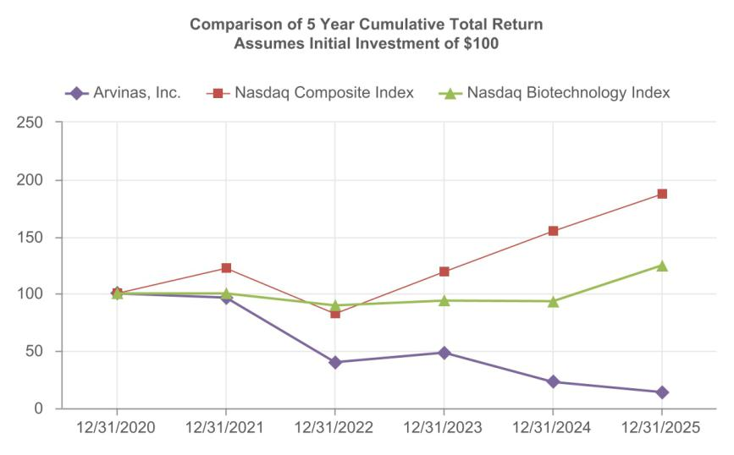

121

Item 6. [Reserved]

Item 7. Management’s Discussion and Analysis of Financial Condition and Results of Operations.

The following discussion and analysis is meant to provide material information relevant to an assessment of the financial condition and results of operations of our company, including an evaluation of the amount and certainty of cash flows from operations and from outside sources, so as to allow investors to better view our company from management's perspective. You should read the following discussion and analysis of financial condition and results of operations together with our consolidated financial statements and the related notes appearing elsewhere in this Annual Report on Form 10-K. This discussion contains forward-looking statements that involve risks and uncertainties. As a result of many factors, such as those set forth in the section titled “Risk Factors” and elsewhere in this Annual Report on Form 10-K, our actual results may differ materially from those anticipated in or implied by these forward-looking statements.

Overview

Our Business

We are a clinical-stage biotechnology company dedicated to improving the lives of patients suffering from debilitating and life-threatening diseases. Through our PROteolysis TArgeting Chimera, or PROTAC, protein degradation platform, we are pioneering the development of a new class of therapeutics designed to harness the body’s own natural protein disposal system to selectively and efficiently degrade and remove disease-causing proteins. We have designed and optimized our proprietary PROTAC Discovery Engine for the discovery of PROTAC therapeutics to address diseases caused by abnormal proteins or aberrant protein expression. We believe that our targeted protein degradation approach is a novel therapeutic modality that may provide distinct advantages over existing therapies and address a broad range of targets, including historically undruggable proteins, in areas of significant unmet need.

In the past five years, seven of the programs developed using our PROTAC protein degradation platform have progressed to clinical trials in oncology and neurology indications after demonstrating potent and selective protein degradation in our preclinical studies. The U.S. Food and Drug Administration, or FDA, has accepted our New Drug Application, or NDA, for vepdegestrant, our most advanced product candidate from the platform, for the treatment of patients with estrogen receptor-positive (ER+)/human epidermal growth factor receptor 2-negative (HER2-), or ER+/HER2-, estrogen receptor 1, or ESR1, mutated advanced or metastatic breast cancer who have previously received endocrine-based therapy, and has assigned a Prescription Drug User Fee Act, or PDUFA, action date of June 5, 2026. We believe favorable clinical trial results in our ongoing oncology and neurology programs would further validate our platform as a new therapeutic modality for the potential treatment of diseases caused by dysregulated intracellular proteins.

We are currently progressing the following product candidates through clinical development programs:

- ARV-102, targeting the leucine-rich repeat kinase 2, or LRRK2, protein for the treatment of neurodegenerative diseases, including Parkinson's disease, or PD, and progressive supranuclear palsy, or PSP;

- ARV-806, targeting Kirsten rat sarcoma, or KRAS, G12D protein for cancers with the G12D mutation, including pancreatic, colorectal and non-small cell lung cancer;

- ARV-393, targeting the B-cell lymphoma 6, or BCL6, protein for the treatment of relapsed/refractory non-Hodgkin lymphoma, or NHL;

- ARV-027, targeting the polyglutamine-expanded androgen receptor, or polyQ-AR, in skeletal muscle; and

- vepdegestrant, targeting the estrogen receptor, or ER, for the treatment of locally advanced or metastatic ER+/HER2- breast cancer.

122

We are also advancing several preclinical candidates through early stage development in a broad range of intracellular disease targets, including proteins that currently cannot be addressed by existing small molecule therapies, commonly referred to as “undruggable” or under-drugged targets. These preclinical candidates include ARV-6723 targeting hematopoietic progenitor kinase 1, or HPK1, and a pan-KRAS degrader targeting multiple variants of KRAS while sparing other RAS isoforms.

In addition to the programs above and our early-stage collaborations, including with Pfizer, Inc., or Pfizer, and Genentech, Inc. and F. Hoffman-La Roche Ltd., or Genentech, we are conducting exploratory research and development work on multiple other undisclosed targets.

Our Clinical Stage Programs

ARV-102: Oral PROTAC LRRK2 Degrader Program

ARV-102 is an investigational, orally bioavailable PROTAC designed to cross the blood-brain barrier and specifically target and degrade LRRK2, which is a large, multi-domain scaffolding kinase with GTPase activity. ARV-102 is our first oral PROTAC protein degrader in clinical development to treat neurodegenerative diseases. We believe our LRRK2 degraders are particularly well positioned to be evaluated in neurodegenerative diseases where there are currently no disease modifying therapies available, including :

- PD, where increased LRRK2 expression and activity contributes to neurodegeneration and pathogenesis of PD; and

- PSP, where genetic variations in LRRK2 are associated with PSP progression and accelerated time to death. Additionally, we have published data associating the tau pathology of PSP with LRRK2-mediated endolysosomal dysfunction.

We have been evaluating ARV-102 in Phase 1 clinical trials in healthy volunteers and patients with PD.

- Healthy Volunteers: We initiated the first-in-human Phase 1 clinical trial for ARV-102 in the first quarter of 2024. We completed the single ascending dose, or SAD, and multiple ascending dose, or MAD, cohorts of the ARV-102 Phase 1 clinical trial in healthy volunteers.

- Patients with PD: We completed enrollment in the SAD cohort of the ARV-102 Phase 1 clinical trial in patients with PD in the second quarter of 2025. We received Clinical Trial Application approval in the Netherlands to initiate a multiple dose cohort of the Phase 1 clinical trial in patients with PD in the second quarter of 2025, and we initiated this multiple dose cohort in the third quarter of 2025. In the fourth quarter of 2025, we completed enrollment in the multiple dose cohort.

In the second quarter of 2025, we presented data from the first-in-human Phase 1 healthy volunteer clinical trial of ARV-102 at the 2025 International Conference on Alzheimer’s and Parkinson’s Diseases, or AD/PD, 2025, including results from the randomized, double-blind, placebo-controlled SAD cohort, and initial results from the MAD cohort. The ARV-102 Phase 1 clinical data in healthy volunteers demonstrated substantial reduction of LRRK2 in CSF with a promising safety/tolerability profile and favorable pharmacodynamic outcomes. Key findings from the clinical trial indicated brain penetration, substantial central and peripheral LRRK2 protein degradation, and downstream LRRK2 pathway engagement.

In the fourth quarter of 2025, we presented late breaking positive Phase 1 data from our clinical trial of ARV-102 in healthy volunteers, and from the SAD cohort of our Phase 1 clinical trial of ARV-102 in patients with PD, as well as CSF Proteomic Data from the Phase 1 clinical trial of ARV-102 in healthy volunteers at the 2025 International Congress of Parkinson’s Disease and Movement Disorders®. Data from the Phase 1 SAD and MAD clinical trial in healthy volunteers showed that ARV-102 was generally well tolerated, with no discontinuations due to adverse events, or AEs, or serious adverse events, or SAEs, observed in the trial population, favorable pharmacokinetics and pharmacodynamics. Interim SAD data from the Phase 1 clinical trial in patients with PD showed single doses of ARV-102 were well tolerated with only mild treatment-related AEs, including headache, diarrhea, and nausea, with no SAEs, and favorable pharmacokinetics and pharmacodynamics.

We plan to present data from the multiple dose cohort of the Phase 1 clinical trial of ARV-102 in patients with PD in the first quarter of 2026 in an oral presentation at 2026 AD/PD. Pending regulatory feedback, we plan

123

to initiate a Phase 1b clinical trial of ARV-102 in patients with PSP in the first half of 2026, and have the potential to initiate a registrational trial of ARV-102 in PSP in late 2026, pending regulatory feedback.

ARV-806: Novel PROTAC KRAS G12D Degrader Program

ARV-806 is an investigational novel PROTAC designed to selectively target and degrade mutant KRAS G12D in solid tumors. KRAS is one of the most frequently mutated human oncogenes and G12D is the most common mutation of the KRAS protein. We believe ARV-806 has the potential to address high unmet need in solid tumors, such as pancreatic, colorectal and non-small cell lung cancer, or NSCLC, with KRAS G12D mutation.

We have conducted preclinical studies of ARV-806 and in the preclinical setting, ARV-806 demonstrated high potency and selectivity, with robust antitumor activity through dose-responsive degradation of KRAS G12D in KRAS G12D mutated cancer models, including pancreatic and colorectal models. These preclinical data demonstrate sustained pharmacodynamic activity consistent with long-lasting target degradation, which we believe supports intermittent clinical dosing. In particular, in the fourth quarter of 2025, we presented new preclinical data at AACR-NCI-EORTC International Conference on Molecular Targets and Cancer Therapeutics highlighting ARV-806's high potency and clear differentiation from both KRAS inhibitors and degraders currently in the clinic while also demonstrating dose-dependent, selective, robust anti-tumor activity, with regressions across preclinical models of KRAS G12D-mutant cancers; in vitro potency approximately 25 times greater than KRAS inhibitors and 40 times greater than the leading clinical-stage degrader, and degradation greater than 90% for seven days after single dose and significant efficacy in models of pancreatic, colorectal, and lung cancer.

We believe ARV-806 has the potential to address high unmet need in solid tumors, such as pancreatic, colorectal and non-small cell lung cancer. We filed an investigational new drug application with the FDA for ARV-806 in the first quarter of 2025 and received a safe-to-proceed letter from the FDA in the second quarter of 2025. We initiated enrollment in a Phase 1 clinical trial of ARV-806 in patients with advanced solid tumors harboring KRAS G12D mutations in the second quarter of 2025 and this trial is currently ongoing.

In the first quarter of 2026, we announced that we had completed dose escalation for once-weekly administration ahead of plan based on faster-than-anticipated enrollment of the Phase 1 clinical trial evaluating ARV-806 in patients with solid tumors harboring KRAS G12D mutations. We plan to continue enrollment in this clinical trial and anticipate sharing initial clinical data in patients with solid tumors harboring KRAS G12D mutations in 2026.

ARV-393: Oral PROTAC BCL6 Degrader Program

ARV-393 is an investigational, orally bioavailable PROTAC designed to specifically target and degrade BCL6, a transcriptional repressor and a key regulator of normal B-cell maturation and differentiation processes. Deregulation of BCL6 function (e.g., via chromosomal translocation, mutations) may lead to malignant transformation and development of NHL. Also as a lineage defining transcription factor of T-follicular helper cells, BCL6 has been implicated in nodal T-follicular helper cell lymphoma, or nTFHL, including the angioimmunoblastic type, formerly angioimmunoblastic T-cell lymphoma, or AITL.

We believe that PROTAC-mediated degradation has the potential to address the historically undruggable nature of BCL6 and that ARV-393 PROTAC -mediated degradation of BCL6 may provide an important novel therapeutic option for patients with NHL. Furthermore, we believe current preclinical data suggest that ARV-393 has the potential to be an attractive combination partner for development of novel therapies for lymphoma, including chemo-free combination regimens and/or “all oral” treatment options.

We have conducted preclinical studies of ARV-393 alone, in combination with SOC chemotherapy and biologic agents, as well as oral, investigational small molecule inhibitors in high grade and aggressive diffuse large B-cell lymphoma, or DLBCL, and in combination with glofitamab, a CD20xCD3 bispecific antibody and an emerging SOC option for DLBCL, in models of aggressive high grade DLBCL. We believe the totality of our ARV-393 preclinical data provides a compelling rationale to evaluate ARV-393 in combination with bi-specifics, oral pathway inhibitors, and potentially other SOCs in the larger DLBCL indication.

124

We initiated the monotherapy cohort of our first-in-human Phase 1 clinical trial of ARV-393 in patients with relapsed or refractory NHL in the second quarter of 2024 and are currently recruiting patients for this clinical trial. We announced previously that there have been multiple responses in early cohorts in both B- and T-cell lymphomas in the first-in-human Phase 1 clinical trial. Dose escalation in the trial is ongoing and the safety profile of ARV-393 supports continuing dose escalation. We also believe these early data support an emerging, and differentiated, therapeutic benefit of ARV-393. We plan to share updated clinical data from the ongoing Phase 1 clinical trial of ARV-393 in patients with relapsed/refractory NHL at a medical congress in the second half of 2026. We also plan to initiate enrollment of a glofitamab combination cohort in patients with DLBCL in the ongoing Phase 1 clinical trial of ARV-393 in the first half of 2026.

ARV-027: Oral PROTAC polyQ-AR Degrader Program

ARV-027 is an investigational, oral, peripherally restricted PROTAC designed to selectively target and eliminate the polyQ-AR in skeletal muscle. In the fourth quarter of 2025 at the International Congress of the World Muscle Society, we presented new preclinical data demonstrating induced robust degradation of polyQ-AR in human myotubes derived from spinal bulbar muscular atrophy, or SBMA, patient-induced pluripotent stem cells. The preclinical ARV-027 data presented also showed dose-dependent degradation of AR in mouse skeletal muscle that was sustained for more than 24 hours (single oral dose), and reductions in muscle monomeric polyQ-AR levels between 40-60%, improved muscle grip strength, and restored muscle endurance to wild-type levels in SBMA mouse model.

We initiated a first-in-human Phase 1 clinical trial in ARV-027 in healthy volunteers in the first quarter of 2026.

Vepdegestrant: Oral PROTAC ER Degrader Program

Vepdegestrant is an investigational orally bioavailable PROTAC estrogen receptor, or ER, degrader being developed for the treatment of ER+/HER2- locally advanced or metastatic breast cancer. We chose ER degradation as a therapeutic focus given the well-documented biology of ER signaling as a principal driver in a high percentage of breast cancers. In July 2021, we announced a global collaboration with Pfizer for the co-development and co-commercialization of vepdegestrant. The FDA has accepted our NDA for vepdegestrant for the treatment of patients with ER+/HER2-, ESR1-mutated advanced or metastatic breast cancer who have previously received endocrine-based therapy, and has assigned a PDUFA date of June 5, 2026.

We, along with Pfizer, have several ongoing clinical trials of vepdegestrant, for which enrollment of patients is complete, which are summarized below.

- VERITAC-2, a Phase 3 clinical trial of vepdegestrant as a monotherapy, for the treatment of patients with metastatic breast cancer previously treated with endocrine based therapy;

- VERITAC, a Phase 2 dose expansion clinical trial of vepdegestrant as a monotherapy, for the treatment of patients with previously treated metastatic breast cancer;

- TACTIVE-K, a Phase 1b/2 clinical trial of vepdegestrant in combination with Pfizer's cyclin-dependent kinase 4, or CDK4, inhibitor, atirmociclib; and

- TACTIVE-U, a group of Phase 1b/2 clinical trials of vepdegestrant in combination with multiple targeted therapies including abemaciclib, ribociclib or Carrick Therapeutics, Inc.'s, or Carrick, cyclin-dependent kinase 7, or CDK7, inhibitor, samuraciclib.

We, along with Pfizer, also have completed two clinical trials of vepdegestrant:

- TACTIVE-N, a Phase 2 clinical trial of vepdegestrant as a monotherapy in the neoadjuvant setting; and

- TACTIVE-E, a Phase 1 clinical trial of vepdegestrant in combination with everolimus.

Additionally, VERITAC-3 a clinical trial with a study lead-in of vepdegestrant in combination with palbociclib for the treatment of patients with first-line metastatic breast cancer, is ongoing and enrollment of patients is complete. As previously disclosed, VERITAC-3 will not proceed beyond the study lead-in.

125

VERITAC-2 Clinical Trial, New Drug Application

In the first quarter of 2025, we, along with Pfizer, announced positive topline results from the Phase 3 VERITAC-2 clinical trial in the estrogen receptor 1-mutant, or ESR1m, population, and in the second quarter of 2025, we, along with Pfizer announced detailed results from this clinical trial. These detailed results were presented in a late-breaking oral presentation at the American Society of Clinical Oncology, or ASCO, 2025 Annual Meeting and were highlighted in the ASCO press briefing and selected for Best of ASCO, and were also simultaneously published in the New England Journal of Medicine.

Based on the results from VERITAC-2, in the second quarter of 2025, we and Pfizer submitted an NDA to the FDA for vepdegestrant for the treatment of patients with ER+/HER2- ESR1-mutated advanced or metastatic breast cancer previously treated with endocrine-based therapy. This represents the first NDA submitted for a PROTAC. In the third quarter of 2025, we announced that the FDA accepted the NDA for vepdegestrant and assigned a PDUFA date of June 5, 2026.

As part of our global collaboration with Pfizer, we and Pfizer presented patient reported outcomes, or PRO, data from the VERITAC-2 clinical trial evaluating vepdegestrant versus fulvestrant for previously treated patients with ESR1 mutated- ER+/HER2- advanced breast cancer in the fourth quarter of 2025 at the European Society for Medical Oncology, or ESMO, 2025 Congress. In the VERITAC-2 clinical trial, in patients with ESR1-mutated disease, vepdegestrant demonstrated a reduced risk of deterioration compared to fulvestrant which was statistically significant in several PRO domains including overall health status, pain severity, and functioning (including role, cognitive, emotional, and social functioning), and vepdegestrant consistently showed reduced risk of deterioration versus fulvestrant across all PRO domains. These PRO data from the VERITAC-2 clinical trial support the clinical benefit of vepdegestrant in patients with ESR1-mutated, ER+/HER2- advanced or metastatic breast cancer previously treated with endocrine-based therapy.

Other Clinical Trials and Information

In the second quarter of 2025, we announced that we and Pfizer removed two planned Phase 3 combination trials of vepdegestrant from the agreed-upon joint development plan: a first-line Phase 3 combination trial with Pfizer’s novel investigational CDK4 inhibitor, atirmociclib, and a second-line Phase 3 combination trial with a CDK4/6 inhibitor.

Additionally, in the second quarter of 2025, Pfizer added a vepdegestrant combination cohort to its ongoing Phase 1 clinical trial evaluating Pfizer’s investigational KAT6 inhibitor in combination with endocrine therapies following CDK4/6 inhibitor treatment. This clinical trial is being operationalized and funded solely by Pfizer.

As part of our global collaboration with Pfizer, we and Pfizer presented results of the TACTIVE-N Phase 2 clinical trial which evaluated neoadjuvant vepdegestrant in postmenopausal women with ER+/HER2– localized breast cancer in the fourth quarter of 2025 at the ESMO 2025 Congress. The results presented showed that neoadjuvant vepdegestrant demonstrated biological and clinical activity in this treatment-naïve, predominantly ESR1 wild-type population of postmenopausal women with ER+/HER2- localized breast cancer.

In addition, as part of our global collaboration with Pfizer, we presented five posters at the San Antonio Breast Cancer Symposium further supporting the potential of vepdegestrant as a potential treatment option for patients with ESR1-mutated ER+/HER2- advanced or metastatic breast cancer previously treated with endocrine-based therapy potential.

We, along with Pfizer, continue market preparations for vepdegestrant in advance of the PDUFA date. While we continue to believe that vepdegestrant has the potential to be a best-in-class monotherapy treatment for advanced/metastatic breast cancer patients in the second-line ESR1m setting, given our and Pfizer’s decision to remove the two planned Phase 3 combination trials of vepdegestrant from the agreed-upon joint development plan as noted above, we determined that it is no longer viable for us to build out our commercial infrastructure as we had previously planned. As such, in the third quarter of 2025, we announced that we and Pfizer have agreed to jointly select a third party for the commercialization and potential future development of vepdegestrant.

126

Our Preclinical and Other Programs

We have active preclinical programs and in neurology and oncology. In 2025 we announced two new product candidate nominees, ARV-027 and ARV-6723. As described above, we initiated a Phase 1 clinical trial for ARV-027 in the first quarter of 2026.

ARV-6723: Oral PROTAC HPK1 Degrader

ARV-6723 is an investigational, preclinical oral PROTAC designed to degrade HPK1 in solid malignancies. Preclinically, ARV-6723 has shown potent, selective HPK1 degradation and strong anti-tumor immune responses with superior tumor control in low- and high- immunogenic murine syngeneic tumor models. We presented preclinical data at the Society for Immunotherapy of Cancer annual meeting in the fourth quarter of 2025 that we believe supports the potential of ARV-6723 to provide sustained anti-tumor immune response as a single agent or in combination with standards of care with improved clinical benefits, including that: ARV-6723, as a single agent, demonstrates anti-tumor efficacy superior to anti-PD1 or a clinical HPK1 inhibitor and combines with anti-PD1 to further enhance response; and ARV-6723 single agent activity outperforms the HPK1 inhibitor and anti-PD-1 efficacy and reinstitutes the tumor microenvironment. We believe these preclinical results support future investigation of ARV-6723 alone or in combination with other agents in patients with high- or low-immunogenic tumors. In addition, we presented preclinical data for ARV-6723 at the American Association for Cancer Research, or AACR, Immuno-Oncology Conference in the first quarter of 2026 that support clinical investigation of ARV-6723 in patients with solid tumors harboring high- or low-immunogenic tumor microenvironments, or TME, including immune checkpoint inhibitor-resistant tumor settings. This preclinical data showed robust single-agent antitumor and proinflammatory activity in multiple syngeneic tumor models, including those with immunosuppressive TMEs, and showed greater preclinical activity than an investigational HPK1 inhibitor or an anti-PD-1 antibody.

Pending regulatory feedback, we plan to initiate a Phase 1 clinical trial of ARV-6723 in patients with advanced solid tumors in mid-2026. Additionally, we plan to present preclinical data evaluating antitumor and unique immunomodulatory activity of ARV-6723 in immuno-oncology-resistant models compared to SOC checkpoint inhibition in the first half of 2026.

Pan-KRAS Program

Our preclinical oral pan-KRAS program targets multiple variants of KRAS that drive solid tumors such as PDAC, colorectal cancer, NSCLC and esophageal cancer, while sparing other RAS isoforms. In the fourth quarter of 2025, a poster presented at the 2025 Triple Meeting, showed that orally bioavailable pan-KRAS degraders have been identified that potently degrade multiple variants of KRAS and spare other RAS isoforms. A tool pan-KRAS PROTAC demonstrated robust single-agent activity and superior combination efficacy with immune checkpoint blockade compared with a pan-RAS ON inhibitor (seven complete responses compared with two complete responses). We plan to present preclinical data evaluating the activity and selectivity of a novel pan-KRAS degrader in multiple KRAS mutants and differentiation over RAS (ON) or pan-KRAS inhibitors in the first quarter of 2026 at the AACR Special Conference in Cancer Research: RAS Oncogenesis and Therapeutics. We also plan to present preclinical data evaluating the efficacy of a novel pan-KRAS degrader in a KRAS syngeneic model, as well as associated immune microenvironment changes in the first half of 2026.

Other Programs: Luxdegalutamide (ARV-766) and bavdegalutamide (ARV-110)

We had been developing luxdegalutamide and bavdegalutamide, each an investigational, orally bioavailable, AR degrading PROTAC targeted protein degrader, for the treatment of men with metastatic castration-resistant prostate cancer, or mCRPC. Both luxdegalutamide and bavdegalutamide demonstrated activity in preclinical models of AR overexpression and AR mutations, both common mechanisms of resistance to current standard-of-care agents in men with prostate cancer. We believed that the differentiated PROTAC pharmacology of luxdegalutamide and bavdegalutamide, including their iterative activity, had the potential to translate into significantly improved clinical outcomes over current SOC agents. However, a comparison of clinical data from separate studies of luxdegalutamide and bavdegalutamide showed that luxdegalutamide’s tolerability and efficacy was more promising than that of bavdegalutamide. As a result, early in the fourth quarter of 2023, we determined to prioritize the initiation of a Phase 3 clinical trial with luxdegalutamide in mCRPC instead of the previously planned Phase 3 clinical trial for bavdegalutamide. Clinical trials for bavdegalutamide (ARV-110-101 and ARV-110-103) were completed in the second quarter of 2025.

127

In the second quarter of 2024, we completed a transaction with Novartis Pharma AG, or Novartis, which comprised a license agreement, or the Novartis License Agreement, and an asset agreement, or the Novartis Asset Agreement. Pursuant to the Novartis License Agreement, we granted Novartis an exclusive worldwide license for the development, manufacture and commercialization of luxdegalutamide, and we completed the transition of our ongoing and planned clinical trials of luxdegalutamide to Novartis in the fourth quarter of 2024. Pursuant to the Novartis Asset Agreement, we sold Novartis all of our rights, title and interest in our PROTAC protein degrader targeting AR-V7, a splice variant of the AR.

Our Operations

We commenced operations in 2013. Our operations to date have been limited to organizing and staffing our company, business planning, raising capital, conducting discovery and research activities, filing patent applications, identifying potential product candidates, undertaking preclinical studies and clinical trials, establishing arrangements with third parties for collaborations and for the manufacture of initial quantities of our product candidates and preparing for potential commercialization. To date, we have not generated any revenue from product sales and have financed our operations primarily through sales of assets and equity, proceeds from collaborations and a licensing arrangement, grant funding and debt financing. Since inception through December 31, 2025, we raised approximately $1.7 billion in gross proceeds from the sale of assets and equity interests and the exercise of stock options, and had received an aggregate of $933.1 million in payments primarily from collaboration partners and a licensing arrangement.

We are a clinical-stage company, with product candidates in clinical development and other drug discovery activities in the research and preclinical development stages. Our ability to generate revenue from product sales sufficient to achieve profitability will depend heavily on the successful development and eventual commercialization of one or more of our product candidates. In June 2025 we announced the submission of an NDA to the FDA with our partner Pfizer for vepdegestrant for the treatment of patients with ER+/HER2-, ESR1-mutated advanced or metastatic breast cancer previously treated with endocrine-based therapy. In August 2025 we announced the FDA's acceptance of this NDA for review and that the FDA had assigned a PDUFA date of June 5, 2026. In September 2025, we and Pfizer announced our plan to jointly select a third party for the commercialization and potential further development of vepdegestrant.

Any delay or failure to obtain regulatory approvals would materially adversely affect our product candidate development efforts and our business overall. Because of the numerous risks and uncertainties associated with product development, we are unable to predict the timing or amount of increased expenses or when or if we will be able to achieve or maintain profitability. Even if we are able to generate product sales, we may not become profitable. If we fail to become profitable or are unable to sustain profitability on a continuing basis, then we may be unable to continue our operations at planned levels and be forced to reduce or terminate our operations.

We regularly review our operations and make decisions we believe best support our business strategy. In April 2025, as part of our decision to streamline operations across our organization and enable the efficient progression of our portfolio, we committed to and approved a reduction of our workforce by approximately 33% across all areas of our company. The workforce reduction was aimed at reducing internal costs while minimally impacting our targeted clinical stage programs to drive value over the next several years by aligning our operations with long-term program development objectives. The workforce reduction was substantially completed by the end of the second quarter of 2025.

In September 2025, we announced an update on our collaboration with Pfizer and further actions to support value creation by optimizing organizational and cost structures and streamlining operations in advance of multiple anticipated upcoming value inflection points, including: further limiting additional expenditures on the vepdegestrant program supporting activities required for commercialization readiness and identification, with Pfizer, of a third party for the commercialization and potential further development of vepdegestrant; reducing our workforce by an additional 15%, with the most significant reductions being roles related to vepdegestrant commercialization; and proactively managing pipeline cost by seeking strategic business development opportunities and by identifying further efficiencies across the business. The September 2025 workforce reduction was substantially completed in the first quarter of 2026.

128

We recognized restructuring charges of $3.7 million related to the two actions noted above, including $15.3 million of cash severance and other one-time employee related termination benefit related to the workforce reductions, partially offset by a reversal of $11.6 million of non-cash stock compensation and bonus expenses. We expect to achieve annual operating cost savings of $100.0 million, on a run-rate basis. Refer to Note 14, Restructuring Activity, in this Annual Report on Form 10-K for further details.

In the first quarter of 2026, we announced the appointment of Randy Teel, Ph.D., as our President, Chief Executive Officer and as a member of our board of directors. Dr. Teel, who previously served as our Chief Business Officer, succeeds John Houston, Ph.D., who is retired from his role as President, Chief Executive Officer, and Chair of Arvinas’ board of directors. Dr. Houston will continue to serve as a member of the Board and has entered into a consulting agreement with us whereby he will provide consulting and advisory services. Briggs Morrison, M.D., our lead independent director, has been elected to serve as Chair of our board of directors.

Since inception, we have incurred significant operating losses and, even in light of our workforce reductions and cost optimization decisions, expect to continue to incur operating losses for at least the next several years. In addition to any additional costs not currently contemplated due to the events associated with or resulting from our workforce reductions, our ability to achieve profitability and our financial position will depend, in part, on the rate of our future expenditures, potential collaboration revenue, our ability to successfully implement cost avoidance measures and reduce overhead costs and our ability to obtain additional funding.

We expect to continue to incur significant expenses associated with: our ongoing and anticipated preclinical and clinical activities, development activities, research activities in oncology, neuroscience and other disease areas, managing our employees and retaining key talent in research, clinical trials, quality and other functional areas, expenses incurred with CMOs and CDMOs to supply us with product for our preclinical and clinical studies and expenses incurred with contract research organizations, or CROs, for the synthesis of compounds in our preclinical development activities, as well as other associated costs including those related to partnering with us on our clinical trial portfolio and the management of our intellectual property portfolio.

We do not expect to generate any revenue from product sales in the near future, if ever. Accordingly, we will need to obtain substantial additional funding in connection with our continuing operations. If we are unable to raise capital when needed or on attractive terms, we could be forced to delay, reduce or eliminate our research or product development programs or any future commercialization efforts, or to relinquish valuable rights to our technologies, future revenue streams, research programs or product candidates or to grant licenses on terms that may not be favorable to us.

As of December 31, 2025, we had cash, cash equivalents and marketable securities of $ 685.4 million. We believe the existing cash, cash equivalents and marketable securities on hand will be sufficient to fund our operations into the second half of 2028, which will enable us to execute on multiple data readouts across our programs. We have based this estimate on assumptions that may prove to be wrong, and we could exhaust our available capital resources sooner than we expect. See “Liquidity and Capital Resources” below.

Financial Operations Overview

Revenue

To date, we have not generated any revenue from product sales and do not expect to generate any revenue from the sale of products in the near future. Our revenues to date have been generated through research collaborations, a licensing arrangement and an asset sale. Revenue is recognized ratably over our expected performance period under each agreement. We expect that any revenue recognized in the near term will be derived primarily from our current collaboration agreements and licensing arrangement and any additional arrangements that we may enter into in the future. During the year ended December 31, 2025, we received a development milestone totaling $20.0 million, pursuant to the terms of the Novartis License Agreement. To date, no other development, regulatory and commercial milestone payments or royalties have been received under any of our other collaboration agreements or licensing arrangement.

129

Pfizer Vepdegestrant (ARV-471) Collaboration Agreement

In July 2021, we entered into the Vepdegestrant (ARV-471) Collaboration Agreement with Pfizer, pursuant to which we granted Pfizer worldwide co-exclusive rights to develop and commercialize products containing our proprietary compound vepdegestrant (ARV-471), or the Licensed Products.

Under the Vepdegestrant (ARV-471) Collaboration Agreement, we received an upfront, non-refundable payment of $650 million. In addition, we are eligible to receive up to an additional $1.4 billion in contingent payments based on specified regulatory and sales-based milestones for the Licensed Products. Of the total contingent payments, $400 million in regulatory milestones are related to marketing approvals and $1.0 billion are related to sales-based milestones.

We and Pfizer share equally (50/50) all development costs (including costs for conducting any clinical trials) for the Licensed Products, subject to certain exceptions.

Unless earlier terminated in accordance with its terms, the Vepdegestrant (ARV-471) Collaboration Agreement will expire on a Licensed Product-by-Licensed Product and country-by-country basis when such Licensed Product is no longer commercialized or developed for commercialization in such country. Pfizer may terminate the Vepdegestrant (ARV-471) Collaboration Agreement for convenience in its entirety or on a region-by-region basis subject to certain notice periods. Either party may terminate the Vepdegestrant
(ARV-471) Collaboration Agreement for the other party’s uncured material breach or insolvency. Subject to applicable terms of the Vepdegestrant (ARV-471) Collaboration Agreement, including certain payments to Pfizer upon termination for our uncured material breach, effective upon termination of the Vepdegestrant (ARV-471) Collaboration Agreement, we are entitled to retain specified licenses to be able to continue to exploit the Licensed Products.

Subject to specified exceptions, we and Pfizer have each agreed not to directly or indirectly research, develop, or commercialize any competing products outside of the Vepdegestrant (ARV-471) Collaboration Agreement anywhere in the world during the term of the Vepdegestrant (ARV-471) Collaboration Agreement.

In the third quarter of 2025, we announced that we and Pfizer have agreed to jointly select a third party for the commercialization and potential future development of vepdegestrant.

Pfizer Research Collaboration Agreement

In December 2017, we entered into a Research Collaboration and License Agreement with Pfizer, setting forth our collaboration to identify or optimize PROTAC targeted protein degraders that mediate for degradation of targets, using our proprietary platform technology that are identified in the agreement or subsequently selected by Pfizer, subject to certain exclusions. We refer to this agreement as the Pfizer Research Collaboration Agreement.

Under the Pfizer Research Collaboration Agreement, Pfizer has designated a number of initial targets. For each identified target, we and Pfizer will conduct a separate research program pursuant to a research plan. Pfizer may make substitutions for any of the initial target candidates, subject to the stage of research for such target.

In the year ended December 31, 2018, we received an upfront, non-refundable payment and certain additional payments totaling $28.0 million in exchange for use of the technology license and to fund Pfizer-related research, as defined within the Pfizer Research Collaboration Agreement. As of December 31, 2025, there remains a single target under the Pfizer Research Collaboration Agreement, and, in accordance with the terms of such Agreement, we are eligible to receive up to an additional $3.8 million in non-refundable option payments if Pfizer exercises its option for such target protein.

We are also entitled to receive up to $225.0 million in development milestone payments and up to $550.0 million in sales-based milestone payments for all designated targets under the Pfizer Research Collaboration Agreement, as well as mid- to high-single digit tiered royalties, which may be subject to reductions, on net sales of PROTAC targeted protein degrader-related products. In 2021 and 2020, we received payments totaling $1.2 million and $4.4 million, respectively. Pfizer selected additional targets and initiated additional services totaling $1.0 million and $3.5 million in December 2022 and 2021, respectively.

130

Novartis Transaction

In April 2024, we entered into the Novartis License Agreement and the Novartis Asset Agreement, with Novartis, collectively referred to as the Novartis Transaction. The Novartis Transaction closed in May 2024 upon the expiration of the waiting period under the Hart-Scott-Rodino Antitrust Improvements Act of 1976, at which time the Novartis License Agreement and the Novartis Asset Agreement became effective.

Pursuant to the Novartis License Agreement, we granted Novartis an exclusive worldwide license for the development, manufacture and commercialization of luxdegalutamide (ARV-766), our second generation PROTAC AR degrader for patients with prostate cancer. Pursuant to the Novartis Asset Agreement, we sold to Novartis all of our rights, title and interest in our PROTAC protein degrader targeting AR-V7, a splice variant of the AR.

Under the terms of and as consideration for entering into the Novartis Transaction, we received a one-time, upfront payment in the aggregate amount of $150.0 million from Novartis. Under the Novartis License Agreement, we are also eligible to receive up to an additional $1.01 billion as contingent payments based on specified development, regulatory, and commercial milestones for luxdegalutamide (ARV-766) being met, as well as tiered royalties based upon worldwide net sales of luxdegalutamide (ARV-766), subject to reduction under certain circumstances as provided in the Novartis License Agreement. During the year ended December 31, 2025, we received $20.0 million upon the achievement of a development milestone pursuant to the terms of the Novartis License Agreement.

The Novartis License Agreement will continue on a country-by-country basis (or, in certain cases, a region-by-region basis) until the expiration of the applicable royalty term for such country (or region, as applicable). The Novartis License Agreement contains customary termination provisions, including that either party may terminate the Novartis License Agreement (a) upon the material breach of the other party or (b) in the event the other party experiences an insolvency event. Additionally, Novartis may terminate the Novartis License Agreement for convenience or upon a safety or regulatory issue.

Genentech License Agreement

In September 2015, we entered into an Option and License Agreement with Genentech, focused on PROTAC targeted protein degrader discovery and research for target proteins, or Targets, based on our proprietary platform technology, other than excluded Targets as described below. Pursuant to this agreement, Genentech has an option to obtain an exclusive worldwide license to the applicable PROTAC targeted protein degraders directed against an applicable Target, which we refer to as Licensed PROTACs. Each such option must be exercised within a specified time after we deliver the data package for such Licensed PROTAC to Genentech. Once Genentech exercises an option, it is responsible, at its cost, to use diligent efforts to develop and commercialize the Licensed PROTAC through first commercial sale in the United States, the European Union and Japan. This collaboration was expanded in November 2017 through an Amended and Restated Option, License and Collaboration Agreement, which we refer to as the Restated Genentech Agreement. Simultaneous with entering into the Restated Genentech Agreement, Genentech exercised its exclusive option with respect to a PROTAC targeted protein degrader. We receive annual updates on research and development activities related to this option.

Under the Restated Genentech Agreement, Genentech had the right to designate up to ten Targets for further discovery and research utilizing our PROTAC platform technology and also had the right to remove a Target from the collaboration and substitute a different Target that is not an excluded Target at any time prior to us commencing research on such Target or in certain circumstances following commencement of research by us. The research phase of the collaboration with Genentech has ended. Genentech is no longer able to nominate new targets into the collaboration, and there are no active targets in the collaboration for which Arvinas was conducting research activities. The only Target that remains part of the collaboration is the PROTAC targeted protein degrader for which Genentech exercised its exclusive option for as noted above.

At the time we entered into the original agreement with Genentech, we received an upfront payment of $11.0 million, and, at the time we entered into the Restated Genentech Agreement, we received an additional $34.5 million in upfront and expansion target payments. We are eligible to receive payments aggregating up to $44.0 million per Target upon the achievement of specified development milestones; payments aggregating up to $52.5 million per Target (assuming approval of two indications) subject to the achievement of specified

131

regulatory milestones; and payments aggregating up to $60.0 million per PROTAC targeted protein degrader directed against the applicable Target, subject to the achievement of specified sales milestones. These milestone payments are subject to reduction if we do not have a valid patent claim covering the licensed PROTAC targeted protein degrader at the time the milestone is achieved. We are also eligible to receive, on net sales of licensed PROTAC targeted protein degraders, mid-single digit royalties, which may be subject to reductions.

Bayer Collaboration Agreement

In June 2019, we entered into a Collaboration and License Agreement, or the Bayer Collaboration Agreement, with Bayer, setting forth our collaboration to identify or optimize PROTAC targeted protein degraders that mediate for degradation of Targets, using our proprietary platform technology, that are selected by Bayer, subject to certain exclusions and limitations. The Bayer Collaboration Agreement became effective in July 2019.

Under the Bayer Collaboration Agreement, we and Bayer conducted a research program pursuant to separate research plans mutually agreed to by us and Bayer and tailored to each Target selected by Bayer. During the term of the Bayer Collaboration Agreement, we were not permitted, either directly or indirectly, to design, identify, discover or develop any small molecule pharmacologically-active agent whose primary mechanism of action is, by design, directed to the inhibition or degradation of any Target selected or reserved by Bayer, or grant any license, covenant not to sue or other right to any third party in the field of human disease under the licensed intellectual property for the conduct of such activities.

Under the terms of the Bayer Collaboration Agreement, we received an aggregate upfront, non-refundable payment of $17.5 million and an additional $12.0 million in aggregate from inception through 2023. We were also eligible to receive up to $ 197.5 million in development milestone payments and up to $490.0 million in sales-based milestone payments for all designated Targets. In addition, we were eligible to receive, on net sales of PROTAC targeted protein degrader-related products, mid-single digit to low-double digit tiered royalties, which were subject to reductions.

Pursuant to notice from Bayer AG in accordance with the terms of the Bayer Collaboration Agreement, the Bayer Collaboration Agreement was terminated, effective August 12, 2024.

Operating Expenses

Our operating expenses since inception have consisted solely of research and development costs and general and administrative costs.

Research and Development Expenses

Research and development expenses consist primarily of costs incurred for our research activities, including our discovery efforts, and the development of our product candidates, and include:

- employee related expenses, including salaries, benefits, stock-based compensation expense and travel, for personnel engaged in research and development functions;

- expenses incurred under agreements with third parties, including CROs and other third parties that conduct research, preclinical and clinical activities on our behalf as well as third parties that manufacture our product candidates for use in our preclinical studies and clinical trials;

- costs of outside consultants, including their fees, stock-based compensation and related travel expenses;

- the costs of laboratory supplies and developing preclinical studies and clinical trial materials;

- facility-related expenses, which include direct depreciation costs of equipment and allocated expenses for rent and maintenance of facilities and other operating costs;

- costs incurred in the development of intellectual property; and

- third-party licensing fees.

132

We expense research and development costs as incurred.

We typically use our employee and infrastructure resources across our development programs, and as such, do not track all of our internal research and development expenses on a program-by-program basis. The following table summarizes our research and development expenses for the years ended December 31, 2025, 2024 and 2023:

 |  |  |  | Years Ended December 31,
(dollars in millions) |  | 2025 |  |  | 2024 |  |  | 2023
Program-specific external expense:
Vepdegestrant (ARV-471) (*) | $ | 62.7 |  | $ | 76.9 |  | $ | 104.8
ARV-102 |  | 21.0 |  |  | 13.0 |  |  | 2.3
ARV-806 |  | 13.5 |  |  | 2.3 |  |  | —
ARV-393 |  | 11.1 |  |  | 6.8 |  |  | 1.4
Bavdegalutamide (ARV-110) |  | 2.7 |  |  | 8.5 |  |  | 26.6
Luxdegalutamide (ARV-766) |  | — |  |  | 19.7 |  |  | 24.2
Other programs |  | 4.5 |  |  | — |  |  | —
Total program-specific external expense |  | 115.5 |  |  | 127.2 |  |  | 159.3
Non program-specific external expense |  | 49.1 |  |  | 62.8 |  |  | 72.4
Unallocated internal expense
Compensation and related personnel expense
(including stock-based compensation) |  | 109.6 |  |  | 145.4 |  |  | 134.2
Other research and development expense |  | 11.0 |  |  | 12.8 |  |  | 13.8
Total unallocated internal expense |  | 120.6 |  |  | 158.2 |  |  | 148.0
Total research and development expense | $ | 285.2 |  | $ | 348.2 |  | $ | 379.7

- Includes net reimbursement to and from Pfizer pursuant to the Vepdegestrant (ARV-471) Collaboration Agreement which are accounted for pursuant to ASC 808 and are recorded as an offset or an increase to research and development expenses.

Research and development activities are central to our business model. We expect that our research and development expenses will continue to increase substantially for the foreseeable future as we continue to conduct our ongoing clinical trials of vepdegestrant, ARV-102, ARV-806, ARV-393, ARV-027 and continue to discover and develop additional product candidates. Research and development expenses related to vepdegestrant are shared equally with Pfizer since July 22, 2021, the effective date of the Vepdegestrant (ARV-471) Collaboration Agreement. We may receive reimbursement from, or make payments to, Pfizer to satisfy the cost sharing requirements. These payments are accounted for pursuant to ASC 808, Collaborative Arrangements, which are recorded as an offset or an increase to research and development expenses.

We cannot determine with certainty the duration and costs of ongoing and future clinical trials of vepdegestrant, ARV-102, ARV-806, ARV-393, ARV-027 or unexpected costs of ongoing clinical trials for any other product candidate we may develop or if, when, or to what extent we will generate revenue from the commercialization and sale of any product candidate for which we obtain marketing approval. We may never succeed in obtaining marketing approval for any product candidate. The successful development and commercialization of our product candidates is highly uncertain. This is due to the numerous risks and uncertainties associated with developing drugs, including the uncertainty of:

- successfully completing preclinical studies and clinical trials;

- receipt and related terms of marketing approvals from applicable regulatory authorities;

- obtaining and maintaining patent and trade secret protection and regulatory exclusivity for our product candidates;

- making or maintaining arrangements with third-party manufacturers, or establishing manufacturing capabilities, for both clinical and commercial supplies of our product candidates;

133

- establishing sales, marketing, market access and distribution capabilities and launching commercial sales of our products, if and when approved, whether alone or in collaboration with others;

- acceptance of our products, if and when approved, by patients, the medical community and third-party payors;

- obtaining and maintaining third-party coverage and adequate reimbursement;

- maintaining a continued acceptable safety profile of the products following approval; and

- effectively competing with other therapies.

A change in the outcome of any of these variables with respect to the development of a product candidate could mean a significant change in the costs and timing associated with the development of that product candidate. For example, if the FDA or another regulatory authority were to require us to conduct clinical trials beyond those that we anticipate will be required for the completion of clinical development of a product candidate, or if we experience significant delays in our clinical trials due to patient enrollment or other reasons, we would be required to expend significant additional financial resources and time on the completion of clinical development.

General and Administrative Expenses

General and administrative expenses consist primarily of salaries and other related costs, including stock-based compensation for personnel in our executive, finance, business development and administrative functions. General and administrative expenses also include legal fees relating to intellectual property and corporate matters; professional fees for accounting, auditing, tax and consulting services; insurance costs; travel expenses; and facility-related expenses, which include direct depreciation costs and allocated expenses for rent and maintenance of facilities and other operating costs.

We expect that our general and administrative expenses will increase in the future as we manage our personnel, including retaining or hiring of key employees, and, as a result of any future need to increase our headcount to support research and development activities relating to our product candidates, develop our infrastructure and build out commercial operations for any potential launch of commercial sales of our products. We also expect to incur increased expenses associated with being a public company, including costs of accounting, audit, legal, regulatory and tax-related services associated with maintaining compliance with Nasdaq Stock Market and Securities and Exchange Commission requirements; director and officer insurance costs; and investor and public relations costs.

Other Income

Other income consists primarily of interest income from marketable securities and money market accounts and losses on the disposal of fixed assets.

Income Taxes

Since our inception in 2013, we have not recorded any U.S. federal or state income tax benefits for the net losses we have incurred in any year or for our federal or state earned research and development tax credits, due to our uncertainty of realizing a benefit from those items.

As of December 31, 2025, we had $533.6 million of federal net operating loss carryforwards, all of which may be carried forward indefinitely, but the deductibility of such carryforwards is limited to 80% of our taxable income in the year in which carryforwards are used, $563.2 million of state and local net operating loss carryforwards which expire at various dates beginning in 2035, $44.7 million of federal tax credit carryforwards and $22.3 million of state tax credit carryforwards as of December 31, 2025 which expire at various dates beginning in 2035.

As of December 31, 2025, Arvinas, Inc. had four wholly owned subsidiaries organized as C-corporations: Arvinas Operations, Inc., Arvinas Androgen Receptor, Inc., Arvinas Estrogen Receptor, Inc., and Arvinas Winchester, Inc. Prior to December 31, 2018, these subsidiaries were separate filers for federal tax purposes. Net operating loss carryforwards are generated from the C-corporation subsidiaries’ filings. We have

134

provided a valuation allowance against the full amount of the deferred tax assets since, in the opinion of management, based upon our earnings history, it is more likely than not that the benefits will not be realized.

Critical Accounting Policies and Use of Estimates

Our management’s discussion and analysis of financial condition and results of operations is based on our consolidated financial statements, which have been prepared in accordance with generally accepted accounting principles in the United States. The preparation of our consolidated financial statements and related disclosures requires us to make estimates and assumptions that affect the reported amounts of assets and liabilities, costs and expenses and the disclosure of contingent assets and liabilities in our consolidated financial statements. We base our estimates on historical experience, known trends and events and various other factors that we believe are reasonable under the circumstances, the results of which form the basis for making judgments about the carrying values of assets and liabilities that are not readily apparent from other sources. We evaluate our estimates and assumptions on an ongoing basis. Our actual results may differ from these estimates under different assumptions or conditions.

While our significant accounting policies are described in more detail in the notes to our consolidated financial statements appearing elsewhere in this Annual Report on Form 10-K, we believe that the following accounting policies are those most critical to the judgments and estimates used in the preparation of our consolidated financial statements.

Revenue Recognition

We recognize revenue under Accounting Standards Codification, or ASC 606, Revenue from Contracts with Customers. Our revenue is primarily generated through research collaboration and license agreements with pharmaceutical partners. The terms of these agreements contain multiple goods and services which may include (i) licenses, (ii) research and development activities and (iii) participation in joint research and development steering committees. The terms of these agreements may include non-refundable, upfront license or option fees, payments for research and development activities, payments upon the achievement of certain milestones and royalty payments based on product sales derived from the collaboration. Under ASC 606, we evaluate whether the license agreement, research and development services and participation in research and development steering committees represent separate or combined performance obligations. We have determined that these services within our existing contracts represent combined single performance obligations. We also generated revenue through the sale of assets based on fair value.

The research collaboration and license agreements typically include contingent milestone payments related to specified preclinical and clinical development milestones and regulatory milestones. These milestone payments represent variable consideration that are not initially recognized within the transaction price as they are fully constrained under the guidance in ASC 606. We continually assess the probability of significant reversals for any amounts that become likely to be realized prior to recognizing the variable consideration associated with these payments within the transaction price.

Revenue is recognized ratably over our expected performance period under each respective arrangement. We make our best estimate of the period over which we expect to fulfill our performance obligations, which includes access to technology through the license agreement and research activities. Given the uncertainties of these collaboration arrangements, significant judgment is required to determine the duration of the performance period.

For the years ended December 31, 2025, 2024 and 2023, the transaction price allocated to the combined performance obligations identified under the individual research collaboration and license agreements was recognized as revenue on either a straight-line basis over the estimated performance period under the arrangement or over the estimated performance period based on our best estimate of costs to be incurred. Straight-line basis was considered the best measure of progress for certain agreements in which control of the combined obligation transfers to the customers, due to the contract containing license rights to technology, research and development services, and joint committee participation, which in totality are expected to occur ratably over the performance period.

135

Our contracts may also call for certain sales-based milestones and royalty payments upon successful commercialization of a target. In accordance with ASC 606-10-55-65, we recognize revenues from sales-based milestone and royalty payments at the later of (i) the occurrence of the subsequent sale, or (ii) the performance obligation to which some or all of the sales-based milestone or royalty payments has been allocated has been satisfied (or partially satisfied). We anticipate recognizing these milestones and royalty payments if and when subsequent sales are generated by customers from the use of the technology. To date, no revenue from these sales-based milestone and royalty payments has been recognized for any periods.

Amounts received prior to satisfying the above revenue recognition criteria are recorded as contract liabilities in our accompanying consolidated balance sheets.

Research and Development Contract Costs and Accruals

As part of the process of preparing our financial statements, we are required to estimate our accrued research and development expenses. This process involves reviewing open contracts and purchase orders, communicating with our applicable personnel to identify services that have been performed on our behalf and estimating the level of service performed and the associated cost incurred for the service when we have not yet been invoiced or otherwise notified of actual costs. The majority of our service providers invoice us in arrears for services performed, on a pre-determined schedule or when contractual milestones are met; however, some require advance payments. We make estimates of our accrued expenses as of each balance sheet date in the consolidated financial statements based on facts and circumstances known to us at that time. We periodically confirm the accuracy of these estimates with the service providers and make adjustments, if necessary. Examples of estimated accrued research and development expenses include fees paid to:

- vendors in connection with clinical development activities;

- CROs and investigative sites in connection with preclinical, non-clinical, and human clinical trials; and

- CMOs and CDMOs in connection with drug substance and drug product formulation of preclinical and clinical trial materials.

We base the expense recorded related to external research and development on our estimates of the services received and efforts expended pursuant to quotes and contracts with multiple CMOs, CDMOs and CROs that supply, conduct and manage clinical trials on our behalf. The financial terms of these agreements are subject to negotiation, vary from contract to contract and may result in uneven payment streams. There may be instances in which payments made to our vendors will exceed the level of services provided and result in a prepayment of the expense. In accruing service fees, we estimate the time period over which services will be performed and the level of effort to be expended in each period. If the actual timing of the performance of services or the level of effort varies from the estimate, we adjust the accrual or the amount of prepaid expenses accordingly. Although we do not expect our estimates to be materially different from amounts actually incurred, our understanding of the status and timing of services performed relative to the actual status and timing of services performed may vary and may result in reporting amounts that are too high or too low in any particular period. To date, there have not been any material adjustments to our prior estimates of accrued research and development expenses.

New Accounting Pronouncements

For information on new accounting standards, see Note 2, Summary of Significant Accounting Policies, to our consolidated financial statements appearing elsewhere in this Annual Report on Form 10-K.

136

Results of Operations

Comparison of Years Ended December 31, 2025 and 2024

 |  |  |  |  | Years Ended December 31,
(dollars in millions) |  | 2025 |  |  | 2024 |  |  | $ change
Revenue | $ | 262.6 |  | $ | 263.4 |  | $ | (0.8)
Research and development expenses |  | (285.2) |  |  | (348.2) |  |  | 63.0
General and administrative expenses |  | (95.9) |  |  | (165.4) |  |  | 69.5
Other income |  | 38.0 |  |  | 51.9 |  |  | (13.9)
Income tax expense |  | (0.3) |  |  | (0.6) |  |  | 0.3
Net loss | $ | (80.8) |  | $ | (198.9) |  | $ | 118.1
Reconciliation of GAAP and Non-GAAP Information
 |  |  |  |  | Year Ended December 31,
(dollars in millions) |  |  |  |  | 2025 |  |  | 2024
Research and development reconciliation
GAAP research and development expenses |  |  |  | $ | 285.2 |  | $ | 348.2
Less: restructuring expense |  |  |  |  | 2.3 |  |  | —
Less: stock-based compensation expense (*) |  |  |  |  | 30.7 |  |  | 49.7
Non-GAAP research and development expenses |  |  |  | $ | 252.2 |  | $ | 298.5
General and administrative reconciliation
GAAP general and administrative expenses |  |  |  | $ | 95.9 |  | $ | 165.4
Less: restructuring expense |  |  |  |  | 1.3 |  |  | —
Less: stock-based compensation expense (*) |  |  |  |  | 23.4 |  |  | 38.5
Non-GAAP general and administrative expenses |  |  |  | $ | 71.2 |  | $ | 126.9

(*) Excludes restructuring related stock-based compensation. See Note 14, Restructuring Activity, to the consolidated financial statements for further details.

Revenue

Revenues for the year ended December 31, 2025 totaled $262.6 million, compared with $263.4 million for the year ended December 31, 2024. The decrease of $0.8 million was primarily due to a decrease of $162.4 million of revenue from the Novartis License Agreement and the Novartis Asset Agreement as we completed the technology transfer of our ongoing and planned clinical trials of luxdegalutamide (ARV-766) to Novartis in 2024, a decrease of $5.1 million of revenue from the Pfizer Research Collaboration Agreement due to changes in estimates of the performance period duration under the agreement resulting from updated research timelines and a decrease of $ 3.8 million in revenue from the Bayer Collaboration Agreement as a result of the termination of the Bayer Collaboration Agreement in August 2024, partially offset by an increase in revenue from the Vepdegestrant (ARV-471) Collaboration Agreement with Pfizer of $150.5 million related primarily to changes in total program cost estimates resulting from the removal of the first-line Phase 3 combination trial with Pfizer’s novel investigational CDK4 inhibitor, atirmociclib, and the removal of the second-line Phase 3 combination trial with a CDK4/6 inhibitor from the development plan and the recognition of $20.0 million for achievement of a development milestone pursuant to the terms of the Novartis License Agreement.

Research and Development Expenses

Research and development expenses for the year ended December 31, 2025 totaled $285.2 million, compared with $348.2 million for the year ended December 31, 2024. The decrease of $63.0 million was primarily due to a decrease in compensation and related personnel expenses of $35.8 million, which are not

137

allocated by program, and a decrease in external expenses of $25.4 million. External expenses include program-specific expenses, which decreased by $11.7 million, driven by decreases in our luxdegalutamide, vepdegestrant and bavdegalutamide programs of $19.7 million, $14.2 million and $5.8 million, respectively, partially offset by increases in our ARV-806, ARV-102 and ARV-393 programs of $11.2 million, $8.0 million and $4.3 million, respectively, and our non-program specific expenses, which decreased by $13.7 million.

Non-GAAP research and development expenses for the year ended December 31, 2025 totaled $252.2 million, compared to $298.5 million for the year ended December 31, 2024, excluding $2.3 million of restructuring expense for the year ended December 31, 2025, and $30.7 million and $49.7 million of non-cash stock-based compensation expense for the years ended December 31, 2025 and 2024, respectively. We define non-GAAP research and development expenses as GAAP research and development expenses excluding restructuring and stock-based compensation expense.

General and Administrative Expenses

General and administrative expenses totaled $95.9 million for the year ended December 31, 2025, compared with $165.4 million for the year ended December 31, 2024. The decrease of $69.5 million was primarily due to a loss on the termination of our laboratory and office space lease with 101 College Street LLC in August 2024 of $43.4 million, a decrease in personnel and infrastructure related costs of $18.9 million and a decrease in professional fees of $6.6 million.

Non-GAAP general and administrative expenses for the year ended December 31, 2025 totaled $71.2 million, compared to $126.9 million for the year ended December 31, 2024, excluding $ 1.3 million of restructuring related reversal of previously recognized expense for the year ended December 31, 2025, and $23.4 million and $38.5 million of non-cash stock-based compensation expense for the years ended December 31, 2025 and 2024, respectively. We define non-GAAP general and administrative expenses as GAAP general and administrative expenses excluding restructuring and stock-based compensation expense.

Other Income

Other income totaled $38.0 million for the year ended December 31, 2025, compared with $51.9 million for the year ended December 31, 2024. The decrease of $ 13.9 million was primarily due to lower interest income of $16.4 million from marketable securities and money market accounts, partially offset by a loss on the disposal of fixed assets of $2.4 million related to the termination of our laboratory and office space lease with 101 College Street LLC in August 2024.

Income Tax Expense

Income tax expense totaled $0.3 million for the year ended December 31, 2025, compared with $0.6 million for the year ended December 31, 2024. For the year ended December 31, 2025, we generated a taxable loss primarily due to losses from operations. For the year ended December 31, 2024, we generated a taxable income primarily due to the Novartis License Agreement, the Novartis Asset Agreement and the required capitalization of research and development expenses, partially offset by operating losses.

Results of Operations — Years Ended December 31, 2024 and 2023

Discussion and analysis of the results of operations for the year ended December 31, 2024 compared to the year ended December 31, 2023 is included under the heading "Comparison of Years Ended December 31, 2024 and 2023" in Part II, Item 7, Management’s Discussion and Analysis of Financial Condition and Results of Operations, in our 2024 Annual Report on Form 10-K as filed with the SEC on February 11, 2025 and incorporated by reference into this Annual Report on Form 10-K.

Non-GAAP Financial Information

We use the non-GAAP financial measures non-GAAP research and development expense and non-GAAP general and administrative expense, to evaluate our ongoing operations and for internal planning and forecasting purposes. We believe that non-GAAP financial information, when taken collectively, may be helpful to investors because it provides consistency and comparability with past financial performance. However, non-

138

GAAP financial information is presented for supplemental informational purposes only, has limitations as an analytical tool, and should not be considered in isolation or as a substitute for financial information presented in accordance with GAAP. Other companies, including companies in our industry, may calculate similarly titled non-GAAP measures differently or may use other measures to evaluate their performance, all of which could reduce the usefulness of our non-GAAP financial measures as tools for comparison. Investors are encouraged to review the related GAAP financial measures and the reconciliation of these non-GAAP financial measures to their most directly comparable GAAP financial measures and not rely on any single financial measure to evaluate our business.

Liquidity and Capital Resources

Sources of Liquidity

We do not currently have any approved products and have never generated any revenue from product sales. To date, we have financed our operations primarily through sales of assets and equity interests, proceeds from collaborations and a licensing arrangement, grant funding and debt financing. Since inception through December 31, 2025, we had received an aggregate of $933.1 million in payments from collaboration partners and a licensing arrangement, grant funding and forgivable and partially forgivable loans from the State of Connecticut, and raised approximately $1.7 billion in gross proceeds from the sale of assets and equity and the exercise of stock options, including:

- October 2018: completion of our initial public offering in which we issued and sold an aggregate of 7,700,482 shares of common stock for aggregate gross proceeds of $123.2 million, before fees and expenses;

- July 2019: sale of 1,346,313 shares of common stock to Bayer AG for aggregate gross proceeds of $32.5 million;

- November 2019: completion of a follow-on offering in which we issued and sold 5,227,273 shares of common stock for aggregate gross proceeds of $115.0 million, before fees and expenses;

- September - December 2020: sale of 2,593,637 shares of common stock in an “at-the-market offering” for aggregate gross proceeds of $65.6 million, before fees and expenses;

- December 2020: completion of a follow-on offering in which we issued and sold 6,571,428 shares of common stock for aggregate gross proceeds of $460.0 million, before fees and expenses;

- September 2021: issuance of 3,457,815 shares of common stock to Pfizer for aggregate gross proceeds of $350.0 million.

- July - September 2023: sale of 1,449,275 shares of common stock in an “at-the-market" offering for aggregate gross proceeds of $37.2 million before fees and expenses;

- November 2023: sale of 12,963,542 shares of common stock and pre-funded warrants to purchase 3,422,380 shares of common stock in a private placement for aggregate gross proceeds of $350.0 million before fees and expenses; and

- April 2024: sale of AR-V7 to Novartis under the Novartis Asset Agreement for $20.0 million.

In November 2023, we amended and restated the Equity Distribution Agreement with Piper Sandler & Company and Cantor Fitzgerald & Co., pursuant to which we may offer and sell from time to time, through the agents, up to approximately $262.8 million of the common stock registered under our universal shelf registration statement pursuant to one or more “at-the-market” offerings. During the years ended December 31, 2025 and 2024, no shares were issued under the amended and restated agreement.

In July 2021, we entered into the Vepdegestrant (ARV-471) Collaboration Agreement with Pfizer, pursuant to which we granted Pfizer worldwide co-exclusive rights to develop and commercialize products containing our proprietary compound vepdegestrant. Under the Vepdegestrant (ARV-471) Collaboration Agreement, Pfizer made an upfront, nonrefundable payment of $650.0 million.

139

Cash Flows

Our cash, cash equivalents and marketable securities totaled $685.4 million and $1.0 billion as of December 31, 2025 and 2024, respectively. We had an outstanding loan balance of $0.6 million and $0.8 million as of December 31, 2025 and 2024, respectively.

The following table summarizes our sources and uses of cash for the period presented:

 |  |  |  | Years Ended December 31,
(dollars in millions) |  | 2025 |  |  | 2024 |  |  | 2023
Net cash used in operating activities | $ | (273.8) |  | $ | (259.3) |  | $ | (347.8)
Net cash provided by investing activities |  | 407.6 |  |  | 34.7 |  |  | 203.5
Net cash (used in) provided by financing activities |  | (91.4) |  |  | 7.9 |  |  | 374.7
Net increase (decrease) in cash, cash equivalents and restricted cash | $ | 42.4 |  | $ | (216.7) |  | $ | 230.4

Operating Activities

Net cash used in operating activities for the year ended December 31, 2025 increased by $14.5 million, compared with the year ended December 31, 2024, primarily due to a decrease in deferred revenue of $141.6 million, driven by changes in total Vepdegestrant (ARV-471) Collaboration Agreement program cost estimates resulting from the removal of two Phase 3 combination trials from the development plan and a decrease in non-cash charges of $39.5 million, partially offset by a decrease in our net loss of $118.1 million, changes in accounts payable and accrued liabilities of $19.5 million, prepaid expenses and other assets of $12.3 million and accounts receivable of $10.4 million. The change in non-cash charges was primarily due to a decrease in stock compensation expense of $44.2 million.

Net cash used in operating activities for the year ended December 31, 2024 decreased by $ 88.5 million, compared with the year ended December 31, 2023, primarily due to a decrease in our net loss of $168.4 million and a net increase in non-cash charges of $16.4 million, partially offset by changes in accounts payable and accrued liabilities of $38.5 million, deferred revenue of $26.4 million, prepaid expenses and other assets of $21.1 million and accounts receivable of $6.7 million. The change in non-cash charges was primarily due to an increase in stock compensation expense of $16.7 million.

Investing Activities

Net cash provided by investing activities for the year ended December 31, 2025 increased by $372.9 million, compared with the year ended December 31, 2024, primarily due to a net decrease in purchases and sales of marketable securities over maturities of $373.0 million.

Net cash provided by investing activities for the year ended December 31, 2024 decreased by $ 168.8 million, compared with the year ended December 31, 2023, primarily due to a net decrease in maturities and sales of marketable securities in excess of purchases of $170.1 million, partially offset by a decrease in purchases of property and equipment of $1.1 million.

Financing Activities

Net cash used in financing activities for the year ended December 31, 2025 decreased by $99.3 million, compared with the year ended December 31, 2024, primarily due to repurchases of common shares of $91.9 million, including commissions and excise tax, under our share repurchase plan and a decrease in proceeds from the exercise of stock options and issuance of ESPP shares of $7.6 million.

Net cash provided by financing activities for the year ended December 31, 2024 decreased by $ 366.8 million, compared with the year ended December 31, 2023, primarily due to net proceeds from the issuance of common stock and pre-funded warrants to purchase shares of our common stock in a private placement in 2023 of approximately $334.1 million and net proceeds from the issuance of common stock under our "at-the-

140

market" offering program in 2023 of approximately $36.1 million, neither of which reoccurred in 2024, partially offset by increased proceeds from the exercise of stock options and issuance of ESPP shares of $3.8 million.

Share Repurchase Activities

On September 17, 2025, we announced that our board of directors authorized and approved a share repurchase program for the repurchase of up to $100.0 million of the currently outstanding shares of our common stock. Share repurchases under the share repurchase program may be made from time to time through a variety of methods, which may include open market purchases, privately negotiated block trades, accelerated share repurchases, other privately negotiated transactions or any combination of these methods. Repurchases may also be made under a Rule 10b5-1 plan, which would permit shares to be repurchased when we might otherwise be precluded from doing so under insider trading laws. The share repurchase program is funded using our working capital. The share repurchase program has no time limit and can be modified, suspended or discontinued at any time without prior notice.

As of December 31, 2025, we have utilized approximately $91.9 million to repurchase shares of our outstanding common stock pursuant to our authorized share repurchase program. We believe we have met our objectives for the stock repurchase program. As of December 31, 2025, we suspended the program and have no further plans to repurchase additional shares.

Funding Requirements

Since our inception, we have incurred significant operating losses. We expect to continue to incur significant expenses and increasing operating losses for the foreseeable future as we advance the preclinical and clinical development of our product candidates.

Specifically, we anticipate that our expenses will increase substantially if, and as we:

- continue our ongoing and planned clinical trials of our product candidates, including ARV-102, our PROTAC protein degrader designed to target the LRRK2 protein, ARV-806, our PROTAC protein degrader designed to target KRAS G12D for mutated cancers, ARV-393, our PROTAC protein degrader designed to target the BCL6 protein, ARV-027, our PROTAC protein degrader designed to target the polyQ-AR protein, and vepdegestrant, for the treatment of patients with locally advanced or metastatic ER+/HER2- breast cancer;

- progress our preclinical programs, including ARV-6723 and our pan-KRAS degrader program;

- progress additional PROTAC protein degrader programs into IND- or CTA-enabling studies;

- apply our PROTAC Discovery Engine to advance additional product candidates into preclinical and clinical development;

- expand the capabilities of our PROTAC Discovery Engine;

- seek marketing approvals for any product candidates that successfully complete clinical trials;

- make decisions with respect to our personnel, including retention or future hiring of key employees, and establishment of a sales, marketing, market access, and distribution infrastructure to launch commercial sales of our products, if and when approved, whether alone or in collaboration with others;

- make decisions with respect to our infrastructure and capabilities, including to support our operations as a public company and our research, product development and future commercialization efforts;

- make or maintain arrangements with third-party manufacturers, or establish manufacturing capabilities, for both clinical and commercial supplies of our product candidates; and

- expand, maintain and protect our intellectual property portfolio.

141

We had cash, cash equivalents and marketable securities of approximately $685.4 million as of December 31, 2025. We believe that our cash, cash equivalents and marketable securities as of December 31, 2025 will enable us to fund our planned operating expenses and capital expenditure requirements into the second half of 2028. We have based this estimate on assumptions that may prove to be wrong and we could use our capital resources sooner than we currently expect. Our future capital requirements will depend on many factors, including:

- the progress, scope, costs and results of our ongoing and planned clinical trials of ARV-102, ARV-806, ARV-393, ARV-027 and vepdegestrant;

- the progress, scope, costs and results of preclinical and clinical development for our other product candidates and development programs, including ARV-6723 and our pan-KRAS degrader program;

- the number of, and development requirements for, other product candidates that we pursue, including our other oncology and neurology research programs;

- the success of our collaborations, including with Pfizer and Genentech;

- the costs, timing and outcome of regulatory review of our product candidates;

- the costs and timing of future commercialization activities, including product manufacturing, marketing, sales and distribution, for any of our product candidates for which we receive marketing approval and which we choose to commercialize ourselves;

- the revenue, if any, received from commercial sales of our product candidates for which we receive marketing approval;

- the costs and timing of preparing, filing and prosecuting patent applications, maintaining and enforcing our intellectual property rights and defending any intellectual property-related claims; and

- our ability to establish additional collaboration arrangements with other biotechnology or pharmaceutical companies on favorable terms, if at all, or enter into license, marketing and royalty arrangements, and similar transactions for the development or commercialization of our product candidates.

As a result of these anticipated expenditures, we will need to obtain substantial additional financing in connection with our continuing operations. Until such time, if ever, as we can generate substantial revenue from product sales, we expect to finance our cash needs through a combination of equity offerings, debt financings, collaborations, strategic alliances and marketing, distribution or licensing arrangements. Although we may receive potential future payments under our collaborations, including with Pfizer and Genentech, and our out-license to Novartis, we do not currently have any committed external source of funds. Adequate additional funds may not be available to us on acceptable terms, or at all. If we are unable to raise capital when needed or on attractive terms, we may be required to delay, limit, reduce or terminate our research, product development programs or any future commercialization efforts or grant rights to develop and market product candidates that we would otherwise prefer to develop and market ourselves.

To the extent that we raise additional capital through the sale of equity or convertible debt securities, the terms of these securities may include liquidation or other preferences that adversely affect the rights of our common stockholders. Debt financing and preferred equity financing, if available, may involve agreements that include covenants limiting or restricting our ability to take specific actions, such as incurring additional debt, making acquisitions or capital expenditures or declaring dividends.

If we raise additional funds through collaborations, strategic alliances or marketing, distribution or licensing arrangements with third parties, we may have to relinquish valuable rights to our technologies, future revenue streams, research programs or product candidates or grant licenses on terms that may not be favorable to us.

Borrowings

In June 2018, we entered into an additional Assistance Agreement with the State of Connecticut, or the 2018 Assistance Agreement, to provide funding for the expansion and renovation of laboratory and office space. We borrowed $2.0 million under the 2018 Assistance Agreement in September 2018, of which $1.0 million was forgiven upon meeting certain employment conditions. Borrowings under the agreement bear an interest rate of

142

3.25% per annum, with interest only payments required for the first 60 months, and mature in September 2028. The 2018 Assistance Agreement requires that we be located in the State of Connecticut through September 2028 with a default penalty of repayment of the full original funding amount of $2.0 million plus liquidated damages of 7.5% of the total amount of funding received. As of December 31, 2025, $0.6 million remains outstanding under the 2018 Assistance Agreement.

Item 7A. Quantitative and Qualitative Disclosures About Market Risk.

We are exposed to market risks in the ordinary course of our business. These risks primarily include interest rate sensitivities. Our interest-earning assets consist of cash, cash equivalents and marketable securities. Interest income earned on these assets totaled $38.5 million in 2025. Our interest income is sensitive to changes in the general level of interest rates, primarily U.S. interest rates. As of December 31, 2025, our cash equivalents consisted of bank deposits and money market funds and our marketable securities included interest-earning securities. Such interest-earning instruments carry a degree of interest rate risk. Our outstanding debt totaled $0.6 million as of December 31, 2025 and carries a fixed interest rate of 3.25% per annum.

Item 8. Financial Statements and Supplementary Data.

Our financial statements, together with the report of our independent registered public accounting firm, appear on pages F-1 through F-31 of this Annual Report on Form 10-

K.

Item 9. Changes in and Disagreements with Accountants on Accounting and Financial Disclosure.

None.

Item 9A. Controls and Procedures.

Evaluation of Disclosure Controls and Procedures

Our management, with the participation of our Chief Executive Officer and Chief Financial Officer (our principal executive officer and principal financial officer, respectively), evaluated the effectiveness of our disclosure controls and procedures as of December 31, 2025. The term “disclosure controls and procedures,” as defined in Rules 13a-15(e) and 15d-15(e) under the Securities Exchange Act of 1934, as amended, or the Exchange Act, means controls and other procedures of a company that are designed to ensure that information required to be disclosed by the company in the reports that it files or submits under the Exchange Act is recorded, processed, summarized and reported, within the time periods specified in the Securities and Exchange Commission’s rules and forms. Disclosure controls and procedures include, without limitation, controls and procedures designed to ensure that information required to be disclosed by a company in the reports that it files or submits under the Exchange Act is accumulated and communicated to the company’s management, including its principal executive and principal financial officers, or persons performing similar functions, as appropriate to allow timely decisions regarding required disclosure. Our management recognizes that any controls and procedures, no matter how well designed and operated, can provide only reasonable assurance of achieving their objectives and our management necessarily applies its judgment in evaluating the cost-benefit relationship of possible controls and procedures. Based on the evaluation of our disclosure controls and procedures as of December 31, 2025, our Chief Executive Officer and Chief Financial Officer concluded that, as of such date, our disclosure controls and procedures were effective at the reasonable assurance level.

Management’s Annual Report on Internal Control over Financial Reporting

Our management is responsible for establishing and maintaining adequate internal control over financial reporting for the company. Internal control over financial reporting is defined in Rule 13a-15(f) or 15d-15(f) promulgated under the Exchange Act as a process designed by, or under the supervision of, the company’s principal executive and principal financial officers and effected by the company’s board of directors, management and other personnel, to provide reasonable assurance regarding the reliability of financial reporting and the preparation of consolidated financial statements for external purposes in accordance with generally accepted accounting principles and includes those policies and procedures that:

- Pertain to the maintenance of records that in reasonable detail accurately and fairly reflect the transactions and dispositions of the assets of the company;

143

- Provide reasonable assurance that transactions are recorded as necessary to permit preparation of consolidated financial statements in accordance with generally accepted accounting principles, and that receipts and expenditures of the company are being made only in accordance with authorizations of management and directors of the company; and

- Provide reasonable assurance regarding prevention or timely detection of unauthorized acquisition, use or disposition of the company’s assets that could have a material effect on the financial statements.

Because of its inherent limitations, internal control over financial reporting may not prevent or detect misstatements. Therefore, even those systems determined to be effective can provide only reasonable assurance with respect to financial statement preparation and presentation. Projections of any evaluation of effectiveness to future periods are subject to the risk that controls may become inadequate because of changes in conditions, or that the degree of compliance with the policies or procedures may deteriorate.

Our management assessed the effectiveness of our internal control over financial reporting as of December 31, 2025. In making this assessment, management used the criteria set forth by the Committee of Sponsoring Organizations of the Treadway Commission (COSO) in Internal Control - Integrated Framework (2013). Based on that assessment, our management concluded that, as of December 31, 2025, our internal control over financial reporting was effective.

Deloitte & Touche LLP, the independent registered public accounting firm that audited the consolidated financial statements included in this Annual Report on Form 10-K, has issued an attestation report on the effectiveness of internal control over financial reporting as of December 31, 2025, included below.

Changes in Internal Control over Financial Reporting

No change in our internal control over financial reporting (as defined in Rules 13a-15(f) and 15d-15(f) under the Exchange Act) occurred during the quarter ended December 31, 2025 that has materially affected, or is reasonably likely to materially affect, our internal control over financial reporting.

144

REPORT OF INDEPENDENT REGISTERED PUBLIC ACCOUNTING FIRM

To the stockholders and the Board of Directors of Arvinas, Inc.

Opinion on Internal Control over Financial Reporting

We have audited the internal control over financial reporting of Arvinas, Inc. and subsidiaries (the “Company”) as of December 31, 2025, based on criteria established in Internal Control — Integrated Framework (2013) issued by the Committee of Sponsoring Organizations of the Treadway Commission (COSO). In our opinion, the Company maintained, in all material respects, effective internal control over financial reporting as of December 31, 2025, based on criteria established in Internal Control — Integrated Framework (2013) issued by COSO.

We have also audited, in accordance with the standards of the Public Company Accounting Oversight Board (United States) (PCAOB), the consolidated financial statements as of and for the year ended December 31, 2025, of the Company and our report dated February 24, 2026, expressed an unqualified opinion on those financial statements.

Basis for Opinion

The Company’s management is responsible for maintaining effective internal control over financial reporting and for its assessment of the effectiveness of internal control over financial reporting, included in the accompanying Management’s Annual Report on Internal Control over Financial Reporting. Our responsibility is to express an opinion on the Company’s internal control over financial reporting based on our audit. We are a public accounting firm registered with the PCAOB and are required to be independent with respect to the Company in accordance with the U.S. federal securities laws and the applicable rules and regulations of the Securities and Exchange Commission and the PCAOB.

We conducted our audit in accordance with the standards of the PCAOB. Those standards require that we plan and perform the audit to obtain reasonable assurance about whether effective internal control over financial reporting was maintained in all material respects. Our audit included obtaining an understanding of internal control over financial reporting, assessing the risk that a material weakness exists, testing and evaluating the design and operating effectiveness of internal control based on the assessed risk, and performing such other procedures as we considered necessary in the circumstances. We believe that our audit provides a reasonable basis for our opinion.

Definition and Limitations of Internal Control over Financial Reporting

A company’s internal control over financial reporting is a process designed to provide reasonable assurance regarding the reliability of financial reporting and the preparation of financial statements for external purposes in accordance with generally accepted accounting principles. A company’s internal control over financial reporting includes those policies and procedures that (1) pertain to the maintenance of records that, in reasonable detail, accurately and fairly reflect the transactions and dispositions of the assets of the company;
- provide reasonable assurance that transactions are recorded as necessary to permit preparation of financial statements in accordance with generally accepted accounting principles, and that receipts and expenditures of the company are being made only in accordance with authorizations of management and directors of the company; and (3) provide reasonable assurance regarding prevention or timely detection of unauthorized acquisition, use, or disposition of the company’s assets that could have a material effect on the financial statements.

Because of its inherent limitations, internal control over financial reporting may not prevent or detect misstatements. Also, projections of any evaluation of effectiveness to future periods are subject to the risk that controls may become inadequate because of changes in conditions, or that the degree of compliance with the policies or procedures may deteriorate.

/s/ Deloitte & Touche LLP

Boston, Massachusetts

February 24, 2026

145

Item 9B. Other Information.

- On February 24, 2026, we issued a press release announcing unaudited financial results for the quarter and year ended December 31, 2025, which was furnished on a Current Report on Form 8-K filed on February 24, 2026, or collectively, the Earnings Materials. We also held a conference call and webcast discussing such results. Subsequent to presenting our Earnings Materials, we made an immaterial adjustment to the fourth quarter 2025 basic and diluted net loss per common share. The amount reported for fourth quarter 2025 basic and diluted net loss per common share in the Earnings Materials was reported as $(1.10) and should be $(1.04).

- Director and Officer Trading Arrangements

None of our directors or officers adopted or terminated a Rule 10b5-1 trading arrangement or a non-Rule 10b5-1 trading arrangement (as defined in Item 408(c) of Regulation S-K) during the fourth quarter of 2025.

Item 9C. Disclosure Regarding Foreign Jurisdictions That Prevent Inspection

Not Applicable.

146

PART III

Item 10. Directors, Executive Officers and Corporate Governance.

The information required by this Item is incorporated by reference from the information that will be contained in our Proxy Statement for our 2026 Annual Meeting of Stockholders, which we intend to file with the SEC within 120 days of the end of the fiscal year to which this Annual Report on Form 10-K relates pursuant to General Instruction G(3) of Form 10-K.

We have adopted a Code of Business Conduct and Ethics that applies to our officers, including our principal executive, financial and accounting officers and our directors and employees. We have posted the text of our Code of Business Conduct and Ethics under the “Investors and Media – Corporate Governance” section of our website, www.arvinas.com. We intend to disclose on our website any amendments to, or waivers from, the Code of Business Conduct and Ethics that are required to be disclosed pursuant to the disclosure requirements of Item 5.05 of Form 8-K.

We have adopted an Insider Trading Policy governing the purchase, sale and/or other dispositions of Company securities by our directors, officers and employees and other covered persons. We believe the Insider Trading Policy is reasonably designed to promote compliance with insider trading laws, rules and regulations, and Nasdaq listing standards. A copy of our Insider Trading Policy is incorporated by reference as Exhibit 19.1 to this Annual Report on Form 10-K for the fiscal year ended December 31, 2025.

Item 11. Executive Compensation.

The information required by this Item (other than the information required by Item 402(v) of Regulation S-K) is incorporated by reference from the information that will be contained in our Proxy Statement for our 2026 Annual Meeting of Stockholders, which we intend to file with the SEC within 120 days of the end of the fiscal year to which this Annual Report on Form 10-K relates pursuant to General Instruction G(3) of Form 10-K.

Item 12. Security Ownership of Certain Beneficial Owners and Management and Related Stockholder Matters.

The information required by this Item is incorporated by reference from the information that will be contained in our Proxy Statement for our 2026 Annual Meeting of Stockholders, which we intend to file with the SEC within 120 days of the end of the fiscal year to which this Annual Report on Form 10-K relates pursuant to General Instruction G(3) of Form 10-K.

Item 13. Certain Relationships and Related Transactions, and Director Independence.

The information required by this Item is incorporated by reference from the information that will be contained in our Proxy Statement for our 2026 Annual Meeting of Stockholders, which we intend to file with the SEC within 120 days of the end of the fiscal year to which this Annual Report on Form 10-K relates pursuant to General Instruction G(3) of Form 10-K.

Item 14. Principal Accountant Fees and Services.

The information required by this Item is incorporated by reference from the information that will be contained in our Proxy Statement for our 2026 Annual Meeting of Stockholders, which we intend to file with the SEC within 120 days of the end of the fiscal year to which this Annual Report on Form 10-K relates pursuant to General Instruction G(3) of Form 10-K.

147

PART IV

Item 15. Exhibits, Financial Statement Schedules.

- Financial Statements - The following consolidated financial statements are filed as part of this Annual Report on Form 10-K:

 |  |  |  |  |  |  |  |  | Page
 | Report of Independent Registered Public Accounting Firm (PCAOB ID No.34) |  |  |  |  |  |  |  | F-2
 | Consolidated Balance Sheets
 | December 31, 2025 and 2024 |  |  |  |  |  |  |  | F-4
 | Consolidated Statements of Operations and Comprehensive Loss
 | Years ended December 31, 2025, |  | 2024 and 2023 |  |  |  |  |  | F-5
 | Consolidated Statements of Changes in |  | Stockholders’ Equity
 | Years ended December 31, 2025, |  | 2024 and 2023 |  |  |  |  |  | F-6
 | Consolidated Statements of Cash Flows
 | Years ended December 31, 2025, |  | 2024 and 2023 |  |  |  |  |  | F-7
 | Notes to Consolidated Financial Statements |  |  |  |  |  |  |  | F-8

- Financial Statement Schedules

All financial statement schedules have been omitted because they are not applicable, not required or the information required is shown in the consolidated financial statements or the notes thereto.

- Index to Exhibits

The following is a list of exhibits filed as part of this Annual Report on Form 10-K.

Exhibit

Number

3.1

3.2

4.1

4.2

4.3

Description

Restated Certificate of Incorporation of the Registrant (incorporated by reference to Exhibit 3.1 to the Registrant’s Current Report on Form 8-K (File No. 001-38672) filed with the SEC on October 1, 2018).

Second Amended and Restated Bylaws of the Registrant (incorporated by reference to Exhibit 3.1 to the Registrant’s Current Report on Form 8-K (File No. 001-38672) filed with the SEC on June 21, 2023).

Specimen Stock Certificate evidencing the shares of common stock (incorporated by reference to Exhibit 4.1 to the Registrant's Registration Statement on Form S-1 (File No. 333-227112) filed with the SEC on August 30, 2018).

Second Amended and Restated Put Agreement among the Registrant, Connecticut Innovations, Incorporated and the other parties thereto, dated March 29, 2018 (incorporated by reference to Exhibit 4.3 to the Registrant's Registration Statement on Form S-1 (File No. 333-2271121) filed with the SEC on August 30. 2018).

Registration Rights Agreement, dated November 24, 2023, by and among the Company and the other parties thereto (incorporated by reference to Exhibit 10.2 to the Registrant’s Current Report on Form 8-K (File No. 001-38672) filed with the SEC on November 27, 2023).

148

4.4

10.1+

10.2+

10.3+

10.4+

10.5+

10.6+

10.7+

10.8+*

10.9+

10.10+

10.11+

10.12+

10.13+

10.14+

10.15+

10.16+*

Description of the Registrant’s Securities Registered Under Section 12 of the Exchange Act (incorporated by reference to Exhibit 4.4 to the Registrant’s Annual Report on Form 10-K (File No. 001-38672) filed with the SEC on March 16, 2020).

Incentive Share Plan, as amended by First Amendment, dated October 16, 2015, Second Amendment, dated December 22, 2016, Third Amendment, dated September 8, 2017, and Fourth Amendment, dated March 29, 2018 (incorporated by reference to Exhibit 10.1 to the Registrant’s Registration Statement on Form S-1 (File No. 333-227112) filed with the SEC on August 30, 2018).

Form of Incentive Share Award Agreement under Incentive Share Plan (incorporated by reference to Exhibit 10.2 to the Registrant’s Registration Statement on Form S-1 (File No. 333-227112) filed with the SEC on August 30, 2018).

Form of Restricted Stock Agreement under Incentive Share Plan (incorporated by reference to Exhibit 10.3 to the Registrant’s Registration Statement on Form S-1/A (File No. 333-227112) filed with the SEC on September 14, 2018).

2018 Stock Incentive Plan (incorporated by reference to Exhibit 10.4 to the Registrant’s Registration Statement on Form S-1/A (File No. 333-227112) filed with the SEC on September 14, 2018).

Form of Stock Option Agreement under 2018 Stock Incentive Plan (incorporated by reference to Exhibit 10.5 to the Registrant’s Registration Statement on Form S-1/A (File No. 333-227112) filed with the SEC on September 14, 2018).

Form of Restricted Stock Unit Agreement under 2018 Stock Incentive Plan (incorporated by reference to Exhibit 10.6 to the Registrant’s Annual Report on Form 10-K (File No. 001-38672) filed with the SEC on March 26, 2019).

2018 Employee Stock Purchase Plan (incorporated by reference to Exhibit 10.6 to the Registrant’s Registration Statement on Form S-1/A (File No. 333-227112) filed with the SEC on September 14, 2018).

Form of Restricted Stock Unit Agreement under 2018 Stock Incentive Plan.

Form of Inducement Stock Option Award Agreement (incorporated by reference to Exhibit 99.3 to the Registrant’s Registration Statement on Form S-8 (File No. 333-276519) filed with the SEC on January 16, 2024).

Form of Inducement Restricted Stock Unit Award Agreement (incorporated by reference to Exhibit 99.4 to the Registrant’s Registration Statement on Form S-8 (File No. 333-276519) filed with the SEC on January 16, 2024).

Form of Director and Officer Indemnification Agreement (incorporated by reference to Exhibit 10.7 to the Registrant’s Registration Statement on Form S-1/A (File No. 333-227112) filed with the SEC on September 14, 2018).

Employment Agreement between the Registrant and John Houston, Ph.D., dated September 13, 2018 (incorporated by reference to Exhibit 10.8 to the Registrant’s Registration Statement on Form S-1/A (File No. 333-227112) filed with the SEC on September 14, 2018).

Employment Agreement between the Registrant and Andrew Saik, dated June 17, 2024 (incorporated by reference to Exhibit 10.1 to the Registrant’s Quarterly Report on Form 10-Q (File No. 001-38672) filed with the SEC on July 30, 2024).

Employment Agreement between the Registrant and Noah Berkowitz M.D., Ph.D., dated March 18, 2024 (incorporated by reference to Exhibit 10.1 to the Registrant’s Quarterly Report on Form 10-Q (File No. 001-38672) filed with the SEC on May 7, 2024).

Amended and Restated Employment Agreement, dated November 4, 2025, by and between the Registrant and Angela Cacace, Ph.D. (incorporated by reference to Exhibit 10.1 to the Registrant’s Quarterly Report on Form 10-Q (File No. 001-38672) filed with the SEC
on November 5, 2025).

Amended and Restated Employment Agreement, dated February 12, 2026, by and between the Registrant and Randy Teel, Ph.D.

149

10.17+ | Consulting Agreement, dated June 6, 2025, by and between Arvinas Operations, Inc. and Ian Taylor, Ph.D. (incorporated by reference
 | to Exhibit 10.1 to the Registrant’s Quarterly Report on Form 10-Q (File No. 001-38672) filed with the SEC on August 6, 2025).

10.18+*

10.19+

Consulting Agreement, dated February 12, 2026, by and between Arvinas, Inc. and John Houston, Ph.D.

Amended and Restated Employment Agreement, dated November 4, 2025, by and between the Registrant and Randy Teel, Ph.D. (incorporated by reference to Exhibit 10.2 to the Registrant’s Quarterly Report on Form 10-Q (File No. 001-38672) filed with the SEC

on November 5, 2025).

10.20 | Lease Agreement between the Arvinas Operations, Inc. (formerly Arvinas, Inc.) and Science Park Development Corporation, dated
 | December 31, 2017, as amended by First Amendment to Lease, dated May 23, 2018, and Second Amendment to Lease, dated
 | September 4, 2018 (incorporated by reference to Exhibit 10.12 to the Registrant’s Registration Statement on Form S-1/A (File No.
 | 333-227112) filed with the SEC on September 14, 2018).
10.21
10.21 | Third Amendment to Lease between Arvinas Operations, Inc. (formerly Arvinas, Inc.) and Science Park Development Corporation,
 | dated March 12, 2019 (incorporated by reference to Exhibit 10.1 to the Registrant’s Current Report on Form 8-K (File No. 001-38672)
 | filed with the SEC on March 15, 2019).
10.22 | Fourth Amendment to Lease between Arvinas Operations, Inc. (formerly Arvinas, Inc.) and Science Park Development Corporation,
 | dated January 31, 2020 (incorporated by reference to Exhibit 10.14 to the Registrant’s Annual Report on Form 10-K (File No. 001-
 | 38672) filed with the SEC on March 16, 2020).
10.23 | Fifth Amendment to Lease between Arvinas Operations, Inc. (formerly Arvinas, Inc.) and Science Park Development Corporation,
 | dated January 4, 2021 (incorporated by reference to Exhibit 10.34 to the Registrant's Annual Report on Form 10-K (File No. 001-
 | 38672) filed with the SEC on March 1, 2021).
10.24 | Sixth Amendment to Lease between Arvinas Operations, Inc. (formerly Arvinas, Inc.) and Science Park Development Corporation,
 | dated June 13, 2023 (incorporated by reference to Exhibit 10.11 to the Registrant’s Quarterly Report on Form 10-Q (File No. 001-
 | 38672) filed with the SEC on August 8, 2023).
10.25 | Seventh Amendment to Lease between Arvinas Operations, Inc. (formerly Arvinas, Inc.) and Science Park Development Corporation,
 | dated December 13, 2024 (incorporated by reference to Exhibit 10.24 to the Registrant’s Annual Report on Form 10-Q (File No. 001-
 | 38672) filed with the SEC |  |  |  |  |  | on February 11, 2025).
10.26 | Eighth Amendment to Lease between Arvinas Operations, Inc. (formerly Arvinas, Inc.) and Science Park Development Corporation,
 | dated December 31, 2024 (incorporated by reference to Exhibit 10.25 to the Registrant’s Annual Report on Form 10-Q (File No. 001-
 | 38672) filed with the SEC |  |  |  |  |  | on February 11, 2025).
10.27 | Ninth Amendment to Lease between Arvinas Operations, Inc. (formerly Arvinas, Inc.) and Science Park Development Corporation,
 | dated February 10, 2025 (incorporated by reference to Exhibit 10.26 to the Registrant’s Annual Report on Form 10-Q (File No. 001-
 | 38672) filed with the SEC on February 11, 2025).
10.28 | Lease Termination Agreement between Arvinas Operations, Inc. (formerly Arvinas, Inc.) and Science Park Development Corporation,
 | dated January 15, 2025 (incorporated by reference to Exhibit 10.31 to the Registrant’s Annual Report on Form 10-K (File No. 001-
 | 38672) filed with the SEC on February 11, 2025).
10.29†
10.29† | Amended and Restated License Agreement between Yale University and Arvinas Operations, Inc. (formerly Arvinas, Inc.), dated June
 | 18, 2024 (incorporated by reference to Exhibit 10.6 to the Registrant’s Quarterly Report on Form 10-Q (File No. 001-36874) filed with
 | the SEC on July 30, 2024).
 |  |  |  |  |  |  |  | 150

10.30†

10.31†

10.32†

10.33†

10.34†

10.35†

10.36†

10.37†

10.38

Amended and Restated License and Option Agreement among Genentech, Inc., F. Hoffmann-La Roche Ltd and Arvinas Operations, Inc. (formerly Arvinas, Inc.), dated November 8, 2017 (incorporated by reference to Exhibit 10.16 to the Registrant’s Registration Statement on Form S-1/A (File No. 333-227112) filed with the SEC on September 14, 2018).

Research Collaboration and License Agreement between Pfizer Inc. and Arvinas Operations, Inc. (formerly Arvinas, Inc.), dated December 22, 2017 (incorporated by reference to Exhibit 10.17 to the Registrant’s Registration Statement on Form S-1/A (File No. 333-227112) filed with the SEC on September 14, 2018).

Amendment No. 1 to Research Collaboration and License Agreement between Pfizer Inc. and Arvinas Operations, Inc. (formerly Arvinas, Inc.), dated December 9, 2019 (incorporated by reference to Exhibit 10.24 to the Registrant’s Annual Report on Form 10-K

(File No. 001-38672) filed with the SEC on March 16, 2020).

Amendment No. 2 to Research Collaboration and License Agreement between Pfizer Inc. and Arvinas Operations, Inc. (formerly Arvinas, Inc.), dated January 14, 2022 (incorporated by reference to Exhibit 10.1 to the Registrant’s Quarterly Report on Form 10-Q

(File No. 001-38672) filed with the SEC on May 5, 2022).

Amendment No. 3 to Research Collaboration and License Agreement between Pfizer Inc. and Arvinas Operations, Inc (formerly Arvinas, Inc.), dated December 21, 2022 (incorporated by reference to Exhibit 10.32 to the Registrant’s Annual Report on Form 10-K

(File No. 001-38672) filed with the SEC on February 23, 2023)

Collaboration Agreement by and between Arvinas, Inc., Arvinas Operations, Inc., Arvinas Estrogen Receptor, Inc. and Pfizer, Inc., dated July 21, 2021 (incorporated by reference to Exhibit 10.1 to the Registrant's Current Report on Form 8-K (File No. 001-38672)

filed with the SEC on July 22, 2021)

Stock Purchase Agreement, dated July 21, 2021, by and between Arvinas, Inc. and Pfizer, Inc. (incorporated by reference to Exhibit 10.2 to the Registrant's Current Report on Form 8-K (File No. 001-38672) filed with the SEC on July 22, 2021).

Investor Agreement, dated July 21, 2021, by and between Arvinas, Inc. and Pfizer, Inc. (incorporated by reference to Exhibit 10.3 to the Registrant's Current Report on Form 8-K (File No. 001-38672) filed with the SEC on July 22, 2021).

Amended and Restated Equity Distribution Agreement, dated November 7, 2023, by and among Arvinas, Inc., Piper Sandler & Co.
and Cantor Fitzgerald & Co. (incorporated by reference to Exhibit 1.2 to the Registrant's Registration Statement on Form S-3 (File No.
333-275377) filed with the SEC on November 7, 2023).

10.39 | Securities Purchase Agreement, dated November 24, 2023, by and among the Company and the other parties thereto (incorporated
 | by reference to Exhibit 10.1 to the Registrant's Current Report on Form 8-K (File No. 001-38672) filed with the SEC on November 27,

10.40†

10.41†

19.1

2023).

License Agreement by and among Arvinas, Inc., Arvinas Operations, Inc., Arvinas Androgen Receptor, Inc. and Novartis Pharma AG, dated April 10, 2024 (incorporated by reference to Exhibit 10.4 to the Registrant's Quarterly Report on Form 10-Q (File No. 001-

38672) filed with the SEC on July 30, 2024).

Asset Purchase Agreement by and among Arvinas, Inc., Arvinas Operations, Inc., Arvinas Androgen Receptor, Inc. and Novartis Pharma AG, dated April 10, 2024 (incorporated by reference to Exhibit 10.5 to the Registrant's Quarterly Report on Form 10-Q (File

No. 001-38672) filed with the SEC on July 30, 2024).

Registrant's Insider Trading Policy (incorporated by reference to Exhibit 19.1 to the Registrant's Annual Report on Form 10-K (File No.
001-38672) filed with the SEC on February 11, 2025).

21.1*

23.1*

31.1*

Subsidiaries of the Registrant.

Consent of Deloitte & Touche LLP, independent registered public accounting firm.

Certification of Principal Executive Officer Pursuant to Rules 13a-14(a) and 15d-14(a) under the Securities Exchange Act of 1934, as Adopted Pursuant to Section 302 of the Sarbanes-Oxley Act of 2002.

151

31.2* | Certification of Principal Financial Officer Pursuant to Rules 13a-14(a) and 15d-14(a) under the Securities Exchange Act of 1934, as
 | Adopted Pursuant to Section 302 of the Sarbanes-Oxley Act of 2002.
32.1** | Certification of Principal Executive Officer Pursuant to 18 U.S.C. Section 1350, as Adopted Pursuant to Section 906 of the Sarbanes-
 | Oxley Act of 2002.
32.2** | Certification of Principal Financial Officer Pursuant to 18 U.S.C. Section 1350, as Adopted Pursuant to Section 906 of the Sarbanes-
 | Oxley Act of 2002.
97.1* | Arvinas, Inc. Dodd-Frank Compensation Recovery Policy (incorporated by reference to Exhibit 97.1 to the Registrant's Annual Report
 | on Form 10-K (File No. 001-38672) filed with the SEC on February 27, 2024).
101.INS* | Inline XBRL Instance Document
101.SCH* | Inline XBRL Taxonomy Extension Schema Document
101.CAL* | Inline XBRL Taxonomy Extension Calculation Linkbase Document
101.DEF* | Inline XBRL Taxonomy Extension Definition Linkbase Document
101.LAB* | Inline XBRL Taxonomy Extension Label Linkbase Document
101.PRE* | Inline XBRL Taxonomy Extension Presentation Linkbase Document

  - Cover Page Interactive Date File (formatted as Inline XBRL and contained in Exhibit 101)

____________________

* Filed herewith.

- Furnished herewith.

- Portions of this exhibit have been omitted pursuant to Item 601(b)(10)(iv) of Regulation S-K. + Management contract or compensatory plan or arrangement.

Item 16. Form 10-K Summary

None.

152

SIGNATURES

Pursuant to the requirements of Section 13 or 15(d) of the Securities Exchange Act of 1934, as amended, the registrant has duly caused this report to be signed on its behalf by the undersigned, thereunto duly authorized.

 | ARVINAS, INC.
Date: February 24, 2026 | By: |  | /s/ Randy Teel, Ph.D.
 |  |  | Randy Teel, Ph.D.
 |  |  | President and Chief Executive Officer

Pursuant to the requirements of the Securities Exchange Act of 1934, as amended, this report has been signed below by the following persons on behalf of the registrant in the capacities and on the dates indicated.

Name |  | Title |  | Date
/s/ Randy Teel, Ph.D. |  | President and Chief Executive Officer, Director |  | February 24, 2026
Randy Teel, Ph.D. |  | (principal executive officer)
/s/ Andrew Saik |  | Chief Financial Officer and Treasurer |  | February 24, 2026
Andrew Saik |  | (principal financial officer)
/s/ David K. Loomis |  | Vice President and Chief Accounting Officer |  | February 24, 2026
David K. Loomis |  | (principal accounting officer)
/s/ Briggs Morrison, M.D. |  | Chair of the Board of Directors |  | February 24, 2026
Briggs Morrison, M.D.
/s/ Sunil Agarwal, M.D. |  | Director |  | February 24, 2026
Sunil Agarwal, M.D.
/s/ Linda Bain |  | Director |  | February 24, 2026
Linda Bain
/s/ Everett Cunningham |  | Director |  | February 24, 2026
Everett Cunningham
/s/ John Houston, Ph.D. |  | Director |  | February 24, 2026
John Houston, Ph.D.
/s/ Edward Kennedy, Jr. |  | Director |  | February 24, 2026
Edward Kennedy, Jr.
/s/ Leslie Norwalk, Esq. |  | Director |  | February 24, 2026
Leslie Norwalk, Esq.
/s/ Laurie Smaldone Alsup, M.D. |  | Director |  | February 24, 2026
Laurie Smaldone Alsup, M.D.
 | 153

Index to Consolidated Financial Statements

 |  |  |  |  |  |  |  |  |  | Page
 | Report of Independent Registered Public Accounting Firm (PCAOB ID No.34) |  |  |  |  |  |  |  |  | F-2
 | Consolidated Balance Sheets
 | December 31, 2025 and 2024 |  |  |  |  |  |  |  |  | F-4
 | Consolidated Statements of Operations and Comprehensive Loss
 | Years ended December 31, 2025, 2024 and 2023 |  |  |  |  |  |  |  |  | F-5
 | Consolidated Statements of Changes in Stockholders’ Equity
 | Years ended December 31, 2025, 2024 and 2023 |  |  |  |  |  |  |  |  | F-6
 | Consolidated Statements of Cash Flows
 | Years ended December 31, 2025, 2024 and 2023 |  |  |  |  |  |  |  |  | F-7
 | Notes to Consolidated Financial Statements |  |  |  |  |  |  |  |  | F-8
 |  |  |  |  |  |  |  |  | F - 1

REPORT OF INDEPENDENT REGISTERED PUBLIC ACCOUNTING FIRM

To the stockholders and the Board of Directors of Arvinas, Inc.

Opinion on the Financial Statements

We have audited the accompanying consolidated balance sheets of Arvinas, Inc. and subsidiaries (the "Company") as of December 31, 2025 and 2024, the related consolidated statements of operations and comprehensive loss, changes in stockholders’ equity, and cash flows, for each of the three years in the period ended December 31, 2025, and the related notes (collectively referred to as the “financial statements”). In our opinion, the financial statements present fairly, in all material respects, the financial position of the Company as of December 31, 2025 and 2024, and the results of its operations and its cash flows for each of the three years in the period ended December 31, 2025, in conformity with accounting principles generally accepted in the United States of America.

We have also audited, in accordance with the standards of the Public Company Accounting Oversight Board (United States) (PCAOB), the Company's internal control over financial reporting as of December 31, 2025, based on criteria established in Internal Control — Integrated Framework (2013) issued by the Committee of Sponsoring Organizations of the Treadway Commission and our report dated February 24, 2026, expressed an unqualified opinion on the Company's internal control over financial reporting.

Basis for Opinion

These financial statements are the responsibility of the Company's management. Our responsibility is to express an opinion on the Company's financial statements based on our audits. We are a public accounting firm registered with the PCAOB and are required to be independent with respect to the Company in accordance with the U.S. federal securities laws and the applicable rules and regulations of the Securities and Exchange Commission and the PCAOB.

We conducted our audits in accordance with the standards of the PCAOB. Those standards require that we plan and perform the audit to obtain reasonable assurance about whether the financial statements are free of material misstatement, whether due to error or fraud. Our audits included performing procedures to assess the risks of material misstatement of the financial statements, whether due to error or fraud, and performing procedures that respond to those risks. Such procedures included examining, on a test basis, evidence regarding the amounts and disclosures in the financial statements. Our audits also included evaluating the accounting principles used and significant estimates made by management, as well as evaluating the overall presentation of the financial statements. We believe that our audits provide a reasonable basis for our opinion.

Critical Audit Matter

The critical audit matter communicated below is a matter arising from the current-period audit of the financial statements that was communicated or required to be communicated to the audit committee and that (1) relates to accounts or disclosures that are material to the financial statements and (2) involved our especially challenging, subjective, or complex judgments. The communication of critical audit matters does not alter in any way our opinion on the financial statements, taken as a whole, and we are not, by communicating the critical audit matter below, providing a separate opinion on the critical audit matter or on the accounts or disclosures to which it relates.

Research and Development Expenses – Research and Development Accruals - Refer to Note 2 in the Consolidated Financial Statements

Critical Audit Matter Description

The Company enters into contracts with third parties to perform research and development activities. Costs are considered incurred based on an evaluation of the progress to completion of specific tasks under each contract using information and data provided by the respective vendors. These costs consist of direct and indirect costs associated with specific projects, as well as fees paid to various entities that perform certain research on behalf of the Company. These accrued expenses are based on management’s estimates of the work performed under

F - 2

service agreements, milestones achieved and experience with similar contracts. The Company monitors each of these factors and adjusts estimates accordingly.

We identified the valuation of certain research and development accruals as a critical audit matter due to the judgments necessary for management to estimate the level of services provided and the costs incurred for the service when the Company has not yet been invoiced or otherwise notified of actual costs. This required a high degree of auditor judgment and an increased extent of effort when performing audit procedures to audit management's estimates of such expenses.

How the Critical Audit Matter Was Addressed in the Audit

Our audit procedures related to research and development accruals included the following, among others:

- We tested the effectiveness of controls over the estimation of research and development accruals.

- For a sample of projects, we read the related contracts and any amendments to the contracts, purchase orders, statements of work and other contractual documentation. We tested the completeness and accuracy of the information used to develop the estimates and evaluated the significant assumptions used by management to estimate the recorded amounts by performing the following:

  - Performed corroborating inquiries with the Company’s research and development personnel to understand the nature and progress of the studies.

  - Inspected information from third-party service providers to evaluate the progress of the activity.

  - Obtained corresponding invoices and evidence of payment to third-party service providers.

  - Compared the estimated accrual balance as of December 31, 2025, to the invoices received after year-end to evaluate the Company’s ability to estimate the accrual.

/s/ Deloitte & Touche LLP

Boston, Massachusetts

February 24, 2026

We have served as the Company's auditor since 2016.

F - 3

ARVINAS, INC. AND SUBSIDIARIES

Consolidated Balance Sheets

 |  | December 31,
(dollars and shares in millions, except per share amounts) |  | 2025 |  |  | 2024
Assets
Current assets:
Cash and cash equivalents | $ | 142.9 |  | $ | 100.5
Marketable securities |  | 542.5 |  |  | 938.9
Accounts receivable |  | 1.0 |  |  | 5.7
Other receivables |  | 5.4 |  |  | 8.0
Prepaid expenses and other current assets |  | 8.9 |  |  | 14.2
Total current assets |  | 700.7 |  |  | 1,067.3
Property, equipment and leasehold improvements, net |  | 5.2 |  |  | 7.0
Operating lease right of use assets |  | 8.2 |  |  | 9.0
Collaboration contract asset and other assets |  | 3.8 |  |  | 8.1
Total assets | $ | 717.9 |  | $ | 1,091.4
Liabilities and stockholders' equity
Current liabilities:
Accounts payable and accrued liabilities | $ | 69.5 |  | $ | 71.8
Deferred revenue |  | 71.3 |  |  | 156.2
Current portion of operating lease liability |  | 1.7 |  |  | 1.8
Total current liabilities |  | 142.5 |  |  | 229.8
Deferred revenue |  | 134.3 |  |  | 292.0
Long term debt |  | 0.4 |  |  | 0.6
Operating lease liability |  | 6.8 |  |  | 7.3
Total liabilities |  | 284.0 |  |  | 529.7
Commitments and contingencies (Note 12)
Stockholders' equity:
Preferred stock, $0.001 par value, zero shares issued and outstanding as of December 31, 2025 and 2024, respectively |  | — |  |  | —
Common stock, $0.001 par value, 73.5 shares issued and 63.5 shares outstanding as of December 31, 2025, and 68.8
shares issued and outstanding as of December 31, 2024 |  | 0.1 |  |  | 0.1
Accumulated deficit |  | (1,612.4) |  |  | (1,531.6)
Additional paid-in capital |  | 2,136.9 |  |  | 2,092.2
Accumulated other comprehensive income |  | 1.2 |  |  | 1.0
Treasury Stock, at cost (10.0 and zero shares at December 31, 2025 and December 31, 2024, respectively) |  | (91.9) |  |  | —
Total stockholders' equity |  | 433.9 |  |  | 561.7
Total liabilities and stockholders' equity | $ | 717.9 |  | $ | 1,091.4

See accompanying notes to the consolidated financial statements

F - 4

ARVINAS, INC. AND SUBSIDIARIES

Consolidated Statements of Operations and Comprehensive Loss

(dollars and shares in millions, except per share amounts) |  |  |  |  | Year Ended December 31,
Consolidated Statements of Operations |  | 2025 |  |  | 2024 |  |  | 2023
Revenue | $ | 262.6 |  | $ | 263.4 |  | $ | 78.5
Operating expenses:
Research and development |  | 285.2 |  |  | 348.2 |  |  | 379.7
General and administrative |  | 95.9 |  |  | 165.4 |  |  | 100.3
Total operating expenses |  | 381.1 |  |  | 513.6 |  |  | 480.0
Loss from operations |  | (118.5) |  |  | (250.2) |  |  | (401.5)
Other income (expense)
Other expense, net |  | (0.4) |  |  | (2.9) |  |  | (1.2)
Interest income, net |  | 38.4 |  |  | 54.8 |  |  | 38.8
Total other income |  | 38.0 |  |  | 51.9 |  |  | 37.6
Net loss before income taxes and loss from equity method investment |  | (80.5) |  |  | (198.3) |  |  | (363.9)
Income tax expense |  | (0.3) |  |  | (0.6) |  |  | (0.9)
Loss from equity method investment |  | — |  |  | — |  |  | (2.5)
Net loss | $ | (80.8) |  | $ | (198.9) |  | $ | (367.3)
Net loss per common share
Basic and diluted | $ | (1.14) |  | $ | (2.77) |  | $ | (6.62)
Weighted-average common shares outstanding
Basic and diluted |  | 70.9 |  |  | 71.9 |  |  | 55.5
(dollars in millions) |  |  |  |  | Year Ended December 31,
Consolidated Statements of Comprehensive Loss |  | 2025 |  |  | 2024 |  |  | 2023
Net loss | $ | (80.8) |  | $ | (198.9) |  | $ | (367.3)
Other comprehensive loss:
Unrealized gain on available-for-sale securities |  | 0.2 |  |  | 4.1 |  |  | 16.1
Comprehensive loss | $ | (80.6) |  | $ | (194.8) |  | $ | (351.2)

See accompanying notes to the consolidated financial statements

F - 5

ARVINAS, INC. AND SUBSIDIARIES

Consolidated Statements of Changes in Stockholders’ Equity

 |  |  |  |  |  |  |  |  |  |  |  |  | Accumulated
 | Common |  |  |  |  |  |  |  |  |  |  |  | Other |  | Treasury |  |  |  |  |  | Total
 |  |  |  |  |  |  | Accumulated |  |  | Additional |  |  | Comprehensive |  |  |  |  |  |  |  | Stockholders'
(dollars and shares in millions) | Shares |  | Amount |  |  |  | Deficit |  |  | Paid-in Capital |  |  | Loss (Income) |  | Shares |  |  | Amount |  |  | Equity
Balance as of December 31, 2022 | 53.2 |  | $ | 0.1 |  | $ | (965.4) |  | $ | 1,549.4 |  | $ | (19.2) |  | — |  | $ | — |  | $ | 564.9
Stock-based compensation | — |  |  | — |  |  | — |  |  | 71.6 |  |  | — |  | — |  |  | — |  |  | 71.6
Net loss | — |  |  | — |  |  | (367.3) |  |  | — |  |  | — |  | — |  |  | — |  |  | (367.3)
Issuance of common stock under equity
incentive plans | 0.4 |  |  | — |  |  | — |  |  | 4.5 |  |  | — |  | — |  |  | — |  |  | 4.5
Common stock issued, net of issuance costs
of $17.0 million | 14.4 |  |  | — |  |  | — |  |  | 370.2 |  |  | — |  | — |  |  | — |  |  | 370.2
Unrealized gain on available-for-sale
securities | — |  |  | — |  |  | — |  |  | — |  |  | 16.1 |  | — |  |  | — |  |  | 16.1
Balance as of December 31, 2023 | 68.0 |  |  | 0.1 |  |  | (1,332.7) |  |  | 1,995.7 |  |  | (3.1) |  | — |  |  | — |  |  | 660.0
Stock-based compensation | — |  |  | — |  |  | — |  |  | 88.2 |  |  | — |  | — |  |  | — |  |  | 88.2
Net loss | — |  |  | — |  |  | (198.9) |  |  | — |  |  | — |  | — |  |  | — |  |  | (198.9)
Issuance of common stock under equity
incentive plans | 0.8 |  |  | — |  |  | — |  |  | 8.3 |  |  | — |  | — |  |  | — |  |  | 8.3
Unrealized gain on available-for-sale
securities | — |  |  | — |  |  | — |  |  | — |  |  | 4.1 |  | — |  |  | — |  |  | 4.1
Balance as of December 31, 2024 | 68.8 |  |  | 0.1 |  |  | (1,531.6) |  |  | 2,092.2 |  |  | 1.0 |  | — |  |  | — |  |  | 561.7
Stock-based compensation | — |  |  | — |  |  | — |  |  | 44.0 |  |  | — |  | — |  |  | — |  |  | 44.0
Net loss | — |  |  | — |  |  | (80.8) |  |  | — |  |  | — |  | — |  |  | — |  |  | (80.8)
Issuance of common stock under equity
incentive plans | 1.3 |  |  | — |  |  | — |  |  | 0.7 |  |  | — |  | — |  |  | — |  |  | 0.7
Issuance of common stock for pre-funded
warrants | 3.4 |  |  | — |  |  | — |  |  | — |  |  | — |  | — |  |  | — |  |  | —
Share repurchases (Treasury stock) | — |  |  | — |  |  | — |  |  | — |  |  | — |  | 10.0 |  |  | (91.9) |  |  | (91.9)
Unrealized gain on available-for-sale
securities | — |  |  | — |  |  | — |  |  | — |  |  | 0.2 |  | — |  |  | — |  |  | 0.2
Balance as of December 31, 2025 | 73.5 |  | $ | 0.1 |  | $ | (1,612.4) |  | $ | 2,136.9 |  | $ | 1.2 |  | 10.0 |  | $ | (91.9) |  | $ | 433.9

See accompanying notes to the consolidated financial statements

F - 6

ARVINAS, INC. AND SUBSIDIARIES

Consolidated Statements of Cash Flows

 |  |  |  | Years Ended December 31,
(dollars in millions) |  | 2025 |  |  | 2024 |  |  | 2023
Cash flows from operating activities:
Net loss | $ | (80.8) |  | $ | (198.9) |  | $ | (367.3)
Adjustments to reconcile net loss to net cash used in operating activities:
Depreciation and amortization |  | 3.0 |  |  | 4.6 |  |  | 4.8
Net accretion of bond discounts/premiums |  | (12.8) |  |  | (21.8) |  |  | (16.6)
Loss on sale of marketable securities |  | — |  |  | — |  |  | 0.9
Amortization of right-of-use assets |  | 2.2 |  |  | 2.0 |  |  | 1.9
Amortization of collaboration contract asset |  | 4.3 |  |  | 4.6 |  |  | 1.3
Net loss on disposal of property, equipment and leasehold improvements |  | — |  |  | 2.6 |  |  | —
Stock-based compensation |  | 44.0 |  |  | 88.2 |  |  | 71.6
Changes in operating assets and liabilities:
Accounts receivable |  | 4.7 |  |  | (5.7) |  |  | 1.0
Other receivables |  | 2.6 |  |  | (0.8) |  |  | (0.2)
Prepaid expenses and other assets |  | 5.3 |  |  | (7.0) |  |  | 14.1
Collaboration contract asset |  | — |  |  | (3.0) |  |  | —
Accounts payable and accrued liabilities |  | (1.7) |  |  | (21.2) |  |  | 17.3
Operating lease liabilities |  | (2.0) |  |  | (1.9) |  |  | (2.0)
Deferred revenue |  | (242.6) |  |  | (101.0) |  |  | (74.6)
Net cash used in operating activities |  | (273.8) |  |  | (259.3) |  |  | (347.8)
Cash flows from investing activities:
Purchase of marketable securities |  | (354.2) |  |  | (652.1) |  |  | (956.3)
Maturities of marketable securities |  | 731.1 |  |  | 644.0 |  |  | 1,103.9
Sale of marketable securities |  | 32.6 |  |  | 44.5 |  |  | 58.8
Purchase of property, equipment and leasehold improvements |  | (1.9) |  |  | (1.8) |  |  | (2.9)
Proceeds from disposal of property, equipment and leasehold improvements |  | — |  |  | 0.1 |  |  | —
Net cash provided by investing activities |  | 407.6 |  |  | 34.7 |  |  | 203.5
Cash flows from financing activities:
Repayments of long-term debt |  | (0.2) |  |  | (0.4) |  |  | —
Proceeds from issuance of common stock and pre-funded warrants |  | — |  |  | — |  |  | 387.2
Payment of common stock offering costs |  | — |  |  | — |  |  | (17.0)
Repurchase of common shares, net |  | (91.9) |  |  | — |  |  | —
Proceeds from exercise of stock options and issuance of ESPP shares |  | 0.7 |  |  | 8.3 |  |  | 4.5
Net cash (used in) provided by financing activities |  | (91.4) |  |  | 7.9 |  |  | 374.7
Net increase (decrease) in cash, cash equivalents and restricted cash |  | 42.4 |  |  | (216.7) |  |  | 230.4
Cash, cash equivalents and restricted cash, beginning of the period |  | 100.5 |  |  | 317.2 |  |  | 86.8
Cash, cash equivalents and restricted cash, end of the period | $ | 142.9 |  | $ | 100.5 |  | $ | 317.2
Supplemental disclosure of cash flow information:
Purchases of property, equipment and leasehold improvements unpaid at period end | $ | 0.3 |  | $ | 0.9 |  | $ | —

See accompanying notes to the consolidated financial statements

F - 7

ARVINAS, INC. AND SUBSIDIARIES

Notes to Consolidated Financial Statements

1. Nature of Business and Basis of Presentation

Nature of Business

Arvinas, Inc. is a clinical-stage biotechnology company dedicated to improving the lives of patients suffering from debilitating and life-threatening diseases through the discovery, development and commercialization of therapies that degrade disease-causing proteins. Arvinas, Inc. has four wholly owned subsidiaries; Arvinas Operations, Inc. formed in 2013, Arvinas Androgen Receptor, Inc. formed in 2015, Arvinas Estrogen Receptor, Inc. formed in 2016, and Arvinas Winchester, Inc. formed in 2018 (collectively, "Arvinas" or the "Company").

Basis of Presentation

The Company's consolidated financial statements are prepared in conformity with accounting principles generally accepted in the United States of America ("U.S. GAAP") and include the accounts of Arvinas, Inc. and its wholly owned subsidiaries. All intercompany transactions have been eliminated upon consolidation. The accounting policies used to prepare the Company's consolidated financial statements are the same as those used to prepare the consolidated financial statements in prior years.

The preparation of the Company’s consolidated financial statements in conformity with U.S. GAAP requires management to make certain estimates and assumptions that affect the reported amounts and disclosures in the consolidated financial statements and notes. While management believes that estimates and assumptions used in the preparation of the consolidated financial statements and notes are appropriate, actual results could differ from those estimates. The most significant estimates are those used in the determination of the Company’s revenue recognition, uncertain tax positions and research and development expenses.

2. Summary of Significant Accounting Policies

Cash and Cash Equivalents

The Company classifies as cash and cash equivalents amounts on deposit in banks and cash invested temporarily in various instruments, primarily money market accounts, with original maturities of three months or less at time of purchase. The carrying amounts reported in the consolidated balance sheets represent the fair values of cash and cash equivalents and are considered Level 1 financial instruments.

Restricted Cash

Restricted cash represents a letter of credit collateralized by a certificate of deposit in the same amount which was canceled in connection with a lease termination agreement the Company entered into with 101 College Street LLC in August 2024.

The following table provides a reconciliation of cash, cash equivalents and restricted cash reported within the consolidated balance sheets to the total amounts shown on the consolidated statements of cash flows for the years ended December 31, 2025, 2024 and 2023:

 |  |  |  |  |  | Year Ended December 31,
(dollars in millions) |  |  | 2025 |  |  | 2024 |  |  | 2023
Cash and cash equivalents | $ |  | 142.9 |  | $ | 100.5 |  | $ | 311.7
Restricted cash |  |  | — |  |  | — |  |  | 5.5
Cash, cash equivalents and restricted cash |  | $ | 142.9 |  | $ | 100.5 |  | $ | 317.2
 | F - 8

Concentration of Credit Risk and Other Risks and Uncertainties

The Company is subject to a number of risks similar to other biotechnology companies in a similar stage, including, but not limited to, the need to obtain adequate additional funding, possible failure of preclinical testing or clinical trials, the need to obtain marketing approval for its product candidates, competitors developing new technological innovations, and the need to successfully commercialize and gain market acceptance of the Company’s products and protect its proprietary technology. If the Company does not successfully obtain regulatory approval for its product candidates, it will be unable to generate revenue from product sales or achieve profitability.

To date, the Company has not generated any revenue from product sales and expects to incur additional operating losses and negative operating cash flows for the foreseeable future. The Company has financed its operations primarily through sales of assets and equity, proceeds from collaborations and a licensing arrangement, grant funding and debt financing. The Company had cash, cash equivalents and marketable securities of approximately $685.4 million as of December 31, 2025.

The Company maintains its cash in financial institution accounts that may at times exceed federally insured limits. The cash balances in the financial institutions are insured by the Federal Deposit Insurance Corporation ("FDIC") up to $250,000. Cash may also be maintained at commercial institutions that are not insured by the FDIC.

For the years ended December 31, 2025, 2024 and 2023, one collaborator represented 92.0%, 62.0% and 97% of the Company's revenue, respectively.

Marketable Securities

The Company's marketable securities are classified as available-for-sale securities and are carried at their fair value based on the quoted market prices of the securities, with unrealized gains and losses reported as accumulated other comprehensive income (loss), a separate component of stockholders' equity. Realized gains and losses on available-for-sale securities are included in other income in the period earned or incurred.

Property, Equipment, and Leasehold Improvements

Property and equipment are recorded at cost. Depreciation is calculated using the straight-line method over the estimated useful lives, which range from three years for office equipment to five years for laboratory equipment. Maintenance and repairs which do not extend the lives of the assets are charged directly to expense as incurred. Upon retirement or disposal, cost and related accumulated depreciation is removed from the related accounts, and any resulting gain or loss is recognized as a component of income or loss for the period. Leasehold improvements are recorded at cost and amortized using the straight-line method over the shorter of the lease term or the useful life of the asset.

Lease and Rent Expense

The Company accounts for leases under Accounting Standards Codification (“ASC”) 842, Leases. At the inception of an arrangement, the Company determines whether the arrangement is or contains a lease based on the unique facts and circumstances present in the arrangement. Leases with a term greater than one year are recognized on the balance sheet as right-of-use ("ROU") assets and short-term and long-term lease liabilities, as applicable. ROU assets represent the Company’s right to use an underlying asset for the lease term and lease liabilities represent its obligation to make lease payments arising from the lease. The Company has elected not to recognize leases with an original term of one year or less on the balance sheet. The Company typically only includes an initial lease term in its assessment of the term of the lease arrangement. It also considers termination options and factors those into the determination of lease payments. Options to renew a lease are not included in the lease term unless there is reasonable certainty of renewal.

Operating lease liabilities and their corresponding ROU assets are recorded based on the present value of lease payments over the expected remaining lease term. Certain adjustments to the ROU asset may be required for items such as incentives received. The interest rate implicit in lease contracts is typically not readily determinable. As a result, the Company utilizes its incremental borrowing rate, which reflects the fixed rate at which it could borrow on a collateralized basis the amount of the lease payments in the same currency, for a

F - 9

similar term, in a similar economic environment. The Company's weighted average incremental borrowing rate at December 31, 2025 totaled 7.0%.

Variable lease payments are not included within the lease right-of-use asset and lease liability on the consolidated balance sheet, and instead are reflected as expense in the period they are incurred.

Impairment of Long-Lived Assets

The Company monitors its long-lived assets for indicators of impairment. If such indicators are present, the Company assesses the recoverability of affected assets by determining whether the carrying value of such assets is less than the sum of the undiscounted future cash flows of the assets. If such assets are found not to be recoverable, the Company measures the amount of such impairment by comparing the carrying value of the assets to the fair value of the assets, with the fair value generally determined based on the present value of the expected future cash flows associated with the assets. No such impairments were recorded during 2025, 2024 or 2023.

Revenue Recognition and Deferred Revenue

Revenues from Contracts

The Company recognizes revenue under ASC 606, Revenue from Contracts with Customers. The Company’s revenue is primarily generated through research collaborations and licensing arrangements with pharmaceutical partners. The terms of these agreements contain multiple goods and services which may include (i) licenses, (ii) research and development activities, and (iii) participation in joint research and development steering committees. The terms of these agreements may include non-refundable, upfront license or option fees, payments for research and development activities, payments upon the achievement of certain milestones and royalty payments based on product sales derived from the collaboration. Under ASC 606, the Company evaluates whether the license agreement, research and development services and participation in research and development steering committees represent separate or combined performance obligations. The Company has determined that these services within its existing contracts represent combined single performance obligations. The Company also generated revenue through the sale of assets based on fair value.

The research collaboration and license agreements may include contingent milestone payments related to specified preclinical and clinical development milestones and regulatory milestones. These milestone payments represent variable consideration to be included within the transaction price using the most likely amount method. The Company continually assesses the probability of significant reversals for any amounts that become likely to be realized prior to recognizing the variable consideration associated with these payments within the transaction price.

Revenue is recognized ratably over the Company’s expected performance period under each respective arrangement. Management makes its best estimate of the period over which the Company expects to fulfill its performance obligations, which includes access to technology through the license agreement and research activities. Given the uncertainties of these collaboration arrangements, significant judgment is required to determine the duration of the performance period. Management evaluates changes in the duration of the performance period at each reporting period and adjusts revenue as necessary. Changes are accounted for prospectively as a change in accounting estimate.

For the years ended December 31, 2025, 2024 and 2023, the transaction price allocated to the combined performance obligation identified under the individual research collaboration and license agreements was recognized as revenue on either a straight-line basis over the estimated performance period under the arrangement or over the estimated performance period based on the Company’s best estimate of costs to be incurred. Straight-line basis was considered the best measure of progress for certain agreements in which control of the combined obligation transfers to the customers, due to the contract containing license rights to technology, research and development services, and joint committee participation, which in totality are expected to occur ratably over the performance period. For agreements accounted for under the costs to be incurred method, revenue is recognized as program costs are incurred by measuring actual costs incurred to date compared to the total expected costs to satisfy the performance obligations. Management evaluates estimates of expected costs to satisfy the performance obligations at each reporting period and adjusts revenue as necessary. Changes are accounted for prospectively as a change in accounting estimate.

F - 10

The Company’s contracts may also call for certain sales-based milestone and royalty payments upon successful commercialization of a target. The Company recognizes revenues from sales-based milestone and royalty payments at the later of a) the occurrence of the subsequent sale, or b) the performance obligation to which some or all of the sales-based milestone or royalty payments has been allocated has been satisfied (or partially satisfied). The Company anticipates recognizing these milestones and royalty payments if and when subsequent sales are generated by customers from the use of the technology. To date, no revenue from these sales-based milestone and royalty payments has been recognized for any periods.

Amounts received prior to satisfying the above revenue recognition criteria are recorded as contract liabilities in the Company’s accompanying consolidated balance sheets.

The Company expenses direct and incremental costs to obtaining and fulfilling a contract as and when incurred if the expected amortization period of the asset that would be recognized is one year or less, or if the amount of the asset is immaterial. Otherwise, such costs are capitalized as collaboration contract assets and amortized as general and administrative expenses over the total estimated period of performance of each underlying contract.

Equity Method Investments

The Company accounts for investments for which it does not have a controlling interest in accordance with ASC 323, Investments – Equity Method and Joint Ventures. The Company recognizes its pro-rata share of income and losses in the investment in “Loss from equity method investment” on the consolidated statement of operations and comprehensive loss, with a corresponding change to the investment in equity method investment in the consolidated balance sheet until such investment is reduced to zero.

Income Taxes

Arvinas, Inc. and its wholly owned subsidiaries use the asset and liability method of accounting for income taxes, as set forth in ASC 740, Accounting for Income Taxes. Under this method, deferred tax assets and liabilities are recognized for the expected future tax consequence of temporary differences between the carrying amounts and the tax basis of assets and liabilities and net operating loss carry forwards, all calculated using presently enacted tax rates. A valuation allowance is established to reduce deferred tax assets to their estimated realizable value. The Company provides a valuation allowance to the extent that it is more likely than not that all or a portion of the deferred tax assets will not be realized.

The Company follows the authoritative guidance under ASC 740 for recognizing and measuring uncertainty in income tax positions taken or expected to be taken in a tax return. The Company recognizes interest accrued related to unrecognized tax benefits and penalties in tax expense.

Equity-based Compensation

The Company measures employee and board of director equity-based compensation for stock option and restricted stock grants based on the grant date fair value of the equity awards. Equity-based compensation expense is recognized over the requisite service period of the awards, net of estimated forfeitures. Estimated forfeitures are updated on a periodic basis based on actual experience. For equity awards that have a performance condition, the Company recognizes compensation expense based on its assessment of the probability that the performance condition will be achieved.

The Company classifies equity-based compensation expense in its consolidated statements of operations in the same manner in which the award recipient’s salary and related costs are classified or in which the award recipient’s service payments are classified.

401(k) Savings Plan

The Company has a defined-contribution savings plan under Section 401(k) of the Internal Revenue Code (the “401(k) Plan”). The 401(k) Plan covers all employees who meet defined minimum age and service requirements and allows participants to defer a portion of their annual compensation on a pretax basis. Under the 401(k) Plan, the Company made discretionary matching contributions on behalf of eligible employees

F - 11

totaling $2.6 million, $3.4 million and $3.1 million for the years ended December 31, 2025, 2024 and 2023, respectively.

Research and Development Expenses

Research and development expenses include (i) employee-related expenses, including salaries, benefits, stock-based compensation expense and travel; (ii) external research and development expenses incurred under arrangements with third parties, such as contract research organization agreements, investigational sites and consultants; (iii) the cost of acquiring, developing and manufacturing clinical study materials; (iv) costs associated with preclinical and clinical activities and regulatory operations; and (v) costs incurred in development of intellectual property. Costs incurred in connection with research and development activities are expensed as incurred.

The Company enters into consulting, research and other agreements with commercial entities, researchers, universities and others for the provision of goods and services. Such arrangements are generally cancellable upon reasonable notice and payment of costs incurred. Costs are considered incurred based on an evaluation of the progress to completion of specific tasks under each contract using information and data provided by the respective vendors, including the Company’s clinical sites. These costs consist of direct and indirect costs associated with specific projects, as well as fees paid to various entities that perform certain research on behalf of the Company. Depending upon the timing of payments to the service providers, the Company recognizes prepaid expenses or accrued expenses related to these costs. These accrued or prepaid expenses are based on management’s estimates of the work performed under service agreements, milestones achieved and experience with similar contracts. The Company monitors each of these factors and adjusts estimates accordingly.

Fair Value Measurements

The Company determines fair value as the price that would be received to sell an asset or paid to transfer a liability in an orderly transaction between market participants at the measurement date. Inputs used in the valuation techniques to determine fair values are classified based on a three-level hierarchy. The basis for fair value measurements for each level within the hierarchy is described below, with Level 1 having the highest priority and Level 3 having the lowest. The three levels of the fair value hierarchy are as follows:

Level 1— Inputs are based upon observable or quoted prices (unadjusted) for identical instruments traded in active markets. The Company’s Level 1 financial instruments consist of cash equivalents.

Level 2— Inputs are based upon quoted prices for similar instruments in active markets, quoted prices for identical or similar instruments in markets that are not active and model-based valuation techniques for which all significant assumptions are observable in the market or can be corroborated by observable market data for substantially the full term of the assets or liabilities. The Company’s Level 2 investments consist primarily of corporate notes and bonds and U.S. government and agency securities.

Level 3— Inputs are generally unobservable and typically reflect management’s estimates of assumptions that market participants would use in pricing the asset or liability. The fair values are therefore determined using model-based techniques that include option pricing models, discounted cash flow models and similar techniques.

In determining fair value, the Company utilizes valuation techniques that maximize the use of observable inputs and minimize the use of unobservable inputs to the extent possible as well as considers counterparty credit risk in its assessment of fair value.

Net Loss per Common Share

Basic net loss per common share is computed by dividing net loss by the weighted-average number of common shares outstanding during the period. Diluted net loss per common share is computed using the weighted-average number of common shares outstanding during the period and, if dilutive, the weighted-average number of potential shares of common shares.

F - 12

The weighted-average number of common shares included in the computation of basic and diluted net loss per common share gives effect to pre-funded warrants. See Note 9, Equity, and Note 13, Net Loss Per Share.

New Accounting Pronouncements

Recently Adopted Accounting Pronouncements

Income Taxes (Topic 740) - In December 2023, the FASB issued ASU No. 2023-09, "Improvements to Income Tax Disclosures," which requires enhanced income tax disclosures, including specific categories and disaggregation of information in the effective tax rate reconciliation, disaggregated information related to income taxes paid, income or loss from continuing operations before income tax expense or benefit and income tax expense or benefit from continuing operations. The requirements of the ASU are effective for annual periods beginning after December 15, 2024, with early adoption permitted. The Company adopted the new standard on January 1, 2025 and presented disclosures on a retrospective basis. The adoption of the standard did not have a material impact on the Company's consolidated financial statements.

Recently Issued Accounting Pronouncements Not Yet Adopted

Income Statement - Reporting Comprehensive Income - Expense Disaggregation Disclosures (Subtopic 220-40) - In November 2024, the FASB issued ASU No. 2024-03, "Disaggregation of Income Statement Expenses," which requires disaggregation and disclosure of specified information about certain costs and expenses in the notes to the financial statements. The requirements of the ASU are effective for annual periods beginning after December 15, 2026, and interim reporting periods beginning after December 15, 2027, with early adoption permitted. The Company is currently evaluating the impact ASU No. 2024-03 will have on its consolidated financial statements.

3. Research Collaboration and License Agreements

Vepdegestrant (ARV-471) Collaboration Agreement

In July 2021, the Company entered into a collaboration agreement with Pfizer (the “Vepdegestrant (ARV-471) Collaboration Agreement”) pursuant to which the Company granted Pfizer worldwide co-exclusive rights to develop and commercialize products containing the Company’s proprietary compound vepdegestrant (the “Licensed Products”). Under the Vepdegestrant (ARV-471) Collaboration Agreement, the Company received an upfront, non-refundable payment of $650.0 million. In addition, the Company will be eligible to receive up to an additional $ 1.4 billion in contingent payments based on specific regulatory and sales-based milestones for the Licensed Products. Of the total contingent payments, $400.0 million in regulatory milestones are related to marketing approvals and $1.0 billion are related to sales-based milestones. There were no regulatory or sales-based milestone payments received through December 31, 2025.

The Company and Pfizer share equally all development costs, including costs of conducting clinical trials, for the Licensed Products, subject to certain exceptions. Except for certain regions described below, the parties will also share equally all profits and losses in commercialization and medical affairs activities for the Licensed Products in all other countries, subject to certain exceptions.

The Company will be the marketing authorization applicant in the United States and, subject to approval, can book sales in the United States, while Pfizer will hold marketing authorizations outside the United States. The parties will determine which, if any, regions within the world will be solely commercialized by one party, and in such region the parties will adjust their share of profits and losses for the Licensed Products based on the role each party will be performing.

In addition, in connection with the execution of the Vepdegestrant (ARV-471) Collaboration Agreement, the Company and Pfizer entered into a Stock Purchase Agreement (the "Pfizer Stock Purchase Agreement") for the sale and issuance of 3,457,815 shares of the Company’s common stock (the “Shares”) to Pfizer at a price of $101.22 per share, for an aggregate purchase price of $350.0 million (the “Pfizer Equity Transaction”), less financial advisor fees of $4.6 million, which was consummated in September 2021. Pursuant to terms of the Pfizer Stock Purchase Agreement, Pfizer has agreed not to sell or transfer the Shares without prior written approval of the Company for a specified time period, subject to specified exceptions.

F - 13

The Company determined that the Vepdegestrant (ARV-471) Collaboration Agreement and the Pfizer Equity Transaction entered into with Pfizer concurrently should be evaluated as a combined contract in accordance with Accounting Standards Codification (“ASC”) 606, Revenue from Contracts with Customers. The Company determined the fair value of the shares sold under the Pfizer Equity Transaction to be $85.4 million less than the contractual purchase price stipulated in the agreement. In accordance with the applicable accounting guidance in ASC 815-40, Contracts in Entity’s Own Equity, the Company determined that the sale of stock should be recorded at fair value and therefore allocated the excess consideration received under the Pfizer Equity Transaction to the Vepdegestrant (ARV-471) Collaboration Agreement, which, along with the non-refundable payment of $650.0 million, is being recognized as revenue over the total estimated period of performance based on the Company’s best estimate of costs to be incurred.

As a direct result of the Company’s entry into the Vepdegestrant (ARV-471) Collaboration Agreement, the Company incurred direct and incremental costs to obtain the contract, paid to a financial advisor, totaling $ 12.9 million. In accordance with ASC 340, Other Assets and Deferred Costs, the Company recognized an asset of $12.9 million in collaboration contract asset and other assets in the consolidated balance sheet, which is being amortized as general and administrative expense over the total estimated period of performance under the Vepdegestrant (ARV-471) Collaboration Agreement.

In September 2025, the Company announced that the Company and Pfizer have agreed to jointly select a third party for the commercialization and potential further development of vepdegestrant. The announcement did not have an effect on revenue recognition for the year ended December 31, 2025.

Pfizer Research Collaboration Agreement

In December 2017, the Company entered into a Research Collaboration and License Agreement with Pfizer (the "Pfizer Research Collaboration Agreement"). Under the terms of the Pfizer Research Collaboration Agreement, the Company received an upfront, non-refundable payment and certain additional payments totaling $28.0 million in 2018 in exchange for use of the Company’s technology license and to fund Pfizer-related research as defined within the Pfizer Research Collaboration Agreement. These payments are being recognized over the total estimated period of performance. As of December 31, 2025, there remains a single target under the Pfizer Research Collaboration Agreement, and, in accordance with the terms of such Agreement, the Company is eligible to receive up to an additional $3.8 million in non-refundable option payments if Pfizer exercises its option for such target protein under the Pfizer Research Collaboration Agreement.

The Company is also entitled to receive up to $225.0 million in development milestone payments and up to $550.0 million in sales-based milestone payments for all designated targets under the Pfizer Research Collaboration Agreement, as well as tiered royalties based on sales. There were no sales-based milestone payments or royalties received through December 31, 2025.

Novartis License and Asset Agreements

In April 2024, the Company entered into a transaction (the "Novartis Transaction"), including both a license agreement (the "Novartis License Agreement") and an asset purchase agreement (the "Novartis Asset Agreement") with Novartis Pharma AG ("Novartis") for the worldwide development, manufacture and commercialization of luxdegalutamide (ARV-766), the Company's second generation PROTAC androgen receptor (AR) degrader for patients with prostate cancer and for the sale of the Company's preclinical AR-V7 program. Under the terms of the agreements, Novartis is responsible for worldwide clinical development and commercialization of luxdegalutamide (ARV-766) and has all research, development, manufacturing, and commercialization rights with respect to the Company’s PROTAC protein degrader targeting AR-V7, a splice variant of the AR.

In May 2024, Novartis paid to the Company a one-time, upfront payment in the aggregate amount of $150.0 million in accordance with the terms of the Novartis License Agreement and the Novartis Asset Agreement. Under the terms of the Novartis License Agreement, the Company is eligible to receive up to an additional $1.01 billion as contingent payments based on specified development, regulatory and commercial milestones for luxdegalutamide (ARV-766) being met, as well as tiered royalties based on worldwide net sales of luxdegalutamide (ARV-766), subject to reduction under certain circumstances as provided in the Novartis License Agreement. During the year ended December 31, 2025, the Company recognized as revenue $20.0 million upon the achievement of a development milestone pursuant to the terms of the Novartis License

F - 14

Agreement. There were no development, regulatory or commercial milestone payments, or sales-based royalties received during the year ended December 31, 2024.

The Novartis License Agreement will continue on a country-by-country basis (or, in certain cases, a region-by-region basis) until the expiration of the applicable royalty term for such country (or region, as applicable). The Novartis License Agreement contains customary termination provisions, including that either party may terminate the Novartis License Agreement (a) upon the material breach of the other party or (b) in the event the other party experiences an insolvency event. Additionally, Novartis may terminate the Novartis License Agreement for convenience or upon a safety or regulatory issue.

The Company determined that the Novartis License Agreement and the Novartis Asset Agreement entered into with Novartis concurrently should be accounted for as a combined contract in accordance with ASC 606, Revenue from Contracts with Customers. The Company determined the fair value of the assets sold under the Novartis Asset Agreement to be $20.0 million, which was recognized at the time of sale as revenue, and the fair value of the Novartis License Agreement to be $130.0 million, which was recognized as revenue over the total estimated period of performance during the technology transfer period, as defined in the agreement, based on the cost incurred input method. Under the Novartis License Agreement, Novartis will also reimburse the Company for development costs incurred during the technology transfer period, which will be recognized as revenue as costs are incurred. As of December 31, 2024, the technology transfer period ended as the Company completed the transition of its ongoing and planned clinical trials of luxdegalutamide (ARV-766) to Novartis.

As a direct result of the Company’s entry into the Novartis Transaction, the Company incurred direct and incremental costs to obtain the contract, paid to a financial advisor, totaling $ 3.0 million. In accordance with ASC 340, Other Assets and Deferred Costs, the Company recognized an asset of $3.0 million in collaboration contract asset and other assets in the consolidated balance sheet at inception of the Novartis License Agreement and the Novartis Asset Agreement, which was amortized as general and administrative expense over the total estimated period of performance under the Novartis License Agreement and the Novartis Asset Agreement.

Genentech Modification

In November 2017, the Company entered into an Amended and Restated Option, License, and Collaboration Agreement (the "Genentech Modification") with Genentech, Inc. and F. Hoffman-La Roche Ltd (together "Genentech"), amending a previous Genentech agreement entered into in September 2015. Under the Genentech Modification, the Company received upfront, non-refundable payments of $34.5 million (in addition to $11.0 million received under the previous agreement in 2015) to fund Genentech-related research. Upfront non-refundable payments were recognized as revenue over the total estimated period of performance, which concluded during the first quarter of 2023.

The Company is eligible to receive up to $44.0 million per target in development milestone payments, $52.5 million in regulatory milestone payments and $60.0 million in commercial milestone payments based on sales as well as tiered royalties based on sales. There were no development, regulatory or commercial milestone payments or royalties received through December 31, 2025.

Bayer Collaboration Agreement

In June 2019, the Company and Bayer AG entered into a Collaboration and License Agreement (the "Bayer Collaboration Agreement") setting forth the Company’s collaboration with Bayer AG to identify or optimize proteolysis targeting chimeras, or PROTAC targeted protein degraders, that mediate for degradation of target proteins ("Targets"), using the Company’s proprietary platform technology, which Targets were selected by Bayer AG, subject to certain exclusions and limitations. Under the terms of the Bayer Collaboration Agreement, the Company received an upfront, non-refundable payment of $17.5 million in exchange for the use of the Company’s technology license. The Company also received an additional $12.0 million from Bayer AG from inception through 2023, including $1.5 million received during the year ended December 31, 2023. These payments were recognized over the total estimated period of performance.

Pursuant to notice from Bayer AG in accordance with the terms of the Bayer Collaboration Agreement, the Bayer Collaboration Agreement was terminated effective August 12, 2024.

F - 15

The Company was also eligible to receive up to $197.5 million in development milestone payments and up to $490.0 million in sales-based milestone payments for all designated Targets. In addition, the Company was eligible to receive, on net sales of PROTAC targeted protein degrader-related products, mid-single digit to low-double digit tiered royalties, which were subject to reductions. There were no development or sales-based milestone payments or royalties received through August 12, 2024, the termination date of the agreement.

Changes in the Company's contract balances were as follows:

 |  | December 31,
(dollars in millions) |  | 2025 |  |  | 2024
Accounts receivable
Beginning balance | $ | 5.7 |  | $ | —
Additions |  | 21.1 |  |  | 12.4
Payments received |  | (25.8) |  |  | (6.7)
Ending balance | $ | 1.0 |  | $ | 5.7
Accounts payable related to collaborations
Beginning balance | $ | 5.3 |  | $ | 13.1
Additions |  | 46.4 |  |  | 48.9
Payments made |  | (34.9) |  |  | (56.7)
Ending balance | $ | 16.8 |  | $ | 5.3
Contract assets: Collaboration contract asset
Beginning balance | $ | 7.8 |  | $ | 9.4
Additions |  | — |  |  | 3.0
Amortization |  | (4.3) |  |  | (4.6)
Ending balance | $ | 3.5 |  | $ | 7.8
Contract liabilities: Deferred revenue
Beginning balance | $ | 448.2 |  | $ | 549.2
Additions to collaboration agreements |  | — |  |  | 130.0
Revenue recognized from balances held at the beginning of the period |  | (242.6) |  |  | (101.0)
Revenue recognized from balances not held at the beginning of the period |  | — |  |  | (130.0)
Ending balance | $ | 205.6 |  | $ | 448.2

During the year ended December 31, 2025, the Company updated its estimate to satisfy the performance obligations under the Vepdegestrant (ARV-471) Collaboration Agreement due to the removal of the first-line Phase 3 combination trial with Pfizer’s novel investigational CDK4 inhibitor, atirmociclib, and the removal of the second-line Phase 3 combination trial with a CDK4/6 inhibitor from the development plan. The change in accounting estimate resulted in an increase in revenue of $ 150.2 million, an increase in operating expenses of $2.6 million, a decrease in net loss of $147.6 million, and a decrease in basic and diluted loss per share of $2.08 for the year ended December 31, 2025.

During the year ended December 31, 2025, the Company also changed its estimate of the duration of the performance period under the Pfizer Research Collaboration Agreement as a result of updated research timelines. The change in accounting estimate resulted in a decrease of $6.6 million in revenue, an increase in net loss, and an increase in basic and diluted loss per share of $0.09 for the year ended December 31, 2025. The reversed revenue will continue to be recognized in future periods as the Company continues to advance on the performance obligation under the updated collaboration timeline.

F - 16

During the year ended December 31, 2024, the Company changed its estimate of the duration of the performance period under the Pfizer Research Collaboration Agreement as a result of updated research timelines. The changes in accounting estimate resulted in a decrease in revenue and an increase in net loss of $2.4 million, respectively, and an increase in net loss per share of $0.03 for the year ended December 31, 2024. The reversed revenue will be recognized in subsequent periods as the Company continues to advance on the performance obligation under the updated collaboration timeline.

During the fourth quarter of 2023, the Company had a change to its estimate to satisfy the performance obligations under the Vepdegestrant (ARV-471) Collaboration Agreement due to the expansion of the development programs. The changes in accounting estimate resulted in a decrease in revenue and increase in net loss of $35.0 million, respectively, and an increase in net loss per share of $0.63 for the year ended December 31, 2023. The reversed revenue will continue to be recognized in future periods as the Company continues to advance on the performance obligation under the collaboration.

During the year ended December 31, 2023, the Company also changed its estimate of the duration of the performance period under the Bayer Collaboration Agreement and Pfizer Research Collaboration Agreement as a result of updated research timelines. The changes in accounting estimate resulted in a decrease in revenue and an increase in net loss of $10.6 million, respectively, and an increase in net loss per share of $0.19 for the year ended December 31, 2023. The reversed revenue was recognized in subsequent periods as the Company continued to advance on the performance obligation under the updated collaboration timelines.

The aggregate amount of the transaction price allocated to performance obligations that were unsatisfied as of December 31, 2025 totaled $205.6 million, which is expected to be recognized in the following periods:

(dollars in millions)
2026 |  |  |  |  |  |  |  |  |  |  | $ |  |  | 71.3
2027 |  |  |  |  |  |  |  |  |  |  |  |  |  | 20.3
2028 |  |  |  |  |  |  |  |  |  |  |  |  |  | 114.0
Total |  |  |  |  |  |  |  |  |  |  | $ |  |  | 205.6
4. Marketable Securities and Fair Value Measurements
The following is a summary of the Company’s available for sale marketable securities measured at fair value on a recurring basis.
 |  |  |  |  |  |  | December 31, 2025
 |  |  |  |  |  |  | Gross |  |  | Gross
(dollars in millions) | Valuation |  |  | Amortized |  |  | Unrealized |  |  | Unrealized |  |  |  | Fair
(dollars in millions) | Hierarchy |  |  | Cost |  |  | Gains |  |  | Losses |  |  |  | Value
Corporate bonds | Level 2 |  | $ | 528.0 |  | $ | 1.1 |  | $ | — | $ |  |  | 529.1
Government securities | Level 2 |  |  | 13.3 |  |  | 0.1 |  |  | — |  |  |  | 13.4
Total |  |  | $ | 541.3 |  | $ | 1.2 |  | $ | — |  |  | $ | 542.5
 |  |  |  |  |  |  | December 31, 2024
 |  |  |  | Amortized |  |  | Gross |  |  | Gross
 | Valuation |  |  |  |  |  | Unrealized |  |  | Unrealized |  |  |  | Fair
(dollars in millions) | Hierarchy |  |  | Cost |  |  | Gains |  |  | Losses |  |  |  | Value
Corporate bonds | Level 2 |  | $ | 934.4 |  | $ | 1.7 |  | $ | (0.7) | $ |  |  | 935.4
Government securities | Level 2 |  |  | 3.5 |  |  | — |  |  | — |  |  |  | 3.5
Total |  |  | $ | 937.9 |  | $ | 1.7 |  | $ | (0.7) |  |  | $ | 938.9
 |  |  |  | F - 17

The Company generally does not intend to sell any investments prior to recovery of their amortized cost basis for any investment in an unrealized loss position. As such, the Company has classified these losses as temporary in nature.

The carrying value of cash and cash equivalents, accounts receivable and accounts payable and accrued liabilities approximate their fair values due to the short-term nature of these assets and liabilities.

5. Property, Equipment and Leasehold Improvements

Property, equipment and leasehold improvements consist of the following:

 |  | December 31,
(dollars in millions) |  | 2025 |  |  | 2024
Laboratory equipment | $ | 21.3 |  | $ | 20.6
Leasehold improvements |  | 9.1 |  |  | 9.3
Office equipment |  | 3.0 |  |  | 2.7
Total property, equipment and leasehold improvements |  | 33.4 |  |  | 32.6
Less: accumulated depreciation and amortization |  | (28.2) |  |  | (25.6)
Property, equipment and leasehold improvements, net | $ | 5.2 |  | $ | 7.0

Depreciation and amortization expense totaled $3.0 million, $4.6 million, and $4.8 million for the years ended December 31, 2025, 2024 and 2023, respectively.

During the year ended December 31, 2024, the Company wrote-off leasehold improvements totaling $2.4 million resulting from the termination of the Terminated Lease, as discussed below in Note 6, Right-of-Use Assets and Liabilities.

6. Right-of-Use Assets and Liabilities

In August 2024, the Company entered into a Lease Termination Agreement with 101 College Street LLC (the "Landlord"). Under the terms of the Lease Termination Agreement, the lease, by and between the Company and the Landlord, dated May 4, 2021 (as amended, the "Terminated Lease"), for certain leased premises of approximately 160,000 square feet of laboratory and office space, was terminated in full, effective August 15, 2024. The leased premises were expected to be occupied by the Company in 2025. In connection with the Lease Termination Agreement and as consideration for the Landlord’s agreement to terminate the lease for its laboratory and office space at 101 College Street in full, the Company agreed to pay to the Landlord a one-time cash termination fee in the amount of $41.5 million and wrote-off $1.9 million of prepaid rent, both of which were recognized in general and administrative operating expenses on the consolidated statements of operations. The Company also cancelled its previously issued letter of credit in the amount of $5.5 million.

The Company has operating leases for its corporate office, laboratories and certain equipment, which expire no later than December 2029. The leases have a weighted-average remaining term of 4.0 years.

The components of lease expense were as follows:

 |  |  |  |  | Year Ended December 31,
(dollars in millions) |  | 2025 |  |  | 2024 |  |  | 2023
Operating lease cost | $ | 2.9 |  | $ | 1.9 |  | $ | 2.1

F - 18

Supplemental cash flow information related to leases was as follows:

 |  |  |  |  | December 31,
(dollars in millions) |  | 2025 |  |  | 2024 |  |  | 2023
Cash paid for amounts included in the measurement of lease liabilities:
Operating cash flows from operating leases | $ | 2.0 |  | $ | 1.9 |  | $ | 2.0
Supplemental non-cash information:
Right-of-use assets obtained in exchange for new lease obligations | $ | 1.5 |  | $ | 8.5 |  | $ | —

In December 2024, the Company, entered into a Seventh Amendment and an Eighth Amendment to its lease (collectively the “Seventh and Eighth Building 5 Lease Amendments") with Science Park Development Corporation for certain premises in New Haven, Connecticut (the “Building 5 Premises”). The Seventh and Eighth Building 5 Lease Amendments extend the term of the original lease to December 31, 2029, resulting in an increase in the Company's ROU assets of $8.5 million, and, effective on January 1 2025, expand the Building 5 Premises to include approximately 11,200 square feet of additional laboratory and office space resulting in an increase in the Company's ROU assets of $1.5 million. The annual base rent during the extended term will range from $2.2 million to $2.6 million.

Maturities of operating lease liabilities as of December 31, 2025 were as follows:

(dollars in millions)
2026 |  |  |  |  | $ | 2.3
2027 |  |  |  |  |  | 2.4
2028 |  |  |  |  |  | 2.5
2029 |  |  |  |  |  | 2.6
Total lease payments |  |  |  |  |  | 9.8
Less: imputed interest |  |  |  |  |  | (1.3)
Total |  |  |  |  | $ | 8.5
7. Accounts Payable and Accrued Liabilities
Accounts payable and accrued liabilities consisted of the following:
 |  |  | December 31,
(dollars in millions) |  |  | 2025 |  |  | 2024
Accounts payable | $ |  | 24.4 |  | $ | 13.4
Accrued liabilities
Research and development expenses |  |  | 18.2 |  |  | 25.9
Employee expenses |  |  | 17.5 |  |  | 22.4
Income taxes |  |  | 4.8 |  |  | 3.2
General and administrative and commercial expenses |  |  | 3.7 |  |  | 5.1
Professional fees |  |  | 0.9 |  |  | 1.8
Accounts payable and accrued liabilities | $ |  | 69.5 |  | $ | 71.8
 | F - 19

8. Long-Term Debt

Debt obligations consisted of the following:

(dollars in millions)

2018 Assistance Agreement Debt

Less: current installments included within Accounts Payable and Accrued Liabilities

Total long-term debt

 |  |  |  |  | December 31,
Maturity Date |  | Interest Rate |  |  | 2025 |  |  | 2024
09/28 |  | 3.25% |  | $ | 0.6 |  | $ | 0.8
 |  |  |  |  | (0.2) |  |  | (0.2)
 |  |  |  | $ | 0.4 |  | $ | 0.6

In June 2018, the Company entered into an Assistance Agreement with the State of Connecticut (the "2018 Assistance Agreement") to provide funding for the expansion and renovation of laboratory and office space. In September 2018, the Company borrowed $2.0 million under the 2018 Assistance Agreement, of which $1.0 million was forgiven by the State of Connecticut in April 2021 as the Company met certain employment conditions, as defined in the agreement. Borrowings under the 2018 Assistance Agreement bear an interest rate of 3.25% per annum, with interest-only payments required for the first 60 months, and mature in September 2028. The 2018 Assistance Agreement requires that the Company be located in the State of Connecticut through September 2028 with a default penalty of repayment of the full original funding amount of $2.0 million plus liquidated damages of 7.5% of the total amount of funding received.

Minimum future principal payments on long-term debt as of December 31, 2025 are as follows:

(dollars in millions)
2026 | $ | 0.2
2027 |  | 0.2
2028 |  | 0.2
Total | $ | 0.6

During the years ended December 31, 2025, 2024 and 2023, interest expense was immaterial.

- Equity Preferred Stock
As of December 31, 2025 and 2024, the Company had authorized 5,000,000 shares of preferred stock, at a $0.001 par value per share. Preferred stock may be issued in one or more series upon authorization of the Company's board of directors. The board of directors is authorized to fix the designations, powers, preferences and the relative, participating, optional or other special rights and any qualifications, limitations and restrictions of the shares of each series of preferred stock. The authorized shares of the Company's preferred stock are available for issuance without further action by the Company's stockholders, unless such action is required by applicable law or the rules of any stock exchange on which our securities may be listed.

Common Stock

As of December 31, 2025 and 2024, the Company had authorized 200,000,000 shares of common stock, at a $0.001 par value per share. The holders of shares of common stock are entitled to one vote for each share of common stock held at all meetings of stockholders and written actions in lieu of meetings. The holders of shares of common stock are entitled to receive dividends, if and when declared by the board of directors. No dividends have been declared or paid by the Company since its inception.

In November 2023, the Company completed a private placement offering with certain institutional investors in which the Company issued and sold 12,963,542 shares of common stock at a price of $21.36 per share and, to one investor, in lieu of common stock, pre-funded warrants to purchase up to 3,422,380 shares of common stock at a price of $21.359 per pre-funded warrant. Each pre-funded warrant has an exercise price of $0.001 per share, is exercisable immediately and is exercisable until exercised in full. The aggregate gross

F - 20

proceeds from the issuance of common stock and pre-funded warrants totaled approximately $350.0 million, before deducting placement agent fees and offering costs of approximately $15.9 million. As of December 31, 2025, all outstanding pre-funded warrants had been cashless exercised for no consideration and the Company issued 3,422,186 shares of common stock to the holders.

Share Repurchase Program

On September 17, 2025, the Company announced that its board of directors authorized and approved a share repurchase program for the repurchase of up to

$100.0 million of the then-currently outstanding shares of the Company’s common stock. Share repurchases under the share repurchase program may be made from time to time through a variety of methods, which may include open market purchases, privately negotiated block trades, accelerated share repurchases, other privately negotiated transactions or any combination of these methods. Repurchases may also be made under a Rule 10b5-1 plan, which would permit shares to be repurchased when the Company might otherwise be precluded from doing so under insider trading laws. The share repurchase program is funded using the Company's working capital. The share repurchase program has no time limit and can be modified, suspended or discontinued at any time without prior notice. Repurchased shares are recorded as treasury stock, at cost, and are eligible to be reissued under the Company's stock plans and for other corporate purposes.

During the year ended December 31, 2025, the Company repurchased 10,009,758 shares of its common stock, at an average price of $9.09 per share, for an aggregate purchase price of $91.0 million, plus commissions and excise tax of $0.9 million. As of December 31, 2025, the Company has suspended the program and has no further plans to repurchase additional shares.

Equity Distribution Agreements

In August 2021, the Company entered into an Equity Distribution Agreement with Piper Sandler & Company (“Piper Sandler”) and Cantor Fitzgerald & Co. (“Cantor”), as agents, pursuant to which the Company may offer and sell from time to time, through the agents, up to $300.0 million of the common stock registered under a universal shelf registration statement pursuant to one or more “at-the-market" offerings. During the year ended December 31, 2023, the Company issued 1,449,275 shares of common stock under this agreement resulting in gross proceeds of approximately $37.2 million, less offering costs of approximately $1.1 million.

In November 2023, the Company amended and restated the Equity Distribution Agreement with Piper Sandler and Cantor, pursuant to which the Company may offer and sell from time to time, through the agents, up to approximately $ 262.8 million of the common stock registered under a universal shelf registration statement pursuant to one or more “at-the-market” offerings. During the years ended December 31, 2025 and 2024, no shares were issued under this amended and restated agreement.

Stock-based Compensation

2018 Employee Stock Purchase Plan

In September 2018, the Company adopted the 2018 Employee Stock Purchase Plan (the "2018 ESPP"), with the first offering period under the 2018 ESPP commencing on January 1, 2020, by initially providing participating employees with the opportunity to purchase an aggregate of 311,850 shares of the Company's common stock. The number of shares of the Company's common stock reserved for issuance under the 2018 ESPP increased, pursuant to the terms of the 2018 ESPP, by additional shares equal to 1% of the Company’s then-outstanding common stock, effective as of January 1 of each year. As of December 31, 2025, 3,577,025 shares remained available for purchase. During the years ended December 31, 2025, 2024 and 2023, the Company issued 110,412, 120,834 and 78,528 shares, respectively, of common stock under the 2018 ESPP.

F - 21

2018 Stock Incentive Plan

In September 2018, the Company’s board of directors adopted, and the Company’s stockholders approved, the 2018 Stock Incentive Plan (the "2018 Plan"), which became effective upon the effectiveness of the registration statement on Form S-1 for the Company’s initial public offering. The number of common shares initially available for issuance under the 2018 Plan equaled the sum of (1) 4,067,007 shares of common stock; plus (2) the number of shares of common stock (up to 1,277,181 shares) issued in respect of incentive units granted under the Incentive Plan that were subject to vesting immediately prior to the effectiveness of the registration statement that expire, terminate or are otherwise surrendered, cancelled, forfeited or repurchased by the Company at their original issuance price pursuant to a contractual repurchase right; plus (3) an annual increase on the first day of each year beginning with the year ended December 31, 2019 and continuing to, and including, the year ending December 31, 2028, equal to the lesser of 4,989,593 shares of the Company’s common stock, 4% of the number of shares of the Company’s common stock outstanding on the first day of the year or an amount determined by the Company’s board of directors. As of December 31, 2025, 2,966,406 shares are available for issuance under the 2018 Plan. Common shares subject to outstanding equity awards that expire or are terminated, surrendered, or cancelled without having been fully exercised or are forfeited in whole or in part are available for future grants of awards.

Compensation Expense

In connection with the strategic restructuring actions initiated by the Company in the second and third quarters of 2025, as further discussed below in Note 14, Restructuring Activity, the Company modified the vesting terms of certain restricted stock units previously granted to employees. The incremental impact of the modification for the year ended December 31, 2025 totaled $5.3 million, as a decrease to compensation expense.

For the years ended December 31, 2025, 2024 and 2023, the Company recognized compensation expense of $44.0 million, $88.2 million and $71.6 million, respectively, related to the issuance of incentive awards, including $0.5 million, $0.7 million and $0.8 million, respectively, related to the 2018 ESPP.

As of December 31, 2025, there was $30.4 million of compensation expense that is expected to be recognized over a weighted-average period of approximately 1.5 years.

Stock Options

The fair value of the stock options granted during each of the years ended December 31, 2025, 2024 and 2023 was determined using the Black-Scholes option pricing model at the grant date with the following range of assumptions:

 |  |  | Year ended December 31,
 | 2025 |  | 2024 |  | 2023
Expected volatility | 72.1% - 80.4% ⁽¹⁾ |  | 72.0% - 75.6% | (1) | 71.3% - 75.0%
Expected term (years) | 5.5 - 5.7 ⁽²⁾ |  | 5.4 - 5.5 | (2) | 5.5 - 7.0
Risk free interest rate | 3.7% - 4.4% | (3) | 3.5% - 4.6% | (3) | 3.4% - 4.8%
Expected dividend yield | 0 % |  | 0 % |  | 0 %
Exercise price | $6.61 - $17.70 |  | $24.19 - $47.00 |  | $16.21 - $36.27

- Expected volatility is calculated by utilizing the Company's historical volatility of its stock price over a period equal to the expected term.
- Expected term is calculated based on the Company's historical experience.
- Risk free interest rate is based on an interpolation of U.S. Treasury rates to reflect the expected term at the date of grant.

During the year ended December 31, 2023, the Company calculated volatility of its common stock by utilizing a weighted-average of a collection of peer company volatilities and its own common stock volatility as the Company’s common stock had not been trading for a sufficient period of time. The expected term was calculated utilizing the simplified method.

F - 22

A summary of the stock option activity under the 2018 Plan as of December 31, 2025 is presented below. Included in the table are stock options granted to employees, directors and consultants under the 2018 Plan, as well as options to purchase 255,611 shares of common stock granted to certain employees pursuant to the Nasdaq inducement grant exception in accordance with Nasdaq Listing Rule 5635(c)(4).

 |  |  |  |  |  | Weighted-Average
(dollars in millions, |  |  |  | Weighted-Average |  | Remaining |  |  | Aggregate
(dollars in millions, | Options |  |  |  |  | Contractual |  |  | Aggregate
except weighted-average exercise price) | Options |  |  | Exercise Price |  | Term (Years) |  |  | Intrinsic Value
Outstanding as of December 31, 2024 | 7,892,330 |  | $ | 44.16 |  | 6.7 |  | $ | 3.2
Granted | 2,253,860 | $ |  | 12.41
Forfeited | (1,515,115) | $ |  | 46.07
Outstanding as of December 31, 2025 | 8,631,075 | $ |  | 35.89 |  | 6.5 |  | $ | 5.3
Vested and exercisable as of December 31, 2025 | 5,607,194 | $ |  | 44.41 |  | 5.3 |  | $ | —
Vested and expected to vest as of December 31, 2025 | 8,304,964 | $ |  | 36.55 |  | 6.4 |  | $ | 4.9

The weighted-average grant date fair value of options granted during the years ended December 31, 2025, 2024 and 2023 was $8.15, $27.35 and $ 21.99, respectively. The total intrinsic value of options exercised during the years ended December 31, 2024 and 2023 was $3.6 million and $1.4 million, respectively. There were no options exercised during the year ended December 31, 2025.

Restricted Stock Units

A summary of restricted stock unit ("RSU") activity under the 2018 Plan for the year ended December 31, 2025 is presented below. Included in the table are RSUs granted to employees and directors under the 2018 Plan, as well as RSUs representing 170,365 shares of common stock granted to certain employees pursuant to the Nasdaq inducement grant exception in accordance with Nasdaq Listing Rule 5635(c)(4).

 |  |  |  | Weighted-Average Grant
 |  |  |  | Date
 | Shares |  |  | Fair Value Per
 | Shares |  |  | Share
Unvested RSUs as of December 31, 2024 | 2,311,291 |  | $ | 42.25
Granted | 3,440,614 | $ |  | 12.34
Released | (1,253,564) | $ |  | 40.06
Forfeited | (874,290) | $ |  | 22.81
Unvested RSUs as of December 31, 2025 | 3,624,051 | $ |  | 18.59

The weighted-average grant date fair value of RSUs granted during the years ended December 31, 2025, 2024 and 2023 was $12.34, $44.43 and $32.27, respectively. The total intrinsic value of RSUs released during the years ended December 31, 2025, 2024 and 2023 was $17.7 million, $ 13.2 million and $4.3 million, respectively. The total fair value of RSUs vested during the years ended December 31, 2025, 2024 and 2023 was $44.3 million, $13.1 million and $6.9 million, respectively.

10. Equity Method Investments

In July 2019, the Company and Bayer CropScience LP ("Bayer LP") formed Oerth Bio, a joint venture to research, develop and commercialize PROTAC targeted protein degraders for applications in the field of agriculture. Pursuant to the terms of the joint venture agreement, the Company made an in-kind intellectual property contribution to Oerth Bio in the form of a license to certain of the Company’s proprietary technology and Bayer LP committed and subsequently made cash contributions to Oerth Bio totaling
$56.0 million, as well as an in-kind intellectual property contribution. The Company and Bayer LP each held an initial ownership interest in Oerth Bio representing 50% of the ownership interests. A 15% ownership interest of Oerth Bio was

F - 23

reserved for the future grants of incentive units to employees and service providers and, as a result, the Company's ownership interest totaled 42.9%, 43.6% and 45.0% as of December 31, 2025, 2024 and 2023, respectively, as a result of vested incentive units.

Under the joint venture agreement, the Company has no obligation to provide additional funding and the Company’s ownership interest will not be diluted from future contributions from Bayer LP. The activities of Oerth Bio are controlled by a management board under the joint control of the Company and Bayer LP. As Oerth Bio is jointly controlled by the Company and Bayer LP, the Company accounts for its interest using the equity method of accounting. The Company determined that Oerth Bio is a variable interest entity and, accordingly, the Company has evaluated the significant activities of Oerth Bio under the variable interest entity model and concluded that the significant activities consist primarily of research and development activities and, as the Company does not have the sole power to direct such activities, the Company is not the primary beneficiary.

Operating expenses and net loss of Oerth Bio for the years ended December 31, 2025, 2024 and 2023 totaled $1.1 million, $3.7 million and $8.3 million, respectively. The Company recognized no equity method losses for the years ended December 31, 2025 and 2024. The Company recognized equity method losses of $2.5 million for the year ended December 31, 2023. As of December 31, 2025, and 2024, the Company’s carrying value of the investment was zero.

The Company also provides Oerth Bio with compensated research and development and administrative services through a separate agreement. The services rendered by the Company during the years ended December 31, 2025, 2024 and 2023 were immaterial.

11. Income Taxes

For the years ended December 31, 2025, 2024 and 2023, income tax expense totaled $0.3 million, $0.6 million and $0.9 million, respectively, and consisted of the following:

 |  |  |  |  | Year Ended December 31,
(dollars in millions) |  | 2025 |  |  | 2024 |  |  | 2023
Current:
U.S.:
Federal | $ | (0.3) |  | $ | — |  | $ | (1.7)
State and local |  | 0.6 |  |  | 0.6 |  |  | 2.6
Total current |  | 0.3 |  |  | 0.6 |  |  | 0.9
Deferred:
U.S.:
Federal |  | — |  |  | — |  |  | —
State and local |  | — |  |  | — |  |  | —
Total deferred |  | — |  |  | — |  |  | —
Income tax expense | $ | 0.3 |  | $ | 0.6 |  | $ | 0.9

The Company generated a taxable loss for the year ended December 31, 2025 primarily due to losses from operations. The Company has not recorded any income tax benefits for the net operating losses incurred in the period due to its uncertainty of realizing a benefit from those items.

The Company generated a taxable income for the year ended December 31, 2024 primarily due to the Novartis License Agreement, the Novartis Asset Agreement and the required capitalization of research and development expenses. The taxable income for federal purposes has been partially offset by losses from operations.

F - 24

The Company generated a taxable loss for the year ended December 31, 2023 primarily due to losses from operations. The Company has not recorded any income tax benefits for the net operating losses incurred in the period due to its uncertainty of realizing a benefit from those items.

On July 4, 2025, H.R.1, commonly referred to as the One Big Beautiful Bill Act, was signed into law in the U.S., which includes a broad range of tax reform provisions, including extending and modifying certain key Tax Cuts and Jobs Act provisions, and provisions allowing accelerated tax deductions for qualified property and research expenditures. The tax impacts of this legislation do not have a material impact on the Company's consolidated financial statements.

All of the Company’s losses before income taxes were generated in the United States.

A reconciliation of the U.S. federal statutory income tax rate to the Company’s effective income tax rate for the years ended December 31, 2025, 2024 and 2023 were as

follows:

 |  |  |  |  |  |  |  | Year ended December 31,
 |  | 2025 |  |  |  |  |  |  | 2024 |  |  |  |  | 2023
(dollars in millions) |  | Amount |  |  | Percent |  |  | Amount |  | Percent |  |  | Amount |  | Percent
U.S. Federal statutory tax rate | $ | (16.9) |  |  | 21.0% |  | $ | (41.6) | 21.0% |  |  | $ | (76.4) | 21.0%
State and local income taxes, net of federal |  | 0.1 |  |  | (0.1%) |  |  | 4.6 | (2.3%) |  |  |  | 2.1 | (0.6%)
income tax effect |  | 0.1 |  |  | (0.1%) |  |  | 4.6 |  |  |  |  | 2.1
Tax credits
Research and development tax credit |  | (6.8) |  |  | 8.5% |  |  | (9.1) | 4.6% |  |  |  | (28.0) | 7.6%
Changes in valuation allowance |  | 16.6 |  |  | (20.6%) |  |  | 43.8 | (22.1%) |  |  |  | 98.2 | (26.9%)
Nontaxable or nondeductible items
Stock compensation |  | 7.5 |  |  | (9.3%) |  |  | 2.1 | (1.1%) |  |  |  | 4.5 | (1.2%)
Other |  | (0.2) |  |  | 0.1% |  |  | 0.8 | (0.4%) |  |  |  | 0.5 | (0.2%)
Effective tax rate | $ | 0.3 |  |  | (0.4%) |  | $ | 0.6 |  | (0.3%) |  | $ | 0.9 |  | (0.3%)

For the year ended December 31, 2025, state and local income taxes in Connecticut, Massachusetts, and New York comprised the majority of the state and local income taxes, net of federal effect. For the year ended December 31, 2024, state and local income taxes in Connecticut comprised the majority of the state and local income taxes, net of federal effect. For the year ended December 31, 2023, state and local income taxes in New York comprised the majority of the state and local income taxes, net of federal effect.

The following table summarizes income taxes paid, net of refunds received for the years ended December 31, 2025, 2024 and 2023:

 |  |  |  |  |  | Year ended December 31,
(dollars in millions) |  |  | 2025 |  |  | 2024 |  |  | 2023
US federal |  | $ | (0.4) |  | $ | 0.7 |  | $ | —
US state and local
California |  |  | * |  |  | * |  |  | 1.3
Massachusetts |  |  | * |  |  | * |  |  | 1.2
New York |  |  | * |  |  | 0.8 |  |  | 2.4
New York City |  |  | * |  |  | 0.5 |  |  | 2.2
New Jersey |  |  | * |  |  | * |  |  | 1.1
Pennsylvania |  |  | * |  |  | * |  |  | 1.9
Other |  |  | — |  |  | 0.3 |  |  | 1.0
Total income taxes paid, net of refunds received |  | $ | (0.4) |  | $ | 2.3 |  | $ | 11.1
 | F - 25

- The amount of income taxes paid during the year does not meet the 5% disaggregation threshold.

Deferred income taxes represent the tax effect of transactions that are reported in different periods for financial and tax reporting purposes. Temporary differences and carryforwards that give rise to a significant portion of the deferred income tax benefits and liabilities were as follows as of December 31, 2025 and 2024:

 |  | December 31,
(dollars in millions) |  | 2025 |  |  | 2024
Deferred income tax assets:
Loss carryforwards | $ | 145.4 |  | $ | 31.7
Capitalized research and development |  | 131.9 |  |  | 161.3
Deferred revenue |  | 81.9 |  |  | 155.6
Tax credits |  | 62.1 |  |  | 55.8
Stock compensation |  | 56.6 |  |  | 60.1
Other |  | 4.4 |  |  | 8.3
Total deferred income tax assets |  | 482.3 |  |  | 472.8
Deferred income tax liabilities:
Property, equipment and leasehold improvements |  | (0.9) |  |  | (1.4)
Total deferred income tax liabilities |  | (0.9) |  |  | (1.4)
Less valuation allowance |  | (481.4) |  |  | (471.4)
Net deferred income tax liability | $ | — |  | $ | —

A valuation allowance is established when it is more likely than not that some portion or all of a deferred tax asset will not be realized. The realization of deferred tax assets depends on the generation of future taxable income during the period in which related temporary differences become deductible. The Company has provided a valuation allowance against the full amount of the deferred tax assets since it is more likely than not that the benefits will not be realized. This assessment is based on the Company's historical cumulative losses, which provide strong objective evidence that cannot be overcome with projections of income, as well as the fact the Company expects continuing losses in the future.

All, or a portion of, the remaining valuation allowance may be reduced in future years based on an assessment of earnings sufficient to utilize these potential tax benefits. The valuation allowance increased by $10.0 million and $63.5 million in 2025 and 2024, respectively, due to increases in net operating loss carryforwards, revenue recognition for tax purposes from the Vepdegestrant (ARV-471) Collaboration Agreement and the mandatory capitalization of qualified research and development costs in 2024.

The Company had $533.6 million and $ 111.0 million of federal net operating loss carryforwards as of December 31, 2025 and 2024, respectively. Federal net operating losses incurred in 2018 and in future years may be carried forward indefinitely, but the deductibility of such carryforwards is limited to 80% of the Company’s taxable income in the year in which carryforwards are used. The Company had $563.2 million and $129.0 million of state and local net operating loss carryforwards as of December 31, 2025 and 2024, respectively, which expire at various dates beginning in 2035. The Company had $44.7 million and $37.7 million of federal tax credit carryforwards as of December 31, 2025 and 2024, respectively. The Company had $22.3 million and $22.4 million of state tax credit carryforwards as of December 31, 2025 and 2024, respectively, which expire at various dates beginning in 2035.

The Company has performed a Section 382 analysis through December 31, 2024 to determine whether an ownership change occurred for tax purposes. Based on this analysis, the Company determined that ownership changes occurred on July 31, 2018 and December 31, 2020 due to various equity offerings, vesting of restricted stock awards and stock option exercises. These ownership changes resulted in Section 382 limitations on the Company’s net operating loss and tax credit carryforwards generated before these dates. However, because the amount of the Section 382 limitations (including carryover of the unused Section 382 limitations and realized built-in gains) exceeds the amount of the Company’s carryforwards generated before these dates, the limitations will not affect the Company's ability to fully utilize these carryforwards.

F - 26

The Company complies with the provisions of ASC 740, Accounting for Income Taxes, in accounting for its uncertain tax positions. ASC 740 addresses the determination of whether tax benefits claimed or expected to be claimed on a tax return should be recorded in the financial statements. Under ASC 740, the Company may recognize the tax benefit from an uncertain tax position only if it is more likely than not that the tax position will be sustained on examination by the taxing authorities, based on the technical merits of the position. As of December 31, 2025 and 2024, the Company recorded net uncertain tax positions of $5.9 million and $5.4 million, respectively, relating primarily to state income tax filing positions in various jurisdictions.

Changes in the Company's gross unrecognized tax benefits were as follows:

 |  |  |  |  | Year ended December 31,
(dollars in millions) |  | 2025 |  |  | 2024 |  |  | 2023
Beginning of period balance - gross | $ | 5.9 |  | $ | 5.9 |  | $ | 4.1
Increases for tax positions taken during the current period |  | — |  |  | — |  |  | 1.8
End of period balance - gross | $ | 5.9 |  | $ | 5.9 |  | $ | 5.9

The Company recognizes interest accrued related to unrecognized tax benefits and penalties in tax expense. The Company's accrual for interest and penalties as of December 31, 2025 and 2024 totaled $1.6 million and $1.0 million, respectively.

The Company is required to file income tax returns in the U.S. Federal and various state jurisdictions. As a result of the Company’s net operating loss carryforwards, the Company’s federal and state statutes of limitations generally remain open for all tax years until its net operating loss and tax credit carryforwards are utilized or expire prior to utilization. The Company is currently under federal income tax examination for the year ended December 31, 2023, and state income tax examination with the state of New York for the years ended December 31, 2021 through December 31, 2023.

12. Commitments and Contingencies

From time to time, the Company may be subject to legal proceedings, claims and disputes that arise in the ordinary course of business. The Company accrues a liability for such matters when it is probable that future expenditures will be made and that such expenditures can be reasonably estimated. Significant judgment is required to determine both probability and the estimated amount, which could differ materially. Legal fees and other costs associated with such actions are expensed as incurred. As of December 31, 2025, 2024 and 2023, the Company accrued zero, $5.0 million and $15.2 million, respectively, for such matters, related to the Amended License Agreement with Yale University ("Yale"), as further described below.

Clinical and Preclinical Development and Licensing Arrangements

From time to time, the Company enters into contracts in the normal course of business with various third parties who support its clinical trials, preclinical research studies and other services related to its development activities. The scope of the services under these agreements can generally be modified at any time, and the agreement can be terminated by either party after a period of notice and receipt of written notice.

In addition, under licensing and related arrangements to which the Company is a party, the Company may be obligated to make milestone payments to third parties. The payment obligations under these arrangements are contingent upon future events, such as achievement of specified milestones or generation of product sales, and the amount, timing and likelihood of such payments are not known.

Yale University License Agreement

In June 2024, the Company entered into an Amended and Restated License Agreement (the “Amended License Agreement”) with Yale pursuant to which the parties amended and restated the license agreement dated July 5, 2013, as amended to date (the "Original Agreement"). In connection with the signing of the Amended License Agreement, the Company made a payment of $14.95 million to Yale, comprising both an upfront payment connected to the Amended License Agreement and an amount related to the collaboration income under the Novartis License Agreement and Novartis Asset Agreement (see Note 3, Research

F - 27

Collaboration and License Agreements, for a description of the agreements). The Company made another $5.0 million payment in June 2025 on the first anniversary of signing. Thereafter, the Company will also pay to Yale (1) up to $15.0 million if it secures approval of the first and second royalty products (as defined in the Amended License Agreement),

- a low single digit percentage royalty on certain, more narrowly defined “collaboration products,” and (3) a lower single digit royalty on its aggregate worldwide net sales of certain newly defined “meaningfully involved products.”

The Company’s obligations under the Original Agreement to pay Yale minimum annual royalties and certain other annual fees have been eliminated and Yale has agreed to release all claims arising previously under the Original Agreement. Other provisions of the Original Agreement remain materially unchanged under the Amended License Agreement, including the requirement to pay to Yale a minimum license maintenance royalty totaling $0.1 million per year until the first sale to a third party of any licensed product, followed by success-based milestones for the first two licensed products for the development of the protein degradation technologies totaling approximately $ 3.0 million for the first licensed product and approximately $1.5 million for the second licensed product, certain of which milestones have already been satisfied, and low single-digit royalties on aggregate worldwide net sales of certain licensed products, which may be subject to reductions, and subject to minimum royalty payments that range from $0.2 million to $0.5 million.

During each of the years ended December 31, 2025, 2024 and 2023, the Company recognized expenses under the license agreement totaling $0.7 million, zero and $0.3 million, respectively, under the license agreement. The payment made in the year ended December 31, 2024 included the payment made in connection with signing the Amended License Agreement, as summarized above.

13. Net Loss Per Share

Basic and diluted loss per common share was calculated as follows:

 |  |  |  |  | Year ended December 31,
(dollars and shares in millions, except per common share amounts) |  | 2025 |  |  | 2024 |  |  | 2023
Net loss | $ | (80.8) |  | $ | (198.9) |  | $ | (367.3)
Weighted-average common shares outstanding |  | 70.9 |  |  | 71.9 |  |  | 55.5
- basic and diluted |  | 70.9 |  |  | 71.9 |  |  | 55.5
Net loss per common share | $ | (1.14) |  | $ | (2.77) |  | $ | (6.62)
- basic and diluted | $ | (1.14) |  | $ | (2.77) |  | $ | (6.62)

Treasury shares are not considered outstanding and are excluded from the calculation of basic and diluted loss per common share.

The weighted-average number of common shares included in the computation of basic and diluted net loss per common share for the years ended December 31, 2024 and 2023 gave effect to pre-funded warrants which allowed holders to acquire a specified number of common shares at a nominal exercise price of $0.001 per share and were classified as equity. The shares underlying the pre-funded warrants were exercisable for little or no consideration and therefore the underlying shares were considered outstanding at the issuance of the pre-funded warrants for purposes of calculating the weighted-average number of common shares outstanding in basic and diluted net loss per share for common share. As of December 31, 2025, all outstanding pre-funded warrants had been cashless exercised for no consideration. See Note 9, Equity.

F - 28

The Company reported net losses for each of the years ended December 31, 2025, 2024 and 2023, and therefore excluded all stock options and RSUs from the computation of diluted net loss per common share as their inclusion would have had an anti-dilutive effect, as summarized below:

 |  |  | Year ended December 31,
(shares in millions) | 2025 |  | 2024 |  | 2023
Stock options | 8.6 |  | 7.9 |  | 7.9
RSUs | 3.6 |  | 2.3 |  | 1.2
 | 12.2 |  | 10.2 |  | 9.1

14. Restructuring Activity

In the second quarter of 2025, the Company committed to and approved a reduction of the Company’s workforce by approximately 33% across all areas of the Company, as part of the Company’s decision to streamline operations across the organization and enable the efficient progression of the Company’s portfolio. This decision was made following a strategic review aimed at reducing internal costs while minimally impacting the Company's targeted clinical stage programs to drive value over the next several years by aligning the Company's operations with long-term program development objectives. As of June 30, 2025, these restructuring activities were substantially completed.

In September 2025, the Company announced an update on its collaboration with Pfizer and further actions to support value creation by optimizing organizational and cost structures and streamlining operations in advance of multiple anticipated upcoming value inflection points, including: further limiting additional expenditures on the vepdegestrant program supporting activities required for commercialization readiness and identification, with Pfizer, of a third party for the commercialization and potential further development of vepdegestrant; reducing the Company's workforce by an additional 15% to streamline operations, with the most significant reductions being roles related to vepdegestrant commercialization; and proactively managing pipeline cost by seeking strategic business development opportunities and by identifying further efficiencies across the business. The September 2025 workforce reduction was substantially completed in the first quarter of 2026.

Components of Restructuring Charges

During the year ended December 31, 2025, the Company recognized net restructuring charges of $3.7 million, including $15.3 million of cash severance and other one-time employee related termination benefit related to the workforce reduction, partially offset by a reversal of $11.6 million of non-cash stock compensation and bonus expenses, of which $2.3 million of charges are reflected in research and development expenses and $1.3 million of a reversal of previously recognized expense reflected in general and administrative expenses in the accompanying consolidated statement of operations. The Company recognized no restructuring charges during the years ended December 31, 2024 and 2023.

The Company's restructuring accrual totaled $4.4 million and zero as of December 31, 2025 and 2024, respectively.

15. Segment Information

The Company's operations are organized into one operating and reportable segment focused on the discovery, development and commercialization of therapies that degrade disease-causing proteins. The segment develops protein degradation therapies designed to harness the body's natural protein disposal system to selectively and efficiently degrade and remove disease-causing protein through the Company's PROTAC (PROteolysis TArgeting Chimera) protein degrader platform. The Company is progressing multiple product candidates through clinical development programs, including ARV-102, targeting the leucine-rich repeat kinase 2 protein for the treatment of neurodegenerative diseases; ARV-806, targeting Kirsten rat sarcoma G12D protein for cancers with the G12D mutation, including pancreatic, colorectal and non-small cell lung cancers; ARV-393, targeting the B-cell lymphoma 6 protein for the treatment of relapsed/refractory non-Hodgkin Lymphoma; ARV-027, targeting the polyQ-AR in skeletal muscle and specifically selected for potent in vitro

F - 29

reduction of cytosolic and nuclear polyQ-AR and for favorable skeletal muscle exposure following oral administration; and vepdegestrant, targeting the estrogen receptor for the treatment of locally advanced or metastatic ER positive / human epidermal growth factor receptor 2 negative breast cancer. The Company's tangible assets are held in the United States and all of the Company's revenue has been generated in the United States. The Company manages all business activities on a consolidated basis. The Company's chief operating decision maker is the Chief Executive Officer.

The operating segment's revenue is primarily generated through research collaborations and licensing arrangements with pharmaceutical partners. The terms of these agreements contain multiple goods and services which may include (i) licenses, (ii) research and development activities, and (iii) participation in joint research and development steering committees. The terms of these agreements may include non-refundable, upfront license or option fees, payments for research and development activities, payments upon the achievement of certain milestones and royalty payments based on product sales derived from the collaboration. Revenue is recognized ratably over the Company’s expected performance period under each respective arrangement. The Company also generated revenue through the sale of assets based on fair value. The Company does not have intra-entity sales or transfers.

The accounting policies of the operating segment are the same as those described in Note 2, Summary of Significant Accounting Policies. The chief operating decision maker evaluates the performance of the operating segment and allocates resources based on net income/ loss that also is reported on the consolidated income statement as net loss. The measure of the operating segment assets is reported on the consolidated balance sheet as total assets.

The chief operating decision maker uses net loss to monitor budget versus actual results and to analyze cash flows in assessing performance of the segment and allocating resources.

F - 30

The following table summarizes the reportable segment's financial information:

 |  |  |  | Years Ended December 31,
(dollars in millions) |  | 2025 |  |  | 2024 |  |  | 2023
Revenue | $ | 262.6 |  | $ | 263.4 |  | $ | 78.5
Less:
Research and development expense
Program-specific external expense:
Vepdegestrant (ARV-471) (*) |  | 62.7 |  |  | 76.9 |  |  | 104.8
ARV-102 |  | 21.0 |  |  | 13.0 |  |  | 2.3
ARV-806 |  | 13.5 |  |  | 2.3 |  |  | —
ARV-393 |  | 11.1 |  |  | 6.8 |  |  | 1.4
Bavdegalutamide (ARV-110) |  | 2.7 |  |  | 8.5 |  |  | 26.6
Luxdegalutamide (ARV-766) |  | — |  |  | 19.7 |  |  | 24.2
Other programs |  | 4.5 |  |  | — |  |  | —
Non program-specific external expense |  | 49.1 |  |  | 62.8 |  |  | 72.4
Compensation and related personnel expense
(including stock-based compensation) |  | 109.6 |  |  | 145.4 |  |  | 134.2
Other research and development expense |  | 11.0 |  |  | 12.8 |  |  | 13.8
Total research and development expense |  | 285.2 |  |  | 348.2 |  |  | 379.7
General and administrative expense |  | 95.9 |  |  | 165.4 |  |  | 100.3
Other segment expense, net (**) |  | 0.4 |  |  | 2.9 |  |  | 1.2
Income tax expense |  | 0.3 |  |  | 0.6 |  |  | 0.9
Loss from equity method investment |  | — |  |  | — |  |  | 2.5
Plus:
Interest income, net |  | 38.4 |  |  | 54.8 |  |  | 38.8
Segment net loss | $ | (80.8) |  | $ | (198.9) |  | $ | (367.3)

- Includes net reimbursement to and from Pfizer pursuant to the Vepdegestrant (ARV-471) Collaboration Agreement which are accounted for pursuant to ASC 808 and are recorded as an offset or an increase to research and development expenses.

- Includes loss on disposal of fixed assets, realized gains/ losses on sale of marketable securities and refundable research and development credits from the State of Connecticut.

Depreciation and amortization expense totaled $3.0 million, $4.6 million, and $4.8 million for the years ended December 31, 2025, 2024 and 2023, respectively.

F - 31



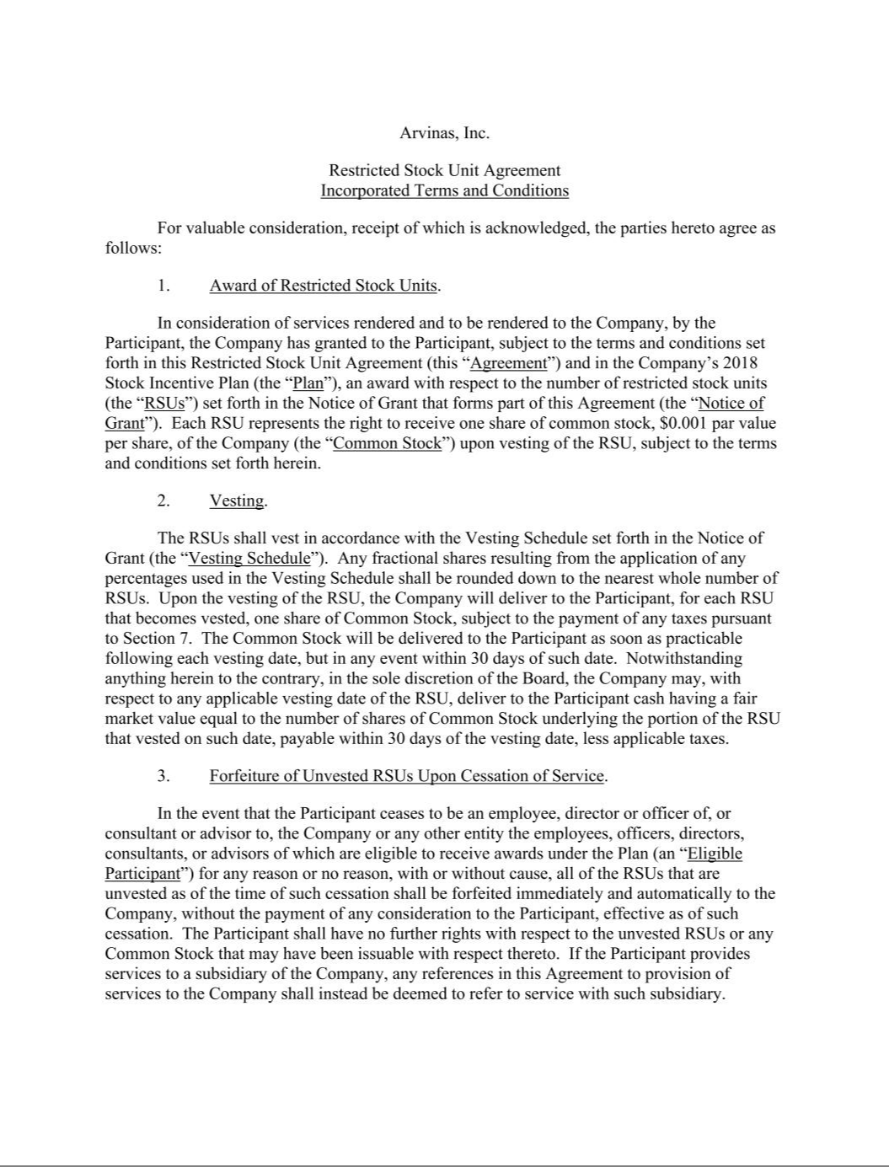

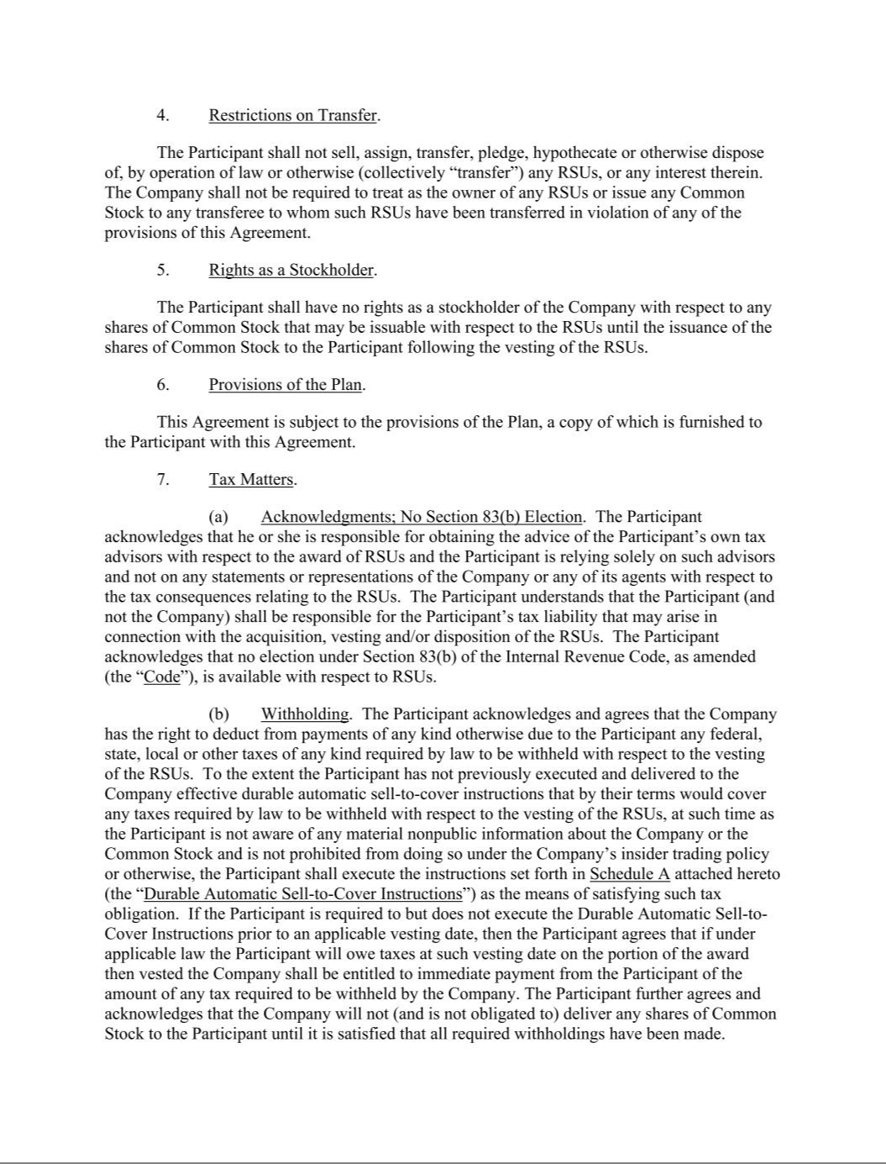

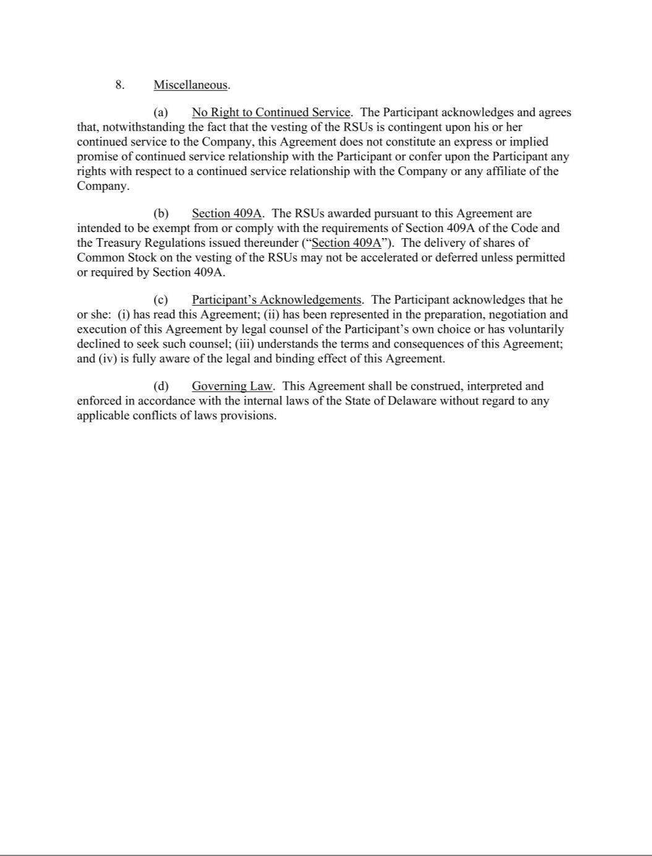

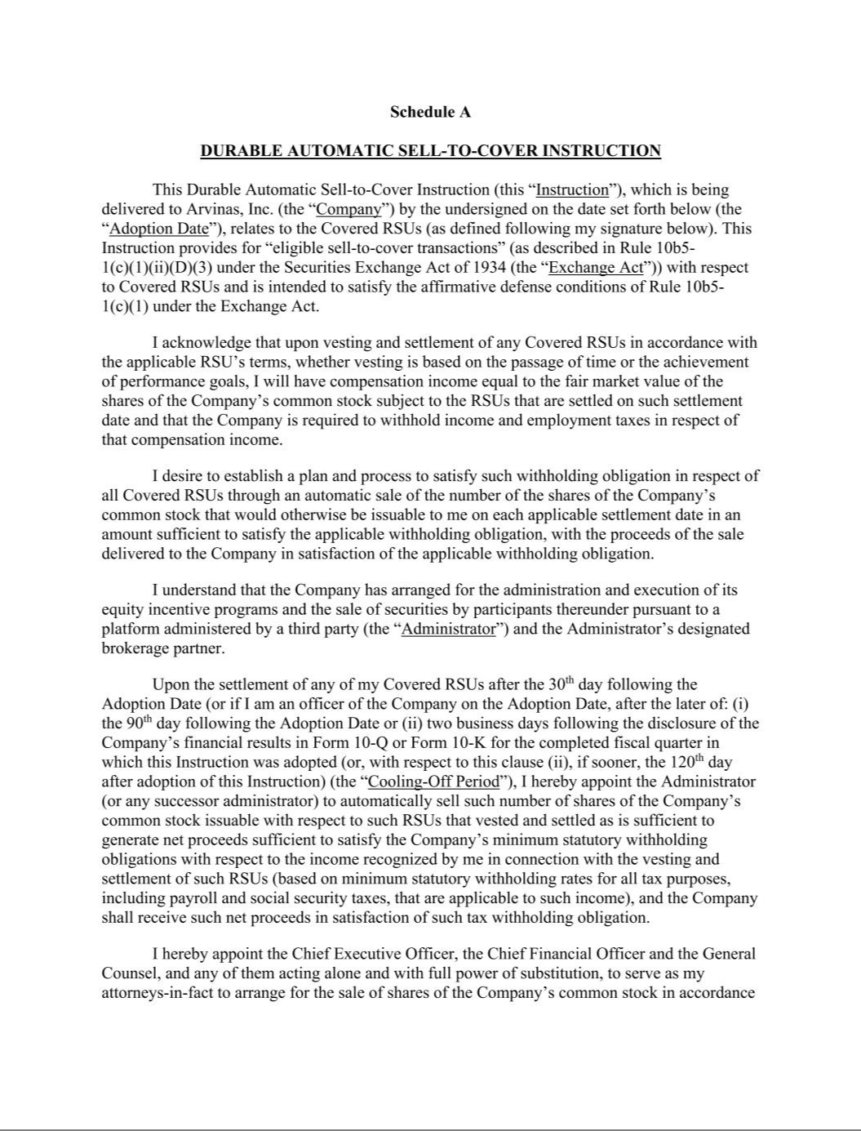

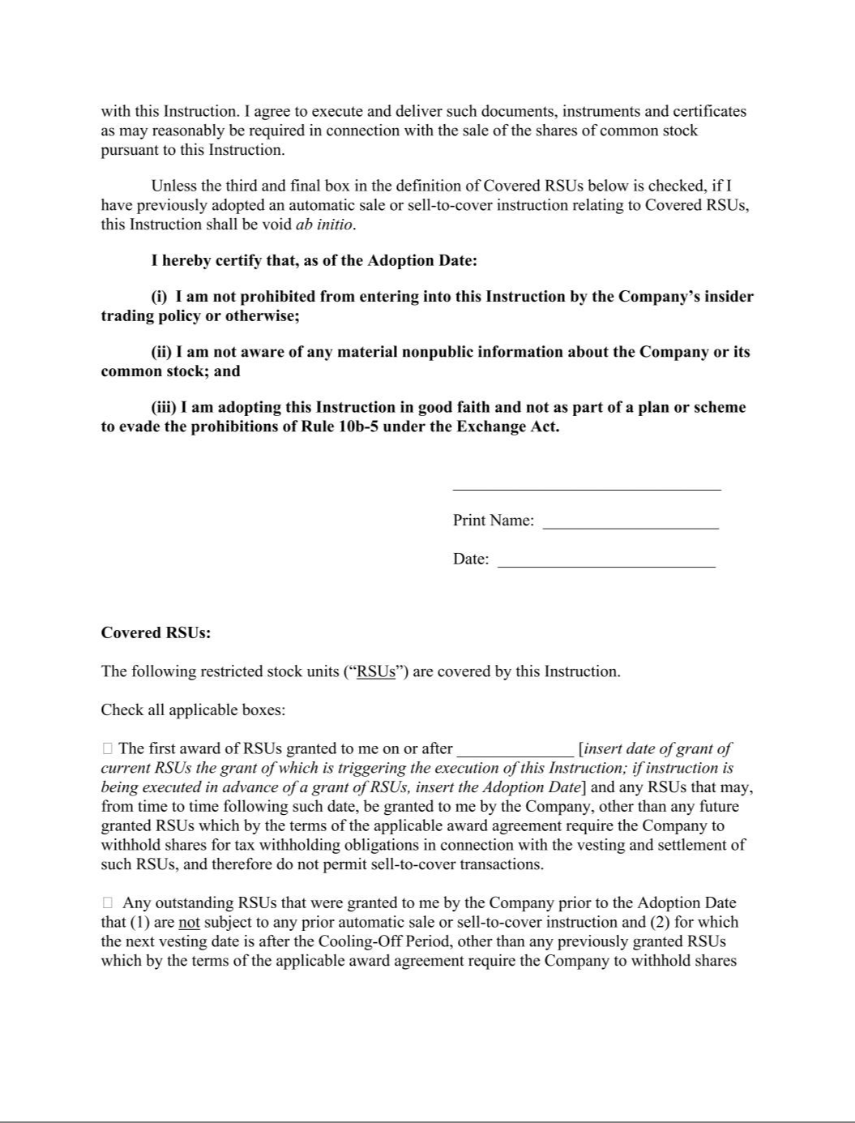



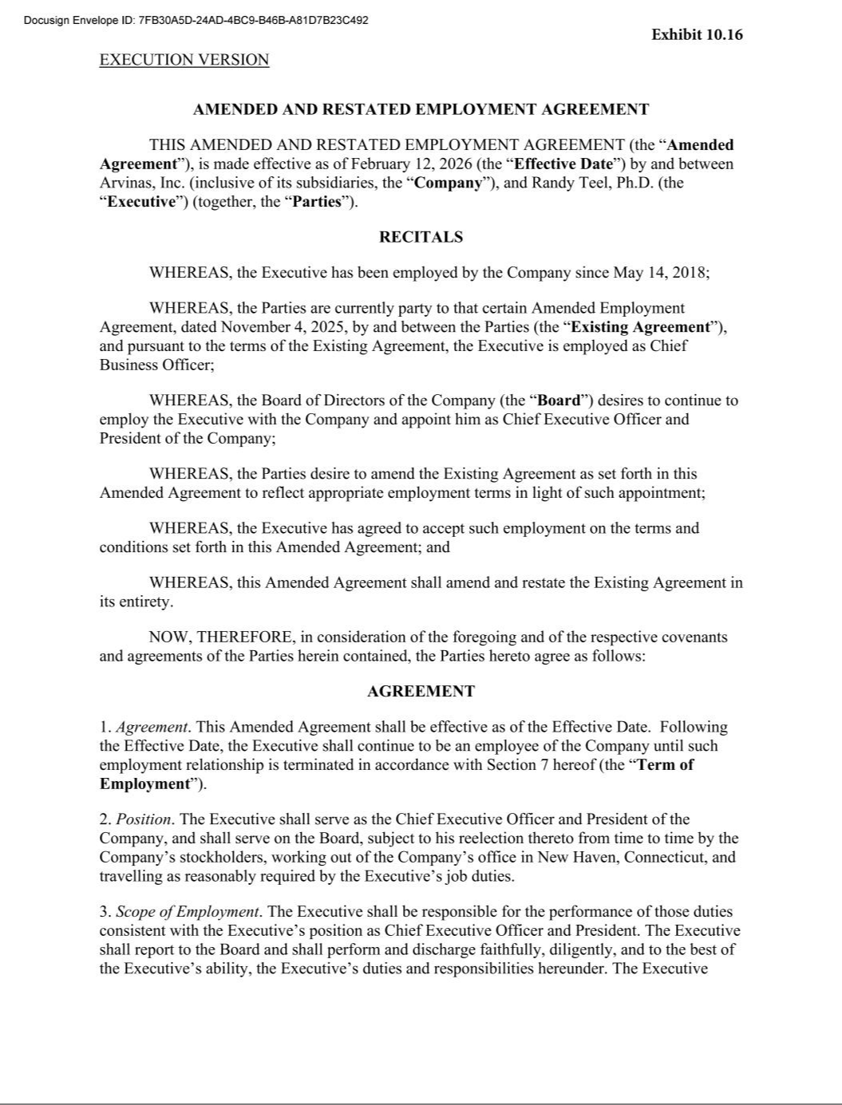

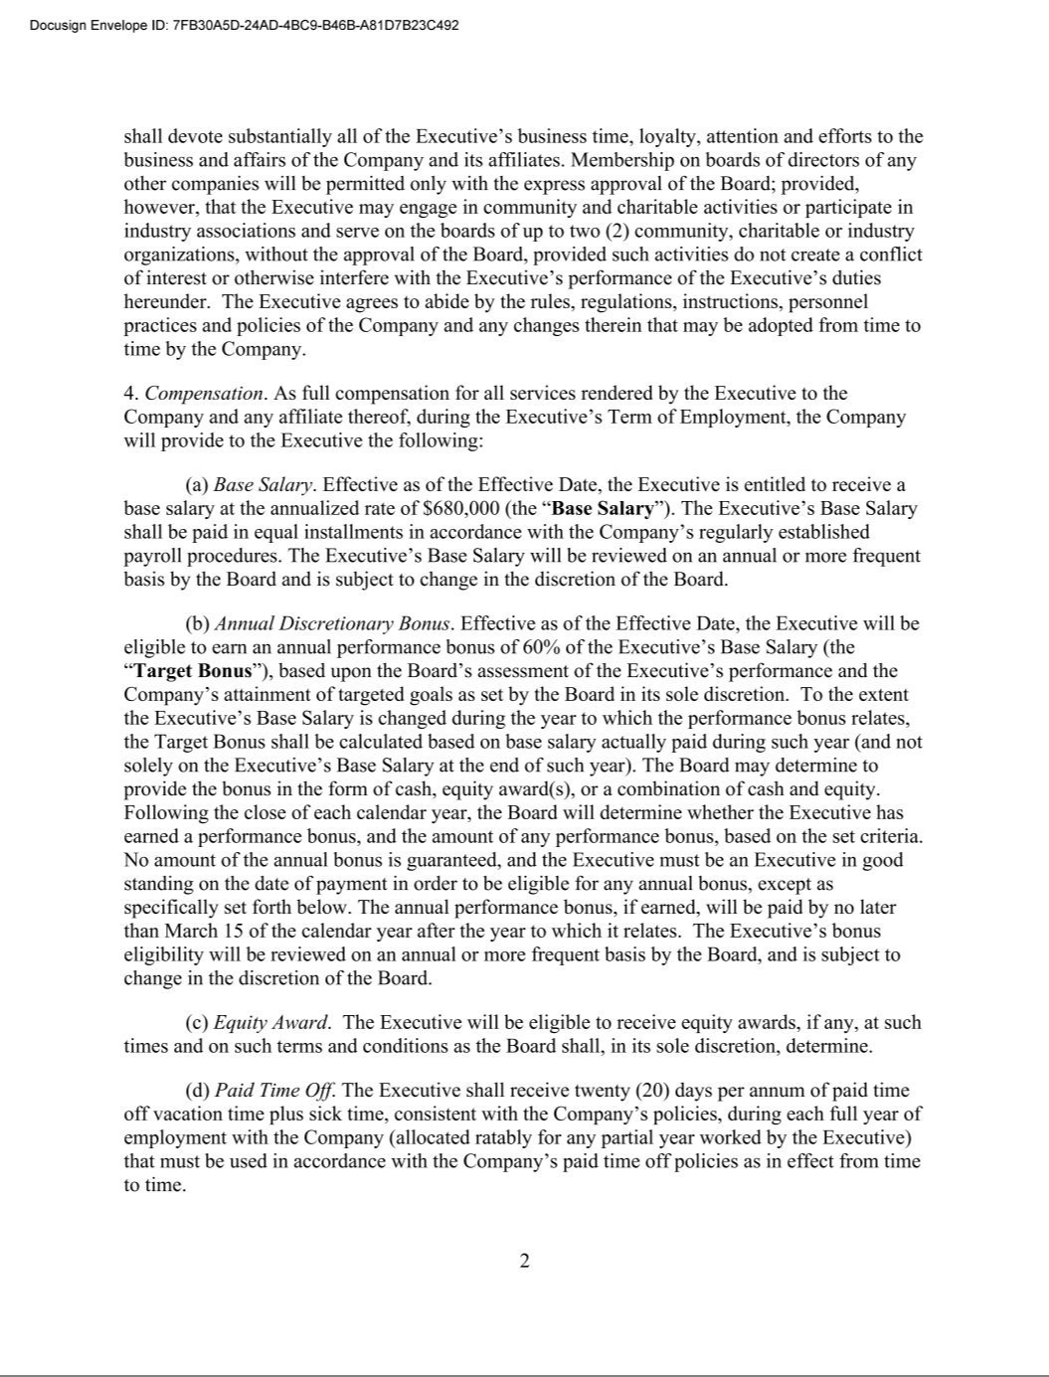

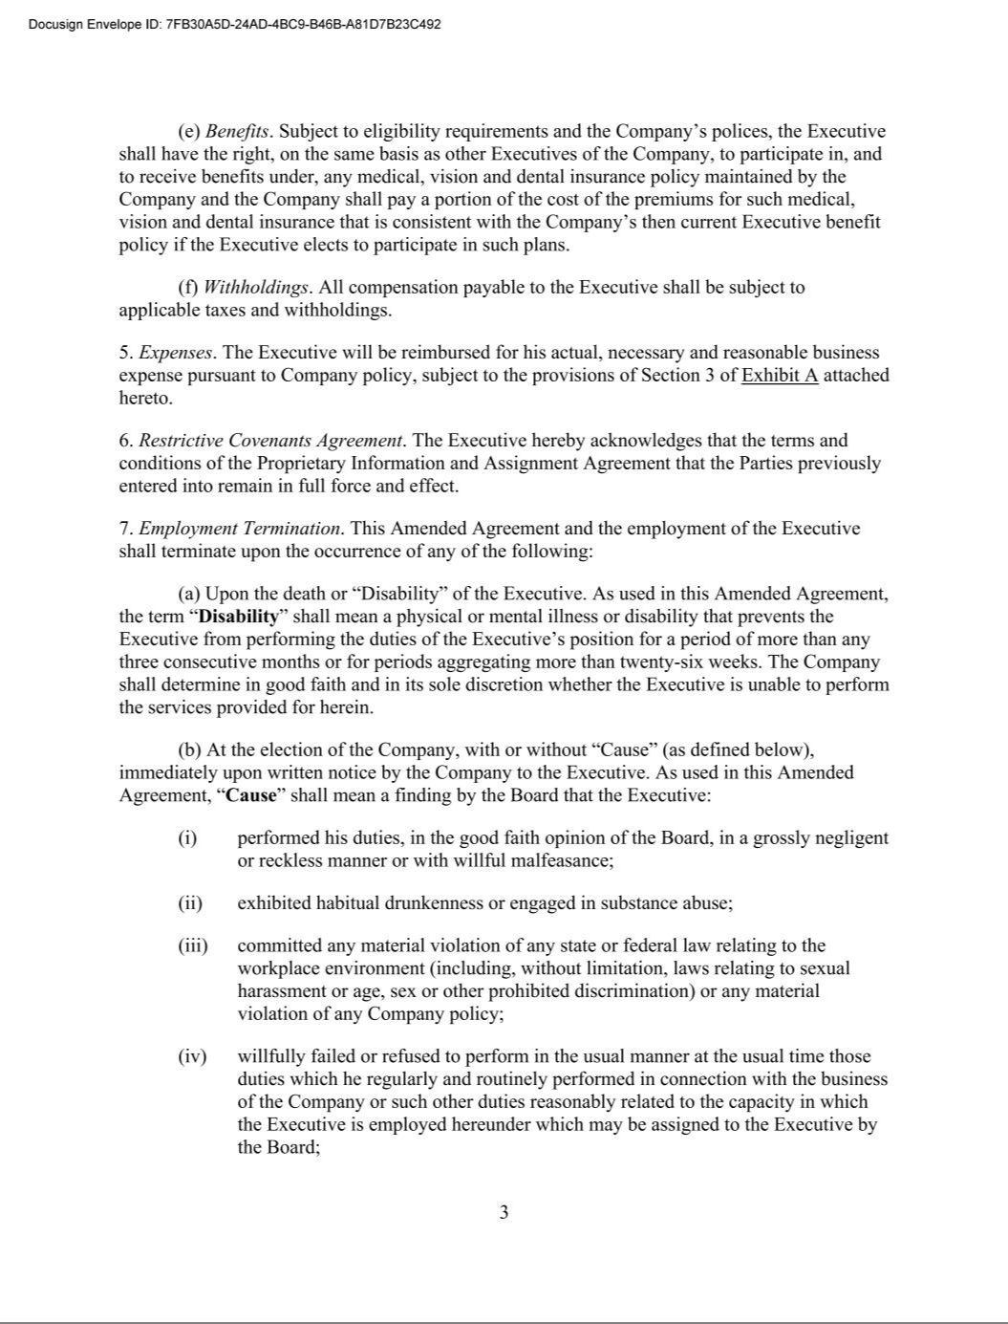

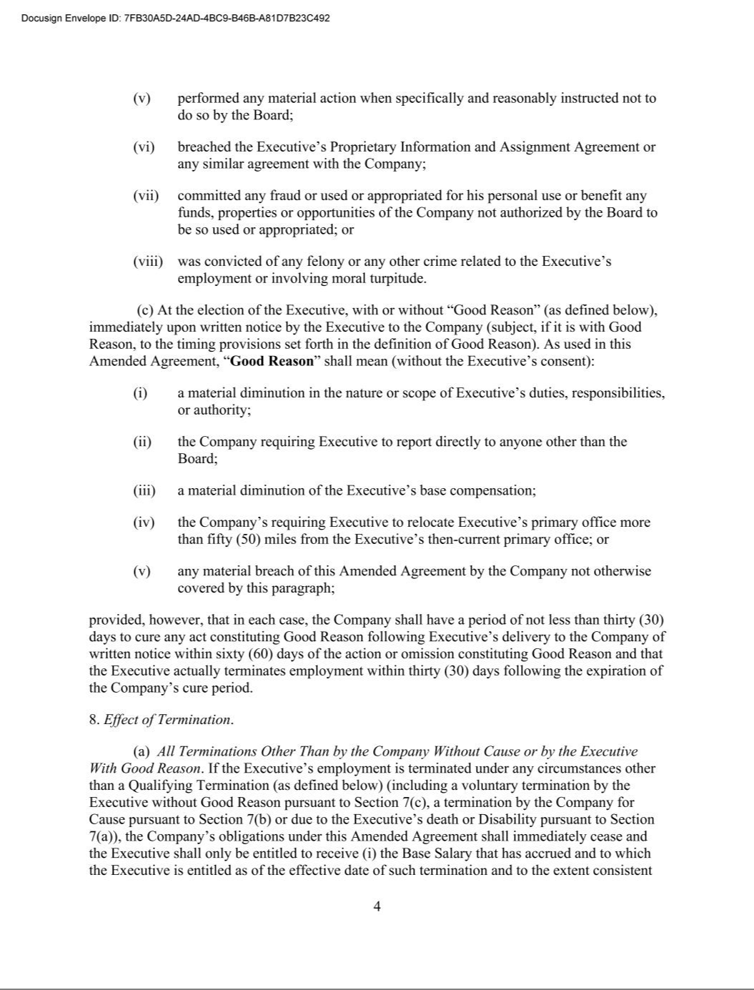

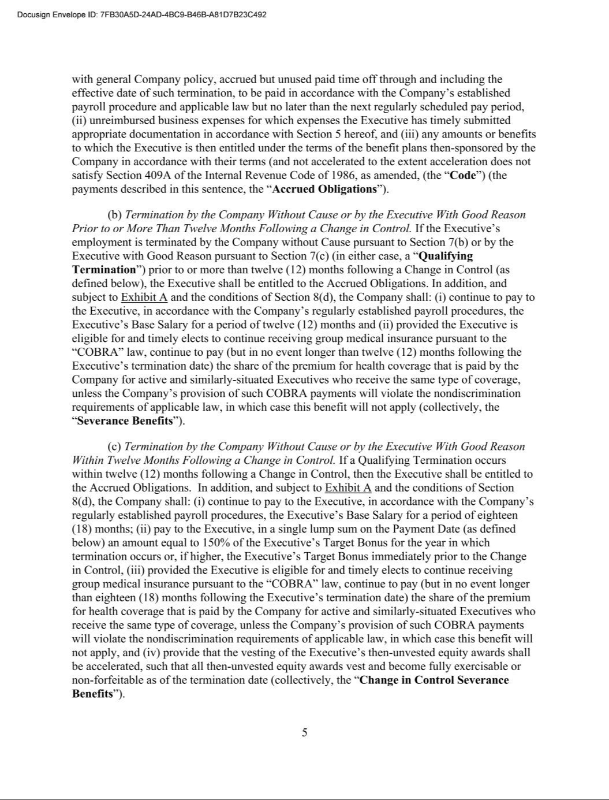

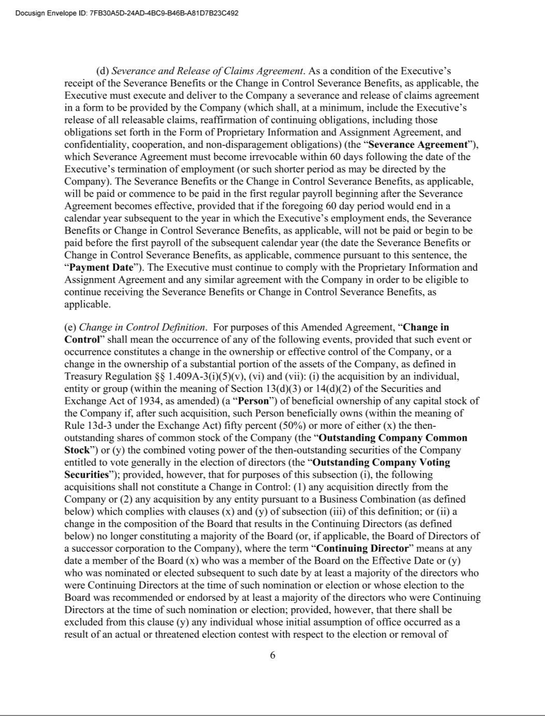

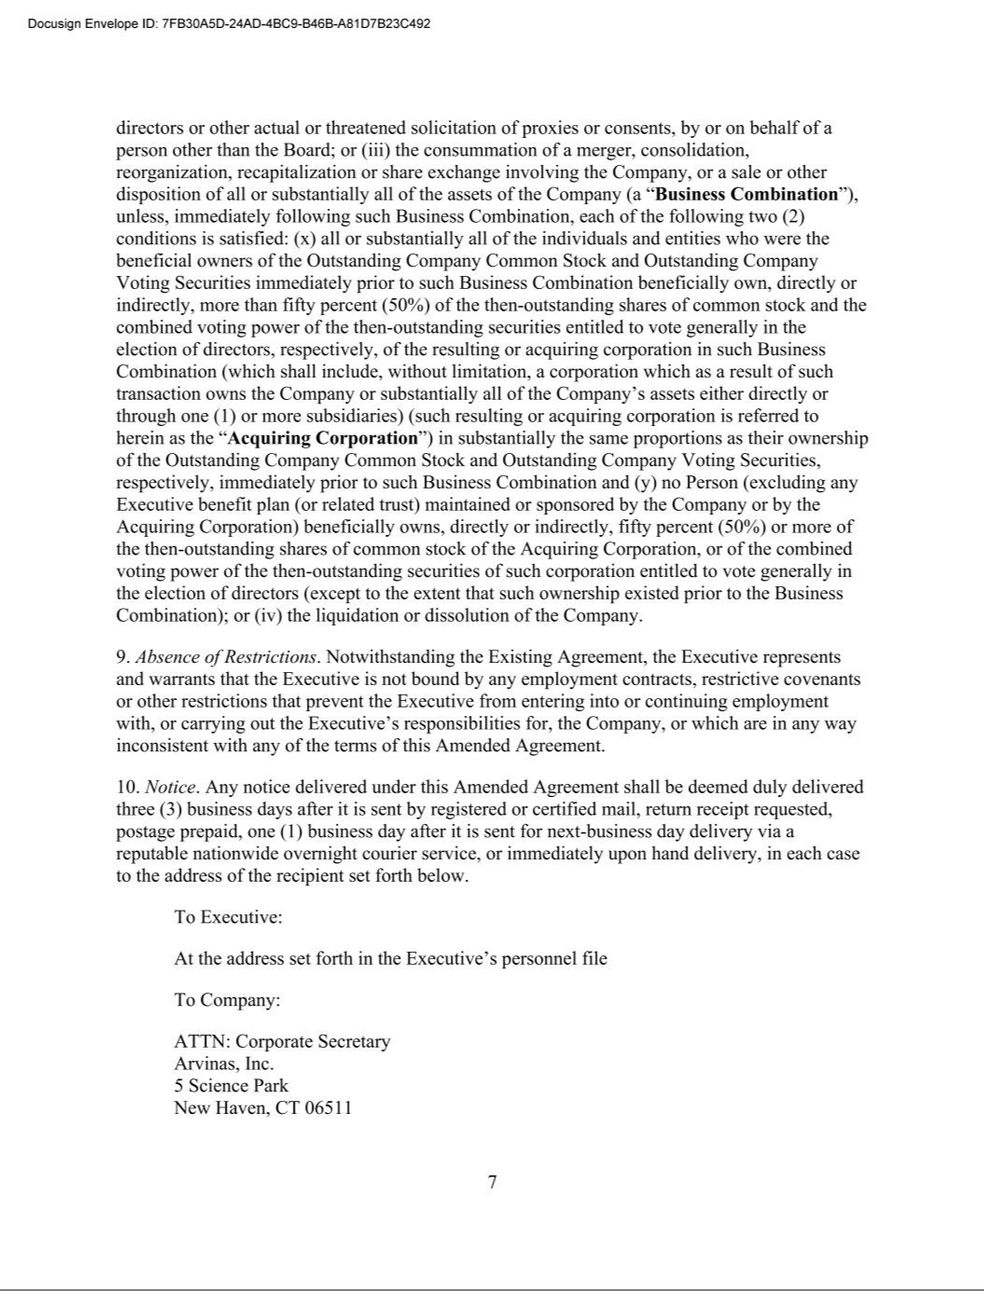

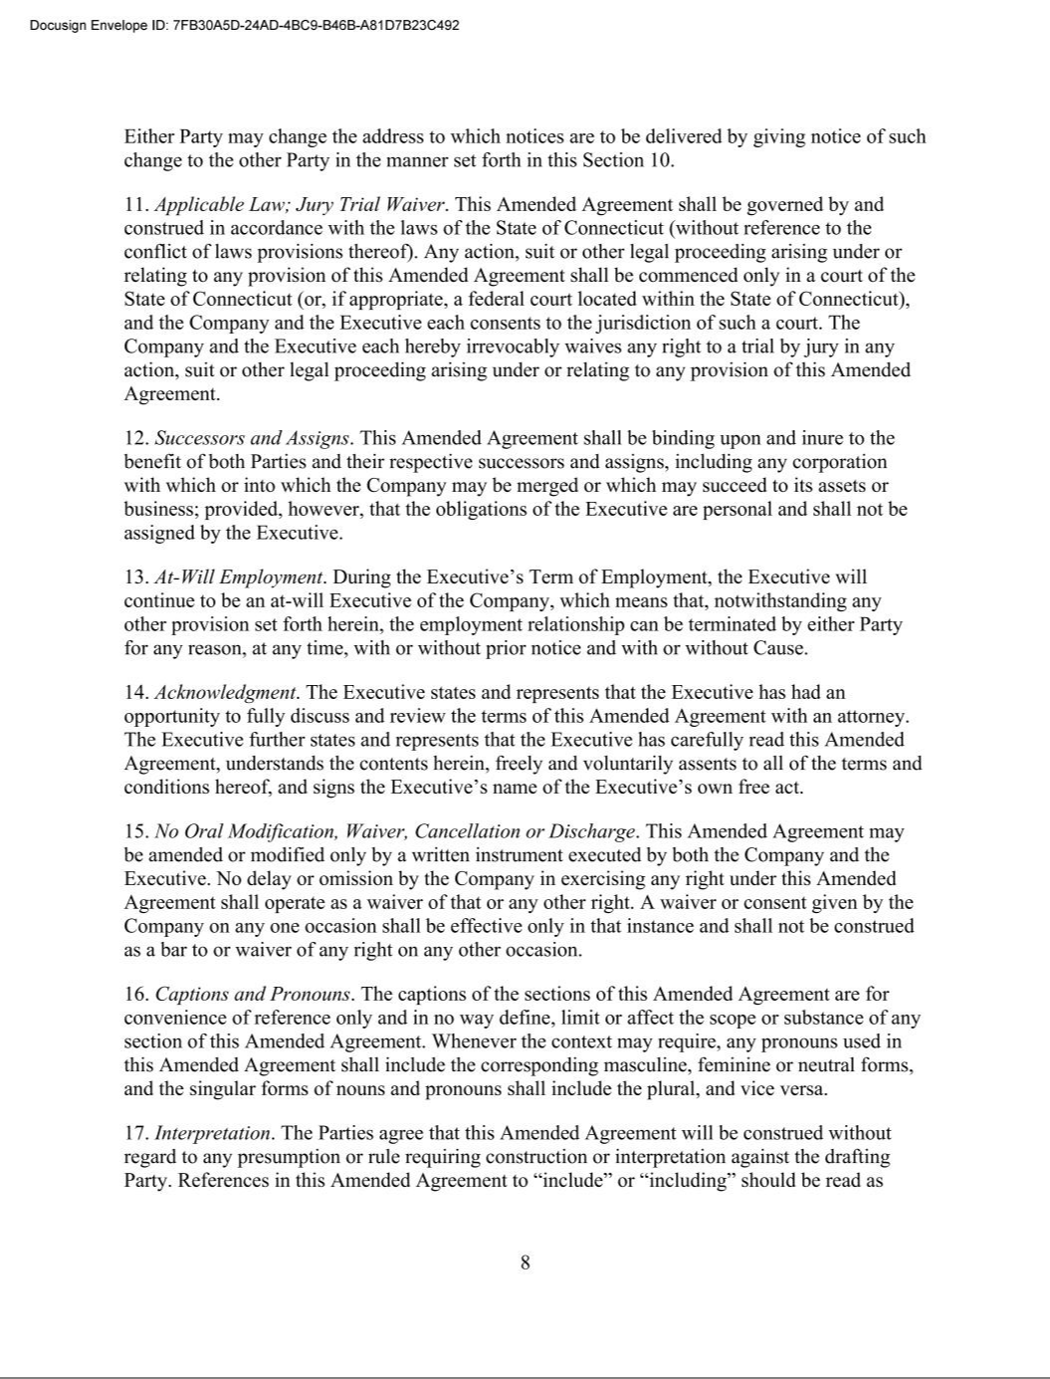

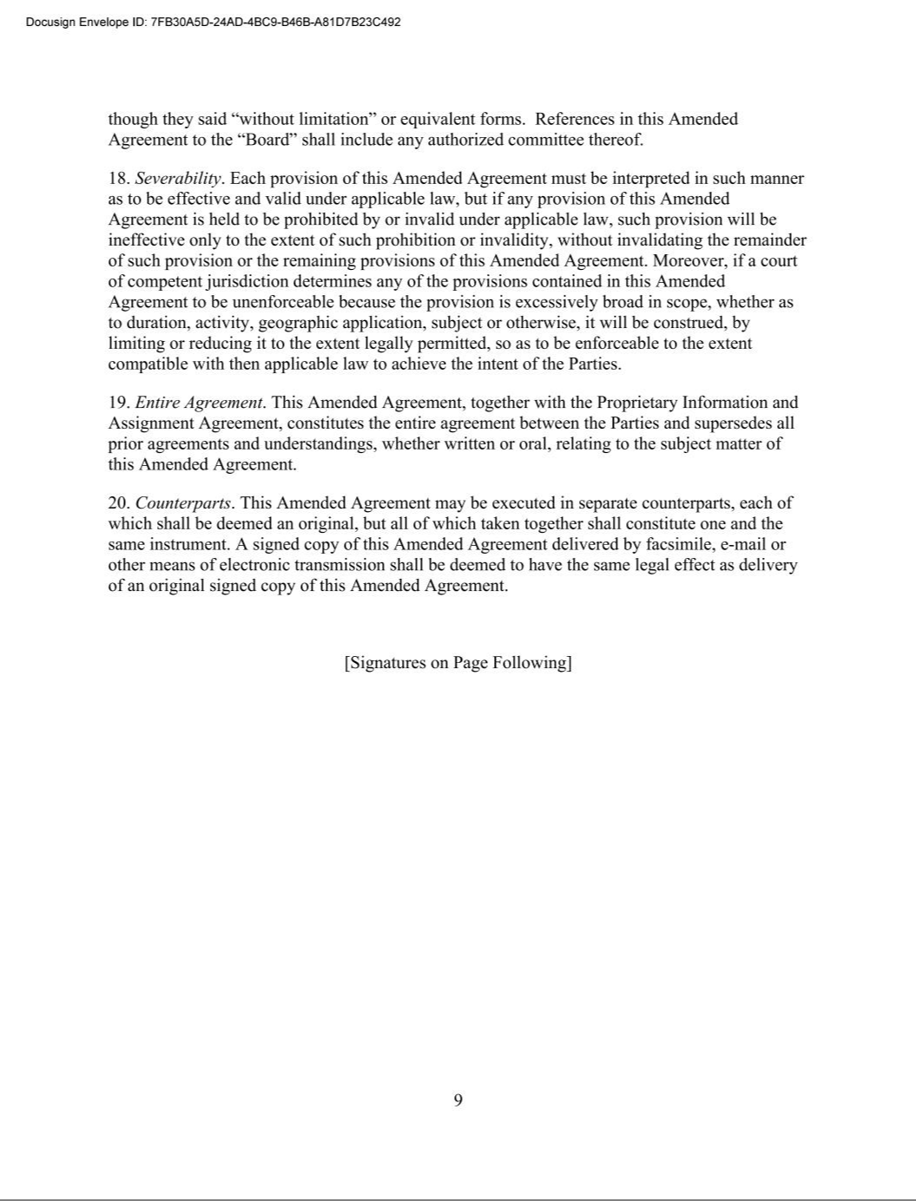

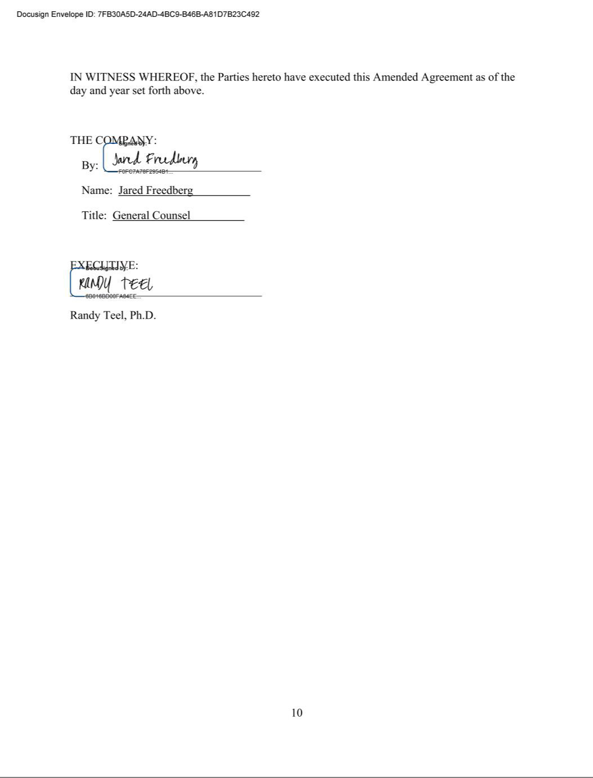

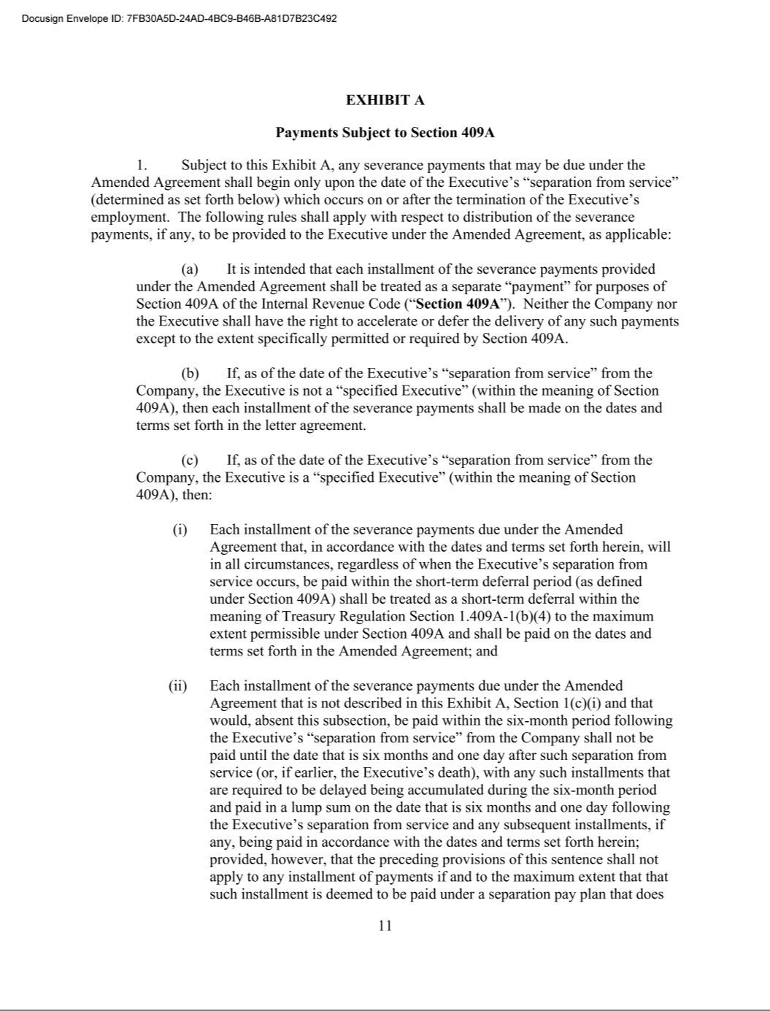

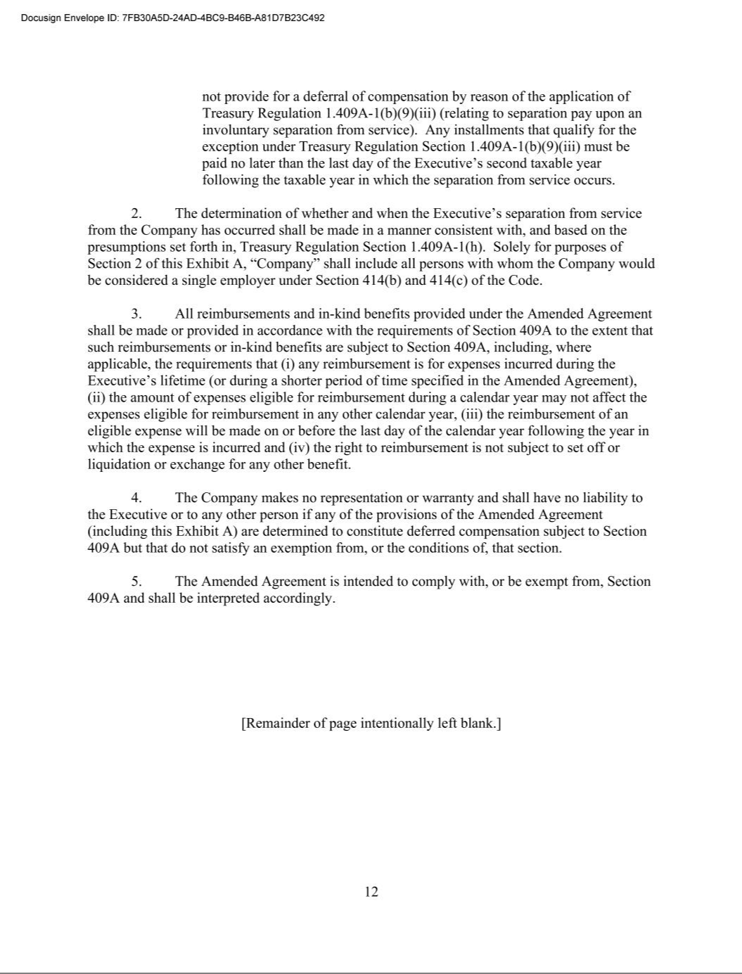

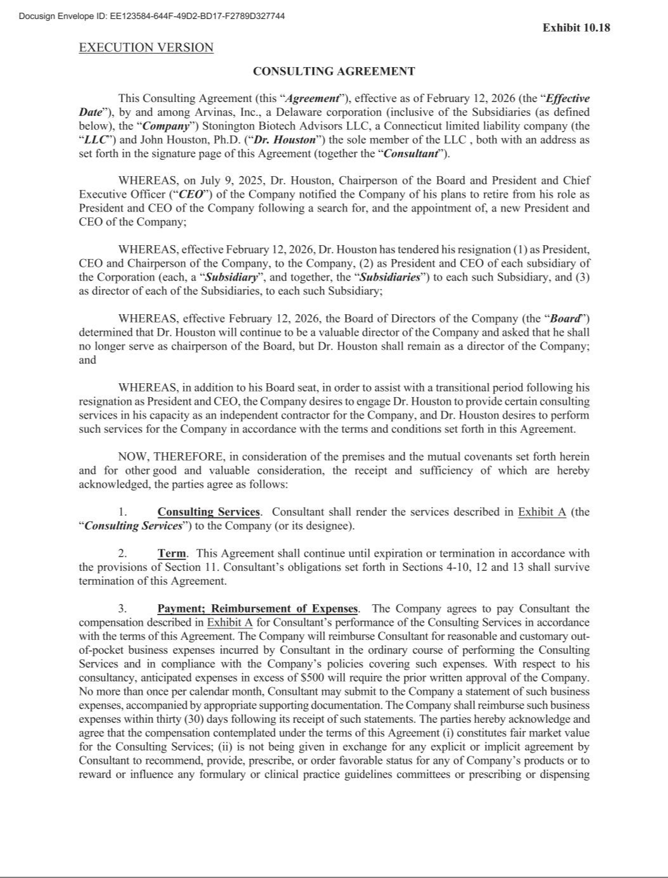

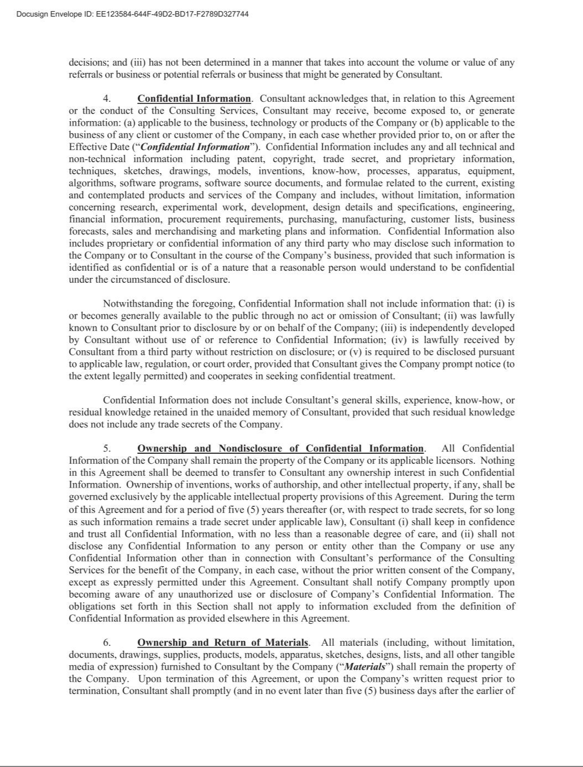

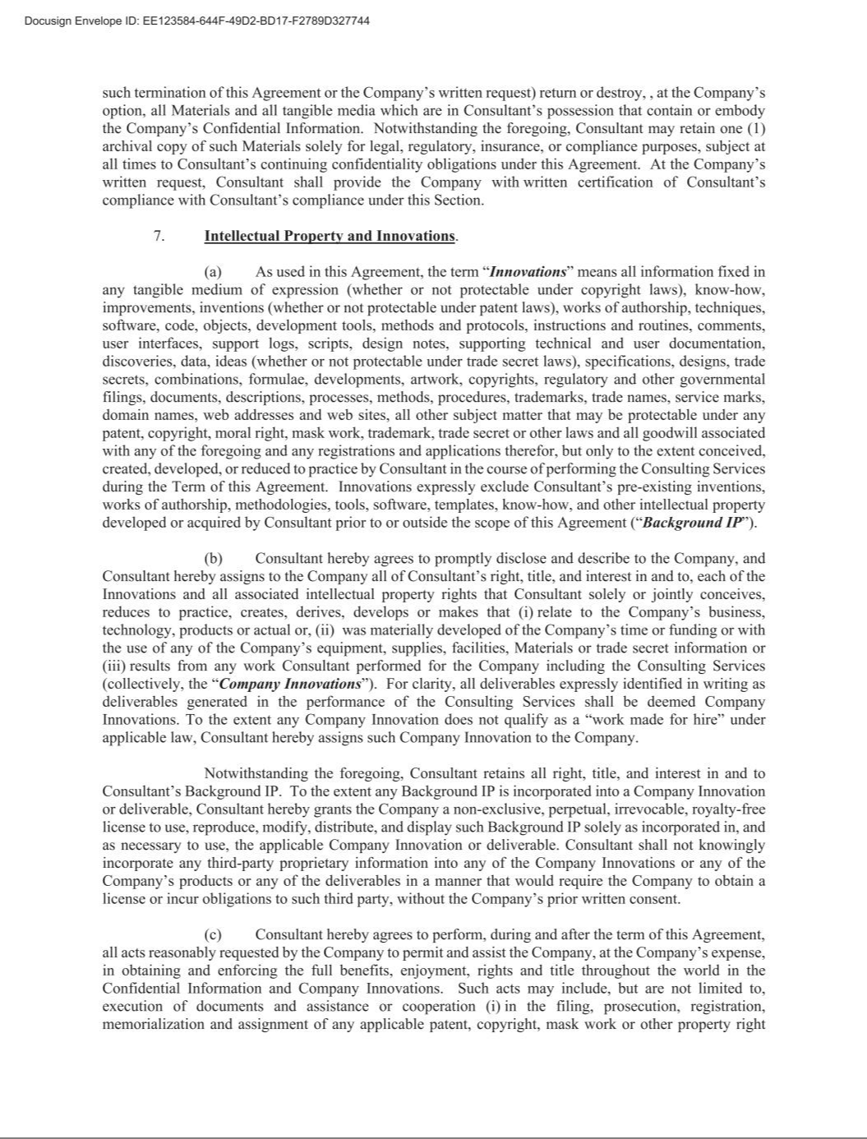

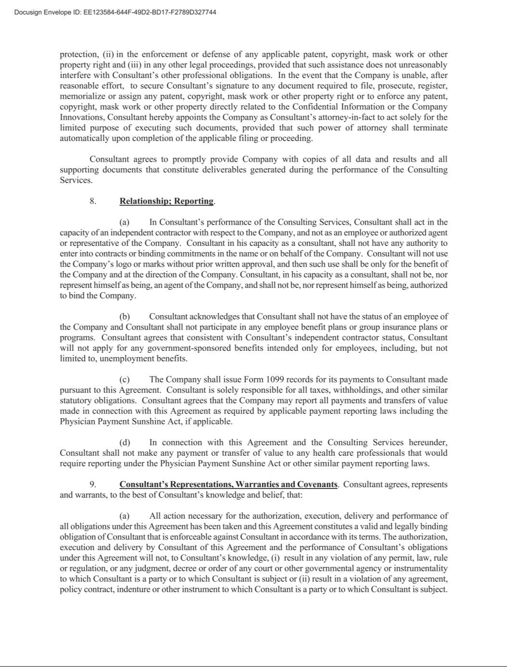

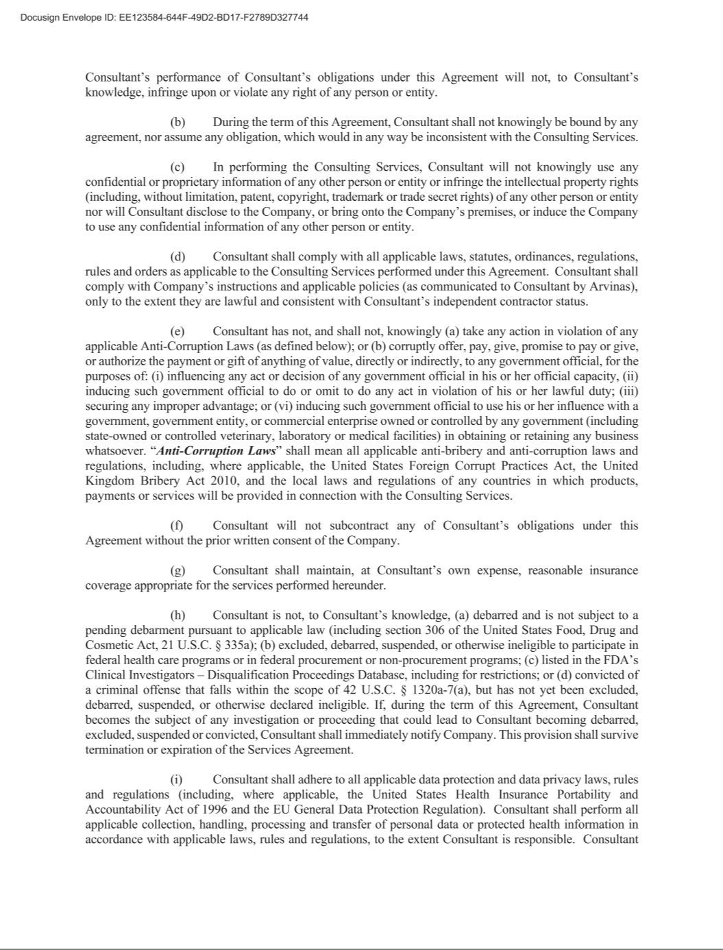

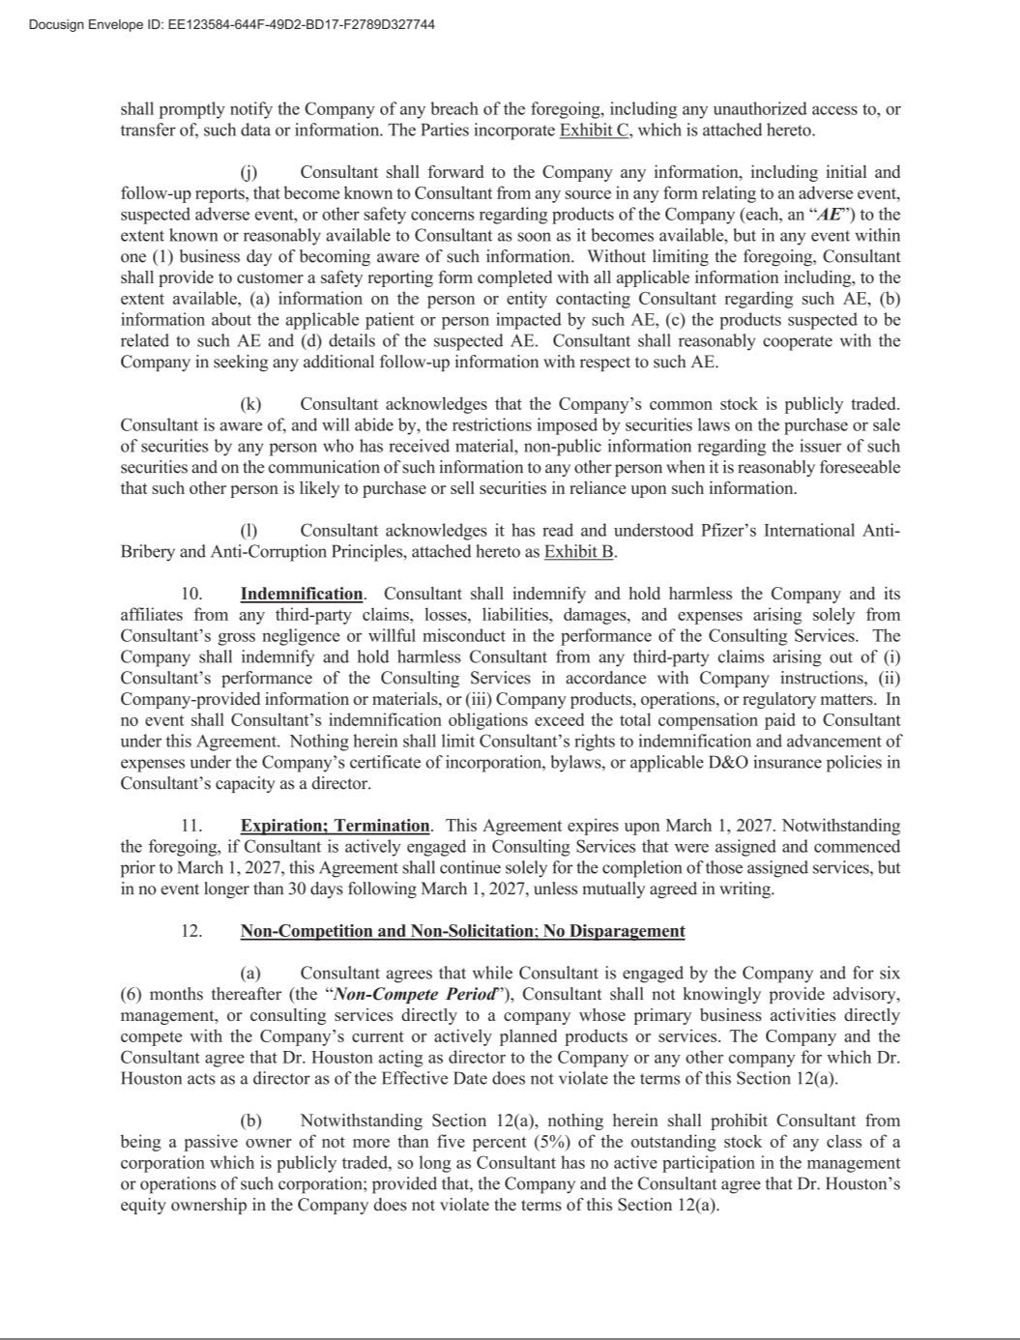

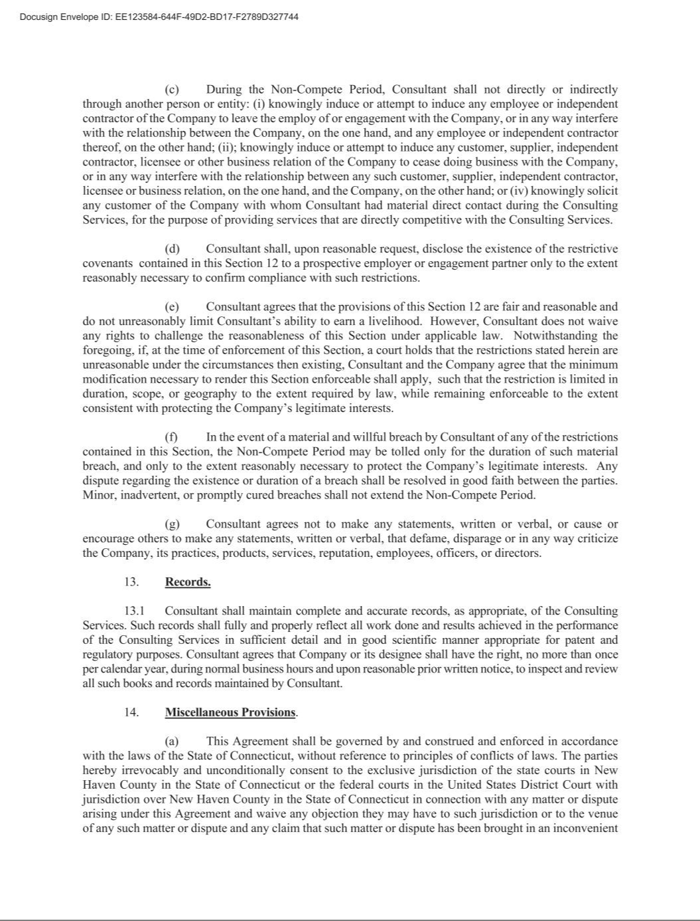

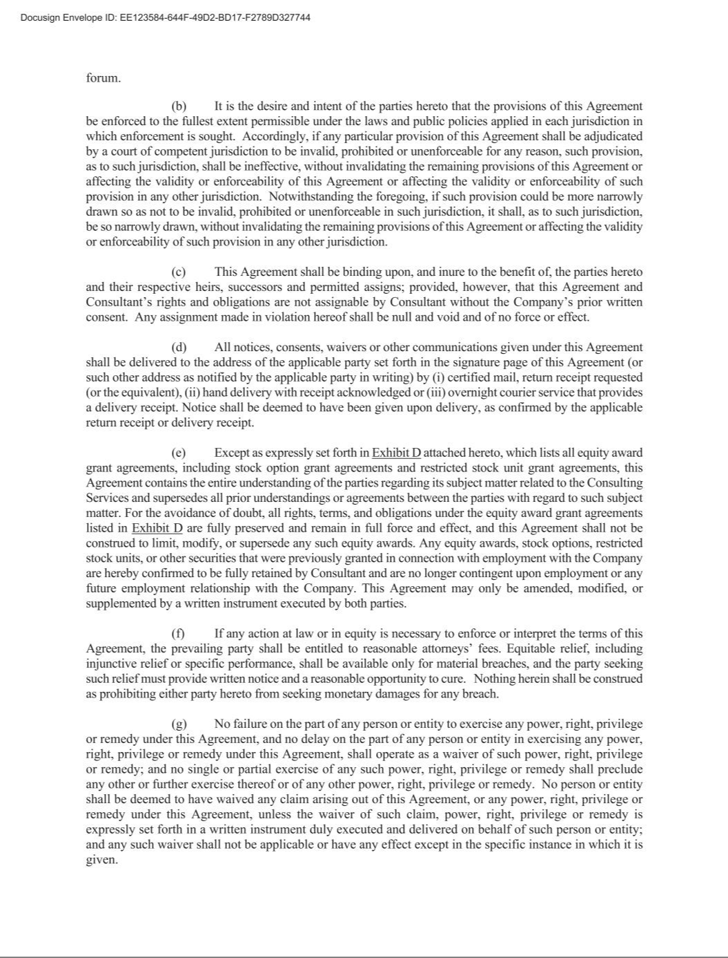



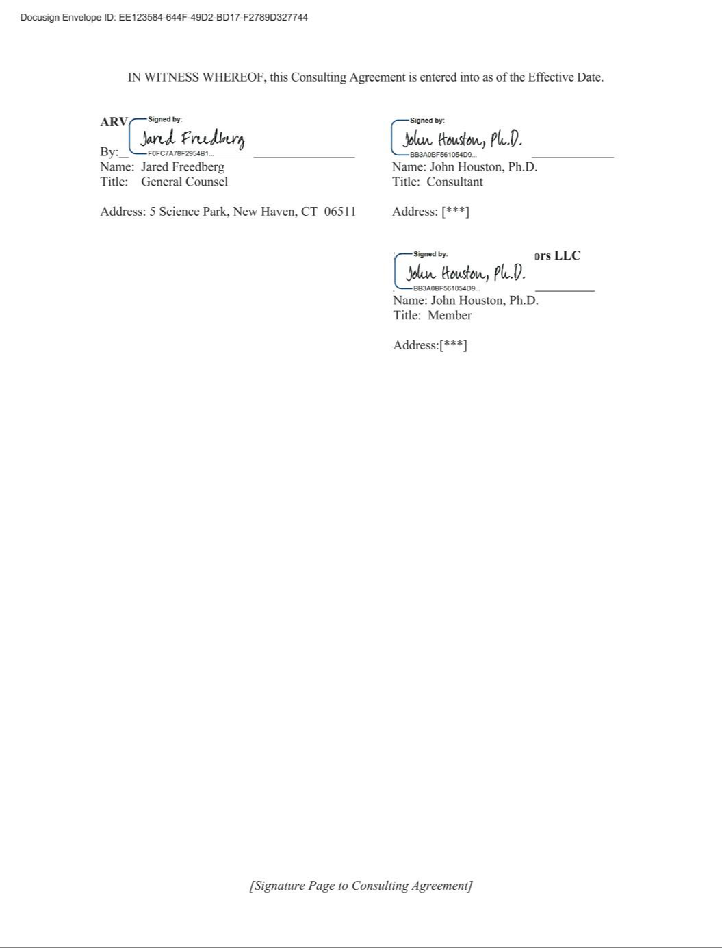

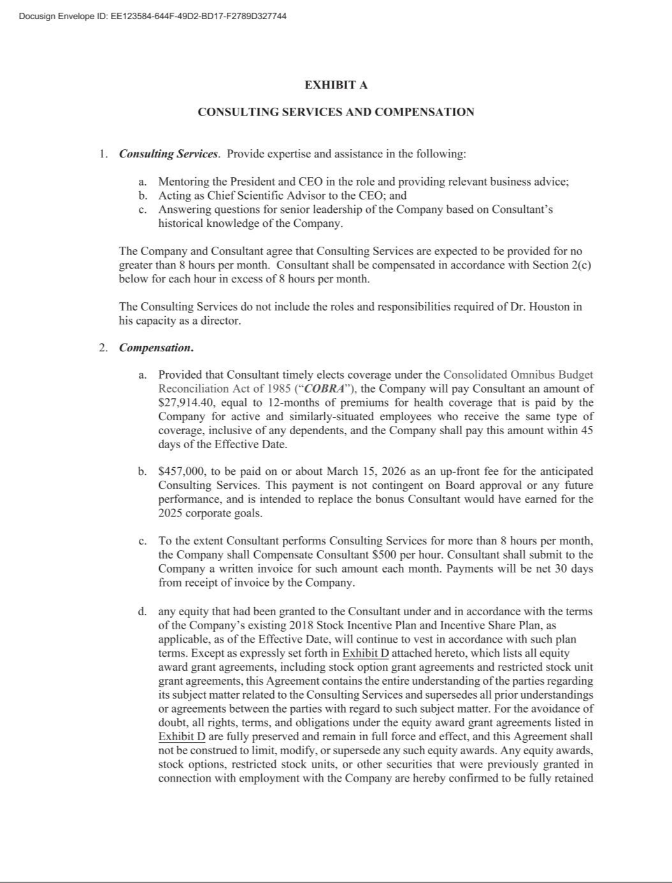



Exhibit 21.1

Name of Subsidiary |  | State of Incorporation
Arvinas Operations, Inc. |  | Delaware
Arvinas Androgen Receptor, Inc. |  | Delaware
Arvinas Estrogen Receptor, Inc. |  | Delaware
Arvinas Winchester, Inc. |  | Delaware

Exhibit 23.1

CONSENT OF INDEPENDENT REGISTERED PUBLIC ACCOUNTING FIRM

We consent to the incorporation by reference in Registration Statement Nos. 333-234031, 333-234035, 333-251326, 333-275377 and 333-275945 on Form S-3 and Registration Statement Nos. 333-227555, 333-231388, 333-237215, 333-253721, 333-263095, 333-270010, 333-276519, 333-278044, 333-280537 and 333-284848 on Form S-8 of our reports dated February 24, 2026 relating to the consolidated financial statements of Arvinas, Inc. and subsidiaries (the “Company”) and the effectiveness of the Company’s internal control over financial reporting appearing in this Annual Report on Form 10-K for the year ended December 31, 2025.

/s/ Deloitte & Touche LLP

Boston, Massachusetts

February 24, 2026

Exhibit 31.1

CERTIFICATION PURSUANT TO

RULES 13a-14(a) AND 15d-14(a) UNDER THE SECURITIES EXCHANGE ACT OF 1934,

AS ADOPTED PURSUANT TO SECTION 302 OF THE SARBANES-OXLEY ACT OF 2002

I, Randy Teel, Ph.D., certify that:

- I have reviewed this Annual Report on Form 10-K of Arvinas, Inc.;

- Based on my knowledge, this report does not contain any untrue statement of a material fact or omit to state a material fact necessary to make the statements made, in light of the circumstances under which such statements were made, not misleading with respect to the period covered by this report;

- Based on my knowledge, the financial statements, and other financial information included in this report, fairly present in all material respects the financial condition, results of operations and cash flows of the registrant as of, and for, the periods presented in this report;

- The registrant's other certifying officer and I are responsible for establishing and maintaining disclosure controls and procedures (as defined in Exchange Act Rules 13a-15(e) and 15d-15(e)) and internal control over financial reporting (as defined in Exchange Act Rules 13a-15(f) and 15d-15(f)) for the registrant and have:

  - Designed such disclosure controls and procedures, or caused such disclosure controls and procedures to be designed under our supervision, to ensure that material information relating to the registrant, including its consolidated subsidiaries, is made known to us by others within those entities, particularly during the period in which this report is being prepared;

  - Designed such internal control over financial reporting, or caused such internal control over financial reporting to be designed under our supervision, to provide reasonable assurance regarding the reliability of financial reporting and the preparation of financial statements for external purposes in accordance with generally accepted accounting principles;

  - Evaluated the effectiveness of the registrant's disclosure controls and procedures and presented in this report our conclusions about the effectiveness of the disclosure controls and procedures, as of the end of the period covered by this report based on such evaluation; and

  - Disclosed in this report any change in the registrant's internal control over financial reporting that occurred during the registrant's most recent fiscal quarter (the registrant's fourth fiscal quarter in the case of an annual report) that has materially affected, or is reasonably likely to materially affect, the registrant's internal control over financial reporting; and

- The registrant's other certifying officer and I have disclosed, based on our most recent evaluation of internal control over financial reporting, to the registrant's auditors and the audit committee of the registrant's board of directors (or persons performing the equivalent functions):

  - All significant deficiencies and material weaknesses in the design or operation of internal control over financial reporting which are reasonably likely to adversely affect the registrant's ability to record, process, summarize and report financial information; and

  - Any fraud, whether or not material, that involves management or other employees who have a significant role in the registrant's internal control over financial reporting.

Date: February 24, 2026 By: /s/ Randy Teel, Ph.D.

Randy Teel, Ph.D.

President and Chief Executive Officer

(Principal Executive Officer)

Exhibit 31.2

CERTIFICATION PURSUANT TO

RULES 13a-14(a) AND 15d-14(a) UNDER THE SECURITIES EXCHANGE ACT OF 1934,

AS ADOPTED PURSUANT TO SECTION 302 OF THE SARBANES-OXLEY ACT OF 2002

I, Andrew Saik, certify that:

- I have reviewed this Annual Report on Form 10-K of Arvinas, Inc.;

- Based on my knowledge, this report does not contain any untrue statement of a material fact or omit to state a material fact necessary to make the statements made, in light of the circumstances under which such statements were made, not misleading with respect to the period covered by this report;

- Based on my knowledge, the financial statements, and other financial information included in this report, fairly present in all material respects the financial condition, results of operations and cash flows of the registrant as of, and for, the periods presented in this report;

- The registrant's other certifying officer and I are responsible for establishing and maintaining disclosure controls and procedures (as defined in Exchange Act Rules 13a-15(e) and 15d-15(e)) and internal control over financial reporting (as defined in Exchange Act Rules 13a-15(f) and 15d-15(f)) for the registrant and have:

  - Designed such disclosure controls and procedures, or caused such disclosure controls and procedures to be designed under our supervision, to ensure that material information relating to the registrant, including its consolidated subsidiaries, is made known to us by others within those entities, particularly during the period in which this report is being prepared;

  - Designed such internal control over financial reporting, or caused such internal control over financial reporting to be designed under our supervision, to provide reasonable assurance regarding the reliability of financial reporting and the preparation of financial statements for external purposes in accordance with generally accepted accounting principles;

  - Evaluated the effectiveness of the registrant’s disclosure controls and procedures and presented in this report our conclusions about the effectiveness of the disclosure controls and procedures, as of the end of the period covered by this report based on such evaluation; and

  - Disclosed in this report any change in the registrant's internal control over financial reporting that occurred during the registrant's most recent fiscal quarter (the registrant's fourth fiscal quarter in the case of an annual report) that has materially affected, or is reasonably likely to materially affect, the registrant's internal control over financial reporting; and

- The registrant's other certifying officer and I have disclosed, based on our most recent evaluation of internal control over financial reporting, to the registrant's auditors and the audit committee of the registrant's board of directors (or persons performing the equivalent functions):

  - All significant deficiencies and material weaknesses in the design or operation of internal control over financial reporting which are reasonably likely to adversely affect the registrant's ability to record, process, summarize and report financial information; and

  - Any fraud, whether or not material, that involves management or other employees who have a significant role in the registrant's internal control over financial reporting.

Date: February 24, 2026 By: /s/ Andrew Saik

Andrew Saik

Chief Financial Officer and Treasurer

(Principal Financial Officer)

Exhibit 32.1

CERTIFICATION PURSUANT TO

18 U.S.C. SECTION 1350, AS ADOPTED PURSUANT TO

SECTION 906 OF THE SARBANES-OXLEY ACT OF 2002

In connection with the Annual Report of Arvinas, Inc. (the “Company”) on Form 10-K for the period ended December 31, 2025 as filed with the Securities and Exchange Commission on the date hereof (the “Report”), I certify, pursuant to 18 U.S.C. § 1350, as adopted pursuant to § 906 of the Sarbanes-Oxley Act of 2002, that:

- The Report fully complies with the requirements of section 13(a) or 15(d) of the Securities Exchange Act of 1934; and

- The information contained in the Report fairly presents, in all material respects, the financial condition and result of operations of the Company.

Date: February 24, 2026 By: /s/ Randy Teel, Ph.D.

Randy Teel, Ph.D.

President and Chief Executive Officer

(Principal Executive Officer)

Exhibit 32.2

CERTIFICATION PURSUANT TO

18 U.S.C. SECTION 1350, AS ADOPTED PURSUANT TO

SECTION 906 OF THE SARBANES-OXLEY ACT OF 2002

In connection with the Annual Report of Arvinas, Inc. (the “Company”) on Form 10-K for the period ended December 31, 2025 as filed with the Securities and Exchange Commission on the date hereof (the “Report”), I certify, pursuant to 18 U.S.C. § 1350, as adopted pursuant to § 906 of the Sarbanes-Oxley Act of 2002, that:

- The Report fully complies with the requirements of section 13(a) or 15(d) of the Securities Exchange Act of 1934; and

- The information contained in the Report fairly presents, in all material respects, the financial condition and result of operations of the Company.

Date: February 24, 2026 By: /s/ Andrew Saik

Andrew Saik

Chief Financial Officer and Treasurer

(Principal Financial Officer)

